UNITED STATES
SECURITIES AND EXCHANGE COMMISSION
Washington, D.C. 20549

SCHEDULE 14A
Proxy Statement Pursuant to Section 14(a) of the
Securities Exchange Act of 1934 (Amendment No. )

Filed by the Registrant ☒ |  | Filed by a party other than the Registrant ☐

Check the appropriate box:
☐ | Preliminary Proxy Statement
☐ | Confidential, for Use of the Commission Only (as permitted by Rule 14a-6(e)(2))
☐ | Definitive Proxy Statement
☒ | Definitive Additional Materials
☐ | Soliciting Material Under Rule §240.14a-12



Weatherford International plc
(Name of Registrant as Specified In Its Charter)

N/A
(Name of Person(s) Filing Proxy Statement, if other than the Registrant)

Payment of Filing Fee (Check all boxes that apply):

☒ | No fee required.
☐ | Fee paid previously with preliminary materials:
☐ | Fee computed on table in exhibit required by Item 25(b) per Exchange Act Rules 14a-6(i)(1) and 0- 11

 | You invested in WEATHERFORD INTERNATIONAL PLC and it’s time to vote! You have the right to vote on proposals being presented at the Annual General Meeting. This is an important notice regarding the availability of proxy material for the shareholder meeting to be held on June 15, 2023. *If you choose to vote these shares in person at the meeting, you must request a “legal proxy.” To do so, please follow the instructions at www.ProxyVote.com or request a paper copy of the materials, which will contain the appropriate instructions. Please check the meeting materials for any special requirements for meeting attendance. Smartphone users Point your camera here and vote without entering a control number V1.1 Your Vote Counts! WEATHERFORD INTERNATIONAL PLC 2023 Annual General Meeting Vote by June 14, 2023 11:59 PM ET For complete information and to vote, visit www.ProxyVote.com Control # V04690-P91706 Get informed before you vote View the Proxy Materials, Form 10-K and Irish Statutory Accounts online OR you can receive a free paper or email copy of the material(s) by requesting prior to June 1, 2023. If you would like to request a copy of the material(s) for this and/or future shareholder meetings, you may (1) visit www.ProxyVote.com, (2) call 1-800-579-1639 or (3) send an email to sendmaterial@proxyvote.com. If sending an email, please include your control number (indicated below) in the subject line. Unless requested, you will not otherwise receive a paper or email copy. Vote in Person at the Meeting* June 15, 2023 10:00 AM Central Time Weatherford International PLC 2000 St. James Place Marcellus Room Houston, Texas 77056
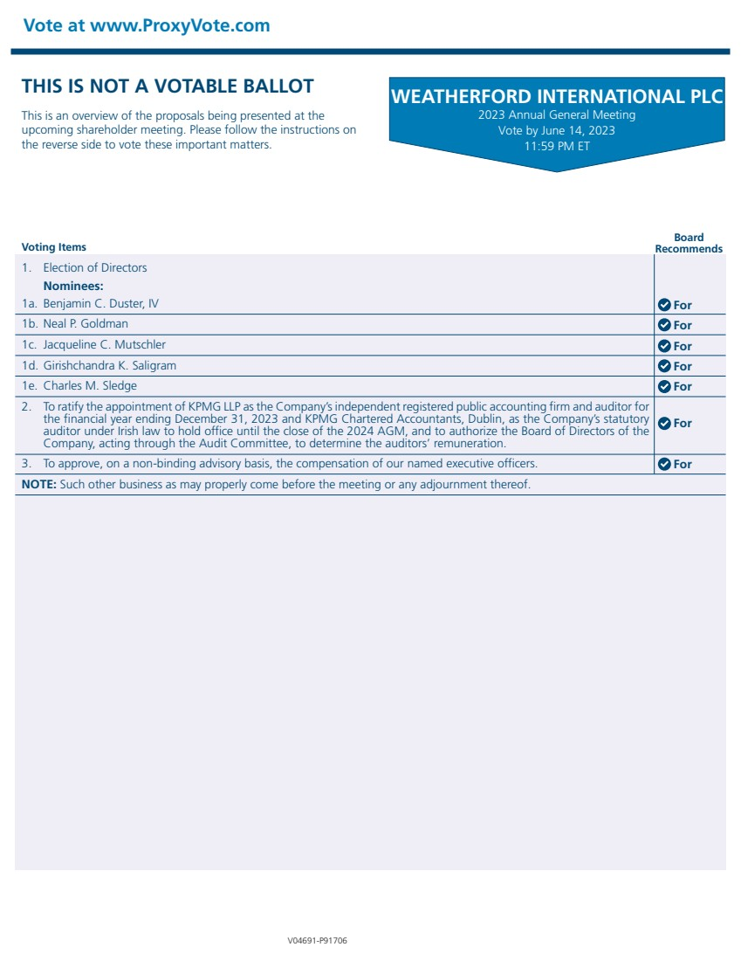 | WEATHERFORD INTERNATIONAL PLC 2023 Annual General Meeting Vote by June 14, 2023 11:59 PM ET Voting Items Board Recommends THIS IS NOT A VOTABLE BALLOT This is an overview of the proposals being presented at the upcoming shareholder meeting. Please follow the instructions on the reverse side to vote these important matters. Vote at www.ProxyVote.com V04691-P91706 1. Election of Directors Nominees: 1c. Jacqueline C. Mutschler 1a. Benjamin C. Duster, IV 1d. Girishchandra K. Saligram 1b. Neal P. Goldman 1e. Charles M. Sledge 2. To ratify the appointment of KPMG LLP as the Company’s independent registered public accounting firm and auditor for the financial year ending December 31, 2023 and KPMG Chartered Accountants, Dublin, as the Company’s statutory auditor under Irish law to hold office until the close of the 2024 AGM, and to authorize the Board of Directors of the Company, acting through the Audit Committee, to determine the auditors’ remuneration. 3. To approve, on a non-binding advisory basis, the compensation of our named executive officers. NOTE: Such other business as may properly come before the meeting or any adjournment thereof. For For For For For For For

