UNITED STATES

SECURITIES AND EXCHANGE COMMISSION
WASHINGTON, D.C. 20549

FORM 8-K

CURRENT REPORT

Pursuant to Section 13 or 15(d) of the Securities Exchange Act of 1934

Date of Report (Date of earliest event reported): August 4, 2020

Weatherford International plc

(Exact name of registrant as specified in its charter)

 | Ireland | 001-36504 | 98-0606750
(State or other jurisdiction of incorporation) |  | (Commission File Number) | (I.R.S. Employer Identification No.)
 | 2000 St. James Place , Houston | , Texas | 77056
 | (Address of principal executive offices) |  | (Zip Code)

Registrant’s telephone number, including area code: 713.836.4000

N/A

(Former Name or Former Address, if Changed Since Last Report)

Check the appropriate box below if the Form 8-K filing is intended to simultaneously satisfy the filing obligation of the registrant under any of the following provisions:

- Written communications pursuant to Rule 425 under the Securities Act (17 CFR 230.425)

- Soliciting material pursuant to Rule 14a-12 under the Exchange Act (17 CFR 240.14a-12)

- Pre-commencement communications pursuant to Rule 14d-2(b) under the Exchange Act (17 CFR 240.14d-2(b))

- Pre-commencement communications pursuant to Rule 13e-4(c) under the Exchange Act (17 CFR 240.13e-4(c))

Securities registered pursuant to Section 12(b) of the Act ⁽¹⁾:

Title of each class | Trading Symbol(s) | Name of each exchange on which registered

Indicate by check mark whether the registrant is an emerging growth company as defined in Rule 405 of the Securities Act of 1933 (§230.405 of this chapter) or Rule 12b-2 of the Securities Exchange Act of 1934 (§240.12b-2 of this chapter).
Emerging growth company ☐

If an emerging growth company, indicate by check mark if the registrant has elected not to use the extended transition period for complying with any new or revised financial accounting standards provided pursuant to Section 13(a) of the Exchange Act. ☐

______________

- On April 17, 2020, the New York Stock Exchange (the “NYSE”) filed a Form 25 (the “Form 25”) with the Securities and Exchange Commission. In accordance with Rule 12d2-2 of the Securities Exchange Act of 1934, as amended (the “Exchange Act”), the de-registration of our ordinary shares under Section 12(b) of the Exchange Act became effective on July 16, 2020.

Item 2.02 Results of Operations and Financial Condition.

On August 5, 2020, Weatherford International plc (“Weatherford plc” and together with its subsidiaries, “we” or the “Company”) issued a news release announcing results for the second quarter and six months ended June 30, 2020.

A copy of the news release is furnished as Exhibit 99.1 and incorporated into this Item 2.02.

We will host a conference call on Wednesday, August 5, 2020, to discuss the results for the second quarter and six months ended June 30, 2020. The conference call is scheduled to begin at 8:30 a.m. Eastern Time (7:30 a.m. Central Time).

Listeners may register in advance for the conference call at http://dpregister.com/10146042 and will receive an email including a calendar reminder, dial-in number, and a PIN providing immediate access to the call.

Weatherford invites investors to listen to the call live via live webcast on the Company’s website at https://www.weatherford.com/en/investor-relations/investor-news-and-events/events/. Alternatively, listeners can access the conference call by dialing +1 877-328-5344 (within the U.S.) or +1 412-902-6762 (outside of the U.S.) and asking for the Weatherford conference call. Listeners should log in or dial in approximately 10 minutes prior to the start of the call.

A telephonic replay of the conference call will be available until August 15, 2020, at 5:00 p.m. Eastern Time. To access the replay, please dial +1 877-344-7529 (within the U.S.) or +1 412-317-0088 (outside of the U.S.) and reference conference number 10146042.

Item 7.01 Regulation FD Disclosure.

On August 5, 2020, we issued a news release announcing results for the Company’s second quarter and six months ended June 30, 2020. A copy of the news release is furnished as Exhibit 99.1 and incorporated into this Item 7.01.

Debt Commitment Letter

On August 4, 2020, Weatherford International Ltd. (“Weatherford Bermuda”), a wholly owned subsidiary of Weatherford plc, entered into a commitment letter (the “Debt Commitment Letter”) with certain parties (such parties, the “Note Purchasers”) that are holders of Weatherford Bermuda’s 11.00% senior unsecured notes due 2024 (the “Senior Unsecured Notes”) or their respective affiliates or affiliated funds, pursuant to which the Note Purchasers committed to purchase $500 million of new 8.75% senior secured first lien notes due 2024 (the “New Notes”) issued by Weatherford Bermuda, subject to the terms and conditions set forth therein. The Note Purchasers’ commitments under the Debt Commitment Letter will expire on August 14, 2020, unless the closing of the New Notes issuance occurs on or prior to such date.

The proceeds of the New Notes would be used to (a) repay all obligations outstanding under, and terminate, the Credit Agreement dated as of December 13, 2019 (the “ABL Credit Agreement”), among Wells Fargo Bank, National Association, as administrative agent, the lenders and issuing banks from time to time party thereto, Weatherford plc, as parent, and Weatherford Bermuda and Weatherford International, LLC (“Weatherford Delaware”), as borrowers, and/or cash collateralize the letters of credit outstanding thereunder, and (b) provide liquidity to the Company for working capital and other general corporate purposes, and to pay fees, costs and expenses associated with the New Notes and the other transactions contemplated by the Debt Commitment Letter.

The New Notes would be guaranteed by (a) Weatherford plc, (b) Weatherford Delaware, (c) all of Weatherford plc’s subsidiaries that guarantee the obligations under (i) the LC Credit Agreement dated as of December 13, 2019 (the “LC Credit Agreement”), among Weatherford Bermuda and Weatherford Delaware, as borrowers, Weatherford plc, as parent, the lenders and issuing banks from time to time party thereto and Deutsche Bank Trust Company Americas, as administrative agent and collateral agent (the “LC Agent”), and (ii) the Senior Unsecured Notes and (d) within a mutually agreed period following the issuance of the New Notes, certain other subsidiaries of Weatherford plc satisfactory to the Note Purchasers (clauses (a) through (d), collectively, the “Guarantors”). The New Notes would be senior secured obligations of Weatherford Bermuda and the Guarantors, and would bear interest at a rate of 8.75% per annum. The scheduled maturity of the New Notes would be September 1, 2024. Weatherford Bermuda will pay certain fees and expenses in connection with the Debt Commitment Letter.

The Note Purchasers’ obligations under the Debt Commitment Letter are subject to certain conditions precedent, including, among others, (a) execution and delivery of all documentation related to the New Notes (subject to post-closing periods to be agreed for certain security matters), (b) execution and delivery of an amendment to the LC Credit Agreement in form and substance satisfactory to the Note Purchasers, which, among other things, shall permit the issuance of the New Notes on the terms contemplated in the Debt Commitment Letter, (c) execution and delivery of an intercreditor agreement between the

trustee for the New Notes and the LC Agent, in form and substance reasonably satisfactory to the Note Purchasers, and (d) execution and delivery of a customary notes purchase agreement in form and substance reasonably satisfactory to the Note Purchasers.

There can be no assurance that such conditions precedent, many of which are beyond the control of the Company, will be satisfied or waived before the Debt Commitment Letter expires on August 14, 2020. If the conditions precedent cannot be satisfied and are not waived by such date, there are no assurances that the Note Purchasers will extend such expiration date. Additionally, under such circumstances, there can be no assurance that Weatherford Bermuda will be able to obtain alternative financing to the transactions contemplated by the Debt Commitment Letter. Accordingly, the failure to consummate the New Notes issuance on or prior to August 14, 2020 could result in the Company being unable to issue the New Notes or obtain alternative financing.

A copy of the Debt Commitment Letter is furnished herewith as Exhibit 99.2.

Discussion Materials

In connection with discussions with the Note Purchasers regarding the Commitment Letter, the Company agreed to publicly disclose certain information. A copy of such discussion materials is furnished herewith as Exhibit 99.3.

The information contained in Items 2.02 and 7.01 of this Current Report on Form 8-K, including in Exhibits 99.1, 99.2, and 99.3, shall not be deemed to be “filed” for purposes of Section 18 of the Securities Exchange Act of 1934, as amended (the “Exchange Act”), or otherwise subject to the liabilities of that section, and shall not be deemed to be incorporated by reference into any of the Company’s filings under the Securities Act of 1933 or the Exchange Act, whether made before or after the date hereof and regardless of any general incorporation language in such filings, except to the extent expressly set forth by specific reference in such a filing. The filing of Item 7.01 of this Current Report on Form 8-K (including the exhibit hereto or any information included herein or therein) shall not be deemed an admission as to the materiality of any information herein that is required to be disclosed solely by reason of Regulation FD.

Item 8.01 Other Events.

Effective July 16, 2020, the Company ceased to have any obligation to file periodic reports with the SEC under Section 13(a) or 15(d) of the Exchange Act. The Company intends to continue filing periodic reports with the SEC on a voluntary basis, and currently expects to file its quarterly report on Form 10-Q for the quarter ended June 30, 2020 on or prior to August 14, 2020.

Item 9.01 |  | Financial Statements and Exhibits.
(d) |  | Exhibits
Exhibit Number |  | Exhibit Description
99.1 |  | News Release dated August 5, 2020, announcing results for the second quarter and six months ended June 30, 2020.
99.2 |  | Commitment Letter dated as of August 4, 2020, by and among Weatherford International Ltd. and the note purchasers party thereto.
99.3 |  | Discussion Materials.
104 |  | Cover Page Interactive Data File - the cover page XBRL tags are embedded within the Inline XBRL document.

SIGNATURE

Pursuant to the requirements of the Securities Exchange Act of 1934, the registrant has duly caused this report to be signed on its behalf by the undersigned hereunto duly authorized.

Weatherford International plc

Date: August 5, 2020

/s/ Christian A. Garcia

Christian A. Garcia

Executive Vice President and Chief Financial Officer

Exhibit 99.1


News Release

Weatherford Announces Second Quarter 2020 Results

- Total cash of $756 million as of June 30, 2020, a decrease of $8 million from March 31, 2020

- Signed financing commitment for $500 million of new senior secured first lien notes, subject to certain closing conditions

- Cash flows from operations of $31 million and unlevered free cash flow of $108 million

- Operating loss of $497 million and adjusted EBITDA of $79 million

- Cost savings plan expanded to deliver an expected $650 million of savings in 2020, of which approximately 85% has been implemented

Note: Upon completing its financial restructuring in late 2019, the Company adopted fresh-start accounting resulting in Weatherford becoming a new entity for accounting and financial reporting purposes. As required by GAAP, results up to and including December 13, 2019 are presented separately as the predecessor period (the “Predecessor” period) and results from December 14, 2019 and onwards are presented as the successor period (the “Successor” period). The results from these Predecessor and Successor periods are not comparable. Nevertheless, for discussion purposes herein, the Company has presented the results of the Predecessor and Successor periods as we believe this provides the most meaningful basis to analyze our results.

Houston, August 5, 2020 – Weatherford International plc (“Weatherford” or the “Company”) announced today its results for the second quarter of 2020.

On a GAAP basis, revenues for the second quarter of 2020 were $821 million, a decline of 32% sequentially and 37% year-on-year. Reported operating loss was $497 million in the second quarter of 2020, compared to an operating loss of $822 million in the first quarter of 2020 and $118 million in the second quarter of 2019. The Company’s second-quarter 2020 net loss was $581 million, compared to a net loss of $966 million in the first quarter of 2020 and $316 million in the second quarter of 2019. Second-quarter 2020 cash flows from operations were $31 million and capital expenditures were $35 million. Available liquidity of $771 million as of June 30, 2020 was comprised of $680 million of cash and cash equivalents and $91 million of availability under the Company’s senior secured asset-based lending agreement (the “ABL Credit Agreement”).

On a non-GAAP basis:

- Adjusted EBITDA ^{[1][2]} of $79 million declined 56% sequentially and 39% year-on-year and associated margins of 10% decreased 503 basis points sequentially and were flat year-on-year

- Unlevered free cash flow of $108 million ^{[1]} during the quarter improved $108 million sequentially and $306 million year-on-year

Karl Blanchard, Interim Chief Executive Officer and Chief Operating Officer, commented, “Disruptions to the global supply and demand of commodities and the resulting decline in prices, combined with COVID-related restrictions, led to unprecedented reductions in customer spending in the quarter. This had a material impact on the industry, with significant declines in activity in North America and internationally. As such, we aggressively expanded our cost reduction actions, and bolstered our financial strength, preserving our margins and enhancing our liquidity position.

“We are pleased to announce a new $500 million financing commitment which, subject to closing conditions, will strengthen the Company’s liquidity as it continues to support customers during this challenging environment.

“Global oil demand is in the early stages of what will likely be an uneven path to recovery, and we expect the market environment to remain challenging over the near-term. Over the medium- to long-term, the backlog of crude inventory, continued uncertainty associated with COVID-19 outbreaks and the resulting changes to global oil consumption patterns are expected to serve as headwinds for commodity prices, yielding a protracted timeline for a rebound in activity.

“We continue to focus on delivering operational excellence to our valued customers, making structural improvements to minimize the impact of activity reductions and further improve the Company’s operating efficiency. We began taking action early in the year, expanded our efforts in the quarter, and will take additional actions as needed going forward. We will maintain disciplined controls on costs and spending to maximize liquidity and preserve our margins as we progress through the cycle. We are proud of how our employees managed in this difficult environment, in both supporting our customers and executing on our plans.”

2

Notes:

- Adjusted EBITDA excludes, among other items, impairments on long-lived assets, including goodwill, property plant and equipment, right-of-use assets, and inventory. Unlevered free cash flow is calculated as cash flows provided by (used in) operating activities, less capital expenditures plus proceeds from the disposition of assets, plus cash paid for interest. Adjusted EBITDA and unlevered free cash flow are non-GAAP measures. Each measure is defined and reconciled to the most directly comparable GAAP measure in the tables below.

- In the first quarter of 2020 the Company began reporting adjusted EBITDA excluding stock-based compensation expense. Additional detail for the current and historical periods is provided in the tables below.

Enhancing Liquidity

In conjunction with its emergence from bankruptcy, the Company obtained the $450 million ABL Credit Agreement and the $200 million senior secured letter of credit agreement (the “LC Credit Agreement”). Borrowing capacity under the ABL Credit Agreement is primarily driven by certain of the Company’s assets in North America, including working capital items such as accounts receivable and inventory. As activity in North America deteriorated during the first half of the year and working capital balances decreased, the Company’s availability under the ABL Credit Agreement reduced meaningfully below the $450 million facility size. This deterioration, combined with the fact that a meaningful portion of the Company’s operations are derived outside of North America, created a mismatch between the Company’s available liquidity and letter of credit capacity and its operational needs. As such, during the Company’s first quarter 2020 earnings release, the Company highlighted concerns around the uncertainty associated with its declining borrowing base.

On August 4, 2020 Weatherford signed a commitment letter for a senior secured first lien notes issuance that, assuming the conditions thereto are satisfied or waived and the notes issued, would substantially increase the Company’s liquidity and enhance its financial strength. Consistent with this financing commitment, and subject to the satisfaction of the conditions thereto, Weatherford expects to issue $500 million of new senior secured first lien notes maturing in September 2024. The proceeds of this note issuance are intended to be used to repay the ABL Credit Agreement, cash collateralize any letters of credit outstanding thereunder, and increase the Company’s liquidity position. This financing is subject to documentation and certain closing conditions that are more fully disclosed in the current report on Form 8-K filed by the Company on August 5, 2020. There can be no assurance that the closing conditions, many of which are beyond the control of the Company, will be satisfied or waived before the financing commitment expires on August 14, 2020.

In addition, the Company has reduced capital expenditures and is monetizing net working capital, with second-quarter 2020 unlevered free cash flow of $108 million having improved $108 million sequentially and $306 million year-on-year.

Weatherford was compliant with the financial covenants under its indentures, the ABL Credit Agreement, and its LC Credit Agreement as of June 30, 2020.

3

Preserving Margin

In light of current market conditions and the outlook for the coming quarters, Weatherford has significantly expanded its cost savings plan and the Company expects to generate $650 million of savings in 2020. Approximately 85% of these actions have already been implemented, with the remainder to be completed during the second half of 2020. On an annualized basis, these actions are expected to yield over $800 million of cost savings.

The Company took aggressive actions to reduce costs during the quarter, and the impact materialized in the Company’s second-quarter results. Second-quarter 2020 adjusted EBITDA margins were flat year-on-year, despite a 37% reduction in revenue over the same period, yielding year-on-year adjusted EBITDA decrementals of 10%.

Leveraging Our Portfolio

Weatherford was awarded a five-year deepwater tubular-running service contract for work in the Gulf of Mexico. As part of this award, Weatherford will design and manufacture equipment to run high-spec tubulars and will provide mechanized equipment for an efficient, hands-free operation. This award highlights the strength of Weatherford’s leading tubular-running services portfolio and leverages the Company’s technology, service quality and its unique solution-based approach.

The Company installed a customer’s first annulus gas-lift system (“AGLS”) in two wells as part of an offshore operation in Norway. The AGLS includes non-standard sizes of completion equipment in an all-new well design. To deliver the installations, the Weatherford team partnered with the customer’s engineering team during the planning, design and testing phases to provide several high-value solutions to its operations achieving a successful outcome. Additionally, certain services were performed remotely from onshore. The operation highlights how Weatherford is quickly adapting operational procedures and is closely collaborating with customers to address their challenges.

Weatherford deployed pressure pumping services in a high-pressure, high-temperature well for the first time in Southern Mexico. The Company used its AcidSure® acidizing system to optimize formulations and applied nodal analysis from its Interpretation and Evaluation Services group to deliver hydrocarbon production that was 30% higher than initial estimates. This operation is one of many highlights of how Weatherford is leveraging its broad portfolio of products and services to increase production at the wellsite.

Weatherford was awarded a large integrated project with a major drilling company in Iraq. The contract includes drilling and completing 20 wells in Southern Iraq, with the customer providing rigs, civil works and drilling services and Weatherford providing project management and all other services. This contract is a testament to the strength of Weatherford’s capabilities across the Middle East.

Weatherford was named “Contractor of the Year” by Santos for the operational performance the Company delivered on an offshore campaign in Australia. Weatherford replaced a competitor who had served on previous campaigns and the Company was expressly recognized for its enhancements to operational efficiency and safety.

4

Results by Operating Segment

Western Hemisphere
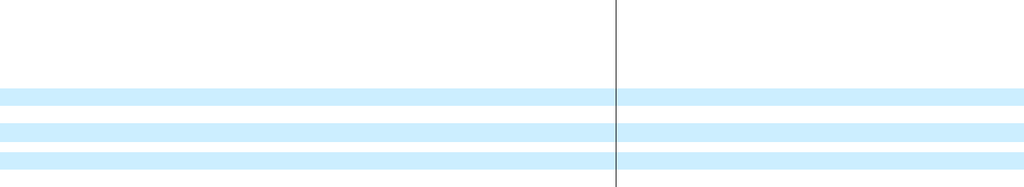

 |  | Successor
 |  | Quarter Ended
($ in Millions) |  | 6/30/20 |  |  | 3/31/20
Revenues:
North America | $ | 172 |  | $ | 341
Latin America |  | 138 |  |  | 247
Total Revenues | $ | 310 |  | $ | 588
Adjusted Segment EBITDA | $ | 6 |  | $ | 76
% Margin |  | 2 % |  |  | 13 %

 | Predecessor
 | Quarter
 | Ended |  |  |  | Variance
 | 6/30/19 |  |  | Seq. |  |  |  | YoY
$ | 420 |  |  | (50) | % |  |  | (59) | %
 | 299 |  |  | (44) | % |  |  | (54) | %
$ | 719 |  |  | (47) | % |  |  | (57) | %
$ | 57 |  |  | (92) | % |  |  | (89) | %
 | 8 | % |  | (1,100) | bps |  |  | (600) | bps

Second-quarter 2020 Western Hemisphere revenues of $310 million decreased 47% sequentially and 57% year-on-year.

In North America, second-quarter 2020 revenues of $172 million declined by 50% sequentially due to activity reductions and production shut-ins in the United States and activity decreases in Canada associated with spring break-up and the COVID-19 pandemic. The 50% sequential revenue decline compares favorably to the market, as the average rig count in North America declined by 57% during the second quarter.

Second-quarter 2020 revenues of $138 million in Latin America declined 44% sequentially, driven primarily by activity reductions due to the COVID-19 pandemic. The activity reductions were the most significant in Argentina and Colombia, where average rig counts declined approximately 90% during the quarter and, for reference, Argentina and Colombia comprised approximately 50% of Weatherford’s revenues in Latin America in 2019.

Second-quarter 2020 adjusted segment EBITDA of $6 million decreased $70 million sequentially and associated margins of 2% decreased by 1,100 basis points versus the first quarter of 2020. The decline in adjusted segment EBITDA was driven by activity reductions in North and Latin America which were offset by meaningful reductions in fixed and variable costs, as evidenced by year-on-year adjusted segment EBITDA decrementals of 12%.

5

Eastern Hemisphere
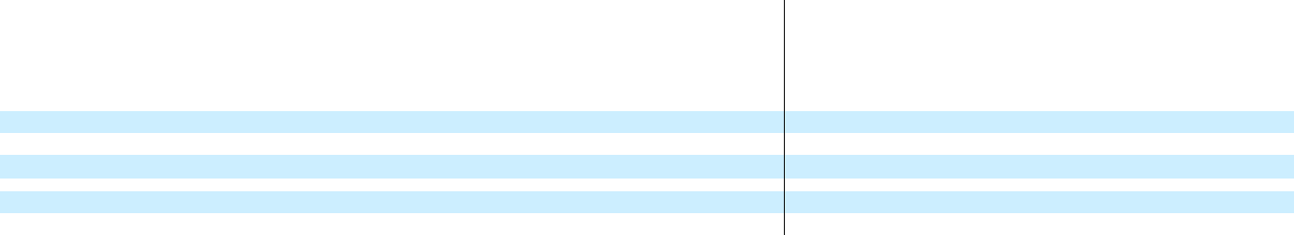

 |  | Successor
 |  | Quarter Ended
($ in Millions) |  | 6/30/20 |  |  | 3/31/20
Revenues:
Middle East, North Africa & Asia | $ | 341 |  | $ | 403
Europe, SSA & Russia |  | 170 |  |  | 224
Total Revenues | $ | 511 |  | $ | 627
Adjusted Segment EBITDA | $ | 100 |  | $ | 127
% Margin |  | 20 % |  |  | 20 %

 | Predecessor
 | Quarter
 | Ended |  |  |  | Variance
 | 6/30/19 |  |  | Seq. |  |  |  | YoY
$ | 362 |  |  | (15) | % |  |  | (6) | %
 | 228 |  |  | (24) | % |  |  | (25) | %
$ | 590 |  |  | (19) | % |  |  | (13) | %
$ | 99 |  |  | (21) | % |  |  | 1 | %
 | 17 | % |  | (70) | bps |  |  | 280 bps

Second-quarter 2020 Eastern Hemisphere revenues of $511 million declined 19% sequentially and 13% year-on-year.

In the Middle East, North Africa, and Asia, second-quarter 2020 revenues of $341 million declined 15% sequentially, due to activity reductions associated with the COVID-19 pandemic and OPEC+ production cuts, which were partially offset by growth in Saudi Arabia driven by increased product sales.

Second-quarter 2020 revenues in Europe, Sub Saharan Africa and Russia of $170 million declined 24% sequentially, driven by activity reductions associated with the COVID-19 pandemic, particularly in Central and Eastern Europe as well as Sub Saharan Africa.

Second-quarter 2020 adjusted segment EBITDA of $100 million decreased $27 million sequentially and associated margins of 20% declined 70 basis points versus the first quarter of 2020. The decrease in adjusted segment EBITDA was primarily driven by the aforementioned reductions in activity and was partially offset by fixed and variable cost reductions, as evidenced by the 280 basis point year-on-year improvement in adjusted segment EBITDA margins.

6

Impairment and Restructuring Charges

In accordance with accounting guidelines, the Company is required to assess its goodwill, tangible and other intangible assets for impairment if events or changes in circumstances indicate the carrying value of the assets may not be recovered. Due to the challenging industry environment, management determined that impairment indicators existed and conducted an assessment resulting in impairment charges of $384 million during the second quarter of 2020. The charges are broken down as follows:

- Goodwill: $72 million

- Other intangible assets: $22 million

- Right of use assets: $15 million

- Property, plant, and equipment: $141 million

- Inventory: $134 million

Additionally, Weatherford recorded pre-tax restructuring and other charges of $79 million related to the Company’s headcount reductions, facility consolidation, and other activities.

7

About Weatherford

Weatherford is the leading wellbore and production solutions company. Operating in more than 80 countries, the Company answers the challenges of the energy industry with its global talent network of approximately 19,000 team members and 600 locations, which include service, research and development, training, and manufacturing facilities. Visit https://www.weatherford.com/ for more information or connect on LinkedIn, Facebook, Twitter, Instagram, or YouTube.

Conference Call Details

Weatherford will host a conference call on Wednesday, August 5, 2020, to discuss the results for the second quarter ending June 30, 2020. The conference call is scheduled to begin at 8:30 a.m. Eastern Time (7:30 a.m. Central Time).

Listeners can access the conference call online at https://www.weatherford.com/en/investor-relations/investor-news-and-events/events/ or by dialing +1 877-328-5344 (within the U.S.) or +1 412-902-6762 (outside of the U.S.) and asking for the Weatherford conference call. Listeners should log in or dial in approximately 10 minutes prior to the start of the call.

A telephonic replay of the conference call will be available until August 15, 2020, at 5:00 p.m. Eastern Time. To access the replay, please dial +1 877-344-7529 (within the U.S.) or +1 412-317-0088 (outside of the U.S.) and reference conference number 10146042.

###

Contacts

For Investors:

Sebastian Pellizzer

Senior Director, Investor Relations

+1 713-836-7777

investor.relations@weatherford.com

For Media:

Christopher Wailes

Director, Global Media Engagement

+1 832-851-8308

christopher.wailes@weatherford.com

8

Forward-Looking Statements

This news release contains forward-looking statements concerning, among other things, the Company’s quarterly and full-year non-GAAP earnings (loss) per share, effective tax rate, net debt, forecasts or expectations regarding business outlook, cost savings plans, and capital expenditures, and are also generally identified by the words “believe,” “project,” “expect,” “anticipate,” “estimate,” “outlook,” “budget,” “intend,” “strategy,” “plan,” “guidance,” “may,” “should,” “could,” “will,” “would,” “will be,” “will continue,” “will likely result,” and similar expressions, although not all forward-looking statements contain these identifying words. Such statements are based upon the current beliefs of Weatherford’s management and are subject to significant risks, assumptions, and uncertainties. Should one or more of these risks or uncertainties materialize, or underlying assumptions prove incorrect, actual results may vary materially from those indicated in our forward-looking statements. Readers are also cautioned that forward-looking statements are only predictions and may differ materially from actual future events or results, including the price and price volatility of oil and natural gas; the extent or duration of business interruptions associated with COVID-19 pandemic; general global economic repercussions related to COVID-19 pandemic; the macroeconomic outlook for the oil and gas industry; the duration and severity of the impact of the COVID-19 pandemic on oil and gas demand and commodity prices; operational challenges relating to the COVID-19 pandemic and efforts to mitigate the spread of the virus, including logistical challenges, protecting the health and well-being of our employees, remote work arrangements, performance of contracts and supply chain disruptions; our ability to generate cash flow from operations to fund our operations; the outcome of any discussions with our lenders and bondholders regarding the new senior secured notes contemplated to be issued or the terms of a potential financing or refinancing transaction and any resulting dilution to our shareholders; the outcome of any discussions with the lenders party to our LC Credit Agreement regarding an amendment thereto; realization of additional cost savings and operational efficiencies; and potential logistical issues and potential non-cash asset impairment charges for long-lived assets, intangible assets or other assets. Forward-looking statements are also affected by the risk factors described in the Company’s Annual Report on Form 10-K for the year ended December 31, 2019, the Company’s Quarterly Report on Form 10-Q for the quarter ended March 31, 2020 and the Company’s Quarterly Report on Form 10-Q for the quarter ended June 30, 2020, and those set forth from time-to-time in the Company’s other filings with the Securities and Exchange Commission. We undertake no obligation to correct or update any forward-looking statement, whether as a result of new information, future events, or otherwise, except to the extent required under federal securities laws.

9

 | Weatherford International plc
 | Quarterly Condensed Consolidated Statements of Operations (Unaudited)
 | ($ in Millions, Except Per Share Amounts)
 |  |  | Successor
 |  |  | Quarter
 |  |  | Ended
 |  |  | 06/30/20
Revenues:
Western Hemisphere | $ |  | 310
Eastern Hemisphere |  |  | 511
Total Revenues |  |  | 821
Operating Income (Loss):
Western Hemisphere |  |  | (23)
Eastern Hemisphere |  |  | 15
Segment Operating Income (Loss) |  |  | (8)
Corporate Expenses |  |  | (26)
Impairments and Other Charges ^{[1]} |  |  | (463)
Gain on Sale of Business |  |  | —
Total Operating Loss |  |  | (497)
Other Income (Expense):
Interest Expense, Net |  |  | (59)
Reorganization Items |  |  | —
Other Non-Operating Expenses, Net |  |  | (11)
Net Loss Before Income Taxes |  |  | (567)
Income Tax Provision |  |  | (12)
Net Loss |  |  | (579)
Net Income Attributable to Noncontrolling Interests |  |  | 2
Net Loss Attributable to Weatherford | $ |  | (581)
Loss Per Share Attributable to Weatherford:
Basic and Diluted | $ |  | (8.30)
Weighted Average Shares Outstanding:
Basic and Diluted |  |  | 70
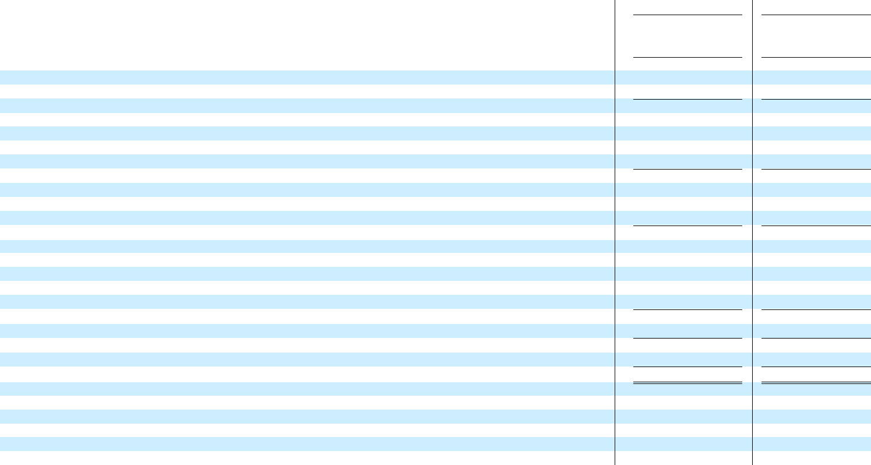

- See Quarterly Selected Statements of Operations Information Table for details of the impairments and other charges by quarter.

10

Predecessor

Quarter

Ended

06/30/19

- 719

590

1,309

11

28

39

(32)

(239)

114

(118)

(160)

—

(1)

(279)

(33)

(312)

4

- (316)

- (0.31)

1,004

Successor

Quarter

Ended

03/31/20

- 588

627

1,215

29

18

47

(26)

(843)

—

(822)

(58)

(9)

(25)

(914)

(44)

(958)

8

- (966)

- (13.80)

70

Weatherford International plc

Full Year Condensed Consolidated Statements of Operations (Unaudited)

($ in Millions, Except Per Share Amounts)

 | Successor |  |  |  |  | Predecessor
 | Six Months |  |  |  |  | Six Months
 | Ended |  |  |  |  | Ended
 | 06/30/20 |  |  |  |  | 06/30/19
Revenues:
Western Hemisphere | $ | 898 |  |  | $ | 1,445
Eastern Hemisphere |  | 1,138 |  |  |  | 1,210
Total Revenues |  | 2,036 |  |  |  | 2,655
Operating Income (Loss):
Western Hemisphere |  | 6 |  |  |  | 20
Eastern Hemisphere |  | 33 |  |  |  | 48
Segment Operating Income |  | 39 |  |  |  | 68
Corporate Expenses |  | (52) |  |  |  | (64)
Impairments and Other Charges ^{[1]} |  | (1,306) |  |  |  | (535)
Gain on Sale of Business |  | — |  |  |  | 112
Total Operating Loss |  | (1,319) |  |  |  | (419)
Other Income (Expense):
Interest Expense, Net |  | (117) |  |  |  | (315)
Reorganization Items |  | (9) |  |  |  | —
Other Non-Operating Expenses, Net |  | (36) |  |  |  | (10)
Net Loss Before Income Taxes |  | (1,481) |  |  |  | (744)
Income Tax Provision |  | (56) |  |  |  | (45)
Net Loss |  | (1,537) |  |  |  | (789)
Net Income Attributable to Noncontrolling Interests |  | 10 |  |  |  | 8
Net Loss Attributable to Weatherford | $ | (1,547) |  |  | $ | (797)
Loss Per Share Attributable to Weatherford:
Basic and Diluted | $ | (22.10) |  |  | $ | (0.79)
Weighted Average Shares Outstanding:
Basic and Diluted |  | 70 |  |  |  | 1,003

- See Quarterly Selected Statements of Operations Information Table for details of the impairments and other charges by quarter.

11

Weatherford International plc

Selected Balance Sheet Data (Unaudited)

($ in Millions)

 | 6/30/2020 |  |  |  | 12/31/2019
Assets:
Cash and Cash Equivalents | $ | 680 |  | $ | 618
Restricted Cash |  | 76 |  |  | 182
Accounts Receivable, Net |  | 927 |  |  | 1,241
Inventories, Net |  | 862 |  |  | 972
Property, Plant and Equipment, Net |  | 1,367 |  |  | 2,122
Goodwill |  | — |  |  | 239
Intangibles, Net |  | 875 |  |  | 1,114
Liabilities:
Accounts Payable |  | 384 |  |  | 585
Short-term Borrowings and Current Portion of Long-term Debt |  | 32 |  |  | 13
Long-term Debt |  | 2,148 |  |  | 2,151
Shareholders’ Equity:
Total Shareholders’ Equity |  | 1,305 |  |  | 2,916
Components of Net Debt ^{[1]}:
Short-term Borrowings and Current Portion of Long-term Debt |  | 32 |  |  | 13
Long-term Debt |  | 2,148 |  |  | 2,151
Less: Cash and Cash Equivalents |  | 680 |  |  | 618
Less: Restricted Cash |  | 76 |  |  | 182
Net Debt ^{[1]} | $ | 1,424 |  | $ | 1,364

[1] Net debt is a non-GAAP measure calculated as total short- and long-term debt less cash and cash equivalents and restricted cash.

12

 | Weatherford International plc
 | Condensed Consolidated Statement of Cash Flows (Unaudited)
 | ($ in Millions)
 |  |  | Successor
 |  |  | Six Months
 |  |  | Ended
 |  |  | 6/30/2020
Cash Flows From Operating Activities:
Net Loss | $ |  | (1,537)
Adjustments to Reconcile Net Income (Loss) to Net Cash Used in Operating Activities:
Depreciation and Amortization |  |  | 270
Goodwill Impairment |  |  | 239
Long-Lived Asset Impairments and Other |  |  | 967
Gain on Sale of Business |  |  | —
Working Capital ^{[1]} |  |  | 47
Other Operating Activities |  |  | 75
Total Cash Flows Provided by (Used in) Operating Activities |  |  | 61
Cash Flows From Investing Activities:
Capital Expenditures for Property, Plant and Equipment |  |  | (73)
Proceeds from Disposition of Assets |  |  | 8
Proceeds from Disposition of Businesses, Net |  |  | —
Other Investing Activities |  |  | (21)
Net Cash Provided by (Used in) Investing Activities |  |  | (86)
Cash Flows From Financing Activities:
Repayments of Long-term Debt |  |  | (5)
Borrowings (Repayments) of Short-term Debt, Net |  |  | 7
Other Financing Activities, Net |  |  | (14)
Net Cash Provided by (Used in) Financing Activities |  |  | (12)
Free Cash Flow ^{[2]}:
Cash Flows Provided by (Used in) Operating Activities | $ |  | 61
Capital Expenditures for Property, Plant and Equipment |  |  | (73)
Proceeds from Disposition of Assets |  |  | 8
Free Cash Flow ^{[2] [3]} | $ |  | (4)
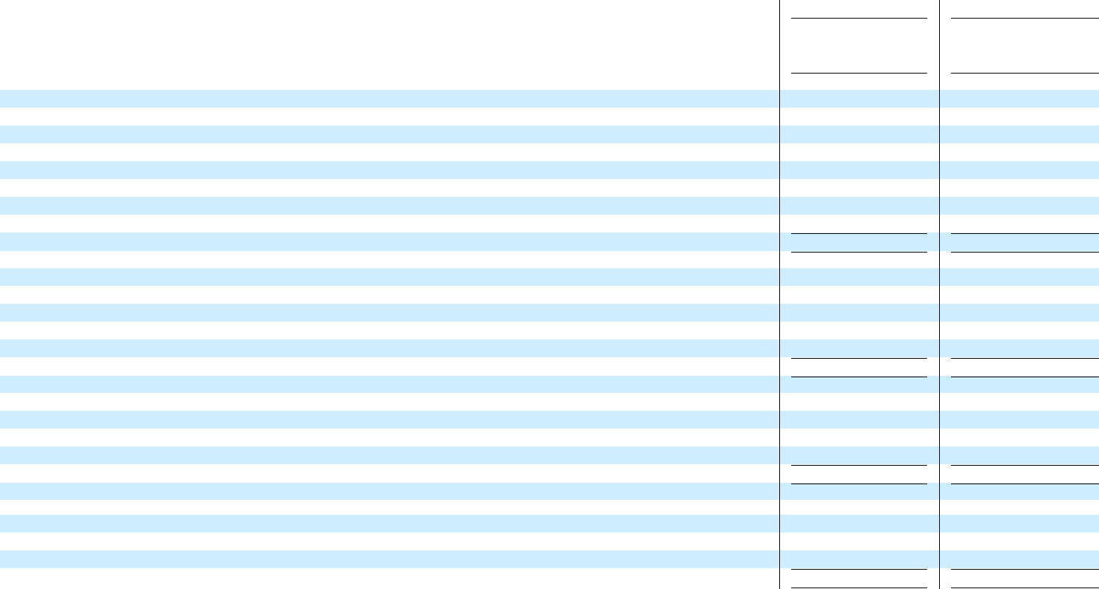

- Working capital is defined as the cash changes in accounts receivable plus inventory less accounts payable.

Predecessor

Six Months

Ended

6/30/19

- (789)

239

331

78

(112)

(174)

(51)

(478)

(114)

45

301

(9)

223

(17)

298

(12)

269

- (478)

(114)

45

- (547)

Successor

Three Months

Ended

6/30/2020

- (579)

113

72

319

—

130

(24)

31

(35)

2

—

(6)

(39)

(3)

10

(11)

(4)

- 31

(35)

2

- (2)

- Free cash flow is a non-GAAP measure calculated as cash flows provided by (used in) operating activities, less capital expenditures for property, plant and equipment plus proceeds from the disposition of assets. Management believes free cash flow is useful to understand liquidity and should be considered in addition to but not substitute cash flows provided by (used in) operating activities.
- Predecessor Free Cash Flow for the second quarter of 2019 was negative $265 million and was comprised of cash used in operating activities of $229 million less capital expenditures of $55 million plus proceeds from the disposition of assets of $19 million.

13

Weatherford International plc

Quarterly Selected Statements of Operations Information (Unaudited)

($ in Millions)
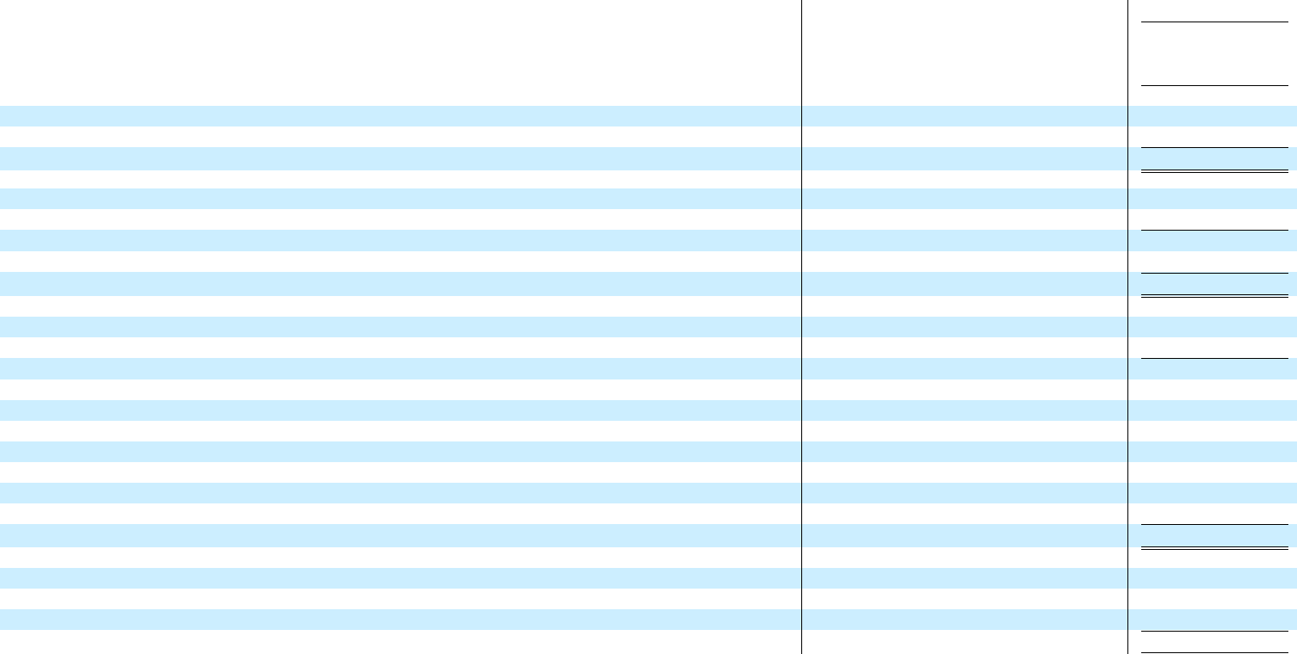

 |  | Successor
 |  | Quarter Ended
 | 6/30/20 |  |  | 3/31/20
Revenues
Western Hemisphere | $ | 310 | $ | 588
Eastern Hemisphere |  | 511 |  | 627
Total Revenues | $ | 821 | $ | 1,215
Adjusted EBITDA^{[1]}
Western Hemisphere | $ | 6 | $ | 76
Eastern Hemisphere |  | 100 |  | 127
Adjusted Segment EBITDA |  | 106 |  | 203
Corporate and Other |  | (27) |  | (25)
Total Adjusted EBITDA | $ | 79 | $ | 178
Operating Income (Loss)
Western Hemisphere | $ | (23) | $ | 29
Eastern Hemisphere |  | 15 |  | 18
Segment Operating Income |  | (8) |  | 47
Corporate Expenses |  | (26) |  | (26)
Long-lived Assets Impairment ^{[2]} |  | (178) |  | (640)
Inventory Charges ^{[3]} |  | (134) |  | —
Goodwill Impairment ^{[2]} |  | (72) |  | (167)
Restructuring and Other Charges ^{[4]} |  | (79) |  | (36)
Prepetition Charges |  | — |  | —
Gain on Sale of Business |  | — |  | —
Total Operating Loss | $ | (497) | $ | (822)
Depreciation and Amortization
Western Hemisphere | $ | 29 |  | 47
Eastern Hemisphere |  | 85 |  | 109
Corporate |  | (1) |  | 1
Total Depreciation and Amortization | $ | 113 |  | 157

 | Predecessor |  |  | Successor
 | Quarter |  |  | Six Months
 | Ended |  |  | Ended
 | 6/30/19 |  |  | 06/30/20
$ | 719 |  |  | 898
 | 590 |  |  | 1,138
$ | 1,309 |  | $ | 2,036
$ | 57 |  | $ | 82
 | 99 |  |  | 227
 | 156 |  |  | 309
 | (27) |  |  | (52)
$ | 129 |  |  | 257
$ | 11 |  |  | 6
 | 28 |  |  | 33
 | 39 |  |  | 39
 | (32) |  |  | (52)
 | (13) |  |  | (818)
 | — |  |  | (134)
 | (102) |  |  | (239)
 | (48) |  |  | (115)
 | (76) |  |  | —
 | 114 |  |  | —
$ | (118) |  | $ | (1,319)
$ | 45 |  | $ | 76
 | 70 |  |  | 194
 | 1 |  |  | —
$ | 116 |  | $ | 270

Predecessor

Six Months

Ended

06/30/19

- 1,445

1,210

- 2,655

- 115

192

307

(50)

257

20

48

68

(64)

(20)

—

(331)

(98)

(86)

112

- (419)

- 93

142

4

- 239

- In the first quarter of 2020 the Company began reporting adjusted EBITDA excluding the burden of stock-based compensation. Historical periods have been restated to reflect this methodology.

- Represents an impairment after a fair value assessment of our business and assets for the periods presented.

- Represents inventory charges for the second quarter of 2020 related to the decline in demand domestically and internationally.

- Represents primarily restructuring, facility consolidation and severance costs and includes certain other charges for the periods presented.

14

Weatherford International plc

Quarterly Selected Statements of Operations Information (Unaudited) - Product Line Revenues

($ in Millions)
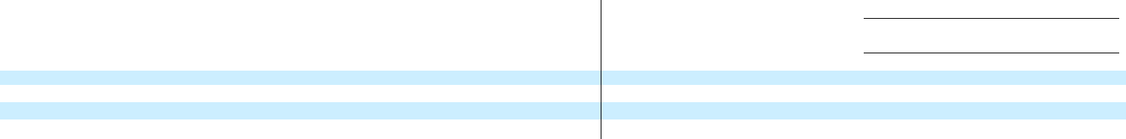

 |  |  |  | Successor
 |  |  |  |  |  |  | Period From
 |  | Quarter Ended |  |  |  |  | 12/14/19 to
 |  | 6/30/20 |  | 3/31/20 |  |  | 12/31/19
Product Line ^{[1]} Revenues
Production and Completions | $ | 405 | $ | 599 |  | $ | 136
Drilling, Evaluation and Intervention |  | 416 |  | 616 |  |  | 125
Total Product Line Revenues | $ | 821 | $ | 1,215 |  | $ | 261

 | Predecessor
 | Period From |  | Non-GAAP
 | 10/01/19 to |  | Combined
 | 12/13/19 |  | Results
$ | 469 | $ | 605
 | 516 |  | 641
$ | 985 | $ | 1,246

Predecessor

Quarter Ended

 | 9/30/19 |  | 6/30/19 |  | 3/31/19
$ | 613 | $ | 636 | $ | 641
 | 701 |  | 673 |  | 705
$ | 1,314 | $ | 1,309 | $ | 1,346

- During the second quarter of 2020 to support the streamlining and realignment of the businesses, we combined our prior reported four product lines into two product lines. Our two primary product lines are as follows: (1) Production and Completions and

  - Drilling, Evaluation and Intervention. Production and Completions includes Artificial Lift Systems, Stimulation and Testing and Production Services, Completion Systems, Liner Systems and Cementing Products. Drilling, Evaluation and Intervention includes Drilling Services, Managed Pressure Drilling, Wireline Services, Tubular Running Services, Intervention Services, and Drilling Tools and Rental Equipment.

15

We report our financial results in accordance with U.S. generally accepted accounting principles (GAAP). However, Weatherford’s management believes that certain non-GAAP financial measures and ratios (as defined under the SEC’s Regulation G and Item 10(e) of Regulation S-K) may provide users of this financial information additional meaningful comparisons between current results and results of prior periods and comparisons with peer companies. The non-GAAP amounts shown in the following tables should not be considered as substitutes for operating income, provision for income taxes, net income or other data prepared and reported in accordance with GAAP, but should be viewed in addition to the Company’s reported results prepared in accordance with GAAP.

Weatherford International plc

Quarterly Reconciliation of GAAP to Non-GAAP Financial Measures (Unaudited)

($ in Millions, Except Per Share Amounts)

 |  | Successor |  |  |  |  |  | Predecessor |  |  | Successor |  |  |  | Predecessor
 |  |  |  |  |  |  |  | Quarter |  |  | Six Months |  |  |  | Six Months
 |  | Quarter Ended |  |  |  |  |  | Ended |  |  | Ended |  |  |  | Ended
 |  | 6/30/20 |  | 3/31/20 |  |  |  | 6/30/19 |  |  | 6/30/20 |  |  |  | 6/30/19
Operating Income (Loss):
GAAP Operating Loss | $ | (497) | $ | (822) |  |  | $ | (118) |  | $ | (1,319) |  |  | $ | (419)
Impairments and Other Charges |  | 463 |  | 843 |  |  |  | 239 |  |  | 1,306 |  |  |  | 535
Gain on Sale of Business |  | — |  | — |  |  |  | (114) |  |  | — |  |  |  | (112)
Operating Non-GAAP Adjustments |  | 463 |  | 843 |  |  |  | 125 |  |  | 1,306 |  |  |  | 423
Non-GAAP Adjusted Operating Income (Loss) | $ | (34) | $ | 21 |  |  | $ | 7 |  | $ | (13) |  |  | $ | 4
Loss Before Income Taxes:
GAAP Loss Before Income Taxes | $ | (567) | $ | (914) |  |  | $ | (279) |  | $ | (1,481) |  |  | $ | (744)
Operating Non-GAAP Adjustments |  | 463 |  | 843 |  |  |  | 125 |  |  | 1,306 |  |  |  | 423
Reorganization Items |  | — |  | 9 |  |  |  | — |  |  | 9 |  |  |  | —
Non-GAAP Adjustments Before Taxes |  | 463 |  | 852 |  |  |  | 125 |  |  | 1,315 |  |  |  | 423
Non-GAAP Loss Before Income Taxes | $ | (104) | $ | (62) |  |  | $ | (154) |  | $ | (166) |  |  | $ | (321)
Provision for Income Taxes:
GAAP Provision for Income Taxes | $ | (12) | $ | (44) |  |  | $ | (33) |  | $ | (56) |  |  | $ | (45)
Tax Effect on Non-GAAP Adjustments |  | (2) |  | (7) |  |  |  | 2 |  |  | (9) |  |  |  | (6)
Non-GAAP Provision for Income Taxes | $ | (14) | $ | (51) |  |  | $ | (31) |  | $ | (65) |  |  | $ | (51)
Net Loss Attributable to Weatherford:
GAAP Net Loss | $ | (581) | $ | (966) |  |  | $ | (316) |  | $ | (1,547) |  |  | $ | (797)
Non-GAAP Adjustments, net of tax |  | 461 |  | 845 |  |  |  | 127 |  |  | 1,306 |  |  |  | 417
Non-GAAP Net Loss | $ | (120) | $ | (121) |  |  | $ | (189) |  | $ | (241) |  |  | $ | (380)
Diluted Loss Per Share Attributable to Weatherford:
GAAP Diluted Loss per Share | $ | (8.30) | $ | (13.80) |  |  | $ | (0.31) |  | $ | (22.10) |  |  | $ | (0.79)
Non-GAAP Adjustments, net of tax |  | 6.59 |  | 12.07 |  |  |  | 0.12 |  |  | 18.66 |  |  |  | 0.41
Non-GAAP Diluted Loss per Share | $ | (1.71) | $ | (1.73) |  |  | $ | (0.19) |  | $ | (3.44) |  |  | $ | (0.38)

16

Net Loss Attributable to Weatherford

Net Income Attributable to Noncontrolling Interests

Net Loss

Interest Expense, Net

Income Tax Provision

Depreciation and Amortization

EBITDA

Other (Income) Expense Adjustments:

Reorganization Items

Impairments and Other Charges

Gain on Sale of Business

Stock-Based Compensation

Other Non-Operating Expense, Net

Adjusted EBITDA ^{[1]}

Weatherford International plc

Quarterly Reconciliation of GAAP to Non-GAAP Financial Measures - EBITDA (Unaudited)

($ in Millions)
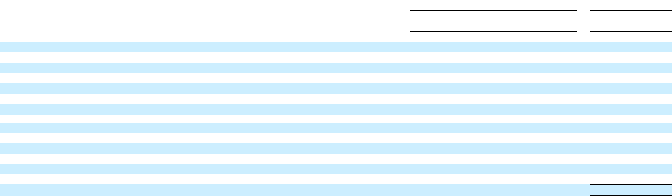

Successor

Quarter Ended

 | 6/30/20 |  | 03/31/20
$ | (581) | $ | (966)
 | 2 |  | 8
 | (579) |  | (958)
 | 59 |  | 58
 | 12 |  | 44
 | 113 |  | 157
 | (395) |  | (699)
 | — |  | 9
 | 463 |  | 843
 | — |  | —
 | — |  | —
 | 11 |  | 25
$ | 79 | $ | 178

Predecessor

Quarter

Ended

6/30/19

- (316)

4

(312)

160

33

116

(3)

—

239

(114)

6

1

- 129

- In the first quarter of 2020 the Company began reporting adjusted EBITDA excluding the burden of stock-based compensation. Historical periods have been restated to reflect this methodology. See continuation of Adjusted EBITDA to Unlevered Free Cash Flow and Free Cash Flow in the last table.

17

Net Loss Attributable to Weatherford

Net Income Attributable to Noncontrolling Interests

Net Loss

Interest Expense, Net

Income Tax Provision

Depreciation and Amortization

EBITDA

Other (Income) Expense Adjustments:

Reorganization Items

Impairments and Other Charges

Gain on Sale of Business

Stock-Based Compensation

Other Non-Operating Expense, Net

Adjusted EBITDA ^{[1]}

Weatherford International plc

Full Year Reconciliation of GAAP to Non-GAAP Financial Measures - EBITDA (Unaudited)

($ in Millions)
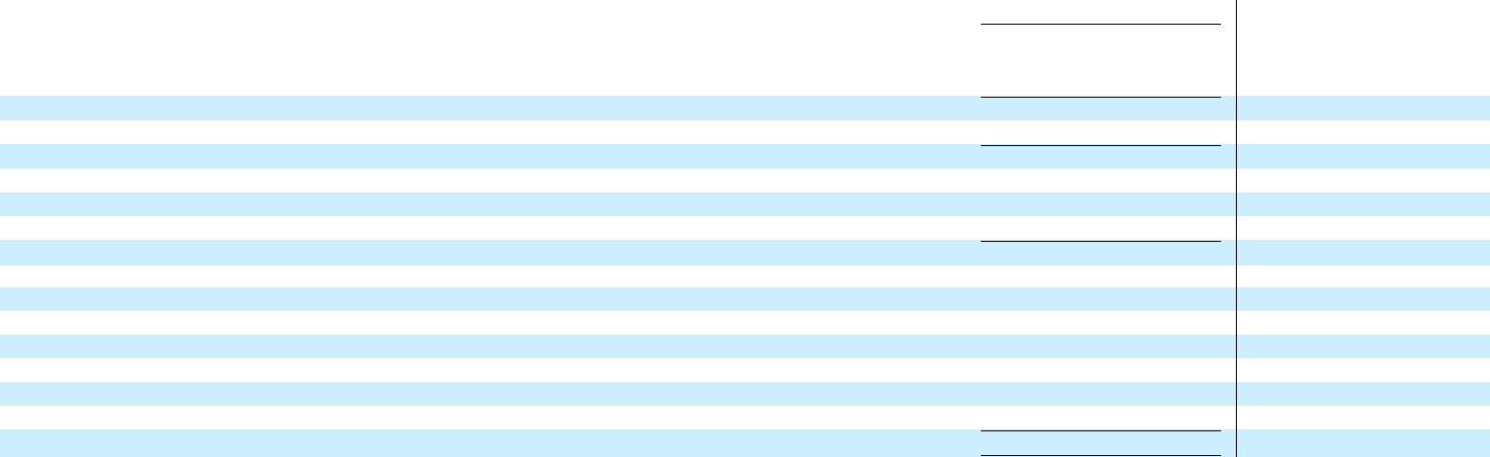

Successor

Six Months

Ended

06/30/20

$ (1,547)

10

(1,537)

117

56

270

(1,094)

9

1,306

—

—

36

$ 257

 | Predecessor
 | Six Months
 | Ended
 | 6/30/19
$ | (797)
 | 8
 | (789)
 | 315
 | 45
 | 239
 | (190)
 | —
 | 535
 | (112)
 | 14
 | 10
$ | 257

- In the first quarter of 2020 the Company began reporting adjusted EBITDA excluding the burden of stock-based compensation. Historical periods have been restated to reflect this methodology. See continuation of Adjusted EBITDA to Unlevered Free Cash Flow and Free Cash Flow in the last table.

18

Weatherford International plc

Quarterly and Full Year GAAP to Non-GAAP Financial Measures (Continued From EBITDA Tables)

Adjusted EBITDA to Unlevered Free Cash Flow and Free Cash Flow (Unaudited)

($ in Millions)
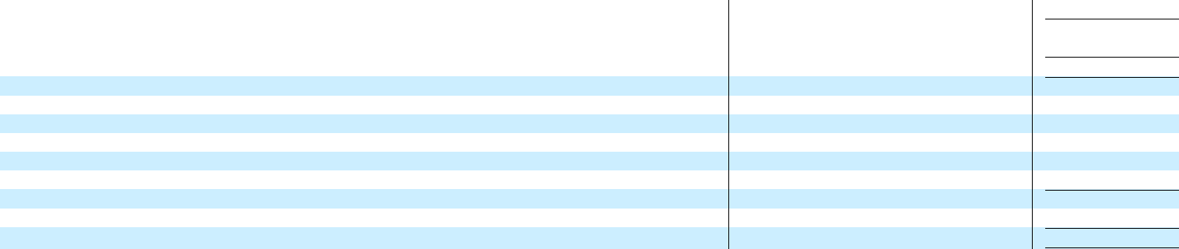

 |  | Successor
 |  | Quarter Ended
 | 6/30/20 |  |  | 3/31/20
Adjusted EBITDA ^{[1]} | $ | 79 | $ | 178
Cash From (Used) for Working Capital |  | 130 |  | (83)
Capital Expenditures for Property, Plant and Equipment |  | (35) |  | (38)
Cash Paid for Taxes |  | (19) |  | (21)
Cash Paid for Severance and Restructuring |  | (58) |  | (17)
Other |  | 11 |  | (19)
Unlevered Free Cash Flow | $ | 108 | $ | —
Cash Paid for Interest |  | (110) |  | (2)
Free Cash Flow ^{[2]} | $ | (2) | $ | (2)

 | Predecessor |  |  | Successor
 | Quarter |  |  | Six Months
 | Ended |  |  | Ended
 | 6/30/19 |  |  | 6/30/20
$ | 129 |  | $ | 257
 | (127) |  |  | 47
 | (55) |  |  | (73)
 | (16) |  |  | (40)
 | (18) |  |  | (75)
 | (111) |  |  | (8)
$ | (198) |  | $ | 108
 | (67) |  |  | (112)
$ | (265) |  | $ | (4)

Predecessor

Six Months

Ended

6/30/19

- 257

(174)

(114)

(51)

(52)

(189)

- (323)

(224)

- (547)

- In the first quarter of 2020 the Company began reporting adjusted EBITDA excluding the burden of stock-based compensation. Historical periods have been restated to reflect this methodology.

- Free cash flow is a non-GAAP measure calculated as cash flows provided by (used in) operating activities, less capital expenditures for property, plant and equipment plus proceeds from the disposition of assets. Management believes free cash flow is useful to understand liquidity and should be considered in addition to but not substitute cash flows provided by (used in) operating activities.

19

Exhibit 99.2

CONFIDENTIAL

Weatherford International Ltd.

$500 Million 8.75% Senior Secured First Lien Notes

Commitment Letter

Weatherford International Ltd.

2000 St. James Place

Houston, Texas 77056

Attention: Karl Blanchard

Interim Chief Executive Officer,

Executive Vice President and

Chief Operating Officer

August 4, 2020

Ladies and Gentlemen:

Weatherford International Ltd. (“Weatherford”, the “Issuer” or “you”) has advised the entities listed on Schedule I hereto (each, a “Notes Purchaser” and together, the “Notes Purchasers”, “we” or “us”) that Weatherford intends to refinance and/or cash collateralize all outstanding obligations under its ABL Credit Agreement (such term and each other capitalized term used but not defined herein having the meaning assigned to such term in the Summary of Principal Terms and Conditions attached hereto as Exhibit A (the “Term Sheet”)).

Weatherford has further advised that, in connection therewith, and subject solely to the conditions set forth in Section 4 of this Commitment Letter and the Term Sheet under the paragraph titled “Conditions to New Notes Purchase,” it will issue the 8.75% senior secured first lien notes (the “New Notes”) described in the Term Sheet, in an aggregate principal amount of $500 million (the date of the issuance of the New Notes, the “Closing Date”).

- Commitments.

In connection with the foregoing, the Notes Purchasers hereby commit, on a several and not joint basis, to purchase, for cash, in the aggregate for all such entities, 100% of the principal amount of the New Notes, in each case upon the terms, and subject solely to the conditions, set forth in this commitment letter (including the Term Sheet and other attachments hereto, this “Commitment Letter”), which commitment is allocated among the Notes Purchasers as set forth on Schedule I hereto.

- Information.

You hereby represent that (a) all written factual information (other than projections (such projections, the “Projections”), forward looking information and information of a general economic or industry specific nature) (the “Information”) that has been or will be made available to any Notes Purchaser by you or any of your representatives on your behalf in connection with the transactions

contemplated hereby, when taken as a whole, is or will be, when furnished, correct in all material respects and does not or will not, when furnished, contain any untrue statement of a material fact or omit to state a material fact necessary in order to make the statements contained therein not materially misleading in light of the circumstances under which such statements are made (giving effect to all supplements and updates provided thereto) and (b) the Projections and other forward looking information that have been or will be made available to any Notes Purchaser by you or any of your representatives on your behalf in connection with the transactions contemplated hereby have been or will be prepared in good faith based upon assumptions that you believe to be reasonable at the time made and at the time such Projections or other forward looking information are made available to us; it being understood by the Notes Purchasers that such Projections and other forward looking information are as to future events and are not to be viewed as facts, such Projections and other forward looking information are subject to significant uncertainties and contingencies, that actual results during the period or periods covered by any such Projections or other forward looking information may differ significantly from the projected results, such differences may be material, and that no assurance can be given that the projected results will be realized. You agree that, if at any time prior to the Closing Date, you become aware that any of the representations in the preceding sentence would be incorrect in any material respect if the Information and Projections were being furnished, and such representations were being made, at such time, then you will use commercially reasonable efforts to promptly supplement the Information and the Projections so that such representations will be correct in all material respects under those circumstances. The Notes Purchasers will be entitled to use and rely on the Information and Projections without responsibility for independent verification thereof.

- Fees.

As consideration for the Notes Purchasers’ commitments hereunder, you agree to pay to us the fees set forth in the Term Sheet on the terms and subject to the conditions set forth therein. Once paid, such fees shall not be refundable under any circumstances except as agreed to between you and us.

- Conditions Precedent.

Each Notes Purchaser’s obligation to purchase its portion of the New Notes on the Closing Date are subject solely to the satisfaction (or waiver by such Notes Purchaser) of the conditions set forth in the Term Sheet under the paragraph titled “Conditions to New Notes Purchase.” There shall be no conditions to the issuance and purchase of the New Notes other than those expressly referred to in this Section 4.

- Indemnification; Expenses.

You agree (a) to indemnify and hold harmless each Notes Purchaser and its affiliates, and their respective officers, directors, employees, agents, controlling persons, members and representatives (each, an “Indemnified Person”) from and against any and all losses, claims, damages, liabilities and expenses, joint or several, to which any such Indemnified Person may become subject or that may be incurred or asserted or awarded against such Indemnified Person arising out of or in connection with this Commitment Letter or any related transaction or any actual or threatened claim, actions, suits, inquiries, litigation, investigation or proceeding (any such claim, actions, suits, inquiries, litigation, investigation or proceeding, a “Proceeding”) relating to any of the foregoing, regardless of whether any such Indemnified Person is a party thereto (and regardless of whether such matter is initiated by you, your equity holders, creditors or any other third party or by any of your subsidiaries or affiliates), and to reimburse each such

Indemnified Person promptly upon demand for any reasonable and documented out-of-pocket legal expenses incurred in connection with investigating or defending any of the foregoing by one firm of counsel for all Indemnified Persons, taken as a whole (and, if necessary, by a single firm of local counsel in each appropriate jurisdiction for all Indemnified Persons, taken as a whole (and, in the case of an actual or perceived conflict of interest where the Indemnified Person affected by such conflict informs you of such conflict and thereafter retains its own counsel with your prior consent (not to be unreasonably withheld), of another firm of counsel in each applicable jurisdiction for such affected Indemnified Person)) and other reasonable and documented out-of-pocket expenses incurred in connection with investigating or defending any of the foregoing or in connection with the enforcement of any provision of this Commitment Letter; provided that the foregoing indemnity will not, as to any Indemnified Person, apply to (A) losses, claims, damages, liabilities or related expenses (i) to the extent they are found in a final, non-appealable judgment of a court of competent jurisdiction to have resulted from the willful misconduct, bad faith or gross negligence of an Indemnified Person or an Indemnified Person’s controlled or controlling affiliates or any of its or their respective officers, directors, employees, agents, controlling persons, members or representatives (collectively, such Indemnified Person’s “Related Persons”), or (ii) arising out of a material breach by an Indemnified Person (or an Indemnified Person’s Related Persons) of any obligations under this Commitment Letter (as determined by a court of competent jurisdiction in a final and non-appealable judgment), or (iii) arising out of any claim, actions, suits, inquiries, litigation, investigation or proceeding that does not involve an act or omission of you or any of your affiliates and that is brought by an Indemnified Person against any other Indemnified Person, (B) any settlement entered into by such Indemnified Person (or any of such Indemnified Person’s Related Persons) without your written consent (such consent not to be unreasonably withheld, delayed or conditioned); or (C) any expenses of the type referred to in clause (b) of this sentence, (b) to reimburse the Notes Purchasers from time to time, upon demand, for all reasonable, documented out-of-pocket expenses (including but not limited to expenses of our due diligence investigation and fees, disbursements and other charges of (i) Akin Gump Strauss Hauer & Feld, LLP, (ii) local counsel in each relevant jurisdiction, (iii) special counsel with respect to each relevant specialty and (iv) such other counsel identified in the Term Sheet), in each case, incurred in connection with the New Notes and the preparation and negotiation of this Commitment Letter, the definitive documentation for the New Notes and any ancillary documents and security and intercreditor arrangements in connection therewith and (c) to pay the fees, expenses, disbursements and other charges of the trustee and collateral agent for the New Notes and their respective counsel. It is further agreed that the Notes Purchasers shall have no liability to any person other than you, and you shall have no liability to any person other than the Notes Purchasers and the Indemnified Persons in connection with this Commitment Letter, the New Notes or the transactions contemplated hereby or thereby. None of the Indemnified Persons or you or any of your affiliates or the respective directors, officers, employees, advisors, and agents of the foregoing shall be liable for any indirect, special, punitive or consequential damages in connection with this Commitment Letter, the New Notes or the transactions contemplated hereby or thereby. The provisions of this Section 5 shall be superseded in each case by the applicable provisions contained in the definitive financing documentation in respect of the New Notes upon execution thereof and thereafter shall have no further force and effect. You shall not, without the prior written consent of each applicable Indemnified Person (which consent, except with respect to a settlement including a statement of the type referred to in clause (b) below, shall not be unreasonably withheld or delayed), effect any settlement of any pending or threatened Proceedings in respect of which indemnity could have been sought hereunder by such Indemnified Person unless such settlement (a) includes an unconditional release of such Indemnified Person from all liability on claims that are the subject matter of such Proceedings, (b) does not include any statement as to or any admission of fault, culpability or a failure to act by or on behalf of any Indemnified Person and (c) requires no action on the part of the Indemnified Person other than its consent (which consent shall not be unreasonably conditioned, withheld or delayed).

- Sharing Information; Absence of Fiduciary Relationship; Affiliate Activities.

You acknowledge that we may be providing debt financing, equity capital or other services (including financial advisory services) to other companies in respect of which you may have conflicting interests regarding the transactions described herein or otherwise. We will not furnish confidential information obtained from you by virtue of the transactions contemplated by this Commitment Letter or our other relationships with you to other companies. You also acknowledge that we do not have any obligation to use in connection with the transactions contemplated by this Commitment Letter, or to furnish to you, confidential information obtained by us from other companies.

You further acknowledge and agree that (a) each Notes Purchaser will act as an independent contractor and no fiduciary, advisory or agency relationship between you and us is intended to be or has been created in respect of any of the transactions contemplated by this Commitment Letter, (b) each Notes Purchaser is acting solely as a principal and not as an agent of yours hereunder and the Notes Purchasers, on the one hand, and you, on the other hand, have an arm’s-length business relationship that does not directly or indirectly give rise to, nor do you rely on, any fiduciary duty on the part of us in connection with this Commitment Letter and the transactions contemplated hereby, and (c) you are capable of evaluating and understanding, and you understand and accept, the terms, risks and conditions of the transactions contemplated by this Commitment Letter.

- Assignments; Amendments; Governing Law, Etc.

This Commitment Letter shall not be assignable by any party hereto without the prior written consent of each other party hereto and any attempted assignment without such consent shall be null and void; provided that each Note Purchaser may assign its commitments and agreements hereunder, in whole or in part, to (a) any of its affiliates, (b) any Affiliated Fund of such Note Purchaser or (c) any other Note Purchaser; provided further that any assignment pursuant to clause (a) or (b) shall not relieve such Note Purchaser of its obligation to purchase its allocation of New Notes as set forth on Schedule I hereto to the extent the conditions thereto have been satisfied and such assignee fails to fund such assigned commitment. For purposes of this Commitment Letter, “Affiliated Fund” means (a) any investment fund or separately managed account the primary investment advisor or sub-advisor to which is a Notes Purchaser or any investment adviser or affiliate thereof or (b) one or more special purpose vehicles that are wholly owned by one or more Notes Purchaser and its or their Affiliated Funds, created for the purpose of holding the commitment hereunder. This Commitment Letter is intended to be solely for the benefit of the parties hereto (and Indemnified Persons to the extent expressly provided for herein), and is not intended to confer any benefits upon, or create any rights in favor of, any person other than the parties hereto (and Indemnified Persons to the extent expressly provided for herein).

NOTWITHSTANDING ANYTHING HEREIN OR IN THE TERM SHEET OR ANY OTHER AGREEMENT TO THE CONTRARY (A) NO NOTES PURCHASER SHALL ACT AS AN UNDERWRITER, ARRANGER, TRUSTEE, AGENT OR IN A SIMILAR ROLE OR OTHERWISE PERFORM ANY SERVICES HEREUNDER AND (B) THE ROLE OF ANY NOTES PURCHASERS HEREUNDER AND UNDER THE TERM SHEET SHALL BE LIMITED TO THEIR COMMITMENT TO PROVIDE DEBT FINANCING AS A PRINCIPAL.

This Commitment Letter may not be amended or any provision hereof waived or modified except by an instrument in writing signed by each of the Note Purchasers and you.

This Commitment Letter may be executed in any number of counterparts, each of which shall be an original and all of which, when taken together, shall constitute one agreement. Delivery of an executed counterpart of a signature page of this Commitment Letter by facsimile or other electronic transmission shall be effective as delivery of a manually executed counterpart hereof. Section headings used herein are for convenience of reference only, are not part of this Commitment Letter and are not to affect the construction of, or to be taken into consideration in interpreting, this Commitment Letter.

This Commitment Letter supersedes all prior understandings, whether written or oral, between us with respect to the New Notes.

THIS COMMITMENT LETTER, AND ALL CLAIMS OR CAUSES OF ACTION (WHETHER IN CONTRACT, TORT OR OTHERWISE) THAT MAY BE BASED UPON, ARISE OUT OF OR RELATE IN ANY WAY TO THIS COMMITMENT LETTER, OR THE NEGOTIATION, EXECUTION OR PERFORMANCE OF THIS COMMITMENT LETTER OR THE TRANSACTIONS CONTEMPLATED HEREBY, SHALL BE GOVERNED BY, AND CONSTRUED IN ACCORDANCE WITH, THE LAWS OF THE STATE OF NEW YORK.

Each of the parties hereto agrees that this Commitment Letter is a binding and enforceable agreement with respect to the subject matter contained herein, including an agreement to negotiate in good faith the New Notes Documentation by the parties hereto in a manner consistent with the terms hereof, it being acknowledged and agreed that the commitments provided hereunder are subject solely to the conditions expressly provided herein.

- Jurisdiction.

Each of the parties hereto hereby irrevocably and unconditionally (a) submits, for itself and its property, to the exclusive jurisdiction of any New York State court or Federal court of the United States of America sitting in the Borough of Manhattan, and any appellate court from any thereof, in any action or proceeding arising out of or relating to this Commitment Letter or the transactions contemplated hereby, and agrees that all claims in respect of any such action or proceeding shall be brought, heard and determined only in such New York State court or, to the extent permitted by law, in such Federal court,

- waives, to the fullest extent it may legally and effectively do so, any objection which it may now or hereafter have to the laying of venue of any suit, action or proceeding arising out of or relating to this Commitment Letter or the transactions contemplated hereby in any such New York State or Federal court, (c) waives, to the fullest extent permitted by law, the defense of an inconvenient forum to the maintenance of such action or proceeding in any such court, and (d) agrees that a final judgment in any such action or proceeding shall be conclusive and may be enforced in other jurisdictions by suit on the judgment or in any other manner provided by law. You and we agree that service of any process, summons, notice or document by registered mail addressed to you or us at the respective addresses set forth above shall be effective service of process for any suit, action or proceeding brought in any such court.

  - Waiver of Jury Trial.

EACH OF THE PARTIES HERETO IRREVOCABLY WAIVES THE RIGHT TO TRIAL BY JURY IN ANY ACTION, PROCEEDING, CLAIM OR COUNTERCLAIM BROUGHT BY OR ON BEHALF OF ANY PARTY RELATED TO OR ARISING OUT OF THIS COMMITMENT LETTER OR THE TRANSACTIONS CONTEMPLATED HEREBY.

- Confidentiality.

This Commitment Letter is delivered to you on the understanding that, prior to your acceptance hereof, this Commitment Letter and its terms or substance shall not be disclosed, directly or indirectly, by you to any other person except (a) to your officers, directors, employees, attorneys, agents, accountants, advisors, controlling persons and equity holders who are directly involved in the consideration of this matter on a confidential basis or (b) pursuant to the order of any court or administrative agency in any pending legal, judicial or administrative proceeding or otherwise as required by applicable law or compulsory legal process or to the extent requested or required by governmental and/or regulatory authorities (in which case you agree to inform us promptly thereof to the extent permitted by law); provided that you may disclose this Commitment Letter and the contents hereof (i) in any public or regulatory filing, (ii) to any rating agencies or (iii) to the extent such information becomes publicly available other than by reason of improper disclosure by you or your Related Persons in violation of any confidentiality obligations hereunder.

- Surviving Provisions.

The reimbursement, indemnification, absence of fiduciary relationship, confidentiality, information, jurisdiction, governing law and waiver of jury trial provisions contained herein and the provisions of Section 5 of this Commitment Letter shall remain in full force and effect in accordance with their terms notwithstanding the termination of this Commitment Letter or the Notes Purchaser’s commitments hereunder; provided, that your obligations under this Commitment Letter, other than those provisions relating to confidentiality, shall automatically terminate and be superseded by the definitive documentation relating to the New Notes (to the extent covered thereby) upon our purchase thereof, and you shall automatically be released from all liability in connection therewith at such time.

- PATRIOT Act Notification.

We hereby notify you that pursuant to the requirements of the USA PATRIOT Act, Title III of Pub. L. 107-56 (signed into law October 26, 2001) (the “PATRIOT Act”) and the requirements of 31 C.F.R. §1010.230 (the “Beneficial Ownership Regulation”), each Notes Purchaser is required to obtain, verify and record information that identifies the Issuer and the Guarantors, which information includes the name, address, tax identification number and other information regarding the Issuer and the Guarantors that will allow the Notes Purchasers to identify the Issuer and the Guarantors in accordance with the PATRIOT Act and the Beneficial Ownership Regulation. This notice is given in accordance with the requirements of the PATRIOT Act and is effective as to each Notes Purchaser.

- Acceptance and Termination.

If the foregoing correctly sets forth our agreement with you, please indicate your acceptance of the terms of this Commitment Letter by returning to us an executed counterpart hereof not later than 11:59 p.m., New York City time, on August 4, 2020. The Notes Purchaser’s commitments and agreements hereunder will expire automatically and without further action or notice and without further obligation to you at such time in the event that we have not received such executed counterpart in accordance with the immediately preceding sentence. In the event that the Closing Date does not occur on or before August 14, 2020, then this Commitment Letter and the Notes Purchasers’ commitments and agreements hereunder shall automatically terminate without further action or notice and without further obligation to you unless you and we shall, in our discretion, agree to an extension.

[Remainder of this page intentionally left blank]

[NOTES PURCHASER SIGNATURE PAGES NOT FURNISHED]

Accepted and agreed to as of the date first above written:

WEATHERFORD INTERNATIONAL LTD.

By: /s/ Stuart Fraser__________________

Name: Stuart Fraser

Title: Vice President and Chief Accounting Officer

SCHEDULE I

COMMITMENTS

[COMMITMENTS SCHEDULE NOT FURNISHED]

 |  |  |  |  |  |  |  |  |  |  |  |  |  |  |  | EXHIBIT A
 |  |  |  |  |  |  |  |  |  |  |  |  |  | TERM SHEET
 |  |  |  |  |  |  |  |  |  |  |  |  |  |  |  | (attached)
 |  |  |  |  |  |  |  |  |  |  |  | Weatherford International Ltd.
 |  |  |  |  |  |  |  | $500 Million 8.75% Senior Secured First Lien Notes
Summary of Principal Terms and Conditions
Issuer: |  |  |  |  | Weatherford International Ltd., a Bermuda exempted company (the “Issuer”).
Purchasers: |  |  |  |  | Each of the Note Purchasers (as defined in the Commitment Letter), each on behalf of certain of its affiliates and managed funds and accounts
 |  |  |  |  | (individually, a “Purchaser” and, collectively, the “Purchasers”).
Notes: |  |  |  |  | Senior secured first lien notes in an aggregate principal amount of $500 million (the “New Notes”), which shall be purchased by the Purchasers.
Guarantors: |  |  |  |  | (a) Weatherford International plc, an Irish public limited company (the “Parent Guarantor”), Weatherford International, LLC, a Delaware limited
 |  |  |  |  | liability company (“WIL-Delaware”), (b) all of the Parent Guarantor’s subsidiaries that guarantee the obligations under (i) the LC Credit Agreement
 |  |  |  |  | dated as of December 13, 2019 (the “LC Credit Agreement”), among the Issuer and WIL-Delaware, as borrowers, the Parent Guarantor, as parent,
 |  |  |  |  | the lenders and issuing banks from time to time party thereto and Deutsche Bank Trust Company Americas, as administrative agent and collateral
 |  |  |  |  | agent, and (ii) the Issuer’s 11.00% senior notes due 2024 (the “Existing Unsecured Notes”) issued and outstanding under that certain Indenture dated
 |  |  |  |  | as of December 13, 2019 (the “Existing Unsecured Notes Indenture”), among the Issuer, as issuer, the Guarantors (as defined below), as guarantors,
 |  |  |  |  | and Deutsche Bank Trust Company Americas, as trustee, and (c) within a mutually agreed period following the Closing Date, all such other
 |  |  |  |  | subsidiaries, including subsidiaries formed in non-US jurisdictions, of the Parent Guarantor that the parties agree to, as permitted by applicable legal
 |  |  |  |  | requirements, subject to exclusions satisfactory to the Purchasers (the entities in clauses (a)-(c), individually, a “Guarantor” and, collectively, the
 |  |  |  |  | “Guarantors”) will guarantee the New Notes on a senior basis (collectively, the “Guarantees”). The Guarantees will be guarantees of payment and
 |  |  |  |  | not of collection.
Notes Parties: |  |  |  |  | The Issuer and the Guarantors (individually, a “Notes Party” and collectively, the “Notes Parties”).

Trustee: |  |  |  |  |  | An institution to be agreed will act as trustee and collateral agent (in such capacities, together with its permitted successors and assigns, the
 |  |  |  |  |  | “Trustee”).
Closing Date: |  |  |  |  |  | The date on which all conditions to the funding of the New Notes have been satisfied and the initial issuance of the New Notes occurs (the “Closing
 |  |  |  |  |  | Date”).
Use of Proceeds: |  |  |  |  |  | The proceeds of the New Notes will be used to (a) repay all obligations outstanding under and terminate the Credit Agreement dated as of December
 |  |  |  |  |  | 13, 2019 (the “ABL Credit Agreement”), among Wells Fargo Bank, National Association, as administrative agent, the lenders and issuing banks
 |  |  |  |  |  | from time to time party thereto, the Parent Guarantor, as parent, and the Issuer and WIL-Delaware, as borrowers, and/or cash collateralize the letters
 |  |  |  |  |  | of credit outstanding thereunder, and (b) provide liquidity to the Notes Parties and their subsidiaries for working capital and other general corporate
 |  |  |  |  |  | purposes, and to pay fees, costs and expenses associated with the New Notes Documentation (as defined herein) and the other transactions
 |  |  |  |  |  | contemplated hereby.
Availability: |  |  |  |  |  | All New Notes shall be issued and sold on the Closing Date. New Notes that are redeemed may not be reissued.
Maturity Date: |  |  |  |  |  | 91 days prior to maturity of the Existing Unsecured Notes (the “New Notes Maturity Date”).
Interest: |  |  |  |  |  | The New Notes shall bear interest payable in cash at a rate equal to 8.75% per annum. Accrued interest shall be payable in cash semi-annually in
 |  |  |  |  |  | arrears and on the New Notes Maturity Date.
 |  |  |  |  |  | Interest shall be computed on the basis of a 360-day year comprised of twelve 30-day months.
Amortization: |  |  |  |  |  | None. The New Notes shall be payable in full on the New Notes Maturity Date.
 |  |  |  |  |  | 2
4823-0034-0933 v16

Redemption: |  |  |  | The New Notes shall be non-callable for one (1) year after the Closing Date; provided, that, prior to the first anniversary of the Closing Date, the
 |  |  |  | Issuer may redeem the New Notes at its option, in whole at any time or in part from time to time, at a redemption price equal to 104.375% of the
 |  |  |  | principal amount of the New Notes redeemed plus the Applicable Premium (as defined below) as of, and accrued and unpaid interest to, the
 |  |  |  | applicable redemption date.
 |  |  |  | Thereafter, the Issuer may redeem the New Notes at its option, in whole at any time or in part from time to time, on and after (i) the first anniversary
 |  |  |  | of the Closing Date, but prior to the second anniversary of the Closing Date, at 104.375% of the principal amount being redeemed, (ii) on or after the
 |  |  |  | second anniversary of the Closing Date, but prior to the third anniversary of the Closing Date, at 102.188% of the principal amount being redeemed
 |  |  |  | and (iii) on and after the third anniversary of the Closing Date, at par, in each case plus accrued and unpaid interest, to the applicable redemption
 |  |  |  | date.
 |  |  |  | “Applicable Premium” shall mean the excess of: (a) the present value at such redemption date of (i) the principal amount of the New Notes to be
 |  |  |  | redeemed plus (ii) all required interest payments due on such New Notes through the first anniversary of the Closing Date (excluding accrued but
 |  |  |  | unpaid interest), computed using a discount rate equal to the Treasury Rate plus 50 basis points; over (b) the then outstanding principal amount of
 |  |  |  | such New Notes.
 |  |  |  | The New Notes shall expressly provide that any premium, including the Applicable Premium, shall become due and payable upon acceleration
 |  |  |  | (including with respect to any bankruptcy event).
Mandatory Redemptions: |  |  |  | The New Notes shall not be subject to mandatory redemption or sinking fund payments.
Offer to Purchase: |  |  |  | The Issuer will be required to make an offer to repurchase the New Notes at par, plus accrued and unpaid interest, from the net cash proceeds of asset
 |  |  |  | sales (defined in a manner consistent with the Documentation Precedent (as defined below)) by the Parent Guarantor or any of its restricted
 |  |  |  | subsidiaries, subject to exceptions and thresholds consistent with the Documentation Precedent. In addition, the Issuer will be required to offer to
 |  |  |  | repurchase the New Notes upon the occurrence of a change of control (defined in a manner consistent with the Documentation Precedent), which
 |  |  |  | offer shall be at 101% of the principal amount plus accrued and unpaid interest, and shall otherwise be consistent with the Documentation Precedent.
 |  |  |  | 3
4823-0034-0933 v16

Security:

Documentation:

Issue Price:

Commitment Fee:

Conditions to New Notes Purchase:

4823-0034-0933 v16

The New Notes will be secured by substantially all assets of the Issuer and the Guarantors, including a pledge of the equity in subsidiaries formed in non-US jurisdictions, as permitted by applicable legal requirements, subject to exclusions satisfactory to the Purchasers (the “Collateral”). The liens on the Collateral securing the New Notes shall be pari passu to the liens on the Collateral securing the obligations under the LC Credit Agreement, subject to an intercreditor agreement that provides for (a) first-out payment to obligations under (i) the LC Credit Agreement with respect to proceeds from Collateral existing on the Closing Date and (ii) the New Notes with respect to proceeds from assets that become Collateral after the Closing Date, and (b) last-out payment to obligations under (i) the New Notes with respect to proceeds from Collateral existing on the Closing Date and (ii) the LC Credit Agreement with respect to proceeds from assets that become Collateral after the Closing Date, which intercreditor agreement to also contain such other terms to be agreed between the Purchasers and the agent under the LC Credit Agreement (the “Intercreditor Agreement”). The New Notes and the Guarantees will rank effectively senior to the notes and the guarantees issued under the Existing Unsecured Notes Indenture to the extent of the value of the Collateral.

The documentation for the New Notes (the “New Notes Documentation”) will be based on and consistent with the Existing Unsecured Notes Indenture, modified as appropriate to take into account the terms set forth in this Term Sheet and otherwise negotiated reasonably and in good faith to reflect the first lien secured nature of the New Notes (the “Documentation Precedent”).

95.00%.

3.00%, to be payable in cash on the Closing Date if the Closing Date occurs, which may, at the option of the Purchasers, be netted out of note proceeds.

The conditions precedent to the purchase by each Purchaser of the New Notes will be only those set forth in the Conditions Annex attached hereto and incorporated by reference herein.

4

Covenants: |  |  |  |  |  | Similar to those in the Documentation Precedent (including obtaining and maintaining a rating of the New Notes and with such changes as necessary
 |  |  |  |  |  | to reflect the secured nature of the New Notes and as to be agreed by the parties, including, among other things, (x) to add prepayment of junior
 |  |  |  |  |  | secured and unsecured indebtedness as restricted payments, (y) to exclude unsecured/junior lien indebtedness from being considered as “cash” for
 |  |  |  |  |  | asset sale covenant purposes and (z) the Guarantors shall not have the ability to incur unlimited liens if the corresponding indebtedness is equally
 |  |  |  |  |  | and ratably secured); provided that the New Notes Documentation shall provide that (a) any secured debt for borrowed money will be limited to (i)
 |  |  |  |  |  | letters of credit issued under the LC Credit Agreement up to the maximum amount then permitted under the LC Credit Agreement as of the Closing
 |  |  |  |  |  | Date, and debt the proceeds of which are used to repay or refinance the obligations under the LC Credit Agreement, which may secured by the
 |  |  |  |  |  | Collateral on a pari passu basis with the New Notes; and (ii) $100 million of additional notes issued under the indenture governing the New Notes
 |  |  |  |  |  | issued at a price no less than par, (b) no additional debt (other than Capitalized Lease Obligations (as defined in the Existing Unsecured Notes
 |  |  |  |  |  | Indenture)) may be incurred by non-Guarantor subsidiaries, (c) the Note Parties and their subsidiaries shall be permitted to incur cash collateralized
 |  |  |  |  |  | letters of credit issued in the ordinary course of business and consistent with past practice and (d) the general restricted payment basket may be used
 |  |  |  |  |  | to prepay junior secured and unsecured indebtedness, but not for the payment of dividends.
Financial Covenants |  |  |  |  |  | Minimum Liquidity (defined in a manner consistent with the LC Credit Agreement) of $200,000,000; provided, however, that to the extent the LC
 |  |  |  |  |  | Credit Agreement is amended to reduce the minimum Liquidity thereunder to an amount that is less than $200,000,000, the minimum Liquidity
 |  |  |  |  |  | threshold under the New Notes Documentation shall be reduced correspondingly, but not to a level that is less than $150,000,000.
Events of Default: |  |  |  |  |  | Consistent with the Documentation Precedent, with such changes as necessary to reflect the secured nature of the New Notes and as to be agreed by
 |  |  |  |  |  | the parties.
Assignments and Participations: |  |  |  |  |  | The New Notes shall be issued in registered form and shall be transferrable subject to compliance with applicable securities laws and procedures
 |  |  |  |  |  | usual and customary for securities of this type.
Voting: |  |  |  |  |  | Consistent with the Documentation Precedent; provided that release of all or substantially all the Collateral shall require the consent of holders of
 |  |  |  |  |  | 66-2/3% of the principal amount then outstanding.
 |  |  |  |  |  | 5
4823-0034-0933 v16

Securities Laws Matters: |  |  |  | The New Notes will not be registered under the Securities Act of 1933, and will be issued in reliance on Section 4(a)(2) thereunder or another
 |  |  |  | exemption from registration.
 |  |  |  | The New Notes will not have any registration rights.
Governing Law: |  |  |  | New York.
Counsel to Purchasers: |  |  |  | Akin Gump Strauss Hauer & Feld LLP.

CONDITIONS ANNEX

The purchase by each Purchaser of the New Notes shall be subject to the satisfaction (or waiver by such Purchaser) of only the following conditions precedent:

  - The New Notes Documentation shall have been executed and delivered, and the Trustee and the Purchasers shall have received the following: (i) customary legal opinions, (ii) a customary closing certificate and customary officers’ certificates attaching evidence of authority and incumbency, charter documents and good standing certificates for the jurisdictions of incorporation and (iii) the results of customary, recent lien searches reasonably satisfactory to the Purchasers.

  - Delivery of all documents and instruments necessary to establish perfected security interests of the Trustee in the Collateral; provided that the perfection of any security interest in the Collateral or any deliverable related to the perfection of security interests in the Collateral (other than Collateral the security interest in which may be perfected by the filing of a UCC financing statement) that is not or cannot be provided and/or perfected on the Closing Date (x) without undue burden or expense or (y) after the Company’s use of commercially reasonable efforts to do so shall not constitute a condition precedent to the issuance of the New Notes, and, in such case, the provision and/or perfection of such security interest(s) or deliverable shall then be required to be delivered, pursuant to arrangements agreed between the Issuer, the Trustee and the Purchasers, within post-closing periods to be mutually agreed.

- Delivery of the Intercreditor Agreement in form and substance reasonably satisfactory to the Purchasers.

- Delivery of an amendment to the LC Credit Agreement in form and substance satisfactory to the Purchasers; provided that such amendment shall permit the issuance of the New Notes on the terms contemplated in the Term Sheet, including (i) the incurrence of liens securing the New Notes with the priorities set forth in the Term Sheet and (ii) permitting the maturity date of the New Notes to be 91 days prior to the maturity of the Existing Unsecured Notes.

  - Substantially concurrently with the issuance of the New Notes, the indebtedness under the ABL Credit Agreement shall be repaid or otherwise discharged (other than in respect of letters of credit that are either rolled into or back-stopped by letters of credit issued under standalone letter of credit facilities or cash collateralized) and all liens and security interests under the ABL Credit Agreement shall be released (other than liens on cash that is collateralizing letters of credit).

  - Payment of all fees and expenses of each of the Purchasers and the Trustee required to be paid by the Issuer on the Closing Date.

6

4823-0034-0933 v16

- Delivery of a customary purchase agreement in form and substance reasonably satisfactory to the Purchasers.

- The New Notes shall be eligible for clearance and settlement through DTC.

7

4823-0034-0933 v16





