UNITED STATES
SECURITIES AND EXCHANGE COMMISSION

Washington, D.C. 20549

SCHEDULE 14A

Proxy Statement Pursuant to Section 14(a) of the
Securities Exchange Act of 1934 (Amendment No. )

☑Filed by the Registrant

☐Filed by a Party other than the Registrant

CHECK THE APPROPRIATE BOX:

- Preliminary Proxy Statement

- Confidential, For Use of the Commission Only (as permitted by Rule 14a-6(e)(2)) ☑ Definitive Proxy Statement
- Definitive Additional Materials

- Soliciting Material Under Rule 14a-12
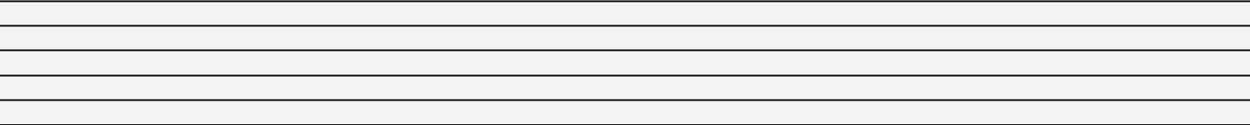


Weatherford International plc

(Name of Registrant as Specified In Its Charter)
(Name of Person(s) Filing Proxy Statement, if Other Than the Registrant)

PAYMENT OF FILING FEE (CHECK THE APPROPRIATE BOX):

- No fee required.
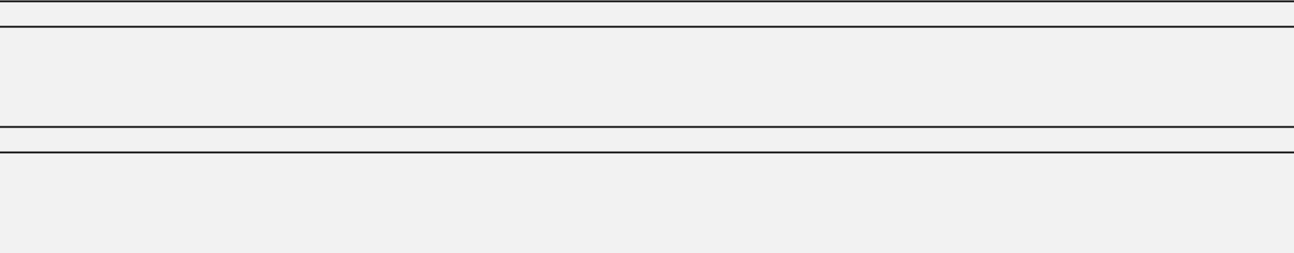

- Fee computed on table below per Exchange Act Rules 14a-6(i)(4) and 0-11.

  - Title of each class of securities to which transaction applies:
  - Aggregate number of securities to which transaction applies:
  - Per unit price or other underlying value of transaction computed pursuant to Exchange Act Rule 0-11 (set forth the amount on which the filing fee is calculated and state how it was determined):
  - Proposed maximum aggregate value of transaction:
  - Total fee paid:

- Fee paid previously with preliminary materials:

- Check box if any part of the fee is offset as provided by Exchange Act Rule 0-11(a)(2) and identify the filing for which the offsetting fee was paid previously. Identify the previous filing by registration statement number, or the form or schedule and the date of its filing.
  - Amount previously paid:
  - Form, Schedule or Registration Statement No.:
  - Filing Party:
  - Date Filed:


PROXY STATEMENT 2016

NOTICE OF ANNUAL GENERAL MEETING OF SHAREHOLDERS

To be held on June 15, 2016

Weatherford International plc



VOTING INSTRUCTIONS

AGENDA ITEMS FOR YOUR VOTE

Items | Board Recommendation | Reasons for Recommendation | Proxy Page
1. Election of Directors | FOR all nominees | The Board believes its members collectively have the skills and | 6
 |  | experience needed to continue to oversee the implementation
 |  | of Weatherford’s strategic plan for the benefit of shareholders,
 |  | employees and other stakeholders

- Appointment of Auditors for 2016 and determining their remuneration

FOR the appointment of KPMG LLP and KPMG Based on the recommendation of the Audit Committee 19 Chartered Accountants, Dublin and authorizing the
Board to determine the auditors’ remuneration

3. Advisory resolution | FOR the resolution | The Board believes Weatherford’s improved and evolving | 21
on compensation |  | executive compensation program effectively aligns executive
of Named Executive |  | compensation with performance
Officers

4. Approve Employee | FOR the plan
Stock Purchase Plan

The Board believes that an ownership culture fosters strong | 53
engagement from all of our employees, thereby contributing to improved performance for Weatherford’s shareholders and customers

VOTING INSTRUCTIONS FOR SHAREHOLDERS OF RECORD AND BENEFICIAL SHAREHOLDERS

You may vote using one of the following options. In all cases, have your proxy card or voting instruction form in hand and follow the instructions.


BY MAIL


Follow the instructions to mark,
sign and date your proxy card

BY PHONE


Use any touch-tone telephone to

transmit your voting instructions
1-800-690-6903

BY INTERNET


Use the Internet to transmit your

voting instructions
www.proxyvote.com

VISIT OUR ANNUAL

MEETING WEBSITE


www.weatherfordannualmeeting.com

A new section of our Annual General Meeting website, www.weatherfordannualmeeting.com/feedback, allows shareholders to provide feedback on our disclosures and ask questions to be considered by the Board, as appropriate.

VOTING DEADLINE

5:59 a.m. Central European Time on June 14, 2016 (11:59 p.m. New York time on June 13, 2016)

Weatherford International plc — 2016 Proxy Statement III

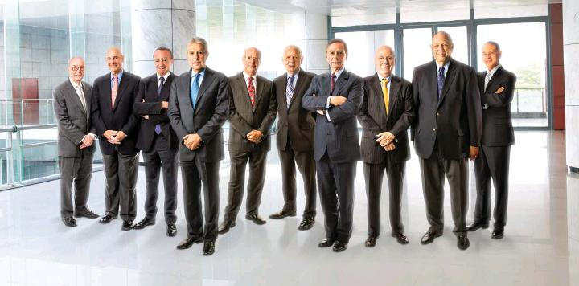

A MESSAGE FROM YOUR BOARD OF DIRECTORS

TO OUR FELLOW SHAREHOLDERS,

In 2015, we made significant progress along our transformational path, positioning Weatherford to aggressively respond to the changing industrial landscape. As your Board of Directors, and keeping the interests of our shareholders, employees and clients at the center of our priorities, we referred to our deep collective experience to guide our Company through the most challenging environment our industry has ever faced. As we continue to progress through 2016, Weatherford has taken the necessary steps to navigate an extended down cycle, successfully implementing fundamental and permanent structural, operational and financial improvements to drive long-term success for our business.

OUR DIRECTION

Our culture has been changed to one of strict focus on our industrial core, stringent cost management and perennial cash returns. In a quickly changing environment, our Company addressed shifting customer priorities and increased demand for efficiencies, while continuing to emphasize safety and deliver quality and reliability in all of our technologies and services. Moving forward, our direction remains steadfast, and we continue to take advantage of the current downturn to make material progress in 2016 and be best prepared for the inevitable upturn in our industry.

IV Weatherford International plc — 2016 Proxy Statement

OUR ACTIONS

Board structure and process

- We continued to enhance our Director orientation programs and site visits to better familiarize the Board with the operations of our Company worldwide

- We hosted an inaugural Board technology event where our Directors had in-depth discussions and demonstrations with product line leaders to better assess and anticipate industry and client trends, opportunities and challenges

- We approved a 10% reduction in Director fees, effective March 2016

- We initiated a Board retirement policy to provide for more frequent refreshment and greater diversity in the future

Shareholder outreach and communication

- We supported Weatherford’s continued shareholder outreach and welcome an additional channel to obtain and implement shareholder feedback; a new section of our Annual General Meeting website that enables shareholders to post comments and questions

Executive compensation

- In response to the sustained industry downturn, we reduced the base salaries of our CEO, other named executive officers (NEOs) and all corporate officers by 10% effective April 1, 2016

- We evaluated and expanded the peer group against which our Compensation Committee benchmarks executive compensation

- We reduced the 2016 equity award of our CEO by 18% as compared to 2015 in response to the sustained industry downturn

Compliance and corporate citizenship

- We adopted an enhanced Code of Business Conduct, which can be accessed on our website at www.weatherford.com

- We seek to ensure that Weatherford continues to elevate its sustainability model, developing programs and policies that benefit our Company and the communities in which we operate

Weatherford achieved additional targets in our business, operations and financial position; for details on these and other significant developments, we encourage you to read the accompanying letter from Weatherford’s Chairman of the Board, President and Chief Executive Officer.

OUR RESPONSIBILITIES

We strive to ensure that Weatherford is managed in an effective and accountable manner. Your Board remains committed to enhanced levels of oversight in the following areas:

- Strategy: We make strategy a dynamic process by challenging assumptions and vigorously monitoring implementation and execution, and stand ready to make mid-course changes as necessary

- Risk: We engage in ongoing evaluations of Weatherford’s risk appetite and risk mitigation initiatives, as well as plans for dealing with critical risks, including financial, operational and regulatory issues that could seriously impact our Company

- Succession planning and talent development: We have a robust and long-term program for effective leadership development and succession; throughout the year, the Board was presented with high-potential leadership candidates and was regularly updated on key talent metrics, including diversity, recruitment and development programs

In all of these areas, on a continuous basis, we pay close attention to the external environment and its developments, actively soliciting third-party views, whether or not they agree with ours. We have a boardroom where ideas are openly expressed and constructively challenged to ensure we effectively represent our shareholders.

LISTENING TO OUR SHAREHOLDERS

Fostering a close and effective relationship between our Board, management and shareholders is one of our top responsibilities. Over recent years, and as a result of shareholder feedback, your Board has made appropriate changes to our compensation programs and corporate governance standards. Please read more about these and other foundational accomplishments on page X.

This year, we have further enhanced our Proxy Statement and Annual Report to clearly present and explain our strategy, performance and corporate arrangements. As noted above, we have created a new section of our Annual General Meeting website, www.weatherfordannualmeeting.com/feedback, which offers you, as well as all other interested parties, an opportunity to provide us with feedback on our disclosures and propose questions to be considered by our Board, as appropriate. Your participation is highly important to the future of our Company.

We ask our shareholders to vote FOR each of the proposals, and we thank you for your high voter turnout and support at last year’s Annual General Meeting.

Mohamed A. Awad | David J. Butters | Bernard J. Duroc-Danner | John D. Gass | Emyr Jones Parry
Francis S. Kalman | William E. Macaulay | Robert K. Moses, Jr. | Guillermo Ortiz | Robert A. Rayne
 |  |  |  | Weatherford International plc — 2016 Proxy Statement V
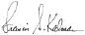
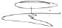
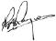



A LETTER FROM

THE CHAIRMAN,

PRESIDENT AND CEO

TO MY FELLOW SHAREHOLDERS,

I am pleased to announce Weatherford’s 2016 Annual General Meeting of Shareholders. The meeting will be held at 10:00 a.m. (Central European Time) on June 15, 2016, at The Mandarin Oriental Hotel, Quai Turrettini 1, 1201 Geneva, Switzerland. We encourage you to support the agenda items presented, as they are highly important to the future of your Company. The Board recommends you vote FOR all of the proposed agenda items.

I invite you to visit www.weatherfordannualmeeting.com, where you can cast your vote and can find centralized and up-to-date details as well as instructions regarding our upcoming Annual General Meeting.

VI Weatherford International plc — 2016 Proxy Statement

DRIVING OUR MOMENTUM IN 2015


Building on our transformational progress and deliberate focus on core, cost and cash, in 2015, we were able to guide Weatherford through the harshest down cycle in our industry's history. Viewing the current market as a challenge as well as an opportunity, the deep and extended drop in commodity prices facilitated our fundamental progress, as we drove permanent and structural operational as well as financial improvements. Following a year of aligned and prioritized actions, our key 2015 achievements are highlighted on this page.


Our direction focused on the strong attributes of our core business segments, and our actions remained centered around perennially improving our cost structure and optimizing cash generation as well as capital allocation. We reduced our support ratio from 59% to 39% between 2013 and 2015. Advances in our technology and closer integration between our product lines improved efficiencies and cost reductions while addressing shifting customer and marketplace needs.
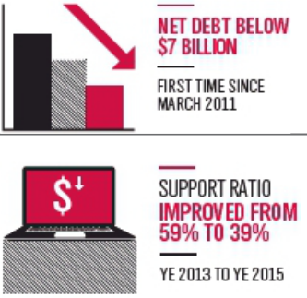

From a human resources perspective, we believe developing and strengthening our talent bench is essential. Human resources has become for us a strategic competency. As such, we have upgraded our middle and senior operational, financial and legal management. This has been accomplished while substantially delayering the organization. We have introduced new career management programs to offer our high potential employees a structured framework within which to grow. This is also an essential ingredient to long-term development and prosperity.
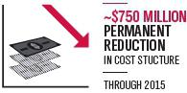

Our corporate sustainability program has evolved and is now firmly rooted in our culture. Our active participation has helped us further embrace and adopt sustainability measures, helping us identify and quantify significant risks and opportunities, while contributing to cost savings for long-term value creation.
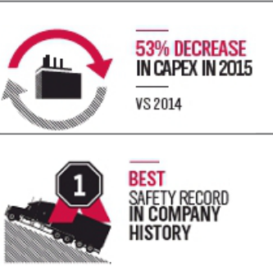

IN APPRECIATION

I am grateful to our shareholders, clients and employees for their understanding and support of who we are as a Company and for the value of our long-term goals. In addition, my appreciation goes to our Board of Directors for their considerable commitment and constructive oversight, carefully guiding our Company against a backdrop of low visibility and volatile markets.

INTENSIFYING OUR MOMENTUM IN 2016

Our strategy is simple, and my belief in Weatherford’s future has never been stronger. We will not let our guard down, and core, cost and cash will remain unyielding priorities. Structural productivity gains, our core's technological development and aggressive marketing and, a primary marker of success, our free cash flow, all continue to drive our decisions, along with a relentless pursuit of the highest safety, quality and reliability industry standards. Our direction remains steadfast, and we will accelerate and go further toward building a better and stronger company.

Sincerely,
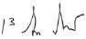

Bernard J. Duroc-Danner

Chairman of the Board, President and Chief Executive Officer

Weatherford International plc — 2016 Proxy Statement VII



OUR DIRECTOR

NOMINEES

Our Board’s composition is carefully considered and evaluated to ensure diversity in the broadest sense – of culture, background, outlook, experience and tenure – to bring together multiple, complementary perspectives.

Our Directors bring an appropriate range of skills and experience in relevant areas, including finance, exploration and production, environment, public policy, international business and leadership as well as oilfield services. This cross-section of capabilities enables our Board to help guide the Company’s strategic objectives and maintain high corporate governance practices.

While each member of our Board has held significant leadership positions in their respective professional fields, of equal importance is each Director’s personal ethics. Each of our Directors embodies the highest degree of personal and professional standards, assets which are complemented by the integrity and professional insights required to function effectively in our boardroom.

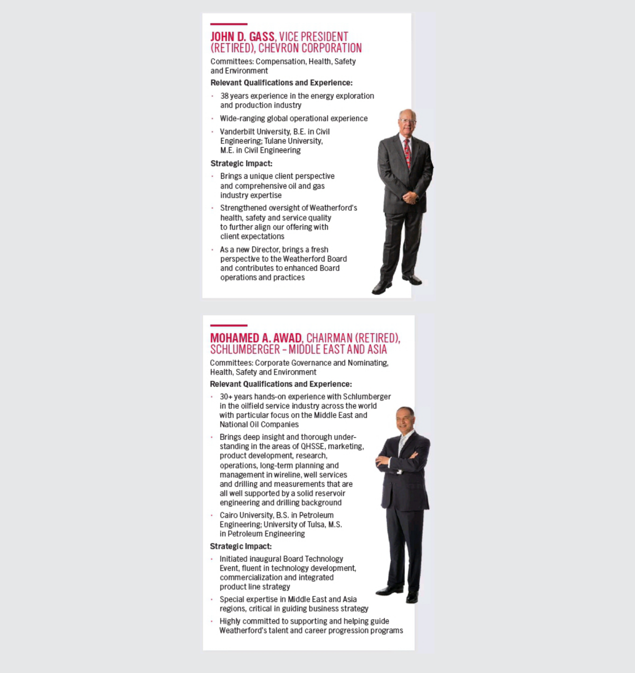

VIII Weatherford International plc — 2016 Proxy Statement

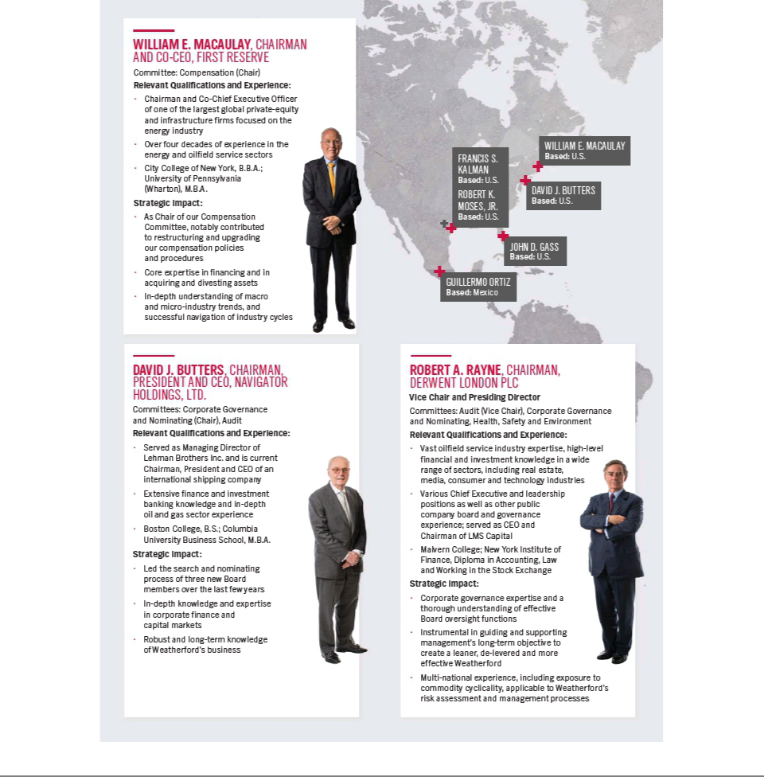

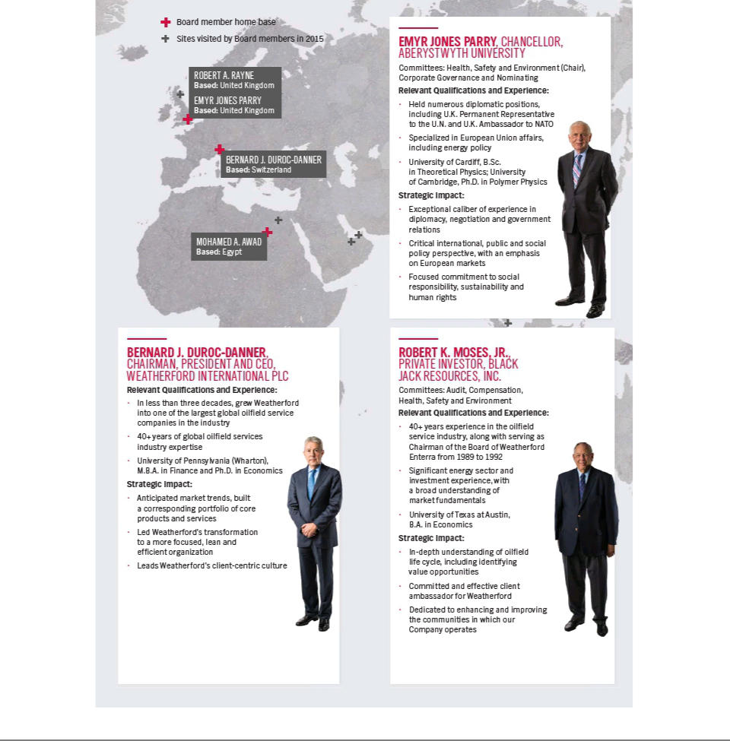

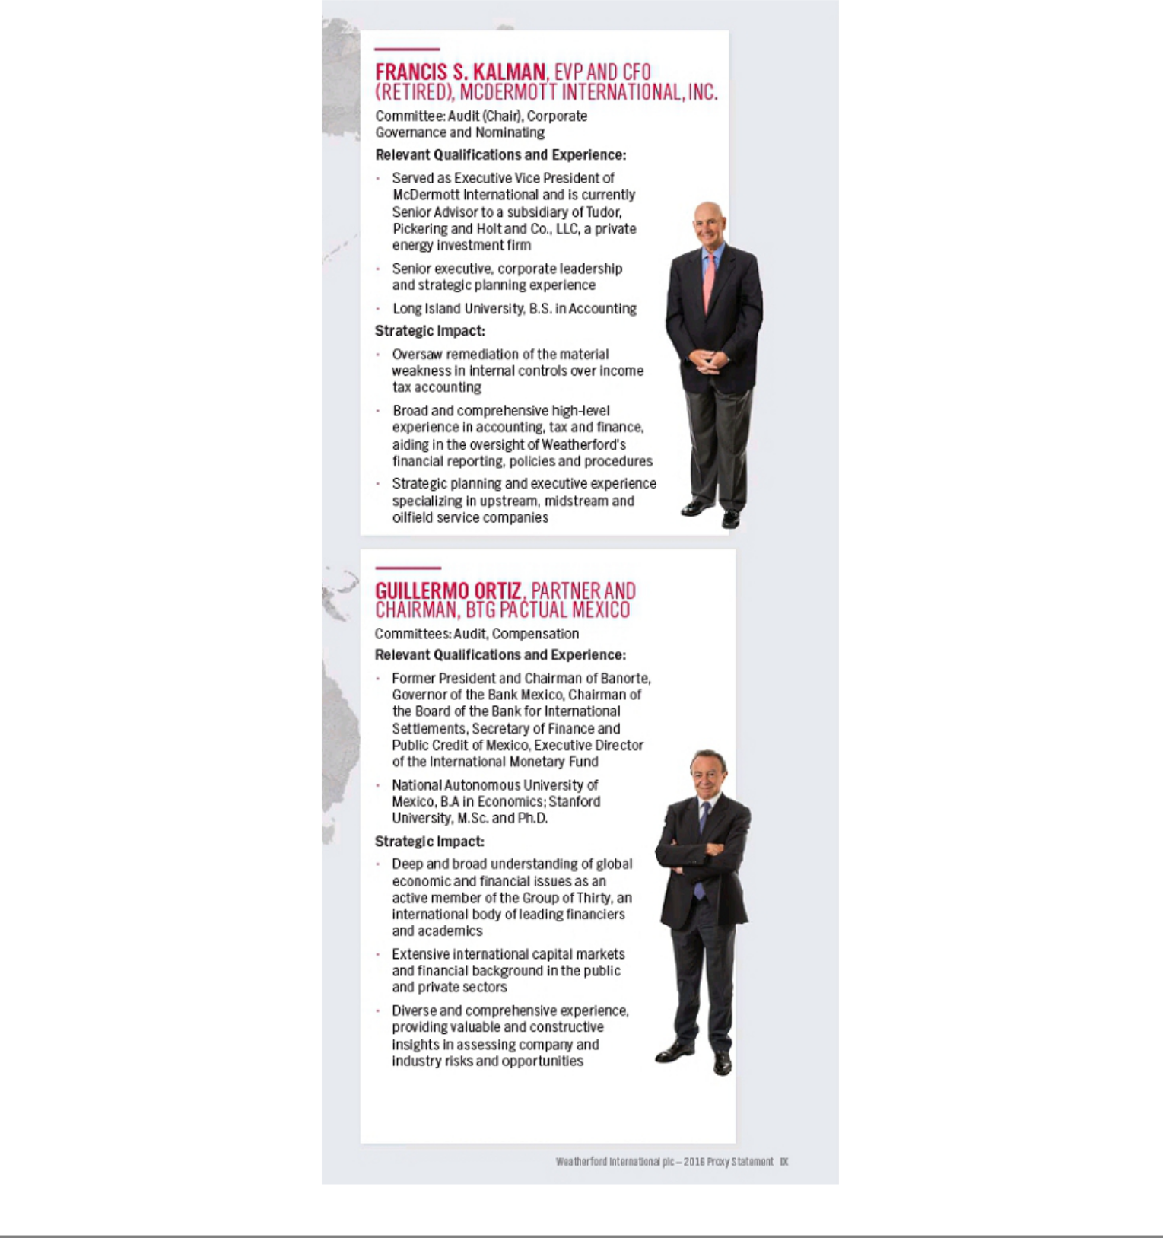

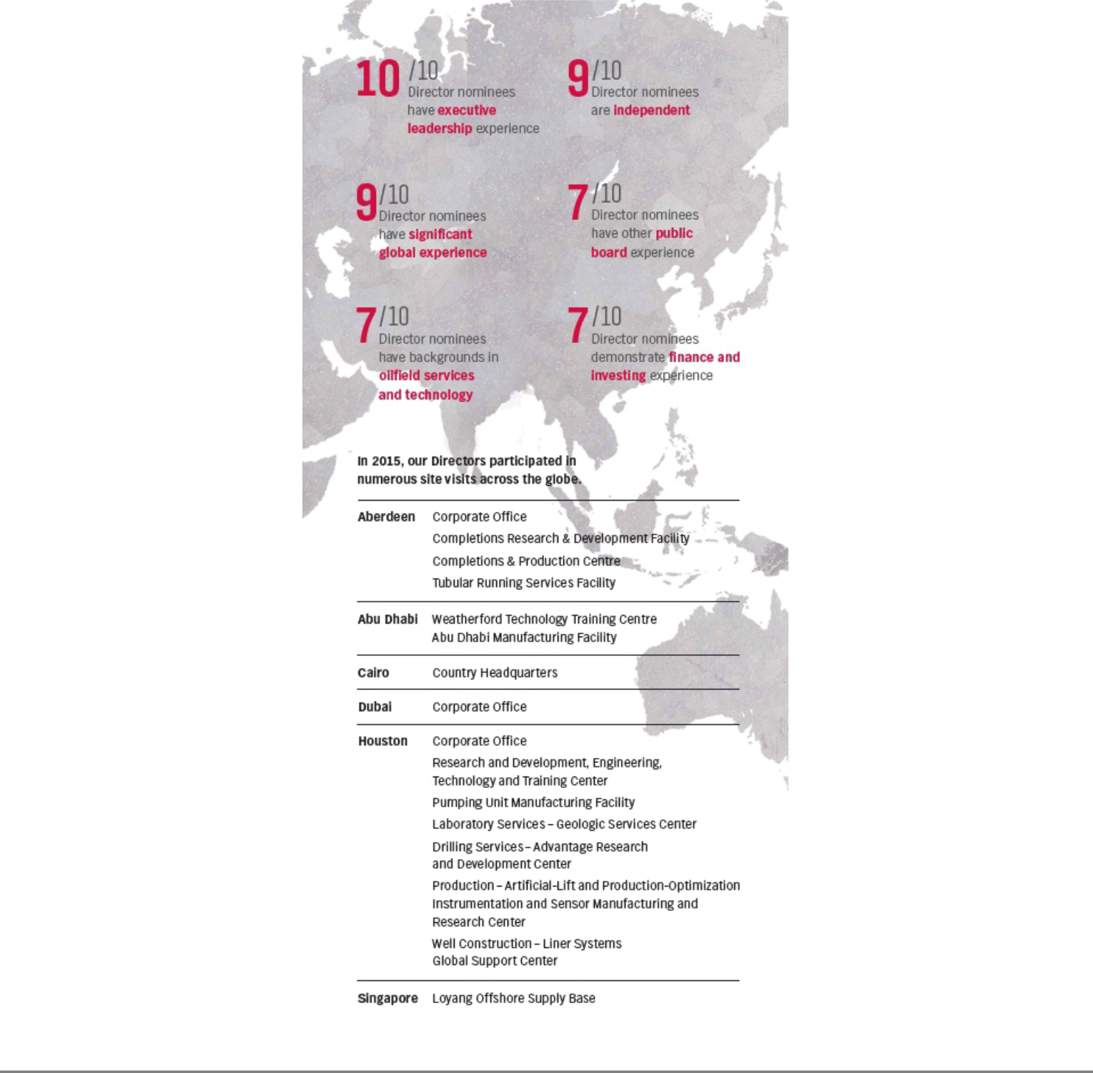

OUR ACCOMPLISHMENTS

Over the past few years, Weatherford has strengthened its core, implemented cost efficiencies, embedded a culture of cash, enhanced corporate governance and compliance practices as well as successfully strengthened its Board and corporate leadership. Below are the foundational accomplishments your Board and management team have led in recent years to position Weatherford on a long-term financially rewarding path.

STRATEGY OPERATIONS


GOVERNANCE


COMPENSATION


HEALTH, SAFETY AND ENVIRONMENT


Implemented operational and financial objectives centered around our core businesses

Company-wide commitment to aggressively lowering costs

Focused on improving cash flow and capital efficiency

Aligned executive compensation metrics with Company’s strategy

Monetized and exited non-core businesses

Delayered organization to operate in a flatter, leaner and faster way

Rationalized support functions and eliminated staff duplication

Introduced systemic talent development program

Upgraded senior operating team

Upgraded regional and product line talent bench

Strengthened financial and legal talent bench

Established and maintained shareholder engagement program

Election of three new Board members, Mohamed Awad, John Gass and Francis Kalman, in last three years

Enhanced new Director orientation, annual training and site visits

Hosted inaugural Board of Director Technology Event

Initiated Board retirement policy to provide for greater refreshment and diversity


Reduced base salaries of our CEO, other NEOs and all corporate officers by 10%, effective April 1, 2016

Reduced Director fees by 10%, effective March 2016

Reduced the 2016 equity award of our CEO by 18% as compared to 2015 in response to the sustained industry downturn

Eliminated future employment agreements

Tied annual cash incentive to peer-based performance

Changed performance unit share price measurement from one-day basis to 30-day basis

Increased disclosure regarding pay and performance

Reviewed and expanded peer group

Best safety record in Company history in 2015

16% reduction in the total recordable incident rate (TRIR)

23% reduction in the lost-time incident rate (LTIR)

33% reduction in the preventable vehicle incident rate (PVIR)

43 manufacturing facilities achieved no lost-time incidents, no recordable injuries, and no preventable vehicle incidents

OUR DIRECTION |  | RESULTS
● | With intensified focus, harvesting our core operating and technology strengths | ● | Permanently lowered cost structure
● | Lowering our cost structure | ● | Transformed culture to a cash-generation focused model

- Strengthening our balance sheet and protecting our Company against a ● Adopted Company-wide capital allocation discipline potential protracted down-cycle
  - Reduced net debt
- Developing our talent bench as a culture

  - Record-level safety performance

  - Systemic talent development and bench strengthening

X Weatherford International plc — 2016 Proxy Statement

GOVERNANCE HIGHLIGHTS


We hold ourselves to the highest standards, as we strive to ensure that Weatherford is managed in an effective and accountable manner. Our Board and Committees regularly optimize and update key governance practices to ensure our processes remain aligned with our strategic financial and operational goals. At all times, we keep the interests of our shareholders, employees and clients at the center of our priorities.

OUR BOARD LEADERSHIP

Our Board is structured to effectively oversee Weatherford’s management team and strategy. On an annual basis, the Board examines its structure based on the existing and future needs of the Company to ensure Weatherford’s business affairs are managed in an effective and accountable manner to drive long-term shareholder value.

To best serve Weatherford and its shareholders, nine of our 10 directors are independent of the Company and its management. The Board believes that the current structure — whereby the Chairman of the Board also carries the operational responsibilities of a CEO, while an engaged Presiding Director provides for strong independent oversight — is the optimal Board composition to lead Weatherford.

Mr. Rayne currently serves as Vice Chair and Presiding Director. In this role, he oversees executive sessions of independent Directors with no members of Company management present. Executive sessions provide the Board with the ability to independently evaluate management and openly discuss strategic and other business issues involving the Company.

DIRECTOR RETIREMENT

In 2016, we further enhanced our Corporate Governance Principles by adopting a mandatory retirement policy. This policy requires each new Director retire from the Board immediately prior to the annual general meeting of shareholders following his or her seventy-second birthday. To allow for a smooth transition of our existing Directors, the requirement shall be automatically waived (i.e. such Directors shall be grandfathered in).

SUCCESSION PLANNING

One of our Board’s key responsibilities is to ensure the Company has a long-term and evolving program for effective leadership development and succession. Our Board is committed to developing talent and high-grading the Company’s global management structure. Throughout the year, the Board was presented with high-potential leadership candidates and regularly updated on key talent metrics, including diversity, recruitment and development programs. The CEO reports to the Board on an annual basis concerning management development and succession planning for all positions other than his own. In addition, in June and December of each year, the Corporate Governance and Nominating Committee conducts a session focused on CEO succession planning. The Corporate Governance and Nominating Committee, like all Board committees, is comprised entirely of independent Directors.

DUTIES AND RESPONSIBILITIES OF VICE CHAIR AND PRESIDING DIRECTOR

The Independent Vice Chair and Presiding Director, i.e. our Lead Independent Director, among other assignments:

- reviews Board meeting schedules and agendas in collaboration with the Chairman to assure there is an adequate number of scheduled meetings and sufficient time for discussion of all agenda items as well as the inclusion of topics deemed important by the independent Directors;

- presides over all meetings of the Board at which the Chairman is not present; presides over executive sessions, and can call for executive sessions of the Board’s independent Directors, if and when deemed appropriate;

- leads the Board’s annual evaluation of the Chairman and Chief Executive Officer;

- monitors and collaborates with management regarding corporate governance matters;

- serves as principal liaison and supplemental channel of communication between the independent Directors and the Chairman; and

- is available for communication with shareholders, in coordination with management, when appropriate.

Weatherford International plc — 2016 Proxy Statement XI

DIRECTOR ORIENTATION AND SITE VISITS

Our Board is deeply invested in understanding all facets of our Company. Upon joining our Board, each new Weatherford Director attends a detailed orientation program, developing relationships with our management and conducting site visits to our operations and manufacturing facilities. These site visits provide insights into our Company and its operations, enabling our Board to drive strategic objectives based on what they observe and learn. Each visit is hands-on for the Directors involved, providing opportunities for meaningful dialogue with local management, staff and clients. Upon completion of the visit, attendees share observations with the full Board and have in-depth discussions with relevant committees to develop action plans, as appropriate.

In 2015, our Directors participated in numerous site visits around the globe including Aberdeen, Abu Dhabi, Cairo, Dubai, Houston and Singapore. The newest member of our Board, Mr. Awad, joined in late 2014. In the first half of 2015, he attended a multi-day orientation, visiting seven of our facilities in Texas. Mr. Awad, often joined by other Directors, participated in meetings with our product line management to become more acquainted with our technology and operational footprint. He also underwent legal and compliance training and met with our tax, internal audit and risk management teams.

In late 2015, we hosted our inaugural Board of Director Technology Event at our Spencer Road Research and Development facility, in Houston, Texas. During this day-long technology showcase, our Directors discussed the industry’s competitive landscape, key client needs and technology innovations with the Company’s product line leadership.

RISK MANAGEMENT

The Board is responsible for the oversight of overall risk management for the Company, and the Audit Committee is responsible for financial and compliance reporting and risk assessment. The Board has implemented an Enterprise Risk Management system to identify and evaluate varying levels of risk and their potential impact on the enterprise as well as steps to further mitigate those risks.

Each committee is instrumental to the Company’s Risk Oversight Management program and regularly and comprehensively updates the Board on its respective categories of risk, as part of its oversight function.
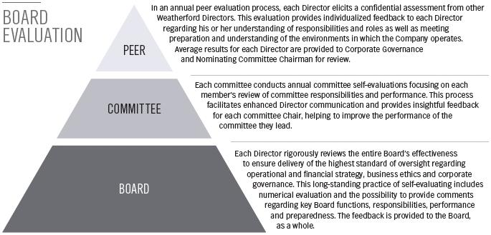

AUDIT COMMITTEE | ● |  | Compliance and Ethics
AUDIT COMMITTEE | ● |  | Financial Reporting
COMPENSATION | ● |  | Compensation Plans and Practices
COMPENSATION | ●
COMMITTEE | ● |  | Talent Development and Retention
CORPORATE | ● |  | Corporate Governance Oversight
GOVERNANCE | ●
AND NOMINATING | ● |  | Board and Committee Evaluations
COMMITTEE
HEALTH, SAFETY | ● |  | Corporate Stewardship
AND | ●
ENVIRONMENT | ● |  | Safety Awareness and Performance
COMMITTEE

XII Weatherford International plc — 2016 Proxy Statement

COMPENSATION HIGHLIGHTS

The Compensation Committee has designed and administered an executive compensation program to reward executives for the achievement of strategic and operational goals as well as increased shareholder value and to attract and retain talented leaders to guide Weatherford to its fullest potential. We aim to provide a framework that aligns the interest of our executives with those of our shareholders. This compensation philosophy gives due consideration to shareholder feedback, playing an important role in helping shape the Company’s compensation metrics, which have been significantly enhanced in recent years.

INDUSTRY LANDSCAPE

- Weatherford’s stock performance remained closely linked to the price of oil with a 94% correlation.

- As of April 1, 2016, the U.S. rig count reached its lowest point in recorded history with 450 rigs operating in the country, according to the Baker Hughes Weekly Rig Count Report, a recognized industry source.

- In less than two years, the downturn in global activity has led to a 53% decline in the capitalization of companies in our industry; the 53 publicly traded oilfield services companies that had a pre-downturn capitalization of $550 billion at June 2014 were valued at a collective market capitalization of less than $260 billion as of April 1, 2016.

WEATHERFORD STOCK HIGHLY CORRELATED TO OIL PRICE
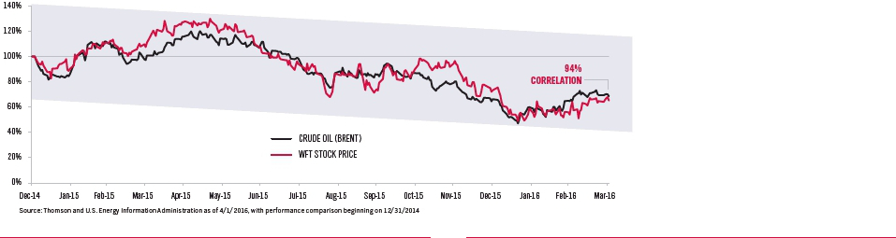

U.S. RIG COUNT SINCE 1968
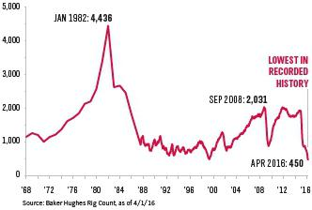

OILFIELD SERVICES SECTOR MARKET CAPITALIZATION

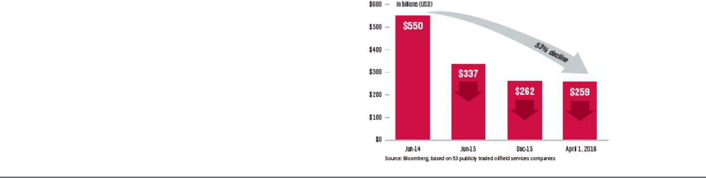

Weatherford International plc — 2016 Proxy Statement XIII

COMPENSATION ACTIONS

The Compensation Committee has made fundamental progress to more closely align pay with performance. These actions have received a high level of support from our shareholders; in 2015, 88% of our outstanding shares were voted (an increase of 16% since 2012), and more than 91% of shares voted in respect of our 2014 executive compensation program approved it. Compensation Committee actions include:

- Established performance goals aligned with the Company’s strategic objectives

- Eliminated employment agreements for future executive officers

- Tied annual cash incentives to peer-based performance

- Changed performance units share price measurement from a one-day basis to a 30-day basis

- No discretionary bonuses

- Discontinued Executive Deferred Compensation (EDC) Plan and suspended Supplemental Executive Retirement Plan (SERP)

- Adopted a robust clawback policy

- Enhanced executive compensation disclosures

OUR RESPONSE TO THE INDUSTRY DOWN CYCLE

We strive to structure our executive compensation program to align pay with performance. In 2014, the Company embarked on a transformational path to focus on core businesses, lower cost structure and improve free cash flow generation. We achieved substantially all of our 2014 key objectives, paving the way for greater long-term shareholder value.

In early 2015, the Compensation Committee set forth key 2015 performance metrics to ensure the Company continued to build upon its transformational progress. During 2015, Weatherford swiftly adapted to a rapidly changing industrial landscape, one which resulted in the harshest and most prolonged downturn that our industry has ever faced. Despite this significant headwind, Weatherford continues to successfully navigate the down cycle with an unyielding focus on capital discipline, cash generation and improved market position.

Most recently, in response to the extended industry challenges, the Board, CEO and Company leadership initiated the following measures to address the current market environment and demonstrate its leadership.

10% |  | 10%
REDUCTION IN |  | REDUCTION IN BASE
DIRECTOR FEES |  | SALARY OF OUR
APPROVED |  | CEO, ALL NEOs AND
 |  | CORPORATE OFFICERS
Effective March 2016 |  | Effective April 2016

18%


REDUCTION IN CEO’S 2016 EQUITY AWARD

Compared to 2016

XIV Weatherford International plc — 2016 Proxy Statement

UNDERSTANDING OUR CEO’S COMPENSATION

- The CEO’s base salary has not increased in over six years
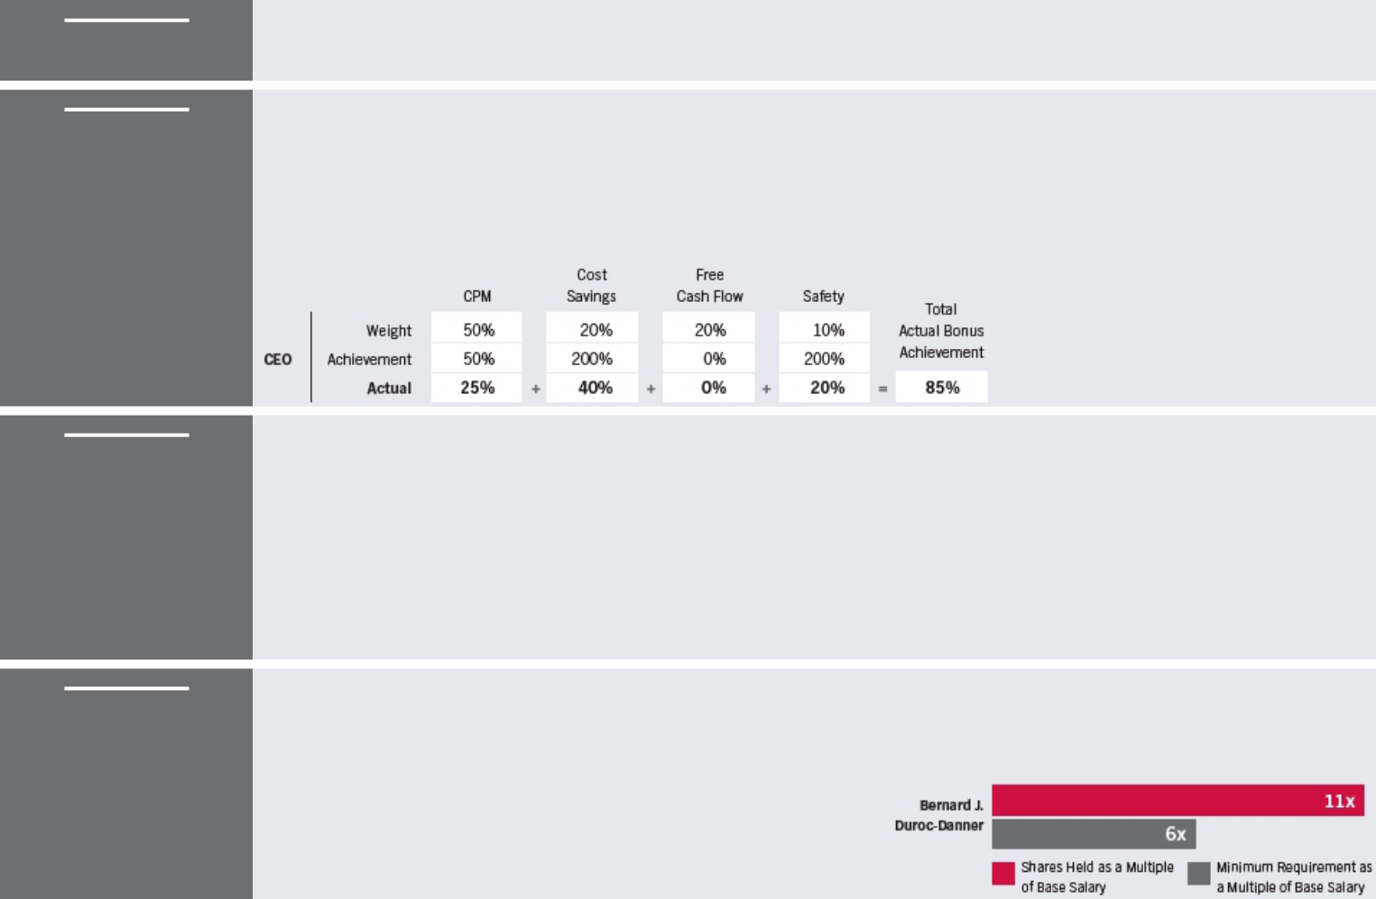

BASE SALARY ● 2016 base salary was reduced by 10% effective April 1 in response to continued challenging market conditions

NON-EQUITY INCENTIVE

●

●

●

●

Structured to deliver payout in line with market multiples when performance targets are achieved or exceeded

Annual Cash Incentive compensation not guaranteed or discretionary and is based on rigorous metrics

In 2015, a comparative peer performance metric (CPM) was added to the compensation incentives

Metrics and results for 2015

 | ● Equity compensation comprised of 41% Restricted Share Units (RSUs) and 59% Performance Units (PUs)
LONG-TERM | ● RSUs motivate our CEO to strive for share price appreciation, as they are granted in an amount based on the closing price on the
EQUITY | date of grant, and the executive realizes value only when the units vest and the underlying shares are delivered
EQUITY | ● PUs have higher possible returns and higher risk because they vest only if specified performance targets are achieved
INCENTIVES
INCENTIVES | ● No PUs that have been awarded since 2010 have paid out, and current PU cycles are tracking at $0, meaning that over the past
 | five years, our CEO has not realized the total compensation reported in the Summary Compensation Table
 | ● In response to the sustained industry downturn, the CEO’s 2016 equity award was reduced by 18% as compared to 2015
 | The Board believes it is important to align the interests of management with the interests of our shareholders. In furtherance of this
CEO SHARE | philosophy, the Company has adopted minimum share ownership guidelines as further described in this Proxy Statement. As a
CEO SHARE | multiple of the base salary, our CEO’s current share ownership as of April 15, 2016, is more than 11 times the base salary
OWNERSHIP | requirements set forth, further demonstrating the alignment with shareholder interests.

Weatherford International plc — 2016 Proxy Statement XV

COMPARISON WITH A CONSIDERED PEER GROUP

While the Committee evaluates a larger group of peers along with broad industry surveys when determining compensation for our CEO and other NEOs, the Committee gives specific consideration to its Significant Peers (Schlumberger, Halliburton and Baker Hughes) as they are the most relevant and appropriate companies for Weatherford to measure against when assessing talent. These peers are all integrated oilfield service companies with truly multi-international footprints against which Weatherford’s performance is measured by industry analysts. As such, in recent years, Weatherford has attracted a significant amount of executive talent from these companies. Also, our clients (whether independent or national oil companies), the financial sector and our investor community are most interested in our performance against these Significant Peers.

In November 2014, two of our largest peers, Halliburton and Baker Hughes, announced their plans to merge and, in April 2016, Schlumberger, our largest peer, completed its merger with Cameron International Corporation, another peer. Based on industry consolidation and other factors, and to ensure that the Committee is considering an appropriate mix for setting total compensation, the Committee determined that the following changes should be made to the Company’s peer group for 2016.

Weatherford’s revenues were in the 50th percentile of the 2015 peer group and 69th percentile of the 2016 peer group.
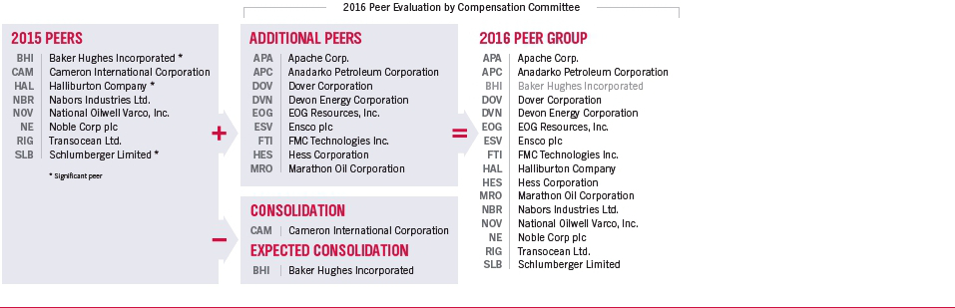

WEATHERFORD 2015 PEER GROUP: 2015 ONE-YEAR TOTAL SHAREHOLDER RETURN

Weatherford performed better than the 2015 peer group median.

XVI Weatherford International plc — 2016 Proxy Statement

TOTAL CEO PEER COMPENSATION VS. SHAREHOLDER RETURN

The executive compensation program is structured to align pay with performance. The chart below illustrates our CEO’s total compensation for the years 2013-2015 and our total shareholder return for the three-year period ended December 31, 2015, measured relative to our 2015 peers, excluding Cameron International Corporation, which merged with Schlumberger Limited in April 2016. Based on the 2016 peer group, Weatherford’s CEO total compensation relative to the three-year total shareholder return position is comparable to our 2015 peers.

3-Year Total Shareholder Return

3-Year Total Compensation is the sum of base salary, annual incentives, bonuses, long-term incentive awards and all other compensation paid (perquisites and change in pension included) for the years 2013-2015 for our Chief Executive Officer and for the chief executive officer of each of our peers as reported in their respective publicly available proxy statements.Compensation information for Nabors Industries Ltd. (NBR) is for the years 2012-2014, which is the latest publicly available information.

3-Year Total Shareholder Return is the percentage increase (or decrease) in stock price for the three years ended December 31, 2015, adjusted for cash dividends paid.

REPORTED VS. REALIZED COMPENSATION

We structure our executive compensation program to align pay with performance, including increases or decreases in our share price. As such, in 2013, 2014 and 2015, the performance units (long-term equity awards) did not vest based on Weatherford’s year-end stock price. As shown below, for the period 2013 to 2015, our CEO’s total realized compensation was 47% lower than the amount presented in the Summary Compensation Table. For 2015, our CEO’s total realized compensation was 36% lower than the amount presented in the Summary Compensation Table.

 | 2013-2015 REPORTED VS. |  |  | 2015 REPORTED VS.
 | REALIZED COMPENSATION |  |  | REALIZED COMPENSATION
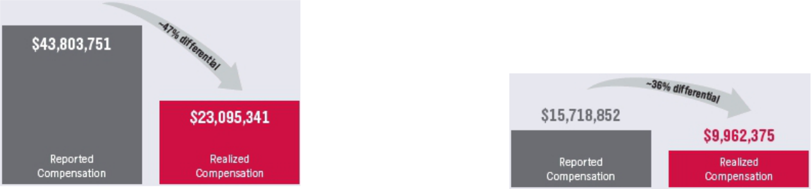

Reported Compensation is as set forth in the Summary Compensation Table in this Proxy Statement.

Realized Compensation includes long-term incentive awards (e.g., RSUs and PUs), only to the extent they were “realized”, i.e. to the extent they vested (or forfeiture restrictions lapsed) during the years described. Value of vested stock is then based on the closing price on the vesting date which, for our long-term incentive awards, differs from the value at the close of grant. The 2011-2015 performance awards did not vest and the NEOs realized zero value for these awards. Additionally, current awards cycles are tracking below threshold.

Weatherford International plc — 2016 Proxy Statement XVII

SHAREHOLDER ENGAGEMENT

At Weatherford, we believe transparent, year-round dialogue around strategy, performance and corporate governance establishes the basis of a trusting relationship with our investors. We also believe strong shareholder engagement leads to long-term value creation.

OUR RESPONSIBILITIES AND PROCESS

SENIOR MANAGEMENT AND INVESTOR RELATIONS

The majority of shareholder contact is between our institutional shareholders and our CEO, CFO and Investor Relations team. During the year, we solicit feedback from our shareholders on strategy, performance and corporate governance issues, including executive compensation.

- The management and Investor Relations team review and collate shareholders’ views on strategy, performance, and corporate governance

- Shareholder feedback is communicated to the Board

CORPORATE SECRETARY


Our Corporate Secretary monitors evolving corporate governance best practices, which are reviewed against Weatherford’s corporate governance framework and principles to ensure we have the most appropriate structure in place.

- The Company’s corporate governance and executive compensation information are provided to shareholders in the weeks before our annual general meeting

- Evolving corporate governance practices are presented to the Corporate Governance and Nominating Committee and to the Board throughout the year

BOARD OF DIRECTORS


The Board recognizes the importance of our shareholders’ views and continues to oversee Weatherford’s shareholder engagement program.

- The Board is informed of evolving corporate governance practices, reviews Weatherford’s governance framework and makes changes as needed

- The Board is informed of shareholder feedback and considers potential responsive actions

SHAREHOLDER FEEDBACK AND EXECUTIVE COMPENSATION

We engage in regular and ongoing dialogue with our investors to gain valuable insights into the issues about which they care most, such as compensation and corporate governance, to ensure our practices remain appropriate to deliver sustainable value over the long-term for our shareholders and other stakeholders.

At our 2015 annual general meeting, as a result of ongoing and mutually beneficial dialogues to align pay with performance, our shareholders expressed a high level of support for the enhancements to our compensation policies and practices and approved the long-term changes to executive compensation.

2015 VOTING


BREAKDOWN

88%

of our outstanding shares were voted (an increase of 16% since 2012)

91%+

of shares voted approved our 2014 executive compensation program

88% - 99%

of shares voted approved

each individual director

ENCOURAGING VOTING AND COMMUNICATION

Our annual general shareholder meeting results are carefully considered as part of our shareholder engagement and process. We are committed to offering a clear explanation of the matters to be voted and encourage all investors to participate in the future of Weatherford by voting their shares.

To go beyond reporting requirements, in recent years, we have created a dedicated Annual General Meeting website at: www.weatherfordannualmeeting.com.

This year, we have introduced a NEW dedicated section that provides an opportunity for shareholders and other interested parties to provide feedback on our disclosures and ask questions to be considered by the Board.

Submit feedback at:

www.weatherfordannualmeeting.com/feedback

TOPICAL SHAREHOLDER INQUIRIES IN 2015

XVIII Weatherford International plc — 2016 Proxy Statement

● The downturn in oil prices (page 25)

● Weatherford’s strategy and performance (page 24)

● Free cash flow generation and capital discipline (page 33)

● Protecting the Company from a protracted down cycle (page 25)

● Managing the cost structure (page 33)

Back to Contents

NOTICE OF 2016 ANNUAL GENERAL MEETING OF SHAREHOLDERS

June 15, 2016
10:00 a.m. (Central European Time)
The Mandarin Oriental Hotel, Quai Turrettini 1, 1201 Geneva, Switzerland

AGENDA

- By separate resolutions, to elect the ten individuals named in this Proxy Statement as directors of Weatherford International plc (the “Company”) until the 2017 annual general meeting of shareholders of the Company (the “2017 AGM”) or, in each case, until his earlier death, retirement, resignation or removal from the position of director.

- To ratify the appointment of KPMG LLP as the Company’s independent registered public accounting firm and auditor for the financial year ending December 31, 2016 and KPMG Chartered Accountants, Dublin, as the Company's statutory auditor under Irish law to hold office until the close of the 2017 AGM, and to authorize the Board of Directors of the Company, acting through the Audit Committee, to determine the auditors' remuneration.

- To adopt an advisory resolution approving the compensation of the named executive officers.

- To approve the Weatherford International plc Employee Stock Purchase Plan (the “ESPP”).

The foregoing items, including the votes required in respect of each, are set forth and more fully described in the accompanying Proxy Statement.

RECORD DATE

April 22, 2016

VOTING

Only registered shareholders as of the close of business on the record date will be entitled to attend, vote or grant proxies to vote at the Annual General Meeting. Any such registered shareholder may appoint one or more proxies to attend, speak and vote in his place at the Annual General Meeting. A proxy holder need not be a registered shareholder.

DISTRIBUTION OF PROXY MATERIALS

A copy of this notice, the Proxy Statement (of which this notice forms a part) and the proxy card are first being sent on or about May 3, 2016, to each registered shareholder in our share register as of the record date, together with a copy of our 2015 Annual Report and Irish Statutory Accounts for fiscal year 2015.

ANNUAL REPORT AND FINANCIAL STATEMENTS

Our audited consolidated financial statements for the year ended December 31, 2015 and accompanying auditor’s reports have been filed with the U.S. Securities and Exchange Commission (the “SEC”). Complete copies of these materials and our 2015 Annual Report and Irish Statutory Accounts

are available on our website at www.weatherford.com. Any shareholder may also obtain a copy of these documents by contacting our U.S. Investor Relations Department at 2000 St. James Place, Houston, Texas 77056 or by telephone at +1 (713) 836-4000. Additionally, during the Annual General Meeting, the Company’s management will present Weatherford’s Irish Statutory Accounts for the fiscal year ended December 31, 2015 along with related directors’ and auditor’s reports and there will be a review of the Company's affairs.

April 26, 2016

By Order of the Board of Directors
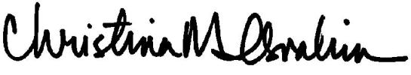

Christina M. Ibrahim
Executive Vice President, General Counsel and Corporate Secretary

Weatherford International plc — 2016 Proxy Statement 1

TABLE OF CONTENTS

03-05 |  |  |  |  |  |  | PROXY STATEMENT
 |  |  |  | 3 |  |  | Meeting and Voting Information
06-19 |  |  |  |  |  |  | AGENDA ITEM 1 – ELECTION OF DIRECTORS
 |  |  |  | 7 |  |  | Director Biographies
 |  |  |  |  | 12 |  | Our Board and Our Board Committees
 |  |  |  |  | 13 |  | Corporate Governance Matters
17 |  |  |  |  |  |  | Director Compensation
 | 19 | - | 21 |  |  |  | AGENDA ITEM 2 – RATIFY APPOINTMENT OF INDEPENDENT AUDITORS AND AUTHORIZE AUDITORS'
 | 19 | - | 21 |  |  |  | REMUNERATION
 |  |  |  |  | 19 |  | Fees Paid to KPMG
 |  |  |  |  | 19 |  | Audit Committee Pre-Approval Policy
20 |  |  |  |  |  |  | Audit Committee Report
21-22 |  |  |  |  |  |  | AGENDA ITEM 3 – ADVISORY APPROVAL OF EXECUTIVE COMPENSATION
 |  |  |  | 22 |  |  | Our Executive Officers
23-42 |  |  |  |  |  |  | COMPENSATION DISCUSSION AND ANALYSIS
 |  |  |  |  | 23 |  | Executive Summary
 |  |  |  |  | 26 |  | Pay for Performance and 2016 Updates
 |  |  |  |  | 29 |  | Compensation Philosophy and Objectives
 |  |  |  |  | 30 |  | Elements of Our Executive Compensation Program
41 |  |  |  |  |  |  | Further Considerations for Setting Executive Compensation
44-52 |  |  |  |  |  |  | EXECUTIVE COMPENSATION TABLES
 |  |  |  |  | 44 |  | 2015 Summary Compensation Table
 |  |  |  |  | 46 |  | Grants of Plan-Based Awards
 |  |  |  |  | 47 |  | Outstanding Equity Awards at December 31, 2015
 |  |  |  |  | 48 |  | Option Exercises and Shares Vested in 2015
 |  |  |  |  | 48 |  | Pension Benefits
 |  |  |  |  | 48 |  | Nonqualified Deferred Compensation
50 |  |  |  |  |  |  | Potential Payments upon Termination or Change of Control
 | 53 | - | 55 |  |  |  | AGENDA ITEM 4 – APPROVE WEATHERFORD INTERNATIONAL PLC EMPLOYEE STOCK PURCHASE
 | 53 | - | 55 |  |  |  | PLAN
56-59 |  |  |  |  |  |  | OTHER INFORMATION
 |  |  |  |  | 56 |  | Share Ownership
 |  |  |  |  | 58 |  | Section 16(a) Beneficial Ownership Reporting Compliance
 |  |  |  |  | 58 |  | Incorporation by Reference
 |  |  |  |  | 58 |  | Presentation of Irish Statutory Accounts
 |  |  |  |  | 58 |  | Proposals by Shareholders
 |  |  |  |  | 59 |  | Other Business
 |  |  |  |  | 59 |  | Householding
59 |  |  |  |  |  |  | Additional Information Available
60-67 |  |  |  |  |  |  | ANNEX A – WEATHERFORD INTERNATIONAL PLC EMPLOYEE STOCK PURCHASE PLAN

Weatherford International plc — 2016 Proxy Statement 2

Back to Contents

PROXY STATEMENT

MEETING AND VOTING INFORMATION

Important Notice Regarding the Availability of Proxy Materials for the Annual General Meeting to be Held on June 15, 2016: The Proxy Statement of

Weatherford International plc, our 2015 Annual Report and Irish Statutory Accounts are available at: www.WeatherfordAnnualMeeting.com.

Annual General Meeting: June 15, 2016 at 10:00 (a.m.) Central European Time, The Mandarin Oriental Hotel, Quai Turrettini 1, 1201 Geneva, Switzerland

GENERAL

In this Proxy Statement, “Weatherford,” “the Company,” “we,” “us” and “our” refer to Weatherford International plc, an Irish public limited company and Swiss tax resident.

Our principal executive offices in Switzerland are located at Bahnhofstrasse 1, 6340 Baar, Switzerland, and our telephone number there is +41.22.816.1500.

References to “$” or “USD” in this Proxy Statement are references to United States dollars, references to “CHF” are references to Swiss francs, and references to “£” are to U.K. pounds sterling.

This Proxy Statement and proxy card are first being mailed on behalf of our Board of Directors, or our “Board,” to all shareholders beginning on or about May 3, 2016.

AGENDA

Item 1 Election of Directors. By separate resolutions, to elect each of the ten individuals named in this Proxy Statement until the 2017 AGM or, in each case, until his earlier death, retirement, resignation or removal from the position of director.
Item 2 Ratify Appointment of Independent Auditors. To ratify the appointment of KPMG LLP as our independent registered public accounting firm and auditor for the fiscal year ending December 31, 2016 and KPMG Chartered Accountants, Dublin as the Company's statutory auditor under Irish law to hold office until the close of the 2017 AGM, and to authorize the Board of Directors, acting through the Audit Committee, to determine the auditors' remuneration.

Item 3 Approve Executive Compensation. To adopt an advisory resolution approving the compensation of the named executive officers.
Item 4 Approve Employee Stock Purchase Plan. To approve the Weatherford International plc Employee Stock Purchase Plan.

The Board recommends you vote FOR each of these nominees for director.
The Board recommends you vote FOR this proposal.

The Board recommends you vote FOR this proposal.
The Board recommends you vote FOR this proposal.

During the Annual General Meeting, management will present the Company's Irish Statutory Accounts for the fiscal year ended December 31, 2015 and there will be a review of the Company's affairs.

WHO CAN VOTE

All registered shareholders at the close of business on the record date of April 22, 2016 have the right to notice of, and to vote, in person or by proxy, at the Annual General Meeting. Registered shareholders are entitled, on a poll, to one vote per ordinary share on all matters submitted to a vote of shareholders at the Annual General Meeting, so long as those shares are represented at the Annual General Meeting in person or by proxy.

A registered shareholder may appoint one or more proxies to attend, speak and vote in their place at the Annual General Meeting. A proxy holder need not be a registered shareholder.

MEETING ATTENDANCE

If you wish to attend the Annual General Meeting in person, you will need to bring proof of identification along with proof of your share ownership. If your shares are held beneficially in the name of a bank, broker or other nominee, you may bring a bank or brokerage account statement as your proof of ownership of shares as of the record date.

Weatherford International plc — 2016 Proxy Statement 3

Back to Contents

PROXY STATEMENT

Furthermore, we have made arrangements for registered shareholders to participate, by technological means, in the Annual General Meeting without leaving Ireland. Registered shareholders who wish to so participate in the Annual General Meeting may do so by attending in person at the offices of our Irish lawyers, Matheson, located at 70 Sir John Rogerson’s Quay, Dublin 2, Ireland, at the time of the meeting (and will need to bring proof of identification along with proof of share ownership).

HOW TO VOTE

To ensure your representation at the Annual General Meeting, we request that you grant your proxy to vote on each of the proposals in this Proxy Statement and any other matters that may properly come before the meeting to the persons named in the proxy card, by completing, signing, dating and returning the enclosed proxy card for receipt by us no later than 5:59 a.m. Central European Time on June 14, 2016 (11:59 p.m. New York Time on June 13, 2016), whether or not you plan to attend.

Most of our individual beneficial owners hold their shares through a brokerage account and therefore are not listed in our share registry.

Shareholders who hold their shares through a broker or other nominee (in “street name”) must vote their shares in the manner prescribed by their broker or other nominee. Shareholders who hold their shares in this manner and wish to vote in person at the meeting must obtain a valid proxy from the organization that holds their shares. This may be very difficult for an individual shareholder to do, so individual shareholders holding in street name are strongly encouraged to submit their proxy to their broker, who in turn will vote in accordance with their directions. See “Quorum and Voting” as to the effect of broker non-votes.

QUORUM AND VOTING

A quorum at our Annual General Meeting will be two or more persons holding or representing by proxy more than 50% of the total issued voting rights of our ordinary shares. For purposes of determining a quorum, abstentions and broker “non-votes” present in person or by proxy are counted as represented. A “non-vote” occurs when a nominee (such as a broker) holding shares for a beneficial owner abstains from voting on a particular proposal because the nominee does not have discretionary voting power for that proposal and has not received instructions from the beneficial owner on how to vote those shares.

If you are a beneficial shareholder and your broker or other nominee holds your shares in its name (in “street name”), the broker generally has discretion to vote your shares with respect to “routine” proposals such as agenda Item 2 (ratification of appointment of independent statutory auditors and authorization of auditors' remuneration), even if the broker does not receive voting instructions from you. However, your broker may not vote your shares with respect to “non-routine” proposals. Proxies submitted by brokers without instructions from customers for non-routine matters are referred to as “broker non-votes.” Under the rules of the New York Stock Exchange (the “NYSE”), agenda Item 1 (election of directors), agenda Item 3 (approval of executive compensation advisory resolution) and agenda Item 4 (approval of the ESPP) are non-routine proposals. Accordingly, if you hold your shares in “street name,” your broker will not be able to vote your shares on these matters unless your broker receives voting instructions from you.

Approval of each of the proposals to be presented at the Annual General Meeting will be decided by an “ordinary resolution” (i.e., by a simple majority of the votes cast “For” or “Against,” in person or by proxy, provided a quorum is present).

The election of each director nominee will be considered and voted upon as a separate proposal. There is no cumulative voting in the election of directors. Abstentions and broker “non-votes” will not affect the voting results.

Agenda Item 4 is also subject to separate NYSE rules. Under NYSE rules, abstentions will be considered votes cast. As a result, abstentions will have the effect of a vote against agenda Item 4 under NYSE rules. Broker “non-votes” will not affect the voting results for agenda Item 4 under Irish law or NYSE rules.

As of April 22, 2016, there were approximately 895,690,433 ordinary shares issued and entitled to vote.

PROXIES

A copy of this Proxy Statement and proxy card are being sent to each shareholder registered in our share register as of April 22, 2016. Shareholders not registered in our share register as of April 22, 2016, will not be entitled to attend, vote or grant proxies to vote at the Annual General Meeting. Your vote and proxy are being solicited by our Board of Directors in favor of Christina M. Ibrahim or, failing her, Dr. Bernard J. Duroc-Danner (the “Proxy Holders”), for use at the Annual General Meeting.

We request that you grant your proxy to vote on each of the proposals in this notice and any other matters that may properly come before the meeting to the Proxy Holders by completing, signing, dating and returning the proxy card, in accordance with the instructions thereon, for receipt by us no later than 5:59 a.m. Central European Time on June 14, 2016 (11:59 p.m. New York Time on June 13, 2016), whether or not you plan to attend.

Weatherford International plc — 2016 Proxy Statement 4

Back to Contents

PROXY STATEMENT

If you are a registered holder and you properly complete and submit your proxy card in a timely manner, you will be legally designating the individual or individuals named by you in the proxy card or, if you do not name your proxy or proxies, the Proxy Holders, to vote your shares in accordance with your instructions indicated on the card. If you are a registered shareholder and properly complete and submit your proxy card in a timely manner without naming your proxy or proxies and you do not indicate how your shares are to be voted, then the Proxy Holders will vote as the Board of Directors recommends on each proposal, and, if other matters properly come before the Annual General Meeting, the Proxy Holders will have your authority to vote your shares in their discretion on such matters.

We may accept a proxy by any form of communication permitted by Irish law and as the Board of Directors may approve in accordance with our Articles of Association (“Articles”).

REVOKING YOUR PROXY

If you are a registered shareholder, you may revoke your proxy by:

writing to the Secretary, such that the revocation is received at Bahnhofstrasse 1, 6340 Baar, Switzerland, or at the Company’s registered office, 70 Sir John Rogerson’s Quay, Dublin 2, Ireland, at least two hours prior to the commencement of the Annual General Meeting; or

submitting a later-dated proxy via mail, to the address specified in the proxy materials, for receipt by us no later than 5:59 a.m. Central European Time on June 14, 2016 (11:59 p.m. New York Time on June 13, 2016).

If you have revoked your proxy as described above, you may attend and vote in person at the Annual General Meeting.

If you are not a registered holder, but you hold your shares through a broker or other nominee, you must follow the instructions provided by your broker or other nominee if you wish to revoke a previously granted proxy, since attending the Annual General Meeting alone will not revoke any proxy.

MULTIPLE PROXY CARDS

If you receive multiple proxy cards, this indicates that your shares are held in more than one account, such as two brokerage accounts and are registered in different names. You should complete and return each of the proxy cards to ensure that all of your shares are voted.

COST OF PROXY SOLICITATION

We have retained Okapi Partners LLC to solicit proxies from our shareholders at an estimated fee of $20,000, plus expenses. Some of our directors, officers and employees may solicit proxies personally, without any additional compensation, electronically or by telephone or mail. Proxy materials also will be furnished without cost to brokers and other nominees to forward to the beneficial owners of shares held in their names. All costs of proxy solicitation will be borne by the Company.

QUESTIONS

You may call our proxy solicitor, Okapi Partners LLC, toll-free at (877) 869-0171 (U.S. callers) or +1 (212) 297-0720 (international callers), or our U.S. Investor Relations Department at +1 (713) 836-4000, or email us at investor.relations@weatherford.com if you have any questions or need directions to be able to attend the meeting and vote in person.

Please Vote. Your Vote is Important.

Weatherford International plc — 2016 Proxy Statement 5

Back to Contents

AGENDA ITEM 1 – ELECTION OF DIRECTORS

The Board of Directors recommends that you vote “FOR” each nominee for director.

Upon the recommendation of the Corporate Governance and Nominating Committee, the Company’s Board of Directors has nominated the following ten nominees to be elected at the Annual General Meeting: Mohamed A. Awad, David J. Butters, Bernard J. Duroc-Danner, John D. Gass, Francis S. Kalman, William E. Macaulay, Robert K. Moses, Jr., Guillermo Ortiz, Emyr Jones Parry and Robert A. Rayne.

All of the nominees for director are independent under the rules of the NYSE, other than Bernard J. Duroc-Danner, who is our Chief Executive Officer.

Each director is an existing director who, in accordance with the Articles, shall retire at the Annual General Meeting and is eligible for re-election.

Each director elected will serve until the 2017 Annual General Meeting or, in each case, until his earlier death, retirement, resignation or removal from the position of director. All of our nominees have consented to serve as directors. Our Board of Directors has no reason to believe that any of the nominees will be unable to act as a director.

The vote will be held by a separate resolution for each director nominee. A director nominee will be re-elected if approved by an ordinary resolution (i.e., a simple majority of the votes cast “For” or “Against,” in person or by proxy, provided a quorum is present). If you properly submit a proxy card but do not indicate how you wish to vote, the Proxy Holders will vote for all of the listed nominees for director. Abstentions and “broker non-votes” will not affect the voting results.

DIVERSITY OF SKILLS AND EXPERTISE

Our Board’s composition is carefully considered to ensure diversity in the broadest sense – of culture, background, outlook, experience, and tenure to bring together multiple, complementary perspectives. Our director nominees bring a powerful range of skills and experience in relevant areas, including finance, exploration and production, environment, public policy, international business and leadership, as well as oilfield services. This unique and highly impactful cross section of capabilities enables our Board to help guide the Company’s strategic objectives and leading corporate governance practices. Further, while each member of our Board has held significant leadership positions in their respective professional fields, of equal importance is each Director’s personal ethics and integrity. Each of our Directors embodies the highest degree of personal and professional standards arming them with the qualified insights to deliver sustainable shareholder value. Please see the information below regarding our directors' significant skills and expertise.
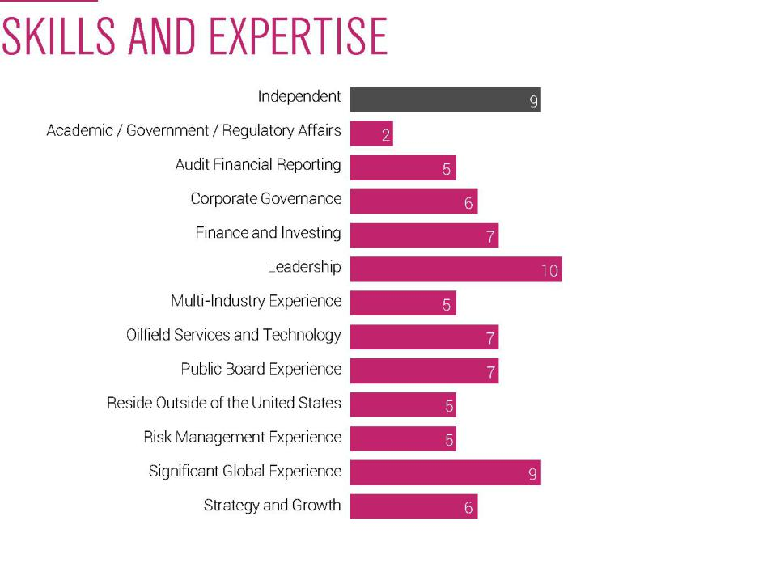

Weatherford International plc — 2016 Proxy Statement 6

Back to Contents

AGENDA ITEM 1

DIRECTOR BIOGRAPHIES


AGE: 66


DIRECTOR SINCE: 2014

COMMITTEES:

Health, Safety and Environment Corporate Governance and Nominating

OTHER PUBLIC COMPANY BOARDS:

None


MOHAMED A. AWAD

Background

Mr. Awad is a retired executive who most recently served as Chairman of Schlumberger–Middle East and Asia, a role he held from 2001 to 2012. Mr. Awad joined Schlumberger in 1981 and, over the next 30 years, held positions of increasing responsibility, both domestically and abroad, including in the wireline, well services, drilling and measurement, and oilfield services groups. In addition to his role at Schlumberger, Mr. Awad served as a director on Arabian Drilling Company in Saudi Arabia from 2005 until 2012.

Education

University of Tulsa, M.S., Petroleum Engineering

Cairo University, B.S., Petroleum Engineering

Relevant qualifications and experience

- Wealth of experience with a career in the oilfield services industry spanning 30+ years

- Strong technology background which enables him to help guide the Company’s strategic direction

- Deep appreciation for diversity established through international leadership experience

- Expertise in Middle East and Asia regions proves beneficial in conducting business in emerging markets

AGE: 75


DIRECTOR SINCE: 1984

COMMITTEES:

Corporate Governance and Nominating (Chair) Audit

OTHER PUBLIC COMPANY BOARDS:

GulfMark Offshore, Inc. (Chairman)

DAVID J. BUTTERS

Background

Mr. Butters has been Chairman, President and Chief Executive Officer of Navigator Holdings, Ltd., an international shipping company, the principal business of which is the transport of liquefied petroleum gas, since September 2008. From 1969 to September 2008, Mr. Butters was a Managing Director of Lehman Brothers Inc., an investment banking company and was previously Chairman of the Board of Directors of ACOL Tankers Ltd., a privately held oil tanker company.

Education

Boston College, B.S.

Colombia University Business School, M.B.A.

Relevant qualifications and experience

- Extensive career in investment banking and finance, an asset to the Audit Committee

- Chief executive officer and leadership experience

- Broad knowledge of oil and gas and shipping industries

- Expansive depth of knowledge of the Company’s business, as a result of his 30-year directorship on our Board

Weatherford International plc — 2016 Proxy Statement 7

Back to Contents

AGENDA ITEM 1


AGE: 62

DIRECTOR SINCE: 1988

COMMITTEES:

None

OTHER PUBLIC COMPANY BOARDS:

LMS Capital plc


AGE: 64

DIRECTOR SINCE: 2013

COMMITTEES:

Compensation

Health, Safety and Environment

OTHER PUBLIC COMPANY BOARDS:

Southwestern Energy Company Suncor Energy Inc.

BERNARD J. DUROC-DANNER

Background

Dr. Duroc-Danner joined EVI, Inc., Weatherford’s predecessor company, at inception in May 1987 and was directly responsible for the growth of EVI, Inc.’s oilfield service and equipment business. He has directed the growth of the Company since that time. He was elected EVI’s President and Chief Executive Officer in 1990. Subsequent to the merger of EVI, Inc. with Weatherford Enterra, Inc. on May 27, 1998, Dr. Duroc-Danner was elected as our Chairman of the Board.

Dr. Duroc-Danner also serves on the National Petroleum Council and is a member of the Society of Petroleum Engineers. He is a frequent speaker at leading industry forums, such as the Oil & Money Conference and the Abu Dhabi International Petroleum Conference, and is recognized in the Oil & Gas Middle East 2016 ‘Power50’.

Education

University of Pennsylvania, Wharton School of Business, M.B.A., Ph.D., Economics

Relevant qualifications and experience

- Economics background brings macro-industry and market expertise

- Substantial depth of knowledge of the oilfield service industry, domestically and internationally

- Successfully lead and expanded the Company’s business to become fourth largest oilfield services company in the world

- Links senior management and the Board, and brings an invaluable perspective in strategic planning for future growth

JOHN D. GASS

Background

Mr. Gass is a retired executive who was formerly a Vice President of Chevron Corporation and President of Chevron Gas and Midstream, a role held from 2003 until 2012. Mr. Gass joined Chevron in 1974 and his career spanned 38 years during which he held positions of increasing responsibility in engineering, operations and executive management, serving both domestically and various global locations.

Mr. Gass has been a director of Southwestern Energy Company since November 2012. He became a director of Suncor Energy Inc. in February 2014. For the past two years, he served as Chairman of the Board of Visitors for the Vanderbilt School of Engineering and is on the Advisory Board for the Vanderbilt Eye Institute. He is a member of the American Society of Civil Engineers and the Society of Petroleum Engineers.

Education

Vanderbilt University, B.E., Civil Engineering

Tulane University, M.E., Civil Engineering

Relevant qualifications and experience

- 38 years of experience in the energy exploration and production industry, providing insight into the needs and priorities of the Company’s clients

- Executive leadership experience, with a strong emphasis in operational strategy, major project development, and executive management

- Significant international experience in Europe, Africa and the Asia Pacific region

Weatherford International plc — 2016 Proxy Statement 8

Back to Contents

AGENDA ITEM 1


AGE: 68

DIRECTOR SINCE: 2010

COMMITTEES:

Health,
Safety and Environment (Chair)

Corporate
Governance and Nominating

OTHER PUBLIC COMPANY BOARDS:

None


AGE: 68

DIRECTOR SINCE: 2013

COMMITTEES:

Audit (Chair)

Corporate Governance and Nominating

OTHER PUBLIC COMPANY

BOARDS:

Ensco plc

Kraton Performance Polymers, Inc.

EMYR JONES PARRY

Background

Sir Emyr served as the Chancellor of Aberystwyth University, located in Wales, from 2008 to 2010 and has been Chairman of the All Wales Convention, a body established by the Welsh Assembly Government to review Wales’s constitutional arrangements, since 2007 and was Chairman of the Corporate and Social Responsibility External Advisory Group of First Group plc, a transport operator, from 2008 to 2011. Sir Emyr previously held numerous diplomatic positions, including UK Permanent Representative to the UN from 2003 to 2007 and UK Ambassador to NATO from 2001 to 2003, specializing in European Union affairs including energy policy. He is the Chairman of Redress, a human rights organization. He is also the President of the Learned Society of Wales and began his three-year term of office in May of 2014.

Education

University of Cardiff, B.Sc., Theoretical Physics

University of Cambridge, Ph.D., Polymer Physics

Relevant qualifications and experience

- Wealth of government relations, diplomatic and negotiation experience

- High level of public and social policy knowledge

- Important international perspective, with an emphasis on global issues and European markets

- Years of dedicated focus on social responsibility, sustainability and human rights

FRANCIS S. KALMAN

Background

Mr. Kalman serves as a senior advisor to a private investment subsidiary of Tudor, Pickering, Holt and Co., LLC that specializes in direct investments in upstream, midstream and oilfield service companies. Mr. Kalman served as Executive Vice President of McDermott International, Inc. from 2002 until his retirement in 2008 and as Chief Financial Officer from 2002 until 2007. From 2000 to 2002, he was Senior Vice President and Chief Financial Officer of Chemical Logistics Corporation; from 1999 to 2000, he was a principal of Pinnacle Equity Partners, LLC; from 1998 to 1999, he was Executive Vice President and Chief Financial Officer of Chemical Logistics Corporation; and from 1996 to 1997, he was Senior Vice President and Chief Financial Officer of Keystone International, Inc.

Mr. Kalman started his career as a Certified Public Accountant with PriceWaterhouse and Co. In addition to the above, he has served in various financial capacities with Atlantic Richfield Company (1975 to 1982), United Gas Pipeline (1982 to 1991) and American Ref-Fuel (1991 to 1996).

In addition to his existing directorships, during the past five years, Mr. Kalman has also served on the board of Pride International, Inc., which merged into Ensco plc, and CHC Group Ltd.

Education

Long Island University, B.S., Accounting

Relevant qualifications and experience

- Extensive knowledge in accounting and financial reporting

- Chief financial officer experience and serving as chairman of the audit committee of other public companies

- Executive leadership and strategic planning experience in the international energy service industry

- Experience in multiple components of the energy industry, including internationally

Weatherford International plc — 2016 Proxy Statement 9

Back to Contents

AGENDA ITEM 1


AGE: 70

DIRECTOR SINCE: 1998

COMMITTEES:

Compensation
(Chair)

OTHER PUBLIC COMPANY BOARDS:

Glencore Xstrata plc
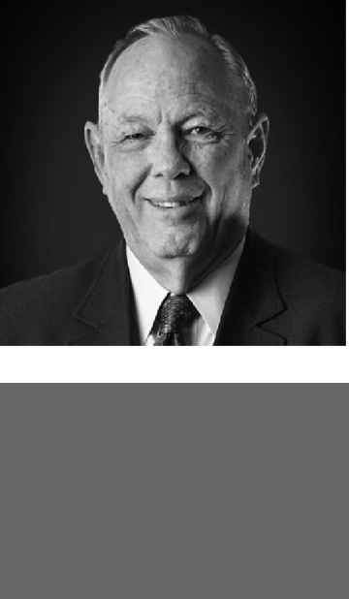

AGE: 76

DIRECTOR SINCE: 1998

COMMITTEES:

Audit

Compensation

Health, Safety and Environment

OTHER PUBLIC COMPANY BOARDS:

None

WILLIAM E. MACAULAY

Background

Mr. Macaulay is the Chairman and Co-Chief Executive Officer of First Reserve. He has been with First Reserve, a global private equity and infrastructure investment firm focused on the energy industry, since 1983. Mr. Macaulay is jointly responsible for supervision of the firm’s investment program and strategy, as well as overall management of the firm. Mr. Macaulay sits on all of the firm's investment committees. Mr. Macaulay served as a director of Weatherford Enterra from October 1995 to May 1998. Mr. Macaulay also served as Director of Corporate Finance for Oppenheimer & Co., Inc., where he worked from 1972 to 1982.

Previously, Mr. Macaulay served as Chairman of CHC Group Ltd., Dresser-Rand Group, Inc., Foundation Coal Holdings Inc. and Pride International, and as a director of Dresser, Inc. and National Oilwell Varco.

Education

City College of New York, B.B.A.

University of Pennsylvania, Wharton School of Business, M.B.A.

Relevant qualifications and experience

- Significant investment and financial expertise as chairman of one of the world’s leading energy and natural gas resources private equity firms

- Chief executive officer experience

- Extensive knowledge of the oilfield service industry

- Expansive depth of knowledge of the Company’s business, as a result of his 20-years of experience with the Company and its predecessor

ROBERT K. MOSES, JR.

Background

Mr. Moses is a private investor, principally in the oil and gas exploration and oilfield services sectors in Houston, Texas, and has invested for more than 20 years. He served as Chairman of the Board of Directors of Weatherford Enterra from May 1989 to December 1992 and continued on as a director of Weatherford Enterra from December 1992 to May 1998. Mr. Moses also devotes substantial time to serving on boards of local healthcare and educational institutions.

Education

University of Texas, B.A., Economics

Relevant qualifications and experience

- Significant investment experience, with an understanding of how to manage through commodity cyclicality

- Extensive knowledge of and experience in the oilfield service industry and ability to identify value opportunities

- Committed to enhancing and improving the communities in which the Company operates

- Substantial institutional knowledge of one of Weatherford’s most significant legacy companies and a committed ambassador for the Company with clients and local communities

Weatherford International plc — 2016 Proxy Statement 10

Back to Contents

AGENDA ITEM 1
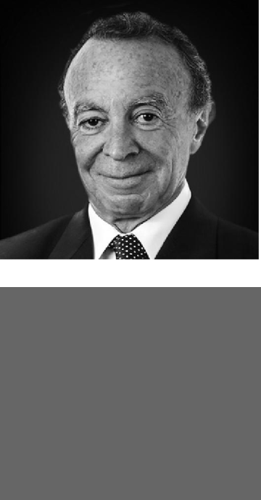

AGE: 67

DIRECTOR SINCE: 2010

COMMITTEES:

Audit

Compensation

OTHER PUBLIC COMPANY

BOARDS:

Grupo Aeroportuario del Sureste S.A.B. de C.V.

Grupo Comercial Chedraui S.A.B. de C.V.

Mexichem S.A.B. de C.V.

Vitro S.A.B. de C.V.


AGE: 67

DIRECTOR SINCE: 1987

COMMITTEES:

Audit (Vice Chair)

Corporate Governance and Nominating

Health, Safety and Environment

OTHER PUBLIC COMPANY

BOARDS:

ChyronHego Corporation

LMS Capital plc

Derwent London plc (Non-Executive Chairman)

GUILLERMO ORTIZ

Background

Dr. Ortiz is currently a partner and Chairman for BTG Pactual Mexico, a Latin American investment bank based in Brazil. He served as the Chairman of Banorte, the third largest bank in Mexico from 2010 until 2014; Governor of the Bank of Mexico from 1998 until 2009; and as Chairman of the Board of the Bank for International Settlements (BIS) in 2009. He previously served as Secretary of Finance and Public Credit in Mexico, from 1994 to 1998. Dr. Ortiz was also Executive Director at the International Monetary Fund and is a director of several international non-profit organizations. He is currently a member of “The Group of Thirty,” an international body of leading financiers and academics.

Education

National Autonomous University of Mexico, B.A., Economics

Stanford University, M.Sc. and Ph.D., Economics

Relevant qualifications and experience

- Extensive international finance and banking experience in the public and private sector

- Expertise regarding global economic matters and multi-national financing, an important element of the Company’s global strategy

- International perspective, with a focus on Latin America

- Frequent speaker, author of topical articles, and educator, providing a current perspective on financial matters

ROBERT A. RAYNE

Background

Mr. Rayne is the current Chairman of Derwent London plc and former non-executive director of LMS Capital plc, an investment company listed on the London Stock Exchange. He was the Chairman of LMS Capital from February 2010 to January 2012 and a director of LMS Capital since February 2010. Mr. Rayne was the Chief Executive Officer and a director of LMS Capital from June 2006, when the investment business of London Merchant Securities plc was demerged and LMS Capital was formed to hold this business, until February 2010. Mr. Rayne was employed by London Merchant Securities from 1968 to June 2006 and served as its Chief Executive Director from May 2001 to June 2006.

Mr. Rayne also serves as the trustee for several charitable foundations, including the National Theatre Foundation, the Imperial College Endowment Fund and the Children of Success Schools, each in the UK.

Education

Malvern College

New York Institute of Finance, Diploma in Accounting, Law, and Working in the Stock Exchange Relevant qualifications and experience

- Serves as Vice Chairman and Presiding Director, i.e. the lead independent director, of the Company’s Board and leads the executive sessions of the non-management Directors

- Financial and investment expertise in a wide range of sectors in addition to the oilfield service industry, including the real estate, media, consumer and technology industries

- Chief executive officer and leadership experience, as well as other public company board and governance experience

- 30-year tenure on the Board provides significant institutional knowledge of the Company

Weatherford International plc — 2016 Proxy Statement 11

Back to Contents

AGENDA ITEM 1
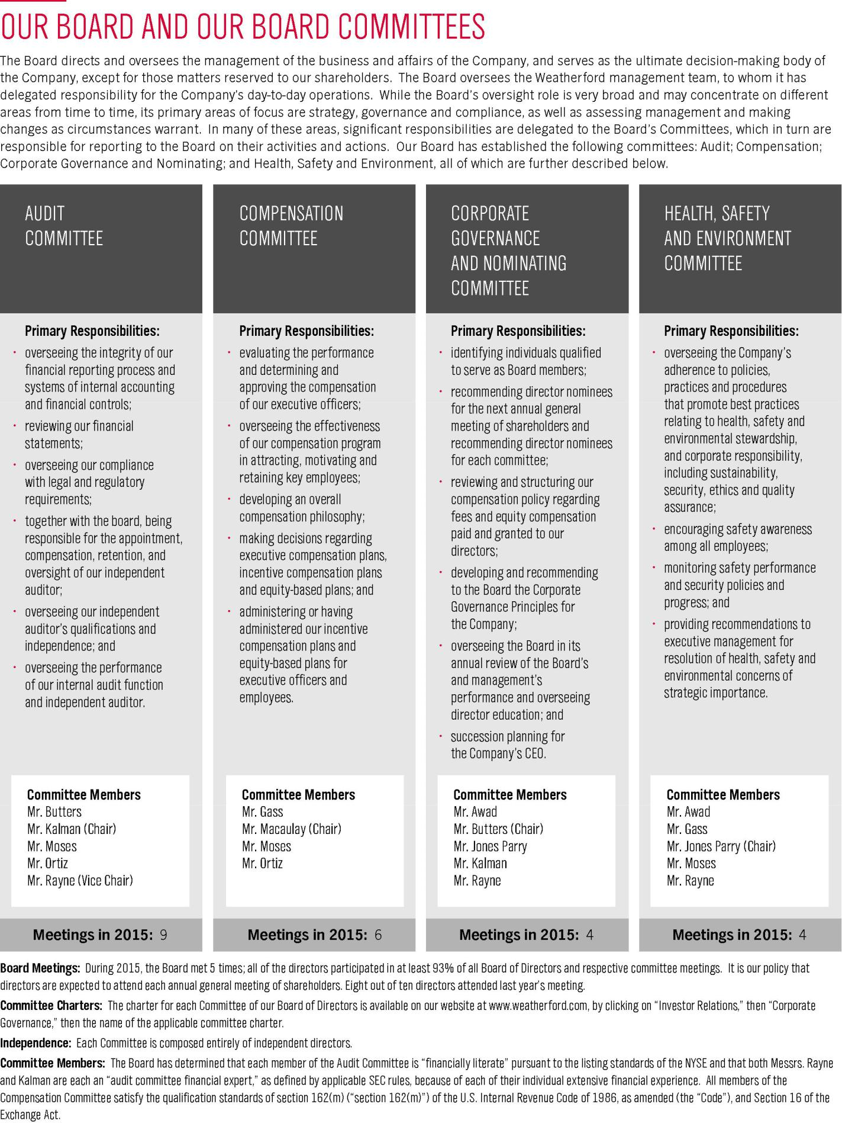

Weatherford International plc — 2016 Proxy Statement 12

Back to Contents

AGENDA ITEM 1

CORPORATE GOVERNANCE MATTERS

Our Board believes sound corporate governance processes and practices, as well as high ethical standards, are critical to handling challenges and to achieving business success. We embrace leading governance practices and also conduct ongoing reviews of our governance structure and processes to reflect shareholder input and changing circumstances. For example, in 2015, we made significant enhancements to our Corporate Governance Principles, including changes to director evaluation practices and factors for consideration for director nominees. Below are highlights of our corporate governance practices and principles.

HIGHLIGHTS

Director Independence | ✓ 9 out of 10 of our directors are independent
Vice Chairman and Presiding Director | ✓ We have an independent vice chair and presiding director who, among other items:
 | • reviews Board meeting schedules and agendas in collaboration with the Chairman to assure there is an adequate
 | number of scheduled meetings and sufficient time for discussion of all agenda items as well as the inclusion of
 | topics deemed important by the independent directors
 | • presides at all meetings of the Board at which the Chairman is not present, including executive sessions, and can
 | call for executive sessions of the Board’s independent directors, if and when deemed appropriate
 | • leads the Board’s annual evaluation of the Chairman and Chief Executive Officer
 | • monitors and collaborates with management regarding corporate governance matters
 | • serves as principal liaison and supplemental channel of communication between the independent directors and the
 | Chairman
 | • is available for communication with stockholders, in coordination with management, when appropriate
Committee Structure | ✓ Our Committees are composed entirely of independent directors; on an annual basis, the Corporate Governance and
 | Nominating Committee evaluates and recommends committee chairman to the Board and assesses the
 | appropriateness of any further chair rotations
Executive Sessions | ✓ Independent directors meet regularly in executive session, including before and after regularly scheduled meetings;
 | in 2015, executive sessions were held at each of the four regularly scheduled Board meetings
Annual Voting | ✓ Each member of Board is elected annually with a majority voting standard for uncontested elections
Shareholder Rights | ✓ Shareholders representing 10% or more of outstanding shares can call a special shareholders meeting
Annual Board and Committee Self Evaluation | ✓ The Board and each Committee conduct annual self-evaluations. In addition, starting in 2016, each independent
 | director has completed an individual evaluation of each other director
Share Ownership Guidelines | ✓ Our directors are required to own at least five times their annual cash retainer
 | ✓ Our CEO is required to own at least six times his annual base salary, and he currently owns in excess of 11 times his
 | annual base salary
 | ✓ Other NEOs are required to own three times their annual salary
Risk Oversight | ✓ Our entire Board is responsible for risk management of the Company, and our Committees have particular oversight
 | of certain key risks
Succession Planning | ✓ CEO succession planning is done in June and December in executive session; additionally, the CEO reports to the
 | Board on an at least annual basis concerning management development and succession planning for all other key
 | positions
Over-boarding | ✓ All of our directors (other than one) serve on three or less public company boards; one director serves on four public
 | company boards
Mandatory Retirement | ✓ In 2016, our Board adopted a mandatory retirement policy for all directors over age 72; however, to facilitate
 | transition, all existing directors are grandfathered in
Code of Business Conduct | ✓ We have a robust and comprehensive Code of Business Conduct that was revised in 2015, with the support and
 | guidance of our Board. The Code of Conduct applies to all employees and each director

Additional information regarding Corporate Governance at Weatherford can be found on our website at www.weatherford.com in the “Investor Relations” section.

Weatherford International plc — 2016 Proxy Statement 13

Back to Contents

AGENDA ITEM 1

RISK MANAGEMENT OVERSIGHT

The Board is responsible for the oversight of overall risk management for the Company, and the Audit Committee is responsible for financial and compliance reporting as well as risk assessment. The Board has implemented an Enterprise Risk Management system to identify and evaluate varying levels of risk and their potential impact on the enterprise, as well as steps to further mitigate those risks.

As part of its oversight function, the Audit Committee discusses and implements guidelines and policies concerning financial and compliance risk assessment and management, including the process by which major financial and compliance risk exposure is monitored and mitigated. The Audit Committee works with members of management to assess and monitor risks facing the Company’s business and operations, as well as the effectiveness of the Company’s guidelines and policies for managing and assessing financial and compliance risk. The Audit Committee meets and discusses, as appropriate, issues regarding the Company’s risk management policies and procedures directly with those individuals responsible for day-to-day risk management in the Company’s internal audit and compliance departments. The Audit Committee has also established policies and procedures for the pre-approval of all services provided by the independent registered public accounting firm as described in “Audit Committee Pre-Approval Policy” in this Proxy Statement. In addition, the Audit Committee has established procedures for the receipt, retention and treatment, on a confidential basis, of complaints received by the Company regarding its accounting, internal controls, Code of Conduct or other matters.

Furthermore, the Corporate Governance and Nominating Committee periodically provides oversight with respect to risks associated with our corporate governance policies and practices, including our Corporate Governance Principles. The Corporate Governance and Nominating Committee also oversees and reviews, on an annual basis, an evaluation of the Board, each of our Board committees and management and, beginning in 2016, a peer evaluation.

The Compensation Committee reviews our compensation plans and practices to ensure they do not encourage excessive risk taking and, instead, encourage behaviors that support sustainable value creation. See “Risk Analysis of our Compensation Programs” in the Compensation Discussion and Analysis section of this Proxy Statement.

Our Health, Safety and Environment Committee oversees the Company’s policies and practices to promote good stewardship, to encourage safety awareness, to monitor safety performance and to provide suggestions to management for the resolution of health, safety and environmental concerns, all with a view towards reducing risks in those areas.

SUCCESSION PLANNING

In addition to oversight of risk management, one of the responsibilities of our Board is to ensure that the Company has a long-term and evolving program for effective leadership development and succession. Our Board is committed to talent management and high-grading the Company’s global management structure. Throughout the year, the Board was presented with high-potential leadership candidates and regularity updated on key talent metrics, including diversity, recruiting and development programs. The CEO reports to the Board on an annual (or more frequent, as needed) basis concerning management development and succession planning for all other positions. In addition, the Corporate Governance and Nominating Committee does CEO succession planning in executive session in June and December of each year.

MANDATORY RETIREMENT

In 2016, we also further enhanced our Corporate Governance Principles by adopting a mandatory retirement policy. This policy requires that each non-employee Director retire from the Board immediately prior to the annual general meeting of shareholders following his or her seventy-second (72nd) birthday. In order to allow a smooth transition of our existing Directors, the requirement has been automatically waived for each of our current directors (i.e. such Directors shall be grandfathered in). We believe this policy will help increase diversity and allow for more frequent Board refreshment.

DIRECTOR INDEPENDENCE

The Board has affirmatively determined that each director is independent under the rules of the NYSE and the SEC, other than Dr. Duroc-Danner, who is our Chief Executive Officer. As contemplated by NYSE rules, the Board has adopted categorical standards to assist it in making independence determinations.
These standards are available on our website at www.weatherford.com, by clicking on “Investor Relations,” then “Corporate Governance,” then “Corporate Governance Principles.” However, in making independence determinations, the Board considers and reviews all relationships with each director, whether or not they fall within the categorical standards. None of the independent directors had relationships relevant to an independence determination that were outside the scope of the Board’s categorical standards. The relationship discussed below under “Related Person Transactions” in this Proxy Statement did not exceed these categorical standards and was determined by the Board not to be material.

Weatherford International plc — 2016 Proxy Statement 14

Back to Contents

AGENDA ITEM 1

RELATED PERSON TRANSACTIONS

Our Board has adopted a policy regarding related person transactions as part of a comprehensive governance program. This policy regarding transactions between us or any of our affiliates and our directors, executive officers and other employees is set forth in writing in our Corporate Governance Principles and
our Code of Business Conduct. These documents are available on our website at www.weatherford.com, by clicking on “Investor Relations,” then “Corporate Governance,” then selecting “Corporate Governance Principles” or “Code of Business Conduct,” as applicable. We also have a Supplemental Code of Business Conduct that applies to our President and Chief Executive Officer, our Chief Financial Officer and our Chief Accounting Officer, which is available on our

website at www.weatherford.com, by clicking on “Investor Relations,” then “Corporate Governance,” then “Supplemental Code of Conduct.” The Board believes these documents promote the effective functioning of the Board, its Committees and management. Accordingly, they are periodically reviewed and revised, as appropriate.

If an actual or potential conflict of interest arises for any director, the director is required to notify the Board and is not allowed to participate in any discussions or vote on any transaction in which the actual or potential conflict of interest may arise. The Board approves any transactions with our Chief Executive Officer, and our Chief Executive Officer approves any transactions with any other officer.

Transactions with Related Persons in 2015. We lease our London office space from Central London Commercial Estates Limited, which is affiliated with Derwent London plc, of which one of our directors, Mr. Robert A. Rayne, is a non-executive chairman. Mr. Rayne was not personally involved in the negotiation of the lease transaction and receives no personal benefit from this transaction. The lease transaction was reviewed by the Corporate Governance and Nominating Committee of our Board of Directors and approved by our Board of Directors, with Mr. Rayne abstaining from voting on the matter. In their review, our Corporate Governance and Nominating Committee considered, among other factors, a report from an independent real estate brokerage firm with expertise in the relevant market analyzing lease alternatives to conclude that the transactions were, taken as a whole, at least as fair to us as would have been obtained on an arms-length basis from a non-affiliated party. In 2015, we paid the lessor a total of approximately £459,000 ($701,640 based on an annual average exchange rate for the year ended December 31, 2015).

LEADERSHIP STRUCTURE AND EXECUTIVE SESSIONS

The Board periodically examines its structure based on the existing and future needs of the Company to ensure its composition delivers the greatest long-term shareholder value. While the Board retains its authority to separate the positions, the Board has determined the most effective leadership structure for the Company is to combine the role of Chief Executive Officer and Chairman. The Board believes that by serving both as Chief Executive Officer and Chairman, Dr. Duroc-Danner brings multiple perspectives to the Board and also is best informed to lead the Board because of his role in the management of the Company’s business and strategic direction. Notwithstanding the foregoing, on at least an annual basis, the Board will consider whether it is appropriate that the positions of Chairman and Chief Executive Officer continue to be held by the same person.

The Board has appointed Mr. Rayne as Vice Chairman and Presiding Director to oversee executive sessions of independent directors, i.e., each of our our non-employee Directors. The Board believes it is in the best interest of the Company’s shareholders to have a Presiding Director who has the authority to call executive sessions as a counterbalance to the Company’s combined roles of Chief Executive Officer and Chairman. The Board believes executive sessions provide the Board with the ability to independently evaluate management, openly discuss strategic and other business issues involving the Company, ensuring that the Company is upholding high standards of corporate governance. Executive sessions are held before and after each regularly scheduled Board meeting and at such additional times as may be needed. In 2015, executive sessions of the independent directors were held at each of the four regularly scheduled Board meetings.

For information on how to communicate with our Presiding Director and other non-employee Directors, please see “Communication with Directors.”

DIRECTOR NOMINATIONS

In obtaining the names of possible director nominees, the Corporate Governance and Nominating Committee conducts its own inquiries and considers suggestions from other directors, management, shareholders and other sources. The Committee’s process for evaluating nominees identified in unsolicited recommendations from shareholders is the same as its process for unsolicited recommendations from other sources.

The Corporate Governance and Nominating Committee will consider nominees recommended by shareholders who submit their recommendations in writing to Chairman, Corporate Governance and Nominating Committee, care of the Secretary, Weatherford International plc, Bahnhofstrasse 1, 6340 Baar, Switzerland. Recommendations received before December 1st in any year will be considered for inclusion in the slate of director nominees to be presented at the annual general meeting in the following year. Unsolicited recommendations must contain the name, address and telephone number of the potential nominee, a statement regarding the potential nominee’s background, experience, expertise and qualifications, a signed statement confirming his or her

Weatherford International plc — 2016 Proxy Statement 15

Back to Contents

AGENDA ITEM 1

willingness and ability to serve as a director and abide by our corporate governance policies, his or her availability for a personal interview with the Corporate Governance and Nominating Committee and evidence that the person making the recommendation is a shareholder of Weatherford.

The Corporate Governance and Nominating Committee believes that nominees should possess the highest personal and professional ethics, reputation, integrity and values and be committed to representing the long-term interests of our shareholders. Directors should have a record of accomplishment in their chosen professional field and demonstrate sound business judgment. Directors must be willing and able to devote sufficient time to carrying out their duties and responsibilities effectively, including attendance at and participation in Board and Committee meetings, and should be committed to serve on the Board for an extended period of time. The Corporate Governance and Nominating Committee will consider independence, diversity of viewpoints, backgrounds and experience, including a consideration of gender, ethnicity, race, country of citizenship and age in determining whether a candidate will be an appropriate fit with, and an asset to, the Board of Directors. When considering existing directors, the Corporate Governance and Nominating Committee evaluate their history of attendance at Board and committee meetings as well as contributions and effectiveness at such meetings.

Rule 14a-8 under the Exchange Act addresses when a shareholder may submit a proposal for inclusion of a nominee for director in our proxy materials. Shareholders who do not comply with Rule 14a-8, but who wish to have a nominee considered by our shareholders at the Annual General Meeting, must comply with the deadlines and procedures set forth in our Articles. Please see “Proposals by Shareholders” in this Proxy Statement for more information.

SHAREHOLDER ENGAGEMENT

Shareholder outreach is a long-standing cornerstone of our governance program. We engage in regular and ongoing dialogue with our investors to gain valuable insights into the governance issues about which they care most. These outreach discussions permit a more reflective and precise exchange of views. During our conversations with shareholders, we listen to constructive input that we believe will better position the Company to deliver sustainable value over the long-term for all of our stakeholders. Members of our executive management team, including our Chief Financial Officer, our General Counsel and Corporate Secretary and our Vice President of Investor Relations, Corporate Marketing and Communications, regularly meet (telephonically or in person) with shareholders and, on occasion, members of our Board will meet with our shareholders as well. The results of our discussions are regularly reported to the Board and to the applicable Committees.

We continue to seek a collaborative and mutually beneficially approach to issues that are important to our investors in ways that ensure our Corporate Governance practices remain best-in-class. These issues affect the success of our business. Additionally, our annual shareholder meeting results are carefully considered as part of our shareholder engagement process. In 2015, over 88% of our outstanding shares voted at our annual general meeting and all of our agenda items were approved, including over 91% of shares voted in respect of our “say-on-pay” agenda item voted in favor of such item and more than 88% of shares voted in respect of each individual director approved each director, with some directors receiving as high as 99% support (of shares voted).

To go beyond reporting requirements, in recent years, we have created a dedicated Annual General Meeting website at:www.weatherfordannualmeeting.com.

In addition, this year, we have introduced a NEW dedicated section that provides an opportunity for shareholders and other interested parties to provide feedback on our disclosures and ask questions to be considered by the Board.

We welcome you to submit feedback on our disclosures at: www.weatherfordannualmeeting.com/feedback

COMMUNICATION WITH DIRECTORS

Any shareholder or other interested party that desires to communicate with the Board of Directors or any of its specific members, including the Vice Chairman and Presiding Director or the independent directors as a group, should send their communication to the Secretary, Weatherford International plc, Bahnhofstrasse 1, 6340 Baar, Switzerland. All such communications will be forwarded, as appropriate, to the members of the Board.

We welcome input from our institutional and individual shareholders, regardless of the number of shares owned.

Shareholders may also direct their comments to our U.S. Investor Relations Department in writing at 2000 St. James Place, Houston, Texas 77056, or by telephone at +1 (713) 836-4000.

Weatherford International plc — 2016 Proxy Statement 16

Back to Contents

AGENDA ITEM 1

DIRECTOR COMPENSATION

We use a combination of cash and share-based incentive compensation to attract and retain qualified candidates to serve on the Board. In setting director compensation, we consider the significant amount of time that directors expend in fulfilling their duties to the Company, including the number and location of meetings, as well as the level of knowledge and experience that we require of and expect from each member of our Board. Our Corporate Governance and Nominating Committee is responsible for reviewing and structuring our compensation policy regarding fees and compensation paid and granted to our Directors.

Each Director who is not an employee of the Company is paid the fees set forth below. No increases to our Director’s fees were made from 2014 to 2015. In the first quarter of 2016, fees were reduced by 10%. The Board approved and agreed to such 10% reduction in connection with the continued industry downturn and the Company's focus on cost savings.

Type of Fee | 2015 Amount
Annual Retainer for all Directors | $95,000
Additional Annual Retainer – Audit Committee Chairman | $22,500
Additional Annual Retainer – Each Audit Committee Member excluding Chairman | $10,000
Additional Annual Retainer – Compensation Committee Chairman | $17,500
Additional Annual Retainer – Corporate Governance and Nominating Committee Chairman | $15,000
Additional Annual Retainer – Health, Safety and Environment Committee Chairman | $15,000
Additional Annual Retainer – Presiding Director | $22,500
Board Meeting Attendance (per meeting) | $5,000
Committee Meeting Attendance (per meeting) | $2,250

Annual retainers are paid quarterly in advance. Meeting fees are paid after each meeting. We do not compensate Dr. Duroc-Danner for his service on the Board.

In addition to the fees described above, on September 25, 2015, we granted to each of the non-employee Directors 12,000 restricted share units pursuant to our 2010 Omnibus Incentive Plan. The awards vest on the first anniversary of the grant, subject to earlier vesting in the event of the death or disability of the director or a change of control of the Company. The Corporate Governance and Nominating Committee believes that providing a significant portion of overall Board compensation in the form of restricted share units aligns the interests of our directors with those of our shareholders. As with Director fees above, no increases in the number of restricted share units granted in 2015 were made as compared to 2014 restricted share unit grants.

Longnecker & Associates (“Longnecker”), a compensation consulting firm, has been retained by the Compensation Committee and the Corporate Governance and Nominating Committee as an independent compensation consultant to advise each Committee on compensation matters. Longnecker provides the Corporate Governance and Nominating Committee with comparative market data regarding board compensation practices and programs; analyses of publicly available information on our peer group (see “Peer Group” in the CD&A section in this Proxy Statement); information regarding industry practices; as well as vesting and valuation information and analysis.

NON-EMPLOYEE DIRECTOR DEFERRED COMPENSATION PLAN (SUSPENDED)

The Weatherford International Ltd. Non-Employee Director Deferred Compensation Plan was suspended effective December 31, 2008, because of changes in tax laws. While the plan is suspended, amounts are still payable to participants on the occurrence of triggering events under the plan.

Prior to the suspension of this plan, Messrs. Butters, Macaulay, Moses and Rayne elected to defer 7.5% of the fees paid by us and to have their distributions paid on the first day of the calendar quarter on or immediately following the date of his cessation of service with the Board. In any event, all benefits under the plan will be distributed no later than January 1, 2017. The amount of the distribution will be a number of ordinary shares equal to the number of units in the director’s account at the time of the distribution. Messrs. Awad, Gass, Kalman, Ortiz and Sir Emyr are not participants in this suspended plan.

NON-EMPLOYEE DIRECTOR RETIREMENT PLAN (DISCONTINUED)

After the merger of EVI, Inc. and Weatherford Enterra in June 1998, we discontinued this plan. Mr. Moses is the only current director who was fully vested and eligible to participate in this plan at the time of the plan’s discontinuance. Mr. Moses had over 10 years of credited service on the Board of Weatherford Enterra

Weatherford International plc — 2016 Proxy Statement 17

Back to Contents

AGENDA ITEM 1

at the time the plan was discontinued, and his annual benefit amount upon his retirement will be $20,000 payable for 10 years, provided that, in any event, benefits under this plan will be completely distributed no later than January 1, 2017.

2015 DIRECTOR COMPENSATION

The following table sets forth the compensation paid to each of our independent directors for the year ended December 31, 2015. Dr. Duroc-Danner was a named executive officer and director in 2015, and information about his compensation is listed in the 2015 Summary Compensation Table in this Proxy Statement.

 |  |  | All Other
 | Fees Earned or Paid in Cash | Share Awards | Compensation | Total
Name | ($) | ($)(1)(2) | ($)(3) | ($)
Mohamed A. Awad | 122,034 | 104,400 | 43,472 | 269,906
David J. Butters | 144,250 | 104,400 | - | 248,650
John D. Gass | 114,250 | 104,400 | - | 218,650
Emyr Jones Parry | 125,500 | 104,400 | - | 229,900
Francis S. Kalman | 133,375 | 104,400 | - | 237,775
William E. Macaulay | 122,875 | 104,400 | - | 227,275
Robert K. Moses, Jr. | 146,500 | 104,400 |  | 250,900
Guillermo Ortiz | 137,500 | 104,400 | 54,844 | 296,744
Robert A. Rayne | 149,875 | 104,400 | - | 254,275

- Each non-employee director was awarded 12,000 restricted share units on September 25, 2015 at a grant date fair value of $104,400, computed in accordance with Financial Accounting Standards Board (“FASB”) Accounting Standards Codification (“ASC”) Topic 718.

- As of December 31, 2015, aggregate outstanding restricted share unit awards for each non-employee director is set forth below.

 | Aggregate Number of Restricted Shares/
Name | Restricted Share Units
Mohamed A. Awad | 23,495
David J. Butters | 24,000
John D. Gass | 27,587
Emyr Jones Parry | 24,000
Francis S. Kalman | 27,587
William E. Macaulay | 24,000
Robert K. Moses, Jr. | 24,000
Guillermo Ortiz | 24,000
Robert A. Rayne | 24,000

- Amounts for 2015 consist of social contribution and withholding taxes paid on behalf of certain directors due to their non-U.S. tax residence. We believe this compensation helps us attract and retain qualified international directors.

Weatherford International plc — 2016 Proxy Statement 18

Back to Contents

AGENDA ITEM 2 – RATIFY APPOINTMENT OF INDEPENDENT AUDITORS AND AUTHORIZE AUDITORS’ REMUNERATION

The Board of Directors recommends that you vote “FOR” this proposal.

KPMG LLP and KPMG Chartered Accountants, Dublin (collectively, “KPMG”) served as the independent and Irish statutory auditors for Weatherford for the year ended December 31, 2015. The Board, upon the recommendation of the Audit Committee, is asking our shareholders to ratify the appointment of KPMG LLP as our independent registered public accounting firm and auditor for the year ending December 31, 2016 and KPMG Chartered Accountants, Dublin as our statutory auditor under Irish law to hold office until the close of the 2017 AGM and to authorize the Board of Directors, acting through the Audit Committee, to determine the independent auditors' remuneration. The selection of KPMG LLP as the independent registered public accounting firm for 2016 was approved by the Audit Committee on March 17, 2016.

An ordinary resolution (i.e., a simple majority of the votes cast “For” or “Against,” in person or by proxy, provided a quorum is present) is required to approve this proposal. If you properly give a proxy but do not indicate how you wish to vote, the persons named on the proxy card, or if you do not name your proxy or proxies, the Proxy Holders, will vote for the proposal. Abstentions and “broker non-votes” will not affect the voting results.

Representatives of KPMG will be present at the Annual General Meeting to respond to any appropriate shareholder questions and will be given an opportunity to make a statement, if they so desire.

FEES PAID TO KPMG

The following table presents fees for professional audit services rendered by KPMG for the audit of the annual consolidated financial statements and statutory financial statements of Weatherford (including its predecessor) for the years ended December 31, 2015 and December 31, 2014 and fees billed for other services rendered by KPMG during those periods. All fees were approved by the Audit Committee pursuant to its pre-approval policy.

 |  | 2015 | 2014
Audit fees(1) | $ | 20,465,000 | $19,477,000
Audit-related fees(2) |  | 29,000 | 42,000
Tax fees(3) |  | 446,000 | 1,059,000
All other fees(4) |  | 297,000 | 234,000
TOTAL | $ | 21,237,000 | $20,812,000

- Audit fees consist of professional services rendered for the audit of Weatherford’s annual financial statements, the audit of the effectiveness of Weatherford’s internal controls over financial reporting and the reviews of Weatherford’s quarterly financial statements. This category also includes fees for issuance of comfort letters, consents, assistance with and review of documents filed with the SEC, statutory audit fees, work performed by tax professionals in connection with the audit and quarterly reviews and accounting consultations and research work necessary to comply with the standards of the Public Company Accounting Oversight Board (United States). Fees are presented in the period to which they relate versus the period in which they were billed.

- Audit-related fees include consultations concerning financial accounting and reporting matters not required by statute or regulation.

- Tax fees consist of non-U.S. tax compliance, planning and U.S./non-U.S. tax-related consultation.

- Other services performed include certain other advisory services and do not include any fees for financial information systems design and implementation.

AUDIT COMMITTEE PRE-APPROVAL POLICY

The Audit Committee has established a pre-approval policy for all audit and non-audit services to be provided by our independent auditor. There are two types of pre-approval. “General” pre-approval is based on pre-determined types of services. “Specific” pre-approval is required for certain types of services or if a service is expected to exceed budgeted amounts. “Specific” pre-approval must be obtained through direct communications with the Audit Committee or the Chairman of the Audit Committee, to whom the Audit Committee has delegated pre-approval authority. The Chairman must report any pre-approved decisions to the Audit Committee at its next scheduled meeting. During 2015, all audit and non-audit services performed by the independent auditor were subject to the pre-approval policy.

The Audit Committee has designated the Company’s Vice President, Audit Services, to monitor and report on the performance of all services provided by our independent auditor and to determine whether such services are in compliance with the pre-approval policy. The Vice President, Audit Services, periodically reports to the Audit Committee regarding the results of her monitoring.

Weatherford International plc — 2016 Proxy Statement 19

Back to Contents

AGENDA ITEM 2

AUDIT COMMITTEE REPORT

February 12, 2016

The Audit Committee represents and assists the Board in providing independent, objective oversight of the Company’s accounting functions and internal

control over financial reporting. The Audit Committee acts under a charter which is available on the Company’s website at www.weatherford.com under “Investor Relations,” then “Corporate Governance,” then Audit Committee Charter. The Audit Committee is composed of five directors and the Board has determined that each of these directors satisfy the requirements of the NYSE as to independence, financial literacy and expertise. In addition, each member of the Audit Committee qualifies as an independent director and possesses the requisite competence in accounting or auditing in satisfaction of the requirements for audit committees prescribed by the Irish Companies Act 2014.

Management is responsible for the Company’s financial statements and the reporting process, including the system of disclosure controls and procedures and internal control over financial reporting.

KPMG LLP, the Company’s independent registered public accounting firm, is responsible for expressing an opinion on the conformity of our financial statements with accounting principles generally accepted in the United States and on the effectiveness of the Company’s internal control over financial reporting.

In discharging its oversight role, the Audit Committee has

- reviewed and discussed with management the audited financial statements of Weatherford International plc as of and for the year ended December 31, 2015; and

- discussed with KPMG LLP the matters required to be discussed by Auditing Standard No. 16, Communications with Audit Committees, as amended, as adopted by the Public Company Accounting Oversight Board. In addition, the Audit Committee has received the written disclosures and the letter from KPMG LLP required by applicable requirements of the Public Company Accounting Oversight Board regarding the independent auditor’s communications with the Audit Committee concerning independence, and has discussed with KPMG LLP their independence.

The Audit Committee and the Board believe that, due to KPMG LLP’s knowledge of the Company and the industry in which the Company operates, it is in the best interest of the Company and its shareholders to continue the retention of KPMG LLP to serve as the Company’s independent registered public accounting firm. Although the Audit Committee has the sole authority to appoint the independent registered public accounting firm, the Audit Committee recommends that the Board ask the shareholders to ratify the appointment of the independent registered public accounting firm at the 2016 Annual General Meeting.

Based on the reviews and discussions referred to above, the Audit Committee recommended to the Board of Directors that the audited financial statements referred to above be included in the Annual Report on Form 10-K of Weatherford International plc for the year ended December 31, 2015.
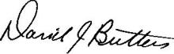

David J. Butters
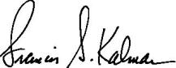

Francis S. Kalman, Chair
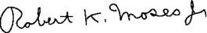

Robert K. Moses, Jr.


Guillermo Ortiz
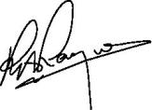

Robert A. Rayne

Weatherford International plc — 2016 Proxy Statement 20

Back to Contents

AGENDA ITEM 3 – ADVISORY APPROVAL OF EXECUTIVE COMPENSATION

The Board of Directors recommends that you vote “FOR” this proposal.

We are asking our shareholders to approve, on an advisory basis, the compensation of our named executive officers (“NEOs”) pursuant to Section 14A of the Exchange Act, as disclosed in this Proxy Statement. While this vote is not binding on our Company, the results of the vote on this proposal will be carefully considered by the Board and the Compensation Committee when making future executive compensation decisions.

We urge you to carefully review the Compensation Discussion and Analysis, or “CD&A,” section in this Proxy Statement, as well as the 2015 Summary Compensation Table, other compensation tables and related narrative discussion, for more information regarding the compensation of our NEOs. As described in those sections, our compensation program is designed and administered to:

- drive and reward strong business performance to create superior value for our shareholders;

- pay for performance, supporting key financial and strategic objectives;

- attract, retain and motivate individuals in key executive positions, while limiting non-performance based entitlements;

- ensure that performance-based compensation supports growth, while managing compensation risk; and

- encourage our executives to focus on both the short-term and long-term performance goals of the Company.

We believe the information in this Proxy Statement demonstrates the successful design and implementation of a compensation program that aligns shareholders’ and management’s interests.

Accordingly, the Board of Directors recommends shareholders approve the program by approving the following resolution:

“RESOLVED, that the shareholders of the Company approve, on an advisory basis, the compensation of the Company’s named executive officers disclosed pursuant to Item 402 of Regulation S-K, including the Executive Compensation section of the Proxy Statement for the Company’s 2016 Annual General Meeting of Shareholders, which includes the Compensation Discussion and Analysis, the 2015 Summary Compensation Table and other executive compensation tables and accompanying narrative discussion.”

At the 2011 annual general meeting, the Board recommended, and the shareholders voted, to conduct advisory, i.e., say-on-pay, votes on an annual basis. The next advisory say-on-pay vote will occur at our 2017 Annual General Meeting.

An ordinary resolution (i.e., a simple majority of the votes cast “For” or “Against,” in person or by proxy, provided a quorum is present) is required to approve this proposal. If you properly give a proxy but do not indicate how you wish to vote, the persons named on the proxy card, or if you do not name your proxy or proxies, the Proxy Holders, will vote for the proposal.

Abstentions and “broker non-votes” will not affect the voting results.

Weatherford International plc — 2016 Proxy Statement 21

Back to Contents

AGENDA ITEM 3

OUR EXECUTIVE OFFICERS

The following persons are our executive officers. Each of our executive officers, other than Mr. Mills, is also a named executive officer. Dr. Duroc-Danner’s biography is on page 8. None of the executive officers or directors has any family relationships with each other. The CD&A that follows covers the compensation of our NEOs.

Name | Age | Position
Bernard J. Duroc-Danner | 62 | Chairman of the Board, President and Chief Executive Officer
Krishna Shivram | 53 | Executive Vice President and Chief Financial Officer
Christina M. Ibrahim | 48 | Executive Vice President, General Counsel and Corporate Secretary
Douglas M. Mills | 41 | Vice President and Chief Accounting Officer
Antony J. Branch | 47 | President—Regional Operations
Lance R. Marklinger | 55 | President—Global Sales

Krishna Shivram was appointed Executive Vice President and Chief Financial Officer in November 2013. Mr. Shivram has over 25 years of financial and operational management experience in the oilfield service industry and previously worked for Schlumberger Ltd. in a variety of roles across the globe. Immediately prior to joining Weatherford, Mr. Shivram served as Vice President and Treasurer of Schlumberger Ltd. since January 2011. Prior to his serving as Vice President and Treasurer, Mr. Shivram held a number of senior management positions at Schlumberger, including Controller - Drilling Group from May 2010 to January 2011, Manager - Mergers and Acquisitions from May 2009 to April 2010 and Controller - Oilfield Services from August 2006 to April 2009. Mr. Shivram is a Chartered Accountant and has experience in financial accounting, income taxes and treasury operations, along with a strong background in corporate finance and mergers and acquisitions.

Christina M. Ibrahim was appointed Executive Vice President, General Counsel and Corporate Secretary in May 2015. Ms. Ibrahim has over 20 years of legal experience primarily in the oilfield services industry. Prior to her appointment, Ms. Ibrahim held a number of senior leadership positions in the legal department of Halliburton Company, including Vice President Commercial – Western Hemisphere, with additional responsibility for the global procurement, employment and real estate practice groups and most recently as Vice President, Chief Commercial Counsel and Corporate Secretary with oversight of mergers and acquisitions, securities, regulatory and governance practice groups. Ms. Ibrahim also served as General Counsel and Chief Compliance Officer for WellDynamics, a Halliburton and Shell joint venture company. Prior to joining Halliburton, Ms. Ibrahim was a litigation attorney with the law firm Wickliff & Hall, PC.

Douglas M. Mills was appointed Vice President and Chief Accounting Officer in June 2013 and serves as the Company’s principal accounting officer. Mr. Mills joined Weatherford in 2003 and served in various financial reporting capacities, including Vice President of Corporate Accounting since 2011, and filled other corporate and regional controller positions of increasing responsibility while at Weatherford. Mr. Mills has over five years of public accounting experience with the firms of Ernst & Young and Arthur Andersen. He is a certified public accountant and holds a M.P.A./B.B.A. from the University of Texas.

Antony J. Branch was appointed President — Regional Operations in February of 2016. Prior to this appointment, he served as President—Global Product Lines and before that, he served as Vice President – Europe, Africa and Middle East. Mr. Branch joined the Company in 2005, when Precision Drilling Corporation was acquired by Weatherford and where he held numerous management positions. Prior to joining the Company, Mr. Branch held management positions with Precision Drilling and Sperry — Sun Drilling Services. Mr. Branch holds a degree in Petroleum Geology from the University of Aberdeen.

Lance R. Marklinger was appointed President—Global Sales in February of 2016. Prior to this appointment, he served as President Eastern Hemisphere in January 2015 and before that, he served as Vice President –Well Construction and Completion. Mr. Marklinger joined the Company in January 2010 and was appointed Vice President - Russia Region in November 2010. Prior to joining Weatherford, Mr. Marklinger was employed by Schlumberger Ltd. from July 1983 to January 2010 in various management positions, including Vice President of Marketing of PetroAlliance, Vice President of Sales and Marketing US Land, and Operations Manager Russia. He is a graduate of the Southern Alberta Institute of Technology with an associate’s degree in Petroleum Engineering.

Weatherford International plc — 2016 Proxy Statement 22

Back to Contents

COMPENSATION DISCUSSION AND ANALYSIS

This Compensation Discussion and Analysis (“CD&A”) is designed to provide shareholders with an understanding of our compensation philosophy, core principles, and decision making process. It explains the compensation-related actions taken with respect to our NEOs who are identified in the 2015 Summary Compensation Table. Details regarding the compensation we paid to the NEOs for 2015 are found in the tables and narrative which follows them.

EXECUTIVE SUMMARY

COMPENSATION PRINCIPLES AND BEST PRACTICES

Our compensation program is designed to reward our NEOs for the achievement of strategic and operational goals and increases in shareholder value, while at the same time avoiding the encouragement of unnecessary or excessive risk-taking. We believe our program supports these goals, avoids objectionable pay practices, and engages in sound governance practices with respect to executive compensation.

WHAT WE DO

- Pay for Performance. We pay annual cash bonuses to NEOs only on the achievement of pre-determined and measurable objectives that benefit our Company and shareholders.

- Share Ownership Guidelines. Each of our NEOs must hold the equity equivalent in value of three times (or six times in the case of the CEO) their base salary.

- Clawbacks. We can recover performance-based compensation, both cash and equity, paid to executives but subsequently determined not to have been earned because financial results are restated, including if an officer has engaged in fraud, willful misconduct or gross negligence that has directly caused or contributed to the need for a material restatement of our financial statements.

- Double-Trigger Vesting. The change of control provisions under our executives' employment or change of control agreements, as applicable, are “double-trigger” arrangements with respect to compensation other than equity awards.

- Independent Compensation Committee and Compensation Consultant. Only independent directors serve on the Compensation Committee. Additionally, the Compensation Committee engages an independent compensation consultant and meets with the consultant in executive sessions.

- Annual Risk Assessment. We conduct an annual comprehensive risk analysis of our executive compensation program with our independent compensation consultant to ensure that our program does not encourage inappropriate risk-taking. We also annually review a calculation of the shareholder value transfer and “burn rate” resulting from equity grants to ensure they are not excessive.

- Reward Future Performance. Annual restricted share and performance awards vest over a three-year period and reward for sustained future performance rather than past behavior. Performance awards do not vest if our share price does not increase.

- Peer Group Comparison. We compare our executives’ total compensation to a consistent peer group for market comparable data. We evaluate that peer group annually to ensure that it remains appropriate, and we add or remove peers only where clearly warranted, as we did in late 2015.

WHAT WE DO NOT DO

- Discretionary Bonuses. We do not pay discretionary bonuses except in the case of extraordinary achievement or sign-on bonuses.

- Guaranteed Bonuses. We do not pay guaranteed bonuses and we do not pay multi-year bonuses.

- Automatic Base Salary Increases. Our NEOs base salaries are reviewed annually and our CEO’s and CFO’s salaries were not increased in 2014 or 2015. No NEO has received a salary increase in 2016.

- Tax Gross Ups. We do not provide tax gross-ups related to Section 280G or Section 409A of the Code.

- Hedging Company Stock. We prohibit our executives, as well as directors, from engaging in hedging or derivative transactions involving our shares.

- Employment Agreements. Effective as of March 2015, we stopped entering into new employment agreements with any existing or future executive officers.

Weatherford International plc — 2016 Proxy Statement 23

Back to Contents

COMPENSATION DISCUSSION AND ANALYSIS

2015 PERFORMANCE HIGHLIGHTS AND OUR COMPANY’S FUTURE

The severity and length of the energy down cycle has challenged our entire industry, including both our clients and our peers. In this environment, our performance drivers are centered on discipline, discernment and focus. The Company was ready for a prolonged period of low oil and gas prices and has adjusted quickly to take advantage of the current environment. In 2015, we fundamentally reduced our cost structure; meanwhile, we also improved service quality, enhanced efficiency and continued to cultivate a performance-driven culture. Our focus remains steadfast on core, cost and cash. Our activities focus on our core portfolio of high quality and market-leading businesses, centered on lowering our cost structure through down cycles and implementing capital allocation and cash generation as company-wide disciplines. Our primary 2015 performance highlights include:

- Completing cost reduction activities and reaching targets, with annualized cost savings of $1.4 billion and a permanent reduction in cost structure of approximately $750 million;

- Realizing positive full year free cash flow from operations of $129 million, our first positive year since 2010;

- Reducing our net debt below $7 billion for the first time since March 2011;

- Attaining industry leading decrementals (i.e. the relative decrease in operating income to the decrease in revenue) of 28%;

- Reducing our employee support ratio for our core businesses from 59% in the beginning of 2014 to 39% at year-end 2015;

- Disciplining our use of capital by reducing our capital expenditures by 53% compared to 2014; and

- Accomplishing the best safety performance record in the Company's history.

Despite the downturn, our Company has demonstrated its ability to successfully manage its assets and balance sheet, while controlling costs.

We believe these and other accomplishments provide a clear and measurable basis for our executive compensation decisions.
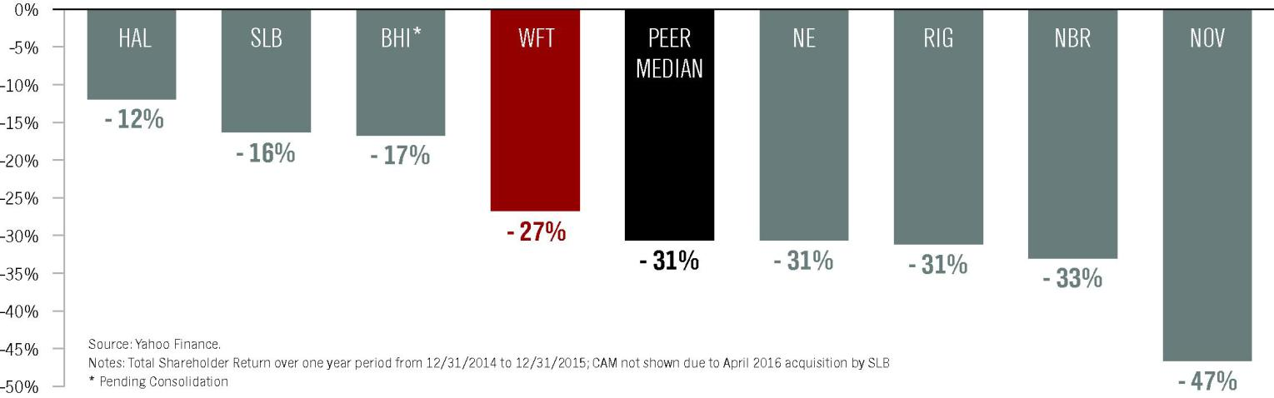

We have excluded Cameron International Corporation from the information above, as it merged with Schlumberger Limited in April 2016.

INDUSTRY LANDSCAPE

For the past year, Weatherford’s stock performance has remained closely linked to the price of oil with a 94% correlation. As of April 1, 2016, the U.S. rig count reached its lowest point in recorded history with 450 rigs operating in the country, according to the Baker Hughes Weekly Rig Count report, a recognized industry source. In less than two years, the downturn in global activity has led to a 53% decline in the capitalization of companies in our industry; the 53 publicly traded oilfield services companies that had a pre-downturn capitalization of $550 billion at June 2014 were valued at a collective market capitalization of less than $260 billion as of April 1, 2016.

Weatherford International plc — 2016 Proxy Statement 24

Back to Contents

COMPENSATION DISCUSSION AND ANALYSIS

This industry information is further detailed below:
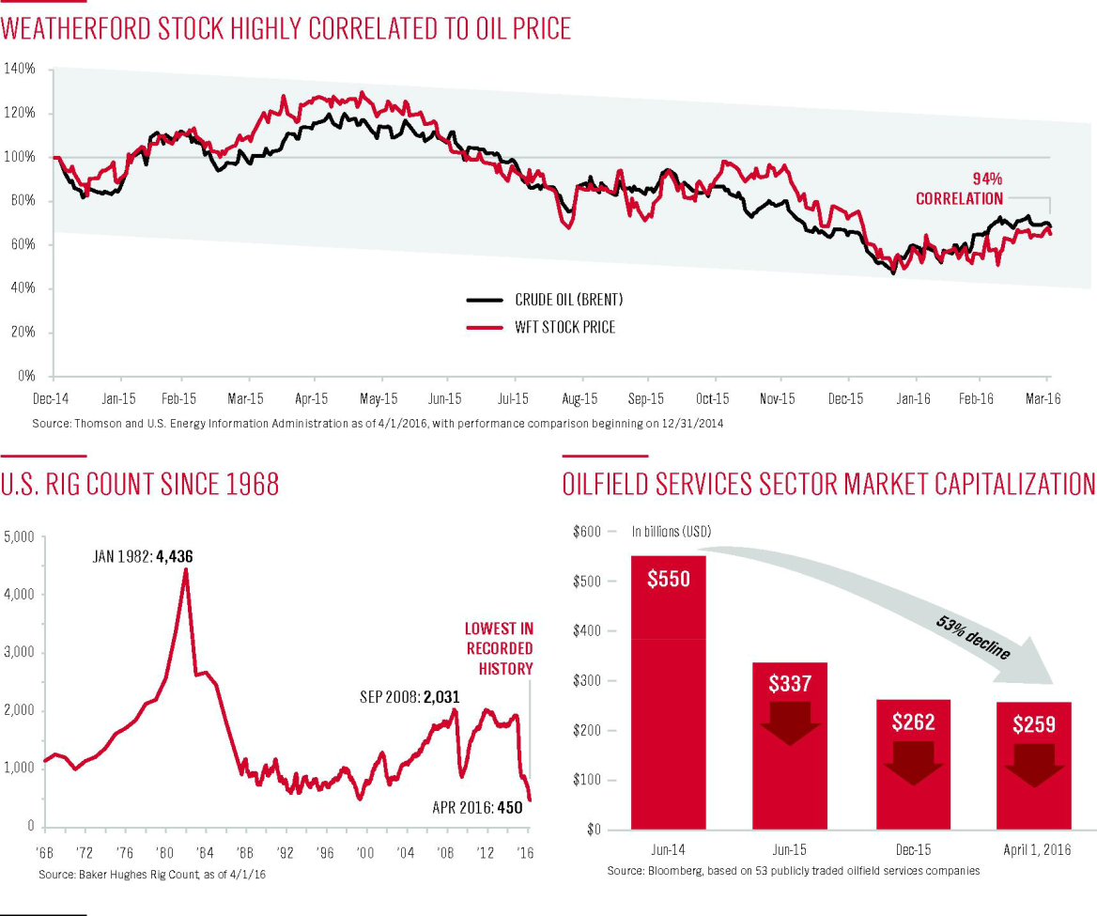

OUR RESPONSE TO THE INDUSTRY DOWN CYCLE

We strive to structure our executive compensation program to align pay with performance. In 2014, the Company embarked on a transformational path to focus on core businesses, lower cost structure and improve free cash flow generation. We achieved substantially all of our 2014 key objectives, paving the way for greater long-term shareholder value.

In early 2015, the Compensation Committee set forth key 2015 performance metrics to ensure the Company continued to build upon its transformational progress. During 2015, Weatherford swiftly adapted to a rapidly changing industrial landscape, one which resulted in the harshest and most prolonged downturn that our industry has ever faced. Despite this significant headwind, Weatherford continues to successfully navigate the down cycle with an unyielding focus on capital discipline, cash generation and improved market position.

Most recently, in response to the extended industry challenges, the Board, CEO and Company leadership initiated the following measures to address the current market environment and demonstrate its leadership.
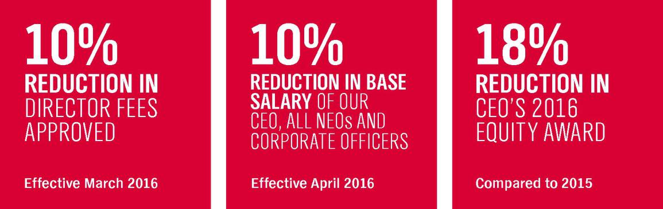

Weatherford International plc — 2016 Proxy Statement 25

Back to Contents

COMPENSATION DISCUSSION AND ANALYSIS

Moving forward in 2016, we will continue to focus on our fundamentals and to build on our operating progress with more efficiency and strict cash discipline. Near term, we are addressing our market and client needs, deemphasizing or exiting markets of low client activity, while high-grading our product line strength, infrastructure and technological leadership. Long-term, our focus remains steadfast on delivering sustainable shareholder value.

KEY ELEMENTS OF EXECUTIVE COMPENSATION

Weatherford’s compensation program is designed to reward executives for the achievement of strategic and operational goals as well as increased shareholder value. Our executive officers receive their maximum reward opportunity only if Weatherford performs exceptionally well, and our shareholders benefit from that performance. The primary elements of total compensation are base salary, annual non-equity (cash) incentives and long-term equity awards, consisting of both performance units and restricted share units. We also provide our NEOs certain retirement and benefit plans, as well as limited perquisites, which are described in detail under “Elements of our Executive Compensation Program” beginning on page 30. The following tables summarize the primary elements of our NEOs’ compensation package.

Compensation Element | Objective | Key Features | Performance-Based
Base Salary | Provides regular income at reasonable, | Reviewed annually and subject to adjustment | No, but increases are not guaranteed
 | competitive levels, reflecting scope of | based on individual performance, experience,
 | responsibilities, job characteristics, leadership | leadership and market factors
 | skills and experience
Annual Cash Incentive | Rewards contributions to the achievement of | Compensation Committee establishes | Yes, pays out based on achievement of
 | annual targets and individual performance; | performance measures to align performance | measurable pre-established goals; will not pay
 | focuses attention on key operational, functional | relative to goals, ultimately driving shareholder | out if goals are not met
 | and financial measures | value
Performance Units (Long- | Correlates realized pay with increases in | In periods of low shareholder return, executives | Yes, pays out only based on increased
Term Equity Awards) | shareholder value in absolute terms over the | realize little or no value; in periods of high | shareholder value; may not vest depending
 | long term | shareholder return, executives may realize | upon shareholder return
 |  | substantial value

Restricted Share Units (Long- Incentivizes management contributions to long-

Term Equity Awards) term increases in shareholder value; helps to retain executives in the competitive energy market

A portion of executive compensation is paid in equity, and value is realized based on future share price; provides a direct correlation of realized pay to changes in shareholder value

Yes, value increases or decreases in correlation to share price

PAY FOR PERFORMANCE AND 2016 UPDATES

BASE SALARY

No increases to base salaries were made for our CEO or CFO from 2013 to 2016 and no NEO received a salary increase in 2016. Additionally, while it is unusual for our Compensation Committee to make mid-year adjustments to base salaries, in light of the extreme client pricing pressures, lower activity and continuing energy industry decline, in March of 2016, all of our NEOs' base salaries were reduced by 10%, effective April 1, 2016. Such reduction was undertaken to strategically manage the Company’s costs. Base salaries will be reevaluated by the Compensation Committee as the year progresses to determine if further changes are warranted.

LONG-TERM EQUITY AWARDS

We structure our executive compensation program to align pay with performance. For example, our average of the closing stock prices as of each trading day in December 2015 was $9.12. As this price did not exceed the performance goals under the terms of 2014 and 2015 performance awards for our executive officers, no shares were issued in settlement of the 1/3 tranche of performance units awarded in 2014 that was eligible to vest based on 2015 performance nor the 1/3 tranche of performance units awarded in 2015 that was eligible to vest based on 2015 performance. As the Company has continued to be affected by the industry downturn, our current NEOs have not realized any value from performance units in the past five years, illustrating the Compensation Committees rigorous focus on requiring improved performance, as illustrated below. Additionally, in light of the current economic environment, the total value of the 2016 equity awards granted by the Compensation Committee to our CEO in January of 2016 decreased by approximately 18% compared to the award made in January 2015.

Weatherford International plc — 2016 Proxy Statement 26

Back to Contents

COMPENSATION DISCUSSION AND ANALYSIS

ANNUAL CASH INCENTIVES

Annual Cash Incentives. For 2015, the Committee evaluated the Company’s ongoing performance and adopted metrics that were designed to reflect the Company’s goals and focus on the key strategies and objectives summarized below. These metrics were used in our NEOs non-equity (cash) incentive awards as further described beginning on page 31. Weatherford delivered as indicated below, with total payout below target for all NEOs other than Mrs. Ibrahim.
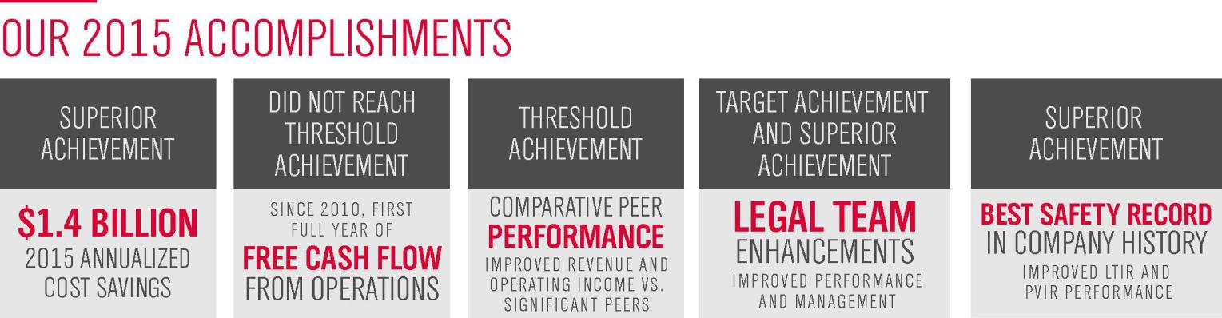

Cost Savings. In recent years, we have lowered our operating cost structure and the manner in which we run our Company resulting in savings that are both permanent and structural. In 2015, we continued to flatten our organizational structure, lower our support ratio and reduce our headcount, in addition to closing or consolidating facilities. The combination of these actions resulted in annualized cost savings of $1.4 billion in 2015 thereby achieving superior payout.

Free Cash Flow. While our free cash flow generation was below threshold, 2015 represented the first full year of free cash flow generation since 2010. This was achieved in the face of the most challenging year in our industry’s history.

Comparative Peer Performance. The Company improved revenue and operating income, comparatively versus a Significant Peer, but did not exceed the performance of our other two Significant Peers.

Legal Metrics (Mrs. Ibrahim). Mrs. Ibrahim achieved target or above on her functional objectives, as further described on page 34.

Best Historical Safety Record. Our vision is to be a company that is incident free, delivers on our promises, and leaves the environments in which we operate better than we found them. We have the upmost concern for the wellbeing of our employees; they are the cornerstone of our business. We develop work processes, invest in employee training, and provide proper equipment to ensure they return home safely at the end of each day. We are proud to say that 2015 was our safest year yet. As safety is such an integral part of our culture, we included this initiative as part of our Non-Equity Cash Incentive objectives, with an equal split for lost-time injury rate (“LTIR”) and preventable vehicle injury rate (“PVIR”) as described in this Proxy Statement. The charts below highlight our recent performance.
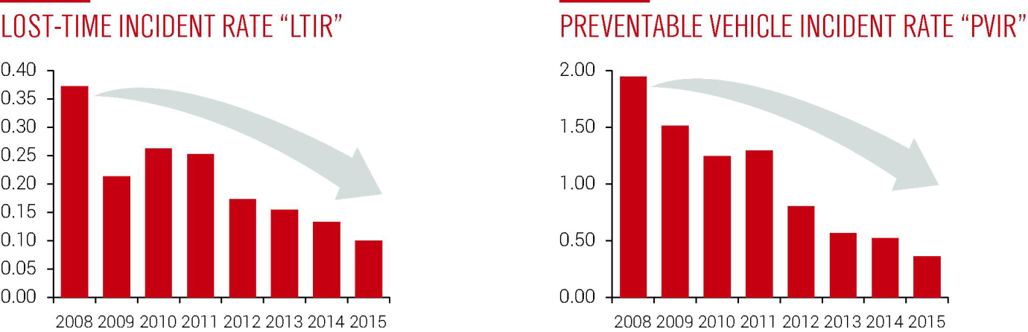

Weatherford International plc — 2016 Proxy Statement 27

Back to Contents

COMPENSATION DISCUSSION AND ANALYSIS

REPORTED AND REALIZED COMPENSATION

To further illustrate our pay for performance, below is our CEO’s total compensation, for the periods indicated, as set forth in the 2015 Summary Compensation Table of this Proxy Statement and prior proxy statements, compared to the total amount of compensation realized by our CEO during such periods.

The Realized Compensation set forth below includes long term incentive awards (restricted share units and performance units), only to the extent they were “realized”, i.e., to the extent they vested (or restrictions lapsed) during the years described. The value of vested stock is included based on closing price on the date of vest which, for our restricted share units, differs from value at the date of grant, and, for our performance units, is zero, as our performance units did not vest based on not reaching performance targets included in such performance units. Performance units awarded to our CEO since 2010 have not paid out, and current performance units cycles are tracking at $0, meaning that over the past five years our CEO has not realized the total compensation reported in the 2015 Summary Compensation Table.

REPORTED COMPENSATION VS. REALIZED COMPENSATION

As shown below, for the period 2013 to 2015 the CEO’s total realized compensation was 47% lower than the amount presented in the Summary Compensation Table. For 2015, the CEO’s total realized compensation was 36% lower than the amount presented in the Summary Compensation Table.
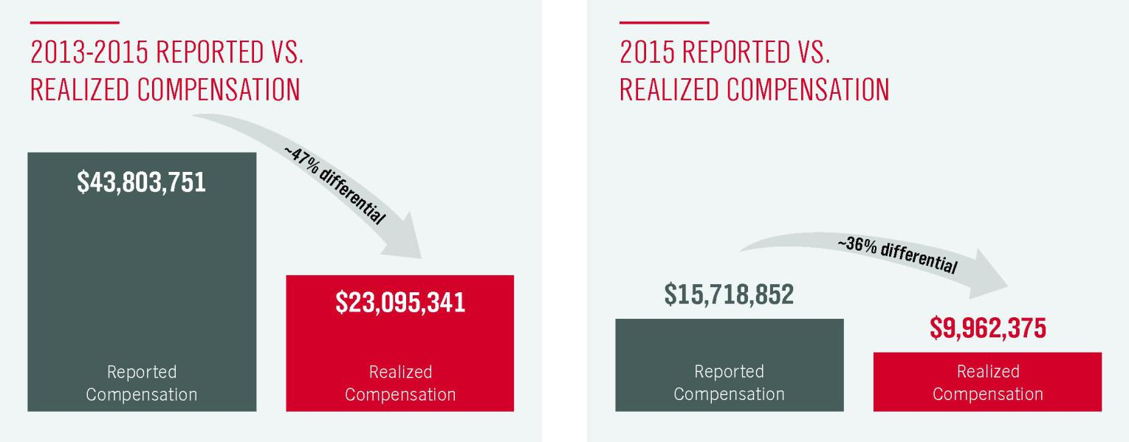

Reported Compensation is as set forth in the Summary Compensation Table in this Proxy Statement.

Realized Compensation includes long-term incentive awards (e.g., RSUs and PUs), only to the extent they were “realized”, i.e. to the extent they vested (or restrictions lapsed) during the years described. Value of vested stock is then based on the closing price on the date of vest which, for our long-term incentive awards, differs from the value at the date of grant. The 2013-2015 performance awards did not vest and the NEOs realized zero value for these awards. Additionally, current awards cycles are tracking below threshold.

Weatherford International plc — 2016 Proxy Statement 28

Back to Contents

COMPENSATION DISCUSSION AND ANALYSIS

Peer Comparison. Our executive compensation program is structured to align pay with performance. The chart below illustrates our CEO's total compensation for the years 2013-2015 and our total shareholder return for the three-year period ended December 31, 2015, measured relative to our 2015 peers, excluding Cameron International Corporation, which merged with Schlumberger Limited in April 2016.
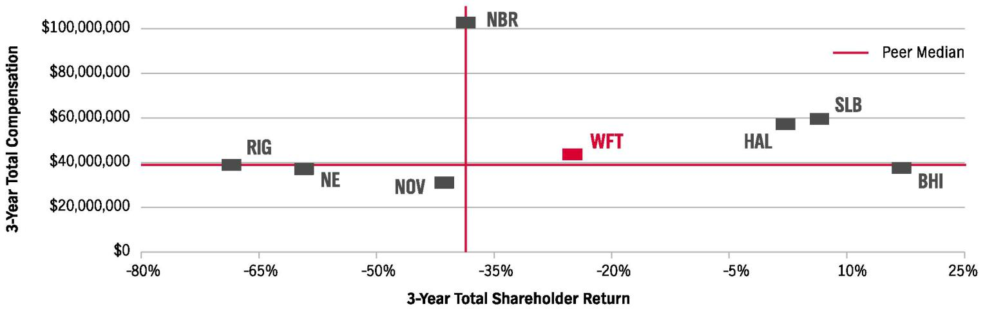

3-Year Total Compensation is the sum of base salary, annual incentives, bonuses, long-term incentive awards and all other compensation paid (perquisites and change in pension included) for the years 2013-2015 for our Chief Executive Officer and for the chief executive officer of each of our peers as reported in their respective publicly available proxy statements. Compensation information for Nabors Industries Ltd. (NBR) is for the years 2012-2014, which is the latest publicly available information.

3-Year Total Shareholder Return is the percentage increase (or decrease) in stock price for the three years ended December 31, 2015, adjusted for cash dividends paid.

SHAREHOLDER OUTREACH AND RESULTS

At our 2015 annual general meeting, as a result of ongoing and mutually beneficial dialogues with our shareholders to align pay with performance, our shareholders expressed a high level of support for our compensation policies and pay practices. At that meeting, over 88% of our outstanding shares were voted and all of our agenda items were approved. Within those approvals, over 91% of shares voted in respect of our 2015 “say-on-pay” agenda item voted in favor of such item. We are grateful for the overwhelming support of our shareholders. We continue to engage in regular and ongoing dialogue with our investors regarding our performance and compensation decisions. Members of our executive management team, including our Chief Financial Officer, our General Counsel and Corporate Secretary, and our Vice President of Investor Relations, Corporate Marketing and Communications, regularly meet (telephonically or in person) with shareholders and the results of our discussions are reported to the Board as well as to the applicable Committees, including our Compensation Committee.

PEER GROUP CHANGES

In November of 2014, two of our largest peers, Halliburton and Baker Hughes, announced their plans to merge. In August of 2015, Schlumberger, our largest peer, announced it was acquiring Cameron International Corp, another peer. In connection with these announcements, the expected consolidation of our peer group, and our annual peer evaluation process, in the fourth quarter of 2015, our Compensation Committee established a new peer group for market comparisons and benchmarking. The new group, consisting of 15 companies following both mergers, replaces our prior group which had been used since 2011 and was last used for establishing the 2015 target compensation during the annual decision making process. The revised peer group contains peers that are similar to our Company under several metrics as well as peers with whom we compete for talent. See page 41 for additional information.

COMPENSATION PHILOSOPHY AND OBJECTIVES

The Compensation Committee follows a pay for performance philosophy in our executive compensation structure. The Committee’s objective is to provide compensation to our executive officers at a level and in a manner that is intended to maximize shareholder value and be market competitive. Additionally, the short-term and long-term interests of our executive officers should be aligned with those of our shareholders. Our programs are designed to:

- drive and reward strong business performance to create superior value for our shareholders;

Weatherford International plc — 2016 Proxy Statement 29

Back to Contents

COMPENSATION DISCUSSION AND ANALYSIS

- support key financial and strategic objectives through pay for performance;

- attract, retain and motivate individuals in key executive positions, while limiting non-performance based entitlements;

- ensure performance-based compensation supports growth, while managing compensation risk; and

- require our executives to focus on both the short-term and long-term performance goals of the Company.

For 2015, the Committee approved base salary, annual performance compensation and long-term incentive compensation for each NEO that was intended to be competitive with our peer group. However, in setting the compensation of our NEOs, the Committee also took into consideration historical and individual circumstances. These include tenure and experience, individual performance, anticipated future contributions, retention factors, including apparent career alternatives for each individual and the availability of comparable data for certain positions.

The Committee believes a majority of executive compensation should be “at risk” — that is, the ultimate, realized value of the compensation is tied to the Company’s financial and equity performance. During periods when our financial performance meets or exceeds established objectives, we believe that NEOs should be rewarded under the incentive compensation programs for their efforts in achieving our goals. Likewise, when our performance does not meet the established goals, incentive compensation may be reduced or eliminated.

ELEMENTS OF OUR EXECUTIVE COMPENSATION PROGRAM

Our compensation program is designed to reward our NEOs for the achievement of strategic and operational goals as well as increased shareholder value, while avoiding unnecessary or excessive risk-taking. Below is a detailed discussion and analysis of each component of our executive compensation for our NEOs for 2015. All information should be read in conjunction with our 2015 Summary Compensation Table on page 44.
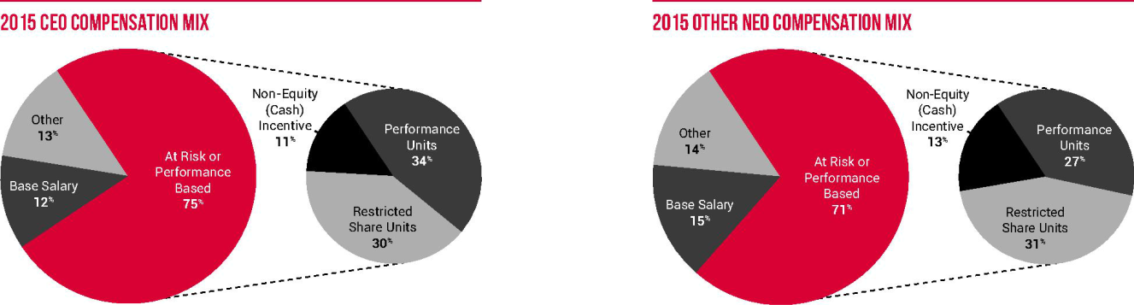

Percentages are based on compensation information for our current NEOs as set forth in the 2015 Summary Compensation Table on page 44, excluding any sign-on bonus. Performance Units and Restricted Share Units are measured using the grant date fair value as set forth in the Grants of Plan-Based Awards table on page 46.

BASE SALARY

Base salary provides a fixed level of compensation to the executive, representative of his or her skills, responsibilities and experience. Base salaries for our executive officers are reviewed annually. Proposed increases to base salaries are reviewed by the Compensation Committee following recommendations from Dr. Duroc-Danner (excluding his own base salary). The Committee does not rely on predetermined formulas or criteria when evaluating executive base salaries, but considers comparable market data provided by Longnecker & Associates (“Longnecker”). The Committee also considers individual contributions, retention and succession planning concerns in setting base salaries.

The table below shows the annual base salaries of the current NEOs effective after adjustments for the applicable year. Where adjustments were made during the year or where an executive officer joined mid-year, these amounts differ than the actual amount paid for the entire year. See the Summary Compensation Table on page 44 for the actual amounts paid. As noted above, base salaries for 2016 were set in the first quarter of 2016; however, all of our NEOs' base salaries were reduced by 10%, to the amount shown below, effective April 1, 2016.

Executive | 2014 Salary | 2015 Salary | 2016 Salary
Dr. Duroc-Danner | CHF1,760,000 | CHF1,760,000 | CHF1,584,000
Mr. Shivram | $750,000 | $750,000 | $675,000
Mrs. Ibrahim (a) | –– | $625,000 | $562,500

Weatherford International plc — 2016 Proxy Statement 30

Back to Contents

COMPENSATION DISCUSSION AND ANALYSIS

Executive | 2014 Salary | 2015 Salary | 2016 Salary
Mr. Branch(b) | – | $450,000 | $405,000
Mr. Marklinger(b) | – | $450,000 | $405,000

- Information for 2014 is not presented for Mrs. Ibrahim, who joined the Company in 2015.

- Information for 2014 is not presented for Messrs. Branch and Marklinger, as neither was an NEO until 2015.

Dr. Duroc-Danner’s base salary has not increased in six years. While his salary is higher than the median salary of CEOs of our peers, the Committee believes his salary is appropriate in light of his unique experience, execution of his 20-plus year vision to create (from scratch and through acquisition) a leading oilfield services Company and his resulting in-depth understanding of our industry— having led the Company for 29 years—and considering alternative career opportunities that could be available to him. None of the CEOs of our peers have this level of experience, tenure, or loyalty.

Mr. Shivram’s salary was determined when he joined the Company in November of 2013 based on market factors, his cross-functional experience, his extraordinarily relevant background and its importance to Weatherford during the Company’s critical drive to core, cost and cash, and value he was giving up at his previous employer. His salary was not increased in 2014 or 2015 and has been decreased in 2016.

Mrs. Ibrahim’s salary was determined when she joined the Company in May of 2015 based on market factors, her significant leadership, legal, and industry experience, the importance of the general counsel role to Weatherford, the departure of the prior general counsel, and the value Mrs. Ibrahim was giving up by leaving her previous employer. Her salary has been decreased in 2016.

Messrs. Branch and Marklinger each became an NEO in 2015. Each of their salaries was set based on market factors, new and increased responsibilities given to each of them in 2015, and the total personal contributions they have made to the Company. Their respective salaries were decreased in 2016.

While it is unusual for our Compensation Committee to make mid-year adjustments to base salaries, in light of the extreme client pricing pressures, lower activity and continuing energy industry decline, in March of 2016, all of our NEOs' base salaries were reduced by 10%, effective April 1, 2016. Such reduction was undertaken to strategically manage the Company’s costs. Base salaries will be reevaluated by the Compensation Committee as the year progresses to determine if further changes are warranted.

SIGN-ON BONUSES

While our Company does not have policy of paying sign-on bonuses, the Company will consider one-time sign-on bonuses to induce certain employees (including executives) to join the Company.

Mrs. Ibrahim was given a one-time sign-on cash payment when she joined the Company in 2015, to replace the value of bonuses and unvested equity being forfeited at her previous employer.

ANNUAL CASH INCENTIVE COMPENSATION

Our annual cash incentive compensation is generally structured to deliver payouts in line with market multiples when performance targets are achieved or exceeded. The Committee annually establishes the terms of any awards under our Executive Non-Equity Incentive Compensation Plan (the “ICP”), including the financial metrics and goals for each award, during the first quarter. While the ICP awards for NEOs are determined primarily based on predetermined formulaic financial metrics aligned with the Company’s strategic and financial goals, an executive’s individual performance or specific function and functional objectives may also be taken into account when the Committee establishes the performance metrics.

Weatherford International plc — 2016 Proxy Statement 31

Back to Contents

COMPENSATION DISCUSSION AND ANALYSIS

2015 Target Goals

For each metric under the ICP, the Committee establishes objective goals at three levels: threshold, target and superior, as further described below, and expressed as a percentage of base salary in effect at the end of the plan year, with a percentage determined for achievement of threshold, target or superior level. If our results fall between the threshold and target goal levels or between the target and superior goal levels (other than for CPM awards (described on page 33)), the award payment will be determined by linear interpolation to derive the percentage of salary that will be paid in respect of such award.
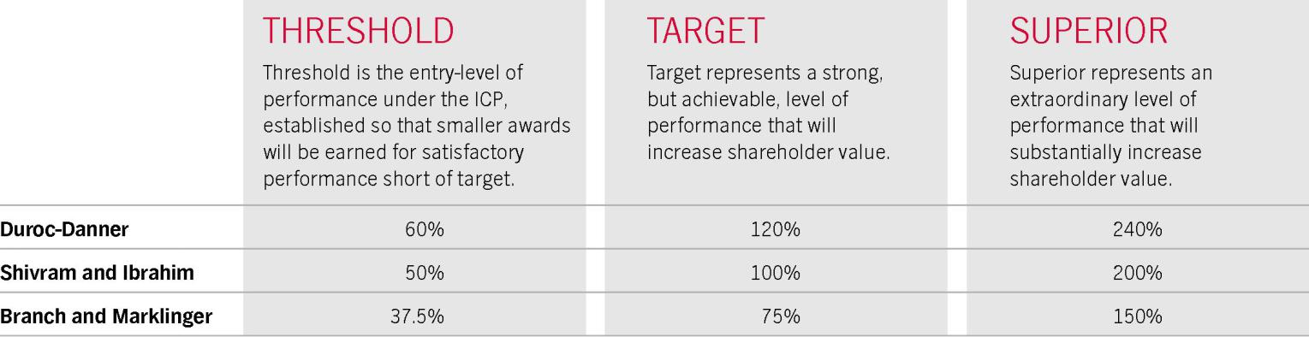

2015 Objectives and Metrics

To set the objectives for 2015, the Committee evaluated the Company’s ongoing performance, market conditions and officer performance and adopted metrics to ensure all of the Company’s key focus areas were included in the objectives for its executive officer group. The 2015 performance goals were designed to incentivize executive officers as follows:

- improve the Company’s performance as compared to our key oilfield service company peers: Schlumberger, Halliburton and Baker Hughes, or our “Significant Peers,” with a focus on both increased market share and profitability;

- respond to the cyclical downturn in the oil and gas industry, with a focus on cost reduction and free cash flow;

- maintain focus on safety, even in a downturn, as it is of paramount importance to our Company, our employees and our clients; and

- with respect to Mrs. Ibrahim, and in light of the significant disruption in legal and compliance leadership over the past two years, her goals are focused on improving management of the legal function by increasing performance related to litigation matters, strengthening policies and contract management and enhancing talent within the legal group.

The targets are also tied to internal budgets and expectations and require incremental improvement and continued savings. Given that the Company had achieved “superior” results with respect to net debt reduction in the prior year, the Committee did not consider it appropriate to include this metric again in 2015. Additionally, with an increased focus on market share gains, the Committee found it more appropriate to include the new CPM metric (described below), with greater weight to evidence the Company’s primary performance focus, rather than to continue to include an earnings per share metric. The Committee believes the targets set are rigorous, appropriate for our market, the shifting industry landscape, and are at or above market expectations.

Weatherford International plc — 2016 Proxy Statement 32

Back to Contents

COMPENSATION DISCUSSION AND ANALYSIS

The objectives are summarized as follows:
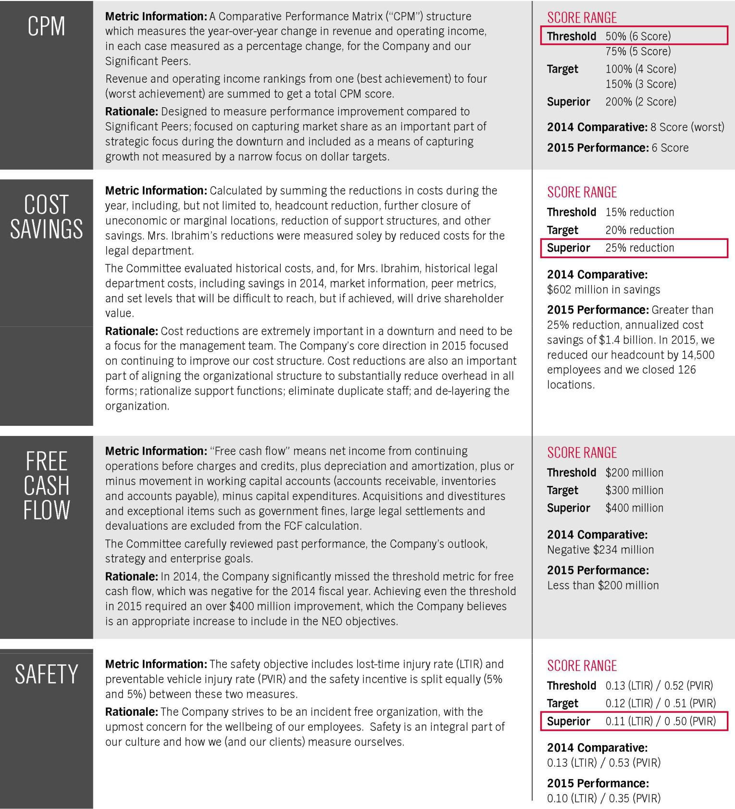

Weatherford International plc — 2016 Proxy Statement 33

Back to Contents

COMPENSATION DISCUSSION AND ANALYSIS
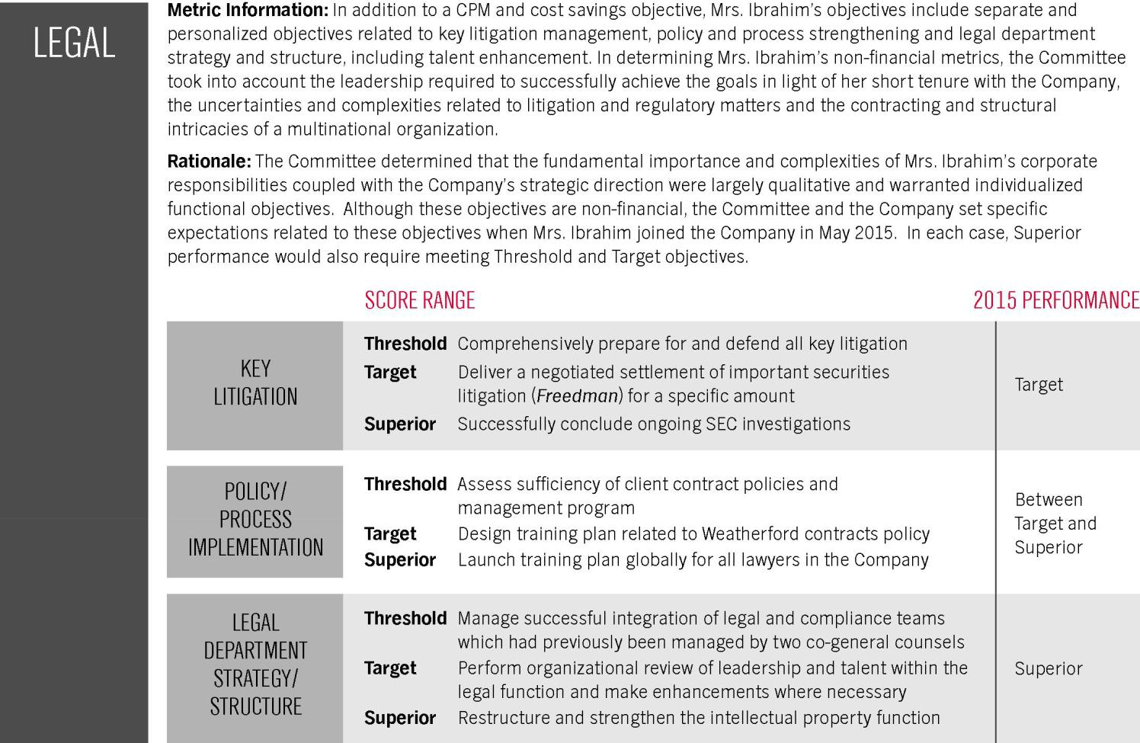

To calculate the cash incentive amount, the following formulas were used, including the performance achieved as set forth below:

Weatherford International plc — 2016 Proxy Statement 34

Back to Contents

COMPENSATION DISCUSSION AND ANALYSIS
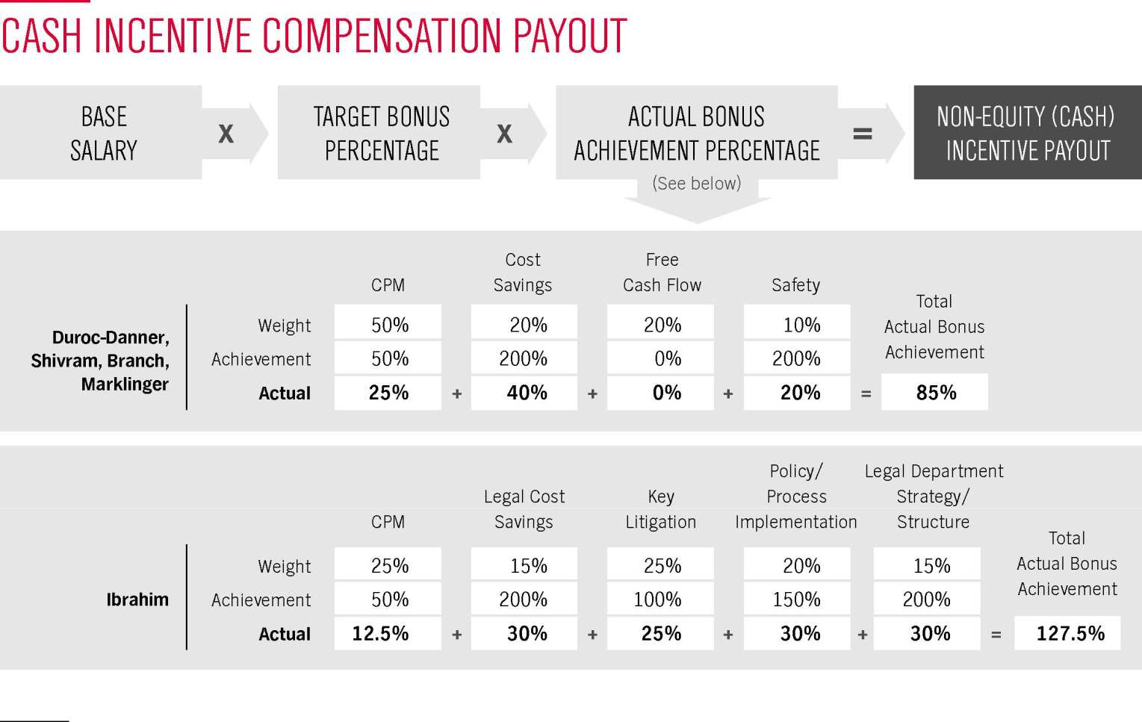

Other Information Regarding Cash Incentive Metrics

- CPM Peers. The Committee determined the CPM should be a significant portion of the NEOs' objectives due to the extremely competitive environment among our peers and need to reward year-over-year performance improvements. While the Committee evaluates a larger group of peers when determining compensation for our NEOs (as described on page 41), the Committee believes the Significant Peers are most relevant and appropriate competitors for measuring the 50% (25% for Mrs. Ibrahim) component of non-equity (cash) compensation and evaluating the Company's ability to capture market share. Our clients (whether independent or national oil companies), the financial sector, and our investor community are most interested in our performance against these Significant Peers. It is with these companies that Weatherford shares the greatest similarity in business purpose within the oilfield services sector, has the most similar client base and competes most fervently for talent. These Significant Peers are all integrated oilfield service companies with truly multi-international footprints against which Weatherford's performance is measured by industry analysts. To include other companies outside of this Significant Peer group would include oil and gas operators and pure oil field manufacturers, against which our performance would be most difficult to measure accurately and with which we do not have the same symbiotic business purpose or strategic alignment. Measuring non-equity (cash) compensation against this Significant Peer group will be more rigorous than if we were to expand the population, especially given the Company’s last-place standing in the CPM metric against the Significant Peers when this metric was implemented. Proportional downward adjustments to the total CPM score would have been made if Baker Hughes and Halliburton merger had occurred in 2015.

- CPM Measurement and Results. The CPM component pieces were measured by calculating year-over-year changes in the Company's revenue and operating income against Significant Peers. The Company’s score of “6” was a result of a “3” score for revenue and a “3” score for operating income. Using publicly available information, the Company’s year-over-year revenue, adjusted for the impact of divested businesses in 2014, declined 33.4%, the third worst among our Significant Peers, as Baker Hughes was lower and Schlumberger and Halliburton were higher. The Company’s year-over-year operating income, adjusted for the impact of divested businesses in 2014, decreased by 74.3%, again the third worst among our Significant Peers, as Baker Hughes had a larger decline in operating income year-over-year, and Schlumberger’s and Halliburton’s operating income decreases were less.
- Cost Savings, Free Cash Flow and Safety Metrics. The Committee believes that these metrics are appropriate representations of and incentives towards the relevant objectives of cost reduction, free cash flow generation and safety, and that the weighting assigned to each is appropriate. The targets are also tied to internal budgets and expectations and require incremental improvement and continued savings with respect to non-CPM score objectives. The Committee believes these targets are rigorous, appropriate for our market, the shifting industry landscape, and are at or above market expectations.

Weatherford International plc — 2016 Proxy Statement 35

Back to Contents

COMPENSATION DISCUSSION AND ANALYSIS

- Payment Timing. Award payments under the ICP are made after the public release of our year-end financial results for the applicable year, and after determination of the award payments by the Committee. No award payment is made until the calculation of the payment award is approved by the Committee. Plan awards earned for a year generally are paid in February or March of the following year. Awards are paid in cash in the currency in which the recipient is ordinarily paid.
- Adjustments. In the event of unforeseen developments, the Committee may determine that modifying the ICP, the goals or the potential award payments would provide more appropriate incentives for executives. The Committee does not intend to exercise this discretion except in extraordinary circumstances and did not exercise this discretion in 2015. However, the Committee has reserved the right, in its sole discretion, to adjust the performance goals under the ICP to reflect, (1) a change in the business, operations, corporate or capital structure, (2) a change in the manner in which business is conducted or (3) any other material change or event which will impact one or more performance goals in a manner the Committee did not intend. The Committee does not currently intend to increase the potential payment amounts in 2016, even if an adjustment to the metrics is warranted.

LONG-TERM EQUITY INCENTIVE COMPENSATION

Long-term equity incentives are designed to motivate management to enable the Company to achieve long-term performance improvements and serve to link a significant portion of compensation to shareholder returns. In March 2010, the Committee approved the 2010 Omnibus Incentive Plan (which was approved by our shareholders at our annual general meeting on June 23, 2010 and amended in 2012, 2014 and 2015), under which the Company may issue awards of long-term equity compensation from time to time consistent with the objectives and philosophy of our compensation programs. We generally grant long-term equity awards annually in the first quarter to incentivize future performance.

Forms of Long-term Incentives

Long-term incentive awards provide our NEOs with a benefit that increases only when the value of our shares increases, which aligns their interests with increasing shareholder value. Long-term incentives are equity-based and include restricted share units (“RSUs”) and performance units (“PUs”). In determining the form or forms of award grants, the Committee considers, among other factors, the seniority of the officer and the ability of the officer to impact our success, as well as the appropriateness of a particular security to the individual executive.

- RSUs motivate our NEOs to strive for share price appreciation, as they are granted in an amount based on the closing price on the date of grant, and the executive realizes value only when the units vest and the underlying shares are delivered. Except as provided below, RSUs generally vest in equal annual installments over a period of three years. Upon vesting, the holder of RSUs receives one ordinary share for each unit that vested. Holders of RSUs do not have voting rights or dividend participation rights until the underlying shares are delivered to them.
- PUs have higher possible returns and also higher risk when compared to the various forms of awards available to the Committee to grant. PUs provide an even stronger correlation to shareholder value, as they vest, if at all, as to a number of shares depending on achievement of specified performance targets. Except as provided below, PUs vest over a specified period of time, as determined for each award. PUs awarded in 2015 and 2016 vest in three equal installments over a three-year period. This vesting schedule was adopted in 2014 (and continued in 2015 and 2016) to alleviate drastic movements, or volatility, in stock price affecting abnormal payouts (high or low) based on a single, three-year stock performance measure. The Committee believes this will smooth out the stock price performance metric and any payouts that may occur through the vesting period of the PUs. As a further improvement, the 2015 and 2016 PU awards include a share price measurement period of each trading day in the month of December of the applicable calendar year which is used to set the stock price performance target and to determine the actual performance result.

With regard to vesting of RSUs and PUs for each current NEO other than Mrs. Ibrahim, if the holder’s employment with the Company is terminated prior to the last vesting date due to the holder’s death or “disability,” by the holder for “good reason” or by the Company without “cause”, the units will automatically vest. If the holder’s employment is terminated for any other reason, any units with respect to which the forfeiture restrictions have not lapsed will be forfeited to the Company. With regard to vesting of RSUs and PUs upon a change of control, any forfeiture restrictions that have not previously lapsed will lapse upon the occurrence of such event. See additional descriptions and definitions in “Other Generally Available Benefits and Other Compensation” on page 39.

Determination of Aggregate Value of Awards

In determining the total value of long-term incentive awards to be granted to each NEO, the Committee determines the award value as a nominal dollar amount in accordance with market data and considers, without giving particular weight to any specific factor, the position of the executive officer (both in terms of function and responsibilities), tenure, anticipated future contributions and the long-term incentive compensation of similarly situated executives in our peer group. In determining the number of restricted or performance units to award, the Committee looks to the closing share price as of the date of grant.

Weatherford International plc — 2016 Proxy Statement 36

Back to Contents

COMPENSATION DISCUSSION AND ANALYSIS

Grants in 2015

In 2014, the Company embarked on a transformational path to focus on core businesses, lower cost structure and improve free cash flow generation. We achieved substantially all of our 2014 key objectives, paving the way for greater shareholder value. Following this performance, in January 2015, the Committee awarded long-term equity incentives at the values below to our current NEOs, based on market comparisons, peer information and the desire to retain and motivate qualified executives, especially during an industry downturn. The Committee believes this mix of awards set forth below aligns the executive’s mix of long-term incentives with awards in our peer group and ties an additional portion of NEO performance to an increase in the Company’s share price, the metric used to determine whether PUs vest.

More recently, given extended industry challenges, the Committee's grants to our CEO in 2016 were reduced from 2015 total amounts. Grants to the CEO in January of 2016 totaled $8,000,000, as the Committee determined that this reduction, as compared to 2015, was appropriate for 2016 to further address the current market environment.

Executive | 2015 RSU Award (a) | 2015 PU Award(a) | Total 2015 Award
Dr. Duroc-Danner | $4,000,000 | $5,700,000 | $9,700,000
Mr. Shivram | $1,500,000 | $2,150,000 | $3,650,000
Mrs. Ibrahim(b) | -- | -- | --
Mr. Branch | $700,000 | $950,000 | $1,650,000
Mr. Marklinger | $700,000 | $950,000 | $1,650,000

- These values were used to calculate a number of units awarded based on the closing share price on the date of grant and may not correlate to the value presented in our 2015 Summary Compensation Table on page 44. The values of PUs reflected in the table are based on a statistical option-value pricing model known as “Monte Carlo Valuation,” which is used for accounting purposes. We encourage you to review the 2015 Summary Compensation Table on page 44 and the subsequent tables.

- In May 2015, Mrs. Ibrahim was given a sign-on award of 100,000 RSUs, with a grant date fair value of $1,451,000 and was not granted any PUs in 2015. The RSUs vest in equal annual installments over a period of three years.

Vesting. The RSUs vest over three years, with 1/3 of the awarded RSUs vesting each year. The PUs will vest over three years, with 1/3 of the awarded number of units vesting (or if the baseline performance goal is not met, being forfeited) each year.

With respect to the PUs, the Committee believes that providing for vesting based on three one-year performance periods versus a three-year performance period, best incentives executives over the long term, as only 1/3 of each grant vests in any given year. Additionally, each year’s vesting of PUs is calculated independently so that under-performance in any one year is not offset by over-performance in any other year.

The PUs will be settled in ordinary shares issued under our 2010 Omnibus Incentive Plan, with the actual number of shares to be issued based on a multiple of each executive’s targeted number of PUs. At each vesting date, the number of shares to be issued will be based on the average of the closing stock prices as of each trading day in December of each calendar year 2015, 2016 and 2017. The following table shows how the level of vesting will be calculated. The baseline share price or “BSP” is $11.78, which was the average of the closing stock prices as of each trading day in December 2014.

 |  | Average Company Stock Price ($ per share) each trading day of December in the calendar year ending(b):
 | Conversion
Performance Goal | Percentage(a) | 2015 | 2016 | 2017
Less than BSP ($11.78) | 0% | <BSP | <BSP | <BSP
10% increase in Stock Price | 0% to 50% | ≥BSP and <1.10 * BSP | ≥BSP and <1.21 * BSP | ≥BSP and <1.33 * BSP
15% increase in Stock Price | 50% to 100% | ≥1.10 * BSP and <1.15 * BSP | ≥1.21 * BSP and <1.32 * BSP | ≥1.33 * BSP and <1.52 * BSP
20% increase in Stock Price | 100% to 200% | ≥1.15 * BSP and <1.20 * BSP | ≥1.32 * BSP and <1.44 * BSP | ≥1.52 * BSP and <1.73 * BSP

- Will be interpolated linearly for intermediate results within the stock price range shown, up to a maximum of 200%.

- Multiplier shown to the nearest hundredth. The actual Company stock price set forth in the award agreements will govern.

For the 2015 grants, if the Company’s closing stock price during each trading day of December of each calendar year 2015, 2016 and 2017 does not average above $11.78, which is the average of the closing share prices as of each trading day in December of 2014, then the PUs provide no value to the NEOs, a situation which occurred in 2014 and 2015, resulting in a zero conversion percentage for the portion of the PUs that could have become vested for performance in those years.

When setting the applicable stock prices used in the performance goals set forth above, the Committee considered the Company’s one year price targets (as published by various third-party analysts), the cyclical nature of the oil and gas industry and current depressed stock prices in the industry, the volatility of the Company’s stock price, and the expected timeline for improvement of the Company’s financial and operational performance.

The Committee continues to believe that linking the results of these long-term incentive awards to the Company’s stock price is appropriate as this approach aligns the financial interests of the NEOs with those of the Company’s shareholders.

Weatherford International plc — 2016 Proxy Statement 37

Back to Contents

COMPENSATION DISCUSSION AND ANALYSIS

OTHER SHARE GRANTS

Due to our suspension of the Executive Deferred Compensation Stock Ownership Plan (“EDC”) in 2008 (see “Retirement Plans—Suspended Deferred Compensation Plan” below), and in order to continue to encourage equity ownership as well as to compensate participants for the loss of this benefit, we grant participants in this plan, including Dr. Duroc-Danner, our current CEO, and 13 other executive and non-executive senior management and key employees, quarterly grants of shares in an amount to approximate the benefits participants would have received had we not suspended the plan. The table entitled “Grants of Plan-Based Awards in 2015” on page 46 reflects these grants to Dr. Duroc-Danner, and these grants are included in the Summary Compensation Table on page 44. We intend to discontinue further grants effective as of January 1, 2017.

PERQUISITES

We provide our NEOs with limited perquisites and other personal benefits that we believe are reasonable and consistent with the practices of our peer group. Perquisites made available to our NEOs include an annual car allowance or the use of a company car and the payment of club dues. The amounts of these perquisites are shown in the Summary Compensation Table on page 44 and the related footnotes.

EXPATRIATE BENEFITS

For our NEOs who are assigned to an international location outside of their home country or country of primary residence, we also provide reasonable and customary expatriate benefits, including relocation expenses, housing allowance and educational expenses for dependent children. The types and values of perquisites for each NEO are shown in the 2015 Summary Compensation Table and notes to that table beginning on page 44. Dr. Duroc-Danner has declined to accept a housing allowance or educational expenses in connection with his assignment to Switzerland.

We also provide NEOs who are on international assignment a benefit designed to absorb part of the additional tax burden resulting from their assignment. We believe these benefits are standard in our industry and generally apply to non-management expatriate employees as well. We believe the level of tax benefit provided is reasonable and not excessive. Further, we believe the cost to the Company of providing this benefit is reasonable in light of the benefits we receive in having our officers assigned outside their home country.

The level of tax benefit we provide to NEOs assigned to our Geneva office is significantly less than the benefit we provide to non-executive employees on international assignment in other jurisdictions. We use a “hypothetical tax” model, in which we deduct a fixed amount from the executive’s cash and equity income (before any international assignment benefit with respect to Messrs. Branch and Marklinger) and then pay taxes on behalf of the executive in his home country and country of assignment. Many companies use a “tax equalization” method, in which the expatriate’s taxes are calculated based on what they would be in his or her home country if he or she were not on an international assignment, and the Company reimburses the expatriate for all taxes above that amount.

For our officers assigned to Switzerland, we generally deduct a 35% hypothetical tax. The effective result is that these officers pay a 35% flat tax on every dollar of income with no deductions and no exemptions. In connection with their assignment to Switzerland, Dr. Duroc-Danner, Messrs. Marklinger and Branch each receive expatriate benefits.

SECTION 162(M) OF THE INTERNAL REVENUE CODE

The Committee considers the tax impact of our executive compensation programs. Section 162(m) of the Code, together with the regulations and official guidance promulgated thereunder, imposes a $1 million limitation on the deductibility of certain compensation paid to certain officers. As a multi-national Irish company (with Swiss tax residency), the significant majority of our executive compensation is not a U.S. tax expense, so the deduction limitation under Section 162(m) of the Code may have a reduced impact on the Company. The Committee may take into account the potential application of Section 162(m) of the Code on incentive compensation awards and other compensation decisions, and it may approve compensation that will not meet these requirements in order to ensure competitive levels of compensation for our executive officers.

Weatherford International plc — 2016 Proxy Statement 38

Back to Contents

COMPENSATION DISCUSSION AND ANALYSIS

RETIREMENT PLANS

DISCONTINUED EXECUTIVE RETIREMENT PLAN (“SERP”)

Historically, we maintained supplemental executive retirement plans. No new participants have been admitted to the plans since 2006. The original plan was frozen in 2008, and the successor plan was frozen in 2010. Since this time, no additional benefits have accrued to the participants, other than de minimis interest accruals on cash balances which ceased after the conversion described in the following paragraph.

The only remaining participant in the plan is Dr. Duroc-Danner. In 2010, Dr. Duroc-Danner elected to convert his fully vested cash balance in the plan into approximately 4.4 million notional share units. He will receive these units upon leaving the Company or no later than January 1, 2017 and the value of these units will increase or decrease in direct correlation to the change in our share price. This provides a strong linkage to our share price performance.

SUSPENDED DEFERRED COMPENSATION PLAN (“EDC”)

We historically maintained the EDC for our executive officers and certain senior managers and key employees. We suspended the EDC in 2008 such that no new participants may join the plan, participants may not make compensation deferrals to the plan, and we do not make credits under the plan on behalf of participants. During 2012, the Committee elected to terminate this plan and make a partial distribution pursuant to it, resulting in the taxable distribution to participants of fully vested balances as of December 31, 2004. The Committee took this action to minimize the ongoing administrative burden of this suspended plan and in anticipation of higher 2013 personal income tax rates for most participants. All participants in the plan are fully vested in their plan balances. In conjunction with our 2014 redomestication, the trustee for the trust sold the shares held in trust. The proceeds of the sale, sufficient to cover all participant account balances remain in a trust. We plan to make future distributions in cash, as is permitted pursuant to an amendment to the EDC made in order to comply with Irish law. The Company does not expect to incur any further liability on distribution of participant account balances. All amounts under the EDC will be distributed upon the respective participants’ leaving the Company or no later than January 1, 2017.

The values of the benefits in the EDC and the change in the value of those benefits is set forth under the heading “Nonqualified Deferred Compensation” on page 48.

OTHER GENERALLY AVAILABLE BENEFITS AND COMPENSATION

Our NEOs are eligible for additional Company-wide benefits on the same basis as other full-time employees. These include a 401(k) plan or other pension plan depending on their jurisdiction (e.g., Switzerland), accrued vacation pay, as well as health, medical and welfare programs. We also pay life insurance premiums on their behalf. Additionally, our NEOs are entitled to severance benefits under one of two types of agreements: an Executive Employment Agreement, which the Company stopped entering into as of March 15, 2015, or a Change of Control Agreement. These agreements are described below.

EXECUTIVE EMPLOYMENT AGREEMENTS

Our current NEOs (other than Mrs. Ibrahim) have each entered into a form of employment agreement that contain substantially the same material terms (the “Executive Employment Agreement”). Under the terms of each Executive Employment Agreement, if the Company terminates an executive’s employment for any reason other than cause, if the executive terminates his employment for good reason or if the employment is terminated as a result of the executive’s death or disability, the executive will be entitled to receive:

a lump sum cash payment equal to three times (or one times upon death, disability or the Company’s non-renewal of the agreement) the sum of the annual base salary received by the executive as of the date of termination plus the target level annual bonus that would be payable for the fiscal year in which termination occurs;

any accrued salary, vacation pay and bonus (including the annual bonus amount for the fiscal year in which termination occurs to the extend earned, pro-rated to the date of termination);

continuation for three years (or one year upon death, disability or the Company’s non-renewal of the agreement) of all dental and health benefits, provided the executive remains responsible for his monthly employee contribution; and

reasonable outplacement services upon request for a period of up to six months beginning with the first full month after termination.

Weatherford International plc — 2016 Proxy Statement 39

Back to Contents

COMPENSATION DISCUSSION AND ANALYSIS

Pursuant to each Executive Employment Agreement, each executive is subject to customary non-competition and non-solicitation covenants that last during the period of his employment and for one year thereafter.

We agree to pay legal fees and expenses reasonably incurred by the executive in any disputes regarding the Executive Employment Agreement, so long as the executive undertakes to reimburse the Company for those fees and expenses if the executive acts in bad faith in connection with the dispute. Benefits potentially payable to our NEOs under the Executive Employment Agreement are described in greater detail under “Potential Payments upon Termination or Change of Control” beginning on page 50.

In March 2015, the Board of Directors, on the recommendation of the Compensation Committee, determined that the Company will not enter into employment agreements with future executive officers. As such, no employment agreement was entered into with Mrs. Ibrahim when she joined the Company in May of 2015.

CHANGE OF CONTROL AGREEMENT

Mrs. Ibrahim is the only NEO with a Change of Control Agreement. The benefits provided to Mrs. Ibrahim in the event of a change of control of the Company are designed to allow her to assess takeover bids objectively and focus solely on the best interests of shareholders. In general, a change of control will occur if (i) another person becomes owner of 30% or more of the combined voting power of our stock, (ii) there is a change in a majority of the members of the then-incumbent Board, or (iii) our shareholders approve a merger with another entity in which our shareholders fail to own more than 50% of the combine voting power of the surviving entity.

The Change of Control Agreement has a term of two years, subject to automatic renewal for successive two-year periods if a change of control has not occurred, unless the Company provides notice of its intent not to renew the Change of Control Agreement. Under the terms of the Change of Control Agreement, if, during the term of the Change of Control Agreement, Mrs. Ibrahim’s employment is terminated by the Company or its successor within 6 months preceding or at any time following a change of control of the Company, other than for “cause,” or by Mrs. Ibrahim for “good reason,” as those terms are defined in the agreement, she is entitled to receive:

- a lump sum cash payment equal to three times the sum of the highest base salary received in the preceding three years and the annual incentive cash compensation averaged over the preceding three years;

- any accrued salary, annual target incentive cash compensation for the year of termination and vacation pay, pro-rated to the date of termination;

- continuation for three years of all dental and health benefits, provided she remains responsible for her monthly employee contribution; and

- reasonable outplacement services upon request for a period of up to six months beginning with the first full month after termination.

Pursuant to the Change of Control, Mrs. Ibrahim is subject to a customary non-solicitation covenant that lasts during the period of her employment and for one year thereafter.

Upon change of control, Mrs. Ibrahim’s equity awards will vest and any applicable forfeiture restrictions will lapse. We agree to pay legal fees and expenses reasonably incurred by Mrs. Ibrahim in any disputes regarding the change of control, provided that she agrees to reimburse for those fees and expenses if she acts in bad faith in connection with any dispute. Benefits potentially payable to Mrs. Ibrahim under the Change of Control Agreement are described in greater detail under “Potential Payments upon Termination or Change of Control” beginning on page 50.

SEVERANCE AND TERMINATION BENEFITS

In the past, the Committee determined that offering severance benefits (which may be payable in the event of a qualifying termination of employment prior to or following a change of control) is beneficial in recruiting and retaining executives and also encourages the retention of our officers during the pendency of a potential change of control transaction or other organizational changes within the Company. Our severance benefits and protections are and were intended to provide for payment to the NEOs in the event their employment with the Company is involuntarily terminated without cause (including in case of death or disability) or they resign for good reason and to encourage the NEOs to continue employment in the event of a potential “change of control.” The Committee believes that these benefits enhanced shareholder value and aligned our officers’ interests with those of our shareholders.

In March 2015, the Board of Directors, on the recommendation of the Compensation Committee, determined that the Company will not enter into employment agreements with future executive officers; as such, Mrs. Ibrahim did not enter into an Employment Agreement when she joined the Company in 2015. As described above, Mrs. Ibrahim is a party to a Change of Control Agreement.

The potential payments that each of our NEOs would have received if a termination of employment had occurred on December 31, 2015 are set forth under the section entitled “Potential Payments Upon Termination or Change of Control” beginning on page 50.

Weatherford International plc — 2016 Proxy Statement 40

Back to Contents

COMPENSATION DISCUSSION AND ANALYSIS

In connection with the separation of Mr. Dharmesh Mehta, our former Executive Vice President, Corporate Strategy, who left the Company effective August 15, 2015, the Company paid Mr. Mehta

accrued vacation of $54,913, a pro-rated 2015 bonus calculated at $400,282, and an additional amount of $4,500,000 (representing three times the sum of base salary plus annual bonus calculated

at a target level), plus interest on certain deferred amounts estimated at $65,217. Mr. Mehta also received cash in the amount of $33,333 in connection with the distribution of his EDC balance.

Further, in settlement of long-term equity-based incentive awards, Mr. Mehta received a gross distribution of 102,984 shares of the Company’s stock with respect to RSUs and PUs. At the election of

Mr. Mehta, shares were withheld to satisfy the minimum tax withholding requirements. The Company agreed to provide Mr. Mehta, upon request, with outplacement services, at a cost of up to

$35,000. All payments and benefits were paid pursuant to the terms of the historical employment agreement and equity award agreements of Mr. Mehta. As part of the Company’s streamlining and

adopting a flatter corporate structure, his position was not filled following his departure.

CLAWBACK POLICY

Our Weatherford International Executive Compensation Clawback Policy sets out the terms under which we may seek to recover performance-based compensation from our officers. The purpose of the policy is to enable the Company to recoup performance-based compensation that is paid but it is subsequently determined not to have been earned had such compensation been calculated on the basis of restated financial results, including if the Committee determines that an officer has engaged in fraud, willful misconduct or gross negligence that has caused or contributed to the need for a material restatement of our financial statements. The Company may recoup all annual and long-term incentives with features based on the Company’s financial performance, whether paid in cash or equity.

FURTHER CONSIDERATIONS FOR SETTING EXECUTIVE COMPENSATION

OVERSIGHT OF OUR EXECUTIVE COMPENSATION PRACTICES

Our executive compensation program is administered by the Compensation Committee of the Board of Directors. The Committee currently consists of four directors, John D. Gass, William E. Macaulay (Chair), Robert K. Moses, Jr. and Guillermo Ortiz. At all times in 2015, all of the persons serving on the Committee were independent, as defined by the standards of the NYSE, and satisfied the qualification standards of section 162(m) of the Code and Section 16 of the Exchange Act. The members of the Committee draw upon a combination of their respective business experience, other board service, advice from our independent compensation consultant, and director continuing education through third party service providers in order to keep themselves abreast of current trends and best practices in the area of executive compensation.

The Committee is responsible for, among other functions, reviewing and approving the total compensation for our NEOs consistent with the philosophy and objectives described above.

COMPENSATION CONSULTANTS AND INDEPENDENCE

As set forth in its charter, which can be found on our website, the Committee has the authority to retain and terminate compensation consultants to provide advice to the Committee. The Committee retained Longnecker & Associates (“Longnecker”) in 2015 to provide information, analyses and advice regarding executive compensation. The NYSE has adopted guidelines for compensation committees to consider when identifying Committee advisor independence. The Committee reviewed these guidelines and determined that Longnecker is an independent consultant, and Longnecker performs no services for the Company other than those related to executive and non-employee director compensation.

Our management communicates with Longnecker and provides data to Longnecker regarding our executive officers, but does not direct Longnecker’s activities. Longnecker has not performed or provided compensation services in the past to our management.

MARKET ANALYSIS AND PEER GROUP

When considering our compensation practices and levels, the Committee has historically reviewed the compensation practices and levels of a peer group of publicly-traded energy service and exploration and production companies to determine market levels. There are a limited number of companies and potential

Weatherford International plc — 2016 Proxy Statement 41

Back to Contents

COMPENSATION DISCUSSION AND ANALYSIS

peers available for us to use in determining an appropriate peer group. Additionally, in November of 2014, two of the largest of our peers, Halliburton and Baker Hughes, announced their plans to merge, and in August of 2015, Schlumberger, our largest peer, announced it was acquiring Cameron International Corp, another peer (and such acquisition has been subsequently completed).

In connection with the Committee’s periodic review of the composition of our peer group to ensure that the companies in the group are relevant for comparative purposes, the Committee considered these mergers, as well as a variety of other factors. In 2015, the Committee, with the assistance of Longnecker, performed an in-depth analysis of our historical peer group, companies in the broader competitive market and the publicly disclosed peers of our peers. Additionally, the Committee, with the assistance of Longnecker, reviewed companies in the energy services industry, as well as companies in the broader and international public market with a similar scope of operations. Weight was given to peer companies’ (and proposed peer companies’) revenues, assets, net income, market capitalization, enterprise value and total shareholder return for one, three and five year periods.

Based on these factors and related analysis, and to ensure that the Committee is considering an appropriate mix, the Committee determined that the following changes should be made to the

Company’s peer group for 2016:
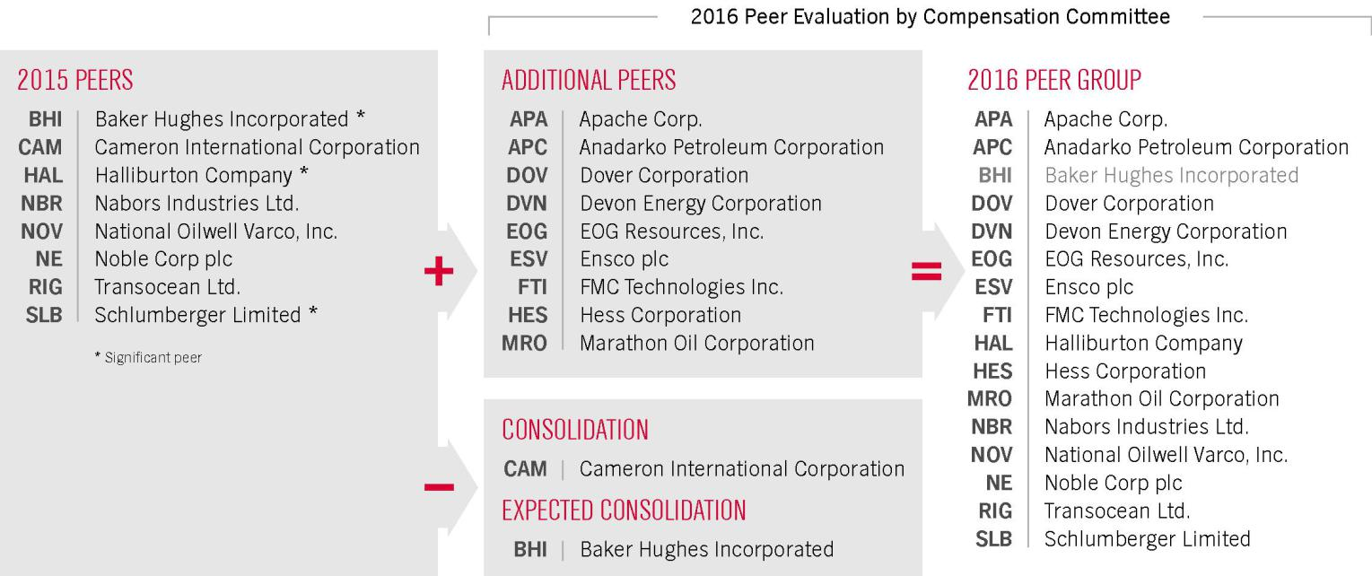

The Company’s 2015 revenues were in the 50th percentile of the 2015 peer group and 69th percentile of the 2016 peer group shown above.

The 2016 peer group was first used in January of 2016 to develop the market data and benchmarking materials provided to the Compensation Committee to assist with the 2016 compensation decision making process. While the Compensation Committee relies on the peer group analysis to provide market data and relevant trend information, it does not consider the peer group analysis as a substitute for its collective business judgment.

RISK ANALYSIS OF OUR COMPENSATION PROGRAMS

The Committee reviews our compensation plans and policies to ensure that they do not encourage unnecessary risk taking and instead encourage behaviors that support sustainable value creation. In 2015, the Committee, with the assistance of Longnecker, reviewed the Company’s compensation policies and practices for executive officers, and believes that our compensation programs are not reasonably likely to have a material adverse effect on the Company. We believe the following factors reduce the likelihood of excessive risk-taking:

- the program design provides a balanced mix of cash and equity, annual and long-term incentives, fixed and variable pay, and performance metrics;

- maximum payout levels for annual cash incentives are capped;

- the Committee has downward discretion over incentive program payouts;

- executive officers are subject to share ownership guidelines;

- compliance and ethical behaviors are integral factors considered in all performance assessments; and

- the Company has a clawback policy that covers performance-based compensation, whether paid in cash or equity.

Weatherford International plc — 2016 Proxy Statement 42

Back to Contents

COMPENSATION DISCUSSION AND ANALYSIS

COMPENSATION COMMITTEE INTERLOCKS AND INSIDER PARTICIPATION

The Compensation Committee’s current members are Dr. Ortiz and Messrs. Gass, Macaulay (Chair) and Moses, all of whom are independent, non-employee directors. None of the current Compensation Committee members has served as an officer or employee of the Company.

COMPENSATION COMMITTEE REPORT

The Compensation Committee believes executive compensation should be based on performance, and Weatherford’s executive pay program implements that belief. Our program is designed to hold our executives accountable for results and to reward them for achieving their targets. The Compensation Discussion and Analysis included above describes the Committee’s decisions regarding our executives’ compensation for 2015 and how those decisions support and implement our philosophy.

We have reviewed the Compensation Discussion and Analysis and discussed it with management and recommended to the Board that the Compensation Discussion and Analysis be included in this Proxy Statement.
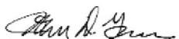

John D. Gass
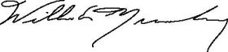

William E. Macaulay (Chair)
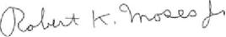

Robert K. Moses Jr.
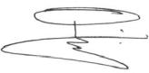

Guillermo Ortiz

Weatherford International plc — 2016 Proxy Statement 43

Back to Contents

EXECUTIVE COMPENSATION TABLES

The base salaries of the CEO, other NEOs and all corporate officers have been reduced by 10% effective April 1, 2016.

The CEO's 2016 equity award was also reduced by 18% as compared to 2015.

2015 SUMMARY COMPENSATION TABLE

This table shows the total compensation paid for the years ended December 31, 2015, 2014 and 2013 to our NEOs. Information is not provided for any year in which an individual was not a NEO. Compensation paid to our former employee and NEO, Dharmesh Mehta, was paid upon his departure in 2015 as required under his contractual agreements with Weatherford and as described on page 40.

 |  |  |  |  |  | Change in
 |  |  |  |  |  | Pension Value
 |  |  |  |  |  | and Nonqualified
 |  |  |  |  | Non-Equity | Deferred | All
 |  |  |  | Stock | Non-Equity | Compensation | Other
 |  | Salary | Bonus | Awards | (Cash) | Earnings | Compensation | Total
Name and Principal Position | Year | ($) | ($)(g) | ($)(h) | Incentive($)(f) | ($) | ($)(i)(j) | ($)
Bernard J. Duroc-Danner
Chairman of the Board, President | 2015 | 1,840,398 | – | 10,072,694 | 1,799,880 | – | 2,005,880 | 15,718,852
and Chief Executive Officer(a) | 2014 | 1,920,708 | – | 8,263,857 | 2,911,012 | – | 1,831,435 | 14,927,012
 | 2013 | 1,901,171 | – | 7,742,425 | 2,506,046 | – | 1,008,245 | 13,157,887
Krishna Shivram
Executive Vice President | 2015 | 750,000 | – | 3,504,236 | 637,500 | – | 26,838 | 4,918,574
and Chief Financial Officer(b) | 2014 | 750,000 | – | 2,818,502 | 980,813 | – | 21,310 | 4,570,625
 | 2013 | 116,477 | 300,000 | 3,936,649 | 120,822 | – | 4,327 | 4,478,275
Christina Ibrahim | 2015 | 416,667 | 150,000 | 1,451,000 | 534,889 | – | 8,920 | 2,561,476
Executive Vice President, General
Counsel and Secretary(c)
Antony Branch | 2015 | 445,166 | – | 1,585,593 | 286,875 | – | 1,279,242 | 3,596,876
President, Regional Operations(d)
Lance Marklinger
President, Global Sales(d) | 2015 | 445,166 | – | 1,585,593 | 286,875 | – | 718,875 | 3,036,509
Dharmesh Mehta
Former Executive Vice President | 2015 | 468,750 | – | 2,176,335 | 400,282 | – | 4,638,964 | 7,684,331
Corporate Strategy(e) | 2014 | 744,167 | – | 3,101,686 | 980,813 | – | 24,283 | 4,850,949
 | 2013 | 699,167 | 250,000 | 2,919,787 | 750,750 | – | 23,840 | 4,643,544

- Dr. Duroc-Danner’s salary for each of 2013, 2014 and 2015 was CHF 1,760,000. The change in value reflected above relates to changes in the USD-CHF exchange rate. Amounts shown in table represent the CHF salary translated to USD at the rate on the respective dates of payment.

- Mr. Shivram joined the Company in November 2013.

- Mrs. Ibrahim joined the Company in May 2015.

- Mr. Branch’s and Mr. Marklinger’s salaries are denominated and paid in USD. There are some perquisites, however, that are denominated in CHF and have been translated to USD at the rate on the respective dates of payment.

- Mr. Mehta left the Company in August 2015.

- Amounts for 2013 relate to the Company’s capital efficiency exceeding the superior target and its safety performance meeting or surpassing the target level as prescribed in the 2013 ICP. Amounts for 2014 relate to the Company’s EPS falling between threshold and target, annualized cost savings exceeding the superior level, net debt reduction exceeding the superior level and its safety performance meeting (LTIR) and surpassing (PVIR) the superior level. Details regarding values for 2015 are set forth on page 33. Amounts for 2015, 2014 and 2013 were paid in 2016, 2015 and 2014, respectively, but were earned by each NEO for performance in the 2015, 2014 and 2013 fiscal years, respectively. Amounts denominated in a currency other than USD, were converted to USD using the appropriate foreign exchange rate as of the applicable payment dates.

- Mr. Shivram and Mrs. Ibrahim were each given a one-time sign-on cash (make-whole) payment when they joined the Company (Mr. Shivram in 2013; Mrs. Ibrahim in 2015) to replace the value of bonuses and unvested equity being forfeited at their respective previous employers.

Weatherford International plc — 2016 Proxy Statement 44

Back to Contents

EXECUTIVE COMPENSATION TABLES

- Assumptions used in the calculation of these amounts are included in Note 18 (Share- Based Compensation) to the audited financial statements included in our Annual Report on Form 10-K for the year ended December 31, 2015. For the PUs granted during 2015, the value of the award at the grant date, assuming that the highest level of performance conditions will be achieved, are set forth below. No PUs were granted to Mrs. Ibrahim. For additional information regarding our 2015 grants, please see page 37 of this Proxy Statement.

Executive | Maximum Payout ($)
Duroc-Danner | $11,400,000
Shivram | $4,300,000
Ibrahim | --
Branch | $1,900,000
Marklinger | $1,900,000

- Year-over-year changes in “All Other Compensation” for our CEO are primarily related to changes in tax liabilities paid by the Company under our tax policies for executive officers on international assignment. These taxes are generally reflected on an as-paid basis and can fluctuate year to year based on the amount of estimated taxes paid during the year and any true up required for final taxes determined on prior years’ income.

- All Other Compensation for 2015 consists of the following:

 |  |  | Matching |  | Expatriate
 |  |  | Contributions
 |  |  | under 401(k) and
 |  | Club | Other |  |  | Housing,
 | Car/Car | Membership | Contribution | Life Insurance | Relocation & Geographic | Schooling | Net Taxes
 | Allowance | Dues | Plans | Premiums | Differential | and Other | Paid | Termination Pay
 | ($) | ($) | ($)(1) | ($) | ($) | ($) | ($)(2) | ($)(3)
Duroc-Danner | 5,527 | 6,840 | 44,079 | 4,284 | 656,727 | 44,227(4) | 1,244,196 | --
Shivram | 10,800 | 1,656 | 10,600 | 3,782 | -- | -- | -- | --
Ibrahim | 7,200 | -- | -- | 1,720 | -- | -- | -- | --
Branch | 17,029 | -- | 28,106 | 1,924 | 202,810 | 242,559(5) | 786,814 | --
Marklinger | 18,007 | -- | 31,996 | 1,943 | 279,825 | 237,854(6) | 149,250 | --
Mehta | 6,750 | -- | 10,600 | 2,026 | -- | -- | -- | 4,619,588

- Dr. Duroc-Danner and Messrs. Branch and Markliner are participants in the Weatherford International Swiss Pension Plan. All other individuals are, or, with respect to Mr. Mehta, were, participants in the U.S. 401(k) plan. Amounts shown represent Company contributions to those plans.

- Net Taxes Paid represents the difference between cash taxes paid on behalf of the executive during the year and amounts withheld from the executive’s compensation for taxes during the year. Taxes paid by the Company to a taxing authority in 2015 with respect to taxes on income earned in previous years are shown in 2015.

- For details of termination pay, see “Severance and Termination Benefits” on page 40 of this Proxy Statement.

- This amount is for U.S and Switzerland tax preparation assistance.

- This amount includes $169,188 for housing allowance, $23, 709 for education costs and $49,662 in vacation pay upon relocation to Switzerland.

- This amount includes $181,318 for housing allowance and $56,536 in vacation pay upon relocation to Switzerland.

Weatherford International plc — 2016 Proxy Statement 45

Back to Contents

EXECUTIVE COMPENSATION TABLES

GRANTS OF PLAN-BASED AWARDS

The following table provides information regarding plan-based awards granted in 2015 to the NEOs.

 |  |  | Estimated Future Payouts |  |  |  |  |  |  | Grant
 |  |  |  |  |  |  |  |  | All Other | Date Fair
 |  |  | Under Non-Equity (Cash) Incentive Plan |  |  | Estimated Future Payouts Under |  |  | All Other | Date Fair
 |  |  |  |  |  |  |  |  | Stock Awards: | Value of
 |  |  |  | Awards(1) |  | Equity Incentive Plan Awards |  |  | Stock Awards: | Value of
 |  |  |  | Awards(1) |  |  |  |  | Number of | Share
 | Grant |  | Threshold | Target | Maximum | Threshold | Target | Maximum | Shares of Stock | Awards
Name | Date | ($) |  | ($) | ($) | (#) | (#) | (#) | (#) | ($)(2)
Bernard J. Duroc-Danner | Jan 8 | (3) |  |  |  |  |  |  | 4,549 | 49,994
 | Jan. 27 | 1,189,457 |  | 2,378,915 | 4,757,830
 | Jan. 27 | (4)(5) |  |  |  | 254,238 | 508,475 | 1,016,950 |  | 5,313,564
 | Jan. 27 | (5) |  |  |  |  |  |  | 356,824 | 3,999,997
 | April 8 | (3) |  |  |  |  |  |  | 43,716 | 581,423
 | July 8 | (3) |  |  |  |  |  |  | 5,027 | 56,855
 | Oct 7 | (3) |  |  |  |  |  |  | 6,794 | 70,861
Krishna Shivram | Jan. 27 | 375,000 |  | 750,000 | 1,500,000
 | Jan. 27 | (4)(5) |  |  |  | 95,897 | 191,793 | 383,586 |  | 2,004,237
 | Jan. 27 | (5) |  |  |  |  |  |  | 133,809 | 1,499,999
Christina Ibrahim | May 4 | 207,192 |  | 414,384 | 828,767
 | May 4 | (6) |  |  |  |  |  |  | 100,000 | 1,451,000
Antony Branch | Jan. 27 | 168,750 |  | 337,500 | 675,000
 | Jan. 27 | (4)(5) |  |  |  | 42,373 | 84,746 | 169,492 |  | 885,596
 | Jan. 27 | (5) |  |  |  |  |  |  | 62,444 | 699,997
Lance Marklinger | Jan. 27 | 168,750 |  | 337,500 | 675,000
 | Jan. 27 | (4)(5) |  |  |  | 42,373 | 84,746 | 169,492 |  | 885,596
 | Jan. 27 | (5) |  |  |  |  |  |  | 62,444 | 699,997
Dharmesh Mehta | Jan 8 | (3) |  |  |  |  |  |  | 1,878 | 20,639
 | Jan. 27 | 375,000 |  | 750,000 | 1,500,000
 | Jan. 27 | (4)(5) |  |  |  | 44,603 | 89,206 | 178,412 |  | 932,203
 | Jan. 27 | (5) |  |  |  |  |  |  | 89,206 | 999,999
 | April 8 | (3) |  |  |  |  |  |  | 15,082 | 200,591
 | July 8 | (3) |  |  |  |  |  |  | 2,025 | 22,903

- Represents potential payments for the year ended December 31, 2015 under the terms of the Weatherford International Executive Non-Equity Incentive Compensation Plan. See “Elements of Our Executive Compensation Program-Annual Cash Incentive Compensation” in the CD&A section of this Proxy Statement for more information including specific payments for 2015. Pursuant to the terms of his employment agreement, payments to Mr. Mehta were prorated based on the date that he left the Company.

- The grant date fair value of each of the awards was based on the Company’s closing share price on the date of the grant for restricted share unit awards and, for performance share unit awards, a calculated fair value derived using a Monte Carlo valuation model, in accordance with FASB ASC Topic 718. See Note 18 (Share-Based Compensation) to the audited financial statements included in our Annual Report on Form 10-K for the year ended December 31, 2015 for details as to the assumptions used to determine the fair value of equity awards. Restricted share unit awards and performance unit awards were granted under the terms of the 2010 Omnibus Incentive Plan, as amended.

- Represents a grant of ordinary shares approximating the benefit that would have been received under the Company’s Executive Deferred Compensation Plan that was suspended in 2008.

- The amounts shown represent the aggregate threshold, target and maximum payment levels with respect to the grant of performance units tied to share price increase over the performance period. The number of shares shown in the “Threshold” column, represents 50% of the number of performance units granted. The number of shares shown in the “Target” column reflects a payout of 100% of the number of performance units granted. The number of shares shown in the “Maximum” column reflects the highest possible payout of 200% of the number of performance units granted. The number of shares earned will be determined by linear interpolation if the performance goal (i.e., an increase in share price) is higher or lower than threshold, target or maximum, up to the maximum number of shares shown in the “Maximum” column.

- Performance units and restricted share units granted on January 27, 2015 vest in equal annual installments over a period of three years.

- Restricted share units vest in equal annual installments over a period of three years.

Weatherford International plc — 2016 Proxy Statement 46

Back to Contents

EXECUTIVE COMPENSATION TABLES

OUTSTANDING EQUITY AWARDS AT DECEMBER 31, 2015

The following table provides information about the number of outstanding equity awards held by our NEOs at December 31, 2015.

 |  | Option Awards |  |  | Stock Awards
 |  |  |  |  |  | Equity Incentive | Equity Incentive
 |  |  |  |  |  | Plan Awards: | Plan Awards
 | Number of |  |  |  | Market | Number of | Market or Payout
 | Securities |  |  | Number | Value | Unearned | Value of Unearned
 | Underlying |  |  | of Shares | of Shares | Shares, Units | Shares, Units
 | Unexercised | Option | Option | or Units | or Units That | or Other Rights | |or Other Rights
 | Options | Exercise | Expiration | That Have | Have Not | That Have not | That Have Not
Name | Exercisable(#) | Price ($) | Date | Not Vested (#) | Vested($) | Vested (#)(1) | Vested($)(1)
Bernard J. Duroc-Danner | 370,000 | 8.79 | 12/17/2016 | – | – | – | –
 | 336,650 | 20.05 | 02/28/2016 | – | – | – | –
 | – | – | – | 163,800(2) | 1,374,282 | – | –
 | – | – | – | 356,824(3) | 2,993,753 | – | –
 | – | – | – | – | – | 343,938(4) | 2,885,640
 | – | – | – | – | – | 81,900(5) | 687,141
 | – | – | – | – |  | 254,238(6) | 2,133,057
Krishna Shivram | – | – | – | 61,425(2) | 515,356 | – | –
 | – | – | – | 133,809(3) | 1,122,658 | –
 | – | – | – | – | – | 30,713(5) | 257,682
 | – | – | – | – | – | 95,897(6) | 804,576
Christina Ibrahim | – | – | – | 100,000(7) | 839,000 | – | –
Antony Branch | – | – | – | 5,000(8) | 41,950 | – | –
 | – | – | – | 25,000(9) | 209,750 | – | –
 | – | – | – | 10,748(8) | 90,176 | – | –
 | – | – | – | 23,206(2) | 194,698 | – | –
 | – | – | – | 62,444(3) | 523,905 | – | –
 | – | – | – | – | – | 16,122(4) | 135,264
 | – | – | – | – | – | 11,603(5) | 97,349
 | – | – | – | – | – | 42,373(6) | 355,509
Lance Marklinger | – | – | – | 25,000(9) | 209,750 | – | –
 | – | – | – | 10,748(8) | 90,176 | – | –
 | – | – | – | 23,284(2) | 195,353 | – | –
 | – | – | – | 62,444(3) | 523,905 | – | –
 | – | – | – | – | – | 16,122(4) | 135,264
 | – | – | – | – | – | 11,642(5) | 97,676
 | – | – | – | – | – | 42,373(6) | 355,509

- For performance units, the number of shares or units reported and the payout value reported are based on achieving the threshold performance level, which is 50% of the performance units granted.

- Restricted share units vested/vest in equal increments on each of February 27, 2016 and 2017.

- Restricted share units vested/vest in equal increments on each of January 27, 2016, 2017 and 2018.

- Performance units were eligible to vest on January 1, 2016. However, no performance units vested because performance objectives were not met.

- Performance units are eligible to vest in equal increments on each of February 27, 2016 and February 27, 2017, subject to the attainment of applicable performance objectives. No performance units vested on February 27, 2016 because performance objectives were not met.

- Performance units are eligible to vest in equal increments on each of January 27, 2016, January 27, 2017 and January 27, 2018, subject to the attainment of applicable performance objectives. No performance units vested on January 27, 2016 because performance objectives were not met.

- Restricted share units vest in equal increments on each of May 4, 2016, 2017 and 2018.

- Restricted units vested March 7, 2016.

- Restricted units vested February 12, 2016.

Weatherford International plc — 2016 Proxy Statement 47

Back to Contents

EXECUTIVE COMPENSATION TABLES

OPTION EXERCISES AND SHARES VESTED IN 2015

The following table provides information about option awards and stock awards that vested, and the value realized on exercise and vesting by our NEOs during 2015.

 | Option Awards |  |  | Share Awards
 | Number of Shares |  | Number of Shares/Units
 | Acquired on Exercise | Value Realized On Exercise | Acquired on Vesting | Value Realized On Vesting
Name | (#) | ($)(a) | (#) | ($)(b)
Bernard J. Duroc-Danner | 785,352 | 2,517,760 | 141,987 | 1,798,457
Krishna Shivram | – | – | 30,713 | 389,748
Christina Ibrahim | – | – | – | –
Antony Branch | – | – | 58,684 | 707,642
Lance Marklinger | – | – | 57,390 | 684,624
Dharmesh Mehta(c) | – | – | 228,109 | 2,577,807

- Calculated using the difference between the market price of our stock on date of exercise and the exercise price of the options.

- Calculated by multiplying the number of shares of stock by the market value of the underlying shares on the date of vesting.

- Mr. Mehta left the Company in August 2015. In connection with the termination of his employment with the Company and pursuant to the terms of his employment agreement with the Company, Mr. Mehta received a gross distribution of 102,984 shares of the Company’s stock with respect to RSUs and PUs.

PENSION BENEFITS

The following table and the information below it contain information regarding the SERP at December 31, 2015. Of our NEOs, only Dr. Duroc-Danner participates in the SERP. As described in the CD&A section in this Proxy Statement, the SERP has been discontinued, and further benefit accruals under the SERP were frozen effective March 31, 2010. In May 2010, Dr. Duroc-Danner elected to convert his accrued pension benefit into approximately 4.4 million notional share units. Therefore, the actual benefit payable to Dr. Duroc-Danner on departure is that number of shares, not the amount reflected below. The actuarial value of the retirement benefit as of December 31, 2015 (using the same assumptions used for financial reporting purposes, with the exception of retirement age) is as follows:

 | Actuarial Present Value of | Payments During
 | Accumulated Benefit | Last Fiscal Year
Name | ($)(1) | ($)
Bernard J. Duroc-Danner | 70,970,599 | –

- Value was determined using the projected unit credit actuarial cost method. The present value number, however, does not reflect the actual value of the eventual payment of these benefits as the payment will be in shares. As Dr. Duroc-Danner has reached retirement age according to plan calculations, there is no further discount to be applied. As a result, the amount above reflects the full benefit value in accordance with pension accounting.

For more information on our retirement plans and the values thereof, see “Retirement Plans” on page 39 of this Proxy Statement.

NONQUALIFIED DEFERRED COMPENSATION

We suspended the EDC in 2008 because of uncertainties concerning the application of Code Section 457, and no further benefits have accrued to participants since that time. Following the suspension, in May of 2012 we terminated the EDC. As a result of the termination, participants who had accrued benefits under the EDC prior to December 31, 2004, including Dr. Duroc-Danner, received a partial distribution of shares in May 2012 in respect of their accrued benefits. All remaining amounts in the EDC will be payable in cash to participants upon the occurrence of triggering events under the plan and, in any event, no later than January 1, 2017. All participants in the EDC are fully vested in their plan balances.

Weatherford International plc — 2016 Proxy Statement 48

Back to Contents

EXECUTIVE COMPENSATION TABLES

The following table and the information below it contain information regarding the NEOs who were participants under our deferred compensation plans in 2015.

 | Executive | Registrant | Aggregate | Aggregate
 | Contributions | Contributions | Earnings | Withdrawals/ | Aggregate Balance
 | in 2015 | in 2015 | in 2015 | Distributions | at 12/31/15
Name | ($)(1) | ($)(1) | ($)(2) | ($) | ($)(3)
Bernard J. Duroc-Danner | – | – | (462,914) | – | 1,269,231
Dharmesh Mehta(4) | – | – | (5,254) | (33,333) | 0

- The EDC was suspended in 2008, there were no executive or Company contributions made during 2015, and, as a result, no corresponding amounts reported in the 2015 Summary Compensation Table.

- Amounts represent stock price appreciation (depreciation) based on normal share price fluctuation as experienced by all Company shareholders.

- The total current value at December 31, 2015 of the deferred salary of $1,269,231 for Dr. Duroc-Danner was comprised of executive contributions of $423,074 and Company contributions of $846,157 that were included as compensation in the Summary Compensation Table in previous years (before 2009).

- Mr. Mehta left the Company in 2015, however, the distribution shown above was deferred until February 2016 in connection with Section 409A of the Code.

Weatherford International plc — 2016 Proxy Statement 49

Back to Contents

EXECUTIVE COMPENSATION TABLES

POTENTIAL PAYMENTS UPON TERMINATION OR CHANGE OF CONTROL

The following table lists the compensation and benefits that Weatherford would provide to our NEOs in various scenarios involving a termination of employment or upon a change of control, other than compensation and benefits generally available to salaried employees. As described on page 40 in this Proxy Statement, all of our NEOs other than Ms. Ibrahim have employment agreements. Mrs. Ibrahim does not have an employment agreement but does have a change of control agreement.


 |  |  | Termination / Change of Control Scenarios
 |  |  |  |  |  |  | Change of
 |  |  |  |  |  |  | Control with
 | Retirement, |  |  |  |  | Change of | Termination of
 | Resignation, |  |  | Termination |  | Control without | Employment without
 | or Termination |  |  | without Cause or with |  | Termination of | Cause or Good
 | with Cause(1) | Death or Disability(2) |  | Good Reason(3) |  | Employment (4) | Reason(4)
Compensation |  |  | NEOs |  | NEOs
Compensation |  |  | other than |  | other than
Elements | All NEOs | Mrs. Ibrahim | Mrs. Ibrahim | Mrs. Ibrahim | Mrs. Ibrahim | All NEOs | All NEOs
Base Salary | Ceases immediately | Ceases | Ceases | Ceases | Ceases | Continues | Ceases immediately
 |  | immediately | immediately | immediately | immediately
Cash Severance | None | None(5) | 1x (salary plus | None | 3x (salary plus | None | 3x (salary plus target
 |  |  | target annual cash |  | target annual cash |  | annual cash incentive) (7)
 |  |  | incentive) |  | incentive)(6)

Annual Cash Incentive | Forfeited | None | Prorated for the | Forfeited | Prorated for the | None
Compensation |  |  | year and subject to |  | year and subject to
 |  |  | actual performance |  | actual performance

Prorated for the year and subject to actual performance

Restricted Stock Units | Forfeited | Awards | Awards | Forfeited | Awards | Awards | Awards immediately vest
 |  | immediately vest | immediately vest |  | immediately vest | immediately vest
Performance Units | Forfeited | Awards | Awards | Forfeited | Awards | Awards | Awards immediately vest
 |  | immediately vest | immediately vest |  | immediately vest | immediately vest | (8)
 |  |  |  |  |  | (8)
Pension Benefits / | Immediately | None | Immediately | None | Immediately | Immediately | Immediately distributed
Nonqualified Deferred | distributed per plan |  | distributed per plan |  | distributed per plan | distributed per | per plan
Compensation (9) |  |  |  |  |  | plan, unless plan
 |  |  |  |  |  | assumed(10)
Health, Welfare and | None | None (5) | 1 year continued | None | Outplacement | Continue | Outplacement services
Other Benefits(11) |  |  | dental/health |  | services provided; |  | provided; 3 years
 |  |  | coverage; legal |  | 3 years continued |  | continued dental/health
 |  |  | fees, upon dispute |  | dental/health |  | coverage; legal fees,
 |  |  |  |  | coverage; legal |  | upon dispute
 |  |  |  |  | fees, upon dispute

- No special or additional payments are payable to any of the NEOs under an Executive Employment Agreement, Change of Control Agreement or otherwise in the event of termination of employment by way of retirement, resignation or termination for “cause.”

- Under each Executive Employment Agreement, “disability” is defined as the absence of the NEO from his duties on a substantial basis for 120 calendar days as a result of incapacity due to physical or mental illness. If we determine that a NEO is disabled, he has 30 days from the date of our notice of intent to terminate employment by reason of disability to return to full-time performance of his duties. The NEO may terminate his employment for disability if a physician selected by the NEO determines that a disability has occurred. Under the Change of Control Agreement, “disability” is defined as the NEO’s incapacity due to physical or mental illness that causes the absence of the NEO from her duties for six months in accordance with the Company’s medical leave policies.

- Under each Executive Employment Agreement, “cause” is defined as the willful and continued failure to substantially perform the NEO’s duties with the Company (other than failure resulting from incapacity due to physical or mental illness or anticipated failure after the NEO has provided a notice of termination for good reason) after written demand is made by the Board of Directors, or the willful engagement in illegal conduct or gross misconduct that is materially and demonstrably injurious to the Company. “Good reason” generally means the occurrence of any of the following: (i) the assignment to the NEO of any position, authorities, duties or responsibilities that are materially inconsistent with the NEO’s position, authorities, duties or responsibilities as provided in the Executive Employment Agreement or any other action that results in a material diminution of the NEO’s position, authorities, duties or responsibilities; (ii) a relocation of the NEO (a provision only included in Dr. Duroc-Danner’s agreement); (iii) a material breach by the Company of the Executive Employment Agreement; (iv) the Company’s giving of notice that the Executive Employment Agreement term will not be extended (“non-renewal”); or (v) the failure by the Company to require any successor to assume and perform the Executive Employment Agreement between the NEO and the Company. After a change of control or other transaction in which our ordinary shares cease to be publicly traded, “good reason” also will be deemed to exist if the NEO is assigned to any position, authority, duties or responsibilities that are not at the ultimate parent company of the surviving entity.

Weatherford International plc — 2016 Proxy Statement 50

Back to Contents

EXECUTIVE COMPENSATION TABLES

- Under each Executive Employment Agreement, “change of control” is generally deemed to occur if (i) any person acquires 20% or more of our ordinary shares; (ii) at least two-thirds of the members of the current Board of Directors cease to be directors other than in specified circumstances; (iii) upon the consummation of a merger or similar transaction other than (a) a transaction in which the shareholders beneficially owning the ordinary shares outstanding immediately prior to the transaction represent at least two-thirds of the voting power immediately after the transaction, (b) a transaction in which no person owns 20% or more of the outstanding ordinary shares or voting power of the surviving entity, and (c) a transaction in which at least two-thirds of the members of the Board of Directors of the surviving entity are current members of the Board of Directors at the time the transaction was approved; or (iv) approval or adoption by the Board of Directors or our shareholders of a plan or proposal which could result directly or indirectly in the liquidation, transfer, sale or other disposal of all or substantially all of the Company’s assets or a dissolution of the Company.

Under the Change of Control Agreement, “change of control” is generally deemed to occur if (i) any person acquires 30% or more of our ordinary shares; (ii) at least a majority of the members of the current Board of Directors cease to be directors other than in specified circumstances; (iii) upon the consummation of a merger or similar transaction other than (a) a transaction in which the shareholders beneficially owning the ordinary shares outstanding immediately prior to the transaction represent at least 50% of the voting power immediately after the transaction, (b) a transaction in which no person owns 30% or more of the outstanding ordinary shares or voting power of the surviving entity, and (c) a transaction in which at least a majority of the members of the Board of Directors of the surviving entity are current members of the Board of Directors at the time the transaction was approved; or (iv) approval or adoption by the Board of Directors or our shareholders of a plan or proposal which could result directly or indirectly in the liquidation, transfer, sale or other disposal of all or substantially all of the Company’s assets or a dissolution of the Company.

There are no additional rights granted to a NEO under an Executive Employment Agreement as a result of a change of control, other than providing that a NEO, in certain circumstances, can terminate his Executive Employment Agreement in connection with a change of control for good reason. (See footnote 3 above).

- Under the Change of Control Agreement, following a change of control and during the term of the agreement, (a) during a period of incapacity, a NEO would continue to receive her full salary and all compensation and benefits payable under the terms of the then-current plans until the NEO is terminated by the C ompany for disability or (b) in the event of death, the NEO’s estate would receive her full salary and all compensation and benefits payable under the terms of the then-current plans. (See footnote 2 above.)

- In the event of non-renewal of an Executive Employment Agreement by the Company, the multiple for calculation of the severance payment is reduced from three to one.

- Under the Change of Control Agreement, severance would be payable if a NEO’s employment is terminated (i) by the Company “without cause” or by the Executive for “good reason” within 6 months preceding or two years following a change of control under certain circumstances. “Cause” means willful and continued failure of the NEO to perform his or her duties or the NEO willfully engaging in illegal conduct or gross misconduct that is harmful to the Company. “Good reason” includes a material reduction in a NEO’s authorities, responsibilities, status, compensation or benefits (unless part of a cost reduction initiative) or the failure of any successor company to assume the agreement.

- The performance unit awards granted in 2016 will accelerate and vest at a multiple of two upon a change of control.

- Bernard J. Duroc-Danner is the only NEO entitled to any Pension Benefits or Nonqualified Deferred Compensation. On termination of Dr. Duroc-Danner for any reason, he would be entitled to a distribution of previously earned and fully vested deferred compensation, which is distributable in Company shares, cash or other investments pursuant to the applicable plan. Accordingly, previously earned and fully vested deferred compensation would become distributable under our EDC, which is distributable in Company shares or cash and SERP, which is distributable in Company shares. The Executive Employment Agreement provides that if the employee is a participant in our now frozen retirement plan (which applies only to Dr. Duroc-Danner), he will be entitled to a “gross up payment” that is limited solely to the payments of penalties, excise or other taxes incurred by him pursuant to Section 457A of the Code with respect to accrued benefits under our retirement plans. The Company does not believe that Section 457A would impose any such penalties, excise or other taxes. The Executive Employment Agreement expressly excludes gross-ups previously provided under those retirement plans. See “Pension Benefits” and “Nonqualified Deferred Compensation” for further detail on benefits and timing of payments.

- If a successor company assumes the terms of the relevant pension or deferred compensation plan, such plans will continue pursuant to their terms and be fully distributable to participants no later than January 1, 2017.

- Under each Executive Employment Agreement and the Change of Control Agreement, (i) all dental and health benefits under any plans that are provided to a NEO and his or her family prior to termination would be maintained after termination for a period of one to three years or such longer period as the plans may require, provided the NEO makes his or her required contribution and that such benefits are secondary to any benefits offered by another employer; and (ii) upon request, up to a maximum of $35,000 or for no longer than 6 months, the Company will pay for outplacement services for the NEO, the provider of which would be selected and paid directly by us for a period not extending beyond the last day of the second taxable year following the taxable year in which the NEO’s termination occurs. We are required to pay reasonable legal fees and expenses incurred by the NEO in any disputes regarding his or her Executive Employment Agreement or Change of Control Agreement, so long as the NEO undertakes to reimburse the Company for such amounts paid if the NEO is determined to have acted in bad faith in connection with the dispute.

Weatherford International plc — 2016 Proxy Statement 51

Back to Contents

EXECUTIVE COMPENSATION TABLES

ESTIMATE OF POTENTIAL PAYMENTS UPON TERMINATION

The table below describes the value of compensation and benefits payable to each NEO upon termination that would exceed the compensation or benefits generally available to salaried employees. Benefits and payments are calculated assuming the triggering event occurred on December 31, 2015. The following includes the various types of circumstances that would trigger payments and benefits under plans, agreements and arrangements currently in effect, but it is always possible that different arrangements could be negotiated in connection with an actual termination of employment or change of control. No information is provided in this table with regard to potential payments to former employees listed as NEOs in this Proxy Statement if such NEO received payments pursuant to an employment agreement and actual payments are described in this Proxy Statement separately under “Compensation Discussion and Analysis.” Compensation paid to Dharmesh Mehta, our former employee and NEO, upon his departure in 2015 is described on page 40.

 |  |  |  |  | Pension | Health,
 |  | Annual | Restricted | Performance | Benefits / | Welfare
 |  | Cash | Stock Units - | Units - | Nonqualified | and
 | Cash | Incentive | Unvested and | Unvested and | Deferred | Other
 | Severance | Compensation | Accelerated | Accelerated | Compensation | Benefits | Total
Name | ($) | ($) | ($) | ($)(2) | ($)(3) | ($) | ($)(4)
Bernard J. Duroc-Danner
Retirement, Resignation or Termination with | 0 | 0 | 0 | 0 | 38,161,815 | 0 | 38,161,815
Cause
Death or Disability | 3,900,149 | 1,799,880 | 4,368,035 | 0 | 38,161,815 | 608,370 | 48,838,249
Termination Without Cause or With Good Reason | 11,700,447 | 1,799,880 | 4,368,035 | 0 | 38,161,815 | 751,979 | 56,782,156
Change of Control Without Termination | 0 | 0 | 4,368,035 | 0 | 0 | 0 | 4,368,035
Change of Control With Termination | 11,700,447 | 1,799,880 | 4,368,035 | 0 | 38,161,815 | 751,979 | 56,782,156
Krishna Shivram
Retirement, Resignation or Termination with | 0 | 0 | 0 | 0 | 0 | 0 | 0
Cause
Death or Disability | 1,500,000 | 637,500 | 1,638,013 | 0 | 0 | 30,912 | 3,806,425
Termination Without Cause or With Good Reason | 4,500,000 | 637,500 | 1,638,013 | 0 | 0 | 110,936 | 6,886,449
Change of Control Without Termination | 0 | 0 | 1,638,013 | 0 | 0 | 0 | 1,638,013
Change of Control With Termination | 4,500,000 | 637,500 | 1,638,013 | 0 | 0 | 110,936 | 6,886,449
Christina Ibrahim
Retirement, Resignation or Termination with | 0 | 0 | 0 | 0 | 0 | 0 | 0
Cause
Death or Disability | 0 | 0 | 839,000 | 0 | 0 | 0 | 839,000
Termination Without Cause or With Good Reason | 0 | 0 | 0 | 0 | 0 | 0 | 0
Change of Control Without Termination | 0 | 0 | 839,000 | 0 | 0 | 0 | 839,000
Change of Control With Termination | 3,750,000 | 414,384 | 839,000 | 0 | 0 | 97,355 | 5,100,739
Antony Branch
Retirement, Resignation or Termination with | 0 | 0 | 0 | 0 | 0 | 0 | 0
Cause
Death or Disability | 787,500 | 286,875 | 1,060,479 | 0 | 0 | 10,112 | 2,144,966
Termination Without Cause or With Good Reason | 2,362,500 | 286,875 | 1,060,479 | 0 | 0 | 48,537 | 3,758,391
Change of Control Without Termination | 0 | 0 | 1,060,479 | 0 | 0 | 0 | 1,060,479
Change of Control With Termination | 2,362,500 | 286,875 | 1,060,479 | 0 | 0 | 48,537 | 3,758,391
Lance Marklinger
Retirement, Resignation or Termination with | 0 | 0 | 0 | 0 | 0 | 0 | 0
Cause
Death or Disability | 787,500 | 286,875 | 1,019,184 | 0 | 0 | 11,937 | 2,105,496
Termination Without Cause or With Good Reason | 2,362,500 | 286,875 | 1,019,184 | 0 | 0 | 54,012 | 3,722,571
Change of Control Without Termination | 0 | 0 | 1,019,184 | 0 | 0 | 0 | 1,019,184
Change of Control With Termination | 2,362,500 | 286,875 | 1,019,184 | 0 | 0 | 54,012 | 3,722,571

- A zero (0) indicates either that there is no amount payable to the NEO, or the amount payable is generally available for both the NEOs and all salaried employees.

- As of December 31, 2015, none of the performance goals were achieved. As a result, no ordinary shares were earned upon vesting of the performance units that were eligible to vest based on 2015 performance.

- Upon a Change of Control without Termination, we assumed all pension benefits and nonqualified deferred compensation plans will be assumed by the acquirer.

- Under an Executive Employment Agreement, we will make required payments (other than the pro-rata bonus payment for the year of termination, which will be paid at the time bonus payments for that year would normally be paid) within 30 days after the date of the participant’s section 409A separation from service with the Company. However, if the participant is a section 409A specified employee, these payments will be made on the date that is six months following date of such separation from service with such payments bearing interest at the prime rate per annum as of the date of termination.

Weatherford International plc — 2016 Proxy Statement 52

Back to Contents

AGENDA ITEM 4 – APPROVE WEATHERFORD INTERNATIONAL PLC EMPLOYEE STOCK PURCHASE PLAN

The Board of Directors recommends that you vote “FOR” this proposal.

We are asking our shareholders to approve the adoption of our Employee Stock Purchase Plan (the “ESPP”). The ESPP was adopted by our Board of Directors on March 18, 2016 and will become effective upon receiving shareholder approval at our Annual General Meeting.

The ESPP will enable eligible employees of the Company and certain of its subsidiaries to use payroll deductions to purchase our ordinary shares and thereby acquire an ownership interest in the Company. The ESPP is intended to qualify as an “employee stock purchase plan” meeting the requirements of Section 423 of the Internal Revenue Code. A non-Section 423 Component to the ESPP will also be used to offer the plan to employees of designated affiliates outside of the United States.

The maximum aggregate number of ordinary shares that may be purchased under the ESPP (including the non-Code 423 component) will be 12,000,000 (the “ESPP Share Pool”), subject to adjustment as provided for in the ESPP. The ESPP Share Pool represents 1.3% of the total number of our ordinary shares outstanding as of April 15, 2016. In establishing the ESPP Share Pool, our Board of Directors considered the potential dilutive impact to shareholders, the projected participation rate over the term of the plan and equity plan guidelines established by certain proxy advisory firms.

An ordinary resolution (i.e., a simple majority of the votes cast “For” or “Against,” in person or by proxy, provided a quorum is present) is required to approve this proposal under Irish law. If you properly give a proxy but do not indicate how you wish to vote, the persons named on the proxy card will vote for the proposal. Under Irish law abstentions and “broker non-votes” will not affect the voting results. However, under NYSE rules, abstentions will be considered votes cast. As a result, abstentions will have the effect of a vote against this proposal under NYSE rules. “Broker non-votes” will not affect the voting results for this proposal under Irish law or NYSE rules.

The full text of the ESPP is set forth in Appendix A. The following description of certain features of the ESPP is qualified in its entirety by reference to the full text of the ESPP.

Summary of the ESPP

Administration. The ESPP will be administered by the Compensation Committee, which will have the authority to interpret and determine eligibility under the plan, prescribe forms, rules and procedures relating to the plan, and otherwise do all things necessary or appropriate to carry out the purposes of the plan. The Compensation Committee may delegate its authority under the ESPP to a subcommittee comprised of one or more of its members, to members of our Board of Directors, or to officers or employees of the Company to the extent permitted by law.

Shares Subject to the Plan. As noted above, the ESPP Share Pool consists of 12,000,000 ordinary shares, subject to adjustment, as described below. Shares delivered upon exercise of purchase rights under the ESPP may be either shares of authorized but unissued ordinary shares, treasury stock, or ordinary shares acquired in an open-market transaction. In the event of any change in our outstanding ordinary shares by reason of a stock dividend, stock split, reverse stock split, split-up, recapitalization, merger, consolidation, reorganization, or other capital change, the aggregate number and type of shares available for purchase under the ESPP, the number and type of shares granted or purchasable during an offering period and the purchase price per share under an outstanding purchase right will be appropriately adjusted in a manner that complies with Section 423 of the Internal Revenue Code.

If any purchase right granted under the ESPP expires or terminates for any reason without having been exercised in full or ceases for any reason to be exercisable in whole or in part, the unpurchased ordinary shares will again be available for purchase pursuant to offerings under the ESPP.

Eligibility. Participation in the ESPP will generally be limited to employees of Weatherford and any of its designated subsidiaries (a) whose customary employment is for more than five months per calendar year, (b) who customarily work 20 hours or more per week, and (c) who satisfy the procedural enrollment and other requirements set forth in the ESPP. Under the ESPP, designated subsidiaries include any subsidiary (within the meaning of Section 424(f) of the Internal Revenue Code) of Weatherford that has been designated by our Board of Directors or the Compensation Committee as eligible to participate in the plan.

No employee may be granted a purchase right under the ESPP if, immediately after the purchase right is granted, the employee would own (or, under applicable statutory attribution rules, would be deemed to own) stock possessing 5% or more of the total combined voting power or value of all classes of stock of the Company or any of its subsidiaries. In addition, employees who are citizens or residents of a foreign jurisdiction will not be eligible to participate in the ESPP if the grant of a purchase right under the plan is prohibited under the laws of the foreign jurisdiction or compliance with the laws of the foreign jurisdiction would cause the plan to violate the requirements of Section 423 of the Internal Revenue Code. The Compensation Committee may establish additional eligibility requirements for offering periods that have not yet commenced that are not inconsistent with Section 423 of the Internal Revenue Code.

As of April 15, 2016, approximately 22,000 employees would be eligible to participate in the ESPP, including certain of our executive officers.

Weatherford International plc — 2016 Proxy Statement 53

Back to Contents

AGENDA ITEM 4 – APPROVE WEATHERFORD INTERNATIONAL PLC EMPLOYEE STOCK PURCHASE PLAN

General Terms of Participation

Offering Periods. The ESPP allows eligible employees to purchase our ordinary shares for separate six-month offering periods, commencing on the first trading day on or after March 1 and September 1 of each year. Each offering has a single coterminous six-month purchase period. The Compensation Committee may change the commencement date, the ending date and the duration of the offering periods to the extent permitted by Section 423 of the Internal Revenue Code. If the ESPP is approved at the Annual General Meeting, the first offering period under the plan will commence on September 1, 2016 and end on February 28, 2017.

Method of Participation. Ordinary shares will be purchased under the ESPP on the last day of each offering period (a purchase date) using accumulated payroll deductions, unless the Compensation Committee provides otherwise with respect to the employees of a designated subsidiary in a manner consistent with Section 423 of the Internal Revenue Code. In order to participate in the ESPP, an eligible employee must complete and submit to the administrator of the ESPP a payroll deduction and participant authorization form in accordance with procedures and prior to the deadlines prescribed by the administrator of the ESPP. Participation will be effective as of the first day of an offering period.

Participants may elect payroll deductions up to 10% of the participant’s total eligible earnings per payroll period within an offering period. Eligible earnings include regular base salary, but exclude of overtime pay and regularly paid wage premiums (such as evening or shift premiums), commissions, income from equity compensation awards, bonuses and other compensation. A participant’s payroll deduction authorization will remain in effect for subsequent offering periods unless the participant’s participation in the ESPP terminates, as described below, or the participant cancels the authorization or submits a new payroll deduction and participant authorization form within the time specified by the administrator of the ESPP prior to the start of the subsequent offering period.

Grant and Exercise of Purchase Rights. On the first day of each offering period, each participant will be granted a right to purchase our ordinary shares on the last day of the offering period, subject to the limitations set forth in the ESPP. On the last day of each offering period, the payroll deductions accumulated by each participant during the offering period will be applied automatically to the purchase of ordinary shares at the purchase price in effect for that offering period. However, no participant may, on any purchase date, purchase more than 20,000 ordinary shares (or such lesser number as the Compensation Committee may prescribe). In addition, no participant will be granted a purchase right under the ESPP that would permit the participant’s right to purchase our ordinary shares under the ESPP to accrue at a rate that exceeds $25,000 in fair market value for each calendar year, determined in accordance with Section 423 of the Internal Revenue Code.

Purchase Price. The purchase price per share of our ordinary shares applicable to purchases during each offering period under the ESPP will be ninety percent (90%) (or such greater percentage as the Compensation Committee may designate) of the lower of (i) the fair market value per ordinary share on the first day of the offering period or (ii) the fair market value per ordinary share on the purchase date.

Termination of Purchase Rights. Upon the termination of a participant’s employment with the Company or a designated subsidiary, or in the event the participant otherwise ceases to qualify as an eligible employee, any purchase right then held by the participant will be canceled. Payroll deductions accumulated by the participant during the offering period in which such purchase right terminates will be returned to the participant (or his or her designated beneficiary or legal representative), without interest, as soon as practicable thereafter, and the participant will have no further rights under the ESPP.

Shareholder Rights. No participant will have any shareholder rights with respect to the ordinary shares covered by his or her purchase right until the shares are actually purchased on the participant’s behalf.

Transferability. Purchase rights granted to participants under the ESPP are not assignable or transferable and may be exercised only by the participant during his or her lifetime.

Amendment and Termination of the ESPP. Our Board of Directors has the right to amend the ESPP to any extent and in any manner it may deem advisable, provided that any amendment that would be treated as the adoption of a new plan for purposes of Section 423 of the Internal Revenue Code will require shareholder approval.

Our Board of Directors also has the right, at any time, to suspend or terminate the ESPP. In connection with such a termination or suspension, our Board of Directors may provide, in its discretion, either that the outstanding purchase rights will be exercisable on the purchase date for the applicable offering period (or such earlier date as the Board of Directors may specify), or that each participant’s accumulated payroll deductions will be returned to the participant without interest.

Sub-Plans. Consistent with the requirements of Section 423 of the Internal Revenue Code, the Compensation Committee may amend the terms of the ESPP, or an offering, or provide for separate offerings under the ESPP to, among other things, reflect the impact of local law outside of the United States as applied to one or more eligible employees of a designated subsidiary and may, where appropriate, establish one or more sub-plans to reflect such amended provisions.

Effective Date and Term. If the ESPP is approved by shareholders at the Annual General Meeting, the ESPP will become effective on the date of the Annual General Meeting. No purchase rights will be granted under the ESPP after the earliest to occur of (i) the date on which all shares available for issuance under the ESPP have been issued or (ii) the termination of the ESPP by the Company.

Corporate Transactions. In the event of a consolidation, merger, redomestication or similar transaction, a sale or transfer of all or substantially all of the Company’s assets, or a dissolution or liquidation of the Company, the Compensation Committee may, in its discretion, provide that each outstanding

Weatherford International plc — 2016 Proxy Statement 54

Back to Contents

AGENDA ITEM 4 – APPROVE WEATHERFORD INTERNATIONAL PLC EMPLOYEE STOCK PURCHASE PLAN

purchase right will be assumed or substituted for a right granted by the acquiror or successor corporation or by a parent or subsidiary of such entity, or will be cancelled with accumulated payroll deductions returned to each participant, or that the offering period will end before the date of the proposed sale, merger or similar transaction.

New Plan Benefits. Benefits and purchases of our ordinary shares under the ESPP depend on elections made by employees and the fair market value of our ordinary shares on dates in the future. As a result, it is not possible to determine the benefits that will be received by eligible executive officers and other employees in the future under the ESPP. As described above, no employee may purchase shares under the ESPP at a rate that exceeds $25,000 in fair market value in any calendar year.

U.S. Federal Income Tax Consequences Relating to the ESPP

The following is a summary of certain material U.S. federal income tax consequences associated with the grant and exercise of purchase rights under the ESPP under current federal tax laws and certain other tax considerations associated with purchase rights under the ESPP. The summary does not address tax rates or non-U.S., state or local tax consequences, nor does it address employment tax or other federal tax consequences except as noted.

The ESPP is intended to qualify as an “employee stock purchase plan” under Section 423 of the Internal Revenue Code. In general, an employee will not recognize U.S. taxable income until the sale or other disposition of our ordinary shares purchased under the ESPP (the “ESPP Shares”). Upon such sale or disposition, the employee will generally be subject to tax in an amount that depends on the employee’s holding period with respect to the ESPP Shares.

If the ESPP Shares are sold or disposed of more than one year from the date of purchase and more than two years after the first day of the offering period in which they were purchased, or upon the employee’s death while owning the ESPP Shares, the employee will recognize ordinary income in an amount generally equal to the lesser of: (i) an amount equal to 10% of the fair market value of the ESPP Shares on the first day of the offering period (or such other percentage equal to the applicable purchase price discount), and (ii) the excess of the sale price of the ESPP Shares over the purchase price. Any additional gain will be treated as long-term capital gain. If the ESPP Shares held for the periods described above are sold and the sale price is less than the purchase price, then the employee will recognize a long-term capital loss in an amount equal to the excess of the purchase price over the sale price of the ESPP Shares.

If the ESPP Shares are sold or otherwise disposed of before the expiration of the holding periods described above, other than following the employee’s death while owning the ESPP Shares, the employee generally will recognize as ordinary income an amount equal to the excess of the fair market value of the ESPP Shares on the date the ESPP Shares were purchased over the sale price. Any additional gain or loss on such sale or disposition will be long-term or short-term capital gain or loss, depending on the employee’s holding period with respect to the ESPP Shares.

We are not entitled to a U.S. corporate income tax deduction for amounts taxed as ordinary income or capital gain to an employee except to the extent of ordinary income recognized upon a sale or disposition of ESPP Shares prior to the expiration of the holding periods described above.

Equity Compensation Plan Information

The following table provides information as of December 31, 2015, about the number of shares to be issued upon vesting or exercise of equity awards as well as the number of shares remaining available for issuance under our equity compensation plans.

 | Numbers of Securities to | Weighted Average |  | Number of Securities
 | be Issued Upon Exercise | Exercise Price of |  | Available for Future
Plan Category | of Outstanding Options, | Outstanding Options, |  | Issuance Under Equity
(Shares in thousands, except share prices) | Warrants and Rights | Warrants and Rights (a) |  | Compensation Plans (b)
Equity compensation plans approved by shareholders (c) (d) | 15,878 | $ | 20.50 | 16,975
Equity compensation plans not approved by shareholders (e) | 1,580 |  | 10.41 | —
Total | 17,458 |  | 14.67 | 16,975

- The weighted average price does not take into account the shares issuable upon vesting of outstanding PUs or RSUs, which have no exercise price.

- Excluding shares reflected in the first column of this table.

- Includes our Omnibus Plan, which was approved by our shareholders in May 2006, and our 2010 Omnibus Incentive Plan, as amended, which was approved by our shareholders in June 2010.

- Includes PUs calculated at target.

- Includes the following compensation plans that were not approved by our shareholders: our 1998 Employee Stock Option Plan; our Non-Employee Director Deferred Compensation Plan; our Foreign Executive Deferred Compensation Stock Ownership Plan; and our 2003 Restricted Share Plan. No awards have been issued under these plans since May 2006 when our Omnibus Plan was approved.

The unapproved plans and other individual compensation arrangements that were not approved by our shareholders with significant shares to be issued are our 1998 Employee Stock Option Plan (“1998 Plan”) and our 2003 Restricted Share Plan (defined below). Our 1998 Plan provides for the grant of nonqualified options to purchase our shares to employees or employees of our affiliates, as determined by the Compensation Committee of our Board of Directors. The price at which shares may be purchased is based on the market price of the shares and cannot be less than the aggregate par value of the shares on the date the option was granted. Unless otherwise provided in an option agreement, no option may be exercised after one day less than 10 years from the date of vesting. All options under this plan are vested. Subsequent to the shareholder approval of our Omnibus Incentive Plan in May 2006, awards are no longer granted under the 1998 Plan. Our restricted share plan approved by the Board in 2003 (the “2003 Restricted Share Plan”) allows for the grant of our shares to our key employees and directors . Restricted shares are subject to forfeiture restrictions that generally lapse after a specified period from the date of grant and are subject to earlier vesting in the event of death, retirement or a change in control. All shares under this plan are vested. Subsequent to the shareholder approval of our Omnibus Incentive Plan in May 2006, awards are no longer made under this plan.

Weatherford International plc — 2016 Proxy Statement 55

Back to Contents

OTHER INFORMATION

SHARE OWNERSHIP

SHARES OWNED BY DIRECTORS AND EXECUTIVE OFFICERS

This table shows the number and percentage of ordinary shares beneficially owned by each of our directors, each of our current and former executive officers named in the 2015 Summary Compensation Table that appears under “Executive Compensation Tables” in this Proxy Statement and all of our directors and current executive officers as a group. Share ownership information of our directors and current executive officers is as of April 15, 2016. Each person has sole voting and investment power for the shares shown below, unless otherwise noted.

 |  | Amount and Nature of Shares Beneficially Owned
 | Number of Shares |  | Total Shares | Percent of
Name | Owned | Right to Acquire(1) | Beneficially Owned | Outstanding Shares
Mohamed A. Awad | 2,133 | – | 2,133 | *
Antony J. Branch | 144,237 | – | 144,237 | *
David J. Butters(2) | 393,042 | 62,831 | 455,873 | *
Bernard J. Duroc-Danner | 1,611,247 | 4,918,488 | 6,529,735 | *
John D. Gass | 20,969 | – | 20,969 | *
Christina M. Ibrahim | – | 33,334 | 33,334 | *
Emyr Jones Parry | 55,812 | – | 55,812 | *
Francis S. Kalman | 12,469 | – | 12,469 | *
William E. Macaulay(3) | 952,490 | 10,710 | 963,200 | *
Lance R. Marklinger | 138,560 | – | 138,560 | *
Robert K. Moses, Jr.(4) | 619,022 | 11,441 | 630,463 | *
Guillermo Ortiz | 66,462 | – | 66,462 | *
Robert A. Rayne(5) | 533,645 | 21,767 | 555,412 | *
Krishna Shivram | 246,656 | – | 246,656 | *
Dharmesh Mehta(6) | 466,040 | – | 466,040 | *
All directors and current executive officers as a group (15 persons) | 4,891,442 | 5,066,115 | 9,957,557 | 1.1%

- Less than 1%.

- Includes ordinary shares that can be acquired through share options exercisable through, and restricted share units that vest on or before, June 14, 2016. Also includes ordinary shares that can be acquired as a result of distributions pursuant to our Non-Employee Director Deferred Compensation Plan or our Executive Deferred Compensation Stock Ownership Plan, as applicable, based on the number of units allocated to each participant’s account as of April 15, 2016. In the case of Duroc-Danner, also includes notional share units representing the right to receive ordinary shares under our discontinued supplemental executive retirement plan. See “Retirement Plans – Discontinued Executive Retirement Plan” in the Compensation Discussion and Analysis section in this Proxy Statement.

- Includes 55,088 shares held by Butters’ wife, over which he has no voting or dispositive power and as to which he disclaims beneficial ownership.

- Includes 26,472 shares held by Macaulay’s wife and 15,504 shares held in the name of or in trust for Macaulay’s adult daughters, over which he has no voting or dispositive power and as to all of which he disclaims beneficial ownership.

- The number of shares owned by Mr. Moses includes 617,422 shares in a collateral account in a local institution with other securities that are pledged as collateral for a line of credit, primarily for short term working capital needs. In accordance with the Company’s insider trading policy, an exception was granted to Moses to pledge these shares based on the clear demonstration of his financial capacity to repay the loan.

- Excludes 1,845,000 shares beneficially owned by LMS Capital plc, of which Rayne serves as a non-executive director, and affiliates of LMS Capital plc. Rayne disclaims beneficial ownership of all of the shares beneficially owned by LMS Capital plc.

- Share ownership information presented for Mr. Mehta is based on his last filed Form 4 dated April 8, 2015 and corporate records of shares distributed to him in connection with his departure from the Company in August 2015 and 401(k) shares sold by him in October 2015.

Weatherford International plc — 2016 Proxy Statement 56

Back to Contents

OTHER INFORMATION

SHARES OWNED BY CERTAIN BENEFICIAL HOLDERS

This table shows information for each person who may be deemed to beneficially own 5% or more of our outstanding ordinary shares as of April 15, 2016, as contained in filings made by the shareholder with the SEC.

 |  | Percent of
 |  | Outstanding
Name and Address of Beneficial Owner | Number of Shares | Shares(1)
Capital World Investors | 95,432,392(2) | 10.7%
333 South Hope Street
Los Angeles, California 90071
ClearBridge Investments, LLC | 84,301,397(3) | 9.4%
620 8th Avenue
New York, New York 10018
Dodge & Cox | 74,325,677(4) | 8.3%
555 California Street, 40th Floor
San Francisco, California 94104
Investco Ltd. | 92,025,690(5) | 10.3%
1555 Peachtree Street NE, Suite 1800
Atlanta, Georgia 30309
The Vanguard Group | 55,536,544(6) | 6.2%
100 Vanguard Blvd.
Malvern, Pennsylvania 19355

- The percentage indicated is based on 895,667,397 outstanding shares as of April 15, 2016.

- The number of shares is based on the Schedule 13G/A filed with the SEC on February 16, 2016 by Capital World Investors, a division of Capital Research and Management Company (“CRMC”). CRMC act as investment adviser to various investment companies registered under Section 8 of the Investment Company Act of 1940 and disclaims beneficial ownership of the shares pursuant to Rule 13d-4. According to the filing, (i) the beneficial owner reports sole voting and sole dispositive power over all shares, and (ii) the beneficial owner does not have shared voting or dispositive power over any of the shares.

- The number of shares is based on the Schedule 13G/A filed with the SEC on February 16, 2016. According to the filing, (i) the beneficial owner has sole voting power over 82,279,383 shares and sole dispositive power over all shares, and (ii) the beneficial owner does not have shared voting or dispositive power over any of the shares.

- The number of shares is based on the Schedule 13G/A filed with the SEC on February 12, 2016. According to the filing, (i) the beneficial owner reports sole voting power over 72,033,927 shares and sole dispositive power over all shares, and (ii) the beneficial owner does not have shared voting or dispositive power over any of the shares.

- The number of shares is based on the Schedule 13G/A filed with the SEC on April 11, 2016 by Investco Ltd. According to the filing, (i) the beneficial owner reports sole voting power over 87,539,042 shares and sole dispositive power over all shares, and (ii) the beneficial owner does not have shared voting or dispositive power over any of the shares.

- The number of shares is based on the Schedule 13G/A filed with the SEC on February 11, 2016. According to the filing, (i) the beneficial owner (including wholly-owned subsidiaries) reports sole voting power over 749,270 shares and sole dispositive power over 54,691,543 shares, and (ii) the beneficial owner reports shared voting power over 75,300 shares and has shared dispositive power over 845,001 of the shares.

Weatherford International plc — 2016 Proxy Statement 57

Back to Contents

OTHER INFORMATION

MANDATORY MINIMUM SHARE OWNERSHIP GUIDELINES

The Board believes that it is important to align the interests of management with the interests of our shareholders. In furtherance of this philosophy, the Company has adopted the following mandatory minimum share ownership guidelines. Share ownership includes shares owned directly as well as equity-based awards not yet fully vested, deferred compensation plans and retirements plans (including our 401(k) plan and suspended plans). The minimum guidelines are based on a multiple of base salary or, in the case of directors, annual cash retainer. The guidelines are as follows:

Chief Executive Officer | 6x
Other Executive Officers | 3x
Directors | 5x

A transition period of five years is allowed for new directors and executive officers in order to achieve the ownership amount, provided, however, that holding requirements are expected to be fulfilled through equity grants issued by Weatherford, not through open market transactions.

The Committee has reviewed the share ownership of our executive officers and directors and, subject to the transition periods and limitations described above, determined that they meet or exceed these share ownership guidelines. For example, our CEO currently owns more than 11 times his annual base salary.

SECTION 16(A) BENEFICIAL OWNERSHIP REPORTING COMPLIANCE

All of our executive officers and directors are required to file initial reports of share ownership and reports of changes in ownership with the SEC pursuant to Section 16(a) of the Exchange Act.

We have reviewed these reports, including any amendments, and written representations from the executive officers and directors of the Company. Based on this review, we believe that all 2015 filing requirements were met for each of our directors and executive officers subject to Section 16(a).

INCORPORATION BY REFERENCE

The Audit Committee Report and the Compensation Committee Report contained in this Proxy Statement are not deemed to be soliciting material or filed with the SEC and shall not be deemed incorporated by reference into any prior or future filings we make under the Securities Act of 1933, as amended, or the Exchange Act, except to the extent that we specifically incorporate any of this information by reference. Information contained in or connected to our website is not incorporated by reference into this Proxy Statement and should not be considered part of this Proxy Statement or any other filing that we make with the SEC.

PRESENTATION OF IRISH STATUTORY ACCOUNTS

The Company’s Irish Statutory Accounts for the fiscal year ended December 31, 2015, including the reports of the Directors and Irish statutory auditor thereon, will be presented at the Annual General Meeting, and there will be a review of the Company's affairs. The Company’s Irish Statutory Accounts have been approved by the Board of Directors of the Company. There is no requirement under Irish law that such statements be approved by shareholders, and no such approval will be sought at the Annual General Meeting. The Company’s Irish Statutory Accounts are available with the Proxy Statement, and the Company’s

Annual Report at www.weatherfordannualmeeting.com and in the Investor Relations section of the Company’s website at www.weatherford.com.

PROPOSALS BY SHAREHOLDERS

Rule 14a-8 under the Exchange Act addresses when a company must include a shareholder’s proposal in its Proxy Statement and identify the proposal in its form of proxy when the company holds a meeting of shareholders. Under Rule 14a-8, in order for your proposals to be considered for inclusion in the Proxy Statement and proxy card relating to our 2017 Annual General Meeting, your proposals must be received by us by December 27, 2016, and must otherwise comply with Rule 14a-8. Any proposal received after such date will be considered untimely.

If you desire to bring a matter before the 2017 annual general meeting and the proposal is submitted outside the process of Rule 14a-8, you may use the procedures set forth in our Articles. Our Articles provide that any shareholders together representing not less than 860,000 shares may request for inclusion of an item on the agenda or a nominee. To be timely for an annual general meeting, a shareholder’s notice to the Corporate Secretary as to the business or nominations to be brought

Weatherford International plc — 2016 Proxy Statement 58

Back to Contents

OTHER INFORMATION

before the meeting must be delivered to or mailed and received by the Corporate Secretary at the address specified below not less than 60 calendar days nor more than 90 calendar days before the first anniversary of the Company’s annual general meeting for the prior year; provided, however, that in the event that no annual general meeting was held the previous year or the date of the annual general meeting is not within 30 calendar days before or after such anniversary date, a member’s notice in order to be timely must be so received not later than the close of business on the 10th calendar day after the date on which public announcement or other notification to the shareholders of the date of the contemplated annual general meeting is first made by the Company.

In no event will the public announcement of an adjournment or postponement of an annual general meeting commence a new time period (or extend any time period) for the giving of a shareholder’s notice. The request must specify the relevant agenda items and motions, together with evidence of the required shareholdings recorded in the share register, as well as any other information that would be required to be included in a Proxy Statement pursuant to the rules of the SEC.

We recommend that any shareholder desiring to make a nomination or submit a proposal for consideration obtain a copy of our Articles. They are available on our

website at www.weatherford.com, by clicking on “Investor Relations,” then “Corporate Governance,” then “Memorandum and Articles of Association.” Shareholders also may obtain a copy of these documents free of charge by submitting a written request to our Corporate Secretary at Bahnhofstrasse 1, 6340 Baar, Switzerland.

Any shareholder proposal (including the nomination of any director), whether or not to be included in our proxy materials, must be sent to our Corporate Secretary at the Company’s registered office, 70 Sir John Rogerson’s Quay, Dublin 2, Ireland.

OTHER BUSINESS

We know of no other business that will be brought before the Annual General Meeting. Under our Articles, shareholders may only bring business before a general meeting if it is requested within the time limits described above in the section entitled “Proposals by Shareholders” or if it is otherwise provided under Irish law or our Articles. If any other matters are properly presented, the persons named on the proxy card will vote the shares represented by proxies as they deem advisable.

HOUSEHOLDING

The SEC permits a single Proxy Statement to be sent to any household at which two or more shareholders reside if they appear to be members of the same family. Each shareholder continues to receive a separate proxy card. This procedure, referred to as householding, reduces the volume of duplicate information shareholders receive and reduces mailing and printing expenses. A number of brokerage firms have instituted householding.

As a result, if you hold your shares through a broker and you reside at an address at which two or more shareholders reside, you will likely be receiving only one Proxy Statement unless any shareholder at that address has given the broker contrary instructions. However, if any such beneficial shareholder residing at such an address wishes to receive a separate Proxy Statement in the future, or if any such beneficial shareholder that elected to continue to receive separate Proxy Statement wishes to receive a single Proxy Statement in the future, that shareholder should contact their broker or send a request to our U.S. Investor Relations Department at 2000 St. James Place, Houston, Texas 77056. Telephone requests may be directed to +1 (713) 836-4000. We will deliver, promptly upon written or oral request to our U.S. Investor Relations Department, a separate copy of this Proxy Statement to a beneficial shareholder at a shared address to which a single copy of the documents was delivered.

ADDITIONAL INFORMATION AVAILABLE

The 2015 Annual Report on Form 10-K and the audited consolidated financial statements of Weatherford for the year ended December 31, 2015 and

accompanying auditor’s reports have been filed with the SEC. Complete copies of these materials are available on our website at www.weatherford.com. Any record shareholder may also obtain a copy of these documents free of charge by contacting our U.S. Investor Relations Department in writing at 2000 St. James Place, Houston, Texas 77056 or by telephone at +1 (713) 836-4000. Copies of any exhibits to Weatherford Annual Report on Form 10-K also are available upon written request subject to a charge for copying and mailing. If you have any other questions about us, please contact our U.S. Investor Relations Department at the address or phone number above or visit our website.

April 26, 2016

By Order of the Board of Directors
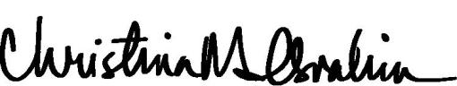

Christina M. Ibrahim

Executive Vice President, General Counsel and Corporate Secretary

Weatherford International plc — 2016 Proxy Statement 59

Back to Contents

ANNEX A –WEATHERFORD INTERNATIONAL PLC EMPLOYEE STOCK PURCHASE PLAN

- Purpose. The purpose of the Plan is to provide employees of the Company and its Designated Subsidiaries and Designated Affiliates with an opportunity to purchase Shares of the Company. This Plan includes two components: a Code Section 423 Component (the “423 Component”) and a non-Code Section 423 Component (the “Non-423 Component”). It is the intention of the Company to have the 423 Component qualify as an “employee stock purchase plan” under Section 423 of the Code. The provisions of the 423 Component, accordingly, shall be construed so as to extend and limit participation in a uniform and nondiscriminatory basis consistent with the requirements of Section 423 of the Code. In addition, this Plan authorizes the grant of purchase rights under the Non-423 Component that does not qualify as an “employee stock purchase plan” under Section 423 of the Code; such purchase rights shall be granted pursuant to rules, procedures or subplans adopted by the Committee designed to achieve tax, securities laws or other objectives for Eligible Employees and the Company. Except as otherwise provided herein, the Non-423 Component will operate and be administered in the same manner as the 423 Component.

- Definitions.

  - “Administrator” means the ESPP Committee, or officer of the Company, as designated by the Board or Committee from time to time. Except as otherwise provided in the Plan, the Board or Committee may assign any of its administrative tasks to the Administrator.

  - “Affiliate” means any Entity that, directly or indirectly, controls, is controlled by, or is under common control with, the Company. For purposes of the preceding sentence, “control” (including, with correlative meanings, the terms “controlled by” and “under common control with”), as used with respect to any Entity, shall mean the possession, directly or indirectly, of the power (a) to vote more than fifty percent (50%) of the securities having ordinary voting power for the election of directors (or other governing body) of the controlled Entity, or (b) to direct or cause the direction of the management and policies of the controlled Entity, whether through the ownership of voting securities, by contract or otherwise.

  - “Beneficial Owner” shall have the meaning set forth in Rule 13d-3 under the Exchange Act.

  - “Board” means the Board of Directors of the Company.

  - “Change in Control” means the occurrence of any event set forth in any one of the following paragraphs:

- any person or Entity is or becomes the Beneficial Owner, directly or indirectly, of twenty percent (20%) or more of either (i) the then outstanding Ordinary Shares of the Company (the “Outstanding Company Ordinary Shares”) or (ii) the combined voting power of the then outstanding voting securities of the Company entitled to vote generally in the election of directors (the “Outstanding Company Voting Securities”), excluding any person or Entity who becomes such a Beneficial Owner in connection with a transaction that complies with clauses (A), (B) and (C) of paragraph (III) below;

- individuals, who, as of the Effective Date, constitute the Board (the “Incumbent Board”) cease for any reason to constitute at least a majority of the Board; provided, however, that any individual becoming a director subsequent to the Effective Date whose election, or nomination for election by the Company’s shareholders, was approved by a vote of at least two-thirds (2/3) of the Incumbent Board shall be considered as though such individual was a member of the Incumbent Board, but excluding, for this purpose, any such individual whose initial assumption of office occurs as a result of an actual or threatened election contest with respect to the election or removal of directors or any other actual or threatened solicitation of proxies or consents by or on behalf of a Person other than the Board;

- the consummation of an acquisition, reorganization, reincorporation, redomestication, merger, amalgamation, consolidation, plan or scheme of arrangement, exchange offer, business combination or similar transaction of the Company or any of its Subsidiaries or the sale, transfer or other disposition of all or substantially all of the Company’s assets (any of which, a “Corporate Transaction”), unless, following such Corporate Transaction or series of related Corporate Transactions, as the case may be, (A) all of the individuals and Entities who were the Beneficial Owners, respectively, of the Outstanding Company Ordinary Shares and Outstanding Company Voting Securities immediately prior to such Corporate Transaction own or beneficially own, directly or indirectly, more than sixty-six and two-thirds percent (66-2/3%) of, respectively, the Outstanding Company Ordinary Shares and the combined voting power of the Outstanding Company Voting Securities entitled to vote generally in the election of directors (or other governing body), as the case may be, of the Entity resulting from such Corporate Transaction (including, without limitation, an Entity (including any new parent Entity) which as a result of such transaction owns the Company or all or substantially all of the Company’s assets either directly or through one (1) or more Subsidiaries or Entities) in substantially the same proportions as their ownership, immediately prior to such Corporate Transaction, of the Outstanding Company Ordinary Shares and the Outstanding Company Voting Securities, as the case may be, (B) no person or Entity (excluding any Entity resulting from such Corporate Transaction or any employee benefit plan (or related trust) of the Company or such Entity resulting from such Corporate Transaction) beneficially owns, directly or indirectly, twenty percent (20%) or more of, respectively, the then outstanding shares of common stock of the Entity resulting from such Corporate Transaction or the combined voting power of the then outstanding voting securities of such Entity except to the extent that such ownership existed prior to the Corporate Transaction and (C) at least a majority of the members of the board of directors (or other governing body) of the Entity resulting from such Corporate Transaction were members of the Incumbent Board at the time of the approval of such Corporate Transaction; or

(IV) approval or adoption by the Board or the shareholders of the Company of a plan or proposal which could result directly or indirectly in the liquidation, transfer, sale or other disposal of all or substantially all of the Company’s assets or the dissolution of the Company, excluding any transaction that complies with clauses (A), (B) and (C) of paragraph (III) above.

Weatherford International plc — 2016 Proxy Statement 60

Back to Contents

ANNEX A –WEATHERFORD INTERNATIONAL PLC EMPLOYEE STOCK PURCHASE PLAN

- “Code” means the U.S. Internal Revenue Code of 1986, as amended from time to time, or any successor statute thereto, and the regulations promulgated thereunder.

- “Committee” means the full Board or a committee of at least two persons who are members of the Board and are appointed by the Board or the Compensation Committee of the Board, or, to the extent it chooses to operate as the Committee, the Compensation Committee of the Board.

- “Company” means Weatherford International plc, an Irish public limited company, or any successor thereto, or any successor or continuing Entity (by acquisition, reorganization, reincorporation, redomestication, merger, amalgamation, consolidation, plan or scheme of arrangement, exchange offer, business combination or similar transaction of the Company or the sale, transfer or other disposition of all or substantially all of the Company’s assets), including its successor issuer for purposes of Rule 414 under the Securities Act of 1933, as amended.

- “Compensation” means base pay but exclusive of overtime pay and regularly paid wage premiums (such as evening or shift premiums), commissions, income from equity compensation awards, bonuses and other compensation, unless otherwise determined by the Committee. The Administrator shall have the discretion to determine the application of this definition to Employees outside the United States.

- “Designated Affiliate” means any Affiliate selected by the Committee as eligible to participate in the Non-423 Component.

- “Designated Subsidiary” means any Subsidiary selected by the Committee as eligible to participate in the 423 Component.

- “Disability” means a permanent and total disability as defined in section 22(e)(3) of the Code. A determination of Disability may be made by a physician selected or approved by the Committee and, in this respect, the Participant shall submit to an examination by such physician upon request by the Committee.

- “Director” means a member of the Board.

- “Effective Date” shall mean the date the Plan becomes effective in accordance with Section 25.

- “Eligible Employee” means (i) any individual who is treated as an active employee in the records of the Company or any Designated Subsidiary or (ii) any individual who is treated as an active employee in the records of the Company or any Designated Affiliate, in each case regardless of any subsequent reclassification by the Company or by any Designated Subsidiary or Designated Affiliate, any governmental agency, or any court; provided, however, in all cases, only as of the first day of the third month, or other period of time determined by the Administrator, following the start of service as an active employee of the Company, Designated Subsidiary, or Designated Affiliate. The Committee, in its discretion, from time to time may, prior to an Offering Date for a particular Offering and for all purchase rights to be granted on such Offering Date under such Offering, determine that the definition of Eligible Employee will or will not include an individual if he or she customarily works not more than twenty (20) hours per week or not more than five (5) months in any calendar year (or, in each case, such lesser period of time as may be determined by the Committee in its discretion), provided that any such exclusion is applied with respect to each Offering in a uniform manner to all similarly-situated employees who otherwise would be Eligible Employees for that Offering, or as may required under local law. For purposes of the 423 Component, the employment relationship shall be treated as continuing intact while the individual is on military or sick leave or other bona fide leave of absence approved by the Company or the Designated Subsidiary so long as the leave does not exceed three (3) months or if longer than three (3) months, the individual’s right to reemployment is provided by statute or has been agreed to by contract or in a written policy of the Company which provides for a right of reemployment following the leave of absence. The employment relationship shall be treated as continuing intact where an Eligible Employee transfers employment between the Company, Designated Subsidiaries and/or Designated Affiliates; provided, however, that an individual who is not employed by the Company or a Designated Subsidiary on the Offering Date and through a date that is no more than three (3) months prior to the Purchase Date will participate only in the Non-423 Component unless the individual continues to have a right to reemployment with the Company or a Designated Subsidiary provided by statute or contract or in a written policy of the Company which provides for a right of reemployment following the leave of absence. The Committee shall establish rules to govern other transfers into the 423 Component, and between any separate Offerings established thereunder, consistent with the applicable requirements of Section 423 of the Code.

- “Entity” means any company, corporation, partnership, association, joint-stock company, limited liability company, trust, unincorporated organization or any other entity or

organization.

- “Exchange Act” means the U.S. Securities Exchange Act of 1934, as amended, from time to time, or any successor law thereto, and the regulations promulgated thereunder.

- “Fair Market Value” means, with respect to the Shares, as of any date, (i) the closing per-share sales price of the Shares (A) as reported by the NYSE composite tape for such date or (B) if the Shares are no longer listed on the NYSE but are listed on any other national stock exchange or national market system, as reported on the stock exchange composite tape for securities traded on such exchange for such date, or, with respect to each of clauses (A) and (B), if there were no sales on such date, on the closest preceding date on which there were sales of Shares, or, (ii) in the event there shall be no public market for the Shares on such date, the fair market value of the Shares as determined in good faith by the Committee upon the reasonable application of a reasonable valuation method.

- “NYSE” means the New York Stock Exchange.

- “Offering” means an offer under the Plan of a purchase right that may be exercised during an Offering Period as further described in Section 2(v). For purposes of this Plan, the Committee may designate separate Offerings under the Plan (the terms of which need not be identical) in which Eligible Employees of one or more Designated Subsidiaries or Designated Affiliates will participate, even if the dates of the applicable Offering Periods of each such Offering are identical.

Weatherford International plc — 2016 Proxy Statement 61

Back to Contents

ANNEX A –WEATHERFORD INTERNATIONAL PLC EMPLOYEE STOCK PURCHASE PLAN

- “Offering Date” means the first Trading Day of each Offering Period.

- “Offering Period” means a period of six months during which a purchase right granted pursuant to the Plan may be offered, or such different period for the offer of the purchase right as may be established by the Committee. In no event shall an Offering Period exceed 27 months. The duration and timing of Offering Periods may be changed pursuant to Section 4. It is the intent of the Company that the initial Offering Period will be the six-month period ending February 28, 2017.

- “Ordinary Share” or “Ordinary Shares” means an ordinary share or ordinary shares of the Company, nominal value $0.001 per ordinary share.

- “Parent” means a “parent corporation” of the Company whether now or hereinafter existing as defined in Section 424(e) of the Code.

- “Participant” means any Eligible Employee who participates in the Plan as described in Section 5.

- “Participation Election” means any written agreement, enrollment form, contract or other instrument or document (in each case in paper or electronic form) evidencing that an Eligible Employee has elected to become a Participant in the Plan, which may, but need not, require execution by a Participant.

- “Plan” means the Weatherford International plc Employee Stock Purchase Plan, including both the 423 Component and the Non-423 Component.

- “Purchase Date” means the last Trading Day of each Offering Period.

- “Purchase Price” means a per-Share amount to be paid by a Participant to purchase a Share on the Purchase Date. Such Purchase Price shall be established in the manner initially specified by the Committee and in effect thereafter unless otherwise changed by the Committee, for each Offering prior to an Offering Period and shall be no less than the lower of (i) ninety percent (90%) of the Fair Market Value of a Share on the Offering Date for the relevant Offering Period or (ii) ninety percent (90%) of the Fair Market Value of a Share on the Purchase Date for the relevant Offering Period. Such Purchase Price may be established by the Committee by any manner or method the Committee determines, pursuant to Section 16, and subject to (i) with respect to the 423 Component, compliance with Section 423 of the Code (or any successor rule or provision or any other applicable law, regulation or stock exchange rule) or (ii) with respect to the Non-423 Component, pursuant to such manner or method as determined by the Committee to comply with applicable local law.

- “Share” means a Ordinary Share or Ordinary Shares, or, in the event that the Ordinary Shares are later changed into or exchanged for a different class of shares or securities of the Company or another Entity, that other share or security. Shares may be represented by a certificate or by book or electronic entry.

- “Subsidiary” means a “subsidiary corporation” of the Company whether now or hereafter existing, as defined in Section 424(f) of the Code.

- “Trading Day” means a day on which the NYSE is open for trading.

- Eligibility. Any Eligible Employee on a given Offering Date shall be eligible to participate in the Plan, provided, however, that employees who are citizens or residents of a non-

U.S. jurisdiction may be excluded from participation in the Plan or an Offering if the participation of such Employees is prohibited under the laws of the applicable jurisdiction or if complying with the laws of the applicable jurisdiction would cause the Plan or an Offering to violate Section 423 of the Code. Further, notwithstanding any provisions of the Plan to the contrary, no Eligible Employee may be granted a purchase right under the 423 Component of the Plan (i) to the extent that, immediately after the grant, such Eligible Employee (or any other person whose stock would be attributed to such Eligible Employee pursuant to Section 424(d) of the Code) would own capital stock of the Company and/or hold outstanding purchase rights to purchase capital stock possessing five percent (5%) or more of the total combined voting power or value of all classes of the capital stock of the Company or of any Subsidiary, or (ii) to the extent that his or her rights to purchase capital stock under all employee stock purchase plans of the Company and its subsidiaries accrues at a rate that exceeds Twenty-Five Thousand Dollars (US$25,000) worth of such stock (determined at the Fair Market Value of the shares of such stock at the time such purchase right is granted) for each calendar year in which such purchase right is both outstanding and exercisable.

- Offering Periods. The first Offering Period under the Plan will commence on September 1, 2016 and will end on February 28, 2017. Subsequently, the Plan shall be implemented by consecutive six-month Offering Periods with a new Offering Period commencing on the first Trading Day on or after March 1, and September 1, or on such other date as the Committee shall determine, and continuing thereafter to the last Trading Day of the respective six-month period or until terminated in accordance with Section 20. Within the limitations set forth in Section 2(v), the Committee shall have the power to change the duration of Offering Periods (including the commencement dates thereof) with respect to future offerings without stockholder approval if such change is announced prior to the scheduled beginning of the first Offering Period to be affected thereafter.

- Participation. An Eligible Employee may become a Participant in the Plan by completing, within any prescribed enrollment period prior to the applicable Offering Date, a Participation Election (electronic or otherwise) and/or any other forms and following any procedures for enrollment in the Plan as may be established by the Administrator from time to time.

- Payroll Deductions or Contributions.

  - At the time a Participant completes any Participation Election, enrollment form and/or procedure to enroll in the Plan, as provided in Section 5, he or she shall elect to have payroll deductions made on each pay day during the Offering Period in an amount not exceeding 10% of the Compensation that he or she receives on each pay day during the Offering Period, provided, that should a pay day occur on a Purchase Date, a Participant shall have the payroll

Weatherford International plc — 2016 Proxy Statement 62

Back to Contents

ANNEX A –WEATHERFORD INTERNATIONAL PLC EMPLOYEE STOCK PURCHASE PLAN

deductions made on such day applied to his or her account under the new Offering Period, unless otherwise provided by the Administrator and subject to withdrawal by the Participant as provided in Section 10. The Administrator may permit Eligible Employees participating in a specified Offering to contribute amounts to the Plan through payment by cash, check or other means to comply with non-U.S. requirements, provided, that such contributions shall not exceed 10% of the Compensation received each pay period, during the Offering Period. A Participant’s enrollment in the Plan shall remain in effect for successive Offering Periods unless terminated as provided in Section 10.

  - Payroll deductions or contributions, as applicable, for a Participant shall commence on the first pay day following the Offering Date and shall end on the last pay day in the Offering Period to which such authorization is applicable (subject to subsection 6(a)), unless sooner terminated by the Participant as provided in Section 10.

  - A Participant may withdraw his or her participation in the Plan as provided in Section 10 by completing any forms and following any procedures for withdrawal from the Plan as may be established by the Administrator from time to time. Further, the Participant may increase or decrease payroll deductions or contributions by completing any form or following any procedure established by the Administrator from time to time.

  - At the time that Shares are purchased under the Plan, or at the time some or all of the Company’s Shares issued under the Plan are disposed of, the Participant must make adequate provision for the Company’s or its Subsidiary’s or Affiliate’s federal, state, or any other tax liability payable to any authority, national insurance, social security, payment-on-account or other tax obligations, if any, which arise as a result of participation in the Plan, including, for the avoidance of doubt, any liability of the Participant to pay an employer tax or social insurance contribution obligation, which liability has been shifted to the Participant as a matter of law or contract. At any time, the Company or its Subsidiary or Affiliate, as applicable, may, but shall not be obligated to, withhold from the Participant’s compensation the amount necessary for the Company or its Subsidiary or Affiliate, as applicable, to meet applicable withholding obligations, including any withholding required to make available to the Company or its Subsidiary or Affiliate, as applicable, any tax deductions or benefits attributable to sale or early disposition of Shares by the Eligible Employee. In addition, the Company or its Subsidiary or Affiliate, as applicable, may withhold from the proceeds of the sale of Shares, may withhold a sufficient whole number of Shares otherwise issuable following purchase having an aggregate fair market value sufficient to pay applicable withholding obligations or may withhold by any other means set forth in the applicable Participation Election. Where necessary to avoid negative accounting treatment, the Company or its Subsidiary or Affiliate shall withhold taxes at the applicable statutory minimum withholding rates.

- Grant of Purchase Right. On the Offering Date of each Offering Period, each Eligible Employee participating in such Offering Period shall be granted a purchase right to purchase on each Purchase Date during such Offering Period (at the applicable Purchase Price) up to a number of Shares determined by dividing such Eligible Employee’s payroll deductions or contributions accumulated prior to such Purchase Date by the applicable Purchase Price; provided, however, that in no event shall an Eligible Employee be permitted to purchase during each Offering Period more than 20,000 Shares subject to adjustment pursuant to Section 15, and provided further that such purchase shall be subject to the limitations set forth in Sections 3 and 14. The Committee may, for future Offering Periods, increase or decrease, in its absolute discretion, the maximum number of Shares that an Eligible Employee may purchase during each Offering Period. The purchase of Shares pursuant to the purchase right shall occur as provided in Section 8, unless the Participant has withdrawn pursuant to Section 10. Each purchase right expires on the last day of the Offering Period.

- Purchase of Shares.

  - Unless a Participant withdraws from the Plan as provided in Section 10 , on the Purchase Date, the maximum whole number of Shares, as may be purchased with the Participant's accumulated payroll deductions or contributions shall be purchased for such Participant at the applicable Purchase Price, subject to the limitations in Section 7 and Section 8(b). Any payroll deductions or contributions accumulated in a Participant’s account which are not sufficient to purchase a full Share shall, at the discretion of the Committee, be returned to the Participant or be retained in the Participant’s account for the subsequent Offering Period, subject to earlier withdrawal by the Participant as provided in Section 10. During a Participant’s lifetime, Shares may be purchased pursuant to the Participant’s purchase right only by the Participant.

  - No Participant of the Plan is permitted to purchase shares under all employee stock purchase plans of the Company and its subsidiaries at a rate that exceeds $25,000 in Fair Market Value (determined at time the purchase right is granted) for each calendar year in which any stock purchase right is both outstanding and exercisable.

  - If the Company determines that, on a given Purchase Date, the number of Shares with respect to which purchase rights are to be exercised may exceed (i) the number of Shares that were available for sale under the Plan on the Offering Date of the applicable Offering Period, or (ii) the number of Shares available for sale under the Plan on such Purchase Date, the Company shall make a pro-rata allocation of the Shares available for purchase on such Purchase Date in as uniform a manner as shall be practicable to be equitable among all Participants exercising purchase rights on such Purchase Date. The Company may make a pro-rata allocation of the Shares available on the Offering Date of any applicable Offering Period pursuant to the preceding sentence, notwithstanding any authorization of additional Shares for issuance under the Plan by the Company’s shareholders subsequent to such Offering Date. In such event, any residual payroll deductions or contributions accumulated in a Participant’s account which are not used to purchase Shares shall be promptly refunded to the relevant Participant or beneficiary, as applicable.

- Delivery. By enrolling in the Plan, each Participant shall be deemed to have authorized the establishment of a brokerage account on his or her behalf at a securities brokerage firm selected by the Company. Alternatively, the Company may provide for Plan share accounts for each Participant to be established by the Company or by an outside entity selected by the Committee which is not a brokerage firm. As soon as reasonably practicable after each Purchase Date on which a purchase of Shares occurs, the Company shall arrange for the delivery to each Participant of the Shares purchased upon exercise of

Weatherford International plc — 2016 Proxy Statement 63

Back to Contents

ANNEX A –WEATHERFORD INTERNATIONAL PLC EMPLOYEE STOCK PURCHASE PLAN

his or her purchase right to the Participant’s brokerage or Plan share account in a form determined by the Company. Notwithstanding any other provision of the Plan, unless otherwise determined by the Administrator or required by any applicable law, rule or regulation, the Company shall not deliver to any Participant certificates evidencing Shares issued in connection with any purchase under the Plan, and instead such Shares shall be recorded in the books of the brokerage firm or, as applicable, the Company, its transfer agent, stock plan administrator or such other outside entity which is not a brokerage firm.

- Withdrawal.

  - A Participant may decide not to purchase Shares on a given Purchase Date and opt to withdraw all, but not less than all, the payroll deductions or contributions credited to his or her account and not yet used to purchase Shares under the Plan at any time by giving notice in a form or manner prescribed by the Administrator from time to time, except that no withdrawals shall be permitted within the thirty (30) day period immediately preceding each Purchase Date, or as may be specified by the Administrator in its discretion. All of the Participant’s payroll deductions or contributions credited to his or her account shall, at the discretion of the Administrator, (i) be retained in Participant’s account and used to purchase Shares at the next Purchase Date, or (ii) be paid to such Participant as soon as reasonably practicable after receipt of notice of withdrawal and such Participant’s purchase right for the Offering Period shall be terminated automatically, and no further payroll deductions or contributions for the purchase of Shares shall be made for such Offering Period. If a Participant withdraws from an Offering Period, payroll deductions or contributions shall not resume at the beginning of the succeeding Offering Period unless he or she satisfactorily completes the process to re-enroll in the Plan as prescribed by the Administrator from time to time.

  - A Participant’s withdrawal from an Offering Period shall not have any effect upon his or her eligibility to participate in any similar plan that may hereafter be adopted by the Company or in succeeding Offerings which commence after the termination of the Offering Period from which he or she has withdrawn.

- No Right to Employment. Participation in the Plan by a Participant shall not be construed as giving a Participant the right to be retained as an employee of the Company, a Subsidiary, or an Affiliate, as applicable. Furthermore, the Company, a Subsidiary, or an Affiliate may dismiss a Participant from employment at any time, free from any liability or any claim under the Plan.

- Termination of Employment. Unless otherwise determined by the Administrator, upon a Participant’s ceasing to be an Eligible Employee, due to termination of employment for any reason (other than death or Disability), he or she shall be deemed to have elected to withdraw from the Plan and the payroll deductions or contributions credited on behalf of the Participant during the Offering Period but not yet used to purchase Shares under the Plan shall be returned to such Participant and such Participant’s purchase right shall be terminated automatically. Unless otherwise determined by the Administrator, upon a Participant’s ceasing to be an Eligible Employee, due to termination of employment on account of death or Disability, the Participant or, in the case of his or her death, the person or persons entitled thereto under Section 17 may elect to (i) purchase Shares on the next applicable Purchase Date, as may be purchased with the accumulated payroll deductions or contributions in the Participant’s account in accordance with the terms of the Plan and Section 8 or, (ii) elect to withdraw from the Plan as described in this Section 12.

- Interest. No interest will accrue on the contributions of a Participant in the Plan, except as may be required by applicable law, as determined by the Administrator.

- Shares Available for Purchase under the Plan.

  - Basic Limitation. Subject to adjustment pursuant to Section 15, the aggregate number of Shares authorized for sale under the Plan is twelve million (12,000,000) Shares. The limitation set forth in this section may be used to satisfy purchases of Shares under either the 423 Component or the Non-423 Component.

  - Rights as an Unsecured Creditor. Until the Shares are issued (as evidenced by the appropriate entry on the books of the Company or of a duly-authorized transfer agent of or broker selected by the Company), a Participant shall only have the rights of an unsecured creditor with respect to such Shares, and no right to vote or receive dividends or any other rights as a stockholder shall exist with respect to such Shares.

  - Sources of Shares Deliverable at Purchase. Any Shares issued after purchase may consist, in whole or in part, of authorized and unissued Shares, previously issued Shares acquired by the Company and held as treasury shares, or shares purchased on the open market.

  - No Fractional Shares. No fractional shares shall be issued or acquired pursuant to the Plan. If the application of any Plan provision would yield a fractional share, such fractional share shall be rounded down to the next whole share.

- Adjustments for Changes in Capitalization and Similar Events.

  - Changes in Capitalization. Subject to any required action by the shareholders of the Company, the maximum number of Shares that shall be made available for sale under the Plan, the maximum number of Shares that each Participant may purchase during the Offering Period (pursuant to Section 7) or over a calendar year under the $25,000 limitation (pursuant to Section 8(b)) and the per Share price used to determine the Purchase Price shall be proportionately adjusted for any increase or decrease in the number of issued Shares resulting from any nonreciprocal transaction between the Company and its shareholders, (such as a stock dividend, stock split, spin-off, rights offering or recapitalization through a large, nonrecurring cash dividend), that affects the Shares (or other securities of the Company) or the price of Shares (or other securities) and causes a change in the per share value of the Shares underlying outstanding purchase rights. Such adjustment shall be made by the Committee, whose determination in that respect shall be final, binding and conclusive. The Committee may not delegate its authority to make adjustments pursuant to this paragraph. Except as expressly provided herein, no issuance by the Company of shares of stock of any class, or securities convertible into shares of stock of any class, shall affect, and no adjustment by reason thereof shall be made with respect to, the number or price of Shares subject to a purchase right.

Weatherford International plc — 2016 Proxy Statement 64

Back to Contents

ANNEX A –WEATHERFORD INTERNATIONAL PLC EMPLOYEE STOCK PURCHASE PLAN

    - Dissolution or Liquidation. In the event of the proposed dissolution or liquidation of the Company as contemplated by Section 2(e)(iv), the Offering Period then in progress shall be shortened by setting a new Purchase Date (the “New Purchase Date”), and shall terminate immediately prior to the consummation of such proposed dissolution or liquidation, unless provided otherwise by the Company. The New Purchase Date shall be before the date of the Company’s proposed dissolution or liquidation. The Company shall notify each Participant in writing, at least ten
- U.S. business days prior to the New Purchase Date, that the Purchase Date for the Participant’s purchase right has been changed to the New Purchase Date and that Shares shall be purchased automatically for the Participant on the New Purchase Date, unless prior to such date the Participant has withdrawn from the Offering Period as provided in Section 10.

    - Change in Control. In the event of a Change in Control, each outstanding purchase right shall be assumed or an equivalent purchase right substituted by the successor corporation or a Parent or Subsidiary of the successor corporation. In the event that the successor corporation refuses to assume or substitute for the purchase right, the Offering Period then in progress shall be shortened by setting a New Purchase Date and shall end on the New Purchase Date. The New Purchase Date shall be before the date of the Company’s proposed merger or Change in Control. The Company shall notify each Participant in writing, at least ten (10) U.S. business days prior to the New Purchase Date, that the Purchase Date for the Participant’s purchase right has been changed to the New Purchase Date and that Shares shall be purchased automatically for the Participant on the New Purchase Date, unless prior to such date the Participant has withdrawn from the Offering Period as provided in Section 10.

  - Administration.

    - Authority of the Committee. Subject to the terms of the Plan and applicable law, and in addition to other express powers and authorizations conferred on the Committee by the Plan, the Committee shall have sole and plenary authority to administer the Plan, including, without limitation, the authority to:

- construe, interpret, reconcile any inconsistency in, correct any default in and supply any omission in, and apply the terms of the Plan and any Participation Election or other instrument or agreement relating to the Plan;

- determine eligibility and adjudicate all disputed claims filed under the Plan, including whether Eligible Employees shall participate in the 423 Component or the Non-423 Component and which entities shall be Designated Subsidiaries or Designated Affiliates;

- determine the terms and conditions of any purchase right to purchase Shares under the Plan;

(IV) establish, amend, suspend or waive such rules and regulations and appoint such agents as it shall deem appropriate for the proper administration of the Plan;

  - amend an outstanding purchase right or grant a replacement purchase right for a purchase right previously granted under the Plan if, in the Committee’s discretion, it determines that

- the tax consequences of such purchase right to the Company or the Participant differ from those consequences that were expected to occur on the date the purchase right was granted, or

- clarifications or interpretations of, or changes to, tax law or regulations permit purchase rights to be granted that have more favorable tax consequences other than initially anticipated; and

(VI) make any other determination and take any other action that the Committee deems necessary or desirable for the administration of the Plan.

Notwithstanding any provision to the contrary in this Plan, the Committee may adopt rules or procedures relating to the operation and administration of the Plan to accommodate the specific requirements of local laws and procedures for jurisdictions outside of the United States. Without limiting the generality of the foregoing, the Committee specifically is authorized to adopt rules, procedures and subplans, which, for purposes of the Non-423 Component, may be outside the scope of Section 423 of the Code, regarding, without limitation, eligibility to participate, the definition of Compensation, handling of payroll deductions, making of contributions to the Plan (including, without limitation, in forms other than payroll deductions), establishment of bank or trust accounts to hold payroll deductions, payment of interest, conversion of local currency, obligations to pay payroll tax, withholding procedures and handling of Share issuances, which may vary according to local requirements. The Committee may assign any of its administrative tasks set forth in this paragraph to the Administrator, including the designation of a Designated Affiliate or Designated Subsidiary under the Plan, unless constrained by applicable law. However, the Committee may not delegate its authority to make adjustments pursuant to Section 15(a).

- Committee Decisions. Unless otherwise expressly provided in the Plan, all designations, determinations, interpretations and other decisions under or with respect to the Plan or any right to purchase Shares granted under the Plan made by the Committee or its delegate, including, but not limited to decisions of the Administrator in fulfilling its duties under the Plan, shall be final, conclusive, and binding upon all persons, including the Company, Designated Subsidiary, Designated Affiliate, Participant, Eligible Employee, or any beneficiary of such person, as applicable.

- Indemnification. To the extent allowable pursuant to applicable law, each member of the Board, the Committee, the Administrator or any employee of the Company, a Designated Subsidiary, or a Designated Affiliate (each such person, a “Covered Person”) shall be indemnified and held harmless by the Company from any loss, cost, liability, or expense that may be imposed upon or reasonably incurred by such Covered Person in connection with or resulting from any claim, action, suit, or proceeding to which he or she may be a party or in which he or she may be involved by reason of any action or failure to act pursuant to the Plan and against and from any and all amounts paid by him or her in satisfaction of judgment in such action, suit, or proceeding against him or her; provided, however, that he or she has acted in accordance with his or her duties and responsibilities to the Company under applicable law, and provided that he or she gives the Company an opportunity, at its own expense, to handle and defend any claim, action, suit, or proceeding to which he or she is a party

Weatherford International plc — 2016 Proxy Statement 65

Back to Contents

ANNEX A –WEATHERFORD INTERNATIONAL PLC EMPLOYEE STOCK PURCHASE PLAN

before he or she undertakes to handle and defend it on his or her own behalf. The foregoing right of indemnification shall not be exclusive of any other rights of indemnification to which such Covered Persons may be entitled pursuant to the Company’s Memorandum of Association or Articles of Association, as a matter of law, or otherwise, or any power that the Company may have to indemnify them or hold them harmless.

- Death. Unless otherwise provided in an enrollment form or procedures established by the Administrator from time to time, in the event of the Participant’s death, any accumulated payroll deductions and other contributions not used to purchase Shares shall be paid to and any Shares credited to his or her brokerage or Plan share account shall be transferred to Participant’s heirs or estate as soon as reasonably practicable following the Participant’s death.

- Transferability. Payroll deductions, contributions credited to a Participant’s account and any rights with regard to the purchase of Shares pursuant to a purchase right or to receive Shares under the Plan may not be assigned, alienated, pledged, attached, sold or otherwise disposed of in any way (other than by will, the laws of descent and distribution or as provided in Section 17) by the Participant. Any such attempt at assignment, transfer, pledge or other disposition shall be without effect, except that the Company may treat such act as an election to withdraw funds from an Offering Period in accordance with Section 10.

- Use of Funds. All payroll deductions or contributions received or held by the Company under the Plan may be used by the Company for any corporate purpose, and the Company shall not be obligated to segregate such payroll deductions or contributions except as may be required by applicable local law, as determined by the Administrator, and if so required by the laws of a particular jurisdiction, shall apply to all Participants in the relevant Offering except to the extent otherwise permitted by U.S. Treasury Regulation Section 1.423-2(f). Until Shares are issued, Participants shall only have the rights of an unsecured creditor, although Participants in specified Offerings may have additional rights where required under local law, as determined by the Administrator.

- Amendment and Termination.

  - Subject to any applicable law or government regulation and to the rules of the NYSE or any successor exchange or quotation system on which the Shares may be listed or quoted, the Plan may be amended, modified, suspended or terminated by the Board without the approval of the shareholders of the Company. This termination authority may not be delegated. Except as provided in Section 15, no amendment may make any change in any purchase right previously granted which adversely affects the rights of any Participant or any beneficiary (as applicable) without the consent of the affected Participant or beneficiary. To the extent necessary to comply with Section 423 of the Code (or any successor rule or provision or any other applicable law, regulation or stock exchange rule), the Company shall obtain shareholder approval of any amendment in such a manner and to such a degree as required.

  - Without shareholder approval and without regard to whether any Participant rights may be considered to have been “adversely affected,” the Committee or its delegate, including the Administrator, in each case to the extent permitted under the terms of the Plan, applicable law, the Articles of Association of the Company and under the Committee Charter, may change the Offering Periods, limit the frequency or number of changes in the amount withheld during an Offering Period, establish the exchange rate applicable to amounts withheld in a currency other than U.S. dollars, permit payroll withholding in excess of the amount designated by a Participant to adjust for delays or mistakes in the Company’s processing of properly completed Participant elections, establish reasonable waiting and adjustment periods and/or accounting and crediting procedures to ensure that amounts applied toward the purchase of Shares for each Participant properly correspond with amounts withheld from the Participant’s Compensation, and establish such other limitations or procedures as the Committee deems appropriate.

- Notices. All notices or other communications by a Participant to the Company under or in connection with the Plan shall be deemed to have been duly given when received in the form and manner specified by the Administrator at the location, or by the person, designated by the Administrator for the receipt thereof.

- Conditions Upon Issuance of Shares.

  - Shares shall not be issued with respect to a purchase right unless the purchase of Shares pursuant to such purchase right and the issuance and delivery of such Shares comply with all applicable law. This may include, without limitation U.S. and non-U.S. and state and local rules and regulations promulgated under U.S. securities laws, and the requirements of any stock exchange upon which the Shares may then be listed. Share issuance is subject to the approval of counsel for the Company with respect to such compliance. In the event that any payroll deductions or contributions cannot be used to purchase shares due to noncompliance with applicable rules and regulations, such payroll deductions or contributions shall be promptly refunded to the relevant Participant or beneficiary, as applicable.

  - As a condition to the purchase of Shares pursuant to a purchase right, the Company may require the person on whose behalf Shares are purchased to represent and warrant at the time of any such purchase that the Shares are being purchased only for investment and without any present intention to sell or distribute such Shares if, in the opinion of counsel for the Company, such a representation is required by any of the applicable provisions of law described in subsection (a) above.

- Share Issuance. All Shares delivered under the Plan pursuant to the exercise of a purchase right to purchase Shares shall be subject to such stop-transfer orders and other restrictions as the Company may deem advisable under the Plan or the rules, regulations, and other requirements of the U.S. Securities and Exchange Commission, the NYSE or any other stock exchange or quotation system upon which such Shares or other securities are then listed or reported and any applicable Federal or state laws, and the Company may take whatever steps are necessary to effect such restrictions.

- Term of Plan. The Plan shall terminate on the earlier of (i) the date the Plan is terminated by the Board in accordance with Section 20 and (ii) the date on which all purchase rights are exercised in connection with a dissolution or liquidation pursuant to Section 15(b) or Change in Control pursuant to Section 15(c). No further purchase rights shall be granted or Shares purchased, and no further payroll deductions or contributions shall be collected under the Plan following such termination.

Weatherford International plc — 2016 Proxy Statement 66

Back to Contents

ANNEX A –WEATHERFORD INTERNATIONAL PLC EMPLOYEE STOCK PURCHASE PLAN

- Shareholder Approval. The Plan will become effective upon approval by the Board. The Plan will be presented for approval by the Company shareholders at the 2016 Annual Shareholder meeting. The Plan shall not be offered to Eligible Employees prior to approval by the Company shareholders.

- Code Section 409A; Tax Qualification.

  - Purchase rights granted under the 423 Component are exempt from the application of Section 409A of the Code. Purchase rights granted under the Non-423 Component to U.S. taxpayers are intended to be exempt from the application of Section 409A under the short-term deferral exception and any ambiguities shall be construed and interpreted in accordance with such intent. Subject to Section 26(b), purchase rights granted to U.S. taxpayers under the Non-423 Component are subject to such terms and conditions that will permit such purchase rights to satisfy the requirements of the short-term deferral exception available under Section 409A of the Code, including the requirement that the Shares subject to a purchase right be delivered within the short-term deferral period. Subject to Section 26(b), in the case of a Participant who would otherwise be subject to Section 409A of the Code, to the extent the Company determines that a purchase right or the exercise, payment, settlement or deferral is subject to Section 409A of the Code, the purchase right shall be granted, exercised, paid, settled or deferred in a manner that will comply with Section 409A of the Code, including Department of Treasury regulations and other interpretive guidance issued thereunder, including without limitation any such regulations or other guidance that may be issued after the Effective Date. Anything in the foregoing to the contrary notwithstanding, the Company shall have no liability to a Participant or any other party if the purchase right that is intended to be exempt from, or compliant with Section 409A of the Code is not so exempt or compliant or for any action taken by the Company with respect thereto.

  - Although the Company may endeavor to (i) qualify a purchase right for favorable tax treatment under the laws of the U.S. or jurisdictions outside of the U.S. or (ii) avoid adverse tax treatment (e.g., under Section 409A of the Code), the Company makes no representation to that effect and expressly disavows any covenant to maintain favorable or avoid unfavorable tax treatment, notwithstanding anything to the contrary in this Plan, including Section 26(a). The Company is not constrained in its corporate activities by any potential negative tax impact on Participants under the Plan.

- Severability. If any particular provision of this Plan is found to be invalid or otherwise unenforceable, such determination shall not affect the other provisions of the Plan, but the Plan shall be construed in all respects as if such invalid provision were omitted.

- Governing Law and Jurisdiction. The validity, construction and effect of the Plan and any rules and regulations relating to the Plan shall be determined in accordance with applicable United States federal law and the laws of the State of Texas, without regard to any conflict of laws principles, except to the extent that the laws of Ireland mandatorily apply.

- Headings. Headings are given to the Sections and subsections of the Plan solely as a convenience to facilitate reference. Such headings shall not be deemed in any way material or relevant to the construction or interpretation of the Plan.

*****

Weatherford International plc — 2016 Proxy Statement 67

Back to Contents





Designed by www.oakwoodagency.com

Prepared by www.argyle.company

WEATHERFORD INTERNATIONAL PLC

ATTN: CHRISTINA M. IBRAHIM
BAHNHOFSTRASSE 1

6340 BAAR, SWITZERLAND

VOTE BY INTERNET - www.proxyvote.com

Use the Internet to transmit your voting instructions and for electronic delivery of information up until 5:59 A.M. Central European Time on June 14, 2016 (11:59 P.M. New York Time on June 13, 2016 ). Have your proxy card in hand when you access the web site and follow the instructions to obtain your records and to create an electronic voting instruction form.

VOTE BY PHONE - 1-800-690-6903

Use any touch-tone telephone to transmit your voting instructions up until 5:59 A.M. Central European Time on June 14, 2016 (11:59 P.M. New York Time on June 13, 2016 ). Have your proxy card in hand when you call and then follow the instructions.

VOTE BY MAIL

Mark, sign and date your proxy card and return it in the postage-paid envelope we have provided or return it to Vote Processing, c/o Broadridge, 51 Mercedes Way, Edgewood, NY 11717.

TO VOTE, MARK BLOCKS BELOW IN BLUE OR BLACK INK AS FOLLOWS:
E06909-P78330 KEEP THIS PORTION FOR YOUR RECORDS
DETACH AND RETURN THIS PORTION ONLY
THIS PROXY CARD IS VALID ONLY WHEN SIGNED AND DATED.


WEATHERFORD INTERNATIONAL PLC

The Board of Directors recommends you vote FOR the following proposals:

- By separate resolutions, to elect the ten individuals named in the Proxy Statement as directors of Weatherford International plc (the “Company”) until the 2017 annual general meeting of shareholders of the Company or, in each case, until his earlier death, retirement, resignation or removal from the position of director:

Nominees: |  | For Against Abstain
1a. | Mohamed A. Awad | ☐ | ☐ | ☐
1b. | David J. Butters | ☐ | ☐ | ☐
1c. | Dr. Bernard J. Duroc-Danner | ☐ | ☐ | ☐
1d. | John D. Gass | ☐ | ☐ | ☐
1e. | Sir Emyr Jones Parry | ☐ | ☐ | ☐
1f. | Francis S. Kalman | ☐ | ☐ | ☐
1g. | William E. Macaulay | ☐ | ☐ | ☐
1h. | Robert K. Moses, Jr. | ☐ | ☐ | ☐
1i. | Dr. Guillermo Ortiz | ☐ | ☐ | ☐
1j. | Robert A. Rayne | ☐ | ☐ | ☐

 |  | For | Against | Abstain
2. | To ratify the appointment of KPMG LLP as the Company's ☐ |  | ☐ | ☐
 | independent registered public accounting firm and auditor for the
 | financial year ending December 31, 2016, and KPMG Chartered
 | Accountants, Dublin, as the Company's statutory auditor under Irish
 | Law to hold office until the close of the 2017 AGM, and to authorize
 | the Board of Directors of the Company, acting through the Audit
 | Committee, to determine the auditor’s remuneration.
3. | To adopt an advisory resolution approving the compensation of the | ☐ | ☐ | ☐
 | named executive officers.
4. | To approve the Weatherford International plc Employee Stock | ☐ | ☐ | ☐
 | Purchase Plan (the “ESPP”).

The foregoing items, including the votes required in respect of each, are more fully described (and the full text of each proposal is set out) in the accompanying Proxy Statement.

Please sign exactly as your name(s) appear(s) hereon. When signing as attorney, executor, administrator, or other fiduciary, please give full title as such. Joint owners should each sign personally. All holders must sign. If a corporation or partnership, please sign in full corporate or partnership name by authorized officer.

Signature [PLEASE SIGN WITHIN BOX] Date Signature (Joint Owners) Date

Important Notice Regarding the Availability of Proxy Materials for the Annual General Meeting:

The Notice and Proxy Statement, Annual Report and Irish Statutory Accounts are available at www.proxyvote.com.

E06910-P78330


WEATHERFORD INTERNATIONAL PLC

Annual General Meeting of Shareholders
June 15, 2016 10:00 A.M. (Central European Time)
This proxy is solicited by the Board of Directors

The undersigned shareholder of Weatherford International plc ("Weatherford") hereby appoints Christina M. Ibrahim or, failing her, Bernard J. Duroc-Danner as proxy, each with the power of substitution, for the undersigned to vote the number of ordinary shares of Weatherford that the undersigned would be entitled to vote if personally present at the Annual General Meeting of Shareholders of Weatherford to be held on June 15, 2016, at 10:00 A.M. (Central European Time) at The Mandarin Oriental Hotel, Quai Turrettini 1, 1201 Geneva, Switzerland, and any adjournment or postponement thereof, on the reverse side matters that are more particularly described in the Proxy Statement for the Annual General Meeting. The undersigned hereby revokes all proxies previously given by the undersigned to vote at the Annual General Meeting.

This proxy card, when properly executed, will be voted in the manner directed by the undersigned shareholder on the reverse side of this proxy card. IF NO DIRECTION IS MADE, THESE SHARES WILL BE VOTED "FOR" EACH OF THE PROPOSALS TO BE CONSIDERED AT THE ANNUAL GENERAL MEETING. In the event other matters properly come before, or are raised at, the Annual General Meeting on which a vote is or may be taken, you instruct and authorize the Proxy Holders to vote the shares in their own discretion on such other matters.

The undersigned hereby acknowledges receipt of Notice of, and the Proxy Statement for, the Annual General Meeting.

Continued and to be signed on reverse side

