Table of Contents

As filed with the Securities and Exchange Commission on | , 2017
Registration No. 333-

Registration No. 333-

Registration No. 333-

UNITED STATES

SECURITIES AND EXCHANGE COMMISSION

Washington, D.C. 20549

FORM S-3

REGISTRATION STATEMENT

UNDER
THE SECURITIES ACT OF 1933

Weatherford International public limited company

 | (Exact name of registrant as specified in its charter)
Ireland | 98-0606750
(State or other jurisdiction of |  |  | (I.R.S. Employer
incorporation or organization) |  |  | Identification Number)

Bahnhofstrasse 1, 6340 Baar, Switzerland

(Address, including zip code, and telephone number, including area code, of registrant’s principal executive offices)

Weatherford International Ltd. | Weatherford International, LLC
(Exact name of co-registrant as specified in its charter) | (Exact name of co-registrant as specified in its charter)
Bermuda | Delaware
(State or other jurisdiction of incorporation or organization) | (State or other jurisdiction of incorporation or organization)
98-0371344 | 33-0430755
(I.R.S. Employer Identification Number) | (I.R.S. Employer Identification Number)
2000 St. James Place, Houston, Texas 77056 | 2000 St. James Place, Houston, Texas 77056
(713) 836-4000 | (713) 836-4000
(Address, including zip code, and telephone number, including area code, | (Address, including zip code, and telephone number, including area code,
of co-registrant’s principal executive offices) | of co-registrant’s principal executive offices)

Christina M. Ibrahim

Weatherford International plc

Executive Vice President, General Counsel and Corporate Secretary

2000 St. James Place

Houston, Texas 77056

(713) 836-4000

(Name, address, including zip code, and telephone number, including area code, of agent for service)

With a copy to:

Sean T. Wheeler

John M. Greer

Latham & Watkins LLP

811 Main Street, Suite 3700

Houston, Texas 77002

(713) 546-5400

Approximate date of commencement of proposed sale to the public: From time to time after the effective date of this Registration Statement.

If the only securities being registered on this Form are being offered pursuant to dividend or interest reinvestment plans, please check the following box. ☐

If any of the securities being registered on this Form are to be offered on a delayed or continuous basis pursuant to Rule 415 under the Securities Act of 1933, other than securities offered only in connection with dividend or interest reinvestment plans, check the following box. ☒

If this Form is filed to register additional securities for an offering pursuant to Rule 462(b) under the Securities Act, please check the following box and list the Securities Act registration statement number of the earlier effective registration statement for the same offering. ☐

If this Form is a post-effective amendment filed pursuant to Rule 462(c) under the Securities Act, check the following box and list the Securities Act registration statement number of the earlier effective registration statement for the same offering. ☐

If this Form is a registration statement pursuant to General Instruction I.D. or a post-effective amendment thereto that shall become effective upon filing with the Commission pursuant to Rule 462(e) under the Securities Act, check the following box. ☐

If this Form is a post-effective amendment to a registration statement filed pursuant to General Instruction I.D. filed to register additional securities or additional classes of securities pursuant to Rule 413(b) under the Securities Act, check the following box. ☐

Table of Contents

Indicate by check mark whether the registrant is a large accelerated filer, an accelerated filer, a non-accelerated filer or a smaller reporting company. See the definitions of “ large accelerated filer,” “ accelerated filer” and “ smaller reporting company” in Rule 12b-2 of the Exchange Act.

Large accelerated filer

☒

Accelerated filer

☐

Non-accelerated filer

☐

(Do not check if smaller reporting company)

Smaller reporting company

☐

The registrant hereby amends this Registration Statement on such date or dates as may be necessary to delay its effective date until the registrant shall file a further amendment which specifically states that this Registration Statement shall thereafter become effective in accordance with Section 8(a) of the Securities Act of 1933 or until the Registration Statement shall become effective on such date as the Commission acting pursuant to said Section 8(a), may determine.

CALCULATION OF REGISTRATION FEE

 |  | Amount | Proposed | Proposed
 | Title of each class of | Amount | maximum | maximum | Amount of
 | Title of each class of | to be | offering price | aggregate | Amount of
 | securities to be registered | registered | per unit (4) | offering price (4) | registration fee
 | Ordinary shares, par value $.001 USD per share, of Weatherford International plc
 | (“Weatherford Ireland”), issuable upon exercise of the outstanding warrant ⁽¹⁾ | 84,500,000 | $6.43 | $543,335,000 | $62,973 ⁽⁶⁾
 | Ordinary shares, par value $.001 USD per share, of Weatherford Ireland ⁽²⁾ | — | (5) | (5) | —
Options of Weatherford Ireland ⁽²⁾ |  | — | (5) | (5) | —
Warrants of Weatherford Ireland ⁽²⁾ |  | — | (5) | (5) | —
Debt securities of Weatherford International Ltd. (“Weatherford Bermuda”) ⁽²⁾⁽³⁾ |  | — | (5) | (5) | —
Debt securities of Weatherford International, LLC (“Weatherford Delaware”) ⁽²⁾⁽³⁾ |  | — | (5) | (5) | —
Guarantees of Weatherford Ireland ⁽²⁾⁽³⁾ |  | — | (5) | (5) | —
Guarantees of Weatherford Bermuda ⁽²⁾⁽³⁾ |  | — | (5) | (5) | —
Guarantees of Weatherford Delaware ⁽²⁾⁽³⁾ |  | — | (5) | (5) | —
Total |  | — | — | $2,543,335,000 | $294,773 ⁽⁶⁾⁽⁷⁾

- Consists of ordinary shares issuable upon the exercise of an outstanding warrant with an exercise price of $6.43 per ordinary share that was issued and sold under the Prior Registration Statement (see footnote (6) below).

- Any securities registered hereunder may be sold separately or as units with other securities registered hereunder.

- Debt securities issued by Weatherford Bermuda may be guaranteed by Weatherford Ireland and Weatherford Delaware. Debt securities issued by Weatherford Delaware may be guaranteed by Weatherford Ireland and Weatherford Bermuda. In accordance with Rule 457(n), no separate fee is payable with respect to the guarantees of the debt securities being registered.
- In addition to the ordinary shares issuable upon the exercise of the outstanding warrant described in footnote (1) above (collectively, the “Warrant Shares”), there are being registered hereunder an indeterminate number of ordinary shares, options to purchase ordinary shares, warrants to purchase ordinary shares, debt securities of Weatherford Bermuda (and related guarantees of Weatherford Ireland and Weatherford Delaware) and debt securities of Weatherford Delaware (and related guarantees of Weatherford Ireland and Weatherford Bermuda), as may from time to time be issued, provided such issuances shall have an aggregate initial offering price not to exceed $2,000,000,000. Separate consideration may or may not be received for securities that are issuable on exercise, conversion or exchange of other securities. The securities registered also include an indeterminate number of ordinary shares as may be issued upon exercise of warrants or pursuant to the anti-dilution provisions of any such securities. In addition, pursuant to Rule 416 under the Securities Act of 1933, as amended (the “Securities Act”), the shares being registered hereunder include a number of ordinary shares as may be issuable with respect to the ordinary shares being registered hereunder as a result of stock splits, stock dividends or similar transactions.

- The proposed maximum aggregate offering price per class of security will be determined from time to time by the registrant in connection with the issuance by the registrant of the securities registered hereunder and is not specified as to each class of security pursuant to General Instruction II.D. of Form S-3 under the Securities Act.

- Pursuant to Rule 415(a)(6) under the Securities Act, the securities registered hereunder include unsold securities previously registered pursuant to Registration Statement No. 333-194431, as amended, which was declared effective on November 16, 2016 (the “Prior Registration Statement”). The Prior Registration Statement registered the offer and sale of an indeterminate number of ordinary shares, warrants to purchase ordinary shares, debt securities of Weatherford Bermuda (and related guarantees of Weatherford Ireland and Weatherford Delaware) and debt securities of Weatherford Delaware (and related guarantees of Weatherford Ireland and Weatherford Bermuda), as may from time to time be issued (the “Shelf Securities”), $543,335,000 of which Shelf Securities remain unsold as of the date of filing of this registration statement. The registrant has determined to include in this registration statement unsold Shelf Securities under the Prior Registration Statement with an aggregate offering price of $543,335,000 (the “Unsold Securities”), which includes the aggregate offering price of $543,335,000 with respect to the Warrant Shares as reflected in the table above. The registrant is also registering new shelf securities on this registration statement with an aggregate initial offering price not to exceed $2,000,000,000 (the “New Securities”), which aggregate offering price is not specified as to each class of security. To the extent that, after the filing date hereof and prior to the effectiveness of this registration statement, the registrant sells any Unsold Securities pursuant to the Prior Registration Statement, the registrant will identify in a pre-effective amendment to this registration statement the updated amount of Unsold Securities from the Prior Registration Statement to be included in this registration statement pursuant to Rule 415(a)(6) and the updated amount of New Securities to be registered on this registration statement. Pursuant to Rule 415(a)(6), the offering of the Unsold Securities under the Prior Registration Statement will be deemed terminated as of the date of effectiveness of this registration statement. The filing fee of $62,973 relating to the Unsold Securities under the Prior Registration Statement, which was paid under the Prior Registration Statement, will continue to be applied to the Unsold Securities registered pursuant to this registration statement. A filing fee of $231,800 with respect to the New Securities is being paid in connection with the filing of this registration statement.

- Calculated pursuant to Rule 457(o) under the Securities Act. The registrant is registering securities on this Registration Statement with an aggregate offering price of $2,543,335,000, which aggregate offering price is not specified as to each class of security (see footnote (5) above).

Table of Contents

EXPLANATORY NOTE

This registration statement contains two prospectuses:

- an indeterminate number of ordinary shares of Weatherford Ireland, options to purchase ordinary shares of Weatherford Ireland, warrants to purchase ordinary shares of Weatherford Ireland, debt securities of Weatherford Bermuda (and related guarantees of Weatherford Ireland and Weatherford Delaware) and debt securities of Weatherford Delaware (and related guarantees of Weatherford Ireland and Weatherford Bermuda), as may from time to time be issued, provided such issuances shall have an aggregate initial offering price not to exceed $2,000,000,000; and

- a warrant exercise prospectus for the offering, issuance and sale of up to 84,500,000 ordinary shares of the registrant pursuant to the exercise of a warrant to purchase the registrant’s ordinary shares outstanding on February 13, 2017.

The base prospectus immediately follows this explanatory note. The specific terms of any securities to be offered pursuant to the base prospectus will be specified in a prospectus supplement to the base prospectus. The warrant exercise prospectus immediately follows the base prospectus.

Table of Contents

The information contained in this prospectus is not complete and may be changed. These securities may not be sold until the registration statement filed with the Securities and Exchange Commission is effective. This prospectus is not an offer to sell these securities and is not soliciting an offer to buy these securities in any jurisdiction where the offer or sale is not permitted.

Subject to Completion, Dated February 13, 2017

PROSPECTUS


Weatherford International plc

(an Irish public limited company)

Ordinary Shares

Options

Warrants

Guarantees of Debt Securities

Weatherford International Ltd. | Weatherford International, LLC
(a Bermuda exempted company) | (a Delaware limited liability company)
Debt Securities | Debt Securities
Guarantees of Debt Securities | Guarantees of Debt Securities

Weatherford International plc, a public limited company organized under the laws of Ireland (“Weatherford Ireland”), Weatherford International Ltd., a Bermuda exempted company (“Weatherford Bermuda”), and Weatherford International, LLC, a Delaware limited liability company (“Weatherford Delaware”), may offer up to $2,000,000,000 of the above listed securities, or any combination thereof, and sell from time to time in one or more offerings, at prices and on terms determined at the time of any such offering, to or through one or more underwriters, dealers and agents, or directly to purchasers, on a continuous or delayed basis.

This prospectus describes some of the general terms that may apply to these securities and the general manner in which they may be offered. The specific terms of any securities to be offered, and the specific manner in which they may be offered, will be described in a supplement to this prospectus. You should read this prospectus and the accompanying prospectus supplement carefully before you make your investment decision. This prospectus may not be used to consummate sales of securities of Weatherford Ireland, Weatherford Bermuda or Weatherford Delaware, unless it is accompanied by a prospectus supplement.

The ordinary shares of Weatherford Ireland are traded under the symbol “WFT” on the New York Stock Exchange.

Investing in our securities involves risk. You should carefully review the risks and uncertainties described under the headings “Forward-Looking Statements” on page 3 and “Risk Factors” on page 6 herein and in the applicable prospectus supplement and any related free writing prospectus and under similar headings in the other documents incorporated by reference into this prospectus and the accompanying prospectus supplement.

Neither the U.S. Securities and Exchange Commission nor any state securities commission has approved or disapproved of these securities or determined if this prospectus is truthful or complete. Any representation to the contrary is a criminal offense.

The date of this prospectus is , 2017.

Table of Contents

 |  |  |  |  |  |  |  |  |  |  |  |  |  |  | TABLE OF CONTENTS
 |  |  |  |  |  |  |  |  |  |  |  |  |  |  |  |  |  | Page
ABOUT THIS PROSPECTUS |  |  |  |  |  |  |  |  |  |  |  |  |  |  |  |  |  | 1
WHERE YOU CAN FIND MORE INFORMATION |  |  |  |  |  |  |  |  |  |  |  |  |  |  |  |  |  | 2
FORWARD-LOOKING STATEMENTS |  |  |  |  |  |  |  |  |  |  |  |  |  |  |  |  |  | 3
ABOUT US |  |  |  |  |  |  |  |  |  |  |  |  |  |  |  |  |  | 5
RISK FACTORS |  |  |  |  |  |  |  |  |  |  |  |  |  |  |  |  |  | 6
USE OF PROCEEDS |  |  |  |  |  |  |  |  |  |  |  |  |  |  |  |  |  | 7
RATIO OF EARNINGS TO FIXED CHARGES |  |  |  |  |  |  |  |  |  |  |  |  |  |  |  |  |  | 8
DILUTION |  |  |  |  |  |  |  |  |  |  |  |  |  |  |  |  |  | 9
DESCRIPTION OF OUR ORDINARY SHARES |  |  |  |  |  |  |  |  |  |  |  |  |  |  |  |  |  | 10
DESCRIPTION OF OPTIONS AND WARRANTS |  |  |  |  |  |  |  |  |  |  |  |  |  |  |  |  |  | 22
DESCRIPTION OF DEBT SECURITIES OF WEATHERFORD BERMUDA |  |  |  |  |  |  |  |  |  |  |  |  |  |  |  |  |  | 25
DESCRIPTION OF DEBT SECURITIES OF WEATHERFORD DELAWARE |  |  |  |  |  |  |  |  |  |  |  |  |  |  |  |  |  | 33
MATERIAL FEDERAL INCOME TAX CONSEQUENCES |  |  |  |  |  |  |  |  |  |  |  |  |  |  |  |  |  | 40
CERTAIN IRISH TAX CONSIDERATIONS |  |  |  |  |  |  |  |  |  |  |  |  |  |  |  |  |  | 41
CERTAIN BERMUDA TAX CONSIDERATIONS |  |  |  |  |  |  |  |  |  |  |  |  |  |  |  |  |  | 44
CERTAIN SWISS TAX CONSIDERATIONS |  |  |  |  |  |  |  |  |  |  |  |  |  |  |  |  |  | 45
PLAN OF DISTRIBUTION |  |  |  |  |  |  |  |  |  |  |  |  |  |  |  |  |  | 51
LEGAL MATTERS |  |  |  |  |  |  |  |  |  |  |  |  |  |  |  |  |  | 53
EXPERTS |  |  |  |  |  |  |  |  |  |  |  |  |  |  |  |  |  | 54

Table of Contents

ABOUT THIS PROSPECTUS

This prospectus is part of a registration statement that we filed with the U.S. Securities and Exchange Commission, which we refer to as the “SEC,” under the U.S. Securities Act of 1933, as amended, which we refer to as the “Securities Act,” using a “shelf” registration process. Under this shelf registration process, Weatherford Ireland, Weatherford Bermuda or Weatherford Delaware may, over time, offer and sell up to $2,000,000,000 of the securities described in this prospectus in one or more offerings. This prospectus describes some of the general terms that may apply to the securities that Weatherford Ireland, Weatherford Bermuda or Weatherford Delaware may offer and the general manner in which the securities may be offered. Each time Weatherford Ireland, Weatherford Bermuda or Weatherford Delaware offer securities, Weatherford Ireland, Weatherford Bermuda or Weatherford Delaware will provide one or more prospectus supplements that will contain specific information about the terms of the securities being offered and the manner in which they may be offered. A prospectus supplement may also add, update or change information contained in this prospectus or in documents we have incorporated by reference into this prospectus. If there is any inconsistency between the information in this prospectus and the applicable prospectus supplement, you must rely on the information in the prospectus supplement. We urge you to read both this prospectus and any prospectus supplement, together with the additional information incorporated by reference as described under the heading “Where You Can Find More Information” in this prospectus. You should rely only on the information incorporated by reference or provided in this prospectus and the applicable prospectus supplement. We have not authorized anyone else to provide you with different information. We are not making an offer to sell in any jurisdiction in which the offer is not permitted.

You should not assume that the information in this prospectus, any prospectus supplement, any related free writing prospectus and any document incorporated by reference is accurate as of any date other than the dates of those documents. Neither the delivery of this prospectus or any applicable prospectus supplement or other offering material (including any free writing prospectus) nor any distribution of securities pursuant to such documents shall, under any circumstances, create any implication that there has been no change in the information set forth in this prospectus or any applicable prospectus supplement or other offering material or in our affairs since the date of this prospectus or any applicable prospectus supplement or other offering material.

Unless the context requires otherwise or unless otherwise noted, as used in this prospectus or any prospectus supplement:

- “Weatherford Ireland” refers to Weatherford International plc, an Irish public limited company.

- “Weatherford Bermuda” refers to Weatherford International Ltd., a Bermuda exempted company and wholly owned, indirect subsidiary of Weatherford Ireland.

- “Weatherford Delaware” refers to Weatherford International, LLC, a Delaware limited liability company and wholly owned, indirect subsidiary of Weatherford Ireland.

- “We,” “us” or “our” refers to Weatherford Ireland and its subsidiaries (including Weatherford Bermuda and Weatherford Delaware) on a consolidated basis.

Consent under the Exchange Control Act of 1972 (and its related regulations) has been granted by the Bermuda Monetary Authority for the issue and transfer of securities of Bermuda companies (other than “Equity Securities”) to and between non-residents of Bermuda for exchange control purposes. In granting such consent, the Bermuda Monetary Authority accepts no responsibility for our financial soundness or the correctness of any of the statements made or opinions expressed in this prospectus or any accompanying prospectus supplement.

1

Table of Contents

WHERE YOU CAN FIND MORE INFORMATION

We file annual, quarterly and current reports, proxy statements and other information with the SEC. Our SEC filings are available to the public over the Internet at the SEC’s website at www.sec.gov and at our website at www.weatherford.com. Information on our website is not incorporated by reference in this prospectus. You may also access, read and copy at prescribed rates any document we file at the SEC’s public reference room at 100 F Street, N.E., Washington, D.C. 20549. You may obtain information on the operation of the SEC’s public reference room by calling the SEC at 1-800-SEC-0330. In addition, our SEC filings may be read and copied at the New York Stock Exchange at 11 Wall Street, New York, New York 10005.

The SEC allows us to “incorporate by reference” the information that we file with the SEC into this prospectus, which means that we can disclose important information to you by referring you to other documents we have filed separately with the SEC. The information incorporated by reference is an important part of this prospectus, and information that we file later with the SEC will automatically update and supersede this information. We incorporate by reference the following documents (other than information furnished rather than filed and corresponding information furnished under Item 9.01 of Form 8-K or included as an exhibit thereto):

- Weatherford Ireland’s Annual Report on Form 10-K for the fiscal year ended December 31, 2015, as filed with the SEC on February 16, 2016;

- Weatherford Ireland’s Quarterly Reports on Form 10-Q for the quarters ended March 31, 2016, June 30, 2016, and September 30, 2016, as filed with the SEC on May 5, 2016, July 29, 2016, and October 28, 2016, respectively;

- Our Definitive Proxy Statement on Schedule 14A filed on April 26, 2016;

- Weatherford Ireland’s Current Reports on Form 8-K or Form 8-K/A, as filed with the SEC on February 4, 2016, March 3, 2016, May 10, 2016, May 27, 2016, June 7, 2016, June 8, 2016, June 10, 2016, June 15, 2016, June 16, 2016, June 17, 2016, June 21, 2016, July 8, 2016, July 22, 2016, September 27, 2016, November 9, 2016, November 21, 2016 and December 15, 2016; and

- The description of Weatherford Ireland’s Ordinary Shares contained in Item 8.01 of Weatherford Ireland’s Current Report on Form 8-K, as filed with the SEC on June 17, 2014.

In addition, all documents that we subsequently file with the SEC under Sections 13(a), 13(c), 14 or 15(d) of the U.S. Securities Exchange Act of 1934, as amended, which we refer to as the “Exchange Act” (other than information furnished rather than filed and corresponding information furnished under Item 9.01 of Form 8-K or included as an exhibit thereto), shall be deemed to be incorporated by reference into this prospectus.

You may request a copy of these filings (other than an exhibit to a filing unless that exhibit is specifically incorporated by reference into that filing), at no cost, by writing to us at our U.S. Investor Relations Department at the following address or calling the following number:

Weatherford International Ltd.

Attention: Investor Relations

2000 St. James Place

Houston, Texas 77056

- 836-4000

2

Table of Contents

FORWARD-LOOKING STATEMENTS

This prospectus includes, and any accompanying prospectus supplement may include, various statements relating to future financial performance and results, including certain projections, business trends and other statements that are not historical facts. These statements constitute “Forward-Looking Statements,” and are generally identified by the words “believe,” “project,” “expect,” “anticipate,” “estimate,” “intend,” “budget,” “strategy,” “plan,” “guidance,” “outlook,” “may,” “should,” “could,” “will,” “would,” “will be,” “will continue,” “will likely result,” and similar expressions, although not all forward-looking statements contain these identifying words.

Forward-looking statements reflect our beliefs and expectations based on current estimates and projections. While we believe these expectations, and the estimates and projections on which they are based, are reasonable and were made in good faith, these statements are subject to numerous risks and uncertainties. Accordingly, our actual outcomes and results may differ materially from what we have expressed or forecasted in the forward-looking statements. Furthermore, from time to time, we update the various factors we consider in making our forward-looking statements and the assumptions we use in those statements. However, we undertake no obligation to correct, update or revise any forward-looking statement, whether as a result of new information, future events or otherwise, except to the extent required under federal securities laws. The following sets forth various assumptions we use in our forward-looking statements, as well as risks and uncertainties relating to those statements. Certain of these risks and uncertainties may cause actual results to be materially different from projected results contained in forward-looking statements in this prospectus and in our other disclosures. These risks and uncertainties include, but are not limited to, those described below under “Risk Factors” and the following:

- the price volatility of oil, natural gas and natural gas liquids, including the impact of the significant decline in the price of crude oil;

- global political, economic and market conditions, political disturbances, war, terrorist attacks, changes in global trade policies, and international currency fluctuations;

- nonrealization of expected benefits from our acquisitions or business dispositions and our ability to execute such acquisitions and dispositions;

- our ability to realize expected revenues and profitability levels from current and future contracts;

- our ability to manage our workforce, supply chain and business processes, information technology systems and technological innovation and commercialization, including the impact of our cost reduction plans;

- our high level of indebtedness;

- increases in the prices and availability of our raw materials;

- potential non-cash asset impairment charges for long-lived assets, goodwill, intangible assets or other assets;

- changes to our effective tax rate;

- nonrealization of potential earnouts associated with business dispositions;

- downturns in our industry which could further affect the carrying value of our goodwill;

- member-country quota compliance within the Organization of the Petroleum Exporting Countries;

- adverse weather conditions in certain regions of our operations;

- our ability to realize the expected benefits from our redomestication from Switzerland to Ireland and to maintain our Swiss tax residency;

3

Table of Contents

- failure to ensure on-going compliance with current and future laws and government regulations, including but not limited to environmental and tax and accounting laws, rules and regulations; and

- limited access to capital, significantly higher cost of capital, or difficulty raising additional funds in the equity or debt capital markets.

Finally, our future results will depend upon various other risks and uncertainties, including, but not limited to, those detailed in our other filings with the SEC under the Exchange Act, and the Securities Act. For additional information regarding risks and uncertainties, see “Where You Can Find More Information.”

4

Table of Contents

ABOUT US

We are one of the world’s leading providers of equipment and services used in the drilling, evaluation, completion, production and intervention of oil and natural gas wells. We conduct operations in over 100 countries and have service and sales locations in nearly all of the oil and natural gas producing regions in the world.

Weatherford Ireland is incorporated in Ireland and is the ultimate parent company of the Weatherford group of affiliates. Each of Weatherford Bermuda and Weatherford Delaware is an indirect, wholly owned subsidiary of Weatherford Ireland. Weatherford Ireland currently conducts all of its operations through its subsidiaries, including Weatherford Bermuda and Weatherford Delaware.

Our principal executive offices are located at Bahnhofstrasse 1, 6340 Baar, Switzerland and our telephone number at that location is +41.22.816.1500. 5

Table of Contents

RISK FACTORS

Investing in our securities involves risk. There are important factors that could cause our actual results, level of activity or performance to differ materially from our past results of operations or from the results, level of activity or performance implied by the forward-looking statements contained in this prospectus or in any prospectus supplement. In particular, you should carefully consider the risk factors described under the caption “Risk Factors” in our most recent Annual Report on Form 10-K, along with any risk factors contained in our quarterly reports on Form 10-Q, which are incorporated by reference into this prospectus. Other sections of this prospectus, any prospectus supplement and the documents incorporated by reference may include additional factors which could adversely impact our business and financial performance. Moreover, we operate in a very competitive and rapidly changing environment. New risk factors emerge from time to time, and it is not possible for us to predict all risk factors, nor can we assess the impact of all risk factors on our business or the extent to which any factor or combination of factors may cause actual results to differ materially from those contained in any forward-looking statements. These risks could materially and adversely affect our business, financial condition or operating results and could result in a partial or complete loss of your investment.

6

Table of Contents

USE OF PROCEEDS

Unless otherwise specified in a prospectus supplement, we will use the net proceeds received by us from the sale of the securities offered by this prospectus and the accompanying prospectus supplement for general corporate purposes. We may invest funds not required immediately for such purposes in marketable securities and short-term investments.

7

Table of Contents

RATIO OF EARNINGS TO FIXED CHARGES

The following table sets forth our ratio of earnings to fixed charges for the periods indicated.

 | Nine Months
 | Ended
 | September 30, |  | 2015 |  | 2014 |  | 2013 |  | 2012 |  | 2011
 | 2016 |  | 2015 |  | 2014 |  | 2013 |  | 2012 |  | 2011
Ratio of earnings to fixed charges | — | (1) | — | (1) | — | (1) | — | (1) | — | (1) | 2.30x

- For the nine months ended September 30, 2016 and for the years ended December 31, 2015, 2014, 2013 and 2012, earnings before fixed charges were inadequate to cover fixed charges by $2.3 billion, $2.1 billion, $266 million, $211 million and $349 million, respectively.

For purposes of computing the ratio of earnings to fixed charges, earnings are divided by fixed charges. “Earnings” represent the aggregate of (a) our earnings (loss) before income taxes, minority interest, discontinued operations and equity in earnings of unconsolidated investees and (b) fixed charges, net of interest capitalized plus (c) distributed income from equity investments. “Fixed charges” represent interest (whether expensed or capitalized), the amortization of capitalized debt costs and original issue discount and that portion of rental expense on operating leases deemed to be the equivalent of interest.

8

Table of Contents

DILUTION

Our net tangible book value as of December 31, 2016 was approximately $(977) million, or approximately $(0.99) per ordinary share. Net tangible book value per ordinary share represents our total tangible assets (which excludes goodwill and other intangible assets), less our total liabilities, divided by the aggregate number of ordinary shares outstanding. If we offer ordinary shares, purchasers of our ordinary shares in that offering may experience immediate dilution in net tangible book value per ordinary share. The prospectus supplement relating to an offering of ordinary shares will set forth the information regarding any dilutive effect of that offering.

9

Table of Contents

DESCRIPTION OF OUR ORDINARY SHARES

The following description is a summary of our share capital. This summary does not purport to be complete and the statements in this summary are qualified in their entirety by reference to, and are subject to, the detailed provisions of the Companies Act 2014 of Ireland, as amended (the “Irish Companies Act”) and our memorandum and articles of association, which is incorporated herein by reference. We encourage you to read those laws and documents carefully.

Capital Structure

Authorized Share Capital

As of December 31, 2016, our authorized share capital is €40,000 and $1,356,000 divided into 40,000 deferred ordinary shares with a nominal value of €1.00 per share and 1,356,000,000 ordinary shares with a nominal value of $0.001 per share. The authorized share capital includes 40,000 deferred ordinary shares with a nominal value of €1.00 per share in order to satisfy statutory requirements for the incorporation of all Irish public limited companies.

We may allot and issue shares subject to the maximum authorized share capital contained in the memorandum and articles of association. The authorized maximum may be increased or reduced by a simple majority of votes cast, in person or by proxy, at a general meeting of shareholders (referred to under Irish law as an “ordinary resolution”). We may from time to time issue shares with such preferred or deferred or other special rights or such restrictions, whether in regard to dividend, voting, return of capital or otherwise, as determined by an ordinary resolution of the shareholders.

Under Irish law, the board of directors of a company may issue new ordinary shares having the rights provided for in the articles of association without shareholder approval once authorized to do so by the articles of association or by an ordinary resolution adopted by the shareholders at a general meeting, subject at all times to the maximum authorized share capital. The authorization may be granted for a maximum period of five years, at which point it must be renewed by the shareholders by an ordinary resolution. Because of this requirement of Irish law, we have been authorized in our articles of association and by ordinary resolution to issue new ordinary shares having the rights provided for in the articles of association without shareholder approval for a period of five years from June 6, 2014, up to the maximum authorized, but unissued, share capital. The rights and restrictions to which the ordinary shares are subject are prescribed by our articles of association.

Irish law does not recognize fractional shares held of record. Accordingly, our articles of association do not provide for the issuance of fractional shares, and the official Irish register does not reflect any fractional shares.

Whenever an alteration or reorganization of our share capital would result in any shareholder becoming entitled to fractions of a share, our directors may, on behalf of those shareholders that would become entitled to fractions of a share arrange for the sale of the shares representing fractions and distribute the net proceeds of such sale in due proportion among the shareholders who would have been entitled to the fractions and for this purpose our directors may authorize any person to execute any instruments or other documents required to transfer the shares representing fractions to the transferee thereof. The transferee shall not be bound to see to the application of the purchase money, nor shall his title to the shares be affected by any irregularity or invalidity in the proceedings relating to the sale.

Issued Share Capital

As of December 31, 2016, our issued share capital is $982,755, comprised of 982,754,588 ordinary shares with a nominal value of $0.001 per share.

10

Table of Contents

Preemption Rights, Share Warrants and Options

Under Irish law, certain statutory preemption rights apply automatically in favor of shareholders where shares are to be issued for cash. However, we opted out of these preemption rights in our articles of association and by special resolution as permitted under Irish law. Because Irish law requires this opt-out to be renewed every five years by a special resolution of the shareholders, this opt-out must be so renewed in accordance with Irish statutory requirements. A “special resolution” requires the approval of not less than 75% of the votes cast, in person or by proxy, at a general meeting of our shareholders at which a quorum is present. If the opt-out is not renewed, shares to be issued for cash must be offered to our existing shareholders on a pro rata basis to their existing shareholding before the shares may be issued to any new shareholders. Statutory preemption rights do not apply:

- where shares are issued for non-cash consideration (such as in a stock-for-stock acquisition);

- to the issue of non-equity shares (that is, shares that have the right to participate only up to a specified amount in any income or capital distribution); or

- where shares are issued pursuant to employee equity compensation plans.

Under Irish law, we are prohibited from allotting shares without consideration. Accordingly, at least the nominal value of the shares issued underlying any restricted share award, restricted share unit, performance share awards, bonus shares or any other share-based grants must be paid pursuant to the Irish Companies Act.

Our articles of association provide that, subject to any shareholder approval requirement under any laws, regulations or the rules of any stock exchange to which we are subject, the board is authorized, from time to time, in its discretion, to grant such persons, for such periods and upon such terms as the board deems advisable, options to purchase such number of shares of any class or classes or of any series of any class as the board may deem advisable, and to cause warrants or other appropriate instruments evidencing such options to be issued. The Irish Companies Act provides that directors may issue share warrants or options without shareholder approval once authorized to do so by the articles of association or an ordinary resolution of shareholders. We are subject to the rules of the NYSE and the U.S. federal tax laws that require shareholder approval of certain equity plan and share issuances. Our board of directors may issue shares upon exercise of warrants or options without shareholder approval or authorization (up to the relevant maximum authorized share capital for the time being in effect).

Dividends

Under Irish law, dividends and distributions may only be made from distributable profits. “Distributable profits” generally means accumulated realized profits, so far as not previously utilized by distribution or capitalization, less accumulated realized losses, so far as not previously written off in a reduction or reorganization of capital, duly made, and includes reserves created by way of a court-approved share capital reduction. In addition, no distribution or dividend may be made unless our net assets are equal to, or in excess of, the aggregate of our paid-up share capital plus undistributable reserves and the distribution or dividend does not reduce our net assets below such aggregate.

Undistributable reserves include the share premium account, the capital redemption reserve fund and the amount by which our accumulated unrealized profits, so far as not previously utilized by any capitalization, exceed our accumulated unrealized losses, so far as not previously written off in a reduction or reorganization of capital.

The determination as to whether or not we have sufficient distributable profits to fund a dividend must be made by reference to our “relevant entity financial statements.” The “relevant entity financial statements” will be either the last set of unconsolidated annual audited financial statements or “initial” or “interim” financial statements properly prepared in accordance with the Irish Companies Act, which give a “true and fair view” of

11

Table of Contents

our unconsolidated financial position and accord with accepted accounting practice. The relevant entity financial statements are filed in the Companies Registration Office (the official public registry for companies in Ireland).

Our articles of association authorize the board of directors to declare dividends without shareholder approval to the extent that the declaration of such dividends appears justified by profits. Our directors may also recommend a dividend to be approved and declared by the shareholders at an annual general meeting and may direct that the payment be made by distribution of assets, shares or cash. No dividend may exceed the amount recommended by our directors.

Dividends may be declared and paid in the form of cash, property, stock or other non-cash assets and may be paid in dollars or any other currency.

Our directors may deduct from any dividend payable to any shareholder any amounts payable by such shareholder to us in relation to the ordinary shares.

Share Repurchases, Redemptions and Conversions

Overview

Our articles of association provide that, unless our directors determines otherwise, any ordinary share that we have agreed to acquire shall be automatically converted into a redeemable share. Accordingly, for purposes of Irish law, the repurchase of ordinary shares by Weatherford may technically be effected as a redemption.

If our articles of association did not contain such provision, all repurchases by us would be subject to many of the same rules that apply to purchases of our shares by subsidiaries described below under “—Purchases by Subsidiaries” including the shareholder approval requirements described below and the requirement that any on-market purchases be effected on a “recognized stock exchange.” Except where otherwise noted, references elsewhere in this prospectus supplement to repurchasing or buying back our shares refer to the redemption of shares by Weatherford or the purchase of shares of Weatherford by a subsidiary of Weatherford, in each case in accordance with our memorandum and articles of association and Irish law as described below.

Repurchases and Redemptions

Under Irish law, repurchased and redeemed shares may be cancelled or held as treasury shares. The aggregate nominal value of shares held in treasury at any time must not exceed 10% of the aggregate nominal value of our issued share capital. We may not exercise any voting rights in respect of any shares held as treasury shares. We may cancel treasury shares or re-issue them subject to certain conditions.

We may also issue redeemable shares and redeem them out of distributable profits or the proceeds of a new issue of shares for that purpose. We may not repurchase any shares if as a result of such repurchase the nominal value of the issued share capital that is not redeemable would be less than 10% of the aggregate nominal value of our entire issued share capital. All redeemable shares must also be fully paid-up and the terms of redemption of the shares must provide for payment on redemption. We may also be given authority to purchase our own shares on-market on a recognized stock exchange such as the NYSE or off-market with such authority to be given by its shareholders at a general meeting, which would take effect on the same terms and be subject to the same conditions as applicable to purchases by our subsidiaries.

Purchases by Subsidiaries

Under Irish law, our subsidiaries may purchase our ordinary shares on-market on a recognized stock exchange such as NYSE or off-market.

For one of our subsidiaries to make on-market purchases of ordinary shares, our shareholders must provide general authorization for such purchase by way of ordinary resolution. However, as long as this general authority

12

Table of Contents

has been granted, no specific shareholder authority for a particular on-market purchase of ordinary shares by one of our subsidiaries is required. For a purchase by a subsidiary of the ordinary shares off-market, the proposed purchase contract must be authorized by special resolution of our shareholders before the contract is executed. The person whose shares are to be bought back cannot vote in favor of the special resolution, and, for at least 21 days prior to the special resolution being passed, the purchase contract must be on display or must be available for inspection by our shareholders at our registered office.

The number of shares in our capital held by our subsidiaries at any time will count as treasury shares and will be included in any calculation of the permitted treasury share threshold of 10% of the nominal value of our issued share capital. While a subsidiary holds shares in our capital, such subsidiary cannot exercise any voting rights in respect of those shares. The acquisition of ordinary shares by a subsidiary must be funded out of distributable profits of the subsidiary.

Lien on Shares, Calls on Shares and Forfeiture of Shares

Our articles of association provide that we will have a first and paramount lien on every share for all moneys, whether currently due or not, payable in respect of such share. Subject to the terms of their allotment, directors may call for any unpaid amounts in respect of any shares to be paid, and if payment is not made, the shares may be forfeited. The provision is a standard inclusion in the articles of association of an Irish public limited company such as Weatherford Ireland and will only be applicable to our shares that have not been fully paid-up.

Consolidation and Division; Subdivision

Our articles of association provide that we may, by ordinary resolution, consolidate and divide all or any of our share capital into shares of larger nominal value than our existing shares, or subdivide our shares into smaller amounts than is fixed by our memorandum of association.

Reduction of Share Capital

We may, by ordinary resolution, effect a reduction in our authorized but unissued share capital by cancelling unissued shares. We also may, by special resolution and subject to confirmation by the Irish High Court, reduce or cancel our issued share capital in any way permitted by the Irish Companies Act.

Annual Meetings of Shareholders

As a matter of Irish law, we are required to hold an annual general meeting at intervals of no more than 15 months from the previous annual general meeting, provided that an annual general meeting is held in each calendar year following the first annual general meeting and no more than nine months after our fiscal year-end.

Our articles of association provide that business may be properly brought before a meeting if directed by a court of competent jurisdiction or if the chairman decides in his discretion that it may be regarded as within the scope of the meeting. The provisions of our articles of association relating to general meetings shall apply to every general meeting of the holders of any class of shares.

As provided under Irish law, notice of an annual or extraordinary general meeting must be given to all our shareholders and to our auditors.

Our articles of association provide for the minimum statutory notice periods of 21 days’ notice in writing for an annual meeting or an extraordinary general meeting to approve a special resolution and 14 days’ notice in writing for any other extraordinary general meeting.

13

Table of Contents

Extraordinary General Meetings of Shareholders

As provided under Irish law, extraordinary general meetings may be convened:

- by our directors;

- on requisition of our shareholders holding not less than 10% of our paid-up share capital carrying voting rights;

- on requisition of our auditors; or

- in exceptional cases, by court order.

Extraordinary general meetings are typically held for the purpose of approving shareholder resolutions as may be required from time to time. At any extraordinary general meeting only such business shall be conducted as is set forth in the notice thereof.

In the case of an extraordinary general meeting convened by our shareholders, the proposed purpose of the meeting must be set out in the requisition notice. Upon receipt of any such valid requisition notice, our directors have 21 days to convene a meeting of our shareholders to vote on the matters set out in the requisition notice. This meeting must be held within two months of the receipt of the requisition notice. If our directors do not convene the meeting within such 21-day period, the requisitioning shareholders, or any of them representing more than one half of the total voting rights of all of them, may themselves convene a meeting, which meeting must be held within three months of our receipt of the requisition notice.

If our directors become aware that our net assets are not greater than half of the amount of our called-up share capital, they must convene an extraordinary general meeting of our shareholders not later than 28 days from the date that our directors learn of this fact to consider how to address the situation (the meeting to be held within 56 days of that date).

Quorum for General Meetings

Our articles of association provide that no business shall be transacted at any general meeting unless a quorum is present. A quorum shall be two or more persons holding or representing by proxy more than 50% of the total issued voting rights of our shares, provided that if we only have one shareholder, one shareholder present in person or by proxy shall constitute a quorum.

Voting

Under our articles of association, each of our shareholders is entitled to one vote for each ordinary share that he or she holds as of the record date for the meeting. Neither Irish law nor any of our constituent document places limitations on the right of nonresident or foreign owners to vote or hold our shares.

Except where a greater majority is required by the Irish Companies Act or otherwise prescribed by the articles of association, any question, business or resolution proposed at any general meeting shall be decided by an ordinary resolution (i.e., by a simple majority of the votes cast, in person or by proxy, at a general meeting, provided a quorum is present).

At any of our general meetings, all resolutions will be decided on a show of hands unless a poll is demanded by:

- the chairman;

- at least three shareholders present in person or by proxy;

- any shareholder or shareholders present in person or proxy and holding not less than one-tenth of the total voting rights of all shareholders having the right to vote at such meeting; or

14

Table of Contents

- any shareholder or shareholders holding shares in the capital of Weatherford Ireland conferring the right to vote at the meeting being shares on which an aggregate sum has been paid-up equal to not less than one tenth of the total sum paid-up on all the shares conferring that right.

Irish law requires approval of certain matters by “special resolutions” of the shareholders at a general meeting (i.e., by not less than 75% of the votes cast, in person or by proxy, at a general meeting, provided a quorum is present). Examples of matters requiring special resolutions include:

- amending our objects or memorandum of association;

- amending our articles of association;

- approving a change of our name;

- authorizing the entering into of a guarantee or provision of security in connection with a loan, quasi-loan or credit transaction to a director or connected person;

- opting out of preemption rights on the issuance of new shares;

- re-registration of Weatherford Ireland from a public limited company to a private company;

- variation of class rights attaching to classes of shares (where the memorandum or articles of association do not provide otherwise);

- repurchase of our own shares off-market;

- reduction of our issued share capital;

- sanctioning a compromise/scheme of arrangement;

- resolving that we be wound-up by the Irish courts;

- resolving in favor of a shareholders’ voluntary winding-up; and

- setting the re-issue price of treasury shares.

Variation of Rights Attaching to a Class or Series of Shares

As a matter of Irish law, unless the memorandum or articles of association provide otherwise, any variation of class rights attaching to our issued shares must be approved: (i) in writing by the holders of 75% or more of the issued shares in that class or (ii) with the sanction of a special resolution passed at a separate general meeting of the holders of the shares of that class; provided that, if the relevant class of holders has only one holder, that person present in person or by proxy shall constitute the necessary quorum.

Inspection of Books and Records

Under Irish law, shareholders have the right to:

- receive a copy of our memorandum and articles of association and any act of the Irish government that alters our memorandum of association;

- inspect and obtain copies of the minutes of our general meetings and resolutions;

- inspect and receive a copy of the register of shareholders, register of directors and secretaries, register of directors’ interests and other statutory registers we maintain;

- receive copies of balance sheets and directors’ and auditors’ reports that have previously been sent to shareholders prior to an annual general meeting; and

- receive balance sheets of any of our subsidiaries that have previously been sent to shareholders prior to an annual general meeting for the preceding 10 years.

15

Table of Contents

The auditors’ report must be circulated to the shareholders with our financial statements prepared in accordance with Irish law 21 days before the annual general meeting.

Acquisitions

There are two principal methods used to acquire listed Irish public companies: (i) a takeover offer; or (ii) a scheme of arrangement. Each method is subject to the Irish Takeover Panel Act 1997, as amended, and the Irish Takeover Rules made thereunder. See “—Anti-Takeover Measures” below.

Under a takeover offer, the bidder will make a general offer to the target shareholders to acquire their shares. The offer must be conditional on the bidder acquiring, or having agreed to acquire (pursuant to the offer, or otherwise) securities conferring more than 50% of the voting rights of the target. The bidder may require any remaining shareholders to transfer their shares on the terms of the offer (i.e., a “squeeze out”) if it has acquired, pursuant to the offer, not less than a specific percentage of the target shares to which the offer relates. The percentage for companies listed on regulated markets in the European Economic Area (“EEA”) is 90%. As we are not listed on an EEA regulated market (NYSE only), the relevant applicable percentage for us is 80%. Dissenting shareholders have the right to apply to the High Court of Ireland for relief.

A scheme of arrangement is a statutory procedure which can be utilized to acquire an Irish company. A scheme of arrangement involves the target company putting an acquisition proposal to its shareholders, which can be (i) a transfer scheme, pursuant to which their shares are transferred to the bidder in return for the relevant consideration or (ii) a cancellation scheme, pursuant to which their shares are cancelled in return for the relevant consideration, with the result in each case that the bidder will become the 100% owner of the target company. A scheme of arrangement requires the approval of a majority in number of the shareholders of each class, representing not less than 75% of the shares of each class, present and voting, in person or by proxy, at a general, or relevant class, meeting of the target company. The scheme also requires the sanction of the High Court of Ireland. Subject to the requisite shareholder approval and sanction of the High Court, the scheme will be binding on all shareholders. Dissenting shareholders have the right to appear at the High Court hearing and make representations in objection to the scheme.

There is also a statutory procedure under the European Communities (Cross-Border Mergers) Regulations 2008 whereby a variety of business combinations between Irish companies and other EEA incorporated companies (including mergers) can be effected, although, to date, it has been rarely used for listed public company acquisitions. Among other matters, a cross border merger will require the approval of not less than 75% of the votes cast, in person or by proxy, at a general meeting together with the sanction of the High Court of Ireland.

The Irish Companies Act also contains statutory provisions relating to mergers between Irish companies and mergers between Irish companies and companies from different states within the EEA which are based on the European Communities (Cross-Border Mergers) Regulations 2008.

Appraisal Rights

Under a takeover offer, the bidder may require any remaining shareholders to transfer their shares on the terms of the offer (i.e., a “squeeze out”) if it has acquired, pursuant to the offer, not less than 80% of the target shares to which the offer relates (in the case of a company that is not listed on an EEA regulated market). Dissenting shareholders have the right to apply to the High Court of Ireland for relief.

A scheme of arrangement which has been approved by the requisite shareholder majority and sanctioned by the High Court of Ireland will be binding on all shareholders. Dissenting shareholders have the right to appear at the High Court hearing and make representations in objection to the scheme.

16

Table of Contents

Under the European Communities (Cross-Border Mergers) Regulations 2008 governing the merger of an Irish public limited company such as us and a company incorporated in the EEA, a shareholder (i) who voted against the special resolution approving the merger or (ii) of a company in which 90% of the shares are held by the other party to the merger, has the right to request that the company acquire his or her shares for cash at a price determined in accordance with the share exchange ratio set out in the merger agreement.

Similar rights apply under the Irish Companies Act in the case of a merger of an Irish public limited company such as us into another company to which the provisions of the Irish Companies Act apply.

Disclosure of Interests in Shares

Under the Irish Companies Act, there is a notification requirement for shareholders who acquire or cease to be interested in 3% of the shares of an Irish public limited company. A shareholder therefore must make such a notification to us if, as a result of a transaction, the shareholder will be interested in 3% or more of our relevant share capital; or if, as a result of a transaction, a shareholder who was interested in more than 3% of our relevant share capital ceases to be so interested. Where a shareholder is interested in more than 3% of our relevant share capital (i.e., voting shares), any alteration of his or her interest that brings his or her total holding through the nearest whole percentage number, whether an increase or a reduction, must be notified to us.

The relevant percentage figure is calculated by reference to the aggregate nominal value of the shares in which the shareholder is interested as a proportion of the entire nominal value of our ordinary share capital. Where the percentage level of the shareholder’s interest does not amount to a whole percentage, this figure may be rounded down to the previous whole number. All such disclosures should be notified to the company within five business days of the alteration of the shareholder’s interests that gave rise to the requirement to notify.

Where a person fails to comply with the notification requirements described above, no right or interest of any kind whatsoever in respect of any of our shares, held by such person, shall be enforceable by such person, whether directly or indirectly, by action or legal proceeding. However, such person may apply to the High Court of Ireland to have the rights attaching to the shares concerned reinstated.

In addition to the above disclosure requirement, under the Irish Companies Act, we may, by notice in writing, require a person whom we know or have reasonable cause to believe, to be, or at any time during the three years immediately preceding the date on which such notice is issued, to have been, interested in shares comprised in our relevant share capital: (i) to indicate whether or not it is the case and (ii) where such person holds or has during that time held an interest in our shares, to give such further information as we may require, including particulars of such person’s own past or present interests in the shares. Any information given in response to the notice is required to be given in writing within such reasonable time as we may specify in the notice.

Where such a notice is served by us on a person who is or was interested in our shares and that person fails to give us any of the requested information within the reasonable time specified, we may apply to the High Court of Ireland for an order directing that the affected shares be made subject to certain restrictions. Under the Irish Companies Act, the restrictions that may be placed on the shares by the High Court of Ireland are as follows:

- any transfer of those shares, or, in the case of unissued shares, any transfer of the right to be issued with shares and any issue of shares, shall be void;

- no voting rights shall be exercisable in respect of those shares;

- no further shares shall be issued in right of those shares or in pursuance of any offer made to the holder of those shares; and

- no payment shall be made of any sums due from Weatherford Ireland on those shares, whether in respect of capital or otherwise.

17

Table of Contents

Where the shares are subject to these restrictions, the High Court of Ireland may order the shares to be sold and may also direct that the shares shall cease to be subject to these restrictions.

Anti-Takeover Measures

A transaction in which a third party seeks to acquire 30% or more of our voting rights will be subject to the Irish Takeover Panel Act 1997, as amended, and the Irish Takeover Rules made thereunder.

The Irish Takeover Rules regulate the conduct of takeovers of, and certain other transactions affecting, Irish public companies listed on certain stock exchanges (including the NYSE). The Irish Takeover Rules are administered by the Irish Takeover Panel, which has supervisory jurisdiction over such transactions. Among other matters, the Irish Takeover Rules operate to ensure that no offer is frustrated or unfairly prejudiced and, in the case of multiple bidders, that there is a level playing field.

The Irish Takeover Rules are based on the following general principles which will apply to the conduct of takeovers:

- all holders of securities of the target company should be afforded equivalent treatment and, if a person acquires control of a company, the other holders of securities must be protected;

- the holders of the securities in the target company must have sufficient time and information to enable them to reach a properly informed decision on the offer; where it advises the holders of securities, the board of the target company must give its views on the effects of implementation of the offer on employment, conditions of employment and the locations of the target company’s places of business;

- the board of the target company must act in the interests of Weatherford Ireland as a whole and must not deny the holders of securities the opportunity to decide on the merits of the offer;

- false markets must not be created in the securities of the target company, the bidder or of any other company concerned by the offer in such a way that the rise or fall of the prices of the securities becomes artificial and the normal functioning of the markets is distorted;

- a bidder must announce an offer only after ensuring that he or she can fulfill in full any cash consideration, if such is offered, and after taking all reasonable measures to secure the implementation of any other type of consideration;

- a target company must not be hindered in the conduct of its affairs for longer than is reasonable by an offer for its securities; and

- a “substantial acquisition” of securities (whether such acquisition is to be effected by one transaction or a series of transactions) shall take place only at an acceptable speed and shall be subject to adequate and timely disclosure.

The Irish Takeover Rules include mandatory bid rules, share dealing restrictions, confidentiality objections and restrictions on frustrating actions. In particular, the board of directors of a target is not permitted without shareholder approval at a duly convened general meeting to take certain actions which might frustrate a takeover once the board has received an approach which may lead to an offer or has reason to believe an offer is, or may be, imminent.

Irish law does not expressly authorize or prohibit companies from issuing share purchase rights or adopting a shareholder rights plan as an anti-takeover measure, although the ability of the board of directors to do so would be subject to their fiduciary duties and, during the course of an offer, the Irish Takeover Rules. However, there is no directly relevant case law on this issue.

Corporate Governance

Our articles of association allocate authority over the day-to-day management of our affairs to the board of directors. The board of directors may then delegate any of its powers, authorities and discretions (with power to

18

Table of Contents

sub-delegate) to any committee, consisting of such person or persons (whether directors or not) as it thinks fit, but regardless, the board of directors will remain responsible, as a matter of Irish law, for the proper management of our affairs. Committees may meet and adjourn as they determine proper. Unless otherwise determined by the board of directors, the quorum necessary for the transaction of business at any committee meeting shall be a majority of the members of such committee then in office unless the committee shall consist of one or two members, in which case one member shall constitute a quorum.

Legal Name; Formation; Fiscal Year; Registered Office

Our current legal and commercial name is Weatherford International public limited company. We were incorporated in Ireland on March 3, 2014 as a private limited company with registration number 540406, and re-registered as a public limited company on May 29, 2014. Our fiscal year ends on December 31st and our registered address is 70 Sir Rogerson’s Quay, Dublin 2, Ireland.

Appointment of Directors

Our articles of association provide that the number of directors will not be less than three nor more than 14, subject to (i) automatic increases to accommodate the exercise of the rights of holders of any class or series of shares in issue having special rights to nominate or appoint directors in accordance with the terms of issue of such class or series and/or (ii) any resolution passed increasing the number of directors. The authorized number of directors (within such fixed maximum and fixed minimum numbers) is determined by our directors.

At each annual general meeting of our shareholders, all of our directors serving on the board of directors shall retire from office and be re-eligible for re-election. Upon the resignation or termination of office of any director, if a new director shall be appointed to the board he will be designated to fill the vacancy arising.

No person shall be appointed as a director unless nominated as follows:

- by the affirmative vote of two-thirds of our board of directors;

- with respect to election at an annual general meeting, by any shareholder who holds ordinary shares or other shares in the capital of Weatherford Ireland carrying the general right to vote at our general meetings, who is a shareholder at the time of the giving of the notice and at the time of the relevant annual general meeting and who timely complies with the notice procedures set out in our articles of association;

- with respect to election at an extraordinary general meeting requisitioned in accordance with section 178 of the Irish Companies Act, by any shareholder or shareholders who holds ordinary shares or other shares in the capital of Weatherford Ireland carrying the general right to vote at our general meetings and who makes such nomination in the written requisition of the extraordinary general meeting and timely complies with the notice procedures set forth in our articles of association; or

- by holders of any class or series of our shares then in issue having special rights to nominate or appoint directors in accordance with the terms of issue of such class or series, but only to the extent provided in such terms of issue.

Directors shall be appointed as follows:

- by our shareholders by ordinary resolution at the annual general meeting in each year or at any extraordinary general meeting called for the purpose;

- by our board in accordance with our articles of association; and

- so long as there is in office a sufficient number of directors to constitute a quorum of the board in accordance with our articles of association, our directors shall have the power at any time and from

19

Table of Contents

time to time to appoint any person to be director, either to fill a vacancy in the board or as an addition to the existing directors provided that the total number of directors shall not at any time exceed the maximum number provided for in the articles of association.

Removal of Directors

Under the Irish Companies Act and notwithstanding anything contained in our memorandum and articles of association or in any agreement between Weatherford and a director, shareholders may, by an ordinary resolution, remove a director from office before the expiration of his or her term, at a shareholders’ meeting at which the director is entitled to be heard. Our articles of association provide that we may, by ordinary resolution, remove any director before the expiration of his period of office notwithstanding anything in any agreement between Weatherford and the removed director. The power of removal is without prejudice to any claim for damages for breach of contract (e.g., employment contract) that the director may have against Weatherford in respect of his removal.

Duration; Dissolution; Rights upon Liquidation

Our duration of existence is unlimited. We may be dissolved and wound-up at any time by way of a shareholders’ voluntary winding-up or a creditors’ winding-up. In the case of a shareholders’ voluntary winding-up, a special resolution of shareholders is required. We may also be dissolved by way of court order on the application of a creditor, or by the Companies Registration Office as an enforcement measure where we have failed to file certain returns.

The rights of our shareholders to a return of our assets on dissolution or winding-up, following the settlement of all claims of creditors, may be prescribed in our articles of association. If our articles of association contain no specific provisions in respect of a dissolution or winding-up, then, subject to the priorities of any creditors, the assets will be distributed to our shareholders in proportion to the paid-up nominal value of the shares held. Our articles of association provide that our ordinary shareholders are entitled to participate pro rata in a winding-up.

Stock Exchange Listing

Our ordinary shares are listed on the NYSE under the symbol “WFT.”

No Liability for Further Calls or Assessments

The shares issued in this offering will be duly and validly issued as fully paid-up.

Transfer and Registration of Shares

Our register of members (our “Official Share Register”), which we are required to maintain under the Irish Companies Act, is maintained by our transfer agent. Registration in the Official Share Register will be determinative of membership. A person who holds shares beneficially will not have his, or her, name entered in the Official Share Register, and for the purposes of Irish law, will not be the registered holder of such shares. Instead, any depository or other nominee whose name is entered in the Official Share Register will be the registered holder of such shares. Accordingly, a transfer of shares from a person who holds shares beneficially to a person who also holds shares beneficially through a depository or other nominee will not be registered in Official Share Register, as the depository or other nominee will remain the registered holder of such shares.

A written instrument of transfer is generally required under Irish law in order to effect a transfer of the registered interest in shares and update the Official Share Register. Accordingly, a written instrument of transfer will be required for transfers of shares: (i) from a registered holder of shares to any other person; (ii) from a

20

Table of Contents

person who holds shares beneficially (where the registered interest is held by the depository or other nominee) to another person who wishes, on transfer, to be registered as the registered holder of such shares; (iii) from a person who holds shares beneficially to another person who also wishes, on transfer, to hold such shares beneficially but where the transfer involves a change in the depository or other nominee that is the registered holder of the shares to be transferred; or (iv) by a registered holder into his or her own broker account (or vice versa).

Such instruments of transfer may give rise to Irish stamp duty, which must be paid prior to registration of the transfer in our Official Share Register. However, a registered holder may transfer shares into his or her own broker account (or vice versa) without giving rise to Irish stamp duty, provided that there is no change in the beneficial ownership of the shares as a result of the transfer and the transfer is not made in contemplation of a subsequent sale of the shares to a third party.

Any transfer of Weatherford International plc’s ordinary shares that is subject to Irish stamp duty will not be registered in the name of the transferee unless an instrument of transfer is duly stamped and provided to the transfer agent. Weatherford International plc, in its absolute discretion and insofar as the Irish Companies Act or any other applicable law permit, may, or may provide that a subsidiary of Weatherford International plc will, pay Irish stamp duty arising on a transfer of ordinary shares on behalf of the transferee of such ordinary shares. If stamp duty resulting from the transfer of ordinary shares which would otherwise be payable by the transferee is paid by Weatherford International plc or any of its subsidiaries on behalf of the transferee, then in those circumstances, Weatherford International plc will, on its behalf or on behalf of its subsidiary (as the case may be), be entitled to (i) seek reimbursement of the stamp duty from the transferee or the transferor (at its discretion), (ii) set-off the stamp duty against any dividends payable to the transferee of those ordinary shares and (iii) claim a first and permanent lien on the ordinary shares on which stamp duty has been paid by Weatherford International plc or its subsidiary for the amount of stamp duty paid. Weatherford International plc’s lien shall extend to all dividends paid on those ordinary shares. Parties to a share transfer may assume that any Irish stamp duty arising in respect of a transaction in Weatherford International plc’s shares has been paid unless one or both of such parties is otherwise notified by Weatherford International plc.

Our articles of association delegate to our secretary, any assistant secretary or a relevant authorized delegate the authority to execute an instrument of transfer on behalf of a transferor.

To help ensure that our Official Share Register is regularly updated to reflect trading of our shares occurring through electronic systems, we intend to regularly produce such instruments of transfer as may be required to effect any transfers of registered interests in shares. These may involve transactions for which we pay stamp duty, subject to the reimbursement and set-off rights described above. In the event that we notify one or both of the parties to a share transfer that we believe stamp duty is required to be paid in connection with such transfer and that we will not pay such stamp duty, such parties may either themselves arrange for the execution of the required instrument of transfer (and may request a form of instrument of transfer from us for this purpose) or request that we execute an instrument of transfer on behalf of the transferring party in a form determined by us. In either event, if the parties to the share transfer have the instrument of transfer duly stamped (to the extent required) and then provide it to our transfer agent, the transferee named therein will be registered as the registered holder of the relevant shares on our Official Share Register (subject to the matters described below).

The registration of transfers may be suspended by our directors at such times and for such period, not exceeding in the whole 30 days in each year, as our directors may from time to time determine.

21

Table of Contents

DESCRIPTION OF OPTIONS AND WARRANTS

The following description, together with the additional information that we may include in any applicable prospectus supplements and in any related free writing prospectus that we may authorize to be distributed to you, summarizes the material terms and provisions of the options and warrants exercisable for the ordinary shares that we may offer under this prospectus. While the terms we have summarized below will apply generally to any options or warrants exercisable for the ordinary shares that we may offer under this prospectus, we will describe the particular terms of any series of options or warrants in more detail in the applicable prospectus supplement. The terms of any options or warrants offered under that prospectus supplement may differ from the terms described below.

We will file as exhibits to the registration statement of which this prospectus is a part, or will incorporate by reference from reports that we file with the SEC, the form of option or warrant agreement, including a form of option or warrant certificate, that describes the terms of the series of options or warrants we are offering, and any supplemental agreements, before the issuance of the related series of options or warrants. The following summaries of material terms and provisions of the option or warrant agreements and option or warrant certificates are subject to, and qualified in their entirety by reference to, all the provisions of the option or warrant agreement, any option or warrant certificate and any supplemental agreements applicable to the particular series of options or warrants that we may offer under this prospectus. We urge you to read the applicable prospectus supplements related to the particular series of options or warrants that we may offer under this prospectus, as well as any related free writing prospectuses and the complete option or warrant agreement, any option or warrant certificate and any supplemental agreements that contain the terms of the options or warrants, as the case may be.

We may issue options and warrants for the purchase of ordinary shares in one or more series. We may issue options and warrants independently or together with ordinary shares, and the options and warrants may be attached to or separate from these securities.

We will evidence each series of options and warrants by certificates that we will issue under a separate agreement. We may enter into an option or warrant agreement with an option or warrant agent, as the case may be. If we elect to do so, the agent will act solely as our agent in connection with the options or warrants, as the case may be, and will not assume any obligation or relationship of agency or trust for or with any registered holders of options or warrants or beneficial owners of options or warrants. We will indicate the name and address and other information regarding the applicable agent in the applicable prospectus supplement relating to a particular series of warrants if we elect to use a warrant agent.

General

We will describe in the applicable prospectus supplement the terms of the series of options and warrants, including:

- the offering price and aggregate number of the options and warrants offered;

- the currency or currencies, including composite currencies, in which the price of such options or warrants may be payable;

- the price at which and the currencies, including composite currencies, in which the securities purchasable upon exercise of such warrants shall commence and the date on which such right will expire;

- if applicable, the designation and terms of the securities with which the options and warrants are issued and the number of options or warrants issued with each such security or each principal amount of such security;

22

Table of Contents

- the terms of the securities issuable upon exercise of the options and warrants;

- the number of shares of ordinary shares purchasable upon the exercise of one option or warrant and the price at which these ordinary shares may be purchased upon such exercise;

- the anti-dilution provisions of the options and warrants, if any;

- any provisions for changes to or adjustments in the exercise price or number of securities issuable upon exercise of the options and warrants;

- the effect of any merger, consolidation, sale or other disposition of our business on the option and warrant agreement and the options and warrants;

- the terms of any rights to redeem or call the options and warrants;

- the dates on which the right to exercise the options and warrants will commence and expire;

- the manner in which the option and warrant agreement and options and warrants may be modified;

- if applicable, the minimum or maximum amount of such options or warrants which may be exercised at any one time;

- if applicable, the title, rank, aggregate principal amount and terms of the securities with which such options or warrants are issued and the number of such options or warrants issued with each such security;

- if applicable, the date on and after which such options and warrants and related securities will be separately transferable;

- the identity of the warrant agent for the warrants and of any other depositaries, execution or paying agents, transfer agents, registrars or other agents;

- the proposed listing, if any, of the options and warrants or any securities purchasable upon exercise of the options and warrants on any securities exchange;

- whether certificates evidencing the options or warrants will be issued in registered or bearer form and, if registered, where they may be transferred and exchanged; and

- any other material terms of the options or warrants.

The prospectus supplement will also contain a discussion of the applicable income tax considerations relevant to the offering.

Exercise of Options and Warrants

Each option and warrant will entitle the holder thereof to purchase the securities that we specify in the applicable prospectus supplement at the exercise price as will in each case be set forth in, or be determinable as set forth in, the applicable prospectus supplement. Unless we otherwise specify in the applicable prospectus supplement, holders of options and warrants may exercise the options and warrants at any time before the expiration date that we set forth in the applicable prospectus supplement, and after the expiration date, unexercised options and warrants will become void. Holders of the options and warrants may exercise the options and warrants by delivering the certificate representing the options and warrants to be exercised together with specified information, and paying the required amount to us or to the warrant agent in immediately available funds, as provided in the applicable prospectus supplement. We will set forth on the reverse side of the certificate and in the applicable prospectus supplement the information that the holder of the option or warrant will be required to deliver to us or to the applicable agent. The holder of an option or warrant will be required to pay any tax or other governmental charge that may be imposed in connection with any transfer involved in the issuance of underlying securities purchased upon exercise.

23

Table of Contents

Upon receipt of the required payment and the certificate properly completed and duly executed at the corporate trust office of the option or warrant agent or any other office indicated in the applicable prospectus supplement, we will issue and deliver the securities purchasable upon such exercise. Unless we otherwise specify in the applicable prospectus supplement, if fewer than all of the options and warrants represented by the certificate are exercised, then we will issue a new certificate for the remaining amount of options and warrants. If we so indicate in the applicable prospectus supplement, holders of the options and warrants may surrender securities as all or part of the exercise price for options and warrants.

Amendments and Supplements to Option and Warrant Agreements

We, and, if applicable, the option or warrant agent, may amend or supplement the option or warrant agreement for a series of options or warrants without the consent of the holders of the options or warrants issued thereunder to effect changes that are not inconsistent with the provisions of the options or warrants and that do not materially and adversely affect the interests of the holders of the options or warrants.

24

Table of Contents

DESCRIPTION OF DEBT SECURITIES OF WEATHERFORD BERMUDA

Any debt securities Weatherford Bermuda offers under a prospectus supplement will be the direct senior unsecured general obligations of Weatherford Bermuda. The debt securities will be issued under the Indenture dated October 1, 2003 among Weatherford Bermuda, Weatherford Delaware and Deutsche Bank Trust Company Americas, as trustee, as supplemented by the First Supplemental Indenture dated March 25, 2008, the Second Supplemental Indenture dated January 8, 2009, the Third Supplemental Indenture dated February 26, 2009, the Fourth Supplemental Indenture dated September 23, 2010, the Fifth Supplemental Indenture dated April 4, 2012, the Sixth Supplemental Indenture dated August 14, 2012, the Seventh Supplemental Indenture dated March 31, 2013, the Eighth Supplemental Indenture dated June 17, 2014, the Ninth Supplemental Indenture dated June 7, 2016, the Tenth Supplemental Indenture dated June 17, 2016, and the Eleventh Supplemental Indenture dated November 18, 2016, by and among Weatherford Bermuda, as issuer, Weatherford Ireland, as guarantor, Weatherford Delaware, as guarantor, and Deutsche Bank Trust Company Americas, as trustee, which are filed as exhibits to, and incorporated by reference into, the registration statement, of which this prospectus is a part (the “2003 Indenture”).

We have summarized selected provisions of the 2003 Indenture below. The following summary is a description of the material provisions of the 2003 Indenture. It does not restate the agreement in its entirety. We urge you to read the 2003 Indenture because it, and not this description, defines the rights of holders of debt securities.

In this summary description of the debt securities of Weatherford Bermuda, unless we state otherwise or the context clearly indicates otherwise, all references to “we,” “us” or “our” mean Weatherford Bermuda, all references to “Weatherford Bermuda” mean Weatherford Bermuda only, all references to “Weatherford Ireland” mean Weatherford Ireland only and all references to “Weatherford Delaware” mean Weatherford Delaware only.

General

The debt securities will be Weatherford Bermuda’s direct, unsecured obligations. The senior debt securities will rank equally with all of our other senior unsecured and unsubordinated debt.

We conduct a substantial part of our operations through our subsidiaries. To the extent of such operations, holders of debt securities will have a position junior to the prior claims of creditors of our subsidiaries, including trade creditors, debtholders, secured creditors, taxing authorities and guarantee holders, and any preference shareholders, except to the extent that we may ourself be a creditor with recognized claims against any subsidiary. Our ability to pay the principal, premium, if any, and interest on any debt securities is, to a large extent, dependent upon the payment to us of dividends, debt principal and interest or other charges by our subsidiaries.

A prospectus supplement and an officer’s certificate or supplemental indenture relating to any series of debt securities being offered will include specific terms relating to the offering. These terms will include some or all of the following:

- the title and type of the debt securities;

- the total principal amount of the debt securities;

- the percentage of the principal amount at which the debt securities will be issued and any payments due if the maturity of the debt securities is accelerated;

- the dates on which the principal of the debt securities will be payable;

- the interest rate which the debt securities will bear and the interest payment dates for the debt securities;

25

Table of Contents

- any conversion or exchange features;

- any optional redemption periods;

- any sinking fund or other provisions that would obligate us to repurchase or otherwise redeem some or all of the debt securities;

- any provisions granting special rights to holders when a specified event occurs;

- any changes to or additional events of default or covenants;

- any special tax implications of the debt securities, including provisions for original issue discount securities, if offered; and

- any other terms of the debt securities.

The 2003 Indenture does not limit the amount of debt securities that may be issued. The 2003 Indenture allows debt securities to be issued up to the principal amount that may be authorized by us and may be in any currency or currency unit designated by us.

Debt securities of a series may be issued in registered, coupon or global form.

Guarantee by Weatherford Ireland

If the applicable prospectus supplement relating to a series of our senior debt securities provides that those senior debt securities will have the benefit of a guarantee by Weatherford Ireland (or its “successor person” as determined in accordance with the applicable provisions of the 2003 Indenture), payment of the principal, premium, if any, and interest on those senior debt securities will be unconditionally guaranteed on an unsecured, unsubordinated basis by Weatherford Ireland (or its successor person). The guarantee of senior debt securities will rank equally in right of payment with all of the unsecured and unsubordinated indebtedness of Weatherford Ireland (or its successor person). Weatherford Ireland’s (or its successor person’s) guarantees will be effectively subordinated to all existing and future obligations of Weatherford Ireland’s (or its successor person’s) subsidiaries.

The obligations of Weatherford Ireland (or its successor person) under any such guarantee will be limited to the extent possible under applicable law to prevent the guarantee from constituting a fraudulent conveyance, fraudulent preference or fraudulent transfer.

Guarantee by Weatherford Delaware

If the applicable prospectus supplement relating to a series of our senior debt securities provides that those senior debt securities will have the benefit of a guarantee by Weatherford Delaware (or its “successor person” as determined in accordance with the applicable provisions of the 2003 Indenture), payment of the principal, premium, if any, and interest on those senior debt securities will be unconditionally guaranteed on an unsecured, unsubordinated basis by Weatherford Delaware (or its successor person). The guarantee of senior debt securities will rank equally in right of payment with all of the unsecured and unsubordinated indebtedness of Weatherford Delaware (or its successor person). The guarantee will be released and discharged at such time as Weatherford Delaware (or its successor person) has no outstanding debt.

The obligations of Weatherford Delaware (or its successor person) under any such guarantee will be limited to the extent possible under applicable law to prevent the guarantee from constituting a fraudulent conveyance, fraudulent preference or fraudulent transfer.

26

Table of Contents

Guarantee by Other Subsidiaries

The 2003 Indenture provides that any other “restricted subsidiary” (as such term is defined in the 2003 Indenture) that becomes a party thereto for purposes of providing a guarantee with respect to the debt securities shall become a “subsidiary guarantor” (as such term is defined in the 2003 Indenture), as determined in accordance with the applicable provisions of the 2003 Indenture. If a series of our debt securities will have the benefit of a guarantee by any such additional subsidiary guarantor(s), the applicable prospectus supplement will specify the identity of the specific guarantor(s) and the other terms of the applicable guarantees.

Denominations

Unless otherwise specified in the applicable prospectus supplement relating to a series of our senior debt securities, the securities issued in registered form will be issued in denominations of $1,000 each or multiples thereof.

Mergers and Sale of Assets

The 2003 Indenture provides that we may not consolidate or amalgamate with or merge into any other person or convey, transfer or lease our properties and assets substantially as an entirety to another person, unless:

- the successor or resulting person assumes all of our obligations under the 2003 Indenture; and

- we or the successor or resulting person will not immediately be in default under the 2003 Indenture.

Upon the assumption of our obligations by a successor or resulting person, subject to certain exceptions, we will be discharged from all obligations under the 2003 Indenture.

Modification of Indenture

The 2003 Indenture provides that our rights and obligations and the rights of the holders may be modified with the consent of the holders of a majority in aggregate principal amount of the outstanding debt securities of each series affected by the modification. No modification of the principal or interest payment terms, and no modification reducing the percentage required for modifications, will be effective against any holder without its consent.

Events of Default

“Event of default,” when used in the 2003 Indenture, means any of the following:

- failure to pay the principal of or any premium on any debt security when due;

- failure to deposit any sinking fund payment when due;

- failure to pay interest on any debt security for 30 days;

- failure to perform any other covenant in the 2003 Indenture that continues for 90 days after being given written notice;

- certain events in bankruptcy, insolvency or reorganization of us; or

- any other event of default included in the 2003 Indenture or officers’ certificate.

An event of default for a particular series of debt securities does not necessarily constitute an event of default for any other series of debt securities issued under the 2003 Indenture. The trustee may withhold notice to the holders of debt securities of any default (except in the payment of principal or interest) if it considers such withholding of notice to be in the best interests of the holders.

27

Table of Contents

If an event of default for any series of debt securities occurs and continues, the trustee or the holders of a specified percentage in aggregate principal amount of the debt securities of the series may declare the entire principal of all the debt securities of that series to be due and payable immediately. If this happens, subject to certain conditions, the holders of a specified percentage of the aggregate principal amount of the debt securities of that series can void the declaration.

Other than its duties in case of a default, a trustee is not obligated to exercise any of its rights or powers under the 2003 Indenture at the request, order or direction of any holders, unless the holders offer the trustee reasonable indemnification. If they provide this reasonable indemnification, the holders of a majority in principal amount of any series of debt securities may direct the time, method and place of conducting any proceeding or any remedy available to the trustee, or exercising any power conferred upon the trustee, for any series of debt securities.

Covenants

Under the 2003 Indenture, we have agreed to:

- pay the principal of, interest and any premium on, the debt securities when due;

- maintain a place of payment;

- deliver a report to the trustee at the end of each fiscal year reviewing our obligations under the 2003 Indenture; and

- deposit sufficient funds with any paying agent on or before the due date for any principal, interest or premium.

We have also agreed to the following covenants relating to limitations on liens and restrictions on sale-and-leaseback transactions.

Limitation on Liens

The 2003 Indenture provides that we will not, nor will we permit any subsidiary to, create, assume, incur or suffer to exist any lien upon any principal property, whether owned or leased on the date of the 2003 Indenture or thereafter acquired, to secure any of our debt or any other person (other than the debt securities issued under the 2003 Indenture), without causing all of the debt securities outstanding under the 2003 Indenture to be secured equally and ratably with, or prior to, the new debt so long as new debt is secured. This restriction does not prohibit us from creating the following:

- certain liens existing, or provided for under the terms of existing agreements, on the date that any debt securities are issued under the 2003 Indenture;

- liens on current assets to secure current liabilities;

- certain liens that are created within one year after acquisition, completion and/or commencement of commercial operation on property acquired, constructed, altered or improved by us or any of our subsidiaries;

- certain preexisting liens on any property acquired and liens on property of a subsidiary existing at the time it became our subsidiary;

- liens in favor of us or our subsidiaries;

- certain liens in favor of governmental bodies to secure progress, advance or other payments;

- liens on any property securing indebtedness incurred for the purpose of financing the purchase price or the cost of constructing, installing or improving the property;

28

Table of Contents

- liens on any property securing indebtedness issued or guaranteed by governmental bodies; and

- any extension, renewal or replacement of the foregoing.

Notwithstanding the foregoing, under the 2003 Indenture we may, and may permit any subsidiary to, issue, assume or guarantee secured indebtedness which would otherwise be subject to the foregoing restrictions, in an aggregate amount which, with all other such secured indebtedness, does not exceed 15% of our consolidated net worth. For purposes of this paragraph, “consolidated net worth” means the amount of total shareholders’ equity shown in Weatherford Ireland’s most recent consolidated statement of financial position.

Sale-and-Leaseback Transactions

The 2003 Indenture provides that we will not, and we will not permit any of our subsidiaries to, enter into any sale-and-leaseback transaction unless:

- at the time of entering into such sale-and-leaseback transaction, we or our subsidiary would be entitled under the 2003 Indenture to mortgage the property under the 2003 Indenture for an amount equal to the proceeds of the sale-and-leaseback transaction without equally and ratably securing the notes in compliance with the exceptions to the liens covenant in the 2003 Indenture;

- within a period commencing six months prior to the consummation of the sale-and-leaseback transaction and ending six months after the consummation of such transaction, we or our subsidiary expend an amount equal to all or a portion of the net proceeds of such sale-and-leaseback transaction for property used or to be used in the ordinary course of our or our subsidiaries’ businesses, and we have elected to designate that amount as a credit against such sale-and-leaseback transaction, with any such amount not so designated to be applied as set forth in the next paragraph; or

- during the 12-month period after the effective date of the sale-and-leaseback transaction, we apply to the retirement of the notes or any of our pari passu indebtedness:

  - an amount equal to the proceeds of the property sold in the sale-and-leaseback transaction, which shall not be less than the fair value of such property at the time of entering into such sale-and-leaseback transaction, less

  - an amount equal to the principal amount of the notes and pari passu indebtedness retired by us within that 12-month period and not designated as a credit against any other sale-and-leaseback transaction by us or any of our subsidiaries during that period.

Payment and Transfer

Principal, interest and any premium on fully registered securities will be paid at designated places. Payment will be made by check and mailed to the persons in whose names the debt securities are registered on days specified in the 2003 Indenture or any prospectus supplement. Debt securities payments in other forms will be paid at a place designated by us and specified in a prospectus supplement.

Fully registered securities may be transferred or exchanged at the corporation trust office of the trustee or at any other office or agency maintained by us for such purposes, without the payment of any service charge except for any tax or governmental charge.

Global Securities

The debt securities of a series may be issued in whole or in part in the form of one or more global certificates that we will deposit with a depositary identified in the applicable prospectus supplement. Unless and

29

Table of Contents

until it is exchanged in whole or in part for the individual debt securities that it represents, a global security may not be transferred except as a whole:

- by the applicable depositary to a nominee of the depositary;

- by any nominee to the depositary itself or another nominee; or

- by the depositary or any nominee to a successor depositary or any nominee of the successor.

We will describe the specific terms of the depositary arrangement with respect to a series of debt securities in the applicable prospectus supplement. We anticipate that the following provisions will generally apply to depositary arrangements.

When we issue a global security in registered form, the depositary for the global security or its nominee will credit, on its book-entry registration and transfer system, the respective principal amounts of the individual debt securities represented by that global security to the accounts of persons that have accounts with the depositary (“participants”). Those accounts will be designated by the dealers, underwriters or agents with respect to the underlying debt securities or by us if those debt securities are offered and sold directly by us. Ownership of beneficial interests in a global security will be limited to participants or persons that may hold interests through participants. For interests of participants, ownership of beneficial interests in the global security will be shown on records maintained by the applicable depositary or its nominee. For interests of persons other than participants, that ownership information will be shown on the records of participants. Transfer of that ownership will be effected only through those records. The laws of some states require that certain purchasers of securities take physical delivery of securities in definitive form. These limits and laws may impair our ability to transfer beneficial interests in a global security.

As long as the depositary for a global security, or its nominee, is the registered owner of that global security, the depositary or nominee will be considered the sole owner or holder of the debt securities represented by the global security for all purposes under the 2003 Indenture. Except as provided below, owners of beneficial interests in a global security:

- will not be entitled to have any of the underlying debt securities registered in their names;

- will not receive or be entitled to receive physical delivery of any of the underlying debt securities in definitive form; and

- will not be considered the owners or holders under the 2003 Indenture relating to those debt securities.

Payments of principal of, any premium on and any interest on individual debt securities represented by a global security registered in the name of a depositary or its nominee will be made to the depositary or its nominee as the registered owner of the global security representing such debt securities. Neither we, the trustee for the debt securities, any paying agent nor the registrar for the debt securities will be responsible for any aspect of the records relating to or payments made by the depositary or any participants on account of beneficial interests in the global security.

We expect that the depositary or its nominee, upon receipt of any payment of principal, any premium or interest relating to a global security representing any series of debt securities, will immediately credit participants’ accounts with the payments. Those payments will be credited in amounts proportional to the respective beneficial interests of the participants in the principal amount of the global security as shown on the records of the depositary or its nominee. We also expect that payments by participants to owners of beneficial interests in the global security held through those participants will be governed by standing instructions and customary practices. This is now the case with securities held for the accounts of customers registered in “street name.” Those payments will be the sole responsibility of those participants.

If the depositary for a series of debt securities is at any time unwilling, unable or ineligible to continue as depositary and we do not appoint a successor depositary within 90 days, we will issue individual debt securities

30

Table of Contents

of that series in exchange for the global security or securities representing that series. In addition, we may at any time in our sole discretion determine not to have any debt securities of a series represented by one or more global securities. In that event, we will issue individual debt securities of that series in exchange for the global security or securities. Furthermore, if we specify, an owner of a beneficial interest in a global security may, on terms acceptable to us, the trustee and the applicable depositary, receive individual debt securities of that series in exchange for those beneficial interests. The foregoing is subject to any limitations described in the applicable prospectus supplement. In any such instance, the owner of the beneficial interest will be entitled to physical delivery of individual debt securities equal in principal amount to the beneficial interest and to have the debt securities registered in its name. Those individual debt securities will be issued in any authorized denominations.

Defeasance

We may choose to either discharge our obligations on the debt securities of any series in a legal defeasance, or to be released from covenant restrictions on the debt securities of any series in a covenant defeasance. We may do so at any time on the 91st day after we deposit with the applicable trustee sufficient cash or government securities to pay the principal, interest, any premium and any other sums due on the stated maturity date or a redemption date of the debt securities of the series. If we choose the legal defeasance option, the holders of the debt securities of the series will not be entitled to the benefits of the 2003 Indenture, except for certain obligations, including obligations to register the transfer or exchange of debt securities, to replace lost, stolen or mutilated debt securities, to pay principal and interest on the original stated due dates and certain other obligations set forth in the 2003 Indenture.

We may discharge our obligations under the 2003 Indenture or be released from covenant restrictions only if we meet certain requirements. Among other things, we must deliver to the trustee an opinion of our legal counsel to the effect that holders of the series of debt securities will not recognize income, gain or loss for United States federal income tax purposes as a result of such defeasance and will be subject to federal income tax on the same amount and in the same manner and at the same times as would have been the case if such deposit and defeasance had not occurred. In the case of legal defeasance only, this opinion must be based on either a ruling received from or published by the Internal Revenue Service or a change in United States federal income tax law since the date of the 2003 Indenture. We may not have a default on the debt securities discharged on the date of deposit.

Governing Law

The 2003 Indenture is, and the debt securities will be, governed by and construed in accordance with the laws of the State of New York.

Notices

Notices to holders of debt securities will be given by mail to the addresses of such holders as they appear in the security register for such debt securities.

No Personal Liability of Officers, Directors, Employees or Shareholders

No director, officer, employee or shareholder, as such, of ours or any of our affiliates shall have any personal liability in respect of our obligations under the 2003 Indenture or the debt securities by reason of his, her or its status as such.

Information Concerning the Trustee

A banking or financial institution will be the trustee under the 2003 Indenture. A successor trustee may be appointed in accordance with the terms of the 2003 Indenture.

31

Table of Contents

The 2003 Indenture and the provisions of the Trust Indenture Act incorporated by reference therein, will contain certain limitations on the rights of the trustee, should it become a creditor of us, to obtain payment of claims in certain cases, or to realize on certain property received in respect of any such claim as security or otherwise. The trustee will be permitted to engage in other transactions; however, if it acquires any conflicting interest (within the meaning of the Trust Indenture Act), it must eliminate such conflicting interest or resign.

32

Table of Contents

DESCRIPTION OF DEBT SECURITIES OF WEATHERFORD DELAWARE

Any debt securities Weatherford Delaware offers under a prospectus supplement will be the direct senior unsecured general obligations of Weatherford Delaware. The debt securities will be issued under the Indenture dated June 18, 2007 among Weatherford Delaware, Weatherford Bermuda and Deutsche Bank Trust Company Americas, as trustee, as supplemented by the First Supplemental Indenture dated June 18, 2007, the Second Supplemental Indenture dated February 26, 2009, the Third Supplemental Indenture dated August 14, 2012, the Fourth Supplemental Indenture dated March 31, 2013, and the Fifth Supplemental Indenture dated June 17, 2014, by and among Weatherford Delaware, as issuer, Weatherford Bermuda, as guarantor, Weatherford Ireland, as guarantor, and Deutsche Bank Trust Company Americas, as trustee, which are filed as exhibits to, and incorporated by reference into, the registration statement, of which this prospectus is a part (the “2007 Indenture”).

We have summarized selected provisions of the 2007 Indenture below. The following summary is a description of the material provisions of the 2007 Indenture. It does not restate the agreement in its entirety. We urge you to read the 2007 Indenture because it, and not this description, defines the rights of holders of debt securities.

In this summary description of the debt securities of Weatherford Delaware, unless we state otherwise or the context clearly indicates otherwise, all references to “we,” “us” or “our” mean Weatherford Delaware, all references to “Weatherford Bermuda” mean Weatherford Bermuda only, all references to “Weatherford Ireland” mean Weatherford Ireland only and all references to “Weatherford Delaware” mean Weatherford Delaware only.

General

The debt securities will be Weatherford Delaware’s direct, unsecured obligations. The senior debt securities will rank equally with all of our other senior unsecured and unsubordinated debt.

We conduct a substantial part of our operations through our subsidiaries. To the extent of such operations, holders of debt securities will have a position junior to the prior claims of creditors of our subsidiaries, including trade creditors, debtholders, secured creditors, taxing authorities and guarantee holders, and any preference shareholders, except to the extent that we may ourself be a creditor with recognized claims against any subsidiary. Our ability to pay the principal, premium, if any, and interest on any debt securities is, to a large extent, dependent upon the payment to us of dividends, debt principal and interest or other charges by our subsidiaries.

A prospectus supplement and an officer’s certificate or supplemental indenture relating to any series of debt securities being offered will include specific terms relating to the offering. These terms will include some or all of the following:

- the title and type of the debt securities;

- the total principal amount of the debt securities;

- the percentage of the principal amount at which the debt securities will be issued and any payments due if the maturity of the debt securities is accelerated;

- the dates on which the principal of the debt securities will be payable;

- the interest rate which the debt securities will bear and the interest payment dates for the debt securities;

- any conversion or exchange features;

- any optional redemption periods;

33

Table of Contents

- any sinking fund or other provisions that would obligate us to repurchase or otherwise redeem some or all of the debt securities;

- any provisions granting special rights to holders when a specified event occurs;

- any changes to or additional events of default or covenants;

- any special tax implications of the debt securities, including provisions for original issue discount securities, if offered; and

- any other terms of the debt securities.

The 2007 Indenture does not limit the amount of debt securities that may be issued. The 2007 Indenture allows debt securities to be issued up to the principal amount that may be authorized by us and may be in any currency or currency unit designated by us.

Debt securities of a series may be issued in registered, coupon or global form.

Guarantee by Weatherford Ireland

If the applicable prospectus supplement relating to a series of our senior debt securities provides that those senior debt securities will have the benefit of a guarantee by Weatherford Ireland (or its “successor person” as determined in accordance with the applicable provisions of the 2007 Indenture), payment of the principal, premium, if any, and interest on those senior debt securities will be unconditionally guaranteed on an unsecured, unsubordinated basis by Weatherford Ireland (or its successor person). The guarantee of senior debt securities will rank equally in right of payment with all of the unsecured and unsubordinated indebtedness of Weatherford Ireland (or its successor person). Weatherford Ireland’s (or its successor person’s) guarantees will be effectively subordinated to all existing and future obligations of Weatherford Ireland’s (or its successor person’s) subsidiaries.

The obligations of Weatherford Ireland (or its successor person) under any such guarantee will be limited to the extent possible under applicable law to prevent the guarantee from constituting a fraudulent conveyance, fraudulent preference or fraudulent transfer.

Guarantee by Weatherford Bermuda

If the applicable prospectus supplement relating to a series of our senior debt securities provides that those senior debt securities will have the benefit of a guarantee by Weatherford Bermuda (or its “successor person” as determined in accordance with the applicable provisions of the 2007 Indenture), payment of the principal, premium, if any, and interest on those senior debt securities will be unconditionally guaranteed on an unsecured, unsubordinated basis by Weatherford Bermuda (or its successor person). The guarantee of senior debt securities will rank equally in right of payment with all of the unsecured and unsubordinated indebtedness of Weatherford Bermuda (or its successor person). Weatherford Bermuda’s (or its successor person’s) guarantees will be effectively subordinated to all existing and future obligations of Weatherford Bermuda’s (or its successor person’s) subsidiaries.

The obligations of Weatherford Bermuda (or its successor person) under any such guarantee will be limited to the extent possible under applicable law to prevent the guarantee from constituting a fraudulent conveyance, fraudulent preference or fraudulent transfer.

Guarantee by Other Subsidiaries

If a series of our debt securities will have the benefit of a guarantee by any additional subsidiary guarantor(s), the applicable prospectus supplement will specify the identity of the specific guarantor(s) and the other terms of the applicable guarantees.

34

Table of Contents

Denominations

Unless otherwise specified in the applicable prospectus supplement relating to a series of our senior debt securities, the securities issued in registered form will be issued in denominations of $1,000 each or multiples thereof.

Mergers and Sale of Assets

The 2007 Indenture provides that we may not consolidate or amalgamate with or merge into any other person or convey, transfer or lease our properties and assets substantially as an entirety to another person, unless:

- the successor or resulting person assumes all of our obligations under the 2007 Indenture; and

- we or the successor or resulting person will not immediately be in default under the 2007 Indenture.

Upon the assumption of our obligations by a successor or resulting person, subject to certain exceptions, we will be discharged from all obligations under the 2007 Indenture.

Modification of Indenture

The 2007 Indenture provides that our rights and obligations and the rights of the holders may be modified with the consent of the holders of a majority in aggregate principal amount of the outstanding debt securities of each series affected by the modification. No modification of the principal or interest payment terms, and no modification reducing the percentage required for modifications, will be effective against any holder without its consent.

Events of Default

“Event of default,” when used in the 2007 Indenture, means any of the following:

- failure to pay the principal of or any premium on any debt security when due;

- failure to deposit any sinking fund payment when due;

- failure to pay interest on any debt security for 30 days;

- failure to perform any other covenant in the 2007 Indenture that continues for 90 days after being given written notice;

- certain events in bankruptcy, insolvency or reorganization of us; or

- any other event of default included in the 2007 Indenture or officers’ certificate.

An event of default for a particular series of debt securities does not necessarily constitute an event of default for any other series of debt securities issued under the 2007 Indenture. The trustee may withhold notice to the holders of debt securities of any default (except in the payment of principal or interest) if it considers such withholding of notice to be in the best interests of the holders.

If an event of default for any series of debt securities occurs and continues, the trustee or the holders of a specified percentage in aggregate principal amount of the debt securities of the series may declare the entire principal of all the debt securities of that series to be due and payable immediately. If this happens, subject to certain conditions, the holders of a specified percentage of the aggregate principal amount of the debt securities of that series can void the declaration.

Other than its duties in case of a default, a trustee is not obligated to exercise any of its rights or powers under the 2007 Indenture at the request, order or direction of any holders, unless the holders offer the trustee

35

Table of Contents

reasonable indemnification. If they provide this reasonable indemnification, the holders of a majority in principal amount of any series of debt securities may direct the time, method and place of conducting any proceeding or any remedy available to the trustee, or exercising any power conferred upon the trustee, for any series of debt securities.

Covenants

Under the 2007 Indenture, we have agreed to:

- pay the principal of, interest and any premium on, the debt securities when due;

- maintain a place of payment;

- deliver a report to the trustee at the end of each fiscal year reviewing our obligations under the 2007 Indenture; and

- deposit sufficient funds with any paying agent on or before the due date for any principal, interest or premium.

We have also agreed to the following covenants relating to limitations on liens and restrictions on sale-and-leaseback transactions.

Limitation on Liens

The 2007 Indenture provides that each “guarantor” (as such term is defined in the 2007 Indenture) will not, nor will it permit any subsidiary of such guarantor to, create, assume, incur or suffer to exist any lien upon any principal property, whether owned or leased on the date of the 2007 Indenture or thereafter acquired, to secure any of our debt or any other person (other than the debt securities issued under the 2007 Indenture), without causing all of the debt securities outstanding under the 2007 Indenture to be secured equally and ratably with, or prior to, the new debt so long as new debt is secured. This restriction does not prohibit such guarantor from creating the following:

- certain liens existing, or provided for under the terms of existing agreements, on the date that any debt securities are issued under the 2007 Indenture;

- liens on current assets to secure current liabilities;

- certain liens that are created within one year after acquisition, completion and/or commencement of commercial operation on property acquired, constructed, altered or improved by us or any of our subsidiaries;

- certain preexisting liens on any property acquired and liens on property of a subsidiary existing at the time it became our subsidiary;

- liens in favor of such guarantor or any of its subsidiaries;

- certain liens in favor of governmental bodies to secure progress, advance or other payments;

- liens on any property securing indebtedness incurred for the purpose of financing the purchase price or the cost of constructing, installing or improving the property;

- liens on any property securing indebtedness issued or guaranteed by governmental bodies; and

- any extension, renewal or replacement of the foregoing.

Notwithstanding the foregoing, under the 2007 Indenture each guarantor may, and may permit any subsidiary of such guarantor to, issue, assume or guarantee secured indebtedness which would otherwise be subject to the foregoing restrictions, in an aggregate amount which, with all other such secured indebtedness,

36

Table of Contents

does not exceed 15% of our consolidated net worth. For purposes of this paragraph, “consolidated net worth” means the amount of total shareholders’ equity shown in Weatherford Ireland’s most recent consolidated statement of financial position.

Sale-and-Leaseback Transactions

The 2007 Indenture provides that a guarantor will not, and such guarantor will not permit any of its subsidiaries to, enter into any sale-and-leaseback transaction unless:

- at the time of entering into such sale-and-leaseback transaction, such guarantor or any of its subsidiaries would be entitled under the 2007 Indenture to mortgage the property under the 2007 Indenture for an amount equal to the proceeds of the sale-and-leaseback transaction without equally and ratably securing the notes in compliance with the exceptions to the liens covenant in the 2007 Indenture;

- within a period commencing six months prior to the consummation of the sale-and-leaseback transaction and ending six months after the consummation of such transaction, such guarantor’s or any of its subsidiaries expend an amount equal to all or a portion of the net proceeds of such sale-and-leaseback transaction for property used or to be used in the ordinary course of such guarantor’s or any of its subsidiaries’ businesses, and we have elected to designate that amount as a credit against such sale-and-leaseback transaction, with any such amount not so designated to be applied as set forth in the next paragraph; or

- during the 12-month period after the effective date of the sale-and-leaseback transaction, we apply to the retirement of the notes or any of our pari passu indebtedness:

  - an amount equal to the proceeds of the property sold in the sale-and-leaseback transaction, which shall not be less than the fair value of such property at the time of entering into such sale-and-leaseback transaction, less

  - an amount equal to the principal amount of the notes and pari passu indebtedness retired by us within that 12-month period and not designated as a credit against any other sale-and-leaseback transaction by such guarantor or any of its subsidiaries during that period.

Payment and Transfer

Principal, interest and any premium on fully registered securities will be paid at designated places. Payment will be made by check and mailed to the persons in whose names the debt securities are registered on days specified in the 2007 Indenture or any prospectus supplement. Debt securities payments in other forms will be paid at a place designated by us and specified in a prospectus supplement.

Fully registered securities may be transferred or exchanged at the corporation trust office of the trustee or at any other office or agency maintained by us for such purposes, without the payment of any service charge except for any tax or governmental charge.

Global Securities

The debt securities of a series may be issued in whole or in part in the form of one or more global certificates that we will deposit with a depositary identified in the applicable prospectus supplement. Unless and until it is exchanged in whole or in part for the individual debt securities that it represents, a global security may not be transferred except as a whole:

- by the applicable depositary to a nominee of the depositary;

- by any nominee to the depositary itself or another nominee; or

- by the depositary or any nominee to a successor depositary or any nominee of the successor. 37

Table of Contents

We will describe the specific terms of the depositary arrangement with respect to a series of debt securities in the applicable prospectus supplement. We anticipate that the following provisions will generally apply to depositary arrangements.

When we issue a global security in registered form, the depositary for the global security or its nominee will credit, on its book-entry registration and transfer system, the respective principal amounts of the individual debt securities represented by that global security to the accounts of persons that have accounts with the depositary (“participants”). Those accounts will be designated by the dealers, underwriters or agents with respect to the underlying debt securities or by us if those debt securities are offered and sold directly by us. Ownership of beneficial interests in a global security will be limited to participants or persons that may hold interests through participants. For interests of participants, ownership of beneficial interests in the global security will be shown on records maintained by the applicable depositary or its nominee. For interests of persons other than participants, that ownership information will be shown on the records of participants. Transfer of that ownership will be effected only through those records. The laws of some states require that certain purchasers of securities take physical delivery of securities in definitive form. These limits and laws may impair our ability to transfer beneficial interests in a global security.

As long as the depositary for a global security, or its nominee, is the registered owner of that global security, the depositary or nominee will be considered the sole owner or holder of the debt securities represented by the global security for all purposes under the 2007 Indenture. Except as provided below, owners of beneficial interests in a global security:

- will not be entitled to have any of the underlying debt securities registered in their names;

- will not receive or be entitled to receive physical delivery of any of the underlying debt securities in definitive form; and

- will not be considered the owners or holders under the 2007 Indenture relating to those debt securities.

Payments of principal of, any premium on and any interest on individual debt securities represented by a global security registered in the name of a depositary or its nominee will be made to the depositary or its nominee as the registered owner of the global security representing such debt securities. Neither we, the trustee for the debt securities, any paying agent nor the registrar for the debt securities will be responsible for any aspect of the records relating to or payments made by the depositary or any participants on account of beneficial interests in the global security.

We expect that the depositary or its nominee, upon receipt of any payment of principal, any premium or interest relating to a global security representing any series of debt securities, will immediately credit participants’ accounts with the payments. Those payments will be credited in amounts proportional to the respective beneficial interests of the participants in the principal amount of the global security as shown on the records of the depositary or its nominee. We also expect that payments by participants to owners of beneficial interests in the global security held through those participants will be governed by standing instructions and customary practices. This is now the case with securities held for the accounts of customers registered in “street name.” Those payments will be the sole responsibility of those participants.

If the depositary for a series of debt securities is at any time unwilling, unable or ineligible to continue as depositary and we do not appoint a successor depositary within 90 days, we will issue individual debt securities of that series in exchange for the global security or securities representing that series. In addition, we may at any time in our sole discretion determine not to have any debt securities of a series represented by one or more global securities. In that event, we will issue individual debt securities of that series in exchange for the global security or securities. Furthermore, if we specify, an owner of a beneficial interest in a global security may, on terms acceptable to us, the trustee and the applicable depositary, receive individual debt securities of that series in exchange for those beneficial interests. The foregoing is subject to any limitations described in the applicable

38

Table of Contents

prospectus supplement. In any such instance, the owner of the beneficial interest will be entitled to physical delivery of individual debt securities equal in principal amount to the beneficial interest and to have the debt securities registered in its name. Those individual debt securities will be issued in any authorized denominations.

Defeasance

We may choose to either discharge our obligations on the debt securities of any series in a legal defeasance, or to be released from covenant restrictions on the debt securities of any series in a covenant defeasance. We may do so at any time on the 91st day after we deposit with the applicable trustee sufficient cash or government securities to pay the principal, interest, any premium and any other sums due on the stated maturity date or a redemption date of the debt securities of the series. If we choose the legal defeasance option, the holders of the debt securities of the series will not be entitled to the benefits of the 2007 Indenture, except for certain obligations, including obligations to register the transfer or exchange of debt securities, to replace lost, stolen or mutilated debt securities, to pay principal and interest on the original stated due dates and certain other obligations set forth in the 2007 Indenture.

We may discharge our obligations under the 2007 Indenture or be released from covenant restrictions only if we meet certain requirements. Among other things, we must deliver to the trustee an opinion of our legal counsel to the effect that holders of the series of debt securities will not recognize income, gain or loss for United States federal income tax purposes as a result of such defeasance and will be subject to federal income tax on the same amount and in the same manner and at the same times as would have been the case if such deposit and defeasance had not occurred. In the case of legal defeasance only, this opinion must be based on either a ruling received from or published by the Internal Revenue Service or a change in United States federal income tax law since the date of the 2007 Indenture. We may not have a default on the debt securities discharged on the date of deposit.

Governing Law

The 2007 Indenture is, and the debt securities will be, governed by and construed in accordance with the laws of the State of New York.

Notices

Notices to holders of debt securities will be given by mail to the addresses of such holders as they appear in the security register for such debt securities.

No Personal Liability of Officers, Directors, Employees or Shareholders

No director, officer, employee or shareholder, as such, of ours or any of our affiliates shall have any personal liability in respect of our obligations under the 2007 Indenture or the debt securities by reason of his, her or its status as such.

Information Concerning the Trustee

A banking or financial institution will be the trustee under the 2007 Indenture. A successor trustee may be appointed in accordance with the terms of the 2007 Indenture.

The 2007 Indenture and the provisions of the Trust Indenture Act incorporated by reference therein, will contain certain limitations on the rights of the trustee, should it become a creditor of us, to obtain payment of claims in certain cases, or to realize on certain property received in respect of any such claim as security or otherwise. The trustee will be permitted to engage in other transactions; however, if it acquires any conflicting interest (within the meaning of the Trust Indenture Act), it must eliminate such conflicting interest or resign.

39

Table of Contents

MATERIAL FEDERAL INCOME TAX CONSEQUENCES

A description of the material federal income tax consequences of the acquisition, ownership and disposition of our debt securities will be set forth in a prospectus supplement relating to the offering of such debt securities.

40

Table of Contents

CERTAIN IRISH TAX CONSIDERATIONS

The following is a summary of certain Irish tax consequences of the purchase, ownership and disposition of Weatherford International plc shares, options to purchase ordinary shares of Weatherford Ireland and warrants to purchase ordinary shares of Weatherford Ireland. The summary does not purport to be a comprehensive description of all of the tax considerations that may be relevant to a decision to purchase, own or dispose of Weatherford Ireland shares, options or warrants. The summary relates only to the position of persons who are the absolute beneficial owners of the shares, options or warrants and may not apply to certain other classes of persons such as dealers in securities or shares. The following also contains a summary of Irish withholding tax issues relating to debt securities issued by Weatherford Bermuda (and related guarantees of Weatherford Ireland and Weatherford Delaware) and Weatherford Delaware (and related guarantees of Weatherford Ireland and Weatherford Bermuda).

The summary is based upon current Irish tax laws and practice of the Irish Revenue Commissioners, which are subject to prospective or retroactive change. The summary does not constitute tax or legal advice and the comments below are of a general nature only. Each potential investor should consult their own advisors as to the Irish or other tax consequences of the purchase, beneficial ownership and disposition of the shares, options, warrants or debt securities including, in particular, the effect of any state or local tax laws.

Tax Consequences to Holders of Shares, Options or Warrants

Taxation of Dividends

The payment of dividends by Weatherford International plc will not be subject to any dividend withholding tax in Ireland provided Weatherford International plc is not a tax resident in Ireland. Weatherford International plc is not currently a tax resident in Ireland.

Sale, Exchange or Other Taxable Disposition

Tax on Chargeable Gains. Weatherford International plc shareholders or holders of options or warrants relating to Weatherford Ireland shares that are not resident or ordinarily resident in Ireland for Irish tax purposes and do not hold the shares, options or warrants in connection with a trade carried on by such shareholders or holders of options or warrants through an Irish branch or agency will not be liable for Irish tax on chargeable gains realized on a subsequent disposal of the shares, options or warrants. A shareholder of Weatherford International plc or holder of options or warrants who is an individual and who is temporarily not a resident in Ireland may, under Irish anti-avoidance legislation, still be liable to Irish tax on any chargeable gain realized upon subsequent disposal of the share, options or warrants.

Stamp Duty. There is no Irish stamp duty on the issuance of new shares of an Irish incorporated company. The rate of stamp duty (where applicable) on transfers of shares of Irish incorporated companies is 1% of the price paid or the market value of the shares acquired, whichever is greater. Where Irish stamp duty arises it is generally a liability of the transferee. The Irish stamp duty treatment will vary depending on whether the shares are held through DTC or not.

Shares Held Through DTC. A transfer of Weatherford International plc shares effected by means of the transfer of book-entry interests in DTC will not be subject to Irish stamp duty. On the basis that most shares in Weatherford International plc are expected to be held through DTC, it is anticipated that most transfers of shares will be exempt from Irish stamp duty.

Shares Held Outside of DTC or Transferred Into or Out of DTC. A transfer of Weatherford International plc shares where any party to the transfer holds such shares outside of DTC may be subject to Irish stamp duty.

41

Table of Contents

Shareholders wishing to transfer their shares into (or out of) DTC may do so without giving rise to Irish stamp duty provided:

- there is no change in the beneficial ownership of such shares as a result of the transfer; and

- the transfer into (or out of) DTC is not effected in contemplation of a subsequent sale of such shares by a beneficial owner to a third party.

A registered holder may transfer shares into his or her own broker account (or vice versa) without giving rise to Irish stamp duty, provided that there is no change in the beneficial ownership of the shares as a result of the transfer and the transfer is not made in contemplation of a subsequent sale of the shares to a third party.

Any transfer of Weatherford International plc’s ordinary shares that is subject to Irish stamp duty will not be registered in the name of the transferee unless an instrument of transfer is duly stamped and provided to the transfer agent. Weatherford International plc, in its absolute discretion and insofar as the Irish Companies Act or any other applicable law permit, may, or may provide that a subsidiary of Weatherford International plc will, pay Irish stamp duty arising on a transfer of ordinary shares on behalf of the transferee of such ordinary shares. If stamp duty resulting from the transfer of ordinary shares which would otherwise be payable by the transferee is paid by Weatherford International plc or any of its subsidiaries on behalf of the transferee, then in those circumstances, Weatherford International plc will, on its behalf or on behalf of its subsidiary (as the case may be), be entitled to (i) seek reimbursement of the stamp duty from the transferee or the transferor (at its discretion), (ii) set-off the stamp duty against any dividends payable to the transferee of those ordinary shares and (iii) claim a first and permanent lien on the ordinary shares on which stamp duty has been paid by Weatherford International plc or its subsidiary for the amount of stamp duty paid. Weatherford International plc’s lien shall extend to all dividends paid on those ordinary shares. Parties to a share transfer may assume that any Irish stamp duty arising in respect of a transaction in Weatherford International plc’s shares has been paid unless one or both of such parties is otherwise notified by Weatherford International plc.

The rate of stamp duty on the grant or transfer of options or warrants to purchase ordinary shares of Weatherford Ireland is 1% of the price paid or the market value of the options or warrants, whichever is greater, and is payable by the transferee.

Capital Acquisitions Tax. Irish capital acquisitions tax (“CAT”) comprises principally gift tax and inheritance tax. CAT could apply to a gift or inheritance of Weatherford International plc shares,options or warrants irrespective of the place of residence, ordinary residence or domicile of the parties. This is because Weatherford International plc shares, options and warrants are regarded as property situated in Ireland as the share register of Weatherford International plc must be held in Ireland. The person who receives the gift or inheritance has primary liability for CAT.

CAT is levied at a rate of 33% above certain tax-free thresholds. The appropriate tax-free threshold is dependent upon (i) the relationship between the donor and the donee and (ii) the aggregation of the values of previous gifts and inheritances received by the donee from persons within the same group threshold. Gifts and inheritances passing between spouses are exempt from CAT. Children have a tax-free threshold of €310,000 in respect of taxable gifts or inheritances received from their parents. Weatherford International plc shareholders or holders of options or warrants relating to Weatherford Ireland shares should consult their own tax advisors as to whether CAT is creditable or deductible in computing any domestic tax liabilities.

Tax Consequences to Holders of Debt Securities

Interest Withholding Tax

Payments under the debt securities can be paid by Weatherford Bermuda or Weatherford Delaware and any paying agent acting on behalf of Weatherford Bermuda or Weatherford Delaware without any withholding or deduction for or on account of Irish income tax.

42

Table of Contents

Irish Encashment Tax

Irish encashment tax may be required to be withheld at the standard rate (currently 20%) from any interest paid in respect of the debt securities where such interest is paid or collected by a person in Ireland on behalf of any holder of the debt securities. Holders of the debt securities should therefore note that the appointment of an Irish collection agent or an Irish paying agent could result in the deduction of 20% encashment tax by such agent from interest payments on the notes. A holder of the debt securities that is not resident in Ireland for tax purposes may claim an exemption from this withholding tax by submitting an appropriate declaration of non-Irish tax residency to the Irish agent.

EACH HOLDER SHOULD CONSULT HIS OR HER TAX ADVISOR AS TO THE PARTICULAR CONSEQUENCES THAT MAY APPLY TO SUCH HOLDER.

43

Table of Contents

CERTAIN BERMUDA TAX CONSIDERATIONS

At the present time, there is no Bermuda income or profits tax, withholding tax, capital gains tax, capital transfer tax, estate duty or inheritance tax payable by us or by our shareholders in respect of our shares. We have obtained an assurance from the Minister of Finance of Bermuda under the Exempted Undertakings Tax Protection Act 1966 that, in the event that any legislation is enacted in Bermuda imposing any tax computed on profits or income, or computed on any capital asset, gain or appreciation or any tax in the nature of estate duty or inheritance tax, such tax shall not, until March 31, 2035, be applicable to us or to any of our operations or to our shares, debentures or other obligations except insofar as such tax applies to persons ordinarily resident in Bermuda or is payable by us in respect of real property owned or leased by us in Bermuda.

44

Table of Contents

CERTAIN SWISS TAX CONSIDERATIONS

The following is a summary of certain Swiss tax consequences for non-Swiss holders of the (i) purchase, ownership and disposition of ordinary shares of Weatherford Ireland and (ii) the issuance, ownership, exercise or other disposition of warrants and options as well as (iii) tax issues relating to debt securities issued by Weatherford Bermuda (and related guarantees of Weatherford Ireland and Weatherford Delaware) and Weatherford Delaware (and related guarantees of Weatherford Ireland and Weatherford Bermuda). The summary does not purport to be a comprehensive description of all of the Swiss tax considerations that may be relevant to a decision to purchase, own and dispose ordinary shares respectively to acquire, own and exercise or dispose warrants, options or debt securities.

The summary is based upon current Swiss tax laws, applicable court decisions and the practice of the relevant Swiss tax administrations, which are subject to prospective or retroactive change. The summary does not constitute tax or legal advice and the comments below are of a general nature only. Each potential investor should consult their own advisors as to the Swiss or other tax consequences of the purchase, beneficial ownership and disposition of the ordinary shares, options, warrants or debt securities including, in particular, the effect of any state or local tax laws. In particular, the specific terms and conditions of any securities to be offered and the specific manner in which they may be offered as described in a supplement to this prospectus are decisive and need to be thoroughly analyzed with regard to potential Swiss tax consequences.

The Swiss tax consequences to potential Swiss holders (Swiss tax residents or non-Swiss holders with any other taxable presence in Switzerland) of ordinary shares, warrants, options or debt securities of Weatherford Ireland are not covered in this summary. It is recommended that any Swiss holders consult their own advisors as to the Swiss or other tax consequences of the purchase, beneficial ownership and disposition of the ordinary shares respectively the acquisition, beneficial ownership, exercise or disposition of warrants, options or debt securities.

Purchase, Ownership and Disposition of Ordinary Shares of Weatherford Ireland Swiss Income Tax on Dividends and Similar Distributions
A non-Swiss holder will not be subject to Swiss income taxes on dividend income and similar distributions in respect of ordinary shares of Weatherford Ireland, unless the ordinary shares are attributable to a permanent establishment, a fixed place of business maintained in Switzerland or another taxable presence in Switzerland of such non-Swiss holder. However, dividends and similar distributions are subject to Swiss withholding tax. See “—Swiss Withholding Tax on Distributions to Shareholders.”

Swiss Wealth Tax

A non-Swiss holder will not be subject to Swiss wealth taxes (net wealth tax or annual capital tax) unless the holder’s ordinary shares are attributable to a permanent establishment, a fixed place of business maintained in Switzerland or another taxable presence in Switzerland of such non-Swiss holder.

Swiss Income Tax on Capital Gains upon Disposal, Exchange or Other Disposition of Ordinary Shares of Weatherford Ireland

A non-Swiss holder will not be subject to Swiss income tax on capital gains upon disposal, exchange or other disposition of the ordinary shares unless the holder’s ordinary shares are attributable to a permanent establishment, a fixed place of business maintained in Switzerland or another taxable presence in Switzerland of such non-Swiss holder.

Swiss Withholding Tax on Distributions to Shareholders

A Swiss withholding tax of 35% is due on dividends and similar distributions to the shareholders of Weatherford Ireland regardless of the place of residency of such shareholders (subject to the exceptions

45

Table of Contents

discussed under “—Exemption from Swiss Withholding Tax on Distributions to Shareholders” below). Weatherford Ireland, as a Swiss tax resident company, will be required to withhold at such rate and remit on a net basis any payments made to a holder of ordinary shares of Weatherford Ireland and pay such withheld amounts to the Swiss federal tax authorities. Please see “—Refund of Swiss Withholding Tax on Dividends and Other Distributions.”

Exemption from Swiss Withholding Tax on Distributions to Shareholders

Under present Swiss tax laws, distributions to shareholders in relation to a reduction of par value are exempt from Swiss withholding tax. Also exempt from Swiss withholding tax are distributions to shareholders that are made out of qualifying capital contribution reserves (Kapitaleinlagereserven) according to the relevant Swiss tax laws (often called “qualifying additional paid-in capital”).

Repurchases of Ordinary Shares

Based on the present Swiss tax laws, repurchases of ordinary shares for the purposes of capital reduction are treated as a partial liquidation subject to the 35% Swiss withholding tax. Weatherford Ireland is required to remit on a net basis the purchase price with the Swiss withholding tax deducted to a holder of ordinary shares of Weatherford Ireland and pay the withholding tax to the Swiss federal tax authorities. However, for ordinary shares repurchased for capital reduction, the portion of the repurchase price attributable to (i) the par value of the ordinary shares repurchased, and (ii) qualifying capital contribution reserves according to the applicable Swiss tax laws will not be subject to the Swiss withholding tax.

With respect to the refund of Swiss withholding tax from the repurchase of ordinary shares, see “—Refund of Swiss Withholding Tax on Dividends and Other Distributions” below.

The repurchase of ordinary shares for purposes other than capital reduction, such as to retain such ordinary shares as treasury shares, will generally not be subject to Swiss withholding tax provided that a certain maximum percentage threshold for treasury shares (typically 10%) is observed and that the treasury shares are resold or used within certain time limits as foreseen by the applicable Swiss tax laws.

Refund of Swiss Withholding Tax on Dividends and Other Distributions

Non-Swiss holders. If the shareholder that receives a distribution from Weatherford Ireland is not a Swiss tax resident, does not hold the ordinary shares of Weatherford Ireland in connection with a permanent establishment or a fixed place of business maintained in Switzerland, and resides in a country that has concluded a treaty for the avoidance of double taxation with Switzerland for which the conditions for the application and protection of and by the treaty are met, then the shareholder may be entitled to a full or partial refund of the withholding tax described above. The procedures for claiming treaty refunds (and the time frame required for obtaining a refund) may differ from country to country.

Switzerland has entered into bilateral treaties for the avoidance of double taxation with respect to income taxes with numerous countries, including the United States, whereby under certain circumstances all or part of the withholding tax may be refunded.

U.S. holders. The Swiss-U.S. tax treaty provides that U.S. residents eligible for benefits under the treaty can seek a refund of the Swiss withholding tax on dividends for the portion exceeding 15% (leading to a refund of 20%) or a 100% refund in the case of qualified pension funds. For sake of completeness, it shall be mentioned that a 5% treaty rate would apply for a U.S. corporate shareholder being treated for U.S. tax purposes as separate legal entity and holding a qualifying investment of at least 10% in Weatherford Ireland.

46

Table of Contents

As a general rule, and provided no abuse provisions would be applicable, the refund will be granted under the treaty if the U.S. resident can show evidence of:

- beneficial ownership;

- U.S. residency; and

- meeting the Swiss-U.S. tax treaty’s limitation on benefits requirements.

The claim for refund must be filed with the Swiss federal tax authorities (Eigerstrasse 65, 3003 Berne, Switzerland), not later than December 31 of the third year following the year in which the dividend or similar payments respectively distributions became due. The relevant Swiss tax form is Form 82C for companies, 82E for other entities and 82I for individuals. These forms can be obtained from any Swiss Consulate General in the United States or from the Swiss federal tax authorities at the address mentioned above. Each form needs to be filled out in triplicate, with each copy duly completed and signed before a notary public in the United States. You must also include evidence that the withholding tax was withheld at the source.

Swiss Stamp Duties

Swiss transfer stamp duty in relation to the transfer of ordinary shares of Weatherford Ireland. The purchase or sale of ordinary shares of Weatherford Ireland may be subject to Swiss transfer stamp duty irrespective of the place of residency of the purchaser or seller if the transaction takes place through or with a Swiss bank or other Swiss securities dealer, as those terms are defined in the Swiss Federal Stamp Tax Act and no exemption applies in the specific case. If a purchase or sale is not entered into through or with a Swiss bank or other Swiss securities dealer, then no transfer stamp duty will be due. The applicable transfer stamp duty rate would be 0.15% for each of the two parties to a transaction provided that no (partial) exemption applies and is calculated based on the purchase price or sale proceeds. If the transaction does not involve cash consideration, the transfer stamp duty is computed on the basis of the market value of the consideration.

Swiss issuance stamp duty on the issuance of ordinary shares of Weatherford Ireland. For sake of completeness, it shall be mentioned that the proceeds paid to Weatherford Ireland for the issuance of new ordinary shares, to the extent no exemption applies, is subject to issuance stamp duty levied at 1%. Weatherford Ireland will be liable to Swiss issuance stamp duty.

Issuance, Exercise or Disposition of Warrants or Options

The summary of Swiss tax considerations reflects the main Swiss tax consequences that should be considered if Weatherford Ireland will issue and deliver new ordinary shares to the entitled warrant or option holder, as the case may be. For sake of completeness, the summary below also outlines how Swiss tax consequences would differ in the event an option holder exercises an option and Weatherford Ireland does not issue and deliver new ordinary shares, but rather delivers its treasury shares. While Weatherford Ireland does not currently have any treasury shares, it may acquire treasury shares in the future through open-market purchases of its ordinary shares. Therefore, Weatherford Ireland currently intends to satisfy any exercise of an option or warrant through the issuance and delivery of new ordinary shares. Unless otherwise indicated, the Swiss tax considerations below are applicable to both warrants and options.

Swiss Income Tax

A non-Swiss holder will not be subject to Swiss income tax neither during the holding period nor on capital gains realized upon disposal, exchange or other disposition of warrants or options unless the holder’s warrant or option is attributable to a permanent establishment, a fixed place of business maintained in Switzerland or another taxable presence in Switzerland of such non-Swiss holder.

Swiss Wealth Tax

A non-Swiss holder will not be subject to Swiss wealth taxes unless the holder’s warrant or option is attributable to a permanent establishment, a fixed place of business maintained in Switzerland or another taxable presence in Switzerland of such non-Swiss holder.

47

Table of Contents

Swiss Withholding Tax

Exercise of Warrants and Options that result in a delivery of newly issued ordinary shares of Weatherford Ireland. A conversion of warrants or the exercise of options into ordinary shares by way of a cash exercise does not trigger Swiss withholding tax consequences provided the strike price equals at least to the nominal value of the newly issued respective ordinary shares.

Any payments from Weatherford Ireland to the holders of warrants or options to compensate them for distributions made to shareholders in Weatherford Ireland or any other cash or similar payments might be subject to Swiss withholding tax.

Non-Swiss tax resident holders of warrants or options that do not hold the warrant or option in connection with a permanent establishment or a fixed place of business maintained in Switzerland, might be entitled for full or partial refund of Swiss withholding tax described above, if they reside in a country that has concluded a treaty for the avoidance of double taxation with Switzerland for which the conditions for the application and protection of and by the treaty can be met. The procedures for claiming treaty refunds (and the time frame required for obtaining a refund) may differ from country to country.

Switzerland has entered into bilateral treaties for the avoidance of double taxation with respect to income taxes with numerous countries, including the United States, whereby under certain circumstances all or part of the withholding tax may be refunded.

Exercise of Options that result in a delivery of preexisting ordinary shares. The exercise of options that result in a delivery of preexisting ordinary shares will generally not be subject to Swiss withholding tax.

The repurchase of our own ordinary shares for purposes of the exercise of options will generally not be subject to Swiss withholding tax provided that a certain maximum percentage threshold for treasury shares (typically 10%) is observed and that the treasury shares are resold or used within certain time limits as foreseen by the applicable Swiss tax laws.

Swiss Federal Stamp Duties

Swiss issuance stamp duty in relation to the issuance of warrants and options. Straight derivatives such as warrants and options should not qualify as taxable security in the meaning of the Swiss Federal Stamp Duty Act and should therefore not be subject to Swiss issuance stamp duty.

Swiss transfer stamp duty in relation to the exercise or disposition of the warrants and options. Straight derivatives such as regular warrants and options should not qualify as taxable security in the meaning of the Swiss Federal Stamp Duty Act and should therefore not be subject to Swiss transfer stamp duty.

The transfer of preexisting ordinary shares of Weatherford Ireland in case of an exercise of options that results in delivery of preexisting ordinary shares may be subject to Swiss transfer stamp duty irrespective of the place of residency of the purchaser or seller if the transaction takes place through or with a Swiss bank or other Swiss securities dealer, as those terms are defined in the Swiss Federal Stamp Tax Act and no exemption applies in the specific case. If the transaction is not entered into through or with a Swiss bank or other Swiss securities dealer, then no transfer stamp duty will be due. The applicable transfer stamp duty rate would be 0.15% for each of the two parties to a transaction provided that no (partial) exemption applies and is calculated based on the exercise price. If the transaction does not involve cash consideration, the transfer stamp duty is computed on the basis of the market value of the consideration.

Swiss issuance stamp duty on the issuance of new ordinary shares of Weatherford Ireland in connection with the exercise of warrants and options. For sake of completeness, it shall be mentioned that the proceeds paid to Weatherford Ireland for the issuance of new ordinary shares as a result of the exercise of a warrant or an option, as the case may be, to the extent no exemption applies, is subject to issuance stamp duty levied at 1%. Weatherford Ireland will be liable for Swiss issuance stamp duty.

48

Table of Contents

Debt Securities and Guarantees

Swiss Income Tax on Interest Payments

A non-Swiss holder will not be subject to Swiss income taxes on interest income in respect of debt securities, unless the debt securities are attributable to a permanent establishment, a fixed place of business maintained in Switzerland or another taxable presence in Switzerland of such non-Swiss holder.

Swiss Wealth Tax

A non-Swiss holder will not be subject to Swiss wealth taxes (net wealth tax or annual capital tax) unless the holder’s debt securities are attributable to a permanent establishment, a fixed place of business maintained in Switzerland or another taxable presence in Switzerland of such non-Swiss holder.

Swiss Income Tax on Capital Gains upon Disposal, Redemption or Other Disposition of Debt Securities

A non-Swiss holder will not be subject to Swiss income tax on capital gains upon disposal, redemption or other disposition of debt securities unless the holder’s notes are attributable to a permanent establishment, a fixed place of business maintained in Switzerland or another taxable presence in Switzerland of such non-Swiss holder.

Swiss Withholding Tax on Interest Payments on Debt Securities

Debt securities guaranteed by Weatherford Ireland could constitute a Swiss bond or bond like instrument subject to Swiss withholding tax in case of a harmful flow back of funds to Switzerland. Interest payments or any similar payments (e.g. in case of zero bonds) on such Swiss bonds or bond like instrument would in such a case be subject to Swiss federal withholding tax. The same applies if the Weatherford entity issuing the debt securities would be effectively managed and controlled in Switzerland.

Swiss Federal Stamp Duties

The issuance of debt securities will not be subject to Swiss federal issuance stamp duty or Swiss federal stamp duty on the dealing in securities. Dealings in debt securities in the secondary markets where a Swiss domestic bank or a Swiss domestic securities dealer (as defined in the Swiss Federal Stamp Duty Act) acts as a party or as an intermediary to the transaction may be subject to Swiss federal stamp duty on dealing in securities. The applicable stamp duty rate would be 0.15% for each of the two parties to a transaction provided that no (partial) exemption applies and is calculated based on the purchase price or sale proceeds. If the transaction does not involve cash consideration, the transfer stamp duty is computed on the basis of the market value of the consideration.

Automatic Exchange of Information in Tax Matters

On November 19, 2014, Switzerland signed the Multilateral Competent Authority Agreement (the MCAA). The MCAA is based on article 6 of the OECD/Council of Europe administrative assistance convention and is intended to ensure the uniform implementation of Automatic Exchange of Information (the AEOI). The Federal Act on the International Automatic Exchange of Information in Tax Matters (the AEOI Act) entered into force on January 1, 2017. The AEOI Act is the legal basis for the implementation of the AEOI standard in Switzerland.

The AEOI is being introduced in Switzerland through bilateral agreements or multilateral agreements. The agreements have, and will be, concluded on the basis of guaranteed reciprocity, compliance with the principle of speciality (i.e. the information exchanged may only be used to assess and levy taxes (and for criminal tax proceedings)) and adequate data protection.

Switzerland has concluded a multilateral AEOI agreement with the EU (replacing the EU savings tax agreement) and has concluded bilateral AEOI agreements with several non-EU countries.

49

Table of Contents

Based on such multilateral agreements and bilateral agreements and the implementing laws of Switzerland, Switzerland will begin to collect data in respect of financial assets held in, and income derived thereon and credited to, accounts or deposits with a paying agent in Switzerland for the benefit of individuals or certain type of entities resident in a EU member state or in a treaty state from, depending on the effectiveness date of the agreement, 2017 or 2018, as the case may be, and begin to exchange it from 2018 or 2019.

EACH SHAREHOLDER OR PURCHASER OF WARRANTS, OPTIONS AND/OR DEBT SECURITIES SHOULD CONSULT HIS OR HER TAX ADVISOR AS TO THE PARTICULAR CONSEQUENCES THAT MAY APPLY TO SUCH SHAREHOLDER OR HOLDER OF WARRANTS, OPTIONS AND/OR DEBT SECURITIES.

50

Table of Contents

PLAN OF DISTRIBUTION

We may sell the securities from time to time pursuant to underwritten public offerings, negotiated transactions, block trades or a combination of these methods or through underwriters or dealers, through agents and/or directly to one or more purchasers. The securities may be distributed from time to time in one or more transactions at:

- a fixed price or prices, which may be changed;

- market prices prevailing at the time of sale;

- prices related to such prevailing market prices; or

- negotiated prices.

Each time that we sell securities covered by this prospectus, we will provide a prospectus supplement or supplements that will describe the method of distribution and set forth the terms and conditions of the offering of such securities, including the offering price of the securities and the proceeds to us, if applicable.

Offers to purchase the securities being offered by this prospectus may be solicited directly. Agents may also be designated to solicit offers to purchase the securities from time to time. Any agent involved in the offer or sale of our securities will be identified in a prospectus supplement. If a dealer is utilized in the sale of the securities being offered by this prospectus, the securities will be sold to the dealer, as principal. The dealer may then resell the securities to the public at varying prices to be determined by the dealer at the time of resale.

If an underwriter is utilized in the sale of the securities being offered by this prospectus, an underwriting agreement will be executed with the underwriter at the time of sale and the name of any underwriter will be provided in the prospectus supplement that the underwriter will use to make resales of the securities to the public. In connection with the sale of the securities, we or the purchasers of securities for whom the underwriter may act as agent, may compensate the underwriter in the form of underwriting discounts or commissions. The underwriter may sell the securities to or through dealers, and those dealers may receive compensation in the form of discounts, concessions or commissions from the underwriters and/or commissions from the purchasers for which they may act as agent. Unless otherwise indicated in a prospectus supplement, an agent will be acting on a best-efforts basis and a dealer will purchase securities as a principal, and may then resell the securities at varying prices to be determined by the dealer.

Any compensation paid to underwriters, dealers or agents in connection with the offering of the securities, and any discounts, concessions or commissions allowed by underwriters to participating dealers will be provided in the applicable prospectus supplement. Underwriters, dealers and agents participating in the distribution of the securities may be deemed to be underwriters within the meaning of the Securities Act, and any discounts and commissions received by them and any profit realized by them on resale of the securities may be deemed to be underwriting discounts and commissions. We may enter into agreements to indemnify underwriters, dealers and agents against civil liabilities, including liabilities under the Securities Act, or to contribute to payments they may be required to make in respect thereof and to reimburse those persons for certain expenses.

Any ordinary shares will be listed on the New York Stock Exchange, but any other securities may or may not be listed on a national securities exchange. To facilitate the offering of securities, certain persons participating in the offering may engage in transactions that stabilize, maintain or otherwise affect the price of the securities. This may include over-allotments or short sales of the securities, which involve the sale by persons participating in the offering of more securities than were sold to them. In these circumstances, these persons would cover such over-allotments or short positions by making purchases in the open market or by exercising their over-allotment option, if any. In addition, these persons may stabilize or maintain the price of the securities by bidding for or purchasing securities in the open market or by imposing penalty bids, whereby selling concessions allowed to dealers participating in the offering may be reclaimed if securities sold by them are

51

Table of Contents

repurchased in connection with stabilization transactions. The effect of these transactions may be to stabilize or maintain the market price of the securities at a level above that which might otherwise prevail in the open market. These transactions may be discontinued at any time.

If indicated in the applicable prospectus supplement, underwriters or other persons acting as agents may be authorized to solicit offers by institutions or other suitable purchasers to purchase the securities at the public offering price set forth in the prospectus supplement, pursuant to delayed delivery contracts providing for payment and delivery on the date or dates stated in the prospectus supplement. These purchasers may include, among others, commercial and savings banks, insurance companies, pension funds, investment companies and educational and charitable institutions. Delayed delivery contracts will be subject to the condition that the purchase of the securities covered by the delayed delivery contracts will not at the time of delivery be prohibited under the laws of any jurisdiction in the United States to which the purchaser is subject. The underwriters and agents will not have any responsibility with respect to the validity or performance of these contracts.

We may engage in at the market offerings into an existing trading market in accordance with Rule 415(a)(4) under the Securities Act. In addition, we may enter into derivative transactions with third parties, or sell securities not covered by this prospectus to third parties in privately negotiated transactions. If the applicable prospectus supplement so indicates, in connection with those derivatives, the third parties may sell securities covered by this prospectus and the applicable prospectus supplement, including in short sale transactions. If so, the third party may use securities pledged by us or borrowed from us or others to settle those sales or to close out any related open borrowings of ordinary shares, and may use securities received from us in settlement of those derivatives to close out any related open borrowings of ordinary shares. The third party in such sale transactions will be an underwriter and, if not identified in this prospectus, will be named in the applicable prospectus supplement (or a post-effective amendment). In addition, we may otherwise loan or pledge securities to a financial institution or other third party that in turn may sell the securities short using this prospectus and an applicable prospectus supplement. Such financial institution or other third party may transfer its economic short position to investors in our securities or in connection with a concurrent offering of other securities.

The specific terms of any lock-up provisions in respect of any given offering will be described in the applicable prospectus supplement.

The underwriters, dealers and agents may engage in transactions with us, or perform services for us, in the ordinary course of business for which they receive compensation.

52

Table of Contents

LEGAL MATTERS

Certain U.S. legal matters in connection with the securities will be passed upon for us by Latham & Watkins LLP. Certain Bermuda legal matters in connection with the securities will be passed upon for us by our special Bermuda counsel, Conyers Dill & Pearman Limited. Certain Irish legal matters in connection with the securities will be passed upon for us by our special Irish counsel, Matheson. If the securities are being distributed in an underwritten offering, the validity of the securities will be passed upon for the underwriters by counsel identified in the accompanying prospectus supplement.

53

Table of Contents

EXPERTS

The consolidated financial statements and schedule of Weatherford International plc as of December 31, 2015 and December 31, 2014 and for each of the years in the three-year period ended December 31, 2015, and management’s assessment of the effectiveness of internal control over financial reporting as of December 31, 2015 have been incorporated by reference herein in reliance upon the reports of KPMG LLP, independent registered public accounting firm, incorporated by reference herein, and upon the authority of said firm as experts in accounting and auditing.

Interests of Named Experts and Counsel

Certain Bermuda legal matters in connection with the debt securities or guarantees that Weatherford Bermuda may issue under a prospectus supplement will be passed upon for Weatherford Bermuda by its special Bermuda counsel, Conyers Dill & Pearman Limited. An employee of that firm’s affiliated company, Codan Services Limited, is Weatherford Bermuda’s Secretary and Codan Services Limited is Weatherford Bermuda’s Assistant Secretary.

54

Table of Contents

The information contained in this prospectus is not complete and may be changed. These securities may not be sold until the registration statement filed with the Securities and Exchange Commission is effective. This prospectus is not an offer to sell these securities and is not soliciting an offer to buy these securities in any jurisdiction where the offer or sale is not permitted.

Subject to Completion, Dated February 13, 2017

PROSPECTUS

Weatherford International plc

(an Irish public limited company)

84,500,000 Ordinary Shares

This prospectus relates to the offer and sale by us of 84,500,000 ordinary shares, $0.001 par value, that are issuable upon the exercise of such warrant to purchase 84,500,000 ordinary shares at an exercise price of $6.43 per ordinary share (the “Warrant”). The Warrant was originally issued by us on November 21, 2016 pursuant to a prospectus dated November 16, 2016. We will receive the proceeds from any exercises of the Warrant. The Warrant is exercisable at any time until its expiration date, which is May 21, 2019.

The ordinary shares of Weatherford Ireland are traded under the symbol “WFT” on the New York Stock Exchange.

Investing in our securities involves risk. You should carefully review the risks and uncertainties described under the headings “Forward-Looking Statements” on page 5 and “Risk Factors” on page 7 herein and any related free writing prospectus and under similar headings in the other documents incorporated by reference into this prospectus.

Neither the U.S. Securities and Exchange Commission nor any state securities commission has approved or disapproved of these securities or determined if this prospectus is truthful or complete. Any representation to the contrary is a criminal offense.

For the avoidance of doubt, this document is not intended to be and is not a prospectus for the purposes of the Companies Act 2014 of Ireland (the “Irish Companies Act”), the Prospectus Directive (2003/71/EC) Regulations 2005 of Ireland (as amended) or the Prospectus Rules issued by the Central Bank of Ireland, and the Central Bank of Ireland has not approved this document.

The date of this prospectus is | , 2017.

Table of Contents

 |  |  |  |  |  |  |  |  |  |  |  |  |  |  |  | Table of Contents
ABOUT THIS PROSPECTUS |  |  |  |  |  |  |  |  |  |  |  |  |  |  |  |  | Page
 |  |  |  |  |  |  |  |  |  |  |  |  |  |  |  |  | 1
PROSPECTUS SUMMARY |  |  |  |  |  |  |  |  |  |  |  |  |  |  |  | 2
WHERE YOU CAN FIND MORE INFORMATION |  |  |  |  |  |  |  |  |  |  |  |  |  |  |  | 4
FORWARD-LOOKING STATEMENTS |  |  |  |  |  |  |  |  |  |  |  |  |  |  |  | 5
RISK FACTORS |  |  |  |  |  |  |  |  |  |  |  |  |  |  |  | 7
USE OF PROCEEDS |  |  |  |  |  |  |  |  |  |  |  |  |  |  |  | 12
RATIO OF EARNINGS TO FIXED CHARGES |  |  |  |  |  |  |  |  |  |  |  |  |  |  |  | 13
DILUTION |  |  |  |  |  |  |  |  |  |  |  |  |  |  |  | 14
DESCRIPTION OF OUR ORDINARY SHARES |  |  |  |  |  |  |  |  |  |  |  |  |  |  |  | 15
DESCRIPTION OF THE WARRANT |  |  |  |  |  |  |  |  |  |  |  |  |  |  |  | 27
CERTAIN IRISH TAX CONSIDERATIONS |  |  |  |  |  |  |  |  |  |  |  |  |  |  |  | 29
CERTAIN SWISS TAX CONSIDERATIONS |  |  |  |  |  |  |  |  |  |  |  |  |  |  |  | 31
PLAN OF DISTRIBUTION |  |  |  |  |  |  |  |  |  |  |  |  |  |  |  | 35
LEGAL MATTERS |  |  |  |  |  |  |  |  |  |  |  |  |  |  |  | 36
EXPERTS |  |  |  |  |  |  |  |  |  |  |  |  |  |  |  | 37

Table of Contents

ABOUT THIS PROSPECTUS

This prospectus relates to the offering of our ordinary shares issuable upon the exercise of an outstanding Warrant. Before buying any of the ordinary shares that we are offering, we urge you to carefully read this prospectus, together with the information incorporated by reference as described under the heading “Where You Can Find More Information” in this prospectus. These documents contain important information that you should consider when making your investment decision.

This prospectus describes the specific terms of the ordinary shares issuable upon exercise of the above-referenced Warrant and also adds to, and updates information contained in the documents incorporated by reference into this prospectus. If there is any inconsistency between the information in this prospectus, on the one hand, and the information in any document incorporated by reference into this prospectus that was filed with the Securities and Exchange Commission, or SEC, before the date of this prospectus, on the other hand, you must rely on the information in this prospectus. If any statement in one of these documents is inconsistent with a statement in another document having a later date—for example, a document incorporated by reference into this prospectus—the statement in the document having the later date modifies or supersedes the earlier statement.

You should rely only on the information incorporated by reference in or provided in this prospectus and in any free writing prospectus that we may authorize for use in connection with this offering. We have not authorized anyone else to provide you with different information. We have not authorized anyone else to provide you with different information. We are not making an offer to sell in any jurisdiction in which the offer is not permitted. You should not assume that the information in this prospectus, any document incorporated by reference in this prospectus, and in any free writing prospectus that we may authorize for use in connection with this offering, is accurate as of any date other than the dates of those documents.

1

Table of Contents


PROSPECTUS SUMMARY

This summary highlights information contained elsewhere in this prospectus. It does not contain all of the information that you should consider before making an investment decision. We urge you to read the entire prospectus and the documents incorporated by reference in this prospectus carefully, including the historical financial statements and notes to those financial statements incorporated by reference in this prospectus. Please read “Risk Factors” and “Forward-Looking Statements” in this prospectus and “Risk Factors” in our Annual Report on Form 10-K for the year ended December 31, 2015 and similar sections in any subsequent Exchange Act reports that we incorporate by reference in this prospectus for more information about important risks that you should consider before investing in the ordinary shares.

Overview

Weatherford International plc, an Irish public limited company, together with its subsidiaries as the context requires (“Weatherford,” the “Company,” “we,” “us” and “our”), is a multinational oilfield service company and is one of the world’s leading providers of equipment and services used in the drilling, evaluation, completion, production and intervention of oil and natural gas wells. Many of our businesses, including those of our predecessor companies, have been operating for more than 50 years. We conduct operations in over 100 countries and have service and sales locations in nearly all of the oil and natural gas producing regions in the world.

Our principal business is to provide equipment and services to the oil and natural gas exploration and production industry, both on land and offshore, through our three business groups: (1) Formation Evaluation and Well Construction, (2) Completion and Production and (3) Land Drilling Rigs, which together include 14 product lines.

Corporate information

Our headquarters are located at Bahnhofstrasse 1, 6340 Baar, Switzerland and our telephone number at that location is +41.22.816.1500. We are incorporated in Ireland; however, we are a Swiss tax resident. Our internet address is www.weatherford.com. General information about us, including our corporate governance policies, code of business conduct and charters for the committees of our Board of Directors, can be found on our web site under the “Investor Relations” section. Except for information specifically incorporated by reference into this prospectus that may be accessed from our website, the information on, or otherwise accessible through, our website or any other website does not constitute a part of this prospectus.

The Offering

This offering involves the offer and sale by us of 84,500,000 ordinary shares issuable upon the exercise of a warrant that is exercisable at an exercise price of $6.43 per ordinary share and that was originally issued by us on November 21, 2016. The warrant is exercisable at any time on or prior to May 21, 2019. Upon exercise of the warrant, the holder of the warrant would pay us the exercise price per ordinary share, or an aggregate of approximately $543,335,000.

Assuming the exercise of the Warrant, the number of ordinary shares to be outstanding after this offering is 1,067,254,588, which is based on 982,754,588 ordinary shares outstanding as of December 31, 2016, and excludes: (i) 598,400 ordinary shares issuable upon the exercise of outstanding and vested stock options as of December 31, 2016, at a weighted average exercise price of $12.59 per ordinary share; (ii) 12,793,187 ordinary shares subject to restricted share units vesting requirements as of December 31, 2016, at a weighted average grant date fair value of $9.15; (iii) 1,931,846 ordinary shares subject to performance units vesting requirements as of December 31, 2016, at a weighted average grant date fair value of $7.08; and 25,328,406 ordinary shares reserved as of December 31, 2016, for future issuance under equity incentive plans.

2

Table of Contents


Use of Proceeds

We intend to use the net proceeds from this offering, if any, for general corporate purposes, including the repayment of debt. See “Use of Proceeds” on page 12 of this prospectus.

Risk Factors

You should carefully read and consider the information beginning on page 7 of this prospectus set forth under the heading “Risk Factors” and all other information set forth in this prospectus before deciding to invest in our ordinary shares.

Trading Symbol

Our ordinary shares are listed on the NYSE under the symbol “WFT.”

3

Table of Contents

WHERE YOU CAN FIND MORE INFORMATION

We file annual, quarterly and current reports, proxy statements and other information with the SEC. Our SEC filings are available to the public over the Internet at the SEC’s website at www.sec.gov and at our website at www.weatherford.com. Information on our website is not incorporated by reference in this prospectus. You may also access, read and copy at prescribed rates any document we file at the SEC’s public reference room at 100 F Street, N.E., Washington, D.C. 20549. You may obtain information on the operation of the SEC’s public reference room by calling the SEC at 1-800-SEC-0330. In addition, our SEC filings may be read and copied at the New York Stock Exchange at 11 Wall Street, New York, New York 10005.

The SEC allows us to “incorporate by reference” the information that we file with the SEC into this prospectus, which means that we can disclose important information to you by referring you to other documents we have filed separately with the SEC. The information incorporated by reference is an important part of this prospectus, and information that we file later with the SEC will automatically update and supersede this information. We incorporate by reference the following documents (other than information furnished rather than filed and corresponding information furnished under Item 9.01 of Form 8-K or included as an exhibit thereto):

- Weatherford Ireland’s Annual Report on Form 10-K for the fiscal year ended December 31, 2015, as filed with the SEC on February 16, 2016;

- Weatherford Ireland’s Quarterly Reports on Form 10-Q for the quarters ended March 31, 2016, June 30, 2016, and September 30, 2016, as filed with the SEC on May 5, 2016, July 29, 2016, and October 28, 2016, respectively;

- Our Definitive Proxy Statement on Schedule 14A filed on April 26, 2016;

- Weatherford Ireland’s Current Reports on Form 8-K or Form 8-K/A, as filed with the SEC on February 4, 2016, March 3, 2016, May 10, 2016, May 27, 2016, June 7, 2016, June 8, 2016, June 10, 2016, June 15, 2016, June 16, 2016, June 17, 2016, June 21, 2016, July 8, 2016, July 22, 2016, September 27, 2016, November 9, 2016, November 21, 2016 and December 15, 2016; and

- The description of Weatherford Ireland’s Ordinary Shares contained in Item 8.01 of Weatherford Ireland’s Current Report on Form 8-K, as filed with the SEC on June 17, 2014.

In addition, all documents that we subsequently file with the SEC under Sections 13(a), 13(c), 14 or 15(d) of the U.S. Securities Exchange Act of 1934, as amended, which we refer to as the “Exchange Act” (other than information furnished rather than filed and corresponding information furnished under Item 9.01 of Form 8-K or included as an exhibit thereto), shall be deemed to be incorporated by reference into this prospectus.

You may request a copy of these filings (other than an exhibit to a filing unless that exhibit is specifically incorporated by reference into that filing), at no cost, by writing to us at our U.S. Investor Relations Department at the following address or calling the following number:

Weatherford International Ltd.

Attention: Investor Relations

2000 St. James Place

Houston, Texas 77056

- 836-4000

4

Table of Contents

FORWARD-LOOKING STATEMENTS

This prospectus includes may include, various statements relating to future financial performance and results, including certain projections, business trends and other statements that are not historical facts. These statements constitute “Forward-Looking Statements,” and are generally identified by the words “believe,” “project,” “expect,” “anticipate,” “estimate,” “intend,” “budget,” “strategy,” “plan,” “guidance,” “outlook,” “may,” “should,” “could,” “will,” “would,” “will be,” “will continue,” “will likely result,” and similar expressions, although not all forward-looking statements contain these identifying words.

Forward-looking statements reflect our beliefs and expectations based on current estimates and projections. While we believe these expectations, and the estimates and projections on which they are based, are reasonable and were made in good faith, these statements are subject to numerous risks and uncertainties. Accordingly, our actual outcomes and results may differ materially from what we have expressed or forecasted in the forward-looking statements. Furthermore, from time to time, we update the various factors we consider in making our forward-looking statements and the assumptions we use in those statements. However, we undertake no obligation to correct, update or revise any forward-looking statement, whether as a result of new information, future events or otherwise, except to the extent required under federal securities laws. The following sets forth various assumptions we use in our forward-looking statements, as well as risks and uncertainties relating to those statements. Certain of these risks and uncertainties may cause actual results to be materially different from projected results contained in forward-looking statements in this prospectus and in our other disclosures. These risks and uncertainties include, but are not limited to, those described below under “Risk Factors” and the following:

- the price volatility of oil, natural gas and natural gas liquids, including the impact of the significant decline in the price of crude oil;

- global political, economic and market conditions, political disturbances, war, terrorist attacks, changes in global trade policies, and international currency fluctuations;

- nonrealization of expected benefits from our acquisitions or business dispositions and our ability to execute such acquisitions and dispositions;

- our ability to realize expected revenues and profitability levels from current and future contracts;

- our ability to manage our workforce, supply chain and business processes, information technology systems and technological innovation and commercialization, including the impact of our cost reduction plans;

- our high level of indebtedness;

- increases in the prices and availability of our raw materials;

- potential non-cash asset impairment charges for long-lived assets, goodwill, intangible assets or other assets;

- changes to our effective tax rate;

- nonrealization of potential earnouts associated with business dispositions;

- downturns in our industry which could further affect the carrying value of our goodwill;

- member-country quota compliance within the Organization of the Petroleum Exporting Countries;

- adverse weather conditions in certain regions of our operations;

- our ability to realize the expected benefits from our redomestication from Switzerland to Ireland and to maintain our Swiss tax residency;

- failure to ensure on-going compliance with current and future laws and government regulations, including but not limited to environmental and tax and accounting laws, rules and regulations; and

5

Table of Contents

- limited access to capital, significantly higher cost of capital, or difficulty raising additional funds in the equity or debt capital markets.

Finally, our future results will depend upon various other risks and uncertainties, including, but not limited to, those detailed in our other filings with the SEC under the Exchange Act, and the Securities Act. For additional information regarding risks and uncertainties, see “Where You Can Find More Information.”

6

Table of Contents

RISK FACTORS

Investing in our ordinary shares involves a high degree of risk. Before deciding whether to purchase our ordinary shares, you should carefully consider the risks and uncertainties described below as well as those described under “Risk Factors” in our Form 10-K, together with all of the other information included in, or incorporated by reference into, this prospectus. See “Where You Can Find More Information.” If any of these risks actually occur, our business, financial condition and results of operations could be materially and adversely affected and we may not be able to achieve our goals, the value of our securities could decline and you could lose some or all of your investment. Additional risks not presently known to us or that we currently deem immaterial may also impair our business operations.

Risks Relating to Our Ordinary Shares

The price of our ordinary shares may be volatile.

The trading price of our ordinary shares has historically fluctuated significantly. For example, since the beginning of 2014, the high closing price per ordinary share on the NYSE was $24.06; in 2016, the low closing price per share was $3.73; and on February 6, 2017, the last reported sale price of our ordinary shares on the NYSE was $6.00 per share. The price of our ordinary shares could be subject to wide fluctuations in the future in response to many events or factors, including those discussed in this risk factors section, as well as:

- actual or anticipated fluctuations in operating results;

- declines in the market prices of oil and natural gas;

- changes in general economic, industry and market conditions;

- changes in expectations as to future financial performance or buy/sell recommendations of securities analysts;

- acquisitions, strategic alliances or joint ventures involving us or our competitors;

- actions of our current stockholders, including sales of ordinary shares by our directors and executive officers;

- the arrival or departure of key personnel;

- regulatory developments in the United States, foreign countries or both;

- investors’ general perception of us;

- our, or a competitor’s, announcement of new products, services or innovations; and

- the operating and stock price performance of other comparable companies.

General market conditions and domestic or international macroeconomic factors unrelated to our performance may also affect the price of our ordinary shares. For these reasons, investors should not rely on recent trends to predict future prices of our ordinary shares or financial results.

Future issuances of equity or equity-linked securities by us may cause the market price of ordinary shares to fall.

As of December 31, 2016, we had 982,754,588 ordinary shares issued and outstanding. As of December 31, 2016, 598,400 ordinary shares were reserved for issuance upon exercise of stock options (of which none were exercisable), 12,793,187 ordinary shares were reserved for issuance upon the vesting of restricted stock units and 1,931,846 ordinary shares were authorized for issuance upon the vesting of performance share units. As of December 31, 2016, 163,394,484 were reserved for issuance upon the exchange of Weatherford International Ltd.’s, a Bermuda exempted company and our wholly owned, indirect subsidiary, 5.875% Exchangeable Senior Notes due 2021 for ordinary shares. The issuance of the ordinary shares offered hereby and the sale of additional shares that may become eligible for sale in the public market from time to time, could have the effect of depressing the market price for our ordinary shares.

7

Table of Contents

Our holding company structure may impact our ability to service debt.

We are a holding company with no material assets other than the capital stock of our subsidiaries. As a result, our ability to repay our indebtedness is dependent on the generation of cash flow by our subsidiaries and their ability to make such cash available to us, by dividend, loan, debt repayment or otherwise. Our subsidiaries do not have any obligation to make funds available to us to repay our indebtedness. Dividends from subsidiaries that are not wholly owned are shared with other equity owners. In addition, cash at our international operations is also subject to foreign withholding taxes upon repatriation.

In addition, our subsidiaries may not be able to, or be permitted to, make distributions to enable us to repay our indebtedness. Each of our subsidiaries is a distinct legal entity and, under certain circumstances, legal restrictions, as well as the financial condition and operating requirements of our subsidiaries, may limit our ability to obtain cash from our subsidiaries. Our rights to participate in any distribution of our subsidiaries’ assets upon their liquidation, reorganization or insolvency would generally be subject to the prior claims of the subsidiaries’ creditors, including any trade creditors.

Irish law differs from the laws in effect in the United States and may afford less protection to holders of ordinary shares.

It may not be possible to enforce court judgments obtained in the United States against Weatherford in Ireland based on the civil liability provisions of the U.S. federal or state securities laws. In addition, there is some uncertainty as to whether the courts of Ireland would recognize or enforce judgments of U.S. courts obtained against Weatherford or its directors or officers based on the civil liabilities provisions of the U.S. federal or state securities laws or hear actions against Weatherford or those persons based on those laws. Weatherford has been advised that the United States currently does not have a treaty with Ireland providing for the reciprocal recognition and enforcement of judgments in civil and commercial matters. Therefore, a final judgment for the payment of money rendered by any U.S. federal or state court based on civil liability, whether or not based solely on U.S. federal or state securities laws, would not automatically be enforceable in Ireland.

As an Irish company, Weatherford International plc is governed by the Irish Companies Act, which differs in some material respects from laws generally applicable to U.S. corporations and shareholders, including, among others, differences relating to interested director and officer transactions and shareholder lawsuits. Likewise, the duties of directors and officers of an Irish company generally are owed to the company only. Shareholders of Irish companies generally do not have a personal right of action against directors or officers of the company and may exercise such rights of action on behalf of the company only in limited circumstances. Accordingly, holders of ordinary shares may have more difficulty protecting their interests than would holders of securities of a corporation incorporated in a jurisdiction of the United States.

Weatherford International plc has never declared or paid cash dividends on its share capital and it does not expect to pay any cash dividends in the near future.

Weatherford International plc has never declared or paid cash dividends on its share capital and does not expect to pay any cash dividends in the near future. If Weatherford International plc proposes to pay dividends in the future, it must do so in accordance with Irish law, which provides that distributions including dividend payments, share repurchases and redemptions be funded from “distributable reserves.” See “Description of Our Ordinary Shares— Dividends.” Any future determination as to the payment of dividends will, subject to Irish legal requirements, be at the sole discretion of Weatherford International plc’s board of directors and will depend on Weatherford International plc’s consolidated financial condition, results of operations, capital requirements, compliance with existing and future borrowing arrangements, and other factors Weatherford International plc’s board of directors deems relevant. Accordingly, holders of ordinary shares must rely on increases in the trading price of their shares for returns on their investment in the foreseeable future.

8

Table of Contents

A transfer of ordinary shares may be subject to Irish stamp duty.

In certain circumstances, the transfer of shares in an Irish incorporated company will be subject to Irish stamp duty, which is a legal obligation of the buyer. This duty is currently charged at the rate of 1.0% of the price paid or the market value of the shares acquired, if higher. Because Weatherford International plc’s ordinary shares are traded on a recognized stock exchange in the United States, an exemption from this stamp duty is available to transfers by shareholders who hold ordinary shares beneficially through brokers which in turn hold those shares through the Depository Trust Company (“DTC”) to holders who also hold through DTC. However, a transfer by or to a record holder who holds ordinary shares directly in his, her or its own name could be subject to this stamp duty. Weatherford International plc, in its absolute discretion and insofar as the Irish Companies Act or any other applicable law permit, may, or may provide that a subsidiary of Weatherford International plc will, pay Irish stamp duty arising on a transfer of ordinary shares on behalf of the transferee of such ordinary shares. If stamp duty resulting from the transfer of ordinary shares which would otherwise be payable by the transferee is paid by Weatherford International plc or any of its subsidiaries on behalf of the transferee, then in those circumstances, Weatherford International plc will, on its behalf or on behalf of its subsidiary (as the case may be), be entitled to (i) seek reimbursement of the stamp duty from the transferee or the transferor (at its discretion), (ii) set-off the stamp duty against any dividends payable to the transferee of those ordinary shares and (iii) claim a first and permanent lien on the ordinary shares on which stamp duty has been paid by Weatherford International plc or its subsidiary for the amount of stamp duty paid. Weatherford International plc’s lien shall extend to all dividends paid on those ordinary shares. Parties to a share transfer may assume that any Irish stamp duty arising in respect of a transaction in Weatherford International plc’s shares has been paid unless one or both of such parties is otherwise notified by Weatherford International plc.

A transfer of ordinary shares may be subject to Swiss transfer stamp duty.

In certain circumstances, the transfer of shares in an Irish incorporated, but Swiss tax resident company, will be subject to Swiss transfer stamp duty irrespective of the place of residency of the purchaser or seller if (i) the transaction takes place through or with a Swiss bank or other Swiss securities dealer, as those terms are defined in the Swiss Federal Stamp Duty Act, and (ii) no exemption applies in the specific case. The applicable transfer stamp duty rate would be 0.15% for each of the two parties to a transaction provided that no (partial) exemption applies and is calculated based on the purchase price or sale proceeds. If the transaction does not involve cash consideration, the transfer stamp duty is computed on the basis of the market value of the consideration. If a purchase or sale is not entered into through or with a Swiss bank or other Swiss securities dealer, as defined in the Swiss Federal Stamp Duty Act, then no Swiss transfer stamp duty will be due.

Dividends paid by Weatherford International plc may be subject to Swiss dividend withholding tax.

In certain circumstances, as a Swiss tax resident company, Weatherford International plc will be required to deduct Swiss dividend withholding tax (currently at the rate of 35%) from dividends (including deemed dividends) and similar distributions paid to Weatherford International plc’s shareholders. Such Swiss withholding tax is due regardless of the place of residency of the shareholder.

Shareholders that are resident in the United States, EU countries and other countries with which Switzerland has signed a tax treaty may be entitled to a partial or full refund of the Swiss withholding tax. Swiss withholding tax could adversely affect the price of ordinary shares.

Ownership, or deemed ownership, of 10% or more of Weatherford Ireland’s shares, or certain of its subsidiaries’ shares, by one or more U.S. persons could cause us to be subject to a substantial amount of additional U.S. federal income tax under the controlled foreign corporation (“CFC”) rules and may cause U.S. persons that own, or are deemed to own, 10% or more of our shares, or certain of our subsidiaries’ shares, to be subject to additional U.S. federal income taxation.

Currently, certain of our non-U.S. subsidiary corporations are not considered CFCs because they are less than 50% owned by our U.S. group of subsidiaries and other 10% or greater U.S. shareholders. However, there is

9

Table of Contents

a risk that if a U.S. shareholder holds 10% or more of the shares of Weatherford Ireland or one of these non-U.S. subsidiary corporations, directly, indirectly, constructively or by attribution, (such shareholder a “10% U.S. Shareholder”) we or some of our subsidiaries could be classified as CFCs for U.S. federal income tax purposes. For purposes of determining CFC status, holders of options (including warrants and exchangeable debt) should, generally, be treated as owning the number of shares into which such options can be exchanged and such shares would be aggregated with other shares held by such holder directly, indirectly, constructively or by attribution for purposes of determining whether such holder was a 10% U.S. Shareholder. If one or more of our subsidiaries is classified as a CFC, we (and any 10% U.S. Shareholders) may be subject to U.S. income taxation at ordinary income tax rates on all or a portion of the CFC’s undistributed earnings and profits attributable to “subpart F income.” The amount of this additional tax could be substantial. The CFC rules, including the rules for determining direct, indirect or constructive ownership of our shares and our subsidiaries’ shares, are complex and U.S. persons, including individuals and entities, that hold, or are deemed to hold, our shares, warrants or exchangeable debt are urged to consult their tax advisors regarding the possible application of the CFC rules and income inclusion rules to them in their particular circumstances.

We may be prohibited from fully using our U.S. net operating loss carryforwards, which could affect our financial performance.

As a result of the recent losses we have incurred in the United States, we have not recorded a federal income tax provision and have recorded a valuation allowance against all future tax benefits of our U.S. net operating loss carryforwards. As of December 31, 2016, we had gross net operating loss (“NOL”) and research tax credit carryforwards of approximately $1.6 billion and $30 million, respectively for federal income tax purposes, expiring in varying amounts through the year 2036. Under Section 382 of the Internal Revenue Code of 1986, as amended, if a corporation undergoes an “ownership change,” generally defined as a greater than 50% change (by value) in its equity ownership over a three year period, the corporation’s ability to use its pre-change NOL carryforwards and other pre-change tax attributes (such as research tax credits) to offset its post-change income may be limited. As of December 31, 2016, we have not experienced an ownership change. Therefore our utilization of NOL carryforwards were not subject to an annual limitation. However, we may experience ownership changes in the future as a result of subsequent shifts in our stock ownership. As a result, if we earn net taxable income, our ability to use our pre-change NOL carryforwards to offset U.S. federal taxable income may be subject to limitations, which could potentially result in increased future tax liability to us. In addition, at the state level, there may be periods during which the use of NOL carryforwards is suspended or otherwise limited, which could accelerate or permanently increase state taxes owed.

Risks Relating to this Offering

There is no public trading market for the Warrant to purchase ordinary shares in this offering.

There is no established public trading market for the Warrant being sold in this offering, and we do not expect such a market to develop. This may negatively affect the market value of the Warrant and your ability to transfer or sell your shares. In addition, we do not intend to apply to list the Warrant on any securities exchange or other nationally recognized trading system. Without an active market, the liquidity of the Warrant will be limited.

The market price of our ordinary shares, which has been volatile and may continue to be volatile, may adversely affect the value of the Warrant sold in this offering and you may not be able to recover the value of your investment.

The market price of our ordinary shares, which has been volatile and may continue to be volatile, will affect the value of the Warrant sold in this offering. The market price of our ordinary shares will likely fluctuate in response to a number of factors including our financial condition and operating results, as well as economic,

10

Table of Contents

financial and other factors, many of which are beyond our control. For more information regarding such factors, see “—Risk Factors Relating to Our Ordinary Shares—The price of our ordinary shares may be volatile.” In order for you to recover the value of your investment in the Warrant, the market price of our ordinary shares must increase from the price in effect on the date of this prospectus. However, there can be no assurance that the market price of our ordinary shares will exceed the price required for you to achieve a positive return on your investment upon a Warrant exercise date.

We may not be able to fully redeem the holder of the Warrant if we experience a Fundamental Transaction.

The holder of our Warrant may require us to redeem the Warrant if we experience a “Fundamental Transaction” (as defined in the Warrant), which includes but is not limited to a change of control, business combination, merger or sale of substantially all of the assets. There can be no assurance that in the event of a change of control we will be able to sufficiently compensate the holder of the Warrant for the impact the change of control has on the price of our ordinary shares. In addition, the Fundamental Transaction terms may delay a potential change of control even if such change may be beneficial to some or all our shareholders. These restrictions may also adversely affect the market price of our ordinary shares.

The holder of the Warrant will have no rights as ordinary shareholders until they acquire our ordinary shares.

Until you become a holder of record of our ordinary shares issued upon settlement of your Warrant, you will have no rights with respect to such ordinary shares, including rights to vote or rights to respond to tender offers. Upon exercise of your Warrant, you will be entitled to exercise the rights of a shareholder only as to matters for which the record date occurs on or after the date you become the holder of record of such ordinary shares.

The Warrant included in this offering may not have any value.

The Warrant has an exercise price of $6.43 per share. In the event the price of our ordinary shares does not exceed the exercise price of the Warrant on its exercise date, the Warrant may not have any value. If the Warrant is not exercised upon the expiration date, it will expire unexercised and you will not receive any of our ordinary shares.

The purchasers in this offering may experience future dilution.

In order to raise additional capital, we may in the future offer additional ordinary shares or other securities convertible into, or exchangeable for, our ordinary shares at prices that may not be the same as the price per ordinary share in this offering. We have an effective shelf registration statement from which additional ordinary shares and other securities can be offered. We cannot assure you that we will be able to sell ordinary shares or other securities in any other offering at a price per share that is equal to or greater than the price per ordinary share paid by investors in this offering. If the price per ordinary share at which we sell additional ordinary shares or related securities in future transactions is less than the price per ordinary share in this offering, investors who purchase our ordinary shares in this offering will suffer a dilution of their investment. You will incur dilution upon vesting of any outstanding restricted share awards, restricted share units or performance units or upon exercise of any outstanding stock options.

11

Table of Contents

USE OF PROCEEDS

We currently intend to use the net proceeds from this offering, if any, for general corporate purposes, including the repayment of debt.

12

Table of Contents

RATIO OF EARNINGS TO FIXED CHARGES

The following table sets forth our ratio of earnings to fixed charges for the periods indicated.

 | Nine Months
 | Ended
 | September 30, |  | 2015 |  | 2014 |  | 2013 |  | 2012 |  | 2011
 | 2016 |  | 2015 |  | 2014 |  | 2013 |  | 2012 |  | 2011
Ratio of earnings to fixed charges | — | (1) | — | (1) | — | (1) | — | (1) | — | (1) | 2.30x

- For the nine months ended September 30, 2016 and for the years ended December 31, 2015, 2014, 2013 and 2012, earnings before fixed charges were inadequate to cover fixed charges by $2.3 billion, $2.1 billion, $266 million, $211 million and $349 million, respectively.

For purposes of computing the ratio of earnings to fixed charges, earnings are divided by fixed charges. “Earnings” represent the aggregate of (a) our earnings (loss) before income taxes, minority interest, discontinued operations and equity in earnings of unconsolidated investees and (b) fixed charges, net of interest capitalized plus (c) distributed income from equity investments. “Fixed charges” represent interest (whether expensed or capitalized), the amortization of capitalized debt costs and original issue discount and that portion of rental expense on operating leases deemed to be the equivalent of interest.

13

Table of Contents

DILUTION

Investors that acquire additional ordinary shares through the exercise of the Warrant offered hereby may experience additional dilution depending on our net tangible book value at the time of exercise. Net tangible book value per ordinary share represents our total tangible assets (which excludes goodwill and other intangible assets), less our total liabilities, divided by the aggregate number of ordinary shares outstanding. If you invest in this offering, your ownership interest will be diluted to the extent of the difference between the public offering price per share and the as adjusted net tangible book value per share after giving effect to this offering. Dilution represents the difference between the portion of the amount per share paid by purchasers of ordinary shares in this offering and the as adjusted net tangible book value per ordinary share immediately after giving effect to this offering. Our net tangible book value as of December 31, 2016 was approximately $(977) million, or approximately $(0.99) per ordinary share.

After giving effect to the sale of 84,500,000 ordinary shares to investors exercising the Warrant for cash at $6.43 per ordinary share, our net tangible book value as of December 31, 2016 would have been $(434) million, or $(0.41) per ordinary share. This represents an immediate increase in the net tangible book value of $0.58 per ordinary share to our existing shareholders and an immediate dilution in net tangible book value of $(0.41) per ordinary share to investors exercising the Warrant for cash at $6.43 per ordinary share.

The following table assumes for illustrative purposes that the Warrant in this offering is exercised for cash at an exercise price of $6.43 per ordinary share. The following table illustrates this per ordinary share dilution:

 | Exercise price of ordinary share warrant | $6.43
 | Net tangible book value per share as of December 31, 2016 | $(0.99)
 | Increase in net tangible book value per share attributable to the exercise of the ordinary share warrant | $0.58
Adjusted net tangible book value per share as of December 31, 2016, after giving effect to the exercise of the
 | ordinary share warrant |  |  | $(0.41)
 | Dilution per ordinary share to holders exercising the ordinary share warrant | $6.84

The table above assumes for illustrative purposes that all 84,500,000 ordinary shares are sold in this offering upon the exercise of the Warrant for cash.

The above discussion and table are based on 982,754,588 ordinary shares issued and outstanding as of December 31, 2016 and exclude the following:

- 598,400 ordinary shares issuable upon the exercise of outstanding and vested stock options as of December 31, 2016, at a weighted average exercise price of $12.59 per ordinary share;

- 12,793,187 ordinary shares subject to restricted share units vesting requirements as of December 31, 2016, at a weighted average grant date fair value of $9.15;

- 1,931,846 ordinary shares subject to performance units vesting requirements as of December 31, 2016, at a weighted average grant date fair value of $7.08; and

- 25,328,406 ordinary shares reserved as of December 31, 2016 for future issuance under equity incentive plans.

To the extent that any of these options, restricted share awards, restricted share units or performance units are exercised or become vested, as applicable, these issuances will cause dilution to the investors purchasing ordinary shares in this offering.

14

Table of Contents

DESCRIPTION OF OUR ORDINARY SHARES

The following description is a summary of our share capital. This summary does not purport to be complete and the statements in this summary are qualified in their entirety by reference to, and are subject to, the detailed provisions of the Irish Companies Act and our memorandum and articles of association, which is incorporated herein by reference. We encourage you to read those laws and documents carefully.

Capital Structure

Authorized Share Capital

As of December 31, 2016, our authorized share capital is €40,000 and $1,356,000 divided into 40,000 deferred ordinary shares with a nominal value of €1.00 per share and 1,356,000,000 ordinary shares with a nominal value of $0.001 per share. The authorized share capital includes 40,000 deferred ordinary shares with a nominal value of €1.00 per share in order to satisfy statutory requirements for the incorporation of all Irish public limited companies.

We may allot and issue shares subject to the maximum authorized share capital contained in the memorandum and articles of association. The authorized maximum may be increased or reduced by a simple majority of votes cast, in person or by proxy, at a general meeting of shareholders (referred to under Irish law as an “ordinary resolution”). We may from time to time issue shares with such preferred or deferred or other special rights or such restrictions, whether in regard to dividend, voting, return of capital or otherwise, as determined by an ordinary resolution of the shareholders.

Under Irish law, the board of directors of a company may issue new ordinary shares having the rights provided for in the articles of association without shareholder approval once authorized to do so by the articles of association or by an ordinary resolution adopted by the shareholders at a general meeting, subject at all times to the maximum authorized share capital. The authorization may be granted for a maximum period of five years, at which point it must be renewed by the shareholders by an ordinary resolution. Because of this requirement of Irish law, we have been authorized in our articles of association and by ordinary resolution to issue new ordinary shares having the rights provided for in the articles of association without shareholder approval for a period of five years from June 6, 2014, up to the maximum authorized, but unissued, share capital. The rights and restrictions to which the ordinary shares are subject are prescribed by our articles of association.

Irish law does not recognize fractional shares held of record. Accordingly, our articles of association do not provide for the issuance of fractional shares, and the official Irish register does not reflect any fractional shares.

Whenever an alteration or reorganization of our share capital would result in any shareholder becoming entitled to fractions of a share, our directors may, on behalf of those shareholders that would become entitled to fractions of a share arrange for the sale of the shares representing fractions and distribute the net proceeds of such sale in due proportion among the shareholders who would have been entitled to the fractions and for this purpose our directors may authorize any person to execute any instruments or other documents required to transfer the shares representing fractions to the transferee thereof. The transferee shall not be bound to see to the application of the purchase money, nor shall his title to the shares be affected by any irregularity or invalidity in the proceedings relating to the sale.

Issued Share Capital

As of December 31, 2016, our issued share capital is $982,755, comprised of 982,754,588 ordinary shares with a nominal value of $0.001 per share.

15

Table of Contents

Preemption Rights, Share Warrants and Options

Under Irish law, certain statutory preemption rights apply automatically in favor of shareholders where shares are to be issued for cash. However, we opted out of these preemption rights in our articles of association and by special resolution as permitted under Irish law. Because Irish law requires this opt-out to be renewed every five years by a special resolution of the shareholders, this opt-out must be so renewed in accordance with Irish statutory requirements. A “special resolution” requires the approval of not less than 75% of the votes cast, in person or by proxy, at a general meeting of our shareholders at which a quorum is present. If the opt-out is not renewed, shares to be issued for cash must be offered to our existing shareholders on a pro rata basis to their existing shareholding before the shares may be issued to any new shareholders. Statutory preemption rights do not apply:

- where shares are issued for non-cash consideration (such as in a stock-for-stock acquisition);

- to the issue of non-equity shares (that is, shares that have the right to participate only up to a specified amount in any income or capital distribution); or

- where shares are issued pursuant to employee equity compensation plans.

Under Irish law, we are prohibited from allotting shares without consideration. Accordingly, at least the nominal value of the shares issued underlying any restricted share award, restricted share unit, performance share awards, bonus shares or any other share-based grants must be paid pursuant to the Irish Companies Act.

Our articles of association provide that, subject to any shareholder approval requirement under any laws, regulations or the rules of any stock exchange to which we are subject, the board is authorized, from time to time, in its discretion, to grant such persons, for such periods and upon such terms as the board deems advisable, options to purchase such number of shares of any class or classes or of any series of any class as the board may deem advisable, and to cause warrants or other appropriate instruments evidencing such options to be issued. The Irish Companies Act provides that directors may issue share warrants or options without shareholder approval once authorized to do so by the articles of association or an ordinary resolution of shareholders. We are subject to the rules of the NYSE and the U.S. federal tax laws that require shareholder approval of certain equity plan and share issuances. Our board of directors may issue shares upon exercise of warrants or options without shareholder approval or authorization (up to the relevant maximum authorized share capital for the time being in effect).

Dividends

Under Irish law, dividends and distributions may only be made from distributable profits. “Distributable profits” generally means accumulated realized profits, so far as not previously utilized by distribution or capitalization, less accumulated realized losses, so far as not previously written off in a reduction or reorganization of capital, duly made, and includes reserves created by way of a court-approved share capital reduction. In addition, no distribution or dividend may be made unless our net assets are equal to, or in excess of, the aggregate of our paid-up share capital plus undistributable reserves and the distribution or dividend does not reduce our net assets below such aggregate.

Undistributable reserves include the share premium account, the capital redemption reserve fund and the amount by which our accumulated unrealized profits, so far as not previously utilized by any capitalization, exceed our accumulated unrealized losses, so far as not previously written off in a reduction or reorganization of capital.

The determination as to whether or not we have sufficient distributable profits to fund a dividend must be made by reference to our “relevant entity financial statements.” The “relevant entity financial statements” will be either the last set of unconsolidated annual audited financial statements or “initial” or “interim” financial statements properly prepared in accordance with the Irish Companies Act, which give a “true and fair view” of

16

Table of Contents

our unconsolidated financial position and accord with accepted accounting practice. The relevant entity financial statements are filed in the Companies Registration Office (the official public registry for companies in Ireland).

Our articles of association authorize the board of directors to declare dividends without shareholder approval to the extent that the declaration of such dividends appears justified by profits. Our directors may also recommend a dividend to be approved and declared by the shareholders at an annual general meeting and may direct that the payment be made by distribution of assets, shares or cash. No dividend may exceed the amount recommended by our directors.

Dividends may be declared and paid in the form of cash, property, stock or other non-cash assets and may be paid in dollars or any other currency.

Our directors may deduct from any dividend payable to any shareholder any amounts payable by such shareholder to us in relation to the ordinary shares.

Share Repurchases, Redemptions and Conversions

Overview

Our articles of association provide that, unless our directors determines otherwise, any ordinary share that we have agreed to acquire shall be automatically converted into a redeemable share. Accordingly, for purposes of Irish law, the repurchase of ordinary shares by Weatherford may technically be effected as a redemption.

If our articles of association did not contain such provision, all repurchases by us would be subject to many of the same rules that apply to purchases of our shares by subsidiaries described below under “—Purchases by Subsidiaries” including the shareholder approval requirements described below and the requirement that any on-market purchases be effected on a “recognized stock exchange.” Except where otherwise noted, references elsewhere in this prospectus to repurchasing or buying back our shares refer to the redemption of shares by Weatherford or the purchase of shares of Weatherford by a subsidiary of Weatherford, in each case in accordance with our memorandum and articles of association and Irish law as described below.

Repurchases and Redemptions

Under Irish law, repurchased and redeemed shares may be cancelled or held as treasury shares. The aggregate nominal value of shares held in treasury at any time must not exceed 10% of the aggregate nominal value of our issued share capital. We may not exercise any voting rights in respect of any shares held as treasury shares. We may cancel treasury shares or re-issue them subject to certain conditions.

We may also issue redeemable shares and redeem them out of distributable profits or the proceeds of a new issue of shares for that purpose. We may not repurchase any shares if as a result of such repurchase the nominal value of the issued share capital that is not redeemable would be less than 10% of the aggregate nominal value of our entire issued share capital. All redeemable shares must also be fully paid-up and the terms of redemption of the shares must provide for payment on redemption. We may also be given authority to purchase our own shares on-market on a recognized stock exchange such as the NYSE or off-market with such authority to be given by its shareholders at a general meeting, which would take effect on the same terms and be subject to the same conditions as applicable to purchases by our subsidiaries.

Purchases by Subsidiaries

Under Irish law, our subsidiaries may purchase our ordinary shares on-market on a recognized stock exchange such as NYSE or off-market.

17

Table of Contents

For one of our subsidiaries to make on-market purchases of ordinary shares, our shareholders must provide general authorization for such purchase by way of ordinary resolution. However, as long as this general authority has been granted, no specific shareholder authority for a particular on-market purchase of ordinary shares by one of our subsidiaries is required. For a purchase by a subsidiary of the ordinary shares off-market, the proposed purchase contract must be authorized by special resolution of our shareholders before the contract is executed. The person whose shares are to be bought back cannot vote in favor of the special resolution, and, for at least 21 days prior to the special resolution being passed, the purchase contract must be on display or must be available for inspection by our shareholders at our registered office.

The number of shares in our capital held by our subsidiaries at any time will count as treasury shares and will be included in any calculation of the permitted treasury share threshold of 10% of the nominal value of our issued share capital. While a subsidiary holds shares in our capital, such subsidiary cannot exercise any voting rights in respect of those shares. The acquisition of ordinary shares by a subsidiary must be funded out of distributable profits of the subsidiary.

Lien on Shares, Calls on Shares and Forfeiture of Shares

Our articles of association provide that we will have a first and paramount lien on every share for all moneys, whether currently due or not, payable in respect of such share. Subject to the terms of their allotment, directors may call for any unpaid amounts in respect of any shares to be paid, and if payment is not made, the shares may be forfeited. The provision is a standard inclusion in the articles of association of an Irish public limited company such as Weatherford and will only be applicable to our shares that have not been fully paid-up.

Consolidation and Division; Subdivision

Our articles of association provide that we may, by ordinary resolution, consolidate and divide all or any of our share capital into shares of larger nominal value than our existing shares, or subdivide our shares into smaller amounts than is fixed by our memorandum of association.

Reduction of Share Capital

We may, by ordinary resolution, effect a reduction in our authorized but unissued share capital by cancelling unissued shares. We also may, by special resolution and subject to confirmation by the Irish High Court, reduce or cancel our issued share capital in any way permitted by the Irish Companies Act.

Annual Meetings of Shareholders

As a matter of Irish law, we are required to hold an annual general meeting at intervals of no more than 15 months from the previous annual general meeting, provided that an annual general meeting is held in each calendar year following the first annual general meeting and no more than nine months after our fiscal year-end.

Our articles of association provide that business may be properly brought before a meeting if directed by a court of competent jurisdiction or if the chairman decides in his discretion that it may be regarded as within the scope of the meeting. The provisions of our articles of association relating to general meetings shall apply to every general meeting of the holders of any class of shares.

As provided under Irish law, notice of an annual or extraordinary general meeting must be given to all our shareholders and to our auditors.

Our articles of association provide for the minimum statutory notice periods of 21 days’ notice in writing for an annual meeting or an extraordinary general meeting to approve a special resolution and 14 days’ notice in writing for any other extraordinary general meeting.

18

Table of Contents

Extraordinary General Meetings of Shareholders

As provided under Irish law, extraordinary general meetings may be convened:

- by our directors;

- on requisition of our shareholders holding not less than 10% of our paid-up share capital carrying voting rights;

- on requisition of our auditors; or

- in exceptional cases, by court order.

Extraordinary general meetings are typically held for the purpose of approving shareholder resolutions as may be required from time to time. At any extraordinary general meeting only such business shall be conducted as is set forth in the notice thereof.

In the case of an extraordinary general meeting convened by our shareholders, the proposed purpose of the meeting must be set out in the requisition notice. Upon receipt of any such valid requisition notice, our directors have 21 days to convene a meeting of our shareholders to vote on the matters set out in the requisition notice. This meeting must be held within two months of the receipt of the requisition notice. If our directors do not convene the meeting within such 21-day period, the requisitioning shareholders, or any of them representing more than one half of the total voting rights of all of them, may themselves convene a meeting, which meeting must be held within three months of our receipt of the requisition notice.

If our directors become aware that our net assets are not greater than half of the amount of our called-up share capital, they must convene an extraordinary general meeting of our shareholders not later than 28 days from the date that our directors learn of this fact to consider how to address the situation (the meeting to be held within 56 days of that date).

Quorum for General Meetings

Our articles of association provide that no business shall be transacted at any general meeting unless a quorum is present. A quorum shall be two or more persons holding or representing by proxy more than 50% of the total issued voting rights of our shares, provided that if we only have one shareholder, one shareholder present in person or by proxy shall constitute a quorum.

Voting

Under our articles of association, each of our shareholders is entitled to one vote for each ordinary share that he or she holds as of the record date for the meeting. Neither Irish law nor any of our constituent document places limitations on the right of nonresident or foreign owners to vote or hold our shares.

Except where a greater majority is required by the Irish Companies Act or otherwise prescribed by the articles of association, any question, business or resolution proposed at any general meeting shall be decided by an ordinary resolution (i.e., by a simple majority of the votes cast, in person or by proxy, at a general meeting, provided a quorum is present).

At any of our general meetings, all resolutions will be decided on a show of hands unless a poll is demanded by:

- the chairman;

- at least three shareholders present in person or by proxy;

19

Table of Contents

- any shareholder or shareholders present in person or proxy and holding not less than one-tenth of the total voting rights of all shareholders having the right to vote at such meeting; or

- any shareholder or shareholders holding shares in the capital of the Company conferring the right to vote at the meeting being shares on which an aggregate sum has been paid-up equal to not less than one tenth of the total sum paid-up on all the shares conferring that right.

Irish law requires approval of certain matters by “special resolutions” of the shareholders at a general meeting (i.e., by not less than 75% of the votes cast, in person or by proxy, at a general meeting, provided a quorum is present). Examples of matters requiring special resolutions include:

- amending our objects or memorandum of association;

- amending our articles of association;

- approving a change of our name;

- authorizing the entering into of a guarantee or provision of security in connection with a loan, quasi-loan or credit transaction to a director or connected person;

- opting out of preemption rights on the issuance of new shares;

- re-registration of the Company from a public limited company to a private company;

- variation of class rights attaching to classes of shares (where the memorandum or articles of association do not provide otherwise);

- repurchase of our own shares off-market;

- reduction of our issued share capital;

- sanctioning a compromise/scheme of arrangement;

- resolving that we be wound-up by the Irish courts;

- resolving in favor of a shareholders’ voluntary winding-up; and

- setting the re-issue price of treasury shares.

Variation of Rights Attaching to a Class or Series of Shares

As a matter of Irish law, unless the memorandum or articles of association provide otherwise, any variation of class rights attaching to our issued shares must be approved: (i) in writing by the holders of 75% or more of the issued shares in that class or (ii) with the sanction of a special resolution passed at a separate general meeting of the holders of the shares of that class; provided that, if the relevant class of holders has only one holder, that person present in person or by proxy shall constitute the necessary quorum.

Inspection of Books and Records

Under Irish law, shareholders have the right to:

- receive a copy of our memorandum and articles of association and any act of the Irish government that alters our memorandum of association;

- inspect and obtain copies of the minutes of our general meetings and resolutions;

- inspect and receive a copy of the register of shareholders, register of directors and secretaries, register of directors’ interests and other statutory registers we maintain;

- receive copies of balance sheets and directors’ and auditors’ reports that have previously been sent to shareholders prior to an annual general meeting; and

20

Table of Contents

- receive balance sheets of any of our subsidiaries that have previously been sent to shareholders prior to an annual general meeting for the preceding 10 years.

The auditors’ report must be circulated to the shareholders with our financial statements prepared in accordance with Irish law 21 days before the annual general meeting.

Acquisitions

There are two principal methods used to acquire listed Irish public companies: (i) a takeover offer; or (ii) a scheme of arrangement. Each method is subject to the Irish Takeover Panel Act 1997, as amended, and the Irish Takeover Rules made thereunder. See “—Anti-Takeover Measures” below.

Under a takeover offer, the bidder will make a general offer to the target shareholders to acquire their shares. The offer must be conditional on the bidder acquiring, or having agreed to acquire (pursuant to the offer, or otherwise) securities conferring more than 50% of the voting rights of the target. The bidder may require any remaining shareholders to transfer their shares on the terms of the offer (i.e., a “squeeze out”) if it has acquired, pursuant to the offer, not less than a specific percentage of the target shares to which the offer relates. The percentage for companies listed on regulated markets in the European Economic Area (“EEA”) is 90%. As we are not listed on an EEA regulated market (NYSE only), the relevant applicable percentage for us is 80%. Dissenting shareholders have the right to apply to the High Court of Ireland for relief.

A scheme of arrangement is a statutory procedure which can be utilized to acquire an Irish company. A scheme of arrangement involves the target company putting an acquisition proposal to its shareholders, which can be (i) a transfer scheme, pursuant to which their shares are transferred to the bidder in return for the relevant consideration or (ii) a cancellation scheme, pursuant to which their shares are cancelled in return for the relevant consideration, with the result in each case that the bidder will become the 100% owner of the target company. A scheme of arrangement requires the approval of a majority in number of the shareholders of each class, representing not less than 75% of the shares of each class, present and voting, in person or by proxy, at a general, or relevant class, meeting of the target company. The scheme also requires the sanction of the High Court of Ireland. Subject to the requisite shareholder approval and sanction of the High Court, the scheme will be binding on all shareholders. Dissenting shareholders have the right to appear at the High Court hearing and make representations in objection to the scheme.

There is also a statutory procedure under the European Communities (Cross-Border Mergers) Regulations 2008 whereby a variety of business combinations between Irish companies and other EEA incorporated companies (including mergers) can be effected, although, to date, it has been rarely used for listed public company acquisitions. Among other matters, a cross border merger will require the approval of not less than 75% of the votes cast, in person or by proxy, at a general meeting together with the sanction of the High Court of Ireland.

The Irish Companies Act also contains statutory provisions relating to mergers between Irish companies and mergers between Irish companies and companies from different states within the EEA which are based on the European Communities (Cross-Border Mergers) Regulations 2008.

Appraisal Rights

Under a takeover offer, the bidder may require any remaining shareholders to transfer their shares on the terms of the offer (i.e., a “squeeze out”) if it has acquired, pursuant to the offer, not less than 80% of the target shares to which the offer relates (in the case of a company that is not listed on an EEA regulated market). Dissenting shareholders have the right to apply to the High Court of Ireland for relief.

21

Table of Contents

A scheme of arrangement which has been approved by the requisite shareholder majority and sanctioned by

the High Court of Ireland will be binding on all shareholders. Dissenting shareholders have the right to appear at the High Court hearing and make representations in objection to the scheme.

Under the European Communities (Cross-Border Mergers) Regulations 2008 governing the merger of an Irish public limited company such as us and a company incorporated in the EEA, a shareholder (i) who voted against the special resolution approving the merger or (ii) of a company in which 90% of the shares are held by the other party to the merger, has the right to request that the company acquire his or her shares for cash at a price determined in accordance with the share exchange ratio set out in the merger agreement.

Similar rights apply under the Irish Companies Act in the case of a merger of an Irish public limited company such as us into another company to which the provisions of the Irish Companies Act apply.

Disclosure of Interests in Shares

Under the Irish Companies Act, there is a notification requirement for shareholders who acquire or cease to be interested in 3% of the shares of an Irish public limited company. A shareholder therefore must make such a notification to us if, as a result of a transaction, the shareholder will be interested in 3% or more of our relevant share capital; or if, as a result of a transaction, a shareholder who was interested in more than 3% of our relevant share capital ceases to be so interested. Where a shareholder is interested in more than 3% of our relevant share capital (i.e., voting shares), any alteration of his or her interest that brings his or her total holding through the nearest whole percentage number, whether an increase or a reduction, must be notified to us.

The relevant percentage figure is calculated by reference to the aggregate nominal value of the shares in which the shareholder is interested as a proportion of the entire nominal value of our ordinary share capital. Where the percentage level of the shareholder’s interest does not amount to a whole percentage, this figure may be rounded down to the previous whole number. All such disclosures should be notified to the company within five business days of the alteration of the shareholder’s interests that gave rise to the requirement to notify.

Where a person fails to comply with the notification requirements described above, no right or interest of any kind whatsoever in respect of any of our shares, held by such person, shall be enforceable by such person, whether directly or indirectly, by action or legal proceeding. However, such person may apply to the High Court of Ireland to have the rights attaching to the shares concerned reinstated.

In addition to the above disclosure requirement, under the Irish Companies Act, we may, by notice in writing, require a person whom we know or have reasonable cause to believe, to be, or at any time during the three years immediately preceding the date on which such notice is issued, to have been, interested in shares comprised in our relevant share capital: (i) to indicate whether or not it is the case and (ii) where such person holds or has during that time held an interest in our shares, to give such further information as we may require, including particulars of such person’s own past or present interests in the shares. Any information given in response to the notice is required to be given in writing within such reasonable time as we may specify in the notice.

Where such a notice is served by us on a person who is or was interested in our shares and that person fails to give us any of the requested information within the reasonable time specified, we may apply to the High Court of Ireland for an order directing that the affected shares be made subject to certain restrictions. Under the Irish Companies Act, the restrictions that may be placed on the shares by the High Court of Ireland are as follows:

- any transfer of those shares, or, in the case of unissued shares, any transfer of the right to be issued with shares and any issue of shares, shall be void;

- no voting rights shall be exercisable in respect of those shares;

22

Table of Contents

- no further shares shall be issued in right of those shares or in pursuance of any offer made to the holder of those shares; and

- no payment shall be made of any sums due from the Company on those shares, whether in respect of capital or otherwise.

Where the shares are subject to these restrictions, the High Court of Ireland may order the shares to be sold and may also direct that the shares shall cease to be subject to these restrictions.

Anti-Takeover Measures

A transaction in which a third party seeks to acquire 30% or more of our voting rights will be subject to the Irish Takeover Panel Act 1997, as amended, and the Irish Takeover Rules made thereunder.

The Irish Takeover Rules regulate the conduct of takeovers of, and certain other transactions affecting, Irish public companies listed on certain stock exchanges (including the NYSE). The Irish Takeover Rules are administered by the Irish Takeover Panel, which has supervisory jurisdiction over such transactions. Among other matters, the Irish Takeover Rules operate to ensure that no offer is frustrated or unfairly prejudiced and, in the case of multiple bidders, that there is a level playing field.

The Irish Takeover Rules are based on the following general principles which will apply to the conduct of takeovers:

- all holders of securities of the target company should be afforded equivalent treatment and, if a person acquires control of a company, the other holders of securities must be protected;

- the holders of the securities in the target company must have sufficient time and information to enable them to reach a properly informed decision on the offer; where it advises the holders of securities, the board of the target company must give its views on the effects of implementation of the offer on employment, conditions of employment and the locations of the target company’s places of business;

- the board of the target company must act in the interests of the Company as a whole and must not deny the holders of securities the opportunity to decide on the merits of the offer;

- false markets must not be created in the securities of the target company, the bidder or of any other company concerned by the offer in such a way that the rise or fall of the prices of the securities becomes artificial and the normal functioning of the markets is distorted;

- a bidder must announce an offer only after ensuring that he or she can fulfill in full any cash consideration, if such is offered, and after taking all reasonable measures to secure the implementation of any other type of consideration;

- a target company must not be hindered in the conduct of its affairs for longer than is reasonable by an offer for its securities; and

- a “substantial acquisition” of securities (whether such acquisition is to be effected by one transaction or a series of transactions) shall take place only at an acceptable speed and shall be subject to adequate and timely disclosure.

The Irish Takeover Rules include mandatory bid rules, share dealing restrictions, confidentiality objections and restrictions on frustrating actions. In particular, the board of directors of a target is not permitted without shareholder approval at a duly convened general meeting to take certain actions which might frustrate a takeover once the board has received an approach which may lead to an offer or has reason to believe an offer is, or may be, imminent.

23

Table of Contents

Irish law does not expressly authorize or prohibit companies from issuing share purchase rights or adopting a shareholder rights plan as an anti-takeover measure, although the ability of the board of directors to do so would be subject to their fiduciary duties and, during the course of an offer, the Irish Takeover Rules. However, there is no directly relevant case law on this issue.

Corporate Governance

Our articles of association allocate authority over the day-to-day management of our affairs to the board of directors. The board of directors may then delegate any of its powers, authorities and discretions (with power to sub-delegate) to any committee, consisting of such person or persons (whether directors or not) as it thinks fit, but regardless, the board of directors will remain responsible, as a matter of Irish law, for the proper management of our affairs. Committees may meet and adjourn as they determine proper. Unless otherwise determined by the board of directors, the quorum necessary for the transaction of business at any committee meeting shall be a majority of the members of such committee then in office unless the committee shall consist of one or two members, in which case one member shall constitute a quorum.

Legal Name; Formation; Fiscal Year; Registered Office

Our current legal and commercial name is Weatherford International public limited company. We were incorporated in Ireland on March 3, 2014 as a private limited company with registration number 540406, and re-registered as a public limited company on May 29, 2014. Our fiscal year ends on December 31st and our registered address is 70 Sir Rogerson’s Quay, Dublin 2, Ireland.

Appointment of Directors

Our articles of association provide that the number of directors will not be less than three nor more than 14, subject to (i) automatic increases to accommodate the exercise of the rights of holders of any class or series of shares in issue having special rights to nominate or appoint directors in accordance with the terms of issue of such class or series and/or (ii) any resolution passed increasing the number of directors. The authorized number of directors (within such fixed maximum and fixed minimum numbers) is determined by our directors.

At each annual general meeting of our shareholders, all of our directors serving on the board of directors shall retire from office and be re-eligible for re-election. Upon the resignation or termination of office of any director, if a new director shall be appointed to the board he will be designated to fill the vacancy arising.

No person shall be appointed as a director unless nominated as follows:

- by the affirmative vote of two-thirds of our board of directors;

- with respect to election at an annual general meeting, by any shareholder who holds ordinary shares or other shares in the capital of the Company carrying the general right to vote at our general meetings, who is a shareholder at the time of the giving of the notice and at the time of the relevant annual general meeting and who timely complies with the notice procedures set out in our articles of association;

- with respect to election at an extraordinary general meeting requisitioned in accordance with section 178 of the Irish Companies Act, by any shareholder or shareholders who holds ordinary shares or other shares in the capital of Weatherford Ireland carrying the general right to vote at our general meetings and who makes such nomination in the written requisition of the extraordinary general meeting and timely complies with the notice procedures set forth in our articles of association; or

- by holders of any class or series of our shares then in issue having special rights to nominate or appoint directors in accordance with the terms of issue of such class or series, but only to the extent provided in such terms of issue.

24

Table of Contents

Directors shall be appointed as follows:

- by our shareholders by ordinary resolution at the annual general meeting in each year or at any extraordinary general meeting called for the purpose;

- by our board in accordance with our articles of association; and

- so long as there is in office a sufficient number of directors to constitute a quorum of the board in accordance with our articles of association, our directors shall have the power at any time and from time to time to appoint any person to be director, either to fill a vacancy in the board or as an addition to the existing directors provided that the total number of directors shall not at any time exceed the maximum number provided for in the articles of association.

Removal of Directors

Under the Irish Companies Act and notwithstanding anything contained in our memorandum and articles of association or in any agreement between Weatherford and a director, shareholders may, by an ordinary resolution, remove a director from office before the expiration of his or her term, at a shareholders’ meeting at which the director is entitled to be heard. Our articles of association provide that we may, by ordinary resolution, remove any director before the expiration of his period of office notwithstanding anything in any agreement between Weatherford and the removed director. The power of removal is without prejudice to any claim for damages for breach of contract (e.g., employment contract) that the director may have against Weatherford in respect of his removal.

Duration; Dissolution; Rights upon Liquidation

Our duration of existence is unlimited. We may be dissolved and wound-up at any time by way of a shareholders’ voluntary winding-up or a creditors’ winding-up. In the case of a shareholders’ voluntary winding-up, a special resolution of shareholders is required. We may also be dissolved by way of court order on the application of a creditor, or by the Companies Registration Office as an enforcement measure where we have failed to file certain returns.

The rights of our shareholders to a return of our assets on dissolution or winding-up, following the settlement of all claims of creditors, may be prescribed in our articles of association. If our articles of association contain no specific provisions in respect of a dissolution or winding-up, then, subject to the priorities of any creditors, the assets will be distributed to our shareholders in proportion to the paid-up nominal value of the shares held. Our articles of association provide that our ordinary shareholders are entitled to participate pro rata in a winding-up.

Stock Exchange Listing

Our ordinary shares are listed on the NYSE under the symbol “WFT.”

No Liability for Further Calls or Assessments

The shares issued in this offering will be duly and validly issued as fully paid-up.

Transfer and Registration of Shares

Our register of members (our “Official Share Register”), which we are required to maintain under the Irish Companies Act, is maintained by our transfer agent. Registration in the Official Share Register will be determinative of membership. A person who holds shares beneficially will not have his, or her, name entered in the Official Share Register, and for the purposes of Irish law, will not be the registered holder of such shares. Instead, any depository or other nominee whose name is entered in the Official Share Register will be the

25

Table of Contents

registered holder of such shares. Accordingly, a transfer of shares from a person who holds shares beneficially to a person who also holds shares beneficially through a depository or other nominee will not be registered in Official Share Register, as the depository or other nominee will remain the registered holder of such shares.

A written instrument of transfer is generally required under Irish law in order to effect a transfer of the registered interest in shares and update the Official Share Register. Accordingly, a written instrument of transfer will be required for transfers of shares: (i) from a registered holder of shares to any other person; (ii) from a person who holds shares beneficially (where the registered interest is held by the depository or other nominee) to another person who wishes, on transfer, to be registered as the registered holder of such shares; (iii) from a person who holds shares beneficially to another person who also wishes, on transfer, to hold such shares beneficially but where the transfer involves a change in the depository or other nominee that is the registered holder of the shares to be transferred; or (iv) by a registered holder into his or her own broker account (or vice versa).

Such instruments of transfer may give rise to Irish stamp duty, which must be paid prior to registration of the transfer in our Official Share Register. However, a registered holder may transfer shares into his or her own broker account (or vice versa) without giving rise to Irish stamp duty, provided that there is no change in the beneficial ownership of the shares as a result of the transfer and the transfer is not made in contemplation of a subsequent sale of the shares to a third party.

Any transfer of Weatherford International plc’s ordinary shares that is subject to Irish stamp duty will not be registered in the name of the transferee unless an instrument of transfer is duly stamped and provided to the transfer agent. Weatherford International plc, in its absolute discretion and insofar as the Irish Companies Act or any other applicable law permit, may, or may provide that a subsidiary of Weatherford International plc will, pay Irish stamp duty arising on a transfer of ordinary shares on behalf of the transferee of such ordinary shares. If stamp duty resulting from the transfer of ordinary shares which would otherwise be payable by the transferee is paid by Weatherford International plc or any of its subsidiaries on behalf of the transferee, then in those circumstances, Weatherford International plc will, on its behalf or on behalf of its subsidiary (as the case may be), be entitled to (i) seek reimbursement of the stamp duty from the transferee or the transferor (at its discretion), (ii) set-off the stamp duty against any dividends payable to the transferee of those ordinary shares and (iii) claim a first and permanent lien on the ordinary shares on which stamp duty has been paid by Weatherford International plc or its subsidiary for the amount of stamp duty paid. Weatherford International plc’s lien shall extend to all dividends paid on those ordinary shares. Parties to a share transfer may assume that any Irish stamp duty arising in respect of a transaction in Weatherford International plc’s shares has been paid unless one or both of such parties is otherwise notified by Weatherford International plc.

Our articles of association delegate to our secretary, any assistant secretary or a relevant authorized delegate the authority to execute an instrument of transfer on behalf of a transferor.

To help ensure that our Official Share Register is regularly updated to reflect trading of our shares occurring through electronic systems, we intend to regularly produce such instruments of transfer as may be required to effect any transfers of registered interests in shares. These may involve transactions for which we pay stamp duty, subject to the reimbursement and set-off rights described above. In the event that we notify one or both of the parties to a share transfer that we believe stamp duty is required to be paid in connection with such transfer and that we will not pay such stamp duty, such parties may either themselves arrange for the execution of the required instrument of transfer (and may request a form of instrument of transfer from us for this purpose) or request that we execute an instrument of transfer on behalf of the transferring party in a form determined by us. In either event, if the parties to the share transfer have the instrument of transfer duly stamped (to the extent required) and then provide it to our transfer agent, the transferee named therein will be registered as the registered holder of the relevant shares on our Official Share Register (subject to the matters described below).

The registration of transfers may be suspended by our directors at such times and for such period, not exceeding in the whole 30 days in each year, as our directors may from time to time determine.

26

Table of Contents

DESCRIPTION OF THE WARRANT

The following summary of certain terms and provisions of the Warrant is not complete and is subject to, and qualified in its entirety by reference to, the terms and provisions set forth in the form of Warrant filed as an exhibit to the registration statement of which this prospectus forms a part.

Form

The Warrant was issued and delivered in physical form.

Exercisability and Duration

The Warrant is exercisable immediately and at any time prior to May 21, 2019 (30 months after its original issuance date). The Warrant will be exercisable, at the option of the holder, in whole or in part, by delivery of a written notice of the holder’s election to exercise the Warrant. Within one trading day following an exercise of the Warrant, the holder shall deliver payment of an amount equal to the exercise price in effect on the date of such exercise multiplied by the number of warrant shares as to which the Warrant was so exercised in cash or via wire transfer of immediately available funds. As an alternative to payment in immediately available funds, the holder may, only if at the time of exercise a registration statement is not effective (or the prospectus contained therein is not available for use), in its sole discretion, elect to exercise the Warrant through a net share exercise, in which case the holder would receive upon such exercise the net number of ordinary shares determined according to the formula set forth in the Warrant.

Fractional Shares

No fractional ordinary shares are to be issued upon exercise of the Warrant, but rather the number of ordinary shares to be issued shall be rounded to the nearest whole number.

Exercise Price

The exercise price per ordinary share purchasable upon the exercise of the Warrant is $6.43 per share. The exercise price of the Warrant is subject to appropriate adjustment in the event of certain share dividends, subdivisions or combinations affecting the ordinary shares. Under certain circumstances, including if the Company issues or sells, or in accordance with the Warrant is deemed to have issued or sold, any ordinary shares (or securities convertible into ordinary shares) for a consideration per share less than the Exercise Price in effect immediately prior to such issuance or sale or deemed issuance or sale, then immediately after such issuance, the Exercise Price then in effect shall be reduced to an amount equal to the price per share in such new issuance.

Exercise Limitations

A holder will not have the right to exercise any portion of the Warrant if the holder (together with its affiliates) would beneficially own in excess of 9.99% of the total number of issued and outstanding ordinary shares immediately after giving effect to such exercise.

Exchange Listing

We do not plan to apply to list the Warrant on the NYSE or any other national securities exchange or automated quotation system.

Change of Control

In the event of a Change of Control, as described in the Warrant, which generally includes a consolidation or merger, sale, assignment, transfer, conveyance or other disposal of all or substantially all of the properties or

27

Table of Contents

assets of the Company, the acquisition of more than 50% of the outstanding ordinary shares of the Company or other similar transactions, the holder of the Warrant shall have the right to require the Company to purchase the Warrant from the holder for the “Holder Black Scholes Value” (as defined in the Warrant) at the time of the redemption. Similarly, in the event of a Change of Control, the Company shall have the right to redeem the Warrant for the “Company Black Scholes Value” (as defined in the Warrant).

Charges, Taxes, and Expenses

Issuance and delivery of ordinary shares upon exercise of the Warrant shall be made without charge to the holder for any documentary, stamp, transfer or similar taxes. We will be responsible for any fees and expenses in respect of the issuance of ordinary shares upon exercise through the facilities of DTC.

No Rights as a Shareholder

Except by virtue of such holder’s ownership of ordinary shares, the holder of a Warrant does not have the rights or privileges of a holder of the ordinary shares, including any voting rights, until the holder exercises the Warrant.

28

Table of Contents

CERTAIN IRISH TAX CONSIDERATIONS

The following is a summary of certain Irish tax consequences of the purchase, ownership and disposition of Weatherford International plc shares and the Warrant. The summary does not purport to be a comprehensive description of all of the tax considerations that may be relevant to a decision to purchase, own or dispose of the shares and the Warrant. The summary relates only to the position of persons who are the absolute beneficial owners of the shares and the Warrant and may not apply to certain other classes of persons such as dealers in securities or shares.

The summary is based upon current Irish tax laws and practice of the Irish Revenue Commissioners, which are subject to prospective or retroactive change. The summary does not constitute tax or legal advice and the comments below are of a general nature only. Each potential investor in the shares and Warrant should consult their own advisors as to the Irish or other tax consequences of the purchase, beneficial ownership and disposition of the shares including, in particular, the effect of any state or local tax laws.

Tax Consequences to Holders

Taxation of dividends

The payment of dividends by Weatherford International plc will not be subject to any dividend withholding tax in Ireland provided Weatherford International plc is not a tax resident in Ireland. Weatherford International plc is not currently a tax resident in Ireland.

Sale, Exchange or Other Taxable Disposition

Tax on Chargeable Gains

Weatherford International plc shareholders or holders of the Warrant that are not resident or ordinarily resident in Ireland for Irish tax purposes and do not hold the shares or the Warrant in connection with a trade carried on by such shareholders or holders of the Warrant through an Irish branch or agency will not be liable for Irish tax on chargeable gains realized on a subsequent disposal of the shares or the Warrant. A shareholder of Weatherford International plc or holder of the Warrant who is an individual and who is temporarily not a resident in Ireland may, under Irish anti-avoidance legislation, still be liable to Irish tax on any chargeable gain realized upon subsequent disposal of the shares or the Warrant.

Stamp Duty

There is no Irish stamp duty on the issuance of new shares of an Irish incorporated company. The rate of stamp duty (where applicable) on transfers of shares of Irish incorporated companies is 1% of the price paid or the market value of the shares acquired, whichever is greater. Where Irish stamp duty arises it is generally a liability of the transferee. The Irish stamp duty treatment will vary depending on whether the shares are held through DTC or not.

Shares Held through DTC

A transfer of Weatherford International plc shares effected by means of the transfer of book-entry interests in DTC will not be subject to Irish stamp duty. On the basis that most shares in Weatherford International plc are expected to be held through DTC, it is anticipated that most transfers of shares will be exempt from Irish stamp duty.

29

Table of Contents

Shares Held outside of DTC or Transferred into or out of DTC

A transfer of Weatherford International plc shares where any party to the transfer holds such shares outside of DTC may be subject to Irish stamp duty.

Shareholders wishing to transfer their shares into (or out of) DTC may do so without giving rise to Irish stamp duty provided:

- there is no change in the beneficial ownership of such shares as a result of the transfer; and

- the transfer into (or out of) DTC is not effected in contemplation of a subsequent sale of such shares by a beneficial owner to a third party.

A registered holder may transfer shares into his or her own broker account (or vice versa) without giving rise to Irish stamp duty, provided that there is no change in the beneficial ownership of the shares as a result of the transfer and the transfer is not made in contemplation of a subsequent sale of the shares to a third party.

Any transfer of Weatherford International plc’s ordinary shares that is subject to Irish stamp duty will not be registered in the name of the transferee unless an instrument of transfer is duly stamped and provided to the transfer agent. Weatherford International plc, in its absolute discretion and insofar as the Irish Companies Act or any other applicable law permit, may, or may provide that a subsidiary of Weatherford International plc will, pay Irish stamp duty arising on a transfer of ordinary shares on behalf of the transferee of such ordinary shares. If stamp duty resulting from the transfer of ordinary shares which would otherwise be payable by the transferee is paid by Weatherford International plc or any of its subsidiaries on behalf of the transferee, then in those circumstances, Weatherford International plc will, on its behalf or on behalf of its subsidiary (as the case may be), be entitled to (i) seek reimbursement of the stamp duty from the transferee or the transferor (at its discretion), (ii) set-off the stamp duty against any dividends payable to the transferee of those ordinary shares and (iii) claim a first and permanent lien on the ordinary shares on which stamp duty has been paid by Weatherford International plc or its subsidiary for the amount of stamp duty paid. Weatherford International plc’s lien shall extend to all dividends paid on those ordinary shares. Parties to a share transfer may assume that any Irish stamp duty arising in respect of a transaction in Weatherford International plc’s shares has been paid unless one or both of such parties is otherwise notified by Weatherford International plc.

The rate of stamp duty on the grant or transfer of the Warrant is 1% of the price paid or the market value of the Warrant, whichever is greater, and is payable by the transferee.

Capital Acquisitions Tax

Irish capital acquisitions tax (“CAT”) comprises principally gift tax and inheritance tax. CAT could apply to a gift or inheritance of Weatherford International plc shares or the Warrant irrespective of the place of residence, ordinary residence or domicile of the parties. This is because Weatherford International plc shares and the Warrant are regarded as property situated in Ireland as the share register of Weatherford International plc must be held in Ireland. The person who receives the gift or inheritance has primary liability for CAT.

CAT is levied at a rate of 33% above certain tax-free thresholds. The appropriate tax-free threshold is dependent upon (i) the relationship between the donor and the donee and (ii) the aggregation of the values of previous gifts and inheritances received by the donee from persons within the same group threshold. Gifts and inheritances passing between spouses are exempt from CAT. Children have a tax-free threshold of €310,000 in respect of taxable gifts or inheritances received from their parents. Weatherford International plc shareholders should consult their own tax advisors as to whether CAT is creditable or deductible in computing any domestic tax liabilities.

EACH SHAREHOLDER SHOULD CONSULT HIS OR HER TAX ADVISOR AS TO THE PARTICULAR CONSEQUENCES THAT MAY APPLY TO SUCH SHAREHOLDER.

30

Table of Contents

CERTAIN SWISS TAX CONSIDERATIONS

The following is a summary of certain Swiss tax consequences of the (i) purchase, ownership and disposition of Weatherford International plc shares and (ii) the issuance, ownership, exercise or other disposition of the Warrant for non-Swiss holders. The summary does not purport to be a comprehensive description of all of the Swiss tax considerations that may be relevant to a decision to purchase, own and dispose of the shares respectively to acquire, own and exercise or dispose of the Warrant.

The summary is based upon current Swiss tax laws, applicable court decisions and the practice of the relevant Swiss tax administrations, which are subject to prospective or retroactive change. The summary does not constitute tax or legal advice and the comments below are of a general nature only. Each potential investor in the shares and the Warrant should consult their own advisors as to the Swiss or other tax consequences of the purchase, beneficial ownership and disposition of the shares and the Warrant including, in particular, the effect of any federal or cantonal/communal tax laws.

The Swiss tax consequences to potential Swiss holders (Swiss tax residents or non-Swiss holders with any other taxable presence in Switzerland) of Weatherford International plc shares and the Warrant are not covered in this summary. It is recommended that any Swiss holders consult their own advisors as to the Swiss or other tax consequences of the purchase, beneficial ownership and disposition of the shares respectively the acquisition, beneficial ownership, exercise or disposition of the Warrant.

The Swiss tax consequences discussed below are not a complete analysis or listing of all the possible Swiss tax consequences that may be relevant to non-Swiss holder. You should consult your own tax advisor in respect of the Swiss tax consequences related to the receipt, ownership, purchase, sale, exercise or other disposition of Weatherford International plc shares and the Warrant as well as the procedures for claiming a refund of Swiss withholding tax on distributions.

Purchase, Ownership and Disposition of Ordinary Shares of Weatherford Ireland Swiss Income Tax on Dividends and Similar Distributions
A non-Swiss holder will not be subject to Swiss income taxes on dividend income and similar distributions in respect of Weatherford International plc shares, unless the shares are attributable to a permanent establishment, a fixed place of business maintained in Switzerland or another taxable presence in Switzerland of such non-Swiss holder. However, dividends and similar distributions are subject to Swiss withholding tax. See “—Swiss Withholding Tax on Distributions to Shareholders.”

Swiss Wealth Tax

A non-Swiss holder will not be subject to Swiss wealth taxes (net wealth tax or annual capital tax) unless the holder’s Weatherford International plc shares are attributable to a permanent establishment, a fixed place of business maintained in Switzerland or another taxable presence in Switzerland of such non-Swiss holder.

Swiss Income Tax on Capital Gains upon Disposal, Exchange or Other Disposition of Ordinary Shares of Weatherford Ireland

A non-Swiss holder will not be subject to Swiss income tax on capital gains upon disposal, exchange or other disposition of the shares unless the holder’s shares are attributable to a permanent establishment, a fixed place of business maintained in Switzerland or another taxable presence in Switzerland of such non-Swiss holder.

31

Table of Contents

Swiss Withholding Tax on Distributions to Shareholders

A Swiss withholding tax of 35% is due on dividends and similar distributions to the shareholders of Weatherford International plc regardless of the place of residency of such shareholders (subject to the exceptions discussed under “—Exemption from Swiss Withholding Tax on Distributions to Shareholders” below). Weatherford International plc, as a Swiss tax resident company, will be required to withhold at such rate and remit on a net basis any payments made to a holder of Weatherford International plc shares and pay such withheld amounts to the Swiss federal tax authorities. Please see “—Refund of Swiss Withholding Tax on Dividends and Other Distributions.”

Exemption from Swiss Withholding Tax on Distributions to Shareholders

Under present Swiss tax law, distributions to shareholders in relation to a reduction of par value are exempt from Swiss withholding tax. Also exempt from Swiss withholding tax are distributions to shareholders that are made out of qualifying capital contribution reserves (Kapitaleinlagereserven) according to the relevant Swiss tax laws (often called “qualifying additional paid-in capital”).

Repurchases of Ordinary Shares

Based on the present Swiss tax laws, repurchases of shares for the purposes of capital reduction are treated as a partial liquidation subject to the 35% Swiss withholding tax. However, for shares repurchased for capital reduction, the portion of the repurchase price attributable to (i) the par value of the shares repurchased, and (ii) qualifying capital contribution reserves according to the applicable Swiss tax laws will not be subject to the Swiss withholding tax.

Weatherford International plc is required to remit on a net basis the purchase price with the Swiss withholding tax deducted to a holder of Weatherford International plc shares and pay the withholding tax to the Swiss federal tax authorities.

With respect to the refund of Swiss withholding tax from the repurchase of shares, see “—Refund of Swiss Withholding Tax on Dividends and Other Distributions” below.

The repurchase of shares for purposes other than capital reduction, such as to retain such shares as treasury shares, will generally not be subject to Swiss withholding tax provided that a certain maximum percentage threshold for treasury shares (typically 10%) is observed and that the treasury shares are re-sold or used within certain time limits as foreseen by the applicable Swiss tax laws.

Refund of Swiss Withholding Tax on Dividends and Other Distributions

Non-Swiss holders. If the shareholder that receives a distribution from Weatherford International plc is not a Swiss tax resident, does not hold the Weatherford International plc shares in connection with a permanent establishment or a fixed place of business maintained in Switzerland, and resides in a country that has concluded a treaty for the avoidance of double taxation with Switzerland for which the conditions for the application and protection of and by the treaty are met, then the shareholder may be entitled to a full or partial refund of the withholding tax described above. The procedures for claiming treaty refunds (and the time frame required for obtaining a refund) may differ from country to country.

Switzerland has entered into bilateral treaties for the avoidance of double taxation with respect to income taxes with numerous countries, including the United States, whereby under certain circumstances all or part of the withholding tax may be refunded.

32

Table of Contents

U.S. holders. The Swiss-U.S. tax treaty provides that U.S. residents eligible for benefits under the treaty can seek a refund of the Swiss withholding tax on dividends for the portion exceeding 15% (leading to a refund of 20%) or a 100% refund in the case of qualified pension funds. For sake of completeness, it shall be mentioned that a 5% treaty rate would apply for a U.S. corporate shareholder being treated for U.S. tax purposes as separate legal entity and holding a qualifying investment of at least 10% in Weatherford International plc.

As a general rule, the refund will be granted under the treaty if the U.S. resident can show evidence of:

- beneficial ownership;

- U.S. residency; and

- meeting the U.S.-Swiss tax treaty’s limitation on benefits requirements.

The claim for refund must be filed with the Swiss federal tax authorities (Eigerstrasse 65, 3003 Berne, Switzerland), not later than December 31 of the third year following the year in which the dividend payments became due. The relevant Swiss tax form is Form 82C for companies, 82E for other entities and 82I for individuals. These forms can be obtained from any Swiss Consulate General in the United States or from the Swiss federal tax authorities at the address mentioned above. Each form needs to be filled out in triplicate, with each copy duly completed and signed before a notary public in the United States. You must also include evidence that the withholding tax was withheld at the source.

Swiss Stamp Duties

Swiss transfer stamp duty in relation to the transfer of Weatherford International plc shares. The purchase or sale of Weatherford International plc shares may be subject to Swiss transfer stamp duty irrespective of the place of residency of the purchaser or seller if the transaction takes place through or with a Swiss bank or other Swiss securities dealer, as those terms are defined in the Swiss Federal Stamp Tax Act and no exemption applies in the specific case. If a purchase or sale is not entered into through or with a Swiss bank or other Swiss securities dealer, then no transfer stamp duty will be due. The applicable transfer stamp duty rate would be 0.15% for each of the two parties to a transaction provided that no (partial) exemption applies and is calculated based on the purchase price or sale proceeds. If the transaction does not involve cash consideration, the transfer stamp duty is computed on the basis of the market value of the consideration.

Swiss issuance stamp duty on the issuance of Weatherford International plc shares. For sake of completeness, it shall be mentioned that the proceeds paid to Weatherford International plc for the issuance of new shares, to the extent no exemption applies, is subject to issuance stamp duty levied at 1%. Weatherford International plc will be liable to Swiss issuance stamp duty.

Issuance, Exercise or Disposition of the Warrant

Swiss Income Tax

A non-Swiss holder will not be subject to Swiss income tax neither during the holding period nor on capital gains realized upon disposal, exchange or other disposition of the Warrant unless the holder’s Warrant is attributable to a permanent establishment, a fixed place of business maintained in Switzerland or another taxable presence in Switzerland of such non-Swiss holder.

Swiss Wealth Tax

A non-Swiss holder will not be subject to Swiss wealth taxes unless the holder’s Warrant is attributable to a permanent establishment, a fixed place of business maintained in Switzerland or another taxable presence in Switzerland of such non-Swiss holder.

33

Table of Contents

Swiss Withholding Tax

While a conversion of the Warrants into ordinary shares by way of a cash exercise does not trigger Swiss withholding tax consequences, a conversion by way of a cashless exercise might trigger Swiss withholding tax consequences.

Further, any payments from Weatherford International plc to the holders of Warrants to compensate them for distributions made to shareholders in Weatherford International plc or any other cash payments might also be subject to Swiss withholding tax.

Non-Swiss tax resident holders of the Warrant that do not hold the Warrant in connection with a permanent establishment or a fixed place of business maintained in Switzerland, might be entitled for full or partial refund of Swiss withholding tax described above, if they reside in a country that has concluded a treaty for the avoidance of double taxation with Switzerland for which the conditions for the application and protection of and by the treaty are met. The procedures for claiming treaty refunds (and the time frame required for obtaining a refund) may differ from country to country.

Swiss Stamp Duties

Swiss issuance stamp duty in relation to the issuance of the Warrant. Straight derivatives for tax purposes such as the Warrant in the case at hand do not qualify as taxable security in the meaning of the Swiss Federal Stamp Duty Act and are therefore not subject to Swiss issuance stamp duty.

Swiss transfer stamp duty in relation to the exercise or disposition of the Warrant. Straight derivatives for tax purposes such as the Warrant in the case at hand do not qualify as taxable security in the meaning of the Swiss Federal Stamp Duty Act and are therefore not subject to Swiss transfer stamp duty.

Swiss issuance stamp duty on the issuance of Weatherford International plc shares. For sake of completeness, it shall be mentioned that the proceeds paid to Weatherford International plc for the issuance of new shares as a result of the exercise of the Warrant, to the extent no exemption applies, is subject to issuance stamp duty levied at 1%. Weatherford International plc will be liable for Swiss issuance stamp duty.

EACH SHAREHOLDER AND/OR WARRANT HOLDER SHOULD CONSULT HIS OR HER TAX ADVISOR AS TO THE PARTICULAR CONSEQUENCES THAT MAY APPLY TO SUCH SHAREHOLDER AND/OR WARRANT HOLDER.

34

Table of Contents

PLAN OF DISTRIBUTION

The ordinary shares referenced on the cover page of this prospectus will be offered solely by us and will be issued and sold upon the exercise of the Warrant described herein. For the holders of Warrant to exercise the Warrant, the ordinary shares issuable upon exercise must either be registered under the Securities Act or exempt from registration. If a registration statement registering the issuance of the shares of ordinary shares underlying the Warrant under the Securities Act is not effective or available for the issuance of such shares, the holder may, in its sole discretion, elect to exercise the Warrant through a cashless exercise, in which case the holder would receive upon such exercise the net number of ordinary determined according to the formula set forth in the Warrant. No fractional ordinary shares are to be issued upon the exercise of this Warrant, but rather the number of ordinary shares to be issued shall be rounded to the nearest whole number.

35

Table of Contents

LEGAL MATTERS

The validity of the ordinary shares and the Warrant being offered by this prospectus with respect to the laws of Ireland will be passed upon for us by Matheson, and certain other legal matters will be passed upon for us by Latham & Watkins LLP.

36

Table of Contents

EXPERTS

The consolidated financial statements and schedule of Weatherford International plc as of December 31, 2015 and December 31, 2014, and for each of the years in the three-year period ended December 31, 2015, and management’s assessment of the effectiveness of internal control over financial reporting as of December 31, 2015 have been incorporated by reference herein in reliance upon the reports of KPMG LLP, independent registered public accounting firm, incorporated by reference herein, and upon the authority of said firm as experts in accounting and auditing.

37

Table of Contents

PART II

INFORMATION NOT REQUIRED IN PROSPECTUS

Item 14. Other Expenses of Issuance and Distribution.

The following table sets forth the best estimate of the registrants as to the anticipated expenses and costs (other than underwriting discounts and commissions) expected to be incurred in connection with the issuance and distribution of securities registered hereby:

SEC registration fee | $ |  | 294,773
Legal fees and expenses | $ |  | 150,000
Accounting fees and expenses |  |  | *
Rating agency fees |  |  | *
Trustee fees and expenses |  |  | *
Printing expenses |  |  | *
Miscellaneous |  |  | *
Total |  | $ | *

* These fees are calculated based upon the number of issuances and amount of securities offered, and accordingly, cannot be estimated at this time.

Item 15. Indemnification of Directors and Officers.

Weatherford Ireland

Weatherford Ireland’s memorandum and articles of association confer an indemnity on its directors and officers, which is limited by the Irish Companies Act 2014, as amended (the “Irish Companies Act”). The Irish Companies Act prescribes that such an indemnity, in effect, only permits a company to pay the costs or discharge the liability of a director or the secretary in defending proceedings, whether civil or criminal, in which judgment is given in his or her favor or in which he or she is acquitted, or where an Irish court otherwise grants relief because the director or the secretary acted honestly and reasonably and ought fairly to be excused. This restriction in the Irish Companies Act does not apply to executives who are not directors or the secretary of Weatherford Ireland. Any provision whereby an Irish company seeks to indemnify its directors or its secretary over and above this shall be void under Irish law, whether contained in its articles of association or any contract between the director and the Irish company.

Weatherford Ireland’s articles of association also contain indemnification and expense advancement provisions for persons who are not directors or the secretary of Weatherford Ireland.

Irish companies may take out directors and officers liability insurance as well as other types of insurance, for their directors and officers.

In addition, Weatherford Ireland and Weatherford International Ltd. (“Weatherford Bermuda”), a Bermuda exempted company and wholly owned, indirect subsidiary of Weatherford Ireland have entered (and/or, if required, any other subsidiary of Weatherford Ireland may enter) into indemnification agreements (or deed poll indemnities) with or as to each of Weatherford Ireland’s directors and certain officers as well as with individuals serving as directors, officers, employees, agents or fiduciaries of our subsidiaries or any other company, corporation, joint venture, trust, employee benefit plan or other entity or enterprise or by reason of anything done or not done by such person in any capacity providing for the indemnification of, and advancement of expenses to, these persons to the fullest extent permitted by law.

II-1

Table of Contents

Under Irish law, a company may not exempt any director or the secretary from liability for negligence, default, breach of duty or breach of trust of which he or she may be guilty in relation to the company. However, where a breach of duty has been established, directors or the secretary may be statutorily exempted by an Irish court from personal liability for negligence or breach of duty if, among other things, the court determines that they have acted honestly and reasonably, and that they may fairly be excused as a result.

Weatherford Bermuda

Section 98 of the Companies Act 1981 of Bermuda, as amended (the “Companies Act”), provides generally that a Bermuda company may indemnify its directors, officers and auditors against any liability which by virtue of any rule of law otherwise would be imposed on them in respect to any negligence, default, breach of duty or breach of trust, except in cases where such liability arises from fraud or dishonesty of which such director, officer or auditor may be guilty in relation to the company. Section 98 further provides that a Bermuda company may indemnify its directors, officers and auditors against any liability incurred by them in defending any proceedings, whether civil or criminal, in which judgment is awarded in their favor or in which they are acquitted or granted relief by the Supreme Court of Bermuda pursuant to Section 281 of the Companies Act. A company may advance monies to a director, officer or auditor for the costs, charges and expenses incurred by them in defending any civil or criminal proceedings against them, on condition that the director, officer or auditor shall repay the advance if any allegation of fraud or dishonesty is proved against them.

Weatherford Bermuda has adopted provisions in its bye-laws that provide that Weatherford Bermuda shall indemnify its officers and directors in respect of their actions and omissions, except in respect of their fraud or dishonesty. Weatherford Bermuda’s bye-laws provide that the shareholders waive all claims or rights of action that they might have, individually or in right of the company, against any of the company’s directors or officers for any act or failure to act in the performance of such director’s or officer’s duties, except in respect of any fraud or dishonesty of such director or officer.

Furthermore, Weatherford Bermuda has entered into indemnification agreements with certain of its directors and executive officers. The indemnification agreements require Weatherford Bermuda to indemnify its officers and directors, except for liability in respect of their fraud or dishonesty, against expenses (including attorneys’ fees and disbursements), judgments, penalties, fines and amounts paid in settlement actually and reasonably incurred in connection with any action, suit, arbitration, alternate dispute resolution mechanism, investigation, administrative hearing or any other proceeding whether civil, criminal, administrative or investigative and whether formal or informal. The indemnification agreements also provide that Weatherford Bermuda must pay all reasonable expenses incurred in advance of a final disposition.

Section 98A of the Companies Act permits Weatherford Bermuda to purchase and maintain insurance for the benefit of any of its office or directors in respect of any loss or liability attaching to him in respect of any negligence, default, breach of duty, or breach of trust, whether or not Weatherford Bermuda may otherwise indemnify such officer or director. Weatherford Ireland’s directors’ and officers’ liability insurance covers the directors and officers of Weatherford Bermuda for such purposes.

Weatherford Delaware

Weatherford International, LLC (“Weatherford Delaware”) is a Delaware limited liability company. Section 18-108 of the Delaware Limited Liability Company Act provides that, subject to such standards and restrictions, if any, as are set forth in its limited liability company agreement, a Delaware limited liability company may, and shall have the power to, indemnify and hold harmless any member or manager or other person from and against any and all claims and demands whatsoever. Weatherford Delaware’s limited liability company agreement provides for indemnification of each member, manager (if any), officer and director (if any) of Weatherford Delaware, as well as, upon approval of the member, other employees or an affiliate of Weatherford Delaware, to the fullest extent permitted by Delaware law.

II-2

Table of Contents

Furthermore, Weatherford Delaware has entered into indemnification agreements with certain of its officers. The indemnification agreements require Weatherford Delaware to indemnify its officers to the fullest extent permitted by applicable law against expenses (including attorneys’ fees and disbursements), judgments, penalties, fines and amounts paid in settlement actually and reasonably incurred in connection with any action, suit or proceeding, whether civil, criminal, administrative or investigative in nature if they acted in good faith or in a manner they reasonably believed to be in or not opposed to the best interests of Weatherford Delaware and, with respect to any criminal action or proceeding, had no reasonable cause to believe his or her conduct was unlawful. In an action brought by or in the right of Weatherford Delaware, as opposed to an action brought by a third party, no such indemnification shall be made in respect of any claim, issue or matter as to which applicable law expressly prohibits such indemnification by reason of an adjudication of liability of indemnitee to the Company (unless a court of competent jurisdiction determines otherwise). The indemnification agreements also provide that Weatherford Delaware must pay all reasonable expenses incurred in advance of a final disposition.

In addition, Weatherford Ireland’s directors’ and officers’ liability insurance, subject to the terms and conditions of the policies, covers those persons who are or were an officer of Weatherford Delaware against liability asserted against or incurred by them in their capacity as such, whether or not Weatherford Delaware would have the power to indemnify such persons against such liability under the provisions of Weatherford Delaware’s limited liability company agreement.

Item 16. |  |  | Exhibits.
Exhibit |  |  |  | Description
Number |  |  |  | Description
 | 2.1** |  |  | Merger Agreement dated April 2, 2014, between Weatherford International Ltd., a Swiss joint stock corporation and Weatherford
 |  |  |  | International Limited, an Ireland limited liability company (incorporated by reference to Exhibit 2.1 to Weatherford International Ltd.’s
 |  |  |  | Current Report on Form 8-K (File No. 1-34258) filed on April 2, 2014)
3.1** |  |  |  | Memorandum and Articles of Association of Weatherford International plc, an Irish public limited company (incorporated by reference
 |  |  |  | to Exhibit 3.1 to Weatherford International plc’s Current Report on Form 8-K12B (File No. 1-36504) filed June 17, 2014)
3.2** |  |  |  | Memorandum of Association of Weatherford International Ltd., a Bermuda exempted company (incorporated by reference to Annex II to
 |  |  |  | the proxy statement/prospectus included in Amendment No. 1 to the Registration Statement on Form S-4 of Weatherford International
 |  |  |  | Ltd., a Bermuda exempted company (File No. 333-85644) filed May 22, 2002)
3.3** |  |  |  | Certificate of Deposit of Memorandum of Increase of Share Capital of Weatherford International Ltd., a Bermuda exempted company
 |  |  |  | (incorporated by reference to Annex II to the proxy statement/prospectus included in Amendment No. 1 to the Registration Statement on
 |  |  |  | Form S-4 of Weatherford International Ltd., a Bermuda exempted company (File No. 333-85644), filed May 22, 2002)
3.4* |  |  |  | Bye-Laws of Weatherford International Ltd., a Bermuda exempted company, as amended on May 10, 2016
3.5** |  |  |  | Certificate of Assistant Secretary of Weatherford International Ltd., a Bermuda exempted company, as to the adoption of a resolution
 |  |  |  | increasing authorized share capital (incorporated by reference to Exhibit 4.1 to the Current Report on Form 8-K of Weatherford
 |  |  |  | International Ltd., a Bermuda exempted company (File No. 1-31339), filed May 15, 2006)
3.6** |  |  |  | Certificate of Formation of Weatherford International, LLC, a Delaware limited liability company (incorporated by reference to Exhibit
 |  |  |  | 4.7 to the Registration Statement on Form S-3 of Weatherford International Ltd., a Swiss joint-stock corporation (File No. 333-194431),
 |  |  |  | filed March 7, 2014)

II-3

Table of Contents

Exhibit |  |  | Description
Number |  |  | Description
 | 3.7** |  | Limited Liability Company Agreement of Weatherford International, LLC, a Delaware limited liability company (incorporated by
 |  |  | reference to Exhibit 4.8 to the Registration Statement on Form S-3 of Weatherford International Ltd., a Swiss joint-stock corporation
 |  |  | (File No. 333-194431), filed March 7, 2014)
4.1** |  |  | Certificate of Assistant Secretary of Weatherford International Ltd., a Bermuda exempted company, as to the adoption of a resolution
 |  |  | increasing authorized share capital (incorporated by reference to Exhibit 4.1 to the Current Report on Form-8-K of Weatherford
 |  |  | International Ltd., a Bermuda exempted company (File No. 1-31339), filed May 15, 2006)
4.2** |  |  | Indenture dated October 1, 2003, among Weatherford International Ltd., a Bermuda exempted company, Weatherford International, LLC,
 |  |  | a Delaware limited liability company, and Deutsche Bank Trust Company Americas, as trustee (incorporated by reference to Exhibit 4.1
 |  |  | to Current Report on Form 8-K of Weatherford International Ltd., a Bermuda exempted company (File No. 1-31339), filed October 2,
 |  | 2003)
4.3** |  |  | First Supplemental Indenture dated March 25, 2008, among Weatherford International Ltd., a Bermuda exempted company, Weatherford
 |  |  | International, LLC, a Delaware limited liability company, and Deutsche Bank Trust Company Americas, as trustee, to the Indenture
 |  |  | dated October 1, 2003 (including the form of notes issued pursuant thereto) (incorporated by reference to Exhibit 4.1 to the Current
 |  |  | Report on Form 8-K of Weatherford International Ltd., a Bermuda exempted company (File No. 1-31339), filed March 25, 2008)
4.4** |  |  | Second Supplemental Indenture dated January 8, 2009, among Weatherford International Ltd., a Bermuda exempted company,
 |  |  | Weatherford International, LLC, a Delaware limited liability company, and Deutsche Bank Trust Company Americas, as trustee, to the
 |  |  | Indenture dated October 1, 2003 (including the form of notes issued pursuant thereto) (incorporated by reference to Exhibit 4.1 to the
 |  |  | Current Report on Form 8-K of Weatherford International Ltd., a Bermuda exempted company (File No. 1-31339), filed January 8, 2009)
4.5** |  |  | Third Supplemental Indenture dated February 26, 2009, among Weatherford International Ltd., a Bermuda exempted company,
 |  |  | Weatherford International, LLC, a Delaware limited liability company, Weatherford International Ltd., a Swiss joint-stock corporation,
 |  |  | and Deutsche Bank Trust Company Americas, as trustee, to the Indenture dated as of October 1, 2003 (incorporated by reference to
 |  |  | Exhibit 4.2 to the Current Report on Form 8-K12B of Weatherford International Ltd., a Swiss joint-stock corporation (File No. 1-34258),
 |  |  | filed February 26, 2009)
4.6** |  |  | Fourth Supplemental Indenture dated as of September 23, 2010, among Weatherford International Ltd., a Bermuda exempted company,
 |  |  | Weatherford International, LLC, a Delaware limited liability company, Weatherford International Ltd., a Swiss joint-stock corporation,
 |  |  | and Deutsche Bank Trust Company Americas, as trustee, to the Indenture dated as of October 1, 2003 (including the form of notes issued
 |  |  | pursuant thereto and form of guarantee notation) (incorporated by reference to Exhibit 4.1 to the Quarterly Report on Form 10-Q of
 |  |  | Weatherford International Ltd., a Swiss joint-stock corporation (File No. 1-34258) for the quarter ended September 30, 2010, filed
 |  |  | November 2, 2010)
4.7** |  |  | Form of Fifth Supplemental Indenture dated April 4, 2012, among Weatherford International Ltd., a Bermuda exempted company,
 |  |  | Weatherford International, LLC, a Delaware limited liability company, Weatherford International Ltd., a Swiss joint-stock corporation,
 |  |  | and Deutsche Bank Trust Company Americas, as trustee, to the Indenture dated as of October 1, 2003 (including the form of notes issued
 |  |  | pursuant thereto and form of guarantee notation) (incorporated by reference to Exhibit 4.1 to the Current Report on Form 8-K of
 |  |  | Weatherford International Ltd., a Swiss joint-stock corporation (File No. 1-34258), filed April 4, 2012)

II-4

Table of Contents

Exhibit |  |  | Description
Number |  |  | Description
 | 4.8** |  | Sixth Supplemental Indenture dated as of August 14, 2012, among Weatherford International Ltd., a Bermuda exempted company
 |  |  | Weatherford International, LLC, a Delaware limited liability company, Weatherford International Ltd., a Swiss joint-stock corporation,
 |  |  | and Deutsche Bank Trust Company Americas, to the indenture dated as of October 1, 2003 (incorporated by reference to Exhibit 4.1 to
 |  |  | the Current Report on Form 8-K of Weatherford International Ltd., a Swiss joint-stock corporation (File No. 1-34258), filed August 14,
 |  |  | 2012)
4.9** |  |  | Seventh Supplemental Indenture dated as of March 31, 2013, among Weatherford International Ltd., a Bermuda exempted company,
 |  |  | Weatherford International, LLC, a Delaware limited liability company, Weatherford International Ltd., a Swiss joint-stock corporation,
 |  |  | and Deutsche Bank Trust Company Americas, to the indenture dated as of October 1, 2003 (incorporated by reference to Exhibit 4.1 to
 |  |  | the Quarterly Report on Form 10-Q for the quarter ended March 31, 2013 of Weatherford International Ltd., a Swiss joint-stock
 |  |  | corporation (File No. 1-34258), filed May 3, 2013)
4.10** |  |  | Eighth Supplemental Indenture dated as of June 17, 2014, among Weatherford International Ltd., a Bermuda exempted company,
 |  |  | Weatherford International, LLC, a Delaware limited liability company, Weatherford International plc, an Irish public limited company,
 |  |  | and Deutsche Bank Trust Company Americas, as trustee, to the indenture dated as of October 1, 2003 (incorporated by reference to
 |  |  | Exhibit 4.1 to Weatherford International plc’s Current Report on Form 8-K12B (File No. 1-36504) filed June 17, 2014)
4.11** |  |  | Ninth Supplemental Indenture dated as of June 7, 2016, among Weatherford International Ltd., a Bermuda exempted company,
 |  |  | Weatherford International, LLC, a Delaware limited liability company, Weatherford International plc, an Irish public limited company,
 |  |  | and Deutsche Bank Trust Company Americas, as trustee, to the indenture dated as of October 1, 2003 (incorporated by reference to
 |  |  | Exhibit 4.1 to Weatherford International plc’s Current Report on Form 8-K (File No. 1-36504) filed June 7, 2016)
4.12** |  |  | Tenth Supplemental Indenture dated as of June 17, 2016, among Weatherford International Ltd., a Bermuda exempted company,
 |  |  | Weatherford International, LLC, a Delaware limited liability company, Weatherford International plc, an Irish public limited company,
 |  |  | and Deutsche Bank Trust Company Americas, as trustee, to the indenture dated as of October 1, 2003 (incorporated by reference to
 |  |  | Exhibit 4.1 to Weatherford International plc’s Current Report on Form 8-K (File No. 1-36504) filed June 17, 2016)
4.13** |  |  | Eleventh Supplemental Indenture dated as of November 18, 2016, among Weatherford International Ltd., a Bermuda exempted company,
 |  |  | Weatherford International, LLC, a Delaware limited liability company, Weatherford International plc, an Irish public limited company,
 |  |  | and Deutsche Bank Trust Company Americas, as trustee, to the indenture dated as of October 1, 2003 (incorporated by reference to
 |  |  | Exhibit 4.1 to Weatherford International plc’s Current Report on Form 8-K (File No. 1-36504) filed November 21, 2016)
4.14** |  |  | Indenture dated June 18, 2007, among Weatherford International, LLC, a Delaware limited liability company, Weatherford International
 |  |  | Ltd., a Bermuda exempted company, and Deutsche Bank Trust Company Americas (incorporated by reference to Exhibit 4.1 to the
 |  |  | Current Report on Form 8-K of Weatherford International Ltd., a Bermuda exempted company (File No. 1-31339), filed June 18, 2007)
4.15** |  |  | First Supplemental Indenture dated June 18, 2007, among Weatherford International, LLC, a Delaware limited liability company,
 |  |  | Weatherford International Ltd., a Bermuda exempted company, and Deutsche Bank Trust Company Americas (including the form of
notes issued pursuant thereto) (incorporated by reference to Exhibit 4.2 to the Current Report on Form 8-K of Weatherford International Ltd., a Bermuda exempted company (File No. 1-31339), filed June 18, 2007)

II-5

Table of Contents

Exhibit |  |  | Description
Number |  |  | Description
 | 4.16** |  | Second Supplemental Indenture dated as of February 26, 2009, among Weatherford International, LLC, a Delaware limited liability
 |  |  | company, Weatherford International Ltd., a Bermuda exempted company, Weatherford International Ltd., a Swiss joint-stock corporation,
 |  |  | and Deutsche Bank Trust Company America (incorporated by reference to Exhibit 4.3 to the Current Report on Form 8-K of Weatherford
 |  |  | International Ltd., a Swiss joint-stock corporation (File No. 1-34258), filed February 26, 2009)
4.17** |  |  | Third Supplemental Indenture dated as of August 14, 2012, among Weatherford International, LLC, a Delaware limited liability
 |  |  | company, Weatherford International Ltd., a Bermuda exempted company, Weatherford International Ltd., a Swiss joint-stock corporation,
 |  |  | and Deutsche Bank Trust Company Americas to the indenture dated as of June 18, 2007 (incorporated by reference to Exhibit 4.2 to the
 |  |  | Current Report on Form 8-K of Weatherford International Ltd., a Swiss joint-stock corporation (File No. 1-34258), filed August 14,
 |  |  | 2012)
4.18** |  |  | Fourth Supplemental Indenture dated as of March 31, 2013, among Weatherford International, LLC, a Delaware limited liability
 |  |  | company, Weatherford International Ltd., a Bermuda exempted company, Weatherford International Ltd., a Swiss joint-stock corporation,
 |  |  | and Deutsche Bank Trust Company Americas to the indenture dated as of June 18, 2007 (incorporated by reference to Exhibit 4.2 to the
 |  |  | Quarterly Report on Form 10-Q for the quarter ended March 31, 2013 of Weatherford International Ltd., a Swiss joint-stock corporation
 |  |  | (File No. 1-34258), filed May 3, 2013)
4.19** |  |  | Fifth Supplemental Indenture dated as of June 17, 2014, among Weatherford International, LLC, a Delaware limited liability company,
 |  |  | Weatherford International Ltd., a Bermuda exempted company, Weatherford International plc, an Irish public limited company, and
 |  |  | Deutsche Bank Trust Company Americas, as trustee, to the indenture dated as of June 18, 2007 (incorporated by reference to Exhibit 4.2
 |  |  | to Weatherford International plc’s Current Report on Form 8-K12B (File No. 1-36504) filed June 17, 2014)
4.20** |  |  | Form of Warrant Agreement dated November 21, 2016, among Weatherford International plc, an Irish public limited company, and the
 |  |  | holder thereof (incorporated by reference to Exhibit 4.3 to Weatherford International plc’s Current Report on Form 8-K (File No. 1-
 |  |  | 36504) filed November 21, 2016)
4.21** |  |  | Registration Rights Agreement dated November 18, 2016, among Weatherford International, LLC, a Delaware limited liability company,
 |  |  | Weatherford International Ltd., a Bermuda exempted company, Weatherford International plc, an Irish public limited company, and
 |  |  | Morgan Stanley & Co. LLC (incorporated by reference to Exhibit 4.2 to the Current Report on Form 8-K of Weatherford International
 |  |  | plc, an Irish public limited company (File No. 1-36504), filed November 21, 2016)
5.1* |  |  | Opinion of Latham & Watkins LLP
5.2* |  |  | Opinion of Conyers Dill & Pearman Limited
5.3* |  |  | Opinion of Matheson
12.1* |  |  | Computation of Ratio of Earnings to Fixed Charges
23.1* |  |  | Consent of Latham & Watkins LLP (included in its opinion filed as Exhibit 5.1)
23.2* |  |  | Consent of Conyers Dill & Pearman Limited (included in its opinion filed as Exhibit 5.2)
23.3* |  |  | Consent of KPMG LLP
23.4* |  |  | Consent of Matheson (included in its opinion filed as exhibit 5.3 hereto)
24.1** |  |  | Power of Attorney for officers and directors of Weatherford International plc, an Irish public limited company
 |  |  | II-6

Table of Contents

Exhibit | Description
Number
24.2** |  | Power of Attorney for officers and directors of Weatherford International Ltd., a Bermuda exempted company
25.1* | Form T-1 Statement of Eligibility under the Trust Indenture Act of 1939 of Deutsche Bank Trust Company Americas

- Filed herewith. ** Filed previously.

*** To be filed by amendment or as an exhibit to a document to be incorporated by reference herein in connection with the issuance of the securities.

Item 17. Undertakings.

- The undersigned registrants hereby undertake:

  - To file, during any period in which offers or sales are being made, a post-effective amendment to this registration statement:

  - To include any prospectus required by Section 10(a)(3) of the Securities Act of 1933;

  - To reflect in the prospectus any facts or events arising after the effective date of the registration statement (or the most recent post-effective amendment thereof) which, individually or in the aggregate, represent a fundamental change in the information set forth in the registration statement. Notwithstanding the foregoing, any increase or decrease in volume of securities offered (if the total dollar value of securities offered would not exceed that which was registered) and any deviation from the low or high end of the estimated maximum offering range may be reflected in the form of prospectus filed with the SEC pursuant to Rule 424(b) if, in the aggregate, the changes volume and price represent no more than a 20% change in the maximum aggregate offering price set forth in the “Calculation of Registration Fee” table in the effective registration statement; and

  - To include any material information with respect to the plan of distribution not previously disclosed in the registration statement or any material change to such information in the registration statement;

provided, however, that paragraphs (a)(1)(i), (a)(1)(ii) and (a)(1)(iii) do not apply if the information required to be included in a post-effective amendment by those paragraphs is contained in reports filed with or furnished to the SEC by any registrant pursuant to Section 13 or Section 15(d) of the Securities Exchange Act of 1934 that incorporated by reference in the registration statement, or is contained in a form of prospectus filed pursuant to Rule 424(b) that is part of the registration statement.

- That, for the purpose of determining any liability under the Securities Act of 1933, each such post-effective amendment shall be deemed to be a new registration statement relating to the securities offered therein, and the offering of such securities at that time shall be deemed to be the initial bona fide offering thereof.

- To remove from registration by means of a post-effective amendment any of the securities being registered which remain unsold at the termination of the offering.

- That, for the purpose of determining liability under the Securities Act of 1933 to any purchaser:

  - Each prospectus filed by a registrant pursuant to Rule 424(b)(3) shall be deemed to be part of the registration statement as of the date the filed prospectus was deemed part of and included in the registration statement; and

II-7

Table of Contents

    - Each prospectus required to be filed pursuant to Rule 424(b)(2), (b)(5) or (b)(7) as part of a registration statement in reliance on Rule 430B relating to an offering made pursuant to Rule 415(a)(1)(i), (vii) or (x) for the purpose of providing the information required by Section 10(a) of the Securities Act of 1933 shall be deemed to be part of an included in the registration statement as of the earlier of the date such form of prospectus is first used after effectiveness or the date of the first contract of sale of securities in the offering described in the prospectus. As provided in Rule 430B, for liability purposes of the issuer and any person that is at that date an underwriter, such date shall be deemed to be a new effective date of the registration statement relating to the securities in the registration statement to which the prospectus relates, and the offering of such securities at that time shall be deemed to be the initial bona fide offering thereof. Provided, however, that no statement made in a registration statement or prospectus that is part of the registration statement or made in a document incorporated or deemed incorporated by reference into the registration statement or prospectus that is part of the registration statement will, as to a purchaser with a time of contract of sale prior to such effective date, supersede or modify any statement that was made in the registration statement or prospectus that was part of the registration statement or made in any such document immediately prior to such effective date.

  - That, for the purpose of determining liability of a registrant under the Securities Act of 1933 to any purchaser in the initial distribution of the securities, each undersigned registrant undertakes that in a primary offering of securities of an undersigned registrant pursuant to this registration statement, regardless of the underwriting method used to sell the securities to the purchaser, if the securities are offered or sold to such purchaser by means of any of the following communications, the undersigned registrant will be a seller to the purchaser and will be considered to offer or sell such securities to such purchaser:

    - Any preliminary prospectus or prospectus of an undersigned registrant relating to the offering required to be filed pursuant to Rule 424;

    - Any free writing prospectus relating to the offering prepared by or on behalf of the undersigned registrants or used or referred to by an undersigned registrant;

    - The portion of any other free writing prospectus relating to the offering containing material information about an undersigned registrant or its securities provided by or on behalf of an undersigned registrant; and

    - Any other communication that is an offer in the offering made by an undersigned registrant to the purchaser.

- The undersigned registrants hereby undertake that, for purposes of determining any liability under the Securities Act of 1933, each filing of a registrant’s annual report pursuant to Section 13(a) or Section 15(d) of the Securities Exchange Act of 1934 (and, w applicable, each filing of an employee benefit plan’s annual report pursuant to Section 15(d) of the Securities Exchange Act of 1934) that is incorporated by reference in the registration statement shall be deemed to be a new registration statement relating to the securities offered therein, and the offering of such securities at that time shall be deemed to be the initial bona fide offering thereof.

- The undersigned registrant hereby undertakes to supplement the prospectus, after the expiration of the subscription period, to set forth the results of the subscription offer, the transactions by the underwriters during the subscription period, the amount of unsubscribed securities to be purchased by the underwriters, and the terms of any subsequent reoffering thereof. If any public offering by the underwriters is to be made on terms differing from those set forth on the cover page of the prospectus, a post-effective amendment will be filed to set forth the terms of such offering.

- The undersigned registrant hereby undertakes to deliver or cause to be delivered with the prospectus, to each person to whom the prospectus is sent or given, the latest annual report to security holders that is incorporated by reference in the prospectus and furnished pursuant to and meeting the requirements of Rule

II-8

Table of Contents

14a-3 or Rule 14c-3 under the Securities Exchange Act of 1934; and, where interim financial information required to be presented by Article 3 of Regulation S-X are not set forth in the prospectus, to deliver, or cause to be delivered to each person to whom the prospectus is sent or given, the latest quarterly report that is specifically incorporated by reference in the prospectus to provide such interim financial information. The undersigned registrant hereby undertakes to deliver or cause to be delivered with the prospectus, to each person to whom the prospectus is sent or given, the latest annual report to security holders that is incorporated by reference in the prospectus and furnished pursuant to and meeting the requirements of Rule 14a-3 or Rule 14c-3 under the Securities Exchange Act of 1934; and, where interim financial information required to be presented by Article 3 of Regulation S-X are not set forth in the prospectus, to deliver, or cause to be delivered to each person to whom the prospectus is sent or given, the latest quarterly report that is specifically incorporated by reference in the prospectus to provide such interim financial information.

- Insofar as indemnification for liabilities arising under the Securities Act of 1933 may be permitted to directors, officers and controlling persons of the registrants pursuant to the foregoing provisions or otherwise, the registrants have been advised that in the opinion of the SEC such indemnification is against public policy as expressed in the Securities Act of 1933 and is, therefore, unenforceable. In the event that a claim for indemnification against such liabilities (other than the payment by a registrant of expenses incurred or paid by a director, officer or controlling person of such registrant in the successful defense of any action, suit or proceeding) is asserted by such director, officer or controlling person in connection with the securities being registered, the registrants will, unless in the opinion of its counsel the matter has been settled by controlling precedent, submit to a court of appropriate jurisdiction the question whether such indemnification by it is against public policy as expressed in the Securities Act of 1933 and will be governed by the final adjudication of such issue.

- The undersigned registrant hereby undertakes that:

  - For purposes of determining any liability under the Securities Act of 1933, the information omitted from the form of prospectus filed as part of this registration statement in reliance upon Rule 430A and contained in a form of prospectus filed by the registrant pursuant to Rule 424(b) (1) or
(4) or 497(h) under the Securities Act shall be deemed to be part of this registration statement as of the time it was declared effective.

  - For the purpose of determining any liability under the Securities Act of 1933, each post-effective amendment that contains a form of prospectus shall be deemed to be a new registration statement relating to the securities offered therein, and the offering of such securities at that time shall be deemed to be the initial bona fide offering thereof.

- The undersigned registrants hereby undertake to file an application for the purpose of determining the eligibility of the trustee to act under subsection

(a) of Section 310 of the Trust Indenture Act in accordance with the rules and regulations prescribed by the under Section 305(b)(2) of the Trust Indenture Act.

II-9

Table of Contents

SIGNATURES

Weatherford International plc

(an Irish public limited company)

Pursuant to the requirements of the Securities Act of 1933, the registrant certifies that it has reasonable grounds to believe that it meets all of the requirements for filing on Form S-3 and has duly caused this registration statement to be signed on its behalf by the undersigned, thereunto duly authorized, in Zurich, Switzerland on February 13, 2017.

WEATHERFORD INTERNATIONAL PLC

By: /s/ Krishna Shivram

Krishna Shivram

Chief Executive Officer

KNOW ALL PERSONS BY THESE PRESENTS, that each person whose signature appears below hereby constitutes and appoints Krishna Shivram, Christina M. Ibrahim and Charity R. Kohl and each of them (with full power to act alone), as his true and lawful attorneys-in-fact and agents, with full power of substitution and re-substitution, for him in his name, place and stead, in any and all capacity, in connection with this registration statement, including to sign and file in the name and on behalf of the undersigned as director or officer of the registrant any and all amendments or supplements (including any and all stickers and post-effective amendments) to this registration statement, with all exhibits thereto, and other documents in connection therewith with the Securities and Exchange Commission and any applicable securities exchange, securities self-regulatory body or other regulatory authority, granting unto said attorneys-in-fact and agents, and each of them (with full power to act alone), full power and authority to do and perform each and every act and things requisite or necessary to be done in and about the premises, as fully to all intents and purposes as he might or could do in person, hereby ratifying and confirming all that said attorneys-in-fact and agents or any of them, or their substitutes, may lawfully do or cause to be done by virtue hereof.

Pursuant to the requirements of the Securities Act of 1933, this Registration Statement on Form S-3 (SEC Registration No. 333-) has been signed by the following persons in the capacities indicated below on February 13, 2017.

Signature | Title
/s/ Krishna Shivram | Chief Executive Officer
Krishna Shivram | (Principal Executive Officer)
/s/ Christopher Bausch | Executive Vice President and Chief Financial Officer
Christopher Bausch | (Principal Financial Officer)
/s/ Douglas M. Mills | Vice President and Chief Accounting Officer
Douglas M. Mills | (Principal Accounting Officer)
/s/ Robert A. Rayne | Chairman of the Board and Director
Robert A. Rayne
/s/ Mohamed A. Awad | Director
Mohamed A. Awad
/s/ David J. Butters | Director
David J. Butters

Table of Contents

/s/ John D. Gass | Director
John D. Gass
/s/ Sir Emyr Jones Parry | Director
Sir Emyr Jones Parry
/s/ Francis S. Kalman | Director
Francis S. Kalman
/s/ William E. Macaulay | Director
William E. Macaulay
/s/ Robert K. Moses, Jr. | Director
Robert K. Moses, Jr.
/s/ Dr. Guillermo Ortiz | Director
Dr. Guillermo Ortiz
/s/ Charity R. Kohl | Authorized U.S. Representative
Charity R. Kohl

Table of Contents

Weatherford International Ltd.

(a Bermuda exempted company)

SIGNATURES

Pursuant to the requirements of the Securities Act of 1933, the registrant certifies that it has reasonable grounds to believe that it meets all of the requirements for filing on Form S-3 and has duly caused this registration statement to be signed on its behalf by the undersigned, thereunto duly authorized, in Houston, Texas on February 13, 2017.

WEATHERFORD INTERNATIONAL LTD.

By: /s/ Douglas M. Mills

Douglas M. Mills

President and Chief Financial Officer

KNOW ALL PERSONS BY THESE PRESENTS, that each person whose signature appears below hereby constitutes and appoints Krishna Shivram, Christina M. Ibrahim and Charity R. Kohl and each of them (with full power to act alone), as his true and lawful attorneys-in-fact and agents, with full power of substitution and re-substitution, for him in his name, place and stead, in any and all capacity, in connection with this registration statement, including to sign and file in the name and on behalf of the undersigned as director or officer of the registrant any and all amendments or supplements (including any and all stickers and post-effective amendments) to this registration statement, with all exhibits thereto, and other documents in connection therewith with the Securities and Exchange Commission and any applicable securities exchange, securities self-regulatory body or other regulatory authority, granting unto said attorneys-in-fact and agents, and each of them (with full power to act alone), full power and authority to do and perform each and every act and things requisite or necessary to be done in and about the premises, as fully to all intents and purposes as he might or could do in person, hereby ratifying and confirming all that said attorneys-in-fact and agents or any of them, or their substitutes, may lawfully do or cause to be done by virtue hereof.

Pursuant to the requirements of the Securities Act of 1933, this Registration Statement on Form S-3 (SEC Registration No. 333-) has been signed by the following persons in the capacities indicated below on February 13, 2017.

Signature | Title
/s/ Douglas M. Mills | President and Chief Financial Officer
Douglas M. Mills | (Principal Executive Officer, Principal Financial Officer and Principal Accounting
 | Officer)
/s/ Charity R. Kohl | Vice President, Assistant Secretary and Authorized U.S. Representative
Charity R. Kohl

Table of Contents

Weatherford International, LLC

(a Delaware limited liability company)

SIGNATURES

Pursuant to the requirements of the Securities Act of 1933, the registrant certifies that it has reasonable grounds to believe that it meets all of the requirements for filing on Form S-3 and has duly caused this registration statement to be signed on its behalf by the undersigned, thereunto duly authorized, in Houston, Texas on February 13, 2017.

WEATHERFORD INTERNATIONAL, LLC

By: /s/ E. Kyle Chapman

E. Kyle Chapman

President

KNOW ALL PERSONS BY THESE PRESENTS, that each person whose signature appears below hereby constitutes and appoints Krishna Shivram, Christina M. Ibrahim and Charity Kohl and each of them (with full power to act alone), as his true and lawful attorneys-in-fact and agents, with full power of substitution and re-substitution, for him in his name, place and stead, in any and all capacity, in connection with this registration statement, including to sign and file in the name and on behalf of the undersigned as director or officer of the registrant any and all amendments or supplements (including any and all stickers and post-effective amendments) to this registration statement, with all exhibits thereto, and other documents in connection therewith with the Securities and Exchange Commission and any applicable securities exchange, securities self-regulatory body or other regulatory authority, granting unto said attorneys-in-fact and agents, and each of them (with full power to act alone), full power and authority to do and perform each and every act and things requisite or necessary to be done in and about the premises, as fully to all intents and purposes as he might or could do in person, hereby ratifying and confirming all that said attorneys-in-fact and agents or any of them, or their substitutes, may lawfully do or cause to be done by virtue hereof.

Pursuant to the requirements of the Securities Act of 1933, this Registration Statement on Form S-3 (SEC Registration No. 333-) has been signed by the following persons in the capacities indicated below on February 13, 2017.

Signature | Title
/s/ E. Kyle Chapman | President
E. Kyle Chapman | (Principal Executive Officer)
/s/ Kyle R. Pounds | Vice President and Chief Financial Officer
Kyle R. Pounds | (Principal Financial Officer and Principal Accounting Officer)

Table of Contents

 |  |  | INDEX TO EXHIBITS
Exhibit |  | Description
Number
 | 2.1** |  | Merger Agreement dated April 2, 2014, between Weatherford International Ltd., a Swiss joint stock corporation and Weatherford
 |  | International Limited, an Ireland limited liability company (incorporated by reference to Exhibit 2.1 to Weatherford International Ltd.’s
 |  | Current Report on Form 8-K (File No. 1-34258) filed on April 2, 2014)
3.1** |  | Memorandum and Articles of Association of Weatherford International plc, an Irish public limited company (incorporated by reference to
 |  | Exhibit 3.1 to Weatherford International plc’s Current Report on Form 8-K12B (File No. 1-36504) filed June 17, 2014)
3.2** |  | Memorandum of Association of Weatherford International Ltd., a Bermuda exempted company (incorporated by reference to Annex II to
 |  | the proxy statement/prospectus included in Amendment No. 1 to the Registration Statement on Form S-4 of Weatherford International
 |  | Ltd., a Bermuda exempted company (File No. 333-85644) filed May 22, 2002)
3.3** |  | Certificate of Deposit of Memorandum of Increase of Share Capital of Weatherford International Ltd., a Bermuda exempted company
 |  | (incorporated by reference to Annex II to the proxy statement/prospectus included in Amendment No. 1 to the Registration Statement on
 |  | Form S-4 of Weatherford International Ltd., a Bermuda exempted company (File No. 333-85644), filed May 22, 2002)
3.4* |  | Bye-Laws of Weatherford International Ltd., a Bermuda exempted company, as amended on May 10, 2016
3.5** |  | Certificate of Assistant Secretary of Weatherford International Ltd., a Bermuda exempted company, as to the adoption of a resolution
 |  | increasing authorized share capital (incorporated by reference to Exhibit 4.1 to the Current Report on Form 8-K of Weatherford
 |  | International Ltd., a Bermuda exempted company (File No. 1-31339), filed May 15, 2006)
3.6** |  | Certificate of Formation of Weatherford International, LLC, a Delaware limited liability company (incorporated by reference to Exhibit
 |  | 4.7 to the Registration Statement on Form S-3 of Weatherford International Ltd., a Swiss joint-stock corporation (File No. 333-194431),
 |  | filed March 7, 2014)
3.7** |  | Limited Liability Company Agreement of Weatherford International, LLC, a Delaware limited liability company (incorporated by
 |  | reference to Exhibit 4.8 to the Registration Statement on Form S-3 of Weatherford International Ltd., a Swiss joint-stock corporation (File
 |  | No. 333-194431), filed March 7, 2014)
4.1** |  | Certificate of Assistant Secretary of Weatherford International Ltd., a Bermuda exempted company, as to the adoption of a resolution
 |  | increasing authorized share capital (incorporated by reference to Exhibit 4.1 to the Current Report on Form-8-K of Weatherford
 |  | International Ltd., a Bermuda exempted company (File No. 1-31339), filed May 15, 2006)
4.2** |  | Indenture dated October 1, 2003, among Weatherford International Ltd., a Bermuda exempted company, Weatherford International, LLC, a
 |  | Delaware limited liability company, and Deutsche Bank Trust Company Americas, as trustee (incorporated by reference to Exhibit 4.1 to
 |  | Current Report on Form 8-K of Weatherford International Ltd., a Bermuda exempted company (File No. 1-31339), filed October 2, 2003)
4.3** |  | First Supplemental Indenture dated March 25, 2008, among Weatherford International Ltd., a Bermuda exempted company, Weatherford
 |  | International, LLC, a Delaware limited liability company, and Deutsche Bank Trust Company Americas, as trustee, to the Indenture dated
 |  | October 1, 2003 (including the form of notes issued pursuant thereto) (incorporated by reference to Exhibit 4.1 to the Current Report on
 |  | Form 8-K of Weatherford International Ltd., a Bermuda exempted company (File No. 1-31339), filed March 25, 2008)

Table of Contents

Exhibit |  |  | Description
Number
 | 4.4** |  |  | Second Supplemental Indenture dated January 8, 2009, among Weatherford International Ltd., a Bermuda exempted company, Weatherford
 |  |  | International, LLC, a Delaware limited liability company, and Deutsche Bank Trust Company Americas, as trustee, to the Indenture dated
 |  |  | October 1, 2003 (including the form of notes issued pursuant thereto) (incorporated by reference to Exhibit 4.1 to the Current Report on
 |  |  | Form 8-K of Weatherford International Ltd., a Bermuda exempted company (File No. 1-31339), filed January 8, 2009)
4.5** |  |  | Third Supplemental Indenture dated February 26, 2009, among Weatherford International Ltd., a Bermuda exempted company,
 |  |  | Weatherford International, LLC, a Delaware limited liability company, Weatherford International Ltd., a Swiss joint-stock corporation, and
 |  |  | Deutsche Bank Trust Company Americas, as trustee, to the Indenture dated as of October 1, 2003 (incorporated by reference to Exhibit 4.2
 |  |  | to the Current Report on Form 8-K12B of Weatherford International Ltd., a Swiss joint-stock corporation (File No. 1-34258), filed
 |  |  | February 26, 2009)
4.6** |  |  | Fourth Supplemental Indenture dated as of September 23, 2010, among Weatherford International Ltd., a Bermuda exempted company,
 |  |  | Weatherford International, LLC, a Delaware limited liability company, Weatherford International Ltd., a Swiss joint-stock corporation, and
 |  |  | Deutsche Bank Trust Company Americas, as trustee, to the Indenture dated as of October 1, 2003 (including the form of notes issued
 |  |  | pursuant thereto and form of guarantee notation) (incorporated by reference to Exhibit 4.1 to the Quarterly Report on Form 10-Q of
 |  |  | Weatherford International Ltd., a Swiss joint-stock corporation (File No. 1-34258) for the quarter ended September 30, 2010, filed
 |  |  | November 2, 2010)
4.7** |  |  | Form of Fifth Supplemental Indenture dated April 4, 2012, among Weatherford International Ltd., a Bermuda exempted company,
 |  |  | Weatherford International, LLC, a Delaware limited liability company, Weatherford International Ltd., a Swiss joint-stock corporation, and
 |  |  | Deutsche Bank Trust Company Americas, as trustee, to the Indenture dated as of October 1, 2003 (including the form of notes issued
 |  |  | pursuant thereto and form of guarantee notation) (incorporated by reference to Exhibit 4.1 to the Current Report on Form 8-K of
 |  |  | Weatherford International Ltd., a Swiss joint-stock corporation (File No. 1-34258), filed April 4, 2012)
4.8** |  |  | Sixth Supplemental Indenture dated as of August 14, 2012, among Weatherford International Ltd., a Bermuda exempted company
 |  |  | Weatherford International, LLC, a Delaware limited liability company, Weatherford International Ltd., a Swiss joint-stock corporation, and
 |  |  | Deutsche Bank Trust Company Americas, to the indenture dated as of October 1, 2003 (incorporated by reference to Exhibit 4.1 to the
 |  |  | Current Report on Form 8-K of Weatherford International Ltd., a Swiss joint-stock corporation (File No. 1-34258), filed August 14, 2012)
4.9** |  |  | Seventh Supplemental Indenture dated as of March 31, 2013, among Weatherford International Ltd., a Bermuda exempted company,
 |  |  | Weatherford International, LLC, a Delaware limited liability company, Weatherford International Ltd., a Swiss joint-stock corporation, and
 |  |  | Deutsche Bank Trust Company Americas, to the indenture dated as of October 1, 2003 (incorporated by reference to Exhibit 4.1 to the
 |  |  | Quarterly Report on Form 10-Q for the quarter ended March 31, 2013 of Weatherford International Ltd., a Swiss joint-stock corporation
 |  |  | (File No. 1-34258), filed May 3, 2013)
4.10** |  |  | Eighth Supplemental Indenture dated as of June 17, 2014, among Weatherford International Ltd., a Bermuda exempted company,
 |  |  | Weatherford International, LLC, a Delaware limited liability company, Weatherford International plc, an Irish public limited company, and
 |  |  | Deutsche Bank Trust Company Americas, as trustee, to the indenture dated as of October 1, 2003 (incorporated by reference to Exhibit 4.1
 |  |  | to Weatherford International plc’s Current Report on Form 8-K12B (File No. 1-36504) filed June 17, 2014)

Table of Contents

Exhibit |  |  | Description
Number
 | 4.11** |  |  | Ninth Supplemental Indenture dated as of June 7, 2016, among Weatherford International Ltd., a Bermuda exempted company,
 |  |  | Weatherford International, LLC, a Delaware limited liability company, Weatherford International plc, an Irish public limited company, and
 |  |  | Deutsche Bank Trust Company Americas, as trustee, to the indenture dated as of October 1, 2003 (incorporated by reference to Exhibit 4.1
 |  |  | to Weatherford International plc’s Current Report on Form 8-K (File No. 1-36504) filed June 7, 2016)
4.12** |  |  | Tenth Supplemental Indenture dated as of June 17, 2016, among Weatherford International Ltd., a Bermuda exempted company,
 |  |  | Weatherford International, LLC, a Delaware limited liability company, Weatherford International plc, an Irish public limited company, and
 |  |  | Deutsche Bank Trust Company Americas, as trustee, to the indenture dated as of October 1, 2003 (incorporated by reference to Exhibit 4.1
 |  |  | to Weatherford International plc’s Current Report on Form 8-K (File No. 1-36504) filed June 17, 2016)
4.13** |  |  | Eleventh Supplemental Indenture dated as of November 18, 2016, among Weatherford International Ltd., a Bermuda exempted company,
 |  |  | Weatherford International, LLC, a Delaware limited liability company, Weatherford International plc, an Irish public limited company, and
 |  |  | Deutsche Bank Trust Company Americas, as trustee, to the indenture dated as of October 1, 2003 (incorporated by reference to Exhibit 4.1
 |  |  | to Weatherford International plc’s Current Report on Form 8-K (File No. 1-36504) filed November 21, 2016)
4.14** |  |  | Indenture dated June 18, 2007, among Weatherford International, LLC, a Delaware limited liability company, Weatherford International
 |  |  | Ltd., a Bermuda exempted company, and Deutsche Bank Trust Company Americas (incorporated by reference to Exhibit 4.1 to the Current
 |  |  | Report on Form 8-K of Weatherford International Ltd., a Bermuda exempted company (File No. 1-31339), filed June 18, 2007)
4.15** |  |  | First Supplemental Indenture dated June 18, 2007, among Weatherford International, LLC, a Delaware limited liability company,
 |  |  | Weatherford International Ltd., a Bermuda exempted company, and Deutsche Bank Trust Company Americas (including the form of notes
 |  |  | issued pursuant thereto) (incorporated by reference to Exhibit 4.2 to the Current Report on Form 8-K of Weatherford International Ltd., a
 |  |  | Bermuda exempted company (File No. 1-31339), filed June 18, 2007)
4.16** |  |  | Second Supplemental Indenture dated as of February 26, 2009, among Weatherford International, LLC, a Delaware limited liability
 |  |  | company, Weatherford International Ltd., a Bermuda exempted company, Weatherford International Ltd., a Swiss joint-stock corporation,
 |  |  | and Deutsche Bank Trust Company America (incorporated by reference to Exhibit 4.3 to the Current Report on Form 8-K of Weatherford
 |  |  | International Ltd., a Swiss joint-stock corporation (File No. 1-34258), filed February 26, 2009)
4.17** |  |  | Third Supplemental Indenture dated as of August 14, 2012, among Weatherford International, LLC, a Delaware limited liability company,
 |  |  | Weatherford International Ltd., a Bermuda exempted company, Weatherford International Ltd., a Swiss joint-stock corporation, and
 |  |  | Deutsche Bank Trust Company Americas to the indenture dated as of June 18, 2007 (incorporated by reference to Exhibit 4.2 to the
 |  |  | Current Report on Form 8-K of Weatherford International Ltd., a Swiss joint-stock corporation (File No. 1-34258), filed August 14, 2012)
4.18** |  |  | Fourth Supplemental Indenture dated as of March 31, 2013, among Weatherford International, LLC, a Delaware limited liability company,
 |  |  | Weatherford International Ltd., a Bermuda exempted company, Weatherford International Ltd., a Swiss joint-stock corporation, and
 |  |  | Deutsche Bank Trust Company Americas to the indenture dated as of June 18, 2007 (incorporated by reference to Exhibit 4.2 to the
 |  |  | Quarterly Report on Form 10-Q for the quarter ended March 31, 2013 of Weatherford International Ltd., a Swiss joint-stock corporation
 |  |  | (File No. 1-34258), filed May 3, 2013)

Table of Contents

Exhibit |  |  | Description
Number
 | 4.19** |  |  | Fifth Supplemental Indenture dated as of June 17, 2014, among Weatherford International, LLC, a Delaware limited liability company,
 |  |  | Weatherford International Ltd., a Bermuda exempted company, Weatherford International plc, an Irish public limited company, and
 |  |  | Deutsche Bank Trust Company Americas, as trustee, to the indenture dated as of June 18, 2007 (incorporated by reference to Exhibit 4.2 to
 |  |  | Weatherford International plc’s Current Report on Form 8-K12B (File No. 1-36504) filed June 17, 2014)
4.20** |  |  | Form of Warrant Agreement dated November 21, 2016, among Weatherford International plc, an Irish public limited company, and the
 |  |  | holder thereof (incorporated by reference to Exhibit 4.3 to Weatherford International plc’s Current Report on Form 8-K (File No. 1-36504)
 |  |  | filed November 21, 2016)
4.21** |  |  | Registration Rights Agreement dated November 18, 2016, among Weatherford International, LLC, a Delaware limited liability company,
 |  |  | Weatherford International Ltd., a Bermuda exempted company, Weatherford International plc, an Irish public limited company, and
 |  |  | Morgan Stanley & Co. LLC (incorporated by reference to Exhibit 4.2 to the Current Report on Form 8-K of Weatherford International plc,
 |  |  | an Irish public limited company (File No. 1-36504), filed November 21, 2016)
5.1* |  |  | Opinion of Latham & Watkins LLP
5.2* |  |  | Opinion of Conyers Dill & Pearman Limited
5.3* |  |  | Opinion of Matheson
12.1* |  |  | Computation of Ratio of Earnings to Fixed Charges
23.1* |  |  | Consent of Latham & Watkins LLP (included in its opinion filed as Exhibit 5.1)
23.2* |  |  | Consent of Conyers Dill & Pearman Limited (included in its opinion filed as Exhibit 5.2)
23.3* |  |  | Consent of KPMG LLP
23.4* |  |  | Consent of Matheson (included in its opinion filed as exhibit 5.3 hereto)
24.1** |  |  | Power of Attorney for officers and directors of Weatherford International plc, an Irish public limited company
24.2** |  |  | Power of Attorney for officers and directors of Weatherford International Ltd., a Bermuda exempted company
25.1* |  |  | Form T-1 Statement of Eligibility under the Trust Indenture Act of 1939 of Deutsche Bank Trust Company Americas

- Filed herewith. ** Filed previously.

*** To be filed by amendment or as an exhibit to a document to be incorporated by reference herein in connection with the issuance of the securities.

Exhibit 3.4
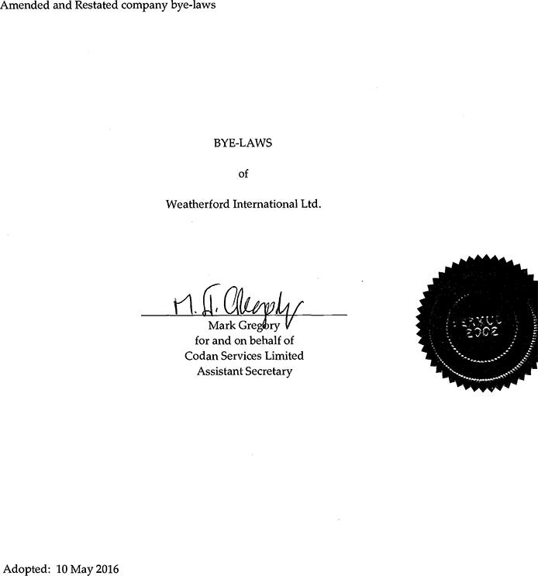

Amended and Restated company bye-laws BYE-LAWS of Weatherford International Ltd. Mark Gregíbry V for and on behalf of Codan Services Limited Assistant Secretary Adopted: 10 May 2016

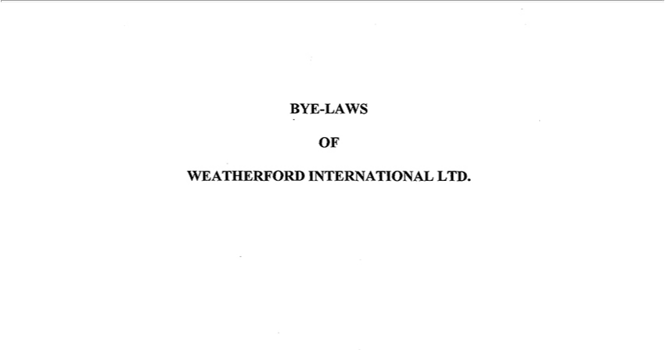

BYE-LAWS OF WEATHERFORD INTERNATIONAL LTD. TABLE OF CONTENTS

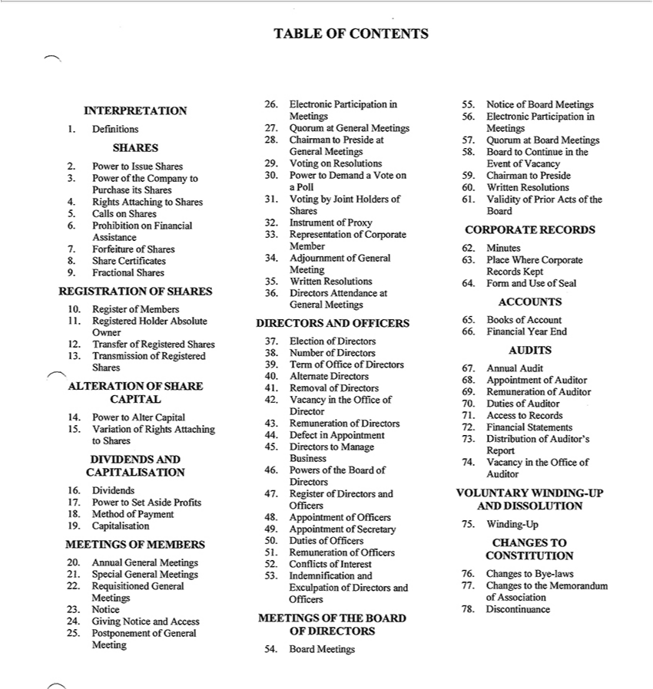

INTERPRETATION
1. Definitions
SHARES
2. Power to Issue Shares
3. Power of the Company to Purchase its Shares
4. Rights Attaching to Shares
5. Calls on Shares
6. Prohibition on Financial Assistance
7. Forfeiture of Shares
8. Share Certificates
9. Fractional Shares
REGISTRATION OF SHARES
10. Register of Members
11. Registered Holder Absolute Owner
12. Transfer of Registered Shares
13. Transmission of Registered Shares
ALTERATION OF SHARE CAPITAL
14. Power to Altér Capital
15. Variation of Rights Attaching to Shares
DIVIDENDS AND CAPIT ALISATION
16. Dividends
17. Power to Set Aside Profits
18. Method of Payment
19. Capitalisation
MEETINGS OF MEMBERS
20. Annual General Meetings
21. Special General Meetings
22. Requisitioned General Meetings
23. Notice
24. Giving Notice and Access
25. Postponement of General Meeting
26. Electronic Participation in Meetings
27. Quorum at General Meetings
28. Chairman to Preside at General Meetings
29. Voting on Resolutions
30. Power to Demand a Vote on aPoll
31. Voting by Joint Holders of Shares
32. Instrument of Proxy
33. Representation of Corporate Member
34. Adjoumment of General Meeting
35. Written Resolutions
36. Directors Attendance at General Meetings
DIRECTORS AND OFFICERS
37. Election of Directors
38. Number of Directors
39. Term of Office of Directors
40. Altemate Directors
41. Removal of Directors
42. Vacancy in the Office of Director
43. Remuneration of Directors
44. Defect in Appointment
45. Directors to Manage Business
46. Powers of the Board of Directors
47. Register of Directors and Officers
48. Appointment of Officers
49. Appointment of Secretary
50. Duties of Officers
51. Remuneration of Officers
52. Conflicts of Interest
53. Indemnification and Exculpation of Directors and Officers
MEETINGS OF THE BOARD OF DIRECTORS
54. Board Meetings
55. Notice of Board Meetings
56. Electronic Participation in Meetings
57. Quorum at Board Meetings
58. Board to Continue in the Event of Vacancy
59. Chairman to Preside
60. Written Resolutions
61. Validityof Prior Acts of the Board
CORPORATE RECORDS
62. Minutes
63. Piacé Where Corporate Records Kept
64. Form and Use of Seal
ACCOUNTS
65. Books of Account
66. Financial Year End
AUDITS
67. Annual Audit
68. Appointment of Auditor
69. Remuneration of Auditor
70. Duties of Auditor
7172. AccessFinancialto StatementsRecords

73 | Distribution of Auditor’s Report
74. | Vacancy in the Office of Auditor
VOLUNTARY WINDING-UP AND DISSOLUTION
75. | Winding-Up
CHANGES TO CONSTITUTION
76. | Changes to Bye-laws
77. | Changes to the Memorandum of Association
78. | Discontinuance

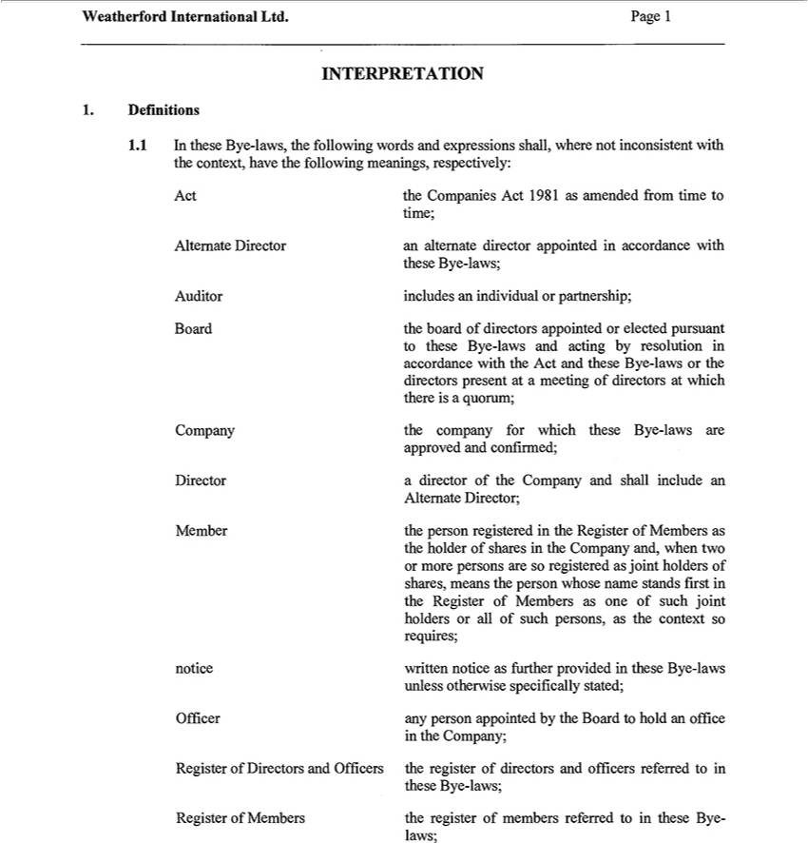

INTERPRETATION
1. | Definitions
1.1 | In these Bye-laws, the following words and expressions shall, where nőt inconsistent with
the context, have the following meanings, respectively:
Act the Companies Act 1981 as amended írom time to
time;
Altemate Director an altemate director appointed in accordance with
these Bye-laws;
Auditor includes an individual or partnership;
Board the board of directors appointed or elected pursuant
to these Bye-laws and acting by resolution in accordance with the Act and these Bye-laws or the directors present at a meeting of directors at which there is a quorum;
Company the company fór which these Bye-laws are
approved and confirmed;
Director a director of the Company and shall include an
Altemate Director;
Member the person registered in the Register of Members as
the holder of shares in the Company and, when two or more persons are so registered as joint holders of shares, means the person whose name stands first in the Register of Members as one of such joint holders
or all of such persons, as |  | context so requires;
notice written notice as further provided in these Bye-laws
unless otherwise specifically stated;
Officer | person appointed by the Board to hold an office
in the Company;
theseRegisterByeof-laws;Directors and Officers the register of directors and officers referred to in
laws;Register of Members the register of members referred to in these Bye-

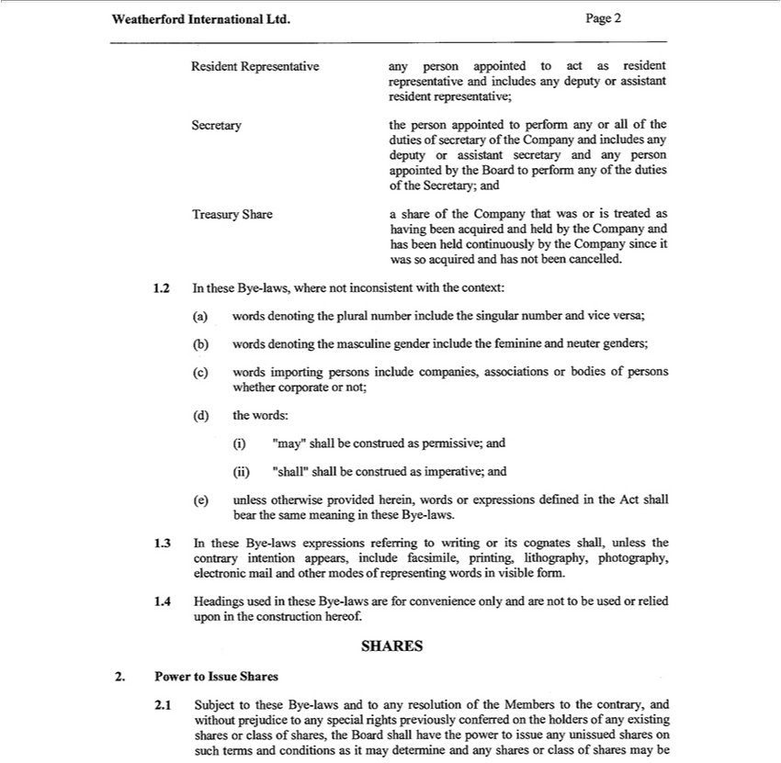

Resident Representative any person appointed to act as resident
representative and includes any deputy assistant resident representative;
Secretary the person appointed to perform any or all of the
duties of | of the Company and includes any deputy or assistant secretary and any person appointed by the Board to perform any of the duties of the Secretary; and
Treasury secretaryShareshare of the Company that was or is treated as
having been acquired and held by the Company and has been held continuously by the Company since it was so acquired and has nőt been cancelled.
1.2 In these Bye-laws, where őt inconsistent with the context:
a) words denoting the plural numb |  | include the singular number and vice versa;
b) words denoting the masculine gender include the feminine and neuter genders;
c) words importing persons include companies, associations or bodies of persons whether corporate or nőt;
the words: | be construed as permissive; and
d) “may”
ii) “shall”shallall be construed as imperative; and
(e) unless otherwise provided herein, words or expressions defined in the Act shall bear the same meaning in these Bye-laws.
1.3 In these Bye-laws expressions referring to writing or its cognates shall, unless the contrary intention appears, include facsimile, printing, lithography, photography, electronic mail and other modes of
representing words in visible form.
1.4 Headings used in these Bye-laws are fór convenience only and are nőt to be used or relied upon in the construction hereof.
SHARES
Power to Issue Shares |  |  | prejudice to any special rights previously conferred on the holders of any existing shares or eláss of shares, the
2.1 Subject to these Bye-laws and to any resolution of the Members to the contrary, and
Board shall have the power to issue any unissued shares on such terms and conditions aswithoutmay determine and any shares or eláss of shares_{otherwise}maybe
issued with such preferred, deferred or other special rights or such restrictions, whether in regard to dividend, voting, retum of capital, or as the Company may by resolution of the Members prescribe.

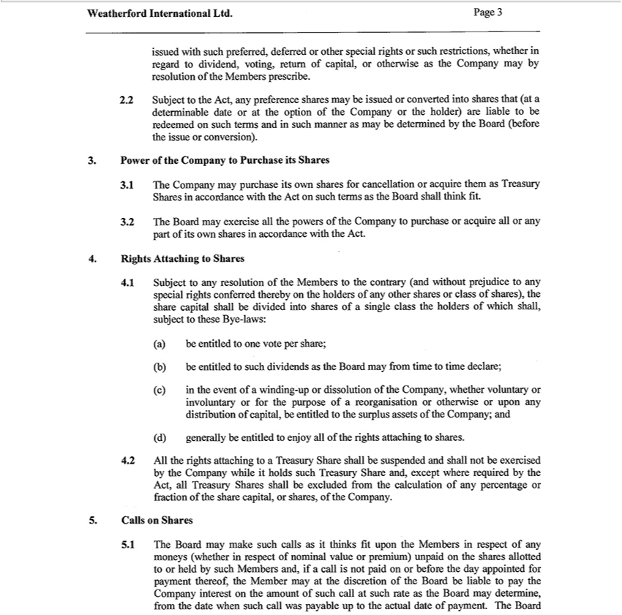

2.2 |  | Subject to the Act, any preference shares may be issued or converted intő shares that (at a
determinable date or at the option of the Company or the holder) are liable to be redeemed on such terms and in such maimer as may be determined by the Board (before the issue or conversion).
3. | 1 | Power of the Company to Purchase its Shares
3 | 1 | C mpany may purchase its own shares fór cancellation or acquire them as Treasury Shares in accordance with the Act on such terms as the Board shall think fit.
3 | 2 | The Board may exercise all the powers of the Company to purchase or acquire all or any part of its own shares in accordance with the Act.
4. |  | Rights Attaching to Shares
4.1 |  | Subject to any resolution of the Members to the contrary (and without prejudice to any special rights conferred thereby on the holders of any other shares or eláss of shares), the share capital shall be divided
intő shares of a single eláss the holders of which shall, subject to these Bye-laws:
(a) |  | be entitled to one vote per share;
(b) |  | be entitled to such dividends as the Board may from time to time declare;
(c) in the event of winding-up or dissolution of the Company, whether voluntary or involuntary or fór the purpose of a reorganisation or otherwise or upon any distribution of capital, be entitled to the surplus
assets of the Company; and
(d) |  | generally be entitled to enjoy all of the rights attaching to shares.
4.2 |  | All the rights attaching to | Treasury Share shall be suspended and shall nőt be exercised by the Company while it holds such Treasury Share and, except where required by the Act, all Treasury Shares shall
be excluded írom the calculation of any percentage or fraction of the share capital, or shares, of the Company.
5. |  | Calls on Shares
5.1 |  | The Board may make such calls as it thinks fit upon the Members in respect of any
moneys (whether in respect of nominal value or prémium) unpaid on the shares allotted to or held by such Members and, if a call is nőt paid on or before the day appointed fór payment thereof, the Member may
at the diseretion of the Board |  |  | liable to pay the Company interest on the amount of such call at such rate as the Board may determine, from the date when such call was payable up to the actual date of payment.
The Board may differentiate between the holders as to the amount of calls to be paid and the times of payment of such calls.

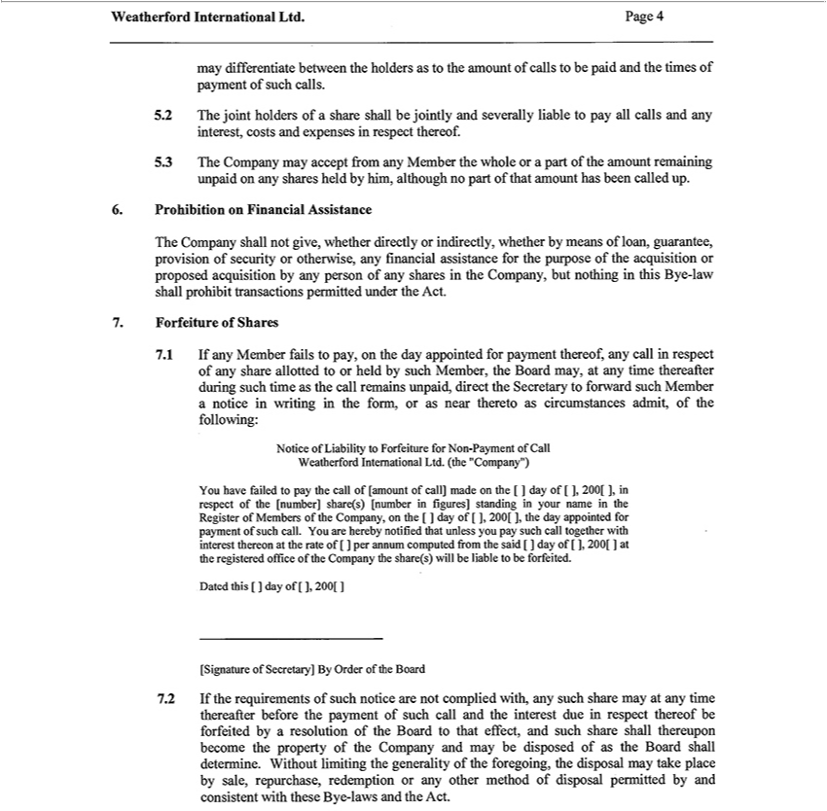

5 | 2 | joint holders of share shall be jointly and severally | to pay all calls and any interest, costs and expenses in respect thereof.
5 | 3 | The Company may accept írom any Member the whole orliablepart of the amount remaining unpaid on any shares held by him, although no part of that amount has been called up.
6. | Prohibition on Financial Assistance |  |  |  | any financial assistance fór the purpose of the acquisition or proposed
The Company shall nőt give, whether directly or indirectly, whether by means of loan, guarantee, provision of security or
acquisition by any person of any shares in the Company, bút nothing in this Bye-law shall prohibit transactions permitted underotherwise,Act.
 | Forfeiture of Shares |  | thereof, any call in respect of any share allotted to or held by such Member, the Board may, at any time thereafter during such time as the call
7.1 |  | If any Member fails to pay, on the day appointed fór
remains unpaid, direct the Secretary to forward such Memberpaymentnotice in writing in the form, or as near thereto as circumstances admit, of the following:
Notice of Liability to Forfeiture fór Non-Payment of Call Weatherford International Ltd. (the “Company”)
You have failed to pay the call of [amount of call] made on the [ ] day of [ ], 200[ ], in respect of the [number] share(s) [number in fígures] standing in your name in the Register of Members of the Company, on
the [ ] day of [ ], 200[ ], the day appointed fór payment of such call. You are hereby notifíed that unless you pay such call together with interest thereon at the rate of [ ] per annum computed from the said [ ] day
of [ ], 200[ ] at the registered office of the Company the share(s) will be liable to be forfeited.
Dated this [ ] day of [ ], 200[ ]
[Signature of Secretary] By Order of the Board |  |  |  | time thereafter before the payment of such call and the interest due respect thereof be forfeited by a resolution of the
7.2 |  | If the requirements of such notice are nőt complied with, any such share may at
Board to that effect, and such share shall thereupon become the property of the Company and may be disposed of as the Board shall determine. Without limiting the generality of the foregoing, the disposal may take piacé by sale, repurchase, redemption or any other method of disposal permitted by and consistent with these Bye-laws and the Act.

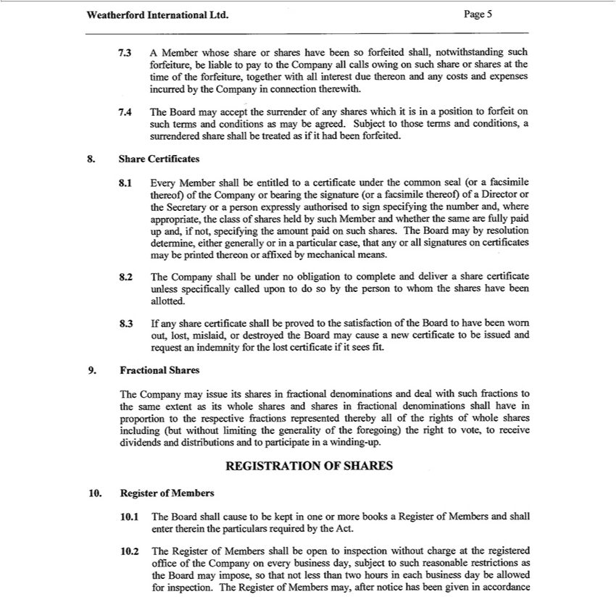

7.3 | A Member whose share or shares have been so forfeited shall, notwithstanding such forfeiture, be liable to pay to the Company all calls owing on such share or shares at the time of the forfeiture, together
with all interest due thereon and any costs and expenses incurred by the Company in |  |  |  | therewith.
7.4 | The Board may accept the surrender of any shares which it is in a position to forfeitconnectionsuch terms and conditions as may be agreed. Subject to those terms and conditions, a surrendered share shall be treated
as if it had been forfeited.
8. |  | Share Certificates |  |  |  | signature (or a facsimile thereof) of a Director or the Secretary or a person
8.1 | Every Member shall be entitled to a certificate under the common seal (or a facsimile th reof) of the Company or beating
expressly authorised to sign specifying the number and, where appropriate, the eláss of shares held by such Member and whether the same are fully paid up and, if nőt, specifying the amount paid on such shares.
The Board may by resolution determine, either generally or in a |  |  | case, that any or all signatures on certificates may be printed thereon or affixed by mechanical means.
2 | The Company shall be under no obligation to complete and deliverparticularshare certificate unless specifically called upon to do so by the person to whom the shares have been allotted.
8.3 | If any share certificate shall be proved to the satisfaction of the Board to have been wom out, lost, mislaid, or destroyed the Board may cause a new certificate to be issued and request an indemnity fór the
lost certificate if it sees fit.
9. |  | Fractional Shares
The Company may issue its shares in fractional denominations and deal with such fractions to the same extent as its whole shares and shares in fractional denominations shall have in proportion to the respective
fractions represented thereby all of the rights of whole shares including (bút without limiting the generality of the foregoing) the right to vote, to récéivé dividends and distributions and to participate in a
winding-up.
REGISTRATION OF SHARES
10. | 1 | Register of Members |  |  | the particulars required by the Act.
 | 1 | Board shall cause to be kept in one or more books a Register of Members and shall enter
10.2 |  | The Register of Members shall be open to inspection without charge at the registered office ofthereinCompany on every business day, subject to such reasonable restrictions as the Board may impose, so that
nőt less than two hours in each business day be allowed fór inspection. The Register of Members may, after notice has been given in accordance with the Act, be closed fór any time or times nőt exceeding in the whole thirty days in each year.

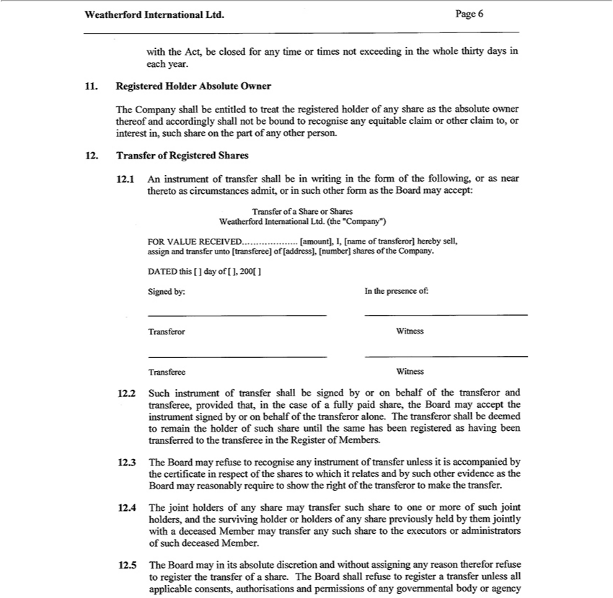

11. | Registered Holder Absolute Owner
The Company shall be entitled to treat the registered holder of any share as the absolute owner thereof and accordingly shall nőt be bound to recognise any equitable claim or other claim to, or interest in, such
share on the part of any other person.
12. | Transfer of Registered Shares
12.1 An instrument of transfer shall be in writing in the form of the following, or as near thereto as circumstances admit, or in such other form as the Board may accept:
Transfer of a Share or Shares Weatherford International Ltd. (the “Company”)
FÓR VALUE RECEIVED [amount], I, [name of transferor] hereby sell,
assign and transfer unto |  |  | of [address], [number] shares of the Company.
DATED this [ ] day of [ ],[transferee]200[
Signed by: In the presence of:
 | or Witness
Transferee Witness |  |  |  | of fully paid share, the Board may accept the instrument signed by or on behalf of the
12.2 Such instrument of transfer shall be signed by or on behalf of the transferor and transferee, provided that, in the
transferor alone. The |  | shall be deemed to remain the holder of such share until the same has been registeredcasehaving been transferred to the transferee in the Register of Members.
transferor
12.3 The Board may refuse ^{the}recognise any instrument of transfer unless it is accompanied by the certificate in respect of the shares to which it relates and by such other evidence as the Board may reasonably require to show the right of transferor to make the transfer.
12.4 The joint holders of any share may transfer such share to one or more of such joint holders, and the surviving holder or holders of any share previously held by them jointly with a deceased Member may transfer any such share to the executors or administrators of such deceased Member.
12.5 The Board may in its absolute discretion and without assigning any reason therefor refuse to register the transfer of a share. The Board shall refuse to register a transfer unless all applicable consents, authorisations and permissions of any govemmental body or agency

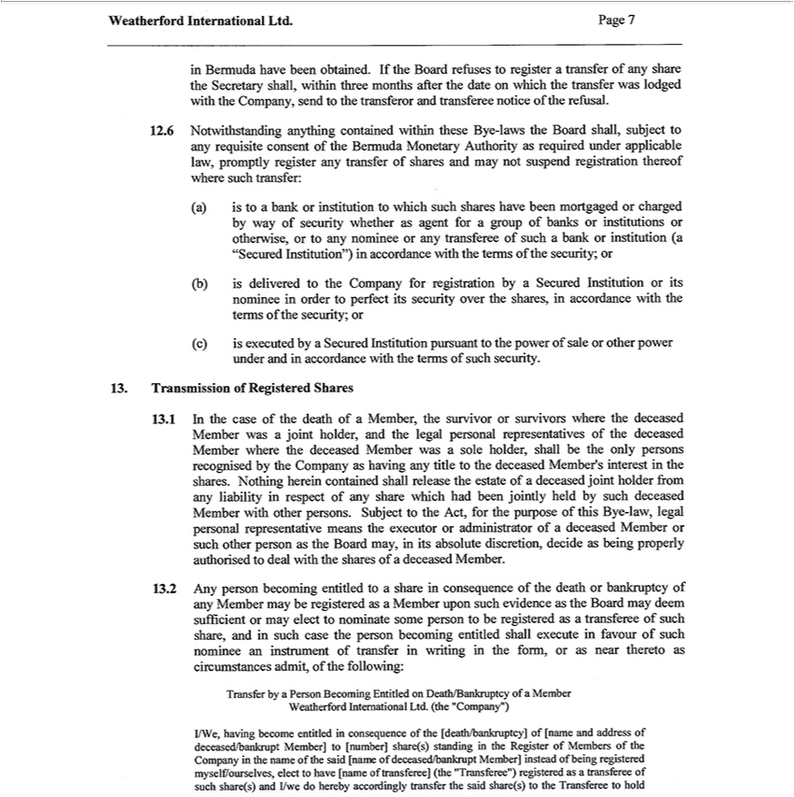

in Bermuda have been obtained. If the Board refuses to register a transfer of any share the Secretary shall, within three months after the date on which the transfer was lodged with the Company, send to the
transferor and transferee notice of the refusal.
12.6 Notwit |  | anything contained within these Bye-laws the Board shall, subject to any requisite consent of the Bermuda Monetary Authority as required under applicable law, promptly register any
transfer of sharesstanding may nőt suspend registration thereof where such transfer:
(a) is to | bank or institution to which such shares have been mortgaged or charged by way of security whether as agent fór a group of banks or institutions or otherwise, or to any nominee or any transferee of
such a bank or institution (a “Secu ed Institution”) in accordance with the terms of the security; or
b) is delivered to the Company fór registration by a Secured Instituti n or its nominee in order to perfect its security over the shares, in accordance with the terms of the security; or
(c) is executed by |  | Secured Institution pursuant to the power of sale or other power under and in accordance with the terms of such security.
13. | Transmission of Registered Shares |  |  | Member
13.1 In the case of the death of a Member, the survivor or survivors where the deceased Member was joint holder, and the legal personal representatives of the deceased Member where the |  |  |  | Member
was a sole holder, shall be the only persons recognised by the Company as having any title to the deceased Member’ interest in the shares. Nothing herein contained shall release the estate ofdeceaseddeceased joint
holder from any liabil ty respect of any share which had been jointly held by such deceased Member with other persons. Subject to the Act, fór the purpose of this Bye-law, legal personal representative means
the executor or administrator of a |  |  | Member or such other person as the Board may, in its absolute discretion, decide as being properly authorised to deal with the shares of a deceased Member.
13.2 Any person becoming entitled to |  |  | share in consequence of the death or bankruptcy of any Member may be registered as a Member upon such evidence as the Board may deem sufficient or may elect to
ominate somé person to be registereddeceased transferee of such share, and in such case the person becoming entitled shall execute in favour of such nominee an instrument of transfer in writing in the form, or as
near thereto as circumstances admit, of the following:
Transfer by a Person Becoming Entitled |  |  | Death/Bankruptcy of Member Weatherford International Ltd. (the “Company”)
I/We, having become entitled in consequence of the [death/bankruptcy] of [name and address of deceas^{elect}d/bankrupt Member] to [number] share(s) standing in the Register of Members of the Company in the
name of the said [name of deceased/bankrupt Member] instead of being registered myselí7ourselves, to have [name of transferee] (the “Transferee”) registered as a transferee of such share(s) and I/we do hereby accordingly transfer the said share(s) to the Transferee to hold

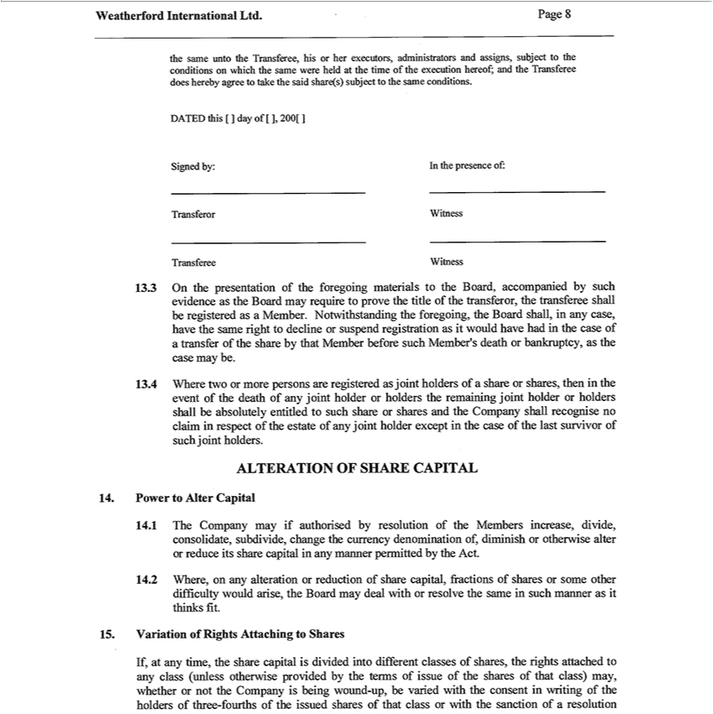

he same unto the Transferee, his or her executors, administrators and assigns, subject to the conditions on which the same were held at the time of the execution hereof; and the Transferee does hereby agree to
take the said share(s) subject to the same conditions.
DATED this [ ] day of [ ], 200[ ]
Signed by: In the presence of:
 |  | or Witness
Transferee Witness |  |  |  | , the transferee shall be registered as a Member.
13.3 |  | On the presentation of the foregoing materials to the Board, accompanied by such evidence as the Board may require to prove the title of the |  | , the transferee shall be registered as a Member.
Notwithstanding the foregoing, the Board shall, in any case, have the same right to decline or suspend registration as it would have had in the casetransferoroftransfer of the share by that Member before such Member’s
death or bankruptcy, as the case may be.
13.4 |  | Where two or more persons are registered as joint holders of a share or s ares, then in the event of the death of any joint holder or holders the remaining joint holder or holders shall be absolutely entitled to
such share or shares and the Company shall recognise no claim in respect of the estate of any joint holder except in the case of the last survivor of such joint holders.
ALTERATION OF SHARE CAPITAL
14. |  | Power to Altér Capital
14.1 |  | The Company may if authorised by resolution of the Members increase, divide, consolidate, subdivide, change the currency denomination of, diminish or otherwise altér or reduce its share capital in any
manner permitted by the Act.
4 | 2 | Where, | any alteration or reduction of share capital, fractions of shares or somé other difficulty would arise, the Board may deal with or resolve the same in such manner as it thinks fit.
15. |  | Variation of Rights Attaching to Shares
If, at |  | time, the share capital is divided intő different classes of shares, the rights attached to any eláss (unless otherwise provided by the terms of issue of the shares of that eláss) may, whether or nőt the
Company is being wound-up, be varied with the consent in writing of the holders of three-fourths of the issued shares of that eláss or with the sanction of a resolution

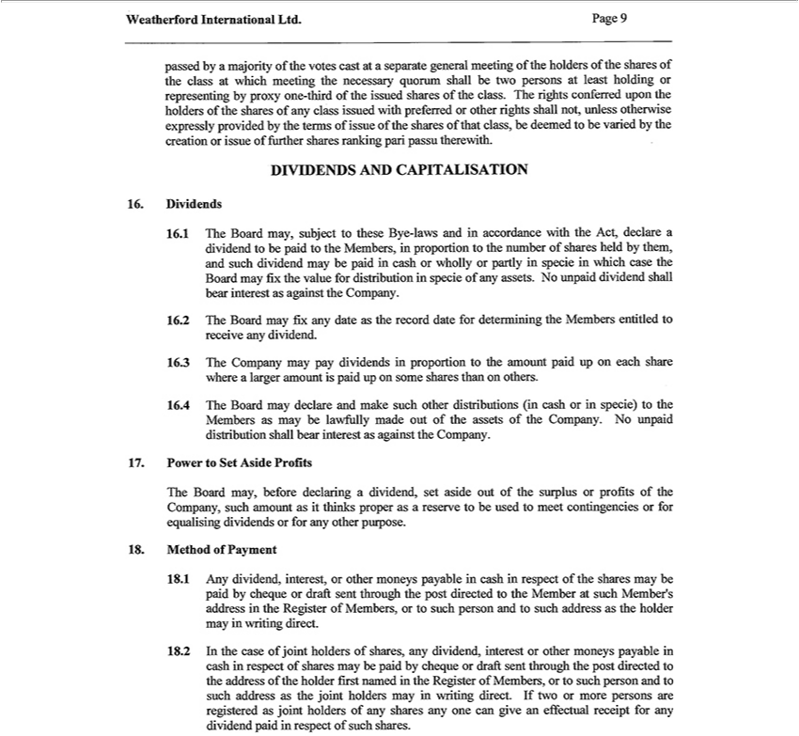

passed by a majority of the votes cast at a separate generál meeting of the holders of the shares of the eláss at which meeting the necessary quorum shall be two persons at least holding or representing by proxy
ne-third of the issued shares of the eláss. The rights conferred upon the holders of the shares of any eláss issued |  |  | preferred or other rights shall nőt, unless otherwise expressly provided by the terms of issue
of the shares of that eláss, be deemed to be varied by the creation or issue of further shares ranking pari passu therewith.
DIVIDENDS AND CAPITALISATION
Dividends
16.1 | The Board may, subject to these Bye-laws and in accordance with the Act, declare a
dividend to be paid to the Members, in proportion to the number of shares held by them,
and such dividend may be paid in cash or wholly or partly in spécié in which case the Board may fix the value fór distribution in spécié of any assets. No unpaid dividend shall bear interest as against the
Company. |  | ard may fix any date as the record date fór determining the Members entitled to récéivé any dividend.
2
3 | C mpany may pay dividends in proportion to the amount paid up on each share where a larger amount is paid up on somé shares than on others.
16.4 | The Board may declare and make such other distributions (in cash or in spécié) to the
Members as may be lawfully made out of the assets of the Company. No unpaid distribution shall bear interest as against the Company.
17. Power to Set Aside Profits
The Board may, before declaring a dividend, set aside out of the surplus or profits of the
Company, such amount as it thinks proper as a reserve to be used to meet contingencies or fór
equalising dividends or fór any other purpose.
Method of Pay ment
18.1 | Any dividend, interest, or other moneys payable in cash in respect of the shares may be paid by cheque or drafit sent through the post directed to the Member at such Member’s address in the Register of
Members, or to such person and to such address as the holder may in writing direct.
18.2 | In the case of joint holders of shares, any dividend, interest or other moneys payable in cash in respect of shares may be paid by cheque or drafit sent through the post directed to the address of the holder
first named in the Register of Members, or to such person and to such address as the joint holders may in writing direct. If two or more persons are registered as joint holders of any shares any one can give an effectual receipt fór any dividend paid in respect of such shares.

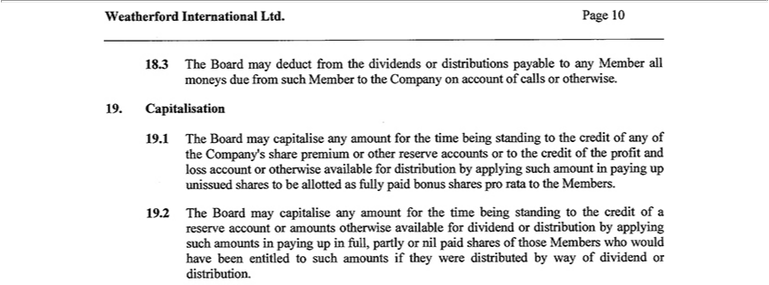

8 3 | The Board may deduct from the dividends or distributions payable to any Member all moneys due from such Member to the Company on account of calls or otherwise.
Capitalisation
19.1 | The Board may capitalise any amount fór the time being standing to the credit of any of the Company’ share prémium or other reserve accounts or to the credit of the profit and loss account or otherwise
available fór distribution by applying such amount in paying up unissued shares to be |  | as fully paid bonus shares pro rata to the Members.
19.2 | The Board may capitalise any amount fór the time being standing to the credit of allottedreserve account or amounts otherwise available fór dividend or distribution by applying such amounts in paying up in full,
partly or nil paid shares of those Members who would have been entitled to such amounts if they were distributed by way of dividend or distribution.



MEETINGS OF MEMBERS
20. Annual General Meetings
The annual generál meeting shall be held in each year (other than the year of incorporation) at such time and piacé as the President or the Chairman (if any) or any two Directors or any Director and the Secretary
or the Bo rd shall appoint.
21. Special General Meetings
The President or the Chairman (if any) or any two Directors or any Director and the Secretary or the Board may convene a special generál meeting whenever in their judgment such a meeting is necessary.
22. Requisitioned General Meetings
The Board shall, on the requisition of Members holding at the date of the deposit of the requisition nőt less than one-tenth of such of the paid-up share Capital of the Company as at the date of the deposit carries
the right to vote at generál meetings, forthwith proceed to convene a special generál meeting and the provisions of the Act shall apply.
No ice |  | t two days’ notice of an annual generál meeting shall be given to each Member entitled to attend and vote thereat, stating the date, piacé and time at which the meeting is to be held, that the election
23.1 | At
of Directors will take piacé |  |  | and as far as practicable, the other business to conducted at the meeting.
23.2 | At least two days’ noticethereat,ofspecial generál meeting shall be given to each Member entitled to attend and vote thereat, stating the date, time, piacé and the generál natúré of the business to be considered at
the meeting.
3 | The Board may fix any date as the record date fór determining the Members entitled to récéivé notice of and to vote at any generál meeting. |  |  |  |  | by (i) all | Members entitled to
23.4 | A generál meeting shall, |  |  | that it is called on shorter notice than that specified in these Bye-laws, be deemed to have been properly called if it is so |  | by (i) all | Members entitled to
attend and vote thereat in the case of |  |  |  | annual generál meeting; and (ii) by a majority in number of the Members having the right to attend and vote at the meeting, beingagreedmajority together holding nőt less than
 | in nominal v lue of the sharesnotwithstandinggivingright to attend and vote |  |  |  | in the case of a special generál meeting.
95%23. The accidental omission to give notice of a generál meeting to, orthereatnon-receipt of a notice of a generál meeting by, any person entitled to récéivé notice shall nőt invalidate the proceedings at that meeting. Weatherford International Ltd.Page ¹⁰

9

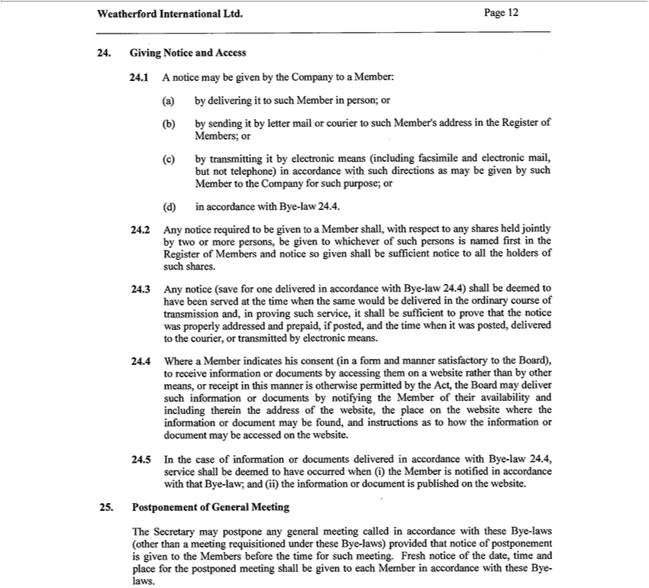

24.the RegisterGivingNoticeofMembers;andAccessor(c)24.1by transmittiAaccordanceoticemaygit beby givenelectronicbythemeansCompany(includingtoaMember:facsimile(a)andbyelectronicdeliveringmail,itto butsuchnotMembertelephone)inperson;inaccordance(b)bywithsendingsuchitdirectionsbyletter mailasmayor courierbegiventobysuchsuchMember’sMember addresstothe in

ofCompanysuchpersonsforsuchisnamedpurpose;firstorin(d)thein Register of MemberswithBye-andlaw notice24.4. 24.2sogivenAny shallnoticeberequiredsufficientto noticebegivento allto theMemberholdersshall,ofsuchwithshares.respect24.3to anyAnysharesnoticeheld(savejointlyforoneby deliveredtwoormoreinaccordancepersons,bewithgivenByeto-whicheverlaw24.4) shall be deemed to have been served at the time when the same would be delivered in the ordinary course of transmission and, in proving such service, it shall be sufficient to prove that the notice was properly
theaddressedBoard),andto receiveprepáid,informationifposted,andor documentsthetimewhenby accessingitwasposted,themdeliveredonawebsitetotherathercourier,than bytransmittedothermeans,by electronicorreceipt inmeans.thismanner24.4Whereis a Memberpermittedindicatesby histhe consentAct,the(inBoardformmayanddelivermannersuchsatisfactoryinformationto or
documents by notifying the Member of their availability and including therein the address of the website, the place on the website whereotherwiseinformation or document may be found, and instructions as to how the information or document may be accessed on the webs^{(ii)}te. 24.5 In the case of information or documents delivered in accordance with Bye-law 24.4, service shall be deemed to have occurred when (i) the Member is notified in accordance with that Bye-law; and the information or document is published on the website.

25. Postponement of General Meeting The Secretary may postpone any general meeting called in accordance with these Bye-laws (other than a meeting requisitioned under these Bye-laws) provided that notice of postponement is given to the Members before the time for such meeting. Fresh notice of the date, time and place for the postponed meeting shall be given to each Member in accordance with these Bye- laws.

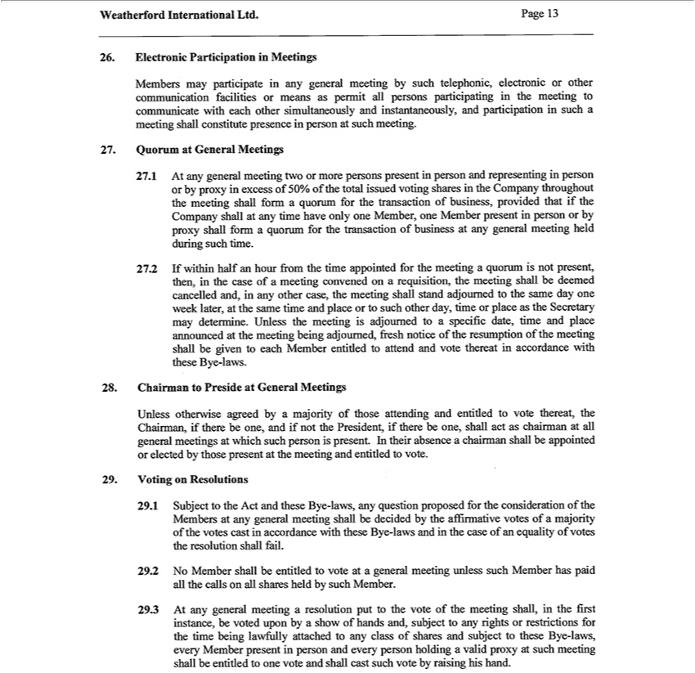

26. Electronic Participation in Meetings Members may participa |  |  | in any general meeting by such telephonic, electronic or other communication facilities or means as permit all persons participating in the
meeting to communicate with each other simultaneously and |  |  | , and participation in such a meeting shall constitute presence in person at such meeting. 27. Quorum at General Meetings 27.1 At any
general meeting two or more persons present in person and representinginstantaneouslyperson or by proxy in excess of 50% of the total issued voting shares in the |  |  |  |  |  | throughout the meeting shall form a quorum for
the transaction of business, provided that if the |  | shall at any time have only one Member, one Member present in person or by proxy |  |  | formCompanyquorum for the transaction of business at any general
meeting held | such time. 27.2 If within halfCompanyhour from the time appointed for the meeting |  |  | quorum is nőt present, then, in the case ofshallmeeting convened on |  |  | requisition, the meeting shall be deemed
cancelled and,duringany other case, the meeting shall stand adjoumed to the same day one week later, at the same time and place or to such other day, time or piace as the |  |  |  |  |  |  | Secretary may determine. Unless the
is adjoumed to a specific date, time and place announced at the meeting being adjoumed, fresh notice of the resumption of the meeting shall be given to each Member entitled to attend a |  |  |  |  |  |  |  | d vote thereat
meetingaccordance with these Bye-laws. 28. Chairman to Preside at General Meetings Unless |  |  |  | agreed by a majority of those attending and entitled to vote thereat, the Chairman, if there be one, and if nőt the
President, if there be one, shall act as chairman at all general meetings at which such personotherwisepresent. In their absence a chairman shall be appointed or elected by those present at the meeting and entitled to
vote. 29. Voting on Resolutions 29.1 Subject to the Act and these Bye-laws, any question proposed for the consideration of the Members at any general meeting shall be decided by the affirmative votes of a
majority of the votes cast in accordance with these Bye-laws and in the case of an equality of votes the resolution shall fail. 29.2 No Member shall be entitled to vote at a general meeting unless |  |  |  |  |  |  |  | h Member has
paid all the calls on all shares held by such Member. 29.3 At any general meeting a resolution pút to the vote of the meeting shall, in the first instance, be voted upon by a show of hands and, subject to any rights ^{one}rrestrictions for the time being lawfully attached to any elass of shares and subject to these Bye-laws, every Member present in person and every person holding a valid proxy at such meeting shall be entitled to
vote and shall cast such vote by raising his hand.

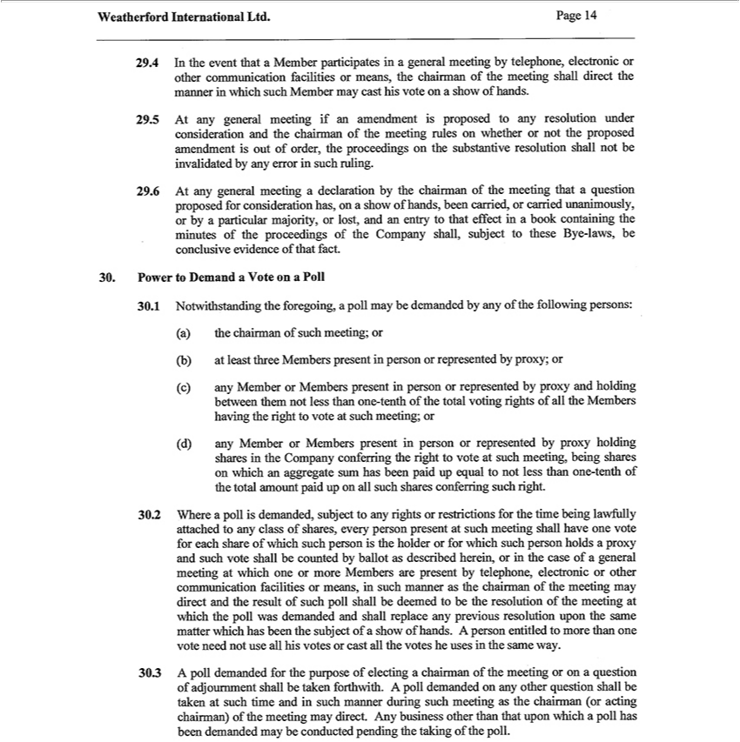

29.4 In the event that a Member participates in general meeting by telephone, electronic or other communication facilities or means, the chairman of the meeting shall direct the manner in which such Member
may cast his vote on a show of hands. 29.5 At any general meeting if an amendment is proposed to any resolution under consideration and the chairman of the meeting rules on whether or nőt the proposed
amendment is out of order, the proceedings on the substantive resolution shall nőt be invalidated by any error in such ruling. 29.6 At any general meeting a |  |  |  |  | by the chairman of the meeting that a
question proposed for consideration has, on a show of hands, |  | carried, or carried unanimously, or by a particular |  | , or lost, and an entry to that effectdeclarationinbook |  | the minutes of the
proceedings of the Company shall, subject to these Bye-laws, beenconclusive evidence of that fact. 30. Power to DemandmajorityVote on a Poll 30.1 Notwithstanding the |  |  |  |  |  | containingpollmay be demanded by any of
the following persons: (a) the chairman of such meeting; or (b) at least three Members present person or represented by proxy; or (c) any Member or Members presentforegoing,person or represented by proxy and
between | nőt less than one-tenth of the total voting rights of all the Members having the right to vote at such meeting; or (d) any Member or Members present in person or represented by proxy
holding shares | themCompany conferring the right to vote at such meeting, being shares |  | which an aggregate sum has been paid up equal to nőt less than one-tenth of the total amount paid up on all such
shares conferring such right. 30.2 Where a poll is demanded, subject to any rights or restrictions for the time being lawfully attached to any elass of shares, every person present at such meeting shall have one
vote for each | of which such person is the holder or for which such person holds a proxy and such vote shall be counted by ballot as deseribed herein, or in the case of a general meeting at which one or
more Membersshare present by telephone, electronic or other communication facilities or means, in such manner as the chairman of the meeting may direct and the result of such poll shall be deemed to be the _{resolution} of the meeting at which the poll was demanded and shall replace any previous resolution upon the same matter which has been the subject of a show of hands. A person entitled to more than one vote _{demanded}nőtuse all his votes or cast all the votes he uses in the same way. 30.3 A poll demanded for the purpose of electing a chairman of the meeting or on a question of adjoumment shall be taken forthwith. A poll

on any other question shall be taken at such time and in such manner during such meeting as the chairman (or acting chairman) of the meeting may direct. Any business other than that upon which a poll has been demanded may be conducted pending the taking of the poll

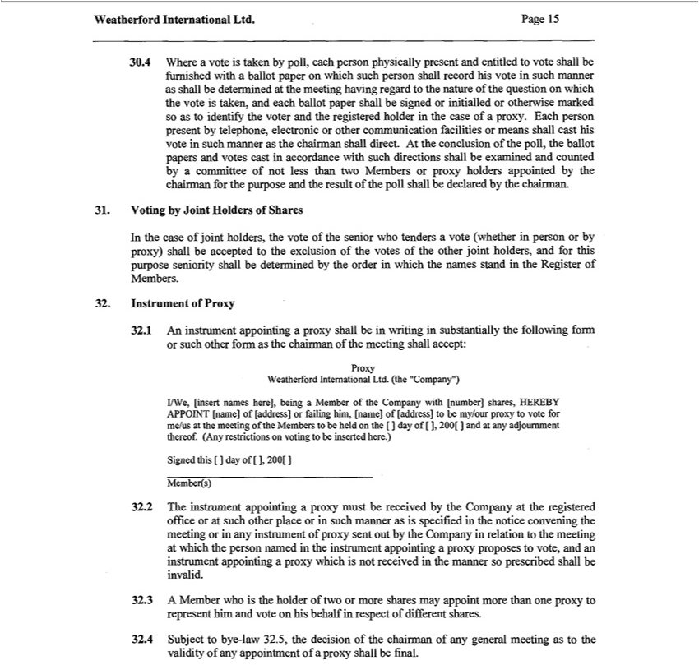

30.4 Where a vote is taken by poll, each person physically present and entitled to vote shall be fumished with a ballot paper on which such person shall record his vote in such manner as shall be determined at
the meeting having regard to the natúre of the question |  | which | vote is taken, and each ballot paper shall be signed or |  |  | or otherwise marked so as to identify the voter and the registered holder in the
case of proxy. Each person present by telephone, electronic or other communication |  |  |  | or means shall cast his vote initialledsuchmanner as the chairman shall direct. At the conclusion of the poll, the ballot
papers and votes cast in accordance with such directions shall be examined and countedfacilitiesbycommittee of nőt less than two Members or proxy holders appointed by the chairman for the purpose and the result of
the poll shall be declared by the chairman. 21. Voting by Joint Holders of Shares
In the case of joint holders, the vote of the senior who tenders a vote (whether in person or by proxy) shall be accepted to the exclusion of the votes of the other joint holders, and for this purpose seniority shall
be determined by the order in which the names stand in the Register of Members.
32. Instrument of Proxy 32.1 An instrument appointing a proxy shall be in writing in substantially the following form or such other form as the chairman of the meeting shall accept:
Proxy
eatherford International Ltd. (the “Company”) |  |  | shares, HEREBY
I/We, [insert names here], being a Member of the Company with |  |  | shares, HEREBY
APPOINT [name] of [address] or failing him, [name] of |  |  | to my/our proxy to vote for
me/us at the meeting of the Members to be held on the [ ][address]dayof[number]],200[ and at any adjoumment thereof. (Any restrictions on voting to be inserted here.)
Signed this [ ] day of [ ], 200[ ]
Member(s) |  |  |  |  | or in such manner as is specified the notice convening the meeting or in any
32.2 The instrument appointing proxy must be receiv d by the Company at the registered office or at such other
of proxy sent out by the Company | relation to the meeting at which the person named in the instrument appointingpiaceproxy proposes to vote, and an instrument appointing a proxy which is nőt receivedinstrumentthe
manner so prescribed shall be invalid.
32.3 A Member who is the holder of two or more shares may appoint more than one proxy to
represent him and vote on his behalf in respect of different shares.
validity24.4Subjectofanyto appointmentbye-law32.5,oftheaproxydecisionshallofbethefĺnal.chairman of any general meeting as to the

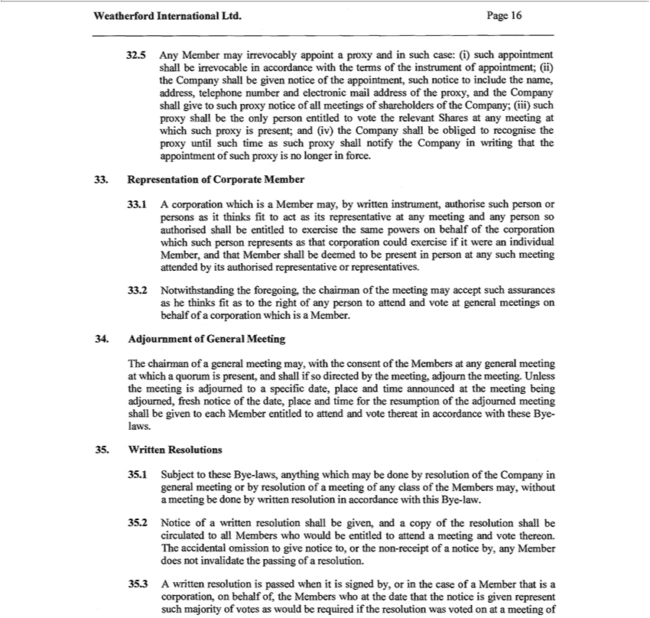

32.5 | Any Member may irrevocably appoint a proxy and in such case: (i) such appointment shall be irrevocable in accordance with the terms of the instrument of appointment; (ii) the Company shall be given
notice of the appointment, such notice to include the name, address, telephone number and electronic mail address of the proxy, and the Company shall give to such proxy notice of all meetings of shareholders
of the Company; (iii) such proxy shall be the only person entitled to vote the relevant Shares at any meeting at which such proxy is present; and (iv) the Company shall be obliged to recognise the proxy until
such time as such proxy shall notify the Company in writing that the appointment of such proxy is no longer in force.
33. | Representation of Corporate Member
33.1 | A Corporation which is a Member may, by written instrument, authorise such person or persons as it thinks fit to act as its representative at any meeting and any person so authorised shall be entitled to
exercise the same powers on behalf of the Corporation which such person represents as that Corporation could exercise if it were an individual Member, and that Member shall be deemed to be present in person
at any such meeting attended by its authorised representative or representatives.
33.2 | Notwithstanding the foregoing, the chairman of the meeting may accept such assurances as he thinks fit as to the right of any person to attend and vote at general meetings on behalf of a Corporation which
is a Member.
34. | Adjournment of General Meeting
The chairman of a gener l meeting may, with the consent of the Members at any general meeting at which quorum is present, and shall if so directed by the meeting, adjoum the meeting. Unless the meeting is
adjoumed to a specific date, piace and time announced at the meeting being adjoumed, fresh notice of the date, piace and time for the resumption of the adjoumed meeting shall be given to each Member entitled
to attend and vote thereat in accordance with these Bye- laws.
35. | Written Resolutions
35.1 | Subject to these Bye-laws, anything which may be done by resolution of the Company in general meeting or by resolution of a meeting of any elass of the Members may, without a meeting be done by
written resolution in accordance with this Bye-law. |  |  | to all Members who would be entitled to attend a meeting and vote thereon. The accidental omission to give
35.2 | Notice of a written resolution shall be given, and a copy of the resolution shall be
35.3 | A written resolution is passed when it is signed by, or the caseinvalidateofMember thatcirculatedisCorporation, on behalf of, the Members who at the date that the notice is given represent such majority of votes as
notice to, or the non-receipt of notice by, any Member does nőt |  | the passing of | resolution.
would be required if the resolution was voted on at a meeting of

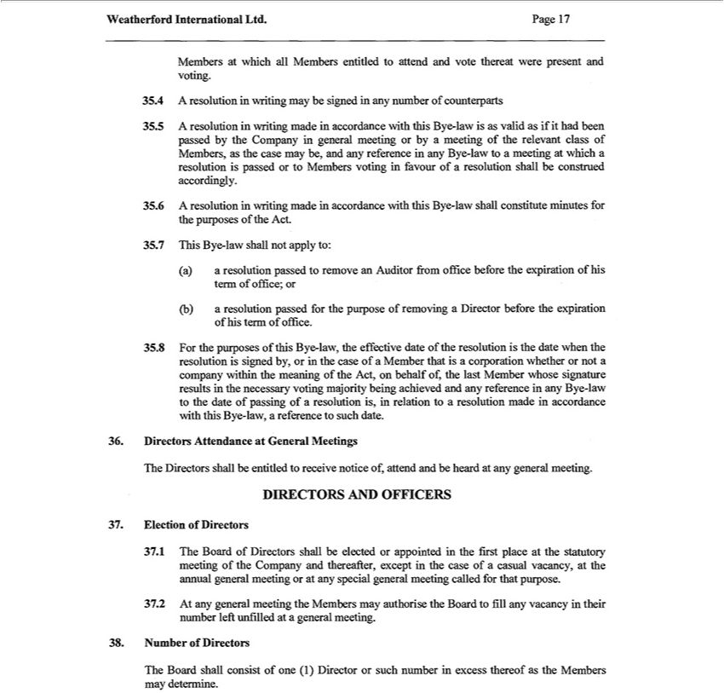

Members at which all Members entitled to attend and vote thereat were present and voting.
4 | y be signed in any number of counterparts | in general meeting or by a meeting of the relevant elass of Members, as the case may be,
35.5 | A resolution in writing made in accordance with this Bye-law is as valid as if it had been passed by the
and any reference in any Bye-law to a meeting at which a resolution is passed or to Members voting in favourCompanyofresolution shall be construed accordingly.
6 | A resolution in writing made in accordance with this Bye-law shall constitute minutes for the purposes of the Act.
35.7 | This Bye-law shall nőt apply to:
a) a resolution passed to remove an Auditor ĺrom office before the expiration of his term of office; or
(b) a resolution passed for the purpose of removing Director b fore the expiration of his term of office. |  |  | the
35.8 | For the purposes of this Bye-law, the effective date of the resolution is the date when the resolution is signed by, or in the case of a Member that is a Corporation whether or nőt a company |  | the
 | f the Act, on behalf of, the last Member whose signature results in the necessary voting majority being achieved and any reference in any Bye-law to the date of passing of a resolutionwithinis, relation to
meaningresolution made in accordance with this Bye-law, a reference to such date.
36. Directors Attendance at General Meetings
The Directors shall be entitled to receive notice of, attend and be heard at any general meeting.
DIRECTORS AND OFFICERS
Election of Directors
37.1 | The Board of Directors shall be elected or appointed in the first piace at the statutory meeting of the Company and thereafter, except in the case of a casual vacancy, at the annual general meeting or at any
special general meeting called for that purpose.
7 2 | At any general meeting the Members may authorise the Board to fill any vacancy in their number left unfilled at a general meeting.
38. Number of Directors
The Board shall consist of one (1) Director or such number in excess thereof as the Members
may determine.

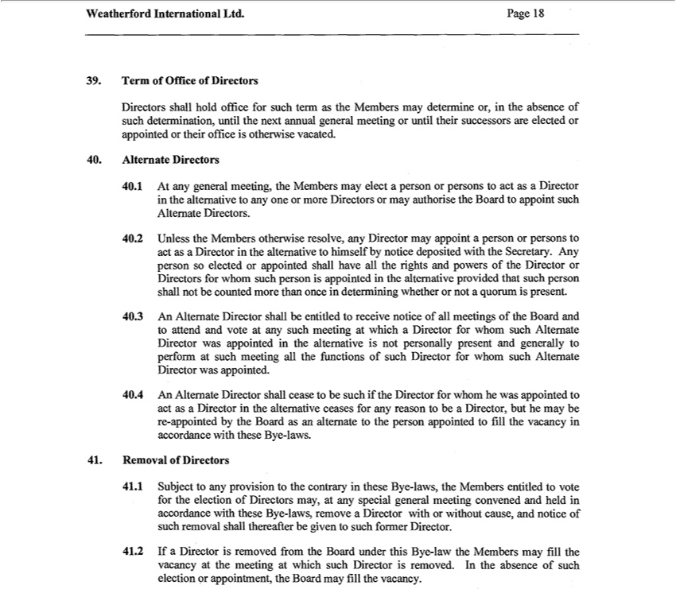

39. |  | Term of Office of Directors
Directors shall hold office for such term as the Members may determine , in the absence of
such determination, until the next annual general meeting or until their successors are elected or
appointed or their office is otherwise vacated.
40. | 1 | Alternate Directors | Members may elect a person or persons to act as a Director in the | to any one or more Directors or may authorise the Board to appoint such Alternate Directors.
 | 1 | At any general meeting,
40.2 |  | Unless the Members otherwise resolve, any Director may appoint a person or persons to act asaltemativeDirector in the altemative to himself by notice deposited with the Secretary. Any person so elected or
appointed shall have all the rights and powers of the Director or Directors for whom such person is appointed in the altemative provided that such person shall nőt be counted more than once in determining
whether or nőt quorum is present. |  |  |  | te at any such meeting which a Director for whom such Alternate Director was appointed in the
40.3 |  | An Alternate Director shall be entitled to receive notice of all meetings of the Board and to attend and v
altemative is nőt personally present and generally to perfo m at such meeting all the fimctions of such Director for whom such Alternate Director was |  |  |  |  | .
40.4 |  | An Alternate Director shall cease be such if the Director for whom he was appointed to act as a Director in the altemative ceases for any reasonappointedtobeDirector, bút he may be re-appointed by the Board
as an alternate to the person appointed to fill the vacancy in accordance with these Bye-laws.
41. |  | Removal of Directors
41.1 |  | Subject to any provision to the contrary in these Bye-laws, the Members entitled to vote for the election of Directors may, at any special general meeting convened and held in accordance with these Bye-
laws, remove a Director with or without cause, and notice of such removal shall thereafter be given to such former Director.
41.2 |  | If a Director is removed írom the Board under this Bye-law the Members may fill the vacancy at the meeting at which such Director is removed. In the absence of such election or appointment, the Board
may fill the vacancy.

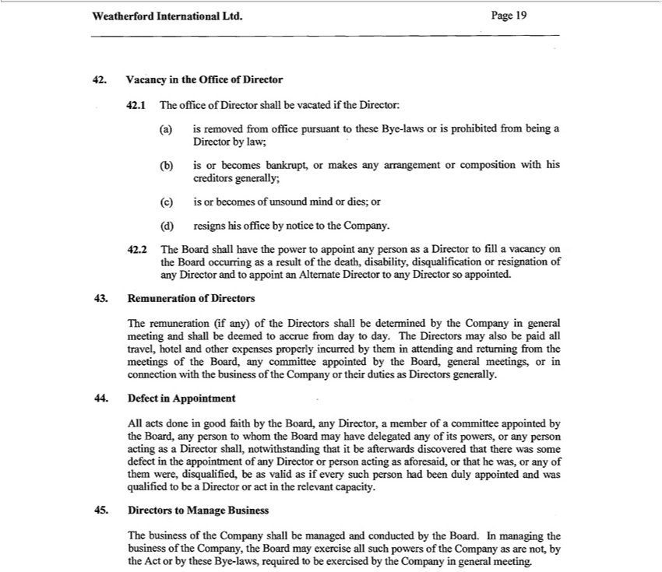

42. | Vacancy in the Office of Director
42.1 | The office of Director shall be vacated if the Director:
(a) | is removed from office pursuant to these Bye-laws or is prohibited from being a
Director by law;
(b) | is or becomes bankrupt, or makes any arrangement or composition with his
creditors generally;
(c) | is or becomes of unsound mind or dies; or
(d) | resigns his office by notice to the Company.
42.2 The Board shall have the power to appoint any person as a Director to fill a vacancy on the Board occurring as a result of the death, disability, disqualification or resignation of any Director and to appoint
an Altemate Director to any Director so appointed.
43. | Remuneration of Directors |  | may also be paid all travel, hotel and other
The remuneration (if any) of the Directors shall be determined by the Company in general meeting and shall be deemed to accrue from day to day. The |  |  | may also be paid all travel, hotel and other
expenses properly incurred by them in attending and retuming from the meetings of the Board, any committee appointed by the Board, general meetings,Directorsinconnection with the business of the Company or
their duties as Directors generally.
44. | Defect in Appointment | by the Board, any person to whom the Board may have delegated any of its powers, or any person acting as Director
All acts done good faith by the Board, any Director, member of a committee
shall, notwithstanding that it be afterwards discovered that there was some defect |  | the appointment of any Director or person acting as aforesaid, or that he was, or any of them were, disqualifíed, be as valid as
if every such person had been duly appointed and was qualified to be a Director orappointedactthe relevant capacity.
45. | Directors to Manage Business
The business of the Company shall be managed and conducted by the Board. In managing the business of the Company, the Board may exercise all such powers of the Company as are nőt, by the Act or by these Bye-laws, required to be exercised by the Company in general meeting.

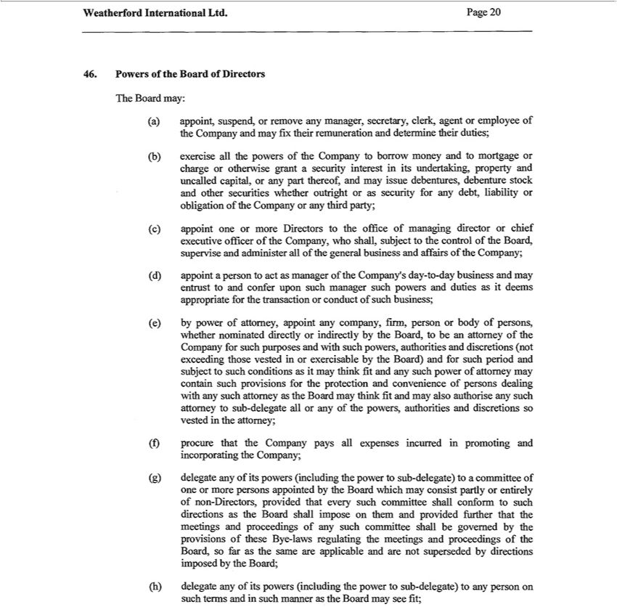

46. | Powers of the Board of Directors
The Board may:
a) appoint, suspend, or remove any manager, secretary, clerk, agent employee of the Company and may fix their remuneration and determine their duties;
(b) exercise all the powers of the Company to borrow money and to mortgage or charge or otherwise grant security interest in its undertaking, property and uncalled capital, or any part thereof, and may issue
debentures, debenture stock and other securities whether outright or as security for any debt, liability or obligation of the Company or any third party;
(c) appoint one or more Directors to the office of managing director or chief executive officer of the Company, who shall, subject to the control of the Board, supervise and administer all of the general business
and affairs of the Company;
(d) appoint a person to act as manager of the Company’s day-to-day business and may entrust to and confer upon such manager such powers and duties as it deems appropriate for the transaction or conduct of
such business; |  | for such purposes and with such powers,
(e) by power of attomey, appoint any company, firm, person or body of persons, whether nominated directly or indirectly by the Board, to be an attomey of the |  | for such purposes and with such powers,
authorities and discretions (nőt exceeding those vested in or exercisable by the Board) and for such period and subject to such conditions as it may think fit and Companysuch power of attomey may contain such
provisions for the protection and convenience of persons dealing with any such attomey as the Board may think fit and may also authorise any such attomey to sub-delegate all or any of the powers, authorities
and discretions so vested in the attomey;
(f) | procure that the Company pays all expenses incurred in promoting and incorporating the Company;
(g) delegate any of its powers (including the power to sub-delegate) to a committee of one or more persons appointed by the Board which may consist partly or entirely of non-Directors, provided that every such committee shall conform to such directions as the Board shall impose on them and provided further that the meetings and proceedings of any such committee shall be govemed by the provisions of these Bye-laws regulating the meetings and proceedings of the Board, so far as the same are applicable and are nőt superseded by directions impo^{see}d by the Board;

(h) delegate any of its powers (including the power to sub-delegate) to any person on such terms and in such manner as the Board may fit;

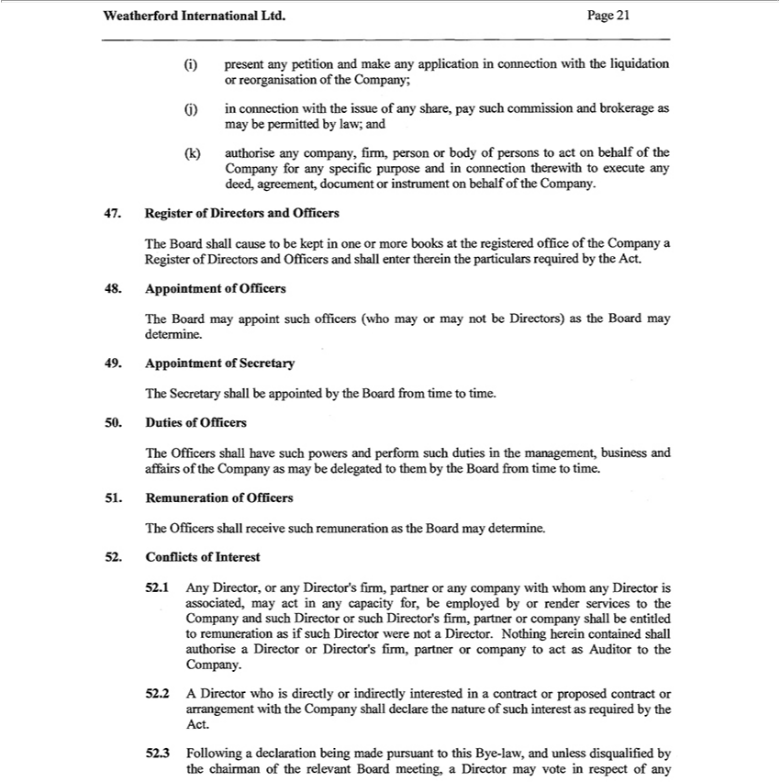

(i) |  | present any petition and make any application in connection with the liquidation
or reorganisation of the Company;
(j) |  | in connection with the issue of any share, pay such commission and brokerage as
may be permitted by law; and
(k) |  | authorise any company, firm, person or body of persons to act on behalf of the
Company for any specific purpose and in connection therewith to execute any deed, agreement, document or instrument on behalf of the Company.
47. |  | Register of Directors and Officers
The Board shall cause to be kept in one or more books at the registered office of the Company a Register of Directors and Officers and shall enter therein the particulars required by the Act.
48. |  | Appointment of Officers
The Board may appoint such officers (who may or may nőt be Directors) as the Board may determine.
49. |  | Appointment of Secretary
The Secretary shall be appointed by the Board írom time to time.
50. |  | Duties of Officers
The Officers shall have such powers and perform such duties in the management, business and affairs of the Company as may be delegated to them by the Board írom time to time.
51. |  | Remuneration of Officers
The Officers shall receive such remuneration as the Board may determine.
52. |  | Conflicts of Interest | ’s firm, partner or any company with whom any Director is | may act | any capacity for, be employed by render services |  | the Company and such Director or
52.1 Any Director or any
such D |  | ’s firm, partnerDirectorcompany shall be entitled to remuneration as if such Director wereassociated,nőtDirector. |  |  | Nothing herein contained shall authorise a Director or |  | Director’s firm, partner or company to act
as |  | rector the Company. |  |  |  | as required by the Act.
 | Auditor2Director who is directly or indirectly interested in a contract or proposed contract or arrangement with the Company shall declare the natúre of such
52.3 Following a declaration being made pursuant to this Bye-law, and unless disqualified by the chairman of the relevant Board meeting, a Director may voteinterestrespect of any

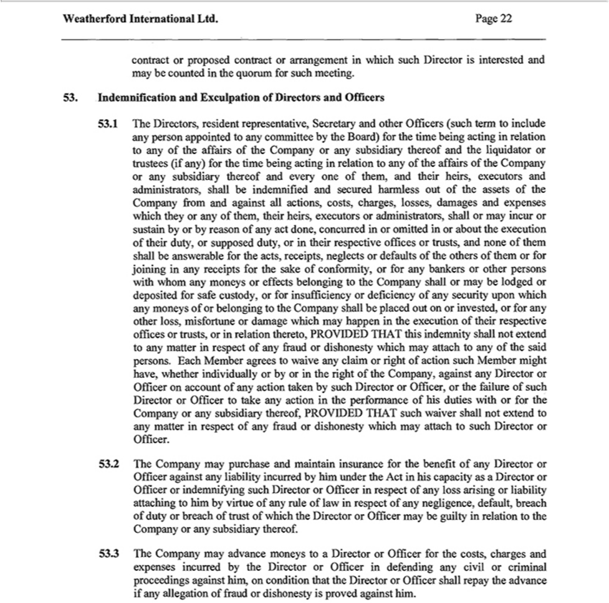

contract or proposed contract or arrangement in which such Director is interested and may be counted |  |  |  |  | the quorum for such meeting. 53.. Indemnification and Exculpation of Directors and Officers 53.1 The
Directors, resident representative, Secretary and other Officers (such term to include any person |  |  |  |  | to any committee by the Board) for the time being acting in relation to any of the affairs of the
Company or any subsidiary thereof and the liquidator or trustees (if any) for the time being actingappointedrelation to any of the affairs of the Company or any subsidiary thereof and every one of them, d their heirs,
executors and |  | shall be indemnified and secured harmless out of the assets of the Company from and against all actions, costs, charges, losses, damages and expenses which they or any of them,
their heirs, executorsadministrators,administrators, shall or may incur or sustain by or by reason of any act done, concurred in or omitted in or about the execution of their duty, or supposed duty, or in their respective offices
or trusts, and nőne of them shall answerable for the acts, receipts, neglects or defaults of the others of them or for joining in any receipts for the sake of conformity, or for any bankers or other persons with
whom any moneys or effects |  |  | to the | shall or may be lodged or deposited for safe custody, or for insufficiency or deficiency of any security upon which any moneys of or belonging to the
Company shall be placed out belongingor |  |  | orCompanyforother loss, misfortune or damage which may happen in the execution of their respective offices or trusts, or in relation thereto, PROVIDED THAT this
indemnity shall nőt extend to any matterinvested,respect of |  |  |  | fraud or dishonesty which may attach to any of the said persons. Each Member agrees to waive any claim or right of action such Member might have,
whether | individually or by or in the right of the Company, against any Director or Officer on account of any ction taken by such |  |  |  |  | or Officer, or the failure of such Director or Officer to take any action in
whether | of his duties with or for the Company or any subsidiary thereof, PROVIDED THAT such waiver shall nőt extendDirectoranymatter respect of any fraud or dishonesty which may attach to such
performanceOfficer. 53.2 The Company may purchase and maintain insurance for the benefit of any Director or Officer against any liability incurred by him under the Act in his capacity as Director or Officer
Directorindemnifying such Director or Officer in respect of |  |  |  | loss ari sing or liability attaching to him by virtue of any rule of law in respect of any negligence, default, breach of duty or breach of trust of which the
_{Director or Officer} may be guilty in relation to the Company or any subsidiary thereof. 53.3 The Company may advance moneys to a Director or Officer for the costs, charges and expenses incurred by the in defending any civil or criminal proceedings against him, on condition that the Director or Officer shall repay the advance if any allegation of fraud or dishonesty is proved against him.

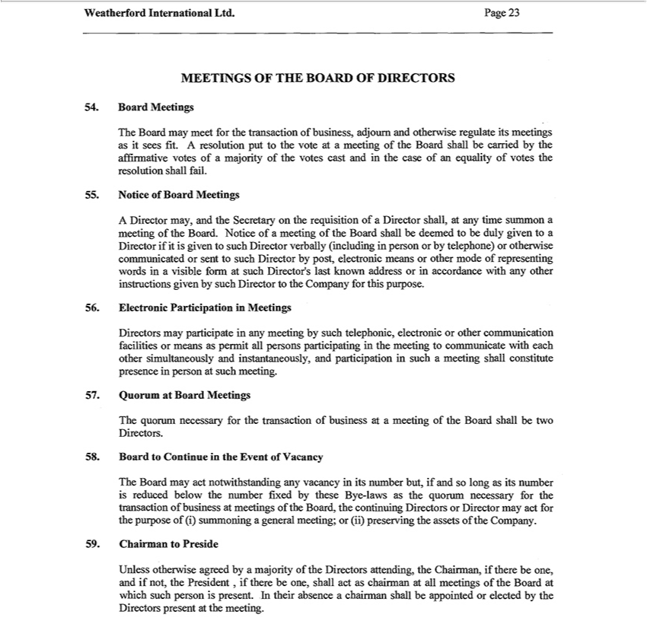

MEETINGS OF THE BOARD OF DIRECTORS 54. Board Meetings The Board may meet for the transaction of business, adjoum and otherwise regulate its meetings as it sees fit. A resolution pút to the vote at
meeting of the Board shall be carried by the affirmative votes of a |  | of the votes cast and in the case of an equality of votes the resolution shall fail. 55. Notice of Board Meetings A Director may, and the
Secretary on the requisition of a | shall, at any time summon majoritymeeting of the Board. Notice of a meeting of the Board shall be deemed to be duly given to a Director if it is given to such Director verbally
in person or by telephone)Directorotherwise communicated or sent to such Director by post, electronic means or other mode of representing words in visible form at such Director’ |  |  |  | last known address or
(includingaccordance with any other instructions given by such Director to the Company for this purpose. 56. Electronic Participation in Meetings Directors may participate in any meeting by such telephonic, electronic
or other communication facilities or means as permit all persons participating in the meeting to communicate with each other |  |  | and instantaneously, and participation in such | meeting shall
constitute presence in person at such meeting. 57. Quorum at Board Meetings The quorum necessary for the transaction of businesssimultaneouslyatmeeting of the Board shall be two Directors. 58. Board to Continue in the
Event of Vacancy The Board may act notwithstanding any vacancy in its number bút, if and so long as its number is reduced below the nu |  |  | ber fixed by these Bye-laws as the quorum necessary for the
transaction of business at meetings of the Board, the continuing Directors or Director may act for the purpose of (i) sumrnoning a general meeting; or (ii) preserving the assets of the Company. 59. Chairman to Preside Unless otherwise agreed by a majority of the Directors attending, the C^{the}airman, if there be one, and if nőt, the President , if there be one, shall act as chairman at all meetings of the Board at which such person is present. In their absence a chairman shall be appointed or elected by Directors present at the meeting.

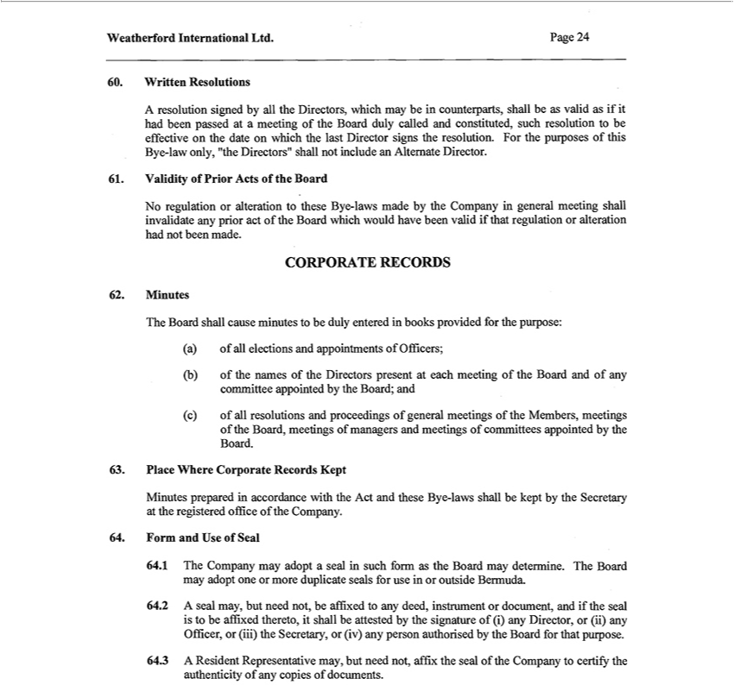

60. Written | A resolution signed by all the Directors, which may be in counterparts, shall be as valid as if it had been passed at a meeting of the Board duly called and constituted, such resolution to be
effective on Resolutionsthedate | which the last Director signs the resolution. For the purposes of this Bye-law only, "the Directors" shall nőt include an Alternate Director. 61. Validity of Prior Acts of the Board No
regulation or alteration to these Bye-laws made by the Company in general meeting shall invalidate any prior act of the Board which would have been valid if that regulation or alteration had not been made.
CORPORATE RECORDS 62. Minutes
The Board shall cause minutes to be duly entered in books provided for the purpose:
a) of all elections and appointments of Officers; |  | of the Board and of any committee appointed by the Board; and
b) of the names of the Directors present at each
(c) of all resolutions and proceedings of general meetings of the Members, meetings of the Board, meetings of managers and meetings of committees appointed by the Board.
63. Piace Where Corporate Records Kept
MinutesFormpreparedandUse inof accordanceSeal with the Act and these Bye-laws shall be kept by the Secretary at the registered office of the Company.
^{64.}1 The Company may adopt a seal in such form as the Board may determine. The Board may adopt one or more duplicate seals for use in or outside Bermuda.
2 A seal may, but need nőt, be affixed to any deed, instrument or document, and if the seal is to be affixed thereto, it shall be attested by the signature of (i) any Director, or (ii) any Officer, or (iii) the Secretary, or (iv) any person authorised by the Board for that purpose.
64.3 A Resident Representative may, bút need nőt, affix the seal of the Company to certify the authenticity of any copies of documents.

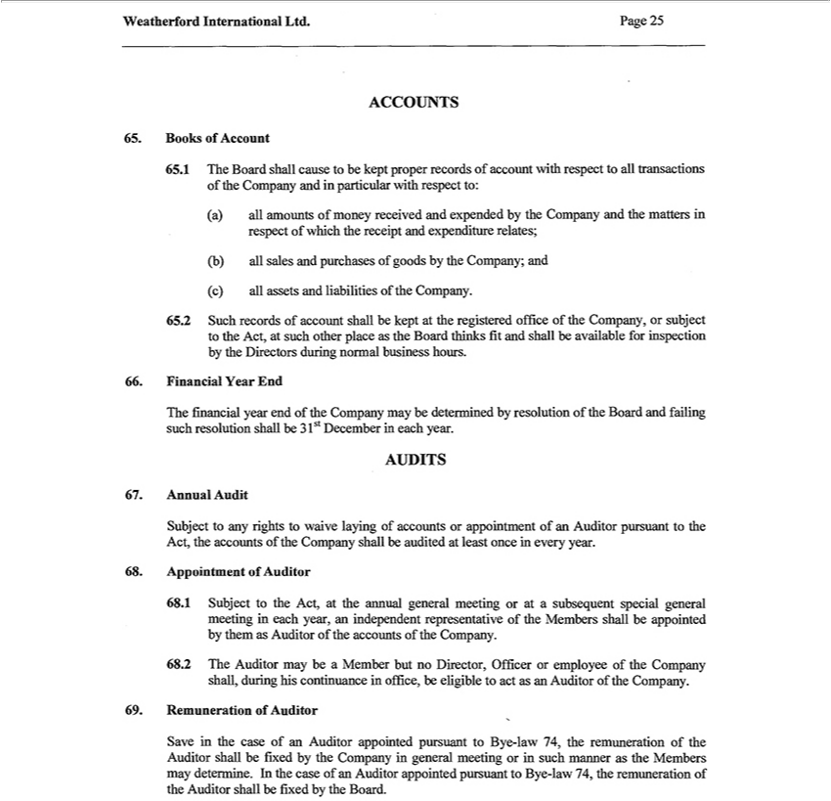

ACCOUNTS
^{65.} Books of Account
1 The Board shall cause to be kept proper records of account with respect to all tran_{respect}actions of the Company and in particular with respect to:
a)^{b)} all amounts of money received and expended by the Company and the matters in of which the receipt and expenditure relates;
^{(c)}
allall assetssalesandandpurchasesliabilities ofof goodstheCompany.bytheCompany; and

65.2 Such records of account shall be kept at the registered office of the Company, or subject to the Act, at such other piace as the Board thinks fit and shall be available for inspection by the Directors during normal business hours.
66. Financial Year End
The financial year end of the Company may be determined by resolution of the Board and failing such resolution shall be 3 lst December in each year.
AUDITS
67. Annual Audit
Subject to any rights_{Auditor}waive laying of accounts or appointment of an Auditor pursuant to the Act, the accounts of the Company shall be audited at least once in every year.
^{68.} Appointment of
1 Subject to the Act, at the annual general meeting or at a subsequent special general meeting in each year, an independent representative of the Members shall be appointed by them as Auditor of the accounts of the Company.
⁶⁹8.2 The Auditor may be a Member bút no Director, Officer or employee of the Company shall, during his continuance in office, be eligible to act as an Auditor of the Company. Remuneration of Auditor
Save in the case of an Auditor appointed pursuant to Bye-law 74, the remuneration of the Auditor shall be fixed by the Company in general meeting or in such manner as the Members may determine. In the case of an Auditor appointed pursuant to Bye-law 74, the remuneration of the Auditor shall be fixed by the Board.

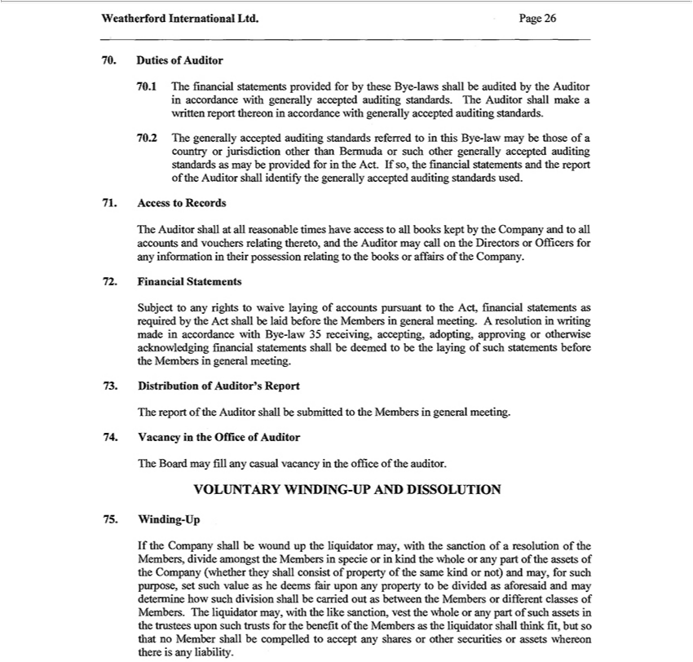

 |  | Duties of Auditor
70.1 The financial statements provided for by these Bye-laws shall be audited by the Auditor in accordance with generally accepted auditing standards. The Auditor shall make a written report thereon in
accordance with generally accepted auditing standards.
70.2 The generally accepted auditing standards referred to in this Bye-law may be those of a country or jurisdiction other than Bermuda or such other generally accepted auditing standards as may be provided
for in the Act. If , the financial statements and the report of the Auditor shall identify the generally accepted auditing standards used.
71. |  | Access to Records
The Auditor shall at all reasonable times have access to all books kept by the Company and to all accounts and vouchers relating thereto, and the Auditor may call on the Directors or Officers for any information
in their possession relating to the books or affairs of the Company.
72. |  | Financial Statements |  | the Members in general meeting. A resolution in writing made accordance
Subject to any rights to waive laying of accounts pursuant to the Act, fin ncial statements as required by the Act shall be laid
with Bye-law 35 receiving, accepting, adopting, approving or otherwise acknowledging financial statements shall be deemed tobeforethe laying of such statements before the Members in general meeting.
73. |  | Distribution of Auditor’ Report
The report of the Auditor shall be submitted to the Members in general meeting.
74. |  | Vacancy in the Office of Auditor
The Board may fill any casual vacancy in the office of the auditor.
VOLUNTARY WINDING-UP AND DISSOLUTION
75. |  | Winding-Up
If |  | Company shall be wound up the liquidator may, with the sanction of a resolution of the Members, divide amongst the Members in specie or in kind the whole any part of the assets of the Company
(whether they shall consist of property of the same kind or nőt) and may, for such purpose, set such value as he deems fair upon any property to be divided as aforesaid and may determine how such division shall
 | carried out as between the Members or different classes of Members. The |  | may, with the like sanction, vest the whole or any part of such assets in the trustees upon such trusts for the benefit of the
Members as the liquidator shall think fit, bút so that no Member shall be compelledliquidatoraccept any shares or other securities or assets whereon there is any liability.

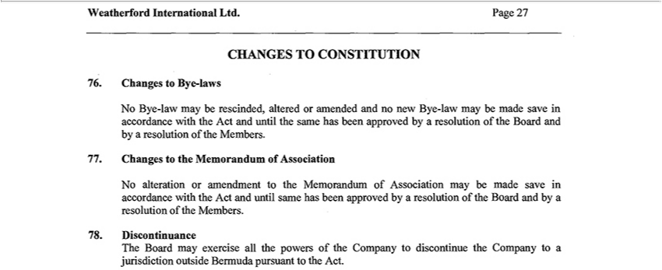

76.CHANGESChanges TOtoByeCONSTITUTION-laws
No Bye-law may be rescinded, altered or amended and no new Bye-law may be made save in accordance with the Act and until the same has been approved by a resolution of the Board and by a resolution of the Members.
77. Changes to the Memorandum of Association

No alteration or amendment to the Memorandum of Association may be made save in accordance with the Act and until same has been approved by a resolution of the Board and by a resolution of the Members. 78. Discontinuance
The Board may exercise all the powers of the Company to discontinue the Company to a jurisdiction outside Bermuda pursuant to the Act.

Exhibit 5.1

February 13, 2017

Page 1

811 Main Street, Suite 3700

Houston, TX 77002

Tel: +1.713.546.5400 Fax: +1.713.546.5401

www.lw.com

 | FIRM / AFFILIATE OFFICES
 | Barcelona | Moscow
 | Beijing | Munich
 | Boston | New Jersey
 | Brussels | New York
 | Century City | Orange County
 | Chicago | Paris
February 13, 2017 | Dubai | Riyadh
 | Düsseldorf | Rome
 | Frankfurt | San Diego
 | Hamburg | San Francisco
 | Hong Kong | Shanghai
 | Houston | Silicon Valley
 | London | Singapore
 | Los Angeles | Tokyo
 | Madrid | Washington, D.C.
 | Milan

Weatherford International plc

Weatherford International Ltd.

Weatherford International, LLC

2000 St. James Place

Houston, Texas 77056

Re: Registration Statement on Form S-3 (No. 333-)

Ladies and Gentlemen:

We have acted as special counsel to Weatherford International plc, a public limited company incorporated under the laws of Ireland (“Weatherford Ireland”), Weatherford International Ltd., a Bermuda exempted company (“Weatherford Bermuda”), and Weatherford International, LLC, a Delaware limited liability company (“Weatherford Delaware” and, together with Weatherford Ireland and Weatherford Bermuda, the “Companies”), in connection with the filing on the date hereof with the Securities and Exchange Commission (the “Commission”) of a registration statement on Form S-3 (the “Registration Statement”), including a base prospectus (the “Base Prospectus”), which provides that it will be supplemented by one or more prospectus supplements (each such prospectus supplement, together with the Base Prospectus, a “Prospectus”), under the Securities Act of 1933, as amended (the “Act”). The Registration Statement relates to, among other things, the issuance and sale from time to time, pursuant to Rule 415 of the General Rules and Regulations promulgated under the Act, of up to a total aggregate $2,000,000,000 of: (i) ordinary shares of Weatherford Ireland, $0.001 par value (“Ordinary Shares”); (ii) options of Weatherford Ireland to purchase Ordinary Shares (the “Options”); (iii) warrants of Weatherford Ireland to purchase Ordinary Shares (the “Warrants”); (iv) debt securities of Weatherford Bermuda (“Bermuda Debt Securities”); (v) debt securities of Weatherford Delaware (“Delaware Debt Securities” and, together with the Bermuda Debt Securities, the “Debt Securities”); and (vi) guarantees of the Debt Securities by Weatherford Ireland, Weatherford Bermuda and/or Weatherford Delaware (collectively, the “Guarantees”). The Ordinary Shares, Options, Warrants, Debt Securities and Guarantees are collectively referred to herein as the “Offered Securities.” The Offered Securities will be issued under an applicable prospectus supplement and the Debt Securities will be issued under (i) the Indenture dated October 1, 2003, as supplemented (the “2003 Indenture”), among the Companies and Deutsche Bank Trust Company Americas, trustee (the “Trustee”), or (ii) the Indenture dated June 18, 2007, as supplemented (the “2007 Indenture” and, together with the 2003 Indenture, the “Indentures”), among the Companies and the Trustee, as such Indentures may hereafter be supplemented from time to time, among other things at the time of and in connection with the issuance of the Debt Securities.

This opinion is being furnished in connection with the requirements of Item 601(b)(5) of Regulation S-K under the Act, and no opinion is expressed herein as to any matter pertaining to the contents of the Registration Statement or related applicable Prospectus, other than as expressly stated herein with respect to the issue of the Offered Securities.

February 13, 2017

Page 2

As such counsel, we have examined such matters of fact and questions of law as we have considered appropriate for purposes of this letter. With your consent, we have relied upon certificates and other assurances of officers of the Companies and others as to factual matters without having independently verified such factual matters. We are opining herein as to the internal laws of the State of New York, and we express no opinion with respect to the applicability thereto, or the effect thereon, of the laws of any other jurisdiction or as to any matters of municipal law or the laws of any local agencies within any state. Various matters concerning the laws of Ireland and Bermuda with respect to the Offered Securities are addressed in opinions provided by other counsel. We express no opinion with respect to those matters herein, and, to the extent such matters are necessary to the conclusions expressed herein, we have, with your consent, assumed such matters.

Based upon and subject to the foregoing, we are of the opinion that, with respect to any series of the Debt Securities to be offered by Weatherford Bermuda or Weatherford Delaware (the “Offered Debt Securities”) and any Guarantees of the Offered Debt Securities to be offered by Weatherford Ireland, Weatherford Bermuda or Weatherford Delaware (the “Offered Guarantees”) pursuant to the Registration Statement, when (i) the terms of the Offered Debt Securities and the Offered Guarantees and of their issuance and sale have been duly established in conformity with the applicable Indenture, (ii) the Offered Debt Securities and the Offered Guarantees have been offered and sold in accordance with the applicable Indenture, the Registration Statement, including the prospectus supplement related thereto, and, if in an underwritten offering, a valid and binding purchase, underwriting or agency agreement, and (iii) the applicable supplemental indenture relating to the Offered Debt Securities and the Offered Guarantees has been duly executed and delivered by each party thereto and the Offered Debt Securities and the Offered Guarantees have been duly executed and authenticated in accordance with the provisions of the applicable Indenture (including the applicable supplemental indenture) and duly delivered to the purchasers thereof upon payment of the agreed-upon consideration therefor, the Offered Debt Securities (including any Debt Securities or Guarantees duly issued upon conversion, exchange or exercise of any Debt Securities) and the Offered Guarantees will be the legally valid and binding obligations of, as applicable, Weatherford Ireland, Weatherford Bermuda and Weatherford Delaware, enforceable against each of Weatherford Ireland, Weatherford Bermuda and Weatherford Delaware, as applicable, in accordance with their terms.

Our opinion is subject to: (i) the effect of bankruptcy, insolvency, reorganization, preference, fraudulent transfer, moratorium or other similar laws relating to or affecting the rights and remedies of creditors; (ii) the effect of general principles of equity, whether considered in a proceeding in equity or at law (including the possible unavailability of specific performance or injunctive relief), concepts of materiality, reasonableness, good faith and fair dealing, and the discretion of the court before which a proceeding is brought; (iii) the invalidity under certain circumstances under law or court decisions of provisions providing for the indemnification of or contribution to a party with respect to a liability where such indemnification or contribution is contrary to public policy; and (iv) we express no opinion as to (a) any provision for liquidated damages, default interest, late charges, monetary penalties, prepayment or make-whole premiums or other economic remedies to the extent such provisions are deemed to constitute a penalty, (b) consents to, or restrictions upon, governing law, jurisdiction, venue, arbitration, remedies, or judicial relief, (c) the waiver of rights or defenses; (d) any provision requiring the payment of attorneys’ fees, where such payment is contrary to law or public policy; (e) any provision permitting, upon acceleration of any indebtedness, collection of that portion of the stated principal amount thereof which might be determined to constitute unearned interest thereon; (f) provisions purporting to waive modifications of any guaranteed obligation to the extent such modification constitutes a novation; (g) provisions purporting to make a guarantor primarily liable rather than as a surety; (h) advance waivers of claims, defenses, rights granted by law, or notice, opportunity for hearing, evidentiary requirements, statutes of limitation, trial by jury or at law, or other procedural rights; (i) waivers of broadly or vaguely stated rights; (j) provisions for exclusivity, election or cumulation of rights or remedies; (k) provisions authorizing or validating conclusive or discretionary determinations; (l) grants of setoff rights; (m) proxies, powers and trusts;

- provisions prohibiting, restricting, or requiring consent to assignment or transfer of any right or property; and (o) the severability, if invalid, of provisions to the foregoing effect.

With your consent, we have assumed (a) that each of the Indentures (including any supplemental indenture thereto) and the Debt Securities and the Guarantees (collectively, the “Documents”) will be governed by the internal laws of the State of New York, (b) that each of the Documents has been or will be duly authorized, executed and delivered by the parties thereto other than with respect to Weatherford Delaware, (c) that each of the Documents constitutes or will constitute legally valid and binding obligations of the parties thereto other than the Companies, enforceable against each of them in accordance with their respective terms, and (d) that the status of each of the Documents as legally valid and binding obligations of the parties will not be affected by any

- breaches of, or defaults under, agreements or instruments, (ii) violations of statutes, rules, regulations or court or governmental orders, or (iii) failures to obtain required consents, approvals or authorizations from, or to make required registrations, declarations or filings with, governmental authorities.

February 13, 2017

Page 3

This opinion is for your benefit in connection with the Registration Statement and may be relied upon by you and by persons entitled to rely upon it pursuant to the applicable provisions of the Act. We consent to your filing this opinion as an exhibit to the Registration Statement and to the reference to our firm contained in the Prospectus under the heading “Legal Matters.” In giving such consent, we do not thereby admit that we are in the category of persons whose consent is required under Section 7 of the Act or the rules and regulations of the Commission thereunder.

Very truly yours,

/s/ Latham & Watkins LLP

Exhibit 5.2

13 February 2017

Matter No.: 356559

Doc Ref: legal12118367

Email: ciara.brady@conyersdill.com

Tel: 441 278 7974

Weatherford International Ltd.

2000 St James Place,

Houston, Texas 77056 U.S.A.

Dear Sirs,

Re: Weatherford International Ltd. (the “Company”)

We have acted as special Bermuda legal counsel to the Company, a Bermuda exempted company, in connection with a registration statement on Form S-3 (Registration No. 333- ) filed with the U.S. Securities and Exchange Commission (the “Commission”) on 13 February 2017 (the “Registration Statement”, which term does not include any other document or agreement whether or not specifically referred to therein or attached as an exhibit or schedule thereto) relating to the shelf registration under the U.S. Securities Act of 1933, as amended, (the “Securities Act”) of up to an aggregate initial offering price of US$2,000,000,000, inter alia, (i) senior debt securities of the Company (the “Company Debt Securities”) to be issued pursuant to an indenture dated October 1, 2003 (as amended and supplemented from time to time) originally among the Company, as issuer, Weatherford International, LLC (“Weatherford Delaware”), a Delaware limited liability company, as guarantor, and Deutsche Bank Trust Company Americas (the “Trustee”), as trustee (the “2003 Indenture”, which term does not include any other document or agreement whether or not specifically referred to therein or attached as an exhibit or schedule thereto) and (ii) the guarantee by the Company (the “Guarantees”) of senior debt securities issued by Weatherford Delaware (the “Weatherford Delaware Debt Securities”, together with the Company Debt Securities, the “Debt Securities”; and the Debt Securities, together with the Guarantees, the “Securities”) pursuant to an indenture dated 18 June 2007 (as amended and supplemented from time to time) originally among Weatherford Delaware, as issuer, the Company, as guarantor, and the Trustee (the “2007 Indenture”, which term does not include any other document or agreement whether or not specifically referred to therein or attached as an exhibit or schedule thereto, together with the 2003 Indenture, the “Indentures” and “Indenture” means either one of them).

For the purposes of giving this opinion, we have examined a copy of the Registration Statement and the Indentures.

- 1 -

We have also reviewed the memorandum of association and the bye-laws of the Company (together, the “Constitutional Documents”) each certified by the Secretary of the Company on 13 February 2017, minutes of meetings of the board of directors of the Company (the “Board”) held on 3 September 2003,
30 May 2007 and 31 January 2017 and minutes of a meeting of the Pricing Committee of the Board held on 13 June 2007, each certified by the Secretary of the Company on 13 February 2017 (together, the “Resolutions”), and such other documents and made such enquiries as to questions of law as we have deemed necessary in order to render the opinion set forth below.

We have assumed (a) the genuineness and authenticity of all signatures and the conformity to the originals of all copies (whether or not certified) examined by us and the authenticity and completeness of the originals from which such copies were taken, (b) that where a document has been examined by us in draft form, it will be or has been executed and/or filed in the form of that draft, and where a number of drafts of a document have been examined by us all changes thereto have been marked or otherwise drawn to our attention, (c) the accuracy and completeness of all factual representations made in the Registration Statement and other documents reviewed by us, (d) that the Resolutions were passed at one or more duly convened, constituted and quorate meetings, or by unanimous written resolutions, remain in full force and effect and have not been, and will not be, rescinded or amended, (e) that the Company will issue the Company Debt Securities and enter into any and all Guarantees, and that the Company has entered into the Indentures, in furtherance of its objects as set out in its memorandum of association, (f) that the Constitutional Documents will not be amended in any manner that would affect the opinions expressed herein,

- that there is no provision of the law of any jurisdiction, other than Bermuda, which would have any implication in relation to the opinions expressed herein, (h) that the consents given by the Bermuda Monetary Authority in its Notice to the Public dated 1 June 2005 will not have been revoked or amended at the time of issuance of any Company Debt Securities, (i) that the form and terms of any and all Securities, the issuance and sale of Securities by the Company and Weatherford Delaware and the Company’s incurrence and performance of its obligations thereunder or in respect thereof (including, without limitation, its obligations under any related agreement, the Indentures (including, without limitation, the Guarantees) and supplements to the Indentures) in accordance with the terms thereof will not violate or will not have violated the Constitutional Documents nor any applicable law, regulation, order or decree in Bermuda,

- that all necessary corporate action has been or will have been taken to authorise and approve the Guarantees and any issuance of Debt Securities, the terms of the offering thereof and related matters, and that the applicable definitive purchase, underwriting or similar agreement and, if any Debt Securities are to be issued, the applicable Indenture and any applicable supplements to the Indentures has been or will have been duly approved, executed and delivered by or on behalf of the Company and all other parties thereto, (k) that the applicable purchase, underwriting or similar agreement, the Debt Securities, the Indentures (including, without limitation, the Guarantees), any supplements to the Indentures and any other agreement or other document relating to the Debt Securities and the Guarantees each are or will be valid, binding and enforceable in accordance with its terms pursuant to its governing law; (l) that the issuance, sale of and payment for the Debt Securities and the form of the Guarantees will be in accordance

  - 2 -

with the applicable purchase, underwriting or similar agreement duly approved by the Board, the Registration Statement (including the prospectus set forth therein and any applicable supplement or amendment thereto) and, if Debt Securities are to be issued, the applicable Indenture and any applicable supplements thereto, (m) that, upon the issue of any Debt Securities, the Company will receive consideration for the full issue price thereof and where the Debt Securities have been issued to a subsidiary of the Company, such consideration shall be from sources external to the Company and/or its subsidiaries,

- that no Company Debt Securities will be convertible or exchangeable into shares in the capital of the Company, (o) that the Company will have complied, to the extent applicable, with the requirements of Part III of the Companies Act 1981, as amended, entitled “Prospectuses and Public Offers”, (p) the capacity, power and authority of each of the parties other than the Company to enter into and perform their obligations under any and all documents (including, without limitation, the Indentures and all supplements thereto) entered into by such parties in connection with the Guarantees and the issuance of the Debt Securities, and the due execution and delivery thereof by each party thereto, (q) that none of the parties to such documents carries on business from premises in Bermuda, at which it employs staff and pays salaries and other expenses, and (r) at no time shall the aggregate initial offering price of securities to be registered under the Registration Statement and offered by the Company, Weatherford Delaware, Weatherford International plc and/or any subsidiary of the Company in connection therewith exceed US $5,000,000,000.

The term “enforceable” as used in this opinion means that an obligation is of a type which the courts of Bermuda enforce. It does not mean that those obligations will be enforced in all circumstances in accordance with the terms of the Documents. In particular, the obligations of the Company in connection with any Security and any agreement or document relating thereto (a) will be subject to the laws from time to time in effect relating to bankruptcy, insolvency, liquidation, possessory liens, rights of set off, reorganisation, amalgamation, merger, moratorium or any other laws or legal procedures, whether of a similar nature or otherwise, generally affecting the rights of creditors as well as applicable international sanctions, (b) will be subject to statutory limitation of the time within which proceedings may be brought, (c) will be subject to general principles of equity and, as such, specific performance and injunctive relief, being equitable remedies, may not be available, (d) may not be given effect to by a Bermuda court if and to the extent they constitute the payment of an amount which is in the nature of a penalty and not in the nature of liquidated damages, and (e) may not be given effect by a Bermuda court to the extent that they are to be performed in a jurisdiction outside Bermuda and such performance would be illegal under the laws of that jurisdiction. Notwithstanding any contractual submission to the jurisdiction of specific courts, a Bermuda court has inherent discretion to stay or allow proceedings in the Bermuda courts.

We have made no investigation of and express no opinion in relation to the laws of any jurisdiction other than Bermuda. This opinion is to be governed by and construed in accordance with the laws of Bermuda and is limited to and is given on the basis of the current law and practice in Bermuda. This opinion is issued solely for the purposes of the filing of the Registration Statement and in connection with the Guarantees and the issuance of the Company Debt Securities by the Company as described in the Registration Statement and is not to be relied upon in respect of any other matter.

- 3 -

On the basis of and subject to the foregoing we are of the opinion that:

- The Company is duly incorporated and existing under the laws of Bermuda in good standing (meaning solely that it has not failed to make any filing with any Bermuda governmental authority or to pay any Bermuda government fee or tax which would make it liable to be struck off the Register of Companies and thereby cease to exist under the laws of Bermuda).

- Upon the due issuance of the Company Debt Securities and payment of the consideration therefor, such Company Debt Securities will constitute valid, binding and enforceable obligations of the Company in accordance with the terms thereof.

- Upon the due execution and delivery of the Guarantees, the Guarantees will constitute valid, binding and enforceable obligations of the Company in accordance with the terms thereof.

We hereby consent to the filing of this opinion as an exhibit to the Registration Statement and to the references to our firm under the caption “Legal Matters” in the prospectus forming a part of the Registration Statement. In giving such consent, we do not hereby admit that we are experts within the meaning of Section 11 of the Securities Act or that we are in the category of persons whose consent is required under Section 7 of the Securities Act or the Rules and Regulations of the Commission promulgated thereunder.

Yours faithfully,

Conyers Dill & Pearman Limited

- 4 -

Exhibit 5.3

Solicitors


70 Sri John Rogerson’s Quay

Dublin 2 Ireland

D02 R296

T + 353 1 232 2000

F + 353 1 232 3333

W www.matheson.com

DX 2 Dublin

Weatherford International plc

Banhofstrasse 1

6340 Baar

Switzerland

Our Ref Your Ref 13 February 2017

FBO 661725.9

Dear Sirs

Weatherford International plc, an Irish public company limited by shares

Registration Statement on Form S-3

We have acted on behalf of Weatherford International plc, a public limited company incorporated under the laws of Ireland with company number 540406 (the “Company”) in connection with the Company’s registration statement on Form S-3 (including the base prospectus therein, the “Registration Statement”) to be filed by the Company, pursuant to the Securities Act of 1933 of the United States of America, as amended (the “Securities Act”), with the Securities and Exchange Commission of the United States of America (the “SEC”).

The Registration Statement relates to, amongst other things, the issuance and sale from time to time, pursuant to Rule 415 of the General Rules and

Regulations promulgated under the Securities Act of up to a total aggregate of $2,000,000,000 of:

- the Company’s ordinary shares (nominal value of US$0.001 per share) (the “Registered Shares”);

- options of the Company entitling the holders thereof to subscribe for Registered Shares (the “Options”)

- debt securities of Weatherford International, LLC, a Delaware limited liability company (“Weatherford Delaware”), in one or more series (the “Weatherford Delaware Debt Securities”), which are guaranteed by the Company under the terms of the Weatherford Delaware Debt Securities Indenture (as defined below);

- debt securities of Weatherford International Ltd., a Bermuda exempted company (“Weatherford Bermuda”), in one or more series (the “Weatherford Bermuda Debt Securities”), which are guaranteed by the Company under the terms of the Weatherford Bermuda Debt Securities Indenture (as defined below); and

- warrants of the Company entitling the holders thereof to subscribe for Registered Shares (the “Warrants”).

The Weatherford Bermuda Debt Securities will be issued under an indenture dated 1 October 2003, as supplemented by supplemental indentures dated

25 March 2008, 8 January 2009, 26 February 2009, 23 September 2010, 4 April 2012, 14 August 2012, 31 March 2013, 17 June 2014, 7 June 2016 and

17 June 2016 (as same may be further supplemented from time to time), to which Weatherford Bermuda, as issuer, the Company and Weatherford Delaware, as guarantors, and Deutsche Bank Trust Company Americas, as trustee, are party (together the “Weatherford Bermuda Debt Securities Indenture”).

The Weatherford Delaware Debt Securities will be issued under an indenture, dated 18 June 2007, as supplemented by supplemental indentures dated 18 June 2007, 26 February 2009, 14 August 2012, 31 March 2013 and 17 June 2014 (as same may be further supplemented from time to time), to which Weatherford Delaware, as issuer, the Company and Weatherford Bermuda, as guarantors, and Deutsche Bank Trust Company Americas, as trustee, are party (together the “Weatherford Delaware Debt Securities Indenture”).

The Weatherford Delaware Debt Securities Indenture and the Weatherford Bermuda Debt Securities Indenture are collectively referred to herein as the “Indentures”, the Weatherford Delaware Debt Securities and the Weatherford Bermuda Debt Securities are collectively referred to herein as the “Debt Securities”, and the Registration Statement and the Indentures are collectively referred to herein as the “Documents”.

- Scope of appointment and basis of opinion

1.1 We have been requested by the Company to provide this opinion.

1.2 For the purpose of giving this opinion, we have examined:

- the final form of the Registration Statement to be filed by the Company with the SEC;

- copies of the Indentures;

- a copy of the Company’s constitution (in the form of a memorandum and articles of association) (as set out in Exhibit 3.1 to the Company’s Current Report on Form 8-K filed with the SEC on 17 June 2014);

- copy minutes of meetings of the board of directors of the Company held on 3 March 2014, 25 March 2014, 15 May 2014, 16 May 2014, 6 June 2014, 1 June 2016, 9 June 2016 and 7 November 2016;

- copy resolutions of the board of directors of the Company passed on 30 May 2016, 8 June 2016 and December 13, 2016;

- copy written resolutions of the shareholders of the Company dated 15 May 2014 (the “Section 60 Special Resolutions”), 27 May 2014 and 6 June 2014;

- a copy statutory declaration of the directors of the Company made on 15 May 2014 pursuant to section 60(2) of the Companies Act 1963;

- a certificate of an assistant secretary of the Company (the “Certificate”); and

- a copy of the results of searches made on 10 February 2017 at the Irish Companies Registration Office, in the Register of Winding Up Petitions at the Central Office of the High Court of Ireland and at the Judgments’ Office in the Central Office of the High Court of Ireland against the Company (together the “Searches”).

1.3 We have made no searches or enquiries concerning, and we have not examined any contracts, instruments or documents entered into by or affecting the Company or any other person, or any corporate records of the aforesaid, save for those searches, enquiries, contracts, instruments, documents or corporate records specified as being made or examined in this opinion.

1.4 We express no opinion and make no representation or warranty as to any matter of fact. Furthermore, we have not been responsible for the investigation or verification of the facts or the reasonableness of any assumption or statements of opinion contained or represented by the Company in any of the Documents nor have we attempted to determine whether any material facts have been omitted therefrom.

1.5 We have not investigated the laws of any country other than Ireland and this opinion is given only with respect to the laws of Ireland in effect at the date of this opinion. We have assumed, without enquiry, that there is nothing in the laws of any other jurisdiction which would or might affect the opinions as stated herein.

1.6 This opinion is to be construed in accordance with, and governed by, the laws of Ireland, and is given solely on the basis that any issues of interpretation or liability arising hereunder may only be brought before the Irish courts, which will have exclusive jurisdiction in respect of such matters.

1.7 This opinion is delivered in connection with the filing of the Registration Statement with the SEC and is strictly limited to the matters stated herein and does not extend to, and is not to be read as extending by implication to, any other matter. We hereby consent to the filing of this opinion as an exhibit to the Registration Statement and to the use of our name therein. In giving this consent, we do not hereby admit that we come within the category of persons whose consent is required under section 7 of the Securities Act or the rules and regulations of the SEC promulgated thereunder. This opinion is furnished to you and the persons entitled to rely upon it pursuant to the applicable provisions of the Securities Act for use in connection with the filing of the Registration Statement and is not to be used, circulated, quoted or otherwise referred to for any other purpose without our express written consent.

1.8 The opinions set forth in this opinion are given on the date hereof. We assume no obligation to update the opinions set forth in this opinion.

- Assumptions

For the purpose of giving this opinion we have assumed:

  - the authenticity and completeness of all documents submitted to us as originals;

  - the completeness and conformity to originals of all documents supplied to us as certified, conformed or photostatic copies or received by us by facsimile or email transmission and the authenticity and completeness of the originals of such documents;

  - the genuineness of the signatures and seals on all original and copy documents which we have examined;

  - that the proceedings described in the copy minutes of the meetings of the board of directors of the Company referred to above at paragraph 1.2(d) and examined for the purposes of this opinion were conducted in the manner therein described, that the meetings were properly convened and constituted and that the resolutions referred to therein were duly passed and adopted and have not since been amended or rescinded;

  - that the copy resolutions of the board of directors of the Company referred to above at paragraph 1.2(e) were duly passed and adopted and have not since been amended or rescinded;

  - that the copy written resolutions of the shareholders referred to above at paragraph 1.2(f) were duly passed and adopted and have not since been amended or rescinded;

  - that the statutory declaration referred to in paragraph 1.2(g) as having been made pursuant to section 60(2) of the Companies Act 1963 was duly made and filed in the Companies Registration Office as therein described;

  - that Registered Shares will be issued by the entry of the name of the registered owner thereof in the register of members of the Company confirming that such Registered Shares have been issued credited as fully paid-up;

- that, at the time of the allotment and issue of any Registered Shares (including upon the exercise of Options and / or Warrants): (i) the Registration Statement will be effective and continue to be effective; (ii) the sale of and payment for any Registered Shares will be in accordance with the Registration Statement (including the prospectus set forth in the Registration Statement and any applicable supplements and amendments thereto); (iii) the Company will have a sufficient number of authorised but unissued Registered Shares in its capital (at least equal to the number of Registered Shares to be allotted and issued); (iv) the directors of the Company will have been generally and unconditionally authorised, as required by section 1021(1) of the Companies Act 2014 (the “2014 Act”) (or as appropriate under the provisions of any former enactment relating to companies), by the constitution, from time to time, of the Company, or by ordinary resolution of the Company’s shareholders, to allot a sufficient number of Registered Shares (at least equal to the number of Registered Shares to be allotted and issued); and (v) if issued for cash consideration, such Registered Shares will be allotted and issued in accordance with section 1022(1) of the 2014 Act or the directors will have been empowered, by special resolution of the shareholders, passed in accordance with section 1023(3) of the 2014 Act (or as appropriate under the provisions of any former enactment relating to companies), to allot and issue such Registered Shares as if the said section 1022(1) did not apply to such allotment and issue;

- that any Registered Shares allotted and issued in accordance with the Registration Statement (including upon the exercise of Options and / or Warrants) will be paid-up in consideration of the receipt by the Company from the party to whom the Registered Shares are to be issued, prior to, or simultaneously with the issue of such Registered Shares, of cash and other consideration at least equal to the nominal value of such Registered Shares and, to the extent that any of the consideration for such Registered Shares is payable otherwise than in cash, that the provisions of sections 1028 to 1035 of the 2014 Act have been complied with;

- that no Registered Shares (including upon the exercise of Options and / or Warrants) will be allotted and issued: (i) for consideration of an undertaking from any person that he or another will do work or perform services for the Company or for any other person; (ii) for consideration otherwise than in cash that includes an undertaking which is to be or may be performed more than five years after the date of allotment; or (iii) for other consideration which, from time to time, is not considered good or adequate consideration;

- that no Registered Shares (including upon the exercise of Options and / or Warrants) or Warrants or Options will be allotted and issued other than pursuant to a resolution of the board of directors of the Company (or duly authorised committee thereof) that has been validly and sufficiently proposed and passed in accordance with the constitution, from time to time, of the Company;

- that the Documents and all deeds, instruments, assignments, agreements and other documents in relation to the matters contemplated by the Documents and / or this opinion are:

- within the capacity and powers of, have been validly authorised, executed and delivered by and are valid, legal, binding and enforceable obligations of the parties thereto; and

- are not subject to avoidance by any person,

under all applicable laws and in all applicable jurisdictions other than (in the case of the Company) the laws of Ireland and the jurisdiction of Ireland;

- that the offering or sale (including the marketing) of any Registered Shares, Debt Securities, Options or Warrants will be made, effected and conducted in accordance with and will not violate: (i) the constitution, from time to time, of the Company; (ii) any applicable laws and regulations (including, without limitation, (A) the securities laws and regulations of any jurisdiction (including Ireland) or supra-national authority which impose any restrictions, or mandatory requirements, in relation to the offering or sale of shares to the public in any jurisdiction (including Ireland) and any prospectus (or analogous disclosure document) prepared in connection therewith; and (B) the competition, anti-trust or merger control laws and regulations of any jurisdiction (including Ireland) or supra-national authority); and (iii) any requirement or restriction imposed by any court, governmental body or supra-national authority having jurisdiction over the Company or the members of its group;

- that, at the time of the issuance and sale of any Debt Securities: (i) the Registration Statement will be effective and continue to be effective; (ii) the sale of and payment for any Debt Securities will be in accordance with the Registration Statement (including the prospectus set forth in the Registration Statement and any applicable supplements and amendments thereto) and the relevant Indenture; (iii) in any underwritten offering, a definitive purchase, underwriting or similar agreement with respect to any Debt Securities will be duly authorised and validly executed and delivered by the Company and the other parties thereto; and (iv) the issuance and sale (including the marketing) of any Debt Securities will not violate the constitution, from time to time, of the Company, any applicable law or any requirement or restriction imposed by any court or governmental body having jurisdiction over the Company or result in a default under or breach of any agreement or instrument binding on the Company;

- that, at the time of the issuance and sale of any Options and / or Warrants: (i) the Registration Statement will be effective and continue to be effective; (ii) the sale of and payment for any Options or Warrants will be in accordance with the Registration Statement (including the prospectus set forth in the Registration Statement and any applicable supplements and amendments thereto); (iii) in any underwritten offering, a definitive purchase, underwriting or similar agreement with respect to any Options or Warrants will be duly authorised and validly executed and delivered by the Company and the other parties thereto; and (iv) the issuance and sale (including the marketing) of any Warrants or Options will not violate the constitution, from time to time, of the Company, any applicable law or any requirement or restriction imposed by any court or governmental body having jurisdiction over the Company or result in a default under or breach of any agreement or instrument binding on the Company;

- that, other than as approved by the Section 60 Special Resolutions, the Company has not, by virtue of the Documents, given, nor shall it give, directly or indirectly, financial assistance, as contemplated by section 82 of the 2014 Act, for the purpose of, or in connection with the subscription for or purchase of shares in itself or any company which is its holding company;

- that the Company has not given, nor shall it give, directly or indirectly, and whether by means of a loan, guarantee, the provision of security or otherwise, any financial assistance, as contemplated by section 82 of the 2014 Act, for the purpose of, or in connection with, the purchase or subscription by any person of, or for, any Registered Shares save as permitted by, or pursuant to an exemption to, the said section 82;

- that insofar as any of the Documents fall to be performed in any jurisdiction other than Ireland its performance will not be illegal or ineffective by virtue of the laws of that jurisdiction;

- that the Company, Weatherford Delaware and Weatherford Bermuda together comprise a “group” for the purposes of section 243 of the 2014 Act and that any person that subsequently becomes an issuer or guarantor under the Indentures or whose obligations are guaranteed thereunder by the Company will also be, and continue to be, a member of such group.

- that there is or are no factual information or documents possessed or discoverable by persons other than ourselves of which we are not aware but of which we should be aware for the purposes of this opinion;

- the accuracy and completeness as to factual matters of the representations and warranties of the Company contained in the Documents and the accuracy of the Certificate;

- that there are no agreements or arrangements in existence which in any way amend or vary or are inconsistent with the terms of the Documents or in any way bear upon, or are inconsistent with, the contents of this opinion;

- that, in approving the filing by the Company of the Registration Statement and the execution and delivery by the Company of the Indentures, any Options and any Warrants, the directors of the Company have acted, or will act, in a manner they consider, in good faith, to be in the best interests of the Company for its legitimate business purposes and would be most likely to promote the success of the Company for the benefit of its members as a whole;

- the absence of fraud and the presence of good faith on the part of all parties to the Documents and their respective officers, employees, agents and advisers;

- that the information disclosed by the Searches was accurate at the date the Searches were made and has not been altered and that the Searches did not fail to disclose any information which had been delivered for registration but did not appear from the information available at the time the Searches were made or which ought to have been delivered for registration at that time, but had not been so delivered, and that no additional matters would have been disclosed by searches carried out since that time;

- that: (i) the Company was, and will be, fully solvent (A) at the time of, and immediately after, the filing of the Registration Statement, (B) at the time of, and immediately after, the execution and delivery of the Indentures and any Options or Warrants and (C) at the date hereof; (ii) the Company would not, as a consequence of doing any act or thing which any of the Documents contemplate, permit or require the Company to do, be insolvent; and (iii) no steps have been taken or, to the best of the knowledge, information and belief of the directors of the Company, are being taken to appoint a receiver, liquidator or an examiner over the Company or any part of its undertaking or assets, or to strike the Company off the Register of Companies or to otherwise dissolve or wind up the Company; and

- the truth of all representations and information given to us in reply to any queries we have made which we have considered necessary for the purposes of giving this opinion.

- Opinion

Based upon, and subject to, the foregoing and subject to the qualifications set out in this opinion and any matter not disclosed to us, we are of the opinion that so far as the laws of Ireland are concerned and are applicable:

  - the Company is a public limited company, duly incorporated and existing under the laws of Ireland;

  - upon the issuance of Registered Shares as contemplated by the Registration Statement, subject to receipt by the Company of the full consideration payable in respect thereof, such Registered Shares will be validly issued, fully-paid and non-assessable (“non-assessable” is a phrase which has no meaning under Irish law, but, for the purposes of this opinion, shall mean the registered holders of Registered Shares are not liable, solely by virtue of their shareholding, for the payment of further amounts of capital on such shares);

  - the Company has the requisite corporate capacity to issue Warrants and Options and, subject to the board of directors of the Company taking all necessary corporate actions to approve the issuance thereof, the issue of Warrants and Options will be duly authorised under Irish law; and

  - the Company has the requisite corporate capacity to guarantee Debt Securities and, subject to the board of directors of the Company taking all necessary corporate actions to approve the issuance thereof, the guarantee of Debt Securities will be duly authorised under Irish law.

- Qualifications

The opinions set forth in this opinion are given subject to the following qualifications:

  - A search at the Companies Registration Office is not capable of revealing whether or not a winding up petition or a petition for the appointment of an examiner has been presented and a search at the Registry of Winding up Petitions at the Central Office of the High Court is not capable of revealing whether or not a receiver has been appointed. Whilst each of the making of a winding up order, the making of an order for the appointment of an examiner and the appointment of a receiver may be revealed by a search at the Companies Registration Office it may not be filed at the Companies Registration Office immediately and, therefore, our searches at the Companies Registration Office may not have revealed such matters.

  - Any provision of any of the Documents which provides for interest to be paid on overdue amounts at a rate higher than the predefault rate may amount to a penalty under the laws of Ireland and may therefore not be recoverable.

  - No opinion is expressed as to whether the courts of Ireland would give effect to any currency indemnity contained in any of the Documents.

  - An Irish court may refuse to give effect to a purported contractual obligation to pay costs imposed upon a party in respect of the costs of any unsuccessful litigation brought against that party and such a court may not award by way of costs all of the expenditure incurred by a successful litigant in proceedings brought before that court.

  - Where any party to the Documents is vested with a discretion or may determine a matter in its opinion, Irish law may require that such discretion is exercised reasonably or that such opinion is based on reasonable grounds.

- Any provision in the Documents providing that any calculation or certification is to be conclusive and binding will not be effective if such calculation or certification is fraudulent and will not necessarily prevent judicial enquiry into the merits of any claim by any party thereto.

- Provisions as to severability may not be binding under the laws of Ireland as the question of whether or not any provision of any of the Documents which may be invalid on account of illegality or otherwise may be severed from the other provisions thereof in order to save such other provisions would be determined by an Irish court at its discretion.

- An agreement may be varied, amended or discharged by a further agreement or affected by a collateral agreement which may be effected by an oral agreement or a course of dealing.

- As regards jurisdiction, the courts of Ireland may stay proceedings if concurrent proceedings are being brought elsewhere.

- Whilst in the event of any proceedings being brought in the Irish courts in respect of a monetary obligation expressed to be payable in a currency other than euro, an Irish court would have power to give a judgement expressed as an order to pay a currency other than euro, it may decline to do so in its discretion and an Irish court might not enforce the benefit of any currency or conversion clause and, with respect to a bankruptcy, liquidation, insolvency, reorganisation or similar proceeding, Irish law may require that all clauses or debts are converted into euro at an exchange rate determined by the court as at a date related thereto, such as the date of commencement of a winding up.

- The effectiveness of terms exculpating any party to the Documents from a liability or duty otherwise owed are limited by law.

- The Companies Act 2014 Act prohibits certain steps being taken except with the leave of the court against a company after the presentation of a petition for the appointment of an examiner. This prohibition continues, if an examiner is appointed, for so long as the examiner remains appointed (maximum period of 100 days or such period as the relevant court may determine). Prohibited steps include steps taken to enforce any guarantees or security, the commencement or continuation of proceedings or execution or other legal process or the levying of distress against the company or its property and the appointment of a receiver.

- A right of set-of provided for in a contract may not be enforceable in all circumstances.

- The courts of Ireland may interpret restrictively any provisions purporting to allow the beneficiary of a guarantee or other suretyship to make a material amendment to the obligations to which the guarantee or suretyship relates without further reference to the guarantor or surety.

Yours faithfully

MATHESON

Exhibit 12.1

Computation of Ratio of Earnings to Fixed Charges

 |  |  |  | Nine Months
 |  |  |  |  | Ended |  |  |  |  | Year Ended December 31,
 | (Dollars in millions except ratios) |  |  | September 30,
 | (Dollars in millions except ratios) |  |  |  | 2016 |  |  | 2015 |  | 2014 |  | 2013 |  |  | 2012 |  |  |  | 2011
 | Income (Loss) from continuing operations before income taxes (a) |  |  | $ | (2,331) |  |  | $(2,099) |  | $(261) |  |  | $(207) |  | $(339) |  |  | $ | 727
 | Fixed charges:
 | Interest expense (b) |  |  |  | 368 |  | 474 |  |  | 507 |  | 524 |  |  | 492 |  |  |  | 462
 | Capitalized Interest |  |  |  | — |  | 1 |  |  | 5 |  | 4 |  |  | 10 |  |  |  | 10
 | Interest factor portion of rentals (c) |  |  |  | 69 |  | 114 |  |  | 132 |  | 131 |  |  | 111 |  |  |  | 81
Total fixed charges |  |  |  |  | 437 |  |  | 589 |  | 644 |  |  | 659 |  | 613 |  |  |  | 553
 | Less: Capitalized Interest |  |  |  | — |  | (1) |  |  | (5) |  | (4) |  |  | (10) |  |  |  | (10)
 | Earnings before income taxes and fixed charges |  |  | $ | (1,894) |  | $ (1,511) |  |  | $ 378 |  | $ 448 |  |  | $ 264 |  | $ |  | 1,270
 | Ratio of earnings to fixed charges (d) |  |  |  | — |  |  | — |  | — |  |  | — |  | — |  |  |  | 2.30

- Income from continuing operations before income taxes has been adjusted to include only distributed income of less-than-fifty-percent-owned persons.
- Interest expense consists of interest expense incurred from continuing operations and amortization of debt issuance costs.
- Interest factor portion of rentals is estimated to be one-third of rental expense.
- For the nine months ended September 30, 2016 and for the years ended December 31, 2016, 2015, 2014, 2013 and 2012, earnings, as defined, before fixed charges were inadequate to cover fixed charges by $2.3 billion, $2.1 billion, $266 million, $211 million and $349 million, respectively.

Exhibit 23.3

Consent of Independent Registered Public Accounting Firm

The Board of Directors

Weatherford International plc:

We consent to the use of our reports dated February 16, 2016, with respect to the consolidated balance sheets of Weatherford International plc, as of December 31, 2015 and 2014, and the related consolidated statements of operations, comprehensive income (loss), shareholders’ equity, and cash flows for each of the years in the three-year period ended December 31, 2015, the related financial statement schedule for each of the years in the three-year period ended December 31, 2015, and the effectiveness of internal control over financial reporting as of December 31, 2015, incorporated herein by reference and to the reference to our firm under the heading “Experts” in the prospectus, which reports appear in the December 31, 2015 annual report on Form 10-K of Weatherford International plc.

/s/ KPMG LLP

Houston, Texas

February 13, 2017

Exhibit 25.1

UNITED STATES

SECURITIES AND EXCHANGE COMMISSION
WASHINGTON, D.C. 20549

FORM T-1

STATEMENT OF ELIGIBILITY UNDER THE TRUST INDENTURE ACT OF 1939 OF A CORPORATION DESIGNATED TO ACT AS TRUSTEE

CHECK IF AN APPLICATION TO DETERMINE ELIGIBILITY OF A

TRUSTEE PURSUANT TO SECTION 305(b)(2)

DEUTSCHE BANK TRUST COMPANY AMERICAS (formerly BANKERS TRUST COMPANY)

(Exact name of trustee as specified in its charter)

NEW YORK | 13-4941247
(Jurisdiction of Incorporation or | (I.R.S. Employer
organization if not a U.S. national bank) | Identification no.)
60 WALL STREET
NEW YORK, NEW YORK | 10005
(Address of principal executive offices) | (Zip Code)
Deutsche Bank Trust Company Americas
Attention: Catherine Wang
Legal Department
60 Wall Street, 36th Floor
New York, New York 10005
(212) 250-7544
(Name, address and telephone number of agent for service)

Weatherford International public limited company

(Exact name of registrant as specified in its charter)

Ireland

(State or other jurisdiction of incorporation or organization)

98-0606750

(I.R.S. Employer Identification Number)

Bahnhofstrasse 1, 6340 Baar, Switzerland

(Address, including zip code, and telephone number, including area code, of registrant’s principal executive offices)

Weatherford International Ltd.

(Exact name of co-registrant as specified in its charter)

Bermuda

(State or other jurisdiction of incorporation or organization)

98-0371344

(I.R.S. Employer Identification Number)

2000 St. James Place, Houston, Texas 77056

(713) 836-4000

(Address, including zip code, and telephone number, including area code,

of co-registrant’s principal executive offices)

Weatherford International, LLC

(Exact name of co-registrant as specified in its charter)

Delaware

(State or other jurisdiction of incorporation or organization)

33-0430755

(I.R.S. Employer Identification Number)

2000 St. James Place, Houston, Texas 77056

(713) 836-4000

(Address, including zip code, and telephone number, including area code,

of co-registrant’s principal executive offices)

DEBT SECURITIES

(Title of the Indenture securities)

Item 1. General Information.

Furnish the following information as to the trustee.

- Name and address of each examining or supervising authority to which it is subject.

Name |  | Address
Federal Reserve Bank (2nd District) |  |  | New York, NY
Federal Deposit Insurance Corporation |  | Washington, D.C.
New York State Banking Department |  | Albany, NY

- Whether it is authorized to exercise corporate trust powers. Yes.

Item 2. Affiliations with Obligor.

If the obligor is an affiliate of the Trustee, describe each such affiliation.

Not Applicable.

Item 3. - 15. Not Applicable

Item 16. List of Exhibits.

Exhibit 1 - Restated Organization Certificate of Bankers Trust Company dated August 31, 1998; Certificate of Amendment of the Organization Certificate of Bankers Trust Company dated September 25, 1998; Certificate of Amendment of the Organization Certificate of Bankers Trust Company dated December 18, 1998; Certificate of Amendment of the Organization Certificate of Bankers Trust Company dated September 3, 1999; and Certificate of Amendment of the Organization Certificate of Bankers Trust Company dated March 14, 2002, incorporated herein by reference to Exhibit 1 filed with Form T-1 Statement, Registration No. 333-201810.

Exhibit 2 - Certificate of Authority to commence business, incorporated herein by reference to Exhibit 2 filed with Form T-1 Statement, Registration No. 333-201810.

Exhibit 3 - Authorization of the Trustee to exercise corporate trust powers, incorporated herein by reference to Exhibit 3 filed with Form T-1 Statement, Registration No. 333-201810.

Exhibit 4 - Existing By-Laws of Deutsche Bank Trust Company Americas, dated July 24, 2014, incorporated herein by reference to Exhibit 4 filed with Form T-1 Statement, Registration No. 333-201810.

Exhibit 5 -

Not Applicable.

Exhibit 6 -

Consent of Bankers Trust Company required by Section 321(b) of the Act, incorporated herein by reference to Exhibit 6 filed with Form T-1 Statement, Registration No. 333-201810.

Exhibit 7 -

A copy of the latest report of condition of the trustee published pursuant to law or the requirements of its supervising or examining authority.

Exhibit 8 -

Not Applicable.

Exhibit 9 -

Not Applicable.

SIGNATURE

Pursuant to the requirements of the Trust Indenture Act of 1939, as amended, the trustee, Deutsche Bank Trust Company Americas, a corporation organized and existing under the laws of the State of New York, has duly caused this statement of eligibility to be signed on its behalf by the undersigned, thereunto duly authorized, all in The City of New York, and State of New York, on this 23rd day of January, 2017.

DEUTSCHE BANK TRUST COMPANY AMERICAS

By: | /s/ Carol Ng
Name: | Carol Ng
Title: | Vice President



