UNITED STATES

SECURITIES AND EXCHANGE COMMISSION
Washington, D.C. 20549

SCHEDULE 14A

Proxy Statement Pursuant to Section 14(a) of the

Securities Exchange Act of 1934 (Amendment No. )

Filed by the Registrant ☒ Filed by a party other than the Registrant ☐

Check the appropriate box:

- Preliminary Proxy Statement

- Confidential, for Use of the Commission Only (as permitted by Rule 14a-6(e)(2))

- Definitive Proxy Statement

- Definitive Additional Materials

- Soliciting Material Under Rule §240.14a-12


Weatherford International plc

(Name of Registrant as Specified In Its Charter)

N/A

(Name of Person(s) Filing Proxy Statement, if other than the Registrant)

Payment of Filing Fee (Check the appropriate box):

- No fee required.

- Fee computed on table below per Exchange Act Rules 14a-6(i)(1) and 0-11.

  - Title of each class of securities to which transaction applies:

  - Aggregate number of securities to which transaction applies:

  - Per unit price or other underlying value of transaction computed pursuant to Exchange Act Rule 0-11 (set forth the amount on which the filing fee is calculated and state how it was determined):

  - Proposed maximum aggregate value of transaction:

  - Total fee paid:

- Fee paid previously with preliminary materials:

- Check box if any part of the fee is offset as provided by Exchange Act Rule 0-11(a)(2) and identify the filing for which the offsetting fee was paid previously. Identify the previous filing by registration statement number, or the Form or Schedule and the date of its filing.

  - Amount previously paid:

  - Form, Schedule or Registration Statement No.:

- Filing party:

- Date Filed:

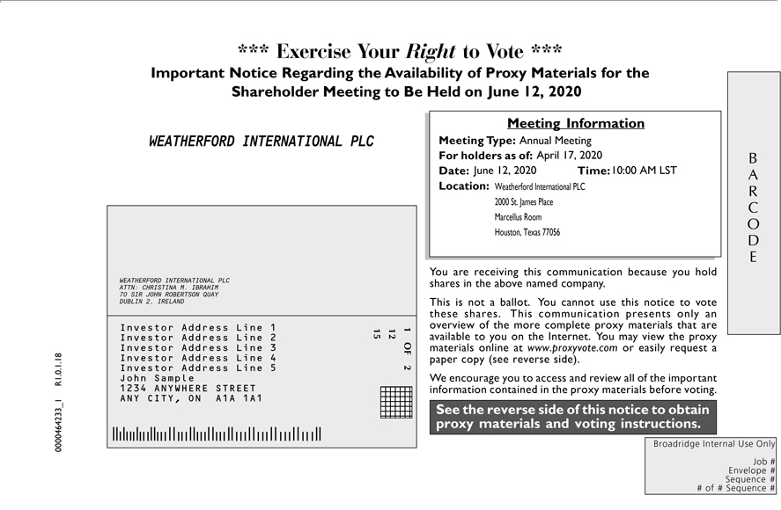

OnlyBARCODEJob#Envelope1OF212# 15Sequence1234567# #1234567of#Sequence1234567# ***1234567Exercise1234567Your 1234567Rightto Vote1234567*** ImportantSeethereverseNoticesideRegardingofthisnoticetheAvailabilitytoobtainproxyofProxymaterialsMaterialsandvotefvotingrthe Shareholderinstructions. MeetingBroadridgeto BeInternalHeld onUse <mtgdate>. You are receiving this communication because you hold shares in the above named company. This is not ballot. You cannot use this notice to these shares. This communication presents
reverseonlyan side)overview.W encourageofthemoreyoucompletetoaccessproxyand materialsreviewallthatof theare importantavailable toinformationyouthecontainedInternet. Youinthemayproxyviewmaterialstheproxybeforematerialsvoting.onlineMeetingatwww.proxyvote.comInformationMeetingor easilyype:<mtgtype>requestpaperForholderscopy(seeas of:
<recdate> Date: Time: <mtgtime> Location: 0000464233_1 R1.0.1.18 WEATHERFORD INTERNATIONAL PLC WEATHERFORD INTERNATIONAL PLC ATTN: CHRISTINA M. IBRAHIM 70 SIR JOHN ROBERTSON QUA^{CITY}DUBLIN 2, IRELAND Investor Address Line 1 Investor Address Line 2 Investor Address Line 3 Investor Address Line 4 Investor Address Line 5 John Sample 1234
ANYWHERE STREET ANY , ON A1A 1A1 Annual Meeting April 17, 2020 June 12, 2020 June 12, 2020 10:00 AM LST Weatherford International PLC 2000 St. James Place Marcellus Room Houston, Texas 77056

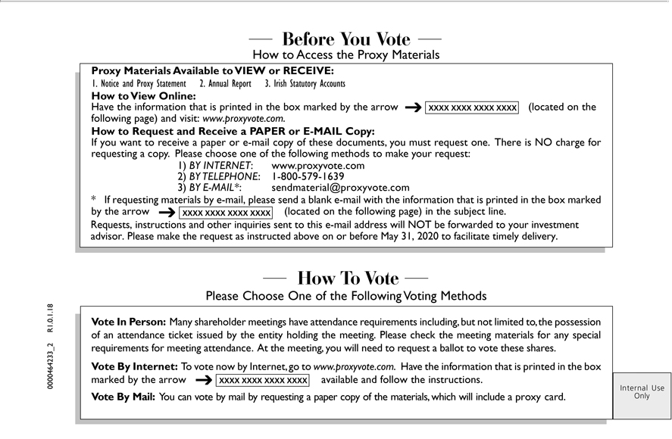

InternalattendanceUseticketOnlyissuedPleasebyChoosetheentityOneholdingoftheFollowingthemeeting.VotingPleaseMethodscheck theVotemeetingInPerson:materialsManyinformationshareholderanyspecialmeetingsrequirementshaveattendanceformeetingrequirementsattendance. including,Atthemeeting,butnotyoulimitedwill needto,theto possessionrequestaballotofanto vote
these shares. Vote By Internet: To vote now by Internet, go to www.proxyvote.com. Have the that is printed in the box marked by the arrow available and follow the instructions. Vote By
VIEWMail:YouorRECEIVE:canvotebyHowmailtobyViewrequestingOnline:a Havepaper thecopyinformationofthematerials,thatis whichprintedwillintheincludeboxmarkedproxybycard.the HowarrowTo(locatedVoteï§onBeforethefollowingYouVotepage)How andtoAccessvisit:www.proxyvote.com.theProxyMaterialsProxychooseHwMaterialstoRequestAvailableand to

methodsReceive atoPAPERmakeyourorE-request:MAILCopy:1)BYIfINTERNET:youwantto www.proxyvote.comreceivepaperore-mail2)BYcopyTELEPHONE:ofthesedocuments,1-800-579you-1639must3)requestBYE-one.MAIL*:Theresendmaterial@proxyvote.comisNOchargeforrequesting a*copy.IfrequestingPlease materialsoneStatementbyofthe-mail,followingplease sendAnnualblank -mail with the informationAccountsthat is printedinstructionsthebox marked by the arrow (located on the following page) in the subject line. 0000464233_2 R1.0.1.18 1. Notice and Proxy 2.
above onReportbefore3.IrishMayStatutory31,2020 to facilitateRequests,timely delivery. and other inquiries sent to this e-mail address will NOT be forwarded to your investment advisor. Please make the request as instructed

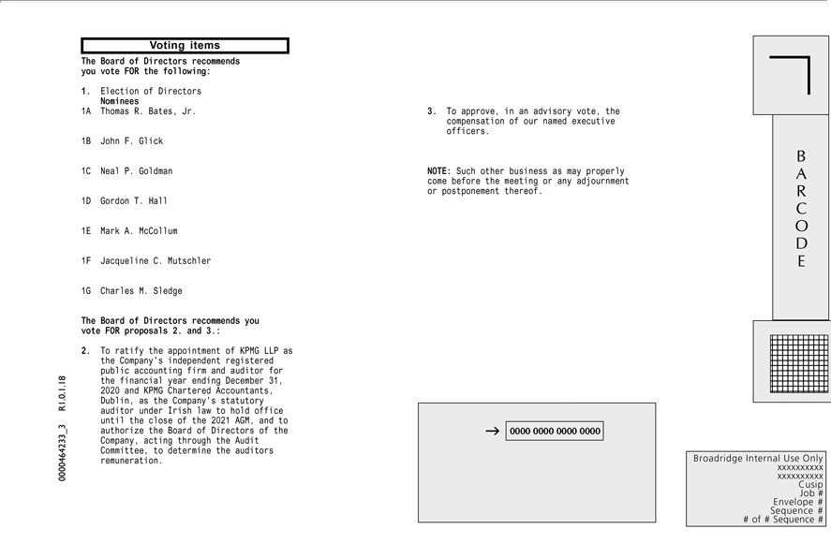

ARCODE 123456789012 123456789012 123456789012 123456789012 123456789012 123456789012 123456789012 123456789012 |  | 123456789012 123456789012 123456789012
Broadridge Internal Use Only xxxxxxxxxx xxxxxxxxxx Cusip Job # Envelope # Sequence # # of # Sequence # Voting items 0000464233 |  | 123456789012R1...18The Board of Directors recommends you vote FOR
the following: 1. Election of Directors Nominees 1A Thomas R. Bates, Jr. 1B John F. Glick 1C Neal P. Goldman 1D Gordon T. Hall 1E Mark A. McCollum 1F Jacqueline C. Mutschler 1G Charles M. |  |  | for
Sledge The Board of Directors recommends you vote FOR proposals 2. and 3.: 2. To ratify the appointment of KPMG LLP as the Company’s independent registered public accounting firm and |  |  | for
the financial year ending December 31, 2020 and KPMG Chartered Accountants, Dublin, as the Company’ | statutory auditor under Irish law to hold office until the close of the 2021 AGM, and auditor
executive officers. NOTE: Such other business as may properly come before the meeting or any adjournmentauditorspostponement thereof.
authorize the Board of Directors of the Company, acting through the Audit Committee, to determine the | remuneration. 3. T approve, in an advisory vote, the compensation of our named

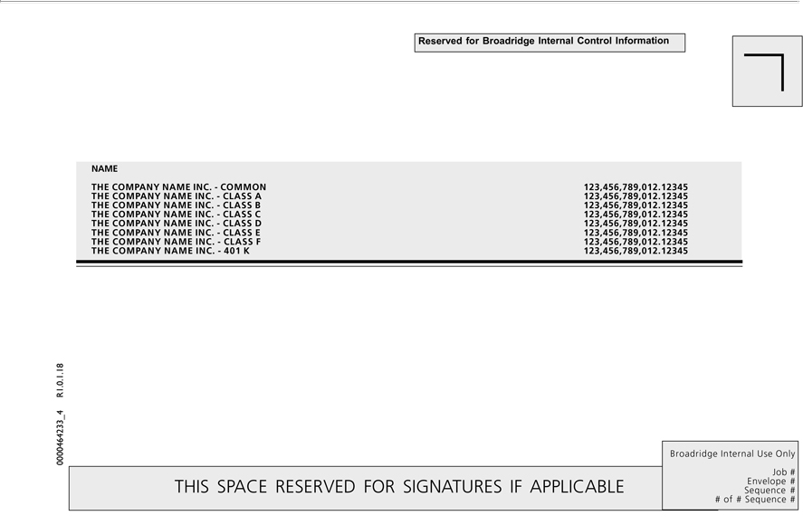

THIS SPACE RESERVED FOR SIGNATURES IF APPLICABLE Reserved for Broadridge Internal Control Information Broadridge Internal Use Only Job # Envelope # Sequence # # of # Sequence # NAME THE COMPANY NAME INC. - COMMON 123,456,789,012.12345 THE COMPANY NAME INC. - CLASS A 123,456,789,012.12345 THE COMPANY NAME INC. - CLASS B 123,456,789,012.12345 THE COMPANY NAME INC. - CLASS C 123,456,789,012.12345 THE COMPANY NAME INC. - CLASS D 123,456,789,012.12345 THE COMPANY NAME INC. - CLASS E 123,456,789,012.12345 THE COMPANY NAME INC. - CLASS F 123,456,789,012.12345 THE COMPANY NAME INC. - 401 K 123,456,789,012.12345 0000464233_4 R1.0.1.18

