UNITED STATES

SECURITIES AND EXCHANGE COMMISSION
Washington, D.C. 20549

Amendment No. 3

to

FORM T-3

FOR APPLICATIONS FOR QUALIFICATION OF INDENTURES

UNDER THE TRUST INDENTURE ACT OF 1939

WEATHERFORD INTERNATIONAL, LLC

(Name of Co-Applicant)*

2000 St. James Place, Houston, Texas 77056

(Address of Principal Executive Offices of Co-Applicant)

WEATHERFORD INTERNATIONAL LTD.

(Name of Co-Applicant)*

2000 St. James Place, Houston, Texas 77056

(Address of Principal Executive Offices of Co-Applicant)

Securities to be Issued Under the Indenture to be Qualified

Title of Class |  |  | Amout
11.000% Senior Unsecured Notes Due 2024 |  |  | $2,100,000,000†
 | Approximate date of proposed public offering:

As soon as practicable after court approval of a rights offering for such securities pursuant to the Joint Prepackaged Plan of Reorganization of Weatherford International plc and its Affiliate Debtors under Chapter 11 of the Bankruptcy Code (as amended or supplemented, the “Plan of Reorganization”).

Christina M. Ibrahim | Copies to:
Weatherford International plc | Ryan J. Maierson
Executive Vice President, General Counsel, | John M. Greer
Chief Compliance Officer and Corporate Secretary | Latham & Watkins LLP
2000 St. James Place | 811 Main Street, Suite 3700
Houston, Texas 77056 | Houston, Texas 77002
(713) 836-4000 | (713) 546-5400
(Name and Address of Agent for Service)

The Applicants hereby amend this application for qualification on such date or dates as may be necessary to delay its effectiveness until (i) the 20th day after the filing of an amendment which specifically states that it shall supersede this application for qualification, or (ii) such date as the Securities and Exchange Commission, acting pursuant to section 307(c) of the Trust Indenture Act of 1939, may determine upon the written request of the Applicants.

- The principal amount of the Notes to be issued by each Co-Applicant will be disclosed in an amendment to this application.

*The Co-Applicants listed on the following page are also included in this application as Applicants.

Table of Co-Applicants

Name of Guarantors

Advantage R&D, Inc.

Benmore In-Depth Corp.

Case Services, Inc.

Colombia Petroleum Services Corp.

Columbia Oilfield Supply, Inc.

Datalog Acquisition, LLC

Discovery Logging, Inc.

Edinburgh Petroleum Services Americas Incorporated

eProduction Solutions, LLC

High Pressure Integrity, Inc.

In-Depth Systems, Inc.

International Logging LLC

International Logging S.A., LLC

Key International Drilling Company Limited

PD Holdings (USA), L.P.

Precision Drilling GP, LLC

Precision Energy International Ltd.

Precision Energy Services Colombia Ltd.

Precision Energy Services ULC

Precision Energy Services, Inc.

Precision Oilfield Services, LLP

Sabre Drilling Ltd.

Stealth Oil & Gas, Inc.

Tooke Rockies, Inc.

Visean Information Services Inc.

Visual Systems, Inc.

Warrior Well Services, Inc.

Weatherford (Nova Scotia) ULC

Weatherford (PTWI), L.L.C.

Weatherford Artificial Lift Systems, LLC

Weatherford Australia Pty Limited

Weatherford Bermuda Holdings Ltd.

Weatherford Canada Ltd.

Weatherford Colombia Limited

Weatherford DISC Inc.

Weatherford Drilling International (BVI) Ltd.

Weatherford Drilling International Holdings (BVI) Ltd.

Weatherford Eurasia Limited

Weatherford European Holdings (Luxembourg) S.à r.l.

Weatherford Global Services LLC

Weatherford Holdings (Bermuda) Ltd.

Weatherford Holdings (BVI) Ltd.

Weatherford Holdings (Switzerland) GmbH

Weatherford International (Luxembourg) Holdings S.à r.l.

Weatherford International Holding (Bermuda) Ltd.

Weatherford International plc

Weatherford Investment Inc.

Weatherford Irish Holdings Limited

Weatherford Latin America LLC

Weatherford Management Company Switzerland Sàrl

2

Weatherford Management, LLC

Weatherford Netherlands B.V.

Weatherford Norge AS

Weatherford Oil Tool Middle East Limited

Weatherford Pangaea Holdings Ltd.

Weatherford Products GmbH

Weatherford Services S. de R.L.

Weatherford Services, Ltd.

Weatherford Switzerland Trading and Development GmbH

Weatherford Technology Holdings, LLC

Weatherford U.K. Limited

Weatherford U.S., L.P.

Weatherford URS Holdings, LLC

Weatherford Worldwide Holdings GmbH

Weatherford/Lamb, Inc.

WEUS Holding, LLC

WIHBV LLC

WOFS Assurance Limited

WOFS International Finance GmbH

WOFS Swiss Finance GmbH

WUS Holding, L.L.C.

EXPLANATORY NOTE

This Amendment No. 3 to Form T-3 (this “Amendment”) is being filed on behalf of Weatherford International, LLC, Weatherford International Ltd. and their affiliates expected to be guarantors of the 11.000% Senior Unsecured Notes due 2024 (collectively, the “Applicants”). This Amendment is being filed solely to (i) provide an updated form of indenture to be qualified hereby as Exhibit T3C-1 filed herewith and remove Exhibit T3C-2, replacing the previous indentures filed with the previous application, and update item 2 accordingly, (ii) file Exhibits T3A-76, T3B-62, T3E-5 and T3E-6 filed herewith, remove Exhibits T3A-47, T3A-65, T3B-44, T3B-46 and T3B-54 and update the table of co-applicants accordingly, (iii) file an updated Form T-1 as Exhibit 25.1 filed herewith, (iv) file the Organizational Chart as Exhibit 99.1 filed herewith, (v) file an updated Exhibit 99.2 and Exhibit 99.3 filed herewith and (vi) update the Index to Exhibits. This Amendment is not intended to amend or delete any other part of the Applicants’ Application for Qualification (the “Application”). All other information in the Application is unchanged and has been omitted from this Amendment.

2. Securities Act Exemption Applicable.

Pursuant to the terms of the proposed Plan of Reorganization, a copy of which is attached as an exhibit to the Disclosure Statement for Joint Prepackaged Plan of Reorganization for Weatherford International plc and its Affiliate Debtors under Chapter 11 of the Bankruptcy Code (as amended or supplemented, the “Disclosure Statement”), copies of which have been or are filed as Exhibits T3E-1, T3E-2, T3E-4 and T3E-5 to this application, respectively, the Applicants will offer, pursuant to a rights offering (the “Rights Offering”) to holders (collectively, the “Allowed Claim Holders”) of (i) those certain 5.125% senior unsecured notes due 2020, issued by Weatherford Bermuda; (ii) those certain 7.750% senior unsecured notes due 2021, issued by Weatherford Bermuda; (iii) those certain 5.875% exchangeable senior unsecured notes due 2021, issued by Weatherford Bermuda; (iv) those certain 4.500% senior unsecured notes due 2022, issued by Weatherford Bermuda; (v) those certain 8.250% senior unsecured notes due 2023, issued by Weatherford Bermuda; (vi) those certain 9.875% senior unsecured notes due 2024, issued by Weatherford Bermuda; (vii) those certain 6.500% senior unsecured notes due 2036, issued by Weatherford Bermuda; (viii) those certain 7.000% senior unsecured notes due 2038, issued by Weatherford Bermuda; (ix) those certain 9.875% senior unsecured notes due 2039, issued by Weatherford Bermuda; (x) those certain 6.750% senior unsecured notes due 2040, issued by Weatherford Bermuda; (xi) those certain 5.950% senior unsecured notes due 2042, issued by Weatherford Bermuda; (xii) those certain 9.875% senior unsecured notes due 2025, issued by Weatherford Delaware; and (xiii) those certain 6.800% senior unsecured notes due 2037, issued by Weatherford Delaware (collectively, the “Old Notes”) subscription rights (the “Subscription Rights”) to acquire each such Allowed Claim Holder’s corresponding pro rata share of up to $1.6 billion aggregate principal amount of

3

the Issuers’ 2024 Notes for cash. Additionally, $500 million aggregate principal amount of the Issuers’ 2024 Notes will be issued on a pro rata basis to Allowed Claim Holders.

The 2024 Notes will be issued pursuant to the indenture to be qualified under this application (the “Indenture”), a copy of which is included herein as Exhibit T3C-1.

In connection with the Rights Offering, the Issuers entered into a backstop commitment agreement with certain holders of the Old Notes (the “Backstop Parties”) pursuant to which the Backstop Parties will commit to purchase any 2024 Notes not subscribed for in the Rights Offering (such unsubscribed 2024 Notes to be purchased by the Backstop Parties, the “Backstop Notes”). The Plan of Reorganization will become effective on the date on which all conditions to the effectiveness of the Plan of Reorganization have been satisfied or waived (the “Effective Date”).

The issuance of the 2024 Notes is exempt from registration under the Securities Act of 1933, as amended (the “Securities Act”), pursuant to the exemption provided by Section 1145(a)(1) of Title 11 of the United States Code (the “Bankruptcy Code”), which exempts an offer and sale of securities under a plan of reorganization from registration under the Securities Act and state securities laws if three principal requirements are satisfied: (i) the securities must be offered and sold under a plan of reorganization and must be securities of the debtor, an affiliate participating in a joint plan of reorganization with the debtor or a successor to the debtor under the plan of reorganization; (ii) the recipients of the securities must hold a claim against, an interest in, or an administrative expense claim against the debtor; and (iii) the securities must be issued entirely in exchange for the recipient’s claim against or interest in the debtor, or principally in such exchange and partly for cash or property.

The Applicants believe that the offer and issuance of the 2024 Notes will satisfy the requirements of Section 1145(a)(1) of the Bankruptcy Code and, therefore, such offer and exchange is exempt from the registration requirements referred to above. To the extent that the offer and issuance of the 2024 Notes constitutes an offer of securities not exempt from registration under Section 1145(a)(1) of the Bankruptcy Code, the Applicants will also rely on Section 4(a)(2) of the Securities Act and, to the extent applicable, Regulation D promulgated thereunder. The issuance of the Backstop Notes will not involve a public offering and is exempt from registration under the Securities Act pursuant to the exemption provided in Section 4(a)(2) of the Securities Act and Regulation D promulgated thereunder.

4

 |  | INDEX TO EXHIBITS
Exhibit |  | Description
Exhibit T3A-1* |  | Certificate of Formation of Weatherford International, LLC, a Delaware limited liability company (incorporated by reference to Exhibit 4.7 to the Registration Statement
 |  | on Form S-3 of Weatherford International Ltd., a Swiss joint-stock corporation (File No. 333-194431), filed March 7, 2014)
Exhibit T3A-2* |  | Memorandum and Articles of Association of Weatherford International plc, an Irish public limited company (incorporated by reference to Exhibit 3.1 to Weatherford
 |  | International plc’s Current Report on Form 8-K12B (File No. 1-36504) filed June 17, 2014)
Exhibit T3A-3* |  | Memorandum of Association of Weatherford International Ltd., a Bermuda exempted company (incorporated by reference to Annex II to the proxy statement/prospectus
 |  | included in Amendment No. 1 to the Registration Statement on Form S-4 of Weatherford International Ltd., a Bermuda exempted company (File No. 333-85644) filed
 |  | May 22, 2002)
Exhibit T3A-4* |  | Certificate of Incorporation of Advantage R & D, Inc., a Delaware corporation
Exhibit T3A-5* |  | Certificate of Formation of Benmore In-Depth Corp., a Texas corporation
Exhibit T3A-6* |  | Amended and Restated Articles of Incorporation of Case Services, Inc., a Texas corporation
Exhibit T3A-7* |  | Certificate of Incorporation of Colombia Petroleum Services Corp., a Delaware corporation
Exhibit T3A-8* |  | Certificate of Incorporation of Columbia Oilfield Supply, Inc., a Delaware corporation
Exhibit T3A-9* |  | Certificate of Formation of Datalog Acquisition, LLC, a Delaware limited liability company
Exhibit T3A-10* |  | Articles of Incorporation of Discovery Logging, Inc., a Texas corporation
Exhibit T3A-11* |  | Articles of Incorporation of Edinburgh Petroleum Services Americas Incorporated, a Texas corporation
Exhibit T3A-12* |  | Certificate of Formation of eProduction Solutions, LLC, a Texas limited liability company
Exhibit T3A-13* |  | Articles of Incorporation of High Pressure Integrity, Inc., a Louisiana corporation
Exhibit T3A-14* |  | Articles of Incorporation of In-Depth Systems, Inc., a Texas corporation
Exhibit T3A-15* |  | Articles of Organization of International Logging LLC, a California limited liability company
Exhibit T3A-16* |  | Articles of Organization of International Logging S.A., LLC, a Nevada limited liability company
Exhibit T3A-17* |  | Memorandum of Association of Key International Drilling Company Limited, a Bermuda exempted company
Exhibit T3A-18* |  | Certificate of Limited Partnership of PD Holdings (USA), L.P., a Delaware limited partnership, as amended
Exhibit T3A-19* |  | Certificate of Formation of Precision Drilling GP, LLC, a Delaware limited liability company
Exhibit T3A-20* |  | Articles of Incorporation of Precision Energy International Ltd., an Alberta corporation
Exhibit T3A-21* |  | Articles of Incorporation of Precision Energy Services Colombia Ltd., an Alberta corporation, as amended
Exhibit T3A-22* |  | Certificate of Amendment and Registration of Restated Articles of Precision Energy Services ULC, an Alberta unlimited liability corporation
Exhibit T3A-23* |  | Certificate of Incorporation of Precision Energy Services, Inc., a Delaware corporation, as amended
Exhibit T3A-24* |  | Certificate of Limited Partnership of Precision Oilfield Services, LLP, a Texas registered limited liability partnership, as amended
Exhibit T3A-25* |  | Memorandum of Association of Sabre Drilling Ltd., a Bermuda exempted company
Exhibit T3A-26* |  | Certificate of Incorporation of Stealth Oil & Gas, Inc., a Delaware corporation
Exhibit T3A-27* |  | Articles of Incorporation of Tooke Rockies, Inc., a Wyoming corporation
Exhibit T3A-28* |  | Articles of Incorporation of Visean Information Services Inc., a Texas corporation, as amended
Exhibit T3A-29* |  | Amended and Restated Articles of Incorporation of Visual Systems, Inc., a California corporation
Exhibit T3A-30* |  | Articles of Incorporation of Warrior Well Services, Inc., an Illinois corporation
Exhibit T3A-31* |  | Memorandum of Association of Weatherford (Nova Scotia) ULC, a Nova Scotia unlimited liability corporation
Exhibit T3A-32* |  | Certificate of Formation of Weatherford (PTWI) L.L.C., a Delaware limited liability company
Exhibit T3A-33* |  | Certificate of Formation of Weatherford Artificial Lift Systems, LLC, a Delaware limited liability company
Exhibit T3A-34* |  | Certificate of Incorporation of Weatherford Australia Pty Limited, an Australian proprietary company
 |  | 5

Exhibit Description

Exhibit T3A-35* | Memorandum of Association of Weatherford Bermuda Holdings Ltd., a Bermuda exempted company
Exhibit T3A-36* | Certificate of Amendment and Registration of Restated Articles of Weatherford Canada Ltd., an Alberta corporation
Exhibit T3A-37* | Amended and Restated Memorandum of Association of Weatherford Colombia Limited, a British Virgin Islands international business company
Exhibit T3A-38* | Articles of Incorporation of Weatherford DISC Inc., a Nevada corporation
Exhibit T3A-39* | Amended and Restated Memorandum of Association of Weatherford Drilling International (BVI) Ltd., a British Virgin Islands international business company
Exhibit T3A-40* | Amended and Restated Memorandum of Association of Weatherford Drilling International Holdings (BVI) Ltd., a British Virgin Islands international business company
Exhibit T3A-41* | Articles of Association of Weatherford Eurasia Limited, an England corporation, as amended
Exhibit T3A-42* | Amended and Restated Articles of Association of Weatherford European Holdings (Luxembourg) S.á r.l, a Luxembourg private limited liability company
Exhibit T3A-43* | Articles of Organization of Weatherford Global Services LLC, a Louisiana limited liability company
Exhibit T3A-44* | Memorandum of Association of Weatherford Holdings (Bermuda) Ltd., a Bermuda exempted company
Exhibit T3A-45* | Amended and Restated Memorandum of Association of Weatherford Holdings (BVI) Ltd., a British Virgin Islands international business company
Exhibit T3A-46* | Articles of Association of Weatherford Holdings (Switzerland) GmbH, a Switzerland limited liability company
Exhibit T3A-47* | [Reserved.]
Exhibit T3A-48* | Amended and Restated Articles of Association of Weatherford International (Luxembourg) Holdings S.á r.l, a Luxembourg private limited liability company
Exhibit T3A-49* | Memorandum of Association of Weatherford International Holding (Bermuda) Ltd., a Bermuda exempted company
Exhibit T3A-50* | Certificate of Formation of Weatherford Investment Holding LLC, a Delaware limited liability company
Exhibit T3A-51* | Certificate of Incorporation of Weatherford Investment Inc., a Delaware corporation, as amended
Exhibit T3A-52* | Certificate of Formation of Weatherford Latin America LLC, a Delaware limited liability company
Exhibit T3A-53* | Articles of Association of Weatherford Management Company Switzerland Sárl, a Switzerland limited liability company
Exhibit T3A-54* | Certificate of Formation of Weatherford Management, LLC, a Delaware limited liability company
Exhibit T3A-55* | Articles of Association of Weatherford Netherlands B.V., a Netherlands private limited liability company
Exhibit T3A-56* | Articles of Association of Weatherford Norge AS, a Norway limited company
Exhibit T3A-57* | Amended and Restated Memorandum of Association of Weatherford Oil Tool Middle East Limited, a British Virgin Islands international business company
Exhibit T3A-58* | Memorandum of Association of Weatherford Pangaea Holdings Ltd., a Bermuda exempted company
Exhibit T3A-59* | Articles of Incorporation of Weatherford Products GmbH, a Switzerland limited liability company
Exhibit T3A-60* | Articles of Incorporation of Weatherford Services S. de R.L., a Panama corporation, as amended
Exhibit T3A-61* | Memorandum of Association of Weatherford Services, Ltd., a Bermuda exempted company
Exhibit T3A-62* | Articles of Association of Weatherford Switzerland Trading and Development GmbH, a Switzerland limited liability company
Exhibit T3A-63* | Certificate of Formation of Weatherford Technology Holdings, LLC, a Delaware limited liability company, as amended
Exhibit T3A-64* | Articles of Association of Weatherford U.K. Limited, an England corporation
Exhibit T3A-65* | [Reserved.]
Exhibit T3A-66* | Louisiana Partnership Registration Form of Weatherford U.S., L.P., a Louisiana limited partnership
Exhibit T3A-67* | Certificate of Formation of Weatherford URS Holdings, LLC, a Delaware limited liability company
Exhibit T3A-68* | Articles of Association of Weatherford Worldwide Holdings GmbH, a Switzerland limited liability company
Exhibit T3A-69* | Certificate of Incorporation of Weatherford/Lamb, Inc., a Delaware corporation
 | 6

Exhibit Description

Exhibit T3A-70* | Certificate of Formation of WEUS Holding, LLC, a Delaware limited liability company
Exhibit T3A-71* | Certificate of Formation of WIHBV LLC, a Delaware limited liability company
Exhibit T3A-72* | Memorandum of Association of WOFS Assurance Limited, a Bermuda exempted company
Exhibit T3A-73* | Articles of Incorporation of WOFS International Finance GmbH, a Switzerland limited liability company
Exhibit T3A-74* | Articles of Association of WOFS Swiss Finance GmbH, a Switzerland limited liability company
Exhibit T3A-75* | Certificate of Formation of WUS Holding, L.L.C., a Delaware limited liability company, as amended
Exhibit T3A-76 | Certificate of Incorporation of Weatherford Irish Holdings Limited, an Irish limited company
Exhibit T3B-1* | Limited Liability Company Agreement of Weatherford International, LLC, a Delaware limited liability company (incorporated by reference to Exhibit 4.8 to the
 | Registration Statement on Form S-3 of Weatherford International Ltd., a Swiss joint-stock corporation (File No. 333-194431), filed March 7, 2014)
Exhibit T3B-2* | Bye-Laws of Weatherford International Ltd., a Bermuda exempted company, as amended on May 10, 2016 (incorporated by reference to Exhibit 3.4 to the Registration
 | Statement on Form S-3 of Weatherford International plc (File No. 333-216034) filed February 13, 2017)
Exhibit T3B-3* | Bye-Laws of Advantage R & D, Inc., a Delaware corporation
Exhibit T3B-4* | Amended and Restated By-Laws of Benmore In-Depth Corp., a Texas corporation
Exhibit T3B-5* | Amended and Restated Bylaws of Case Services, Inc., a Texas corporation
Exhibit T3B-6* | By-Laws of Colombia Petroleum Services Corp., a Delaware corporation
Exhibit T3B-7* | Bylaws of Columbia Oilfield Supply, Inc., a Delaware corporation
Exhibit T3B-8* | Amended and Restated Limited Liability Company Agreement of Datalog Acquisition, LLC, a Delaware limited liability company
Exhibit T3B-9* | By-Laws of Discovery Logging, Inc., a Texas corporation
Exhibit T3B-10* | By-Laws of Edinburgh Petroleum Services Americas Incorporated, a Texas corporation
Exhibit T3B-11* | Company Agreement of eProduction Solutions, LLC, a Texas limited liability company
Exhibit T3B-12* | By-Laws of High Pressure Integrity, Inc., a Louisiana corporation
Exhibit T3B-13* | Bylaws of In-Depth Systems, Inc., a Texas corporation
Exhibit T3B-14* | Operating Agreement of International Logging LLC, a California limited liability company, as amended
Exhibit T3B-15* | Limited-Liability Company Agreement of International Logging S.A., LLC, a Nevada limited liability company, as amended
Exhibit T3B-16* | Bye-Laws of Key International Drilling Company Limited, a Bermuda exempted company
Exhibit T3B-17* | Agreement of Limited Partnership of PD Holdings (USA), L.P., a Delaware limited partnership, as amended
Exhibit T3B-18* | Limited Liability Company Agreement of Precision Drilling GP, LLC, a Delaware limited liability company
Exhibit T3B-19* | By-Law No. 1 of Precision Energy International Ltd., an Alberta corporation
Exhibit T3B-20* | By-Law Number 1 of Precision Energy Services Colombia Ltd., an Alberta corporation
Exhibit T3B-21* | By-Law No. 1 of Precision Energy Services ULC, an Alberta unlimited liability corporation
Exhibit T3B-22* | By-Law No. 2 of Precision Energy Services ULC, an Alberta unlimited liability corporation
Exhibit T3B-23* | Bylaws of Precision Energy Services, Inc., a Delaware corporation
Exhibit T3B-24* | Agreement of Limited Partnership of Precision Oilfield Services, LLP, a Texas registered limited liability partnership, as amended
Exhibit T3B-25* | Amended and Restated Bye-Laws of Sabre Drilling Ltd., a Bermuda exempted company
Exhibit T3B-26* | By-Laws of Stealth Oil & Gas, Inc., a Delaware corporation
Exhibit T3B-27* | Bylaws of Tooke Rockies, Inc., a Wyoming corporation
Exhibit T3B-28* | Amended and Restated By-Laws of Visean Information Services Inc., a Texas corporation
Exhibit T3B-29* | Amended and Restated Bylaws of Visual Systems, Inc., a California corporation
Exhibit T3B-30* | Bylaws of Warrior Well Services, Inc., an Illinois corporation
Exhibit T3B-31* | Articles of Association of Weatherford (Nova Scotia) ULC, a Nova Scotia unlimited liability corporation
 | 7

Exhibit Description

Exhibit T3B-32* | Limited Liability Company Agreement of Weatherford (PTWI), L.L.C., a Delaware limited liability company
Exhibit T3B-33* | Limited Liability Company Agreement of Weatherford Artificial Lift Systems, LLC, a Delaware limited liability company, as amended
Exhibit T3B-34* | Constitution of Weatherford Australia Pty Limited, an Australian proprietary company
Exhibit T3B-35* | Amended and Restated Bye-Laws of Weatherford Bermuda Holdings Ltd., a Bermuda exempted company
Exhibit T3B-36* | By-Law No. 1 of Weatherford Canada Ltd., an Alberta corporation
Exhibit T3B-37* | Amended and Restated Articles of Association of Weatherford Colombia Limited, a British Virgin Islands international business company
Exhibit T3B-38* | By-Laws of Weatherford DISC Inc., a Nevada corporation
Exhibit T3B-39* | Amended and Restated Articles of Association of Weatherford Drilling International (BVI) Ltd., a British Virgin Islands international business company
Exhibit T3B-40* | Amended and Restated Articles of Association of Weatherford Drilling International Holdings (BVI) Ltd., a British Virgin Islands international business company
Exhibit T3B-41* | Regulations of Weatherford Global Services LLC, a Louisiana limited liability company, as amended
Exhibit T3B-42* | Bye-Laws of Weatherford Holdings (Bermuda) Ltd., a Bermuda exempted company
Exhibit T3B-43* | Amended and Restated Articles of Association of Weatherford Holdings (BVI) Ltd., a British Virgin Islands international business company
Exhibit T3B-44* | [Reserved.]
Exhibit T3B-45* | Bye-Laws of Weatherford International Holding (Bermuda) Ltd., a Bermuda exempted company
Exhibit T3B-46* | [Reserved.]
Exhibit T3B-47* | Bylaws of Weatherford Investment Inc., a Delaware corporation
Exhibit T3B-48* | Amended and Restated Limited Liability Company Agreement of Weatherford Latin America LLC, a Delaware limited liability company
Exhibit T3B-49* | Limited Liability Company Agreement of Weatherford Management, LLC, a Delaware limited liability company, as amended
Exhibit T3B-50* | Amended and Restated Articles of Association of Weatherford Oil Tool Middle East Limited, a British Virgin Islands international business company
Exhibit T3B-51* | Bye-Laws of Weatherford Pangaea Holdings Ltd., a Bermuda exempted company
Exhibit T3B-52* | Amended and Restated Bye-Laws of Weatherford Services, Ltd., a Bermuda exempted company
Exhibit T3B-53* | Limited Liability Company Agreement of Weatherford Technology Holdings, LLC, a Delaware limited liability company, as amended
Exhibit T3B-54* | [Reserved.]
Exhibit T3B-55* | Amended and Restated Articles of Partnership in Commendam of Weatherford U.S., L.P., a Louisiana limited partnership
Exhibit T3B-56* | Limited Liability Company Agreement of Weatherford URS Holdings, LLC, a Delaware limited liability company
Exhibit T3B-57* | Bylaws of Weatherford/Lamb, Inc., a Delaware corporation
Exhibit T3B-58* | Limited Liability Company Agreement of WEUS Holding, LLC, a Delaware limited liability company, as amended
Exhibit T3B-59* | Limited Liability Company Agreement of WIHBV LLC, a Delaware limited liability company
Exhibit T3B-60* | Amended and Restated Bye-Laws of WOFS Assurance limited, a Bermuda exempted company
Exhibit T3B-61* | Limited Liability Company Agreement of WUS Holding, L.L.C., a Delaware limited liability company
Exhibit T3B-62 | Constitution of Weatherford Irish Holdings Limited, an Irish limited company
Exhibit T3C-1 | Form of Indenture Governing the 2024 Notes to be issued by Weatherford Delaware
Exhibit T3D | Not applicable
Exhibit T3E-1*** | Disclosure Statement for the Joint Prepackaged Plan of Reorganization of Weatherford International plc and its Affiliate Debtors, dated June 28, 2019
 | 8

Exhibit |  | Description
Exhibit T3E-2* |  | Joint Prepackaged Plan of Reorganization of Weatherford International plc and its Affiliate Debtors, dated June 28, 2019
Exhibit T3E-3* |  | Backstop Commitment Agreement among Weatherford International plc, the other Debtors and the Commitment Parties party thereto, dated July 1, 2019
Exhibit T3E-4* |  | First Amended Joint Prepackaged Plan of Reorganization of Weatherford International plc and its Affiliate Debtors, dated September 3, 2019
Exhibit T3E-5 |  | Second Amended Joint Prepackaged Plan of Reorganization of Weatherford International plc and its Affiliate Debtors, dated September 9, 2019
Exhibit T3E-6 |  | First Amendment to Backstop Commitment Agreement, by and among Weatherford International plc, its Affiliate Debtors and the Commitment Parties, dated as of
 |  | September 9, 2019
Exhibit T3F-1 |  | Cross-reference sheet (included in Exhibit T3C-1)
Exhibit 25.1 |  | Form T-1 qualifying the Trustee under each Indenture to be qualified pursuant to this application
Exhibit 99.1 |  | Organizational Chart
Exhibit 99.2 |  | Directors, Executive Officers and Capitalization of each Applicant
Exhibit 99.3 |  | Principal Owners of Voting Securities of each Applicant

- Filed previously.

- Post Effective Date Organizational Chart to be filed by amendment. Current Organizational Chart filed previously.

- The exhibits related to the Disclosure Statement attached to Amendment No. 1 to this Form T-3 are available at http://www.primeclerk.com/Weatherford.

9

SIGNATURE

Pursuant to the requirements of the Trust Indenture Act of 1939, the applicant, Weatherford International, LLC, a limited liability company organized and existing under the laws of the State of Delaware, has duly caused this application to be signed on its behalf by the undersigned, thereunto duly authorized, and its seal to be hereunto affixed and attested, all in the City of Houston, and State of Texas, on the 23rd day of October, 2019.

(SEAL) |  | WEATHERFORD INTERNATIONAL, LLC
Attest: | /s/ Joshua S. Silverman | By: | /s/ Christine M. Morrison
 | Name: Joshua S. Silverman |  | Name: | Christine M. Morrison
 |  |  | Title: | Sole Manager of Sole Member

Pursuant to the requirements of the Trust Indenture Act of 1939, the applicant, Weatherford International, Ltd., an exempted company organized and existing under the laws of Bermuda, has duly caused this application to be signed on its behalf by the undersigned, thereunto duly authorized, and its seal to be hereunto affixed and attested, all in Dubai, United Arab Emirates, on the 23rd day of October, 2019

(SEAL) |  | WEATHERFORD INTERNATIONAL, LTD.
Attest: | /s/ Christine M. Morrison | By: | /s/ Mohammed Dadhiwala
 | Name: Christine M. Morrison |  | Name: | Mohammed Dadhiwala
 |  |  | Title: | Vice President

Pursuant to the requirements of the Trust Indenture Act of 1939, the guarantors listed below have duly caused this application to be signed on its behalf by the undersigned, thereunto duly authorized, and its seal to be hereunto affixed and attested, all in the City of Houston, and State of Texas, on the 23rd day of October, 2019.

(SEAL) |  | ADVANTAGE R&D, INC.
 |  | BENMORE IN-DEPTH CORP.
 |  | CASE SERVICES, INC.
 |  | COLOMBIA PETROLEUM SERVICES CORP.
 |  | COLUMBIA OILFIELD SUPPLY, INC.
 |  | DATALOG ACQUISITION, LLC
 |  | DISCOVERY LOGGING, INC.
 |  | EDINBURGH PETROLEUM SERVICES AMERICAS INCORPORATED
 |  | EPRODUCTION SOLUTIONS, LLC
 |  | HIGH PRESSURE INTEGRITY, INC.
 |  | IN-DEPTH SYSTEMS, INC.
 |  | INTERNATIONAL LOGGING LLC
 |  | INTERNATIONAL LOGGING S.A., LLC
 |  | PD HOLDINGS (USA), L.P.
 |  | PRECISION DRILLING GP, LLC
 |  | PRECISION ENERGY SERVICES, INC.
 |  | PRECISION OILFIELD SERVICES, LLP
 |  | STEALTH OIL & GAS, INC.
 |  | VISEAN INFORMATION SERVICES INC.
 |  | WEATHERFORD (PTWI), L.L.C.
 |  | WEATHERFORD ARTIFICIAL LIFT SYSTEMS, LLC
 |  | WEATHERFORD DISC INC.
 |  | WEATHERFORD GLOBAL SERVICES LLC
 |  | WEATHERFORD INVESTMENT INC.
 |  | WEATHERFORD LATIN AMERICA LLC
 |  | WEATHERFORD MANAGEMENT, LLC
 |  | WEATHERFORD TECHNOLOGY HOLDINGS, LLC
 |  | WEATHERFORD U.S., L.P.
 |  | WEATHERFORD URS HOLDINGS, LLC
 |  | WEATHERFORD/LAMB, INC.
 |  | WEUS HOLDING, LLC
 |  | WIHBV LLC
 |  | WUS HOLDING, L.L.C.
Attest: | /s/ Joshua S. Silverman | By: | /s/ Christine M. Morrison
 | Name: Joshua S. Silverman |  | Name: | Christine M. Morrison
 |  |  | Title: | Vice President
 |  | 10

(SEAL) |  | TOOKE ROCKIES, INC.
 |  | VISUAL SYSTEMS, INC.
 |  | WARRIOR WELL SERVICES, INC.
Attest: | /s/ Joshua S. Silverman | By: | /s/ Christine M. Morrison
 | Name: Joshua S. Silverman |  | Name: | Christine M. Morrison
 |  |  | Title: | Vice President
(SEAL) |  | WEATHERFORD SERVICES, LTD.
Attest: | /s/ Christine M. Morrison | By: | /s/ Mohammed Dadhiwala
 | Name: Christine M. Morrison |  | Name: | Mohammed Dadhiwala
 |  |  | Title: | Vice President
(SEAL) |  | WEATHERFORD INTERNATIONAL PLC
Attest: | /s/ Christine M. Morrison | By: | /s/ Christoph Bausch
 | Name: Christine M. Morrison |  | Name: | Christoph Bausch
 |  |  | Title: | Executive Vice President and Chief Financial Officer

Pursuant to the requirements of the Trust Indenture Act of 1939, the guarantors listed below have duly caused this application to be signed on its behalf by the undersigned, thereunto duly authorized, and its seal to be hereunto affixed and attested, all in Dubai, United Arab Emirates, on the 23rd day of October, 2019.

(SEAL)

KEY INTERNATIONAL DRILLING COMPANY LIMITED

WEATHERFORD DRILLING INTERNATIONAL (BVI) LTD.

Attest:

/s/ Christine M. Morrison

By:

/s/ Andrew David Gold

 | Name: Christine M. Morrison |  | Name: | Andrew David Gold
 |  |  | Title: | President
(SEAL) |  | SABRE DRILLING LTD.
 |  | WEATHERFORD BERMUDA HOLDINGS LTD.
 |  | WEATHERFORD COLOMBIA LIMITED
 |  | WEATHERFORD DRILLING INTERNATIONAL HOLDINGS (BVI) LTD.
 |  | WEATHERFORD HOLDINGS (BERMUDA) LTD.
 |  | WEATHERFORD INTERNATIONAL HOLDING (BERMUDA) LTD.
 |  | WEATHERFORD PANGAEA HOLDINGS LTD.
 |  | WOFS ASSURANCE LIMITED
Attest: | /s/ Christine M. Morrison | By: | /s/ Mohammed Dadhiwala
 | Name: Christine M. Morrison |  | Name: | Mohammed Dadhiwala
 |  |  | Title: | Vice President
(SEAL) |  | WEATHERFORD HOLDINGS (BVI) LTD.
 |  | WEATHERFORD OIL TOOL MIDDLE EAST LIMITED
Attest: | /s/ Christine M. Morrison | By: | /s/ Mohammed Dadhiwala
 | Name: Christine M. Morrison |  | Name: | Mohammed Dadhiwala
 |  |  | Title: | Senior Vice President

Pursuant to the requirements of the Trust Indenture Act of 1939, the guarantors listed below have duly caused this application to be signed on its behalf by the undersigned, thereunto duly authorized, and its seal to be hereunto affixed and attested, all in the City of Calgary, and Province of Alberta, on the 23rd day of October, 2019.

(SEAL) |  | PRECISION ENERGY INTERNATIONAL LTD.
 |  | PRECISION ENERGY SERVICES COLOMBIA LTD.
 |  | PRECISION ENERGY SERVICES ULC
 |  | WEATHERFORD (NOVA SCOTIA) ULC
 |  | WEATHERFORD CANADA LTD.
Attest: | /s/ Pamela M. Webb | By: | /s/ Raymond Charles Smith
 | Name: Pamela M. Webb |  | Name: | Raymond Charles Smith
 |  |  | Title: | Vice President
 |  | 11

Pursuant to the requirements of the Trust Indenture Act of 1939, the guarantors listed below have duly caused this application to be signed on its behalf by the undersigned, thereunto duly authorized, and its seal to be hereunto affixed and attested, all in Baar, Switzerland on the 23rd day of October, 2019.

(SEAL)

WEATHERFORD HOLDINGS (SWITZERLAND) GMBH

WEATHERFORD MANAGEMENT COMPANY SWITZERLAND SÀRL

WEATHERFORD WORLDWIDE HOLDINGS GMBH

Attest:

/s/ Cristina Waber

By:

/s/ Valentin Mueller

 | Name: Cristina Waber |  | Name: | Valentin Mueller
 |  |  | Title: | Managing Officer
(SEAL) |  | WEATHERFORD PRODUCTS GMBH
 |  | WEATHERFORD SWITZERLAND TRADING AND DEVELOPMENT GMBH
 |  | WOFS INTERNATIONAL FINANCE GMBH
Attest: | /s/ Cristina Waber | By: | /s/ Mathias Neuenschwander
 | Name: Cristina Waber |  | Name: | Mathias Neuenschwander
 |  |  | Title: | Managing Officer
(SEAL) |  | WOFS SWISS FINANCE GMBH
Attest: | /s/ Cristina Waber | By: | /s/ Arjana Cabariu-Truong
 | Name: Cristina Waber |  | Name: | Arjana Cabariu-Truong
 |  |  | Title: | Manging Officer
(SEAL) |  | WEATHERFORD SERVICES S. DE R.L.
Attest: | /s/ Cristina Waber | By: | /s/ Mathias Neuenschwander
 | Name: Cristina Waber |  | Name: | Mathias Neuenschwander
 |  |  | Title: | Managing Officer, Weatherford Worldwide Holdings GmbH, as
 |  |  |  | shareholder

Pursuant to the requirements of the Trust Indenture Act of 1939, the guarantors listed below have duly caused this application to be signed on its behalf by the undersigned, thereunto duly authorized, and its seal to be hereunto affixed and attested, all in Luxembourg, on the 23rd day of October, 2019.

(SEAL) |  | WEATHERFORD EUROPEAN HOLDINGS (LUXEMBOURG) S.À R.L.
 |  | WEATHERFORD INTERNATIONAL (LUXEMBOURG) HOLDINGS S.À R.L.
Attest: | /s/ Cristina Waber | By: | /s/ Mathias Neuenschwander
 | Name: Cristina Waber |  | Name: | Mathias Neuenschwander
 |  |  | Title: | Manager A

Pursuant to the requirements of the Trust Indenture Act of 1939, the guarantors listed below have duly caused this application to be signed on its behalf by the undersigned, thereunto duly authorized, and its seal to be hereunto affixed and attested, all in Aberdeen, United Kingdom, on the 23rd day of October, 2019.

(SEAL) |  | WEATHERFORD EURASIA LIMITED
Attest: | /s/ Richard Strachan | By: | /s/ Neil MacLeod
 | Name: Richard Strachan |  | Name: | Neil MacLeod
 |  |  | Title: | Director
(SEAL) |  | WEATHERFORD U.K. LIMITED
Attest: | /s/ Richard Strachan | By: | /s/ Alexander Olsson
 | Name: Richard Strachan |  | Name: | Alexander Olsson
 |  |  | Title: | Director
(SEAL) |  | WEATHERFORD IRISH HOLDINGS LIMITED
Attest: | /s/ Christine M. Morrison | By: | /s/ Neil Alexander MacLeod
 | Name: Christine M. Morrison |  | Name: | Neil Alexander MacLeod
 |  |  | Title: | Director
 |  | 12

Pursuant to the requirements of the Trust Indenture Act of 1939, the guarantors listed below have duly caused this application to be signed on its behalf by the undersigned, thereunto duly authorized, and its seal to be hereunto affixed and attested, all in Amsterdam, the Netherlands, on the 23rd day of October, 2019.

(SEAL) |  | WEATHERFORD NETHERLANDS B.V.
Attest: | /s/ Marcus Johannes van Dijk | By: | /s/ August Willem Versteeg
 | Name: Marcus Johannes van Dijk |  | Name: | August Willem Versteeg
 |  |  | Title: | Managing Director

Pursuant to the requirements of the Trust Indenture Act of 1939, the guarantors listed below have duly caused this application to be signed on its behalf by the undersigned, thereunto duly authorized, and its seal to be hereunto affixed and attested, all in Stavanger, Norway, on the 23rd day of October, 2019.

(SEAL) |  | WEATHERFORD NORGE AS
Attest: | /s/ Arve Eide Haraldsen | By: | /s/ Geir Egil Moller Olsen
 | Name: Arve Eide Haraldsen |  | Name: | Geir Egil Moller Olsen
 |  |  | Title: | Chairman of the Board

Pursuant to the requirements of the Trust Indenture Act of 1939, the guarantors listed below have duly caused this application to be signed on its behalf by the undersigned, thereunto duly authorized, and its seal to be hereunto affixed and attested, all in Australia, on the 23rd day of October, 2019.

(SEAL) |  | WEATHERFORD AUSTRALIA PTY LIMITED
Attest: | /s/ Antonino Gullotti | By: | /s/ Robert Antonio DeGasperis
 | Name: Antonino Gullotti |  | Name: | Robert Antonio DeGasperis
 |  |  | Title: | Director
 |  | 13

Exhibit T3A-76
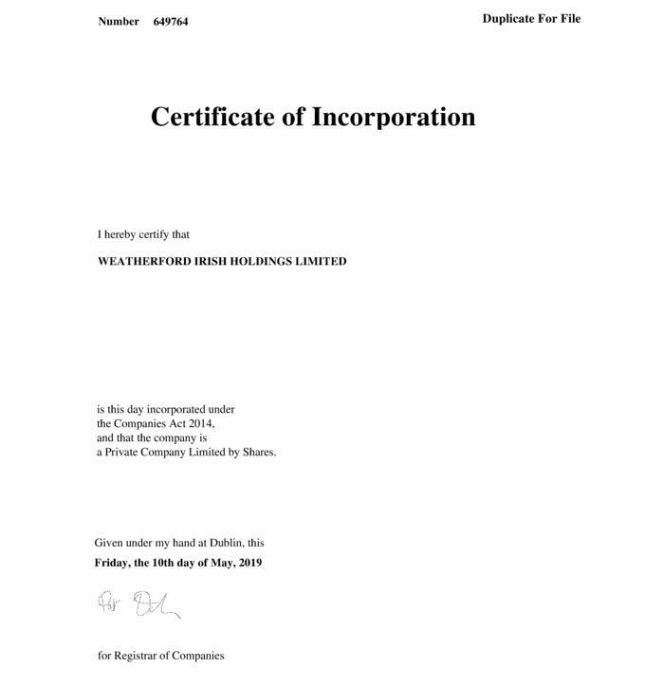

Exhibit T3B-62


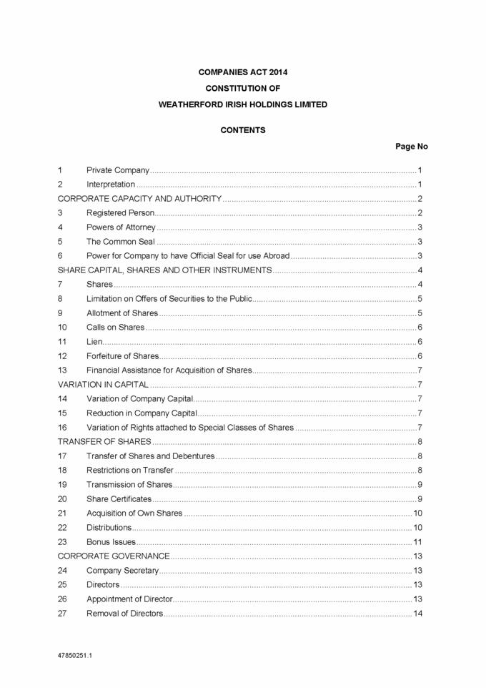

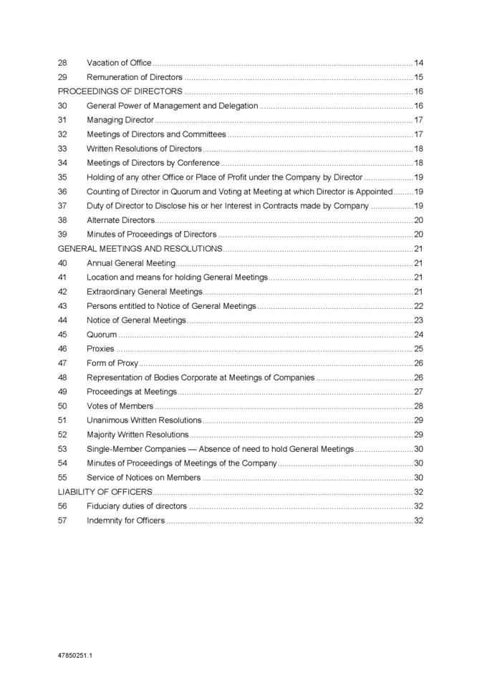

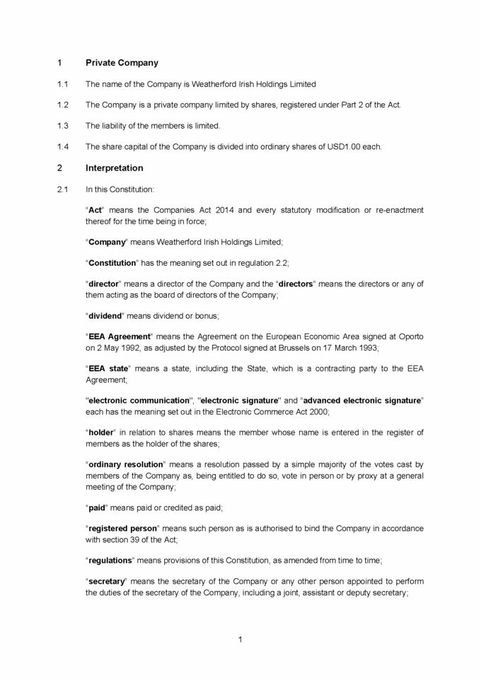

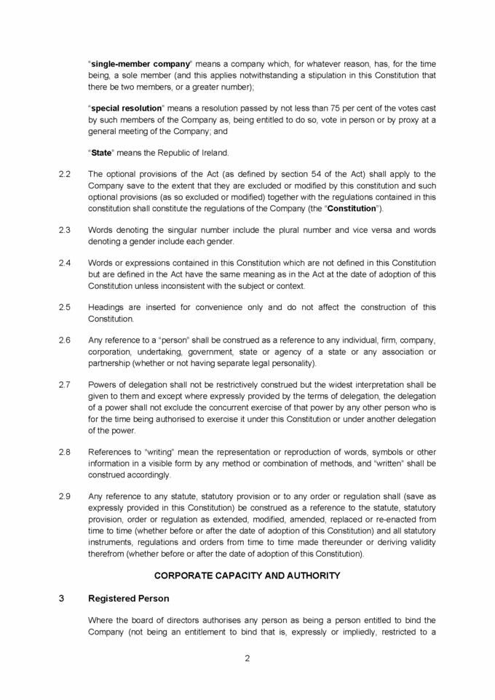

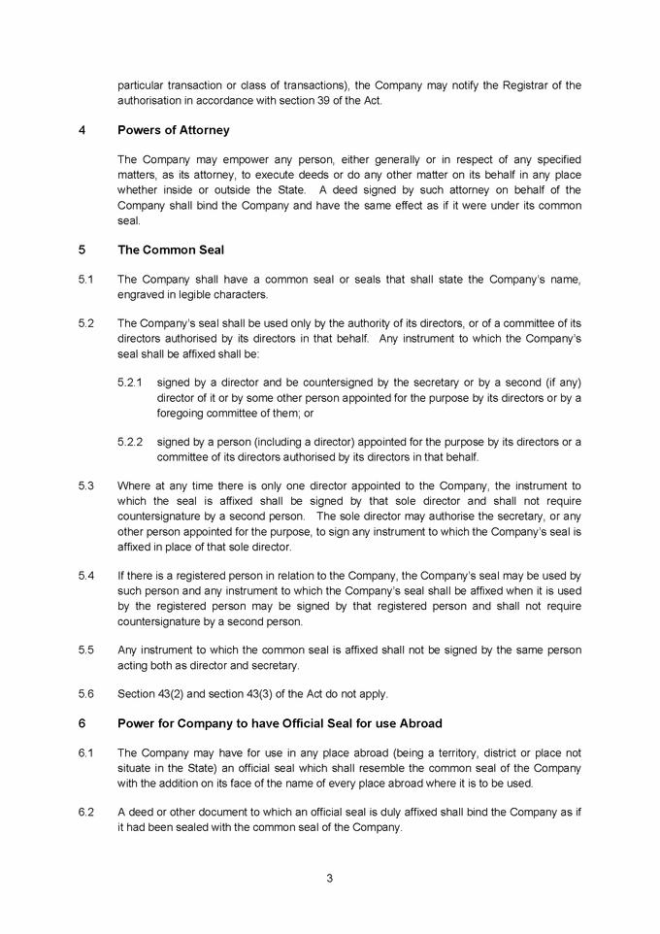

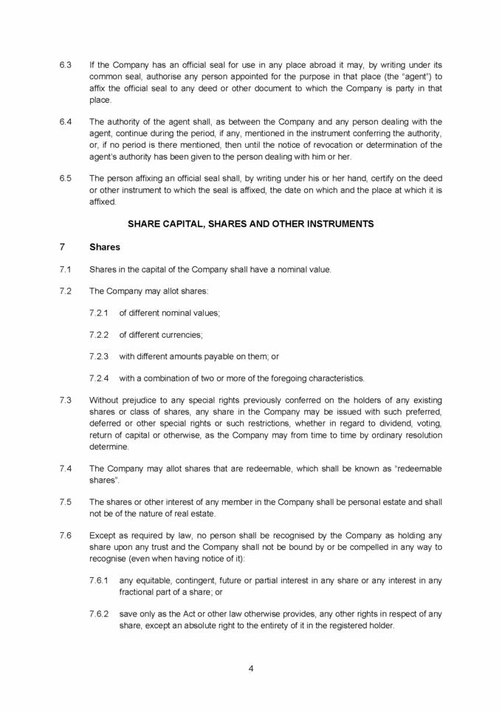

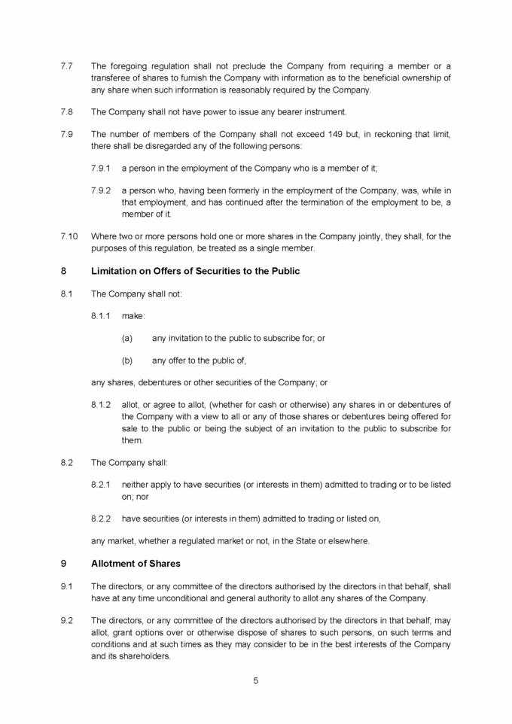

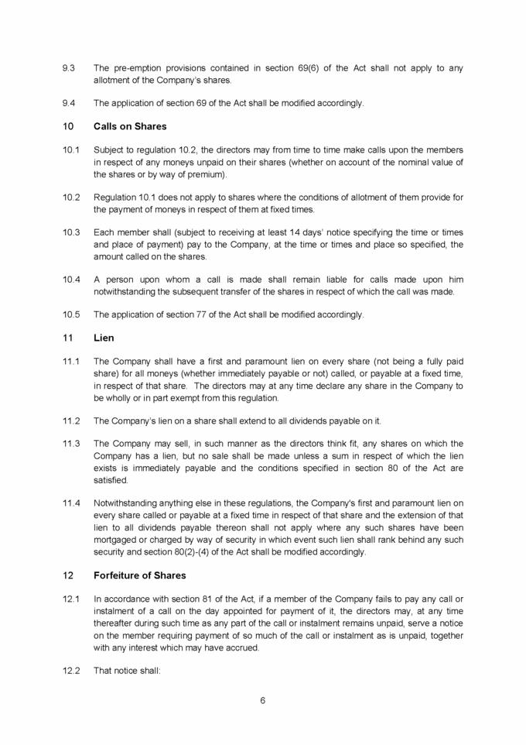

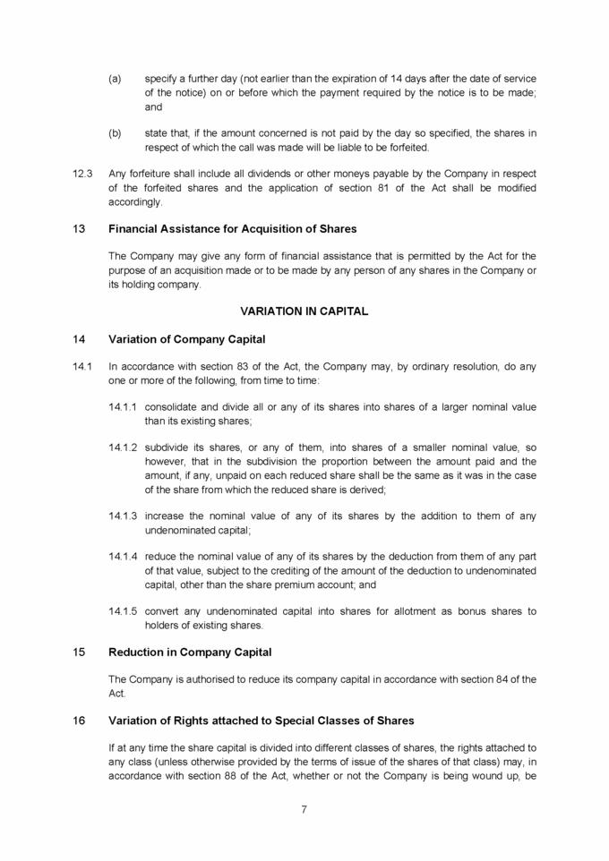

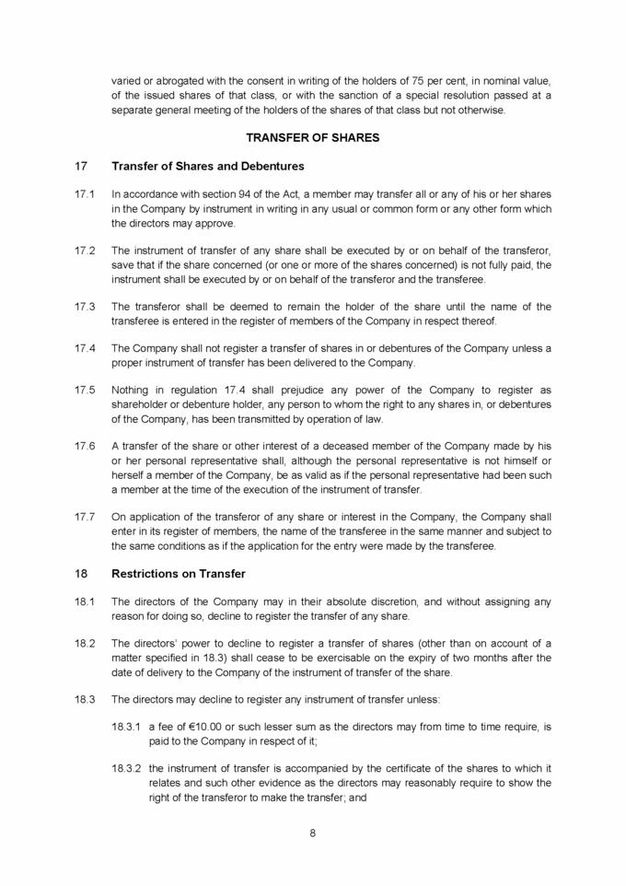

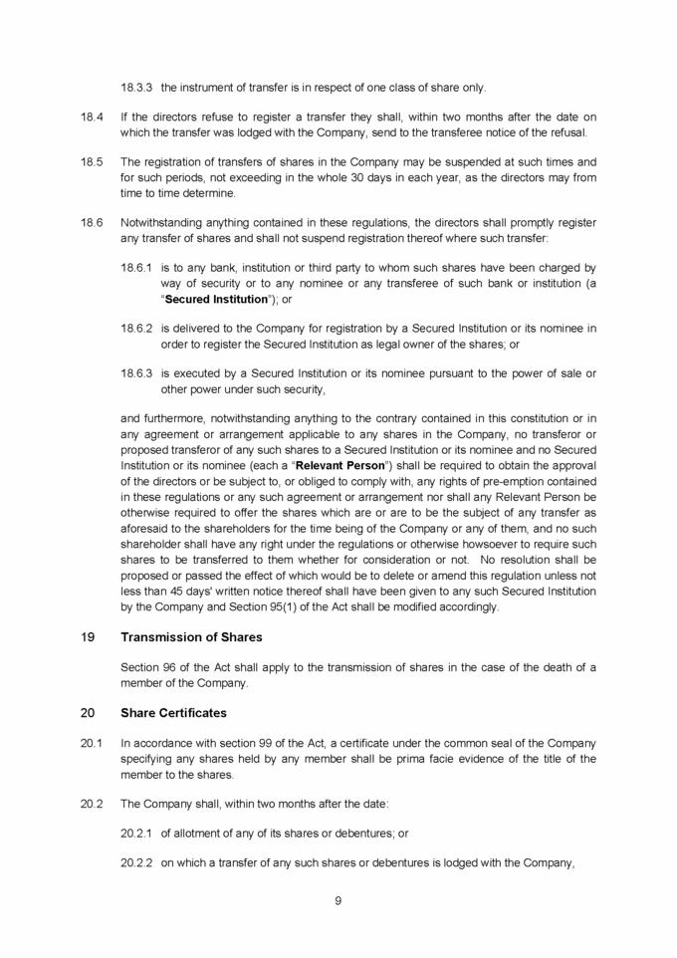

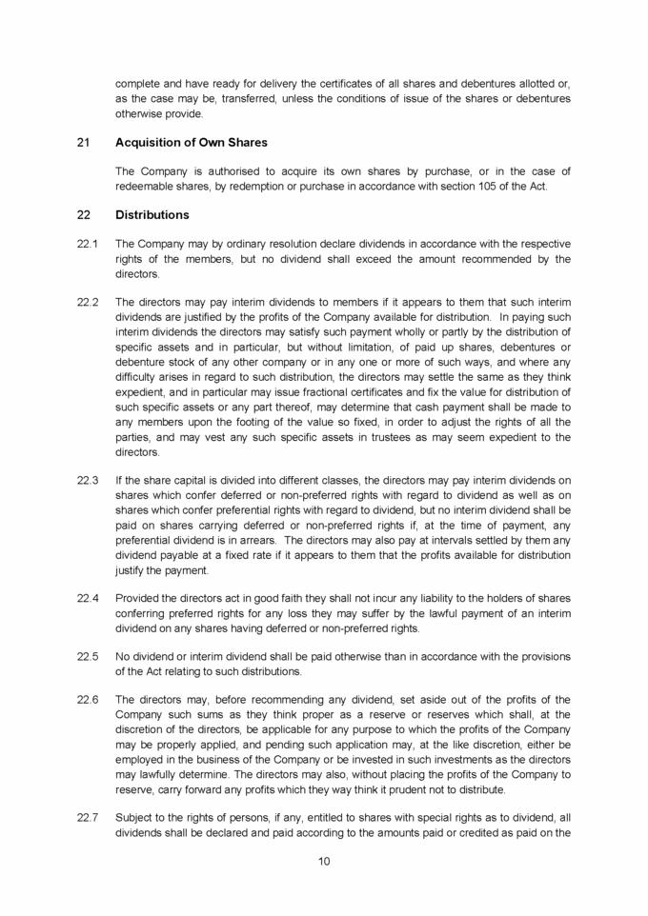

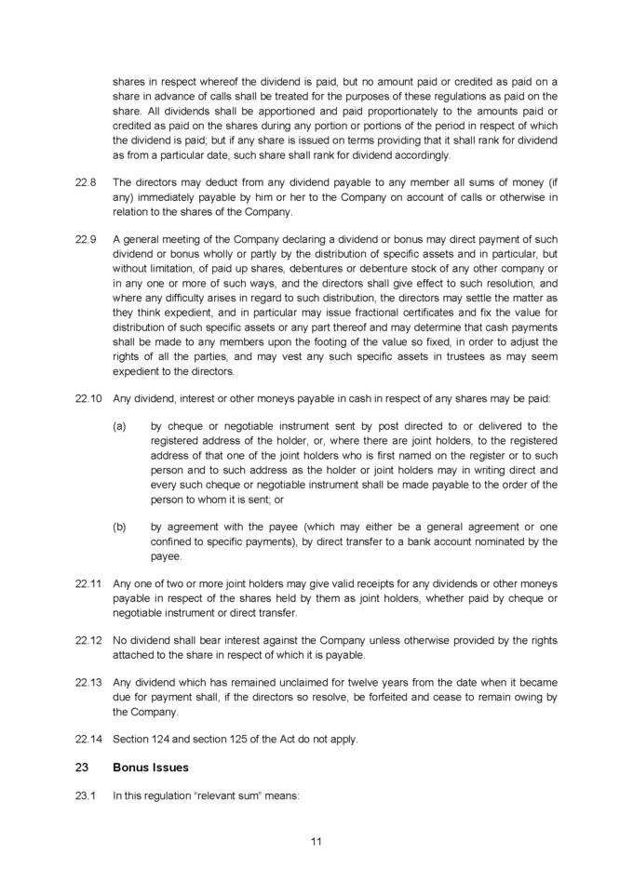

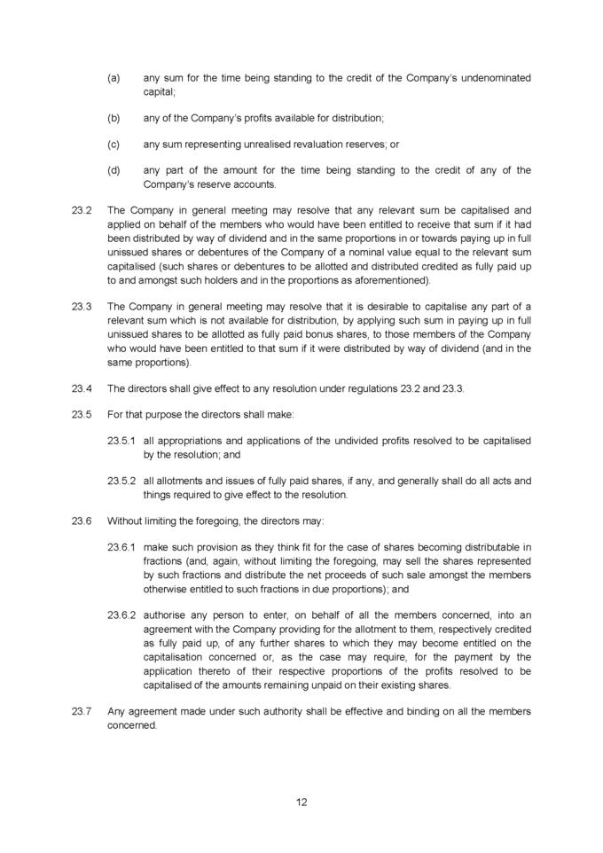

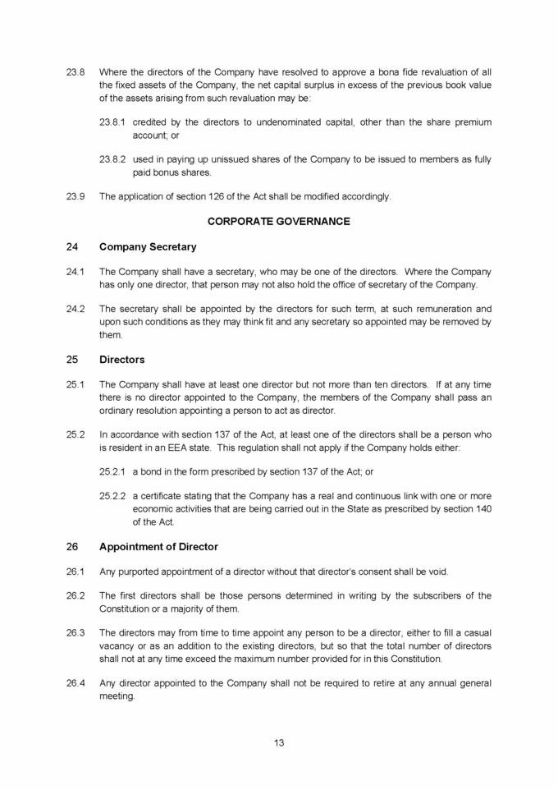

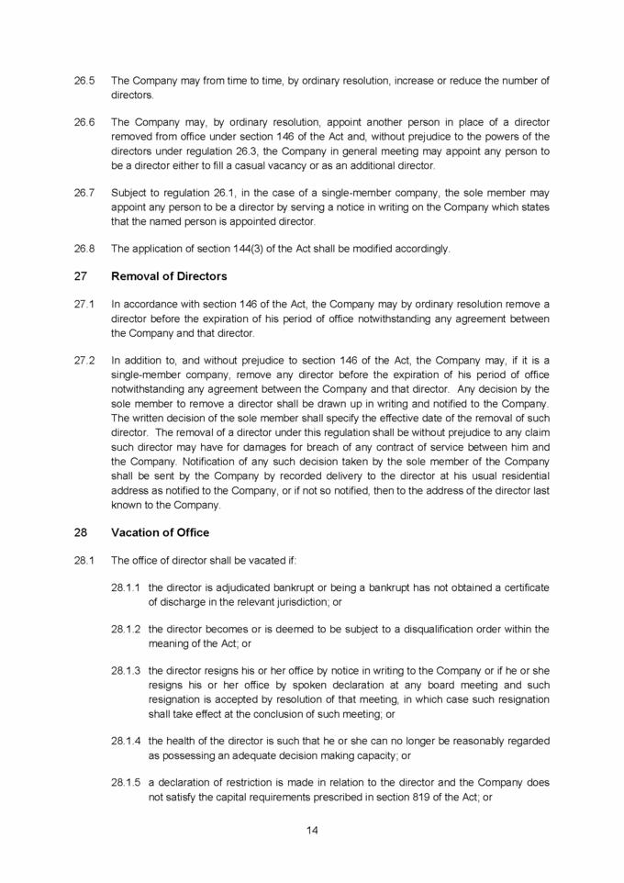

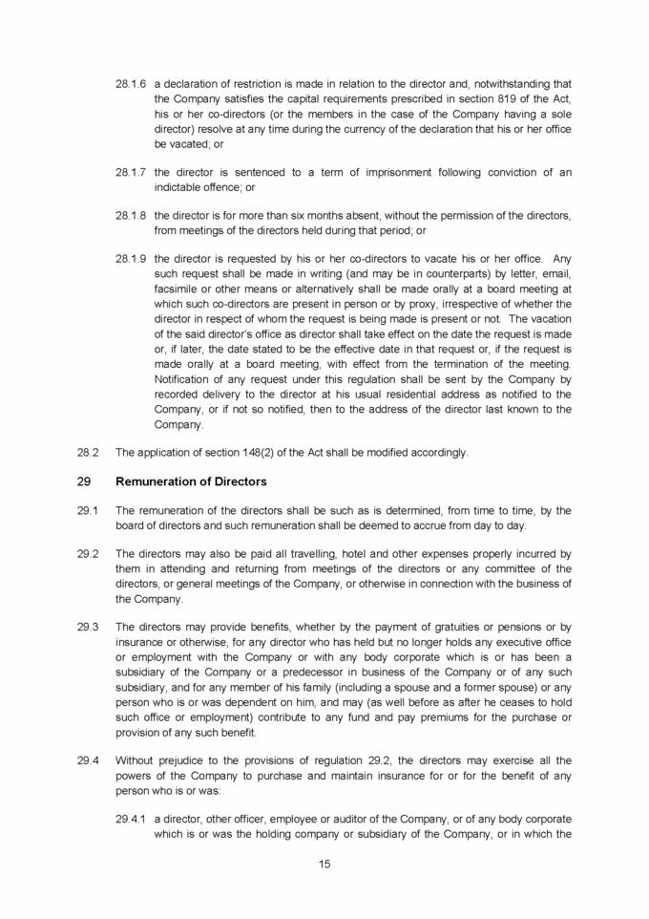

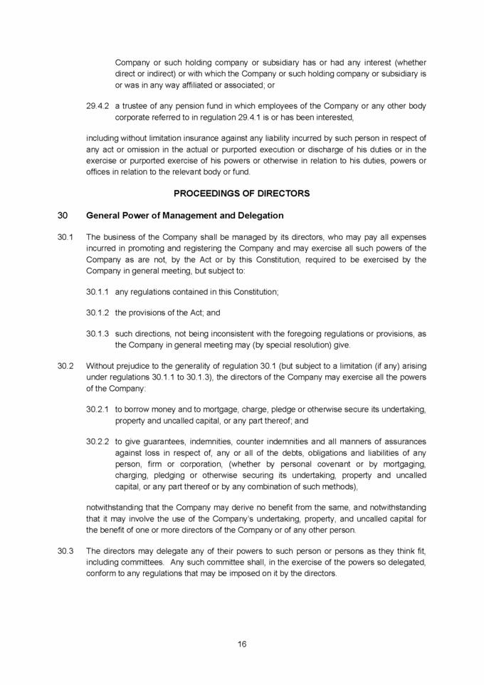

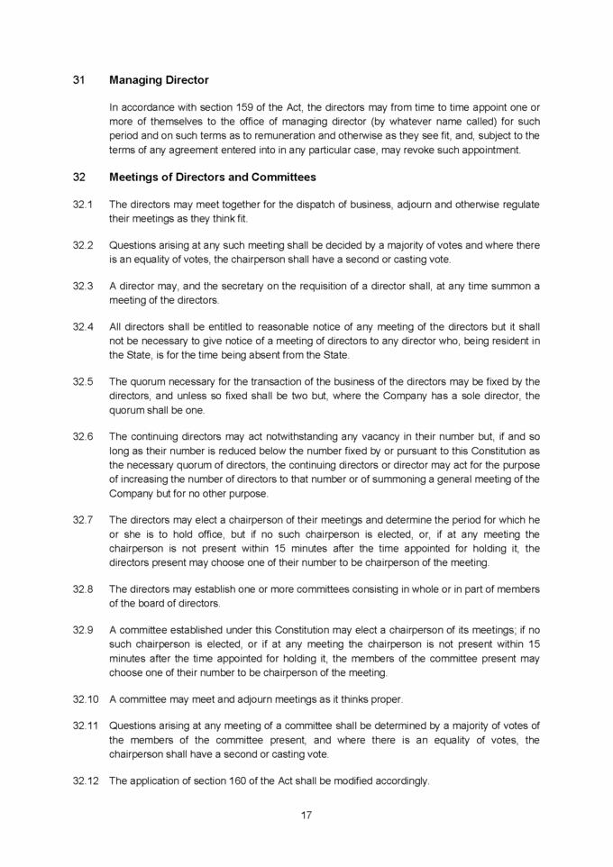

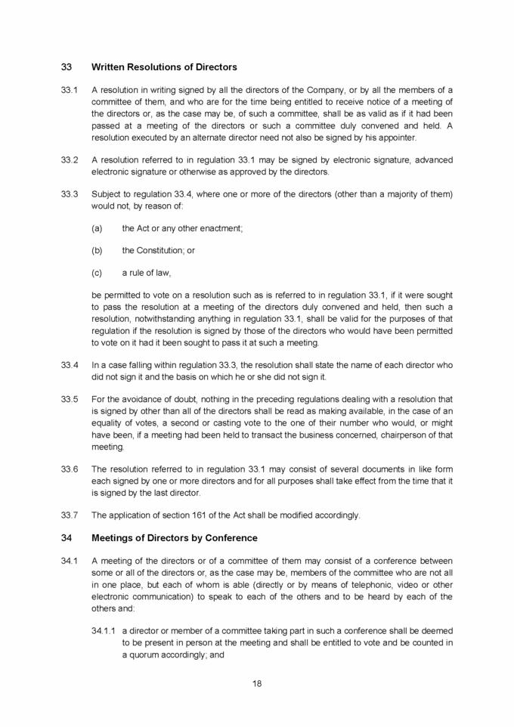

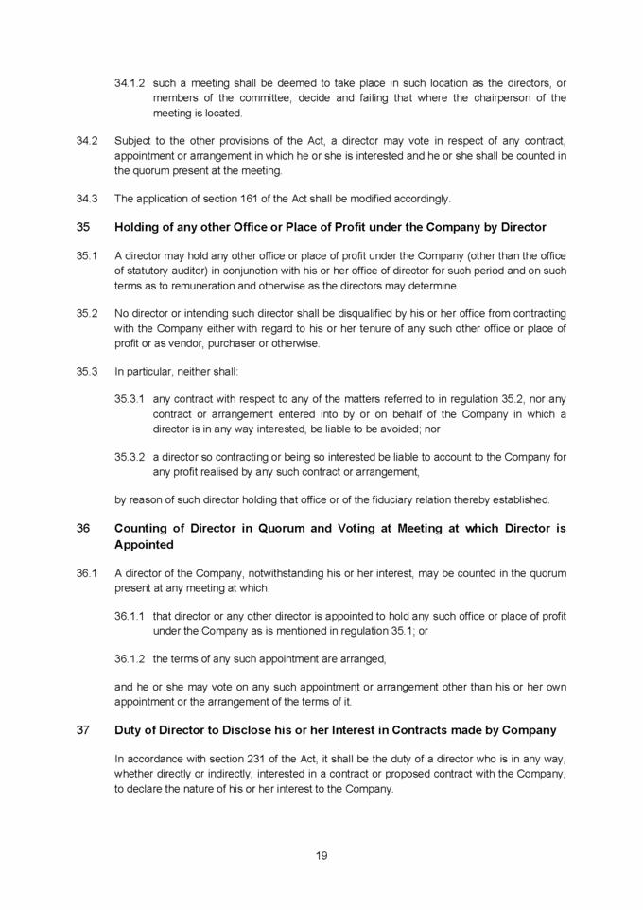

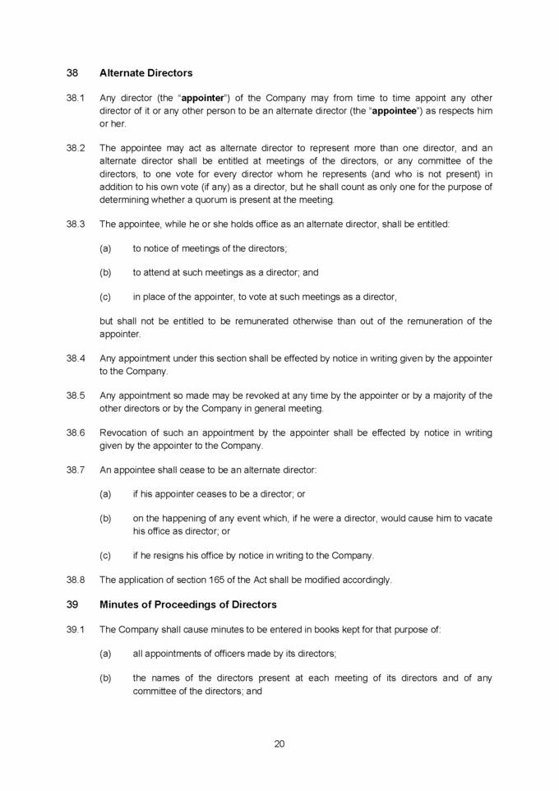



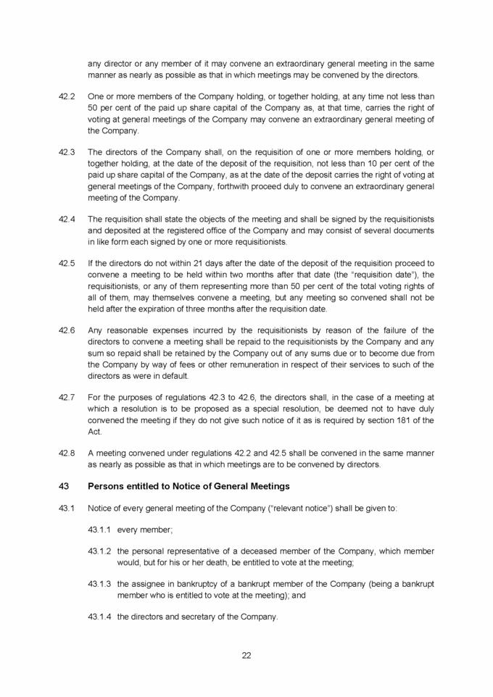



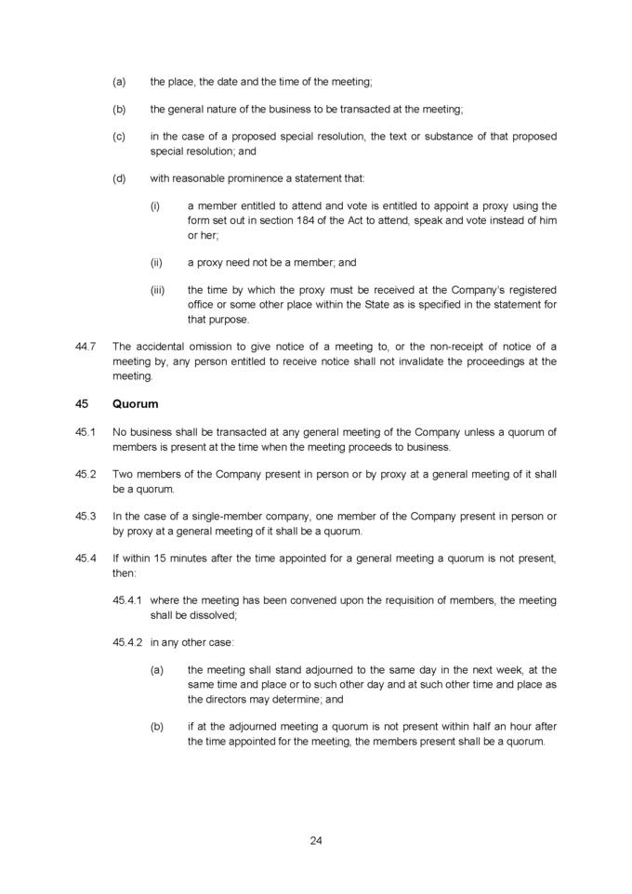

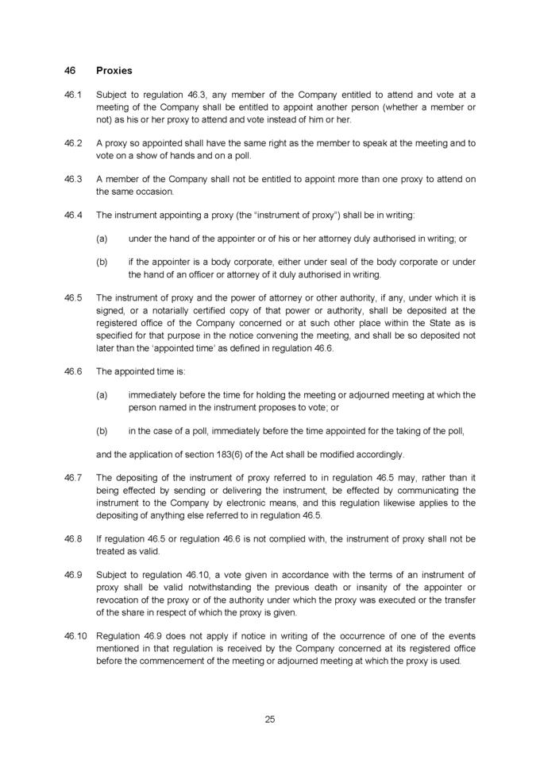

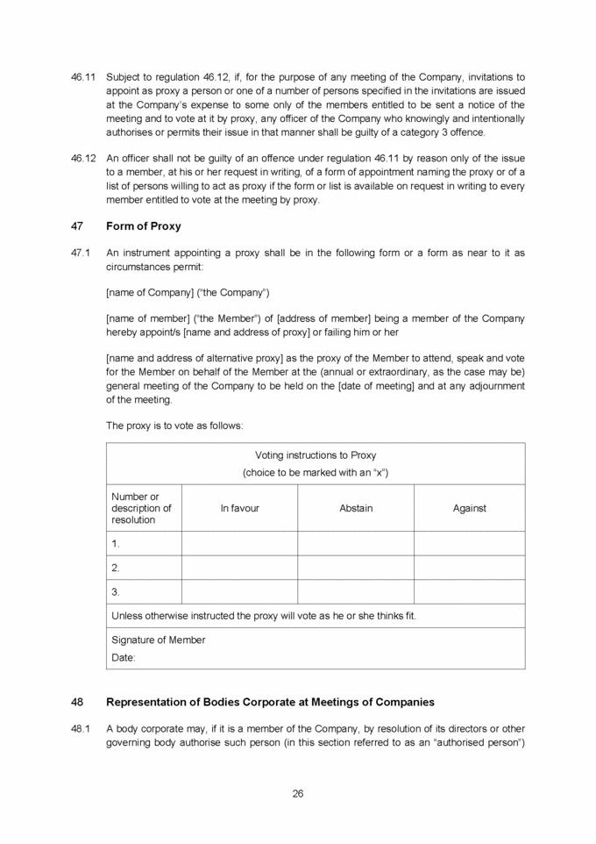

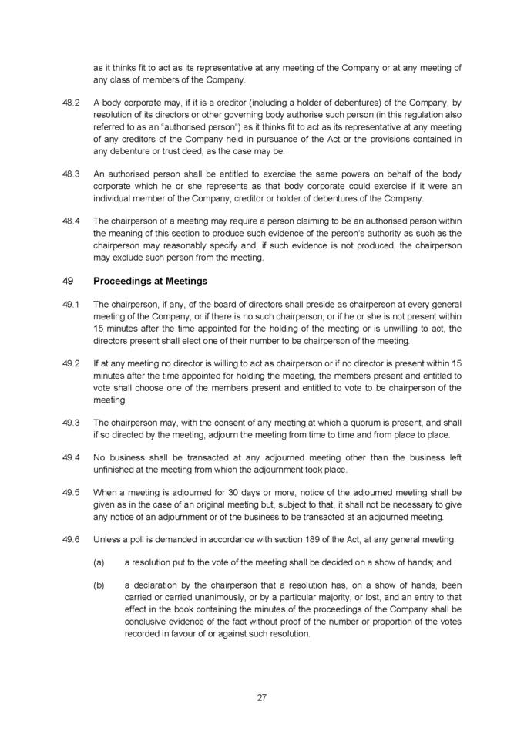



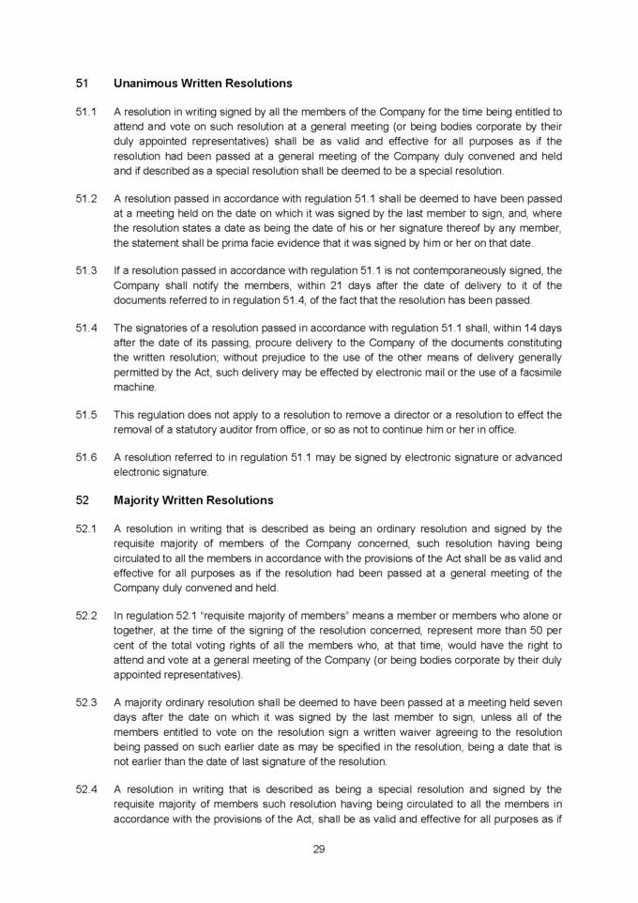

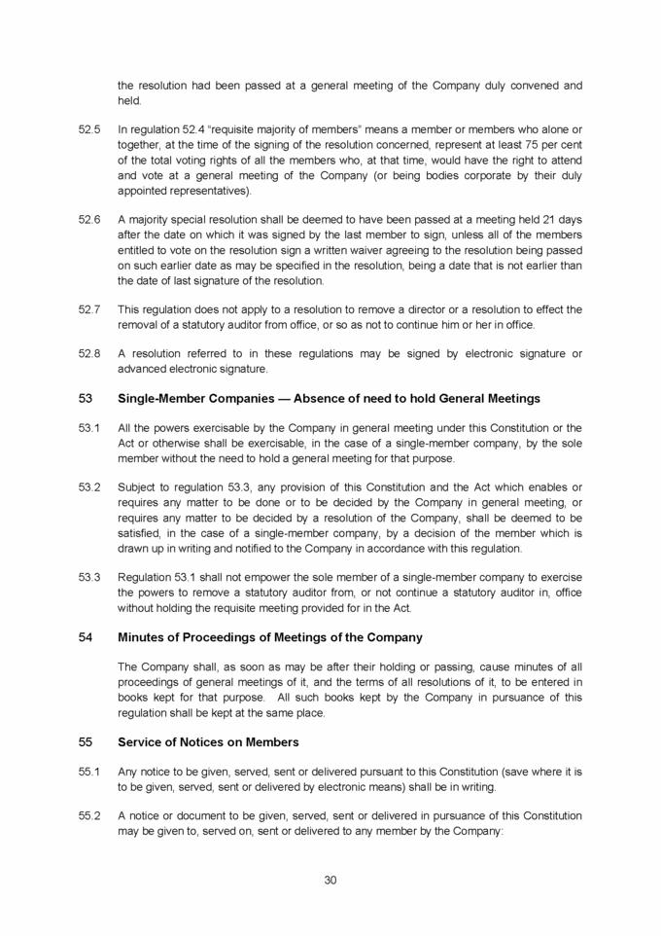

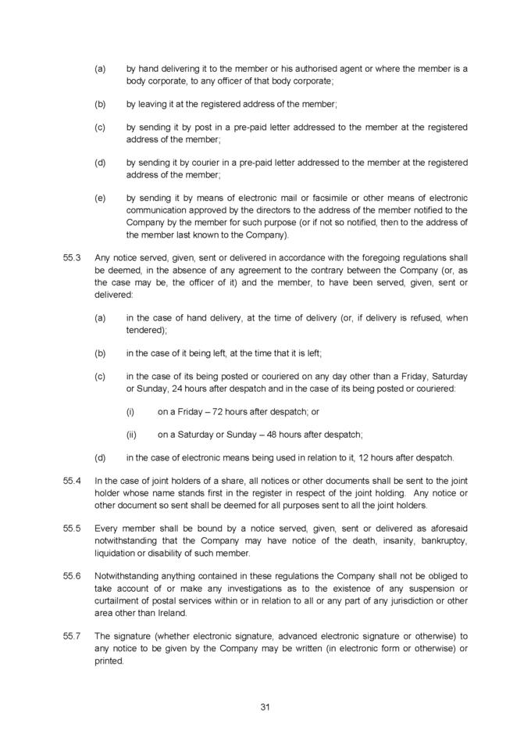

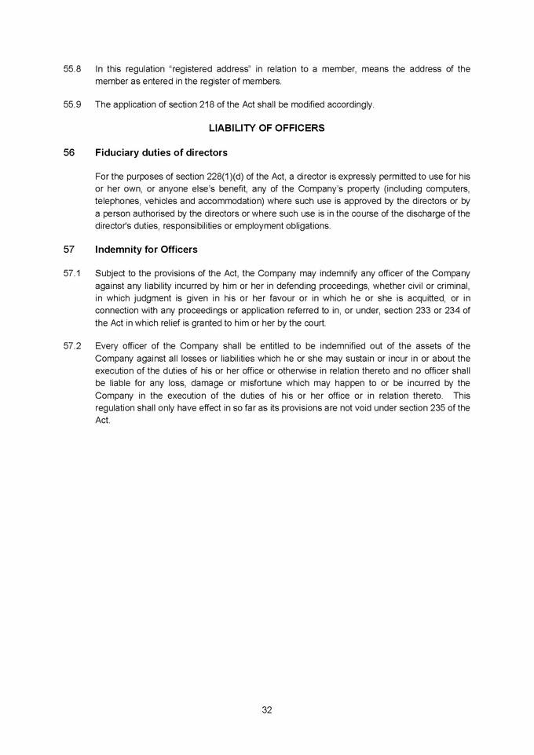

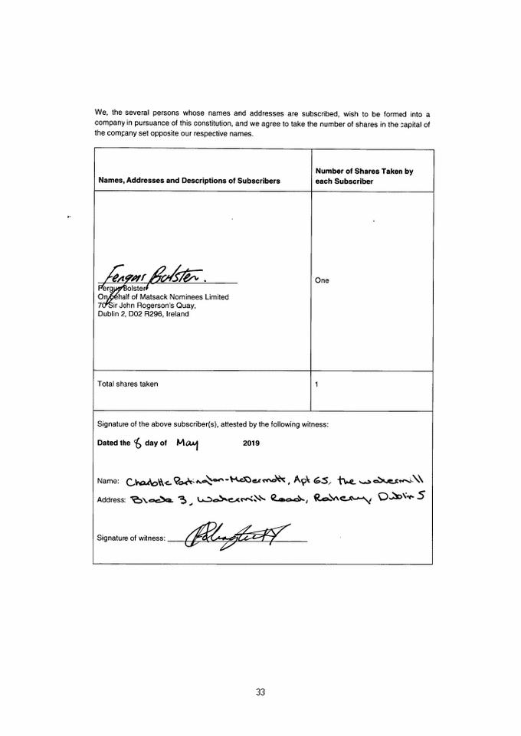

Exhibit T3C-1

[WEATHERFORD INTERNATIONAL, LLC,

a Delaware limited liability company,](1)

as Issuer,

WEATHERFORD INTERNATIONAL PLC,

an Irish public limited company,

as Parent Guarantor,

[WEATHERFORD INTERNATIONAL, LTD.],

a Bermuda exempted company,

as Subsidiary Guarantor, and

DEUTSCHE BANK TRUST COMPANY AMERICAS,

as Trustee

INDENTURE

dated as of [·], 2019

11.00% Senior Notes due 2024

(1) NTD: Notes issued by Delaware entity will be guaranteed by Bermuda and[, if applicable,] notes issued by Bermuda entity will be guaranteed by Delaware entity.

 |  | CROSS-REFERENCE TABLE
TIA |  |  |  | Indenture
Section |  |  |  | Section
310 | (a)(1) |  |  | 609
 | (a)(2) | 609
 | (a)(3) |  |  | N.A.
 | (a)(4) |  |  | N.A.
 | (b) | 608
 | (b) | 610
311 | (a) | 613
 | (b) | 613
312 | (a) | 701
 | (a) | 702
 | (b) | 702
 | (c) | 702
313 | (a) | 703
 | (b) | 703
 | (c) | 703
 | (d) | 703
314 | (a) | 704
 | (a)(4) | 101
 | (a)(4) | 1004
 | (b) |  |  | N.A.
 | (c)(1) | 102
 | (c)(2) | 102
 | (c)(3) |  |  | N.A.
 | (d) |  |  | N.A.
 | (e) | 102
315 | (a) | 601;603
 | (b) | 602
 | (c) | 601
 | (d)(1) | 601
 | (d)(2) | 601
 | (d)(3) |  |  | N.A.
 | (e) | 514
316 | (a)(1)(A) |  |  | N.A.
 | (a)(1)(A) |  |  | N.A.
 | (a)(1)(B) |  |  | N.A.
 | (a)(2) |  |  | N.A.
 | (b) | 508
 | (c) | 104
317 | (a)(1) | 503
 | (a)(2) | 504
 | (b) | 1003
318 | (a) | 107
N.A. | means Not Applicable

CROSS-REFERENCE TABLE

NOTE: This Cross Reference Table shall not, for any purpose, be deemed to be a part of the Indenture.

 | TABLE OF CONTENTS
 | ARTICLE ONE
 | DEFINITIONS AND OTHER PROVISIONS
 | OF GENERAL APPLICATION
Section 101. | Definitions | 1
Section 102. | Compliance Certificates and Opinions | 31
Section 103. | Form of Documents Delivered to Trustee | 32
Section 104. | Acts of Holders; Record Dates | 32
Section 105. | Notices, Etc., to Trustee, Issuer and Guarantors | 34
Section 106. | Notice to Holders; Waiver | 34
Section 107. | Conflict with Trust Indenture Act | 35
Section 108. | Effect of Headings and Table of Contents | 35
Section 109. | Successors and Assigns | 35
Section 110. | Separability Clause | 35
Section 111. | Benefits of Indenture | 35
Section 112. | Governing Law; Submission to Jurisdiction | 36
Section 113. | Legal Holidays | 36
Section 114. | No Personal Liability of Directors, Officers, Employees and Shareholders | 37
Section 115. | No Adverse Interpretation of Other Agreements | 37
Section 116. | U.S.A. PATRIOT Act | 37
Section 117. | Payment in Required Currency; Judgment Currency | 37
Section 118. | Language of Notices, Etc | 38
Section 119. | Counterpart Originals | 38
 | ARTICLE TWO
 | NOTE FORMS
Section 201. | Forms Generally | 38
Section 202. | Legends for Notes | 38
Section 203. | Global Notes | 39
 | ARTICLE THREE
 | THE NOTES
Section 301. | Title and Terms | 39
Section 302. | Denominations | 40
Section 303. | Execution, Authentication, Delivery and Dating | 40
Section 304. | Temporary Notes | 41
Section 305. | Registrar, Global Notes and Definitive Notes | 41
Section 306. | Mutilated, Destroyed, Lost and Stolen Notes | 44
Section 307. | Payment of Interest; Interest Rights Preserved | 44
Section 308. | Persons Deemed Owners | 45
Section 309. | Cancellation | 45
Section 310. | Computation of Interest | 45
Section 311. | Transfer and Exchange | 45
Section 312. | When Securities Disregarded | 47

Section 313. | Calculation of Specified Percentage of Notes | 47
 | ARTICLE FOUR
 | SATISFACTION AND DISCHARGE
Section 401. | Satisfaction and Discharge of Indenture | 48
Section 402. | Application of Trust Money | 49
 | ARTICLE FIVE
 | REMEDIES
Section 501. | Events of Default | 49
Section 502. | Acceleration of Maturity; Rescission and Annulment | 51
Section 503. | Collection of Indebtedness and Suits for Enforcement by Trustee | 52
Section 504. | Trustee May File Proofs of Claim | 52
Section 505. | Trustee May Enforce Claims Without Possession of Notes | 53
Section 506. | Application of Money Collected | 53
Section 507. | Limitation on Suits | 54
Section 508. | Unconditional Right of Holders to Receive Principal, Premium and Interest | 54
Section 509. | Restoration of Rights and Remedies | 54
Section 510. | Rights and Remedies Cumulative | 55
Section 511. | Delay or Omission Not Waiver | 55
Section 512. | Control by Holders | 55
Section 513. | Waiver of Existing Defaults | 55
Section 514. | Undertaking for Costs | 56
Section 515. | Waiver of Usury, Stay or Extension Laws | 56
 | ARTICLE SIX
 | THE TRUSTEE
Section 601. | Certain Duties and Responsibilities | 56
Section 602. | Notice of Defaults | 56
Section 603. | Certain Rights of Trustee | 57
Section 604. | Not Responsible for Recitals or Issuance of Notes | 58
Section 605. | May Hold Notes | 58
Section 606. | Money Held in Trust | 59
Section 607. | Compensation and Reimbursement | 59
Section 608. | Conflicting Interests | 60
Section 609. | Corporate Trustee Required; Eligibility | 60
Section 610. | Resignation and Removal; Appointment of Successor | 60
Section 611. | Acceptance of Appointment by Successor | 61
Section 612. | Merger, Conversion, Consolidation or Succession to Business | 62
Section 613. | Preferential Collection of Claims Against Issuer | 62
Section 614. | Appointment of Authenticating Agent | 62
 | ARTICLE SEVEN
 | HOLDERS’ LISTS AND REPORTS BY TRUSTEE AND ISSUER
Section 701. | Issuer to Furnish Trustee Names and Addresses of Holders | 63
Section 702. | Preservation of Information; Communications to Holders | 64

ii

Section 703. | Reports by Trustee | 64
Section 704. | Reports by Issuer | 64
 | ARTICLE EIGHT
 | CONSOLIDATION, MERGER, CONVEYANCE, TRANSFER OR LEASE
Section 801. | Issuer and Guarantors May Consolidate, Etc., Only on Certain Terms | 65
Section 802. | Successor Substituted | 66
 | ARTICLE NINE
 | SUPPLEMENTAL INDENTURES
Section 901. | Supplemental Indentures Without Consent of Holders | 66
Section 902. | Supplemental Indentures With Consent of Holders | 67
Section 903. | Execution of Supplemental Indentures | 68
Section 904. | Effect of Supplemental Indentures | 68
Section 905. | Conformity with Trust Indenture Act | 68
Section 906. | Reference in Notes to Supplemental Indentures | 69
 | ARTICLE TEN
 | COVENANTS
Section 1001. | Payment of Principal, Premium, Interest and Additional Amounts | 69
Section 1002. | Maintenance of Office or Agency | 69
Section 1003. | Money for Notes Payments to Be Held in Trust | 70
Section 1004. | Annual Compliance Certificate; Statement by Officers as to Default | 71
Section 1005. | Existence | 71
Section 1006. | Limitation on Designation of Unrestricted Subsidiaries | 71
Section 1007. | Purchase of Notes Upon a Change of Control | 73
Section 1008. | Limitation on Additional Indebtedness | 75
Section 1009. | Limitation on Restricted Payments | 78
Section 1010. | Limitation on Liens | 81
Section 1011. | Limitation on Dividends and Other Restrictions Affecting Restricted Subsidiaries | 83
Section 1012. | Limitation on Asset Sales | 85
Section 1013. | Limitation on Affiliate Transactions | 88
Section 1014. | Additional Guarantees | 90
Section 1015. | Covenant Suspension | 90
 | ARTICLE ELEVEN
 | REDEMPTION OF NOTES
Section 1101. | Applicability of Article | 91
Section 1102. | Election to Redeem; Notice to Trustee | 91
Section 1103. | Optional Redemption | 92
Section 1104. | Selection by Trustee of Notes to Be Redeemed | 93
Section 1105. | Notice of Redemption | 93
Section 1106. | Deposit of Redemption Price | 94
Section 1107. | Notes Payable on Redemption Date | 94
Section 1108. | Notes Redeemed in Part | 94

iii

ARTICLE TWELVE

SINKING FUND; OTHER ACQUISITIONS OF NOTES

Section 1201. | Mandatory Redemption, Etc. | 95
 | ARTICLE THIRTEEN
 | LEGAL DEFEASANCE AND COVENANT DEFEASANCE
Section 1301. | Issuer’s Option to Effect Legal Defeasance or Covenant Defeasance | 95
Section 1302. | Defeasance and Discharge | 95
Section 1303. | Covenant Defeasance | 96
Section 1304. | Conditions to Legal Defeasance or Covenant Defeasance | 96
Section 1305. | Deposited Money and U.S. Government Obligations to Be Held in Trust; Miscellaneous Provisions | 97
Section 1306. | Reinstatement | 98
 | ARTICLE FOURTEEN
 | GUARANTEES
Section 1401. | Unconditional Guarantee | 98
Section 1402. | Subsidiary Guarantee Evidenced by Indenture | 100
Section 1403. | Limitation on Guarantors’ Liability | 101
Section 1404. | Release of Guarantors from Guarantees | 101
Section 1405. | Guarantor Contribution | 102
FORM OF NOTE | ANNEX A | A-1
 | ANNEX B
FORM OF SUPPLEMENTAL INDENTURE |  | B-1

iv

THIS INDENTURE (herein called the “Indenture”), dated as of [·], 2019, is among [Weatherford International, LLC, a Delaware limited liability company (herein called the “Issuer”)],

Weatherford International plc, an Irish public limited company (herein called the “Parent Guarantor”), [Weatherford International, Ltd., a Bermuda exempted company (herein called a “Subsidiary

Guarantor”)], the other Subsidiary Guarantors party hereto from time to time and Deutsche Bank Trust Company Americas, as Trustee (herein called the “Trustee”).

NOW, THEREFORE, THE INDENTURE WITNESSETH:

For and in consideration of the premises and the purchase of the Notes by the Holders thereof, it is mutually agreed, for the equal and proportionate benefit of all Holders of the Notes of each series as follows:

ARTICLE ONE

DEFINITIONS AND OTHER PROVISIONS

OF GENERAL APPLICATION

Section 101. Definitions.

For all purposes of the Indenture, except as otherwise expressly provided or unless the context otherwise requires:

- the terms defined in this Article have the meanings assigned to them in this Article and include the plural as well as the singular;

- all other terms used herein which are defined in the Trust Indenture Act, in the Exchange Act or in the Securities Act, either directly or by reference therein, have the meanings assigned to them therein;

- all accounting terms not otherwise defined herein have the meanings assigned to them in accordance with GAAP;

- unless the context otherwise requires, any reference to an “Article” or a “Section” refers to an Article or a Section, as the case may be, of the Indenture;

- unless the context otherwise requires, the word “will” shall be interpreted to express a command;

- references to sections of or rules under the Securities Act, Trust Indenture Act or Exchange Act will be deemed to include substitute, replacement of successor sections or rules that come into force from time to time; and

- the words “herein,” “hereof” and “hereunder” and other words of similar import refer to the Indenture as a whole and not to any particular Article, Section or other subdivision.

“acceleration declaration” has the meaning specified in Section 502.

“Acquired Indebtedness” means (1) with respect to any Person that becomes a Restricted Subsidiary after the Issue Date, Indebtedness of such Person and its Subsidiaries (including, for the avoidance of doubt, Indebtedness incurred in the ordinary course of such Person’s business to acquire assets used or useful in its business) existing at the time such Person becomes a Restricted Subsidiary and (2) with respect to the Parent Guarantor or any Restricted Subsidiary, any Indebtedness of a Person (including, for the avoidance of doubt, Indebtedness incurred in the ordinary course of such Person’s business to acquire assets used or useful in its business), other than the Parent Guarantor or a Restricted Subsidiary, existing at the time such Person is merged with or into the Parent Guarantor or a Restricted Subsidiary, or Indebtedness expressly assumed by the Parent Guarantor or any Restricted Subsidiary in connection with the acquisition of an asset or assets from another Person.

“Act,” when used with respect to any Holder, has the meaning specified in Section 104.

“Additional Assets” means:

- any assets used or useful in a Permitted Business, other than cash, Cash Equivalents, Indebtedness or Capital Stock;

- Equity Interests of a Person that becomes a Restricted Subsidiary as a result of the acquisition of such Equity Interests by the Parent Guarantor or any of its Restricted Subsidiaries; or

- Equity Interests in any Person that at such time is a Restricted Subsidiary;

provided, however, that any such Restricted Subsidiary described in clause (2) or (3) is primarily engaged in a Permitted Business.

“Affiliate” of any specified Person means any other Person directly or indirectly controlling or controlled by, or under direct or indirect common control with, such specified Person. For purposes of this definition, “control” when used with respect to any specified Person means the power to direct the management and policies of such Person, directly or indirectly, whether through the ownership of voting securities, by contract or otherwise; and the terms “controlling” and “controlled” have meanings correlative to the foregoing.

“Affiliate Transaction” has the meaning specified in Section 1013.

“Agent Members” has the meaning specified in Section 305.

“amend” means to amend, supplement, restate, amend and restate or otherwise modify, including successively, and “amendment” shall have a correlative meaning.

“Applicable Banking Laws” has the meaning specified in Section 116.(2)

“Asset Acquisition” means:

(2) NTD: Indenture is subject to LW tax review.

2

- an Investment by the Parent Guarantor or any Restricted Subsidiary in any other Person if, as a result of such Investment, such Person shall become a Restricted Subsidiary of the Parent Guarantor, or shall be merged with or into the Parent Guarantor or any of its Restricted Subsidiaries, or

- the acquisition by the Parent Guarantor or any of its Restricted Subsidiaries of all or substantially all of the properties and assets of any other Person (other than a Restricted Subsidiary of the Parent Guarantor) or any division or line of business of any such other Person (other than in the ordinary course of business).

“Asset Sale” means:

- the sale, lease (other than operating leases entered into in the ordinary course of business), conveyance or other disposition of any properties or assets (including by way of a Sale-Leaseback Transaction or mergers, amalgamations, consolidations or otherwise); and

- the issuance of Equity Interests in any of the Parent Guarantor’s Restricted Subsidiaries or the sale by the Parent Guarantor or any Restricted Subsidiary of Equity Interests in any of the Parent Guarantor’s Restricted Subsidiaries (in either case other than Preferred Stock of any Restricted Subsidiary issued in compliance with the Indenture and directors’ qualifying shares or shares required by applicable law to be held by a Person other than the Parent Guarantor or a Restricted Subsidiary);

provided that, in the case of (1) or (2), the sale, assignment, transfer, lease, conveyance or other disposition of all or substantially all of the properties or assets of the Parent Guarantor and its Restricted Subsidiaries (including by way of a merger, amalgamation or consolidation) will be governed by Section 801 and not by the provisions of Section 1012.

Notwithstanding the preceding, the following items will not be deemed to be Asset Sales:

- any single transaction or series of related transactions that involves properties, assets or Equity Interests having a Fair Market Value of less than $10.0 million;

- a transfer or other disposition of assets between or among any of the Parent Guarantor and its Restricted Subsidiaries;

- an issuance or sale or other disposition of Equity Interests by a Restricted Subsidiary to the Parent Guarantor or to another Restricted Subsidiary;

- the sale or other disposition of Receivables in connection with any Permitted Factoring Transaction;

- the sale, lease or other disposition of equipment, inventory, products, services, accounts receivable or other properties or assets in the ordinary course of business and any sale or other disposition of surplus, damaged, worn-out or obsolete assets;

3

- the sale or other disposition of (a) financial instruments in the ordinary course of business or (b) cash or Cash Equivalents;

- a disposition of properties or assets that constitutes (or results in by virtue of the consideration received for such disposition) either a Restricted Payment that does not violate Section 1009 or a Permitted Investment;

- the creation or perfection of a Permitted Lien and dispositions in connection with Permitted Liens and the exercise by any Person in whose favor a Permitted Lien is granted of any of its rights in respect of that Permitted Lien;

- a surrender or waiver of contract rights or the settlement, release or surrender of contract, tort or other claims of any kind;

- the grant in the ordinary course of business of any non-exclusive license or sublicense of patents, trademarks, registrations therefor and other similar intellectual property;

- the disposition of assets or Equity Interests received in settlement of debts owing to a Person as a result of foreclosure, perfection or enforcement of any Lien or debt, which debts were owing to such Person;

- any sale or other disposition of Equity Interests in, or Indebtedness or other securities of, an Unrestricted Subsidiary; and

- any expropriation, taking, sale or other disposition of assets (including any receipt of proceeds related thereto) by any foreign government or any of its political subdivisions, agencies or controlled entities.

“Asset Sale Offer” has the meaning set forth in Section 1012.

“Attributable Indebtedness” means, with respect to any Sale-Leaseback Transaction as of any particular time, the present value (discounted at the rate of interest implicit in the terms of the lease) of the obligations of the lessee under such lease for net rental payments during the remaining term of the lease (including any period for which such lease has been extended). For purposes of this definition, “net rental payments” under any lease for any period means the sum of the rental payments required to be paid in such period by the lessee thereunder, not including, however, any amounts required to be paid by such lessee (whether or not designated as rental or additional rental) on account of maintenance and repairs, insurance, taxes, assessments or similar charges required to be paid by such lessee thereunder contingent upon the amount of sales or deliveries, maintenance and repairs, insurance, taxes, assessments or similar charges.

“Authenticating Agent” means any Person authorized by the Trustee pursuant to Section 614 to act on behalf of the Trustee to authenticate Notes.

“Bankruptcy Law” means Title 11, United States Code, or any similar U.S. federal or state of non-U.S. law for relief of creditors.

4

“Board of Directors” means, with respect to any Person, (i) in the case of any corporation, the board of directors of such Person and (ii) in any other case, the functional equivalent of the foregoing or, in each case, other than for purposes of the definition of “Change of Control,” any duly authorized committee of such body.

“Board Resolution” means a copy of a resolution certified by the Secretary or an Assistant Secretary of the Parent Guarantor, the Issuer or a Guarantor, the principal financial officer of the Parent Guarantor, the Issuer or such Guarantor, any other authorized officer of the Issuer or such Guarantor, or a person duly authorized by any of them, in each case as applicable, to have been duly adopted by the Board of Directors of the Issuer or such Guarantor, as applicable, and to be in full force and effect on the date of such certification, and delivered to the Trustee. Where any provision of the Indenture refers to action to be taken pursuant to a Board Resolution, such action may be taken by any committee, officer or employee of the Parent Guarantor, the Issuer or the Guarantor, as applicable, authorized to take such action by its Board of Directors as evidenced by a Board Resolution.

“Business Day” means each Monday, Tuesday, Wednesday, Thursday and Friday which is not a day on which banking institutions in the City and State of New York are authorized or obligated by law, executive order or regulation to close.

“Capitalized Lease” means a lease required to be capitalized for financial reporting purposes in accordance with GAAP. Notwithstanding the foregoing, any lease that would have been classified as an operating lease pursuant to GAAP as in effect on [December 31, 2018] shall be deemed not to be a Capitalized Lease.

“Capitalized Lease Obligations” of any Person means the obligations of such Person to pay rent or other amounts under a Capitalized Lease, and the amount of such obligation shall be the capitalized amount thereof determined in accordance with GAAP, excluding liabilities resulting from a change in GAAP subsequent to the date of the Indenture, and the Stated Maturity thereof shall be the date of the last payment of rent or any other amount due under such lease prior to the first date upon which such lease may be prepaid by the lessee without payment of a penalty.

“Cash Equivalents” means:

- direct obligations of, or obligations the principal of and interest on which are unconditionally guaranteed by, the United States (or any agency thereof to the extent such obligations are backed by the full faith and credit of the United States), in each case maturing within one year from the date of acquisition thereof;

- investments in commercial paper maturing within 270 days from the date of acquisition thereof and having, at such date of acquisition, the highest credit rating obtained from S&P

or from Moody’s;

- investments in certificates of deposit, bankers’ acceptances and time deposits maturing within 180 days from the date of acquisition thereof issued or guaranteed by or placed with, and money market deposit accounts issued or offered by, any domestic office of any commercial bank organized under the laws of the

5

United States or any State thereof which has a combined capital and surplus and undivided profits of not less than $500.0 million;

- fully collateralized repurchase agreements with a term of not more than 30 days for securities described in clause (1) above and entered into with a financial institution satisfying the criteria described in clause (3) above;

- money market funds that (i) comply with the criteria set forth in SEC Rule 2a-7 under the Investment Company Act, (ii) are rated AAA by S&P and Aaa by Moody’s and (iii) have portfolio assets of at least $5.0 billion; and

- in the case of any Foreign Restricted Subsidiary, other investments that are analogous to the items specified in clauses (1) through (5) above, are of comparable credit quality and are customarily used by companies in the jurisdiction of such Foreign Restricted Subsidiary for cash management purposes.

“Change of Control” means the occurrence of any of the following: (a) the direct or indirect sale, transfer, conveyance or other disposition (other than by way of merger, amalgamation, consolidation, plan or scheme of arrangement, exchange offer, business combination or similar transaction of the Weatherford Parent Company), in one or a series of related transactions, of all or substantially all of the properties or assets of the Weatherford Parent Company and its Restricted Subsidiaries taken as a whole to any person (as such term is used in Section 13(d) of the Exchange Act) other than the Weatherford Parent Company or one of its Subsidiaries or a Person controlled by the Weatherford Parent Company or one of its Restricted Subsidiaries; (b) the consummation of any transaction (including, without limitation, any merger, amalgamation, consolidation, plan or scheme of arrangement, exchange offer, business combination or similar transaction) the result of which is that any person (as such term is used in Section 13(d) of the Exchange Act) other than the Permitted Holders becomes the beneficial owner, directly or indirectly, of more than 50% of the then outstanding Voting Stock of the Weatherford Parent Company (excluding a Redomestication of the Weatherford Parent Company); and (c) the first day on which a majority of the members of the Weatherford Parent Company Board of Directors are not Continuing Directors.

“Change of Control Offer” has the meaning specified in Section 1007.

“Change of Control Payment” has the meaning specified in Section 1007.

“Change of Control Payment Date” has the meaning specified in Section 1007.

“Code” has the meaning specified in Section 1001.

“Common Stock” means with respect to any Person, any and all shares, interest or other participations in, and other equivalents (however designated and whether voting or nonvoting) of such Person’s common stock or common shares whether or not outstanding on the Issue Date, and includes, without limitation, all series and classes of such common stock.

6

“Consolidated Amortization Expense” for any period means the amortization expense of the relevant Person and the Restricted Subsidiaries for such period, determined on a consolidated basis in accordance with GAAP.

“Consolidated Cash Flow” for any period means, with respect to any specified Person and its Restricted Subsidiaries, without duplication, the sum of the amounts for such period of:

- Consolidated Net Income, plus

- in each case only to the extent deducted in determining Consolidated Net Income,

  - Consolidated Income Tax Expense,

  - Consolidated Amortization Expense,

  - Consolidated Depreciation Expense,

  - Consolidated Interest Expense, and

  - all other non-cash items reducing the Consolidated Net Income (excluding any non-cash charge that results in an accrual of a reserve for cash charges in any future period) for such period, minus

- the aggregate amount of all non-cash items, determined on a consolidated basis, to the extent such items increased Consolidated Net Income for such period (excluding any non-cash items to the extent they represent the reversal of an accrual of a reserve for a potential cash item that reduced Consolidated Cash Flow in any prior period); and

- to the extent included in Consolidated Net Income, any nonrecurring or unusual gain or income (or nonrecurring or unusual loss or expense), together with any related provision for taxes on any such nonrecurring or unusual gain or income (or the tax effect of any such nonrecurring or unusual loss or expense), realized by such Person or any of its Restricted Subsidiaries during such period, shall be excluded.

“Consolidated Depreciation Expense” for any period means the depreciation expense of the relevant Person and its Restricted Subsidiaries for such period, determined on a consolidated basis in accordance with GAAP.

“Consolidated Income Tax Expense” for any period means the provision for taxes of the relevant Person and its Restricted Subsidiaries, determined on a consolidated basis in accordance with

GAAP.

“Consolidated Interest Coverage Ratio” means, on any date of determination, with respect to any Person, the ratio of (x) Consolidated Cash Flow of such Person during the most recent four consecutive full fiscal quarters for which financial statements prepared on a consolidated basis in accordance with GAAP are available (the “Four-Quarter Period”) ending

7

on or prior to the date of the transaction giving rise to the need to calculate the Consolidated Interest Coverage Ratio (the “Transaction Date”) to (y) Consolidated Interest Expense of such Person for the Four-Quarter Period. For purposes of this definition, Consolidated Cash Flow and Consolidated Interest Expense shall be calculated after giving effect on a pro forma basis for the period of such calculation to:

- the incurrence of any Indebtedness or the issuance of any Disqualified Equity Interests of such Person or Preferred Stock of any Restricted Subsidiary of such Person (and the application of the proceeds thereof) and any repayment, repurchase or redemption of other Indebtedness or other Disqualified Equity Interests or Preferred Stock (and the application of the proceeds therefrom) (other than the incurrence or repayment of Indebtedness in the ordinary course of business for working capital purposes pursuant to any revolving credit arrangement) occurring during the Four-Quarter Period or at any time subsequent to the last day of the Four-Quarter Period and on or prior to the Transaction Date, as if such incurrence, repayment, repurchase, issuance or redemption, as the case may be (and the application of the proceeds thereof), occurred on the first day of the Four-Quarter Period; and

- any asset sale outside the ordinary course of business or Asset Acquisition (including, without limitation, any Asset Acquisition giving rise to the need to make such calculation as a result of the Parent Guarantor or any Restricted Subsidiary (including any Person who becomes a Restricted Subsidiary as a result of such Asset Acquisition) incurring Acquired Indebtedness and also including any Consolidated Cash Flow (including any pro forma expense and cost reductions that have occurred or are reasonably expected to occur within the next 12 months)) in each case occurring during the Four-Quarter Period or at any time subsequent to the last day of the Four-Quarter Period and on or prior to the Transaction Date, as if such asset sale or Asset Acquisition (including the incurrence of, or assumption or liability for, any such Indebtedness or Acquired Indebtedness) occurred on the first day of the Four-Quarter Period; provided, that such pro forma calculations shall be determined in good faith by a responsible financial or accounting officer of the Parent Guarantor whether or not such pro forma adjustments would be permitted under SEC rules or guidelines.

In calculating Consolidated Interest Expense for purposes of determining the denominator (but not the numerator) of this Consolidated Interest Coverage Ratio:

- interest on outstanding Indebtedness determined on a fluctuating basis as of the Transaction Date and which will continue to be so determined thereafter shall be deemed to have accrued at a fixed rate per annum equal to the rate of interest on such Indebtedness in effect on the Transaction Date;

- if interest on any Indebtedness actually incurred on the Transaction Date may optionally be determined at an interest rate based upon a factor of a prime or similar rate, a eurocurrency interbank offered rate, or other rates, then the interest rate in effect on the Transaction Date will be deemed to have been in effect during the Four- Quarter Period; and

8

- notwithstanding clause (1) or (2) above, interest on Indebtedness determined on a fluctuating basis, to the extent such interest is covered by agreements relating to Hedging Obligations, shall be deemed to accrue at the rate per annum resulting after giving effect to the operation of such agreements.

“Consolidated Interest Expense” for any period means the sum, without duplication, of the total interest expense of the relevant Person and its Restricted Subsidiaries for such period, determined on a consolidated basis in accordance with GAAP, including, without duplication:

- imputed interest on Capitalized Lease Obligations and Attributable Indebtedness;

- the net costs associated with Hedging Obligations related to interest rates;

- amortization of debt issuance costs, debt discount or premium and other financing fees and expenses;

- the interest portion of any deferred payment obligations;

- all other non-cash interest expense;

- capitalized interest;

- all dividend payments on any series of Disqualified Equity Interests of the Parent Guarantor or any Preferred Stock of any Restricted Subsidiary (other than dividends on Equity Interests payable solely in Qualified Equity Interests of the Parent Guarantor or to the Parent Guarantor or a Restricted Subsidiary);

- all interest payable with respect to discontinued operations; and

- all interest on any Indebtedness described in clause (6) or (7) of the definition of Indebtedness.

“Consolidated Net Income” for any period means the net income (or loss) of a specified Person and its Restricted Subsidiaries, in each case for such period determined on a consolidated basis in accordance with GAAP; provided that there shall be excluded in calculating such net income (or loss), to the extent otherwise included therein, without duplication:

- the net income (or loss) of any Person (other than a Restricted Subsidiary) in which the specified Person or its Restricted Subsidiaries has an ownership interest, except to the extent that cash in an amount equal to any such income has actually been received by the specified Person or any of its Restricted Subsidiaries during such period;

- except to the extent includible in the net income (or loss) of the specified Person pursuant to the foregoing clause (1), the net income (or loss) of any other Person that accrued prior to the date that (a) such other Person becomes a Restricted Subsidiary

9

of the specified Person or is merged into or consolidated with the specified Person or any of its Restricted Subsidiaries or (b) the assets of such other Person are acquired by the specified Person or any of its Restricted Subsidiaries;

- the net income of any Restricted Subsidiary of the specified Person (other than the Issuer or a Subsidiary Guarantor) during such period to the extent that the declaration or payment of dividends or similar distributions by such Restricted Subsidiary of that income is not permitted by operation of the terms of its charter or any agreement, instrument, judgment, decree, order, statute, rule or governmental regulation applicable to that Subsidiary during such period, unless such restriction with respect to the payment of dividends has been legally waived;

- gains or losses attributable to discontinued operations;

- any gain (or loss), together with any related provisions for taxes on any such gain (or the tax effect of any such loss), realized during such period by the Parent Guarantor or any Restricted Subsidiary upon the acquisition of any securities, or the extinguishment of any Indebtedness, of the specified Person or any Restricted Subsidiary;

- gains and losses due solely to fluctuations in currency values and the related tax effects according to GAAP;

- unrealized gains and losses with respect to Hedging Obligations;

- the cumulative effect of any change in accounting principles or policies;

- extraordinary gains and losses and the related tax effect;

- non-cash charges or expenses with respect to the grant of stock options, restricted stock or other equity compensation awards; and

- goodwill write-downs or other non-cash impairments of assets.

“Consolidated Tangible Assets” means, with respect to any Person as of any date, the amount which, in accordance with GAAP, would be set forth under the caption “Total Assets” (or any like caption) on a consolidated balance sheet of such Person and its Restricted Subsidiaries determined in accordance with GAAP, less, to the extent included in a determination of “Total Assets,” and without duplication, all goodwill, patents, tradenames, trademarks, copyrights, franchises, experimental expenses, organization expenses and any other amounts classified as intangible assets in accordance with GAAP.

“Continuing Directors” means, as of any date of determination, any member of the Board of Directors of the Weatherford Parent Company who (a) was a member of such Board of Directors on the date of the issuance of the Notes or (b) was nominated for election or appointed or elected to such Board of Directors with the approval of a majority of the Continuing Directors who were members of such Board of Directors at the time of such nomination, appointment or election (either by a specific vote or by approval of the Weatherford

10

Parent Company’s proxy statement in which such member was named as a nominee for election as a director, without objection to such nomination).

“Corporate Trust Office” means the office of the Trustee at which at any particular time its corporate trust business in relation to the Notes shall be administered, which office on the date hereof is located at [·], or such other address as the Trustee may designate from time to time by notice to the Holders and the Issuer, or the principal corporate trust office of any successor Trustee (or such other address as such successor Trustee may designate from time to time by notice to the Holders and the Issuer).

“corporation” includes corporations, companies, associations, partnerships, limited partnerships, limited liability companies, joint-stock companies and trusts.

“Covenant Defeasance” has the meaning specified in Section 1303.

“Coverage Ratio Exception” has the meaning set forth in the proviso in the first paragraph of Section 1008.

“Credit Agreement” means the [Credit Agreement dated as of [·], 2019], among the Issuer, the Parent Guarantor, the other Subsidiaries of the Parent Guarantor from time to time party thereto, [·], as administrative agent and swingline lender, and the several lenders and other agents party thereto, including any notes, guarantees, collateral and security documents, instruments and agreements executed in connection therewith (including Hedging Obligations related to the Indebtedness incurred thereunder), and in each case as such agreement or facility may be amended (including any amendment or restatement thereof), supplemented or otherwise modified from time to time, including any agreement made in the commercial bank market exchanging, extending the maturity of, refinancing, renewing, replacing, substituting or otherwise restructuring (including increasing the amount of available borrowings thereunder or adding or removing Subsidiaries as borrowers or guarantors thereunder) all or any portion of the Indebtedness under such agreement or facility or any successor or replacement agreement or facility.(3)

“Credit Facilities” means one or more debt facilities or indentures (which may be outstanding at the same time and including, without limitation, the Credit Agreement) providing for revolving credit loans, swingline loans, term loans, overdraft loans, debt securities, term loans, receivables financing or letters of credit and, in each case, as such agreements may be amended, refinanced, restated, refunded or otherwise restructured, in whole or in part from time to time (including increasing the amount of available borrowings thereunder or adding Subsidiaries of the Parent Guarantor as additional borrowers or guarantors thereunder) with respect to all or any portion of the Indebtedness under such agreement or agreements or any successor or replacement agreement or agreements and whether by the same or any other agent, lender, group of lenders or institutional lenders or investors.

“Customary Recourse Exceptions” means, with respect to any Non-Recourse Debt of an Unrestricted Subsidiary, exclusions from the exculpation provisions with respect to such Non-

(3) NTD: To be updated.

11

Recourse Debt for the voluntary bankruptcy of such Unrestricted Subsidiary, fraud, misapplication of cash, environmental claims, waste, willful destruction and other circumstances customarily excluded by lenders from exculpation provisions or included in separate indemnification agreements in non-recourse financings.

“Debt” means any obligation created or assumed by any Person for the repayment of money borrowed and any Purchase Money Indebtedness created or assumed by such Person and any guarantee of the foregoing.

“Default” means any event, act or condition that, after notice or the passage of time or both, would be an Event of Default.

“Defaulted Interest” has the meaning specified in Section 307.

“Definitive Notes” means certificated Notes that are not required to bear the legend set forth in the first paragraph of Section 202.

“Depositary” means, with respect to Notes issued in whole or in part in the form of one or more Global Notes, The Depository Trust Company (“DTC”) or any other clearing agency registered under the Exchange Act that is designated to act as successor Depositary for such Notes.

“Designation” has the meaning given to this term in Section 1006.

“Designation Amount” has the meaning given to this term in Section 1006.

“Disqualified Equity Interests” of any Person means any class of Equity Interests of such Person that, by its terms, or by the terms of any related agreement or of any security into which it is convertible, puttable or exchangeable (in each case, at the option of the holder thereof), is, or upon the happening of any event or the passage of time would be, required to be redeemed by such Person, at the option of the holder thereof, or matures or is mandatorily redeemable, pursuant to a sinking fund obligation or otherwise, in whole or in part, on or prior to the date which is 91 days after the Stated Maturity of the Notes; provided, however, that any class of Equity Interests of such Person that, by its terms, authorizes such Person to satisfy in full its obligations with respect to the payment of dividends or upon maturity, redemption (pursuant to a sinking fund or otherwise) or repurchase thereof or otherwise by the delivery of Equity Interests that are not Disqualified Equity Interests, and that is not convertible, puttable or exchangeable for Disqualified Equity Interests or Indebtedness, will not be deemed to be Disqualified Equity Interests so long as such Person satisfies its obligations with respect thereto solely by the delivery of Equity Interests that are not Disqualified Equity Interests; provided, further, however, that any Equity Interests that would not constitute Disqualified Equity Interests but for provisions thereof giving holders thereof (or the holders of any security into or for which such Equity Interests are convertible, exchangeable or exercisable) the right to require such Person to repurchase or redeem such Equity Interests upon the occurrence of a change of control occurring prior to the 91st day after the Stated Maturity of the Notes shall not constitute Disqualified Equity Interests if the change of control provisions applicable to such Equity Interests are no more favorable to such holders than the provisions of Section 1007, and such Equity Interests specifically provide that the Issuer will not repurchase or redeem any such Equity Interests

12

pursuant to such provisions prior to the Issuer’s purchase of the Notes as required pursuant to the provisions of Section 1007.

“Dollars,” “U.S. dollars” or “$” shall mean the coin or currency of the United States of America, which at the time of payment is legal tender for the payment of public and private debts.

“DTC” has the meaning specified in the definition of Depositary.

“Equity Interests” of any Person means (1) any and all shares or other equity interests (including Common Stock, Preferred Stock, limited liability company interests, trust units and partnership interests) in such Person and (2) all rights to purchase, warrants or options (whether or not currently exercisable), participations or other equivalents of or interests in (however designated) such shares or other interests in such Person, but excluding from all of the foregoing any debt securities convertible into Equity Interests, regardless of whether such debt securities include any right of participation with Equity Interests.

“Event of Default” has the meaning specified in Section 501.

“Excess Proceeds” has the meaning specified in Section 1012.

“Exchange Act” means the U.S. Securities Exchange Act of 1934, as amended.

“Expiration Date” has the meaning specified in Section 104.

“Fair Market Value” means, with respect to any asset, the price (after taking into account any liabilities relating to such asset) that would be negotiated in an arm’s-length transaction for cash between a willing seller and a willing and able buyer, neither of which is under any compulsion to complete the transaction as such price is determined in good faith by management of the Parent Guarantor.

“Foreign Restricted Subsidiary” means any Restricted Subsidiary not organized or existing under the laws of the United States, any State thereof or the District of Columbia, other than a Guarantor.

“Funding Guarantor” has the meaning specified in Section 1405.

“GAAP” means generally accepted accounting principles in the United States set forth in the opinions and pronouncements of the Accounting Principles Board of the American Institute of Certified Public Accountants and statements and pronouncements of the Financial Accounting Standards Board or in such other statements by such other entity as may be approved by a significant segment of the accounting profession of the United States, as in effect from time to time.

“Global Notes” means a permanent global Note bearing the legend set forth in Section 201.

13

“guarantee” means a direct or indirect guarantee by any Person of any Indebtedness or other obligation of any other Person and includes any obligation, direct or indirect, contingent or otherwise, of such Person entered into for purposes of assuring in any other manner the obligee of such Indebtedness of the payment thereof or to protect such obligee against loss in respect thereof (in whole or in part); “guarantee,” when used as a verb, and “guaranteed” have correlative meanings.

“Guarantee” means, individually, any guarantee of payment of the Notes by a Guarantor pursuant to the terms of the Indenture and any supplemental indenture thereto, and, collectively, all such guarantees.

“Guarantors” means the Parent Guarantor and each Subsidiary Guarantor, until such Person is released from its Guarantee in accordance with the terms of the Indenture.

“Hedging Obligations” of any Person means the obligations of such Person under option, swap, cap, collar, forward purchase or similar agreements or arrangements intended to manage exposure to interest rates or currency exchange rates or commodity prices (including, without limitation, for purposes of this definition, rates for electrical power used in the ordinary course of business), either generally or under specific contingencies.

“Holder” means any registered holder, from time to time, of the Notes.

“incur” means, with respect to any Indebtedness or Obligation, incur, create, issue, assume, guarantee or otherwise become directly or indirectly liable, contingently or otherwise, with respect to such Indebtedness or Obligation; provided that (1) the Indebtedness of a Person existing at the time such Person becomes a Restricted Subsidiary of the Parent Guarantor shall be deemed to have been incurred by such Restricted Subsidiary at the time it becomes a Restricted Subsidiary and (2) neither the accrual of interest nor the accretion of original issue discount or the accretion or accumulation of dividends on any Equity Interests shall be deemed to be an incurrence of Indebtedness.

“Indebtedness” of any Person at any date means, without duplication:

- all liabilities, contingent or otherwise, of such Person for borrowed money (whether or not the recourse of the lender is to the whole of the assets of such Person or only to a portion

thereof);

- all obligations of such Person evidenced by bonds, debentures, bankers’ acceptances, notes or other similar instruments;

- all non-contingent reimbursement obligations of such Person in respect of letters of credit, letters of guaranty and similar credit transactions;

- all obligations of such Person to pay the deferred and unpaid purchase price of property or services, except deferred compensation, trade payables and other obligations and accrued expenses incurred by such Person in the ordinary course of business in connection with obtaining goods, materials or services and not overdue by more than 180 days unless subject to a bona fide dispute;

14

- the maximum fixed redemption or repurchase price of all Disqualified Equity Interests of such Person or, with respect to any Subsidiary of such Person, any Preferred Stock;

- all Capitalized Lease Obligations of such Person to the extent such obligations would appear as a liability on a balance sheet (excluding the footnotes thereto) of such Person prepared in accordance with GAAP;

- all Indebtedness of others secured by a Lien on any asset of such Person, whether or not such Indebtedness is assumed by such Person;

- all Indebtedness of others guaranteed by such Person to the extent of such guarantee; provided that Indebtedness of such Person or its Subsidiaries that is guaranteed by such Person or its Subsidiaries shall only be counted once in the calculation of the amount of Indebtedness of such Person and its Subsidiaries on a consolidated basis; and

- to the extent not otherwise included in this definition, net Hedging Obligations of such Person to the extent such obligations would appear as a liability on a balance sheet (excluding the footnotes thereto) of such Person prepared in accordance with GAAP.

The amount of any Indebtedness which is incurred at a discount to the principal amount at maturity thereof as of any date shall be deemed to have been incurred at the accreted value thereof as of such date. The amount of Indebtedness of any Person at any date shall be the outstanding balance at such date of all unconditional obligations as described above, the maximum liability of such Person for any such contingent obligations at such date and, in the case of clause (7), the lesser of (a) the Fair Market Value of any asset subject to a Lien securing the Indebtedness of others on the date that the Lien attaches and (b) the amount of the Indebtedness secured. For purposes of clause (5), the “maximum fixed redemption or repurchase price” of any Disqualified Equity Interests or Preferred Stock that do not have a fixed redemption or repurchase price shall be calculated in accordance with the terms of such Disqualified Equity Interests or Preferred Stock, as applicable, as if such Disqualified Equity Interests or Preferred Stock were redeemed or repurchased on any date on which an amount of Indebtedness outstanding shall be required to be determined pursuant to the Indenture.

The term “Indebtedness” excludes any repayment or reimbursement obligation of such Person or any of its Subsidiaries with respect to Customary Recourse Exceptions, unless and until an event or circumstance occurs that triggers the Person’s or such Subsidiary’s direct repayment or reimbursement obligation (as opposed to contingent or performance obligations) to the lender or other Person to whom such obligation is actually owed, in which case the amount of such direct payment or reimbursement obligation shall constitute Indebtedness.

“Indenture” has the meaning stated in the first paragraph of the Indenture.

“Indenture Obligations” has the meaning specified in Section 1401.

15

“Independent Director” means a director of the Parent Guarantor who is independent with respect to the transaction at issue.

“Insolvency or Liquidation Proceeding” has the meaning specified in Section 607.

“Interest Payment Date,” when used with respect to any Note, means the Stated Maturity of an installment of interest on such Note.

“Investment Company Act” means the Investment Company Act of 1940 and any statute successor thereto, in each case as amended from time to time.

“Investment Grade Rating” means, with respect to the Notes, a rating equal to or higher than Baa3 (or the equivalent under any successor ratings categories of Moody’s) by Moody’s and BBB- (or the equivalent under any successor ratings categories by S&P) by S&P.

“Investments” of any Person means:

- all direct or indirect investments by such Person in any other Person (including Affiliates) in the form of loans, advances or capital contributions or other credit extensions constituting Indebtedness of such other Person, and any guarantee of Indebtedness of any other Person;

- all purchases (or other acquisitions for consideration) by such Person of Indebtedness, Equity Interests or other securities of any other Person (other than any such purchase that constitutes a Restricted Payment of the type described in clause (2) of the definition thereof);

- all other items that would be classified as investments in another Person on a balance sheet of such Person prepared in accordance with GAAP; and

- the Designation of any Subsidiary as an Unrestricted Subsidiary.

Except as otherwise expressly specified in this definition, the amount of any Investment (other than an Investment made in cash) shall be the Fair Market Value thereof on the date such Investment is made. The amount of an Investment pursuant to clause (4) shall be the Designation Amount determined in accordance with Section 1006. If the Parent Guarantor or any Restricted Subsidiary sells or otherwise disposes of any Equity Interests of any Restricted Subsidiary, or any Restricted Subsidiary issues any Equity Interests, in either case, such that, after giving effect to any such sale or disposition, such Person is no longer a Subsidiary, the Parent Guarantor shall be deemed to have made an Investment on the date of any such sale or other disposition equal to the Fair Market Value of the Equity Interests of and all other Investments in such Restricted Subsidiary retained. Notwithstanding the foregoing, purchases or redemptions of Equity Interests of the Parent Guarantor shall be deemed not to be Investments.

“Issue Date” means the first date on which the Notes are issued under the Indenture.

16

“Issuer” means the Person named as the “Issuer” in the first paragraph of the Indenture until a successor Person shall have become such pursuant to the applicable provisions of the Indenture, and thereafter “Issuer” shall mean such successor Person.

“Issuer Request” or “Issuer Order” means a written request or order signed in the name of the Issuer by an Officer and delivered to the Trustee.

“Judgment Currency” has the meaning specified in Section 117.

“Legal Defeasance” has the meaning specified in Section 1302.

“Lien” means any mortgage, pledge, security interest, charge, lien or other encumbrance of any kind, whether or not filed, recorded or perfected under applicable law; provided that “Lien” shall not include or cover setoff rights and other standard arrangements for netting payment obligations in the settlement of obligations arising under (i) ISDA standard documents or agreements otherwise customary in swap or hedging transactions, (ii) deposit, securities and commodity accounts and (iii) banking services (credit cards for commercial customers (including commercial credit cards and purchasing cards), stored value cards, merchant processing services and treasury management services (including controlled disbursement, automated clearinghouse transactions, return items, any direct debit scheme or arrangement, overdrafts and interstate depository network services)).

“Make Whole Premium” means, with respect to a Note at any time as calculated by the Issuer, the excess, if any, of (a) the present value at such time of (i) the redemption price of such Note at [ ], 2021 pursuant to Section 1103(a) plus (ii) any required interest payments due on such Note through [ ], 2021 (except for currently accrued and unpaid interest), computed using a discount rate equal to the Treasury Rate at such time plus 50 basis points, discounted to the redemption date on a semi-annual basis (assuming a 360-day year consisting of twelve 30-day months), over (b) the principal amount of such Note.

“Moody’s” means Moody’s Investors Service, Inc., and its successors.

“Net Proceeds” means the aggregate cash proceeds and Cash Equivalents received by the Parent Guarantor or any of its Restricted Subsidiaries in respect of any Asset Sale (including, without limitation, any cash or Cash Equivalents received upon the sale or other disposition of any noncash consideration received in any Asset Sale but excluding any non-cash consideration deemed to be cash or Cash Equivalents pursuant to Section 1012), net of:

- the direct costs relating to such Asset Sale, including, without limitation, legal, accounting and investment banking fees, title and recording tax expenses and sales commissions, severance and associated costs, expenses and charges of personnel and any relocation expenses relating to the properties or assets subject to or incurred as a result of the Asset Sale;

- taxes paid or payable or required to be accrued as a liability under GAAP as a result of the Asset Sale, in each case, after taking into account any available tax credits or deductions and any tax sharing arrangements;

17

- amounts required to be applied to the repayment of Indebtedness secured by a Lien on the properties or assets that were the subject of such Asset Sale;

- all distributions and other payments required to be made to minority interest holders in Restricted Subsidiaries or joint ventures as a result of such Asset Sale; and

- any amounts to be set aside in any reserve established in accordance with GAAP or any amount placed in escrow, in either case for adjustment in respect of the sale price of such properties or assets or for liabilities associated with such Asset Sale and retained by the Parent Guarantor or any of its Restricted Subsidiaries (including, without limitation, pension and other post-employment benefit liabilities and liabilities related to environmental matters or against any indemnification obligations associated with such transaction) until such time as such reserve is reversed or such escrow arrangement is terminated, in which case Net Proceeds shall include only the amount of the reserve so reversed or the amount returned to the Parent Guarantor or its Restricted Subsidiaries from such escrow arrangement, as the case may be.

“Non-Recourse Debt” means Indebtedness of an Unrestricted Subsidiary:

- as to which neither the Parent Guarantor nor any Restricted Subsidiary (a) provides credit support of any kind (including any undertaking, agreement or instrument that would constitute Indebtedness), except for Customary Recourse Exceptions, (b) is directly or indirectly liable as a guarantor or otherwise, or (c) constitutes the lender; and

- no default with respect to which (including any rights that the holders thereof may have to take enforcement action against an Unrestricted Subsidiary) would permit upon notice, lapse of time or both any holder of any other Indebtedness of the Parent Guarantor or any Restricted Subsidiary to declare a default on the other Indebtedness or cause the payment thereof to be accelerated or payable prior to its Stated Maturity.

“Non-U.S. Person” means a Person who is not a U.S. Person (as defined in Regulation S).

“Notes” means the 11.00% Senior Notes due 2024 issued by the Issuer under the Indenture.

“Obligation” means any principal, interest, penalties, fees, indemnification, reimbursements, costs, expenses, damages and other liabilities payable under the documentation governing any Indebtedness.

“Officer” means any of the following of the Issuer or any Guarantor: the Chairman of the Board, the Chief Executive Officer, the President, any Vice President, or any other duly authorized officer of the Issuer or such Guarantor, as the case may be, or (save in the case of the Parent Guarantor) any other person duly authorized by any such person.

“Officers’ Certificate” means a certificate signed on behalf of the Issuer or a Guarantor, as appropriate, by two of its Officers, one of whom, in the case of any Officers’

18

Certificate delivered pursuant to Section 1004, must be the principal/chief executive officer, the principal/chief financial officer or the principal/chief accounting officer of the Issuer, that meets the requirements of Section 102 hereof.

“Opinion of Counsel” means a written opinion from counsel, who may be an employee of or counsel for the Issuer, a Guarantor or a Restricted Subsidiary, as the case may be, but in the case of New York or U.S. federal law, will be reputable outside counsel, and in each case, who shall be reasonably acceptable to the Trustee.

“Outstanding,” when used with respect to the Notes, means, as of the date of determination, all Notes theretofore authenticated and delivered under the Indenture, except:

  - Notes theretofore cancelled by the Trustee or delivered to the Trustee for cancellation;

  - Notes for whose payment or redemption money in the necessary amount has been theretofore deposited with the Trustee or any Paying Agent (other than the Issuer or an Affiliate of the Issuer) in trust or set aside and segregated in trust by the Issuer (if the Issuer or an Affiliate of the Issuer shall act as its own Paying Agent) for the Holders of such Notes; provided that, if such Notes are to be redeemed, notice of such redemption has been duly given pursuant to the Indenture or provision therefor satisfactory to the Trustee has been made;

  - Notes as to which Legal Defeasance has been effected pursuant to Section 1302; and

- Notes which have been paid pursuant to Section 306 or in exchange for or in lieu of which other Notes have been authenticated and delivered pursuant to the Indenture, other than any such Notes in respect of which there shall have been presented to the Trustee proof satisfactory to it that such Notes are held by a protected purchaser in whose hands such Notes are valid obligations of the Issuer. “Parent Guarantor” means the Person named as the “Parent Guarantor” in the first paragraph of the Indenture until a successor Person shall have become such pursuant to the applicable provisions of the Indenture, and thereafter “Parent Guarantor” shall mean such successor Person.

“Pari Passu Indebtedness” means any Indebtedness of the Parent Guarantor that is not Subordinated Indebtedness.

“Paying Agent” means any Person authorized by the Issuer to pay the principal of or any premium or interest on any Notes on behalf of the Issuer.

“Permitted Business” means the businesses engaged in by the Parent Guarantor and its Subsidiaries on the Issue Date and businesses that are reasonably related, incidental or ancillary thereto or reasonable extensions thereof as determined by the Board of Directors of Parent Guarantor.

“Permitted Business Investment” means Investments in any Person (other than an Unrestricted Subsidiary) made in the course of conducting a Permitted Business, whether

19

through agreements, transactions, joint ventures, expenditures or other arrangements that permit one to share risks or costs of such activities or comply with regulatory requirements regarding local ownership, including, without limitation, direct or indirect ownership interests in all types of drilling, transportation and oilfield services assets, property and equipment.

“Permitted Factoring Transactions” means receivables purchase facilities and factoring transactions in existence on the Issue Date or entered into by Parent Guarantor or any Restricted Subsidiary with respect to Receivables originated by Parent Guarantor or such Restricted Subsidiary in the ordinary course of business, which may contain Standard Securitization Undertakings.

“Permitted Holders” means Capital Research and Management Company and its affiliates, on behalf of certain managed funds and accounts and Franklin Advisers, Inc., as investment manager on behalf of certain funds and accounts.

“Permitted Indebtedness” has the meaning set forth in the second paragraph of Section 1008.

“Permitted Investment” means:

- Investments by the Parent Guarantor or any Restricted Subsidiary in (a) any Restricted Subsidiary or (b) any Person that will become immediately after such Investment a Restricted Subsidiary or that will merge or consolidate into the Parent Guarantor or any Restricted Subsidiary and any Investment held by any such Person at such time that was not incurred in contemplation of such acquisition, merger or consolidation;

- Investments in the Parent Guarantor by any Restricted Subsidiary;

- loans and advances to directors, employees and officers of the Parent Guarantor and its Restricted Subsidiaries in the ordinary course of business;

- Hedging Obligations entered into in the ordinary course of business for bona fide hedging purposes of the Parent Guarantor or any Restricted Subsidiary not for the purpose of

speculation;

- Investments in cash and Cash Equivalents;

- receivables owing to the Parent Guarantor or any Restricted Subsidiary if created or acquired in the ordinary course of business; provided, however, that such trade terms may include such concessionary trade terms as the Parent Guarantor or any such Restricted Subsidiary deems reasonable under the circumstances;

- Investments in securities of trade creditors or customers received pursuant to any plan of reorganization or similar arrangement upon the bankruptcy or insolvency of such trade creditors or customers or received in compromise or resolution of litigation, arbitration or other disputes with such parties;

20

- Investments evidencing the right to receive a deferred purchase price or other consideration for the disposition of Receivables and Receivables Related Security in connection with any Permitted Factoring Transaction;

- guarantees of performance or similar obligations (other than Indebtedness) arising in the ordinary course of business;

- lease, utility and other similar deposits in the ordinary course of business;

- stock, obligations or securities received in settlement of debts created in the ordinary course of business and owing to the Parent Guarantor or any Restricted Subsidiary or in satisfaction of judgments;

- Permitted Business Investments;

- guarantees of Indebtedness of the Parent Guarantor or any of its Restricted Subsidiaries permitted in accordance with Section 1008;

- repurchases of, or other Investments in, the Notes, Secured Indebtedness, and Pari Passu Indebtedness;

- advances or extensions of credit in the nature of accounts receivable arising from the sale or lease of goods or services, the leasing of equipment or the licensing of property in the ordinary course of business and payable or dischargeable in accordance with customary trade terms; provided that such trade terms may include such concessionary trade terms as the Parent Guarantor or the applicable Restricted Subsidiary deems reasonable under the circumstances;

- Investments made pursuant to commitments in effect on the Issue Date;

- Investments the payment for which consists of Equity Interests (exclusive of Disqualified Equity Interests) of the Parent Guarantor; provided, however, that such Equity Interests will not increase the amount available for Restricted Payments under the Restricted Payments Basket;

- Investments consisting of the licensing or contribution of intellectual property pursuant to joint marketing arrangements with other Persons;

- other Investments in any Person having an aggregate Fair Market Value (measured on the date each such Investment was made and without giving effect to subsequent changes in value) that, when taken together with all other Investments made pursuant to this clause (19) since the Issue Date and then outstanding, do not exceed the

21

greater of (i) $100 million and (ii) [·]% of the Parent Guarantor’s Consolidated Tangible Assets;(4) and

- performance guarantees of any trade or non-financial operating contract (other than such contract that itself constitutes Indebtedness) in the ordinary course of business.

In determining whether any Investment is a Permitted Investment, the Parent Guarantor may allocate or reallocate all or any portion of an Investment among the clauses of this definition and any of the provisions of Section 1009.

“Permitted Liens” means the following types of Liens: (i) any governmental Lien, mechanics’, materialmen’s, carriers’ or similar Lien incurred in the ordinary course of business which is not overdue for more than 60 days or which is being contested in good faith by appropriate proceedings and any undetermined Lien which is incidental to construction; (ii) the right reserved to, or vested in, any municipality or public authority by the terms of any right, power, franchise, grant, license, permit or by any provision of law, to purchase or recapture or to designate a purchaser of, any property, (iii) Liens of taxes and assessments which are (A) for the then current year, (B) not at the time delinquent, or (C) delinquent but the validity of which is being contested at the time by the Parent Guarantor or any Subsidiary in good faith; (iv) Liens of, or to secure performance of, leases; (v) any Lien upon, or deposits of, any assets in favor of any surety company or clerk of court for the purpose of obtaining indemnity or stay of judicial proceedings; (vi) any Lien upon property or assets acquired or sold by the Parent Guarantor or any Subsidiary resulting from the exercise of any rights arising out of defaults or receivables; (vii) any Lien incurred in the ordinary course of business in connection with workmen’s compensation, unemployment insurance, temporary disability, social security, retiree health or similar laws or regulations or to secure obligations imposed by statute or governmental regulations; (viii) any Lien incurred to secure the performance of tenders, bids, leases, statutory obligations, surety and appeal bonds, government contracts, performance and return-of-money bonds and other obligations of a like nature incurred in the ordinary course of business; (ix) any Lien upon any property or assets in accordance with customary banking practice to secure any Indebtedness incurred by the Parent Guarantor or any Subsidiary in connection with the exporting of goods to, or between, or the marketing of goods in, or the importing of goods from, foreign countries; (x) any Lien upon property or assets in accordance with non-contingent reimbursement obligations of the Parent Guarantor or any Subsidiary in respect of letters of credit, letters of guaranty and similar credit transactions; (xi) any Lien in favor of the United States or any State thereof, or any other country, or any political subdivision of any of the foregoing, to secure partial, progress, advance, or other payments pursuant to any contract or statute, or any Lien securing industrial development, pollution control, or similar revenue bonds; or

- additional Liens securing obligations not to exceed the greater of (a) $125 million and (b) [·]% of the Parent Guarantor’s Consolidated Tangible Assets at any one time;(5) (xiii) easements, rights-of-way, use restrictions, minor defects or irregularities in title, reservations (including reservations in any original grant from any government of any land or interests therein and statutory exceptions to title) and other similar encumbrances incurred in the ordinary course of

- NTD: CTA grower component of basket to be set to corresponding percentage after “fresh start accounting.”

- NTD: CTA grower component of basket to be set to corresponding percentage after “fresh start accounting.”

22

business which, in the aggregate, are not substantial in amount and which do not in any case materially detract from the value of the property subject thereto or materially interfere with the ordinary conduct of the business of the Issuer, the Parent Guarantor or any other Guarantor hereto; and (xiv) judgment and attachment Liens not giving rise to an Event of Default or Liens created by or existing from any litigation or legal proceeding that are currently being contested in good faith by appropriate proceedings, promptly instituted and diligently conducted, and for which adequate reserves have been made to the extent required by GAAP.

“Person” means any individual, corporation, company, limited liability company, partnership, limited partnership, joint venture, association, joint-stock company, trust, other legal entity of any kind, unincorporated organization or government or agency or political subdivision thereof.

“Place of Payment” means the place or places where the principal of and any premium and interest on the Notes are payable as specified in Section 1002.

“Predecessor Note” of any particular Note means every previous Note evidencing all or a portion of the same debt as that evidenced by such particular Note; and, for the purposes of this definition, any Note authenticated and delivered under Section 306 in exchange for or in lieu of a mutilated, destroyed, lost or stolen Note shall be deemed to evidence the same debt as the mutilated, destroyed, lost or stolen Note.

“Preferred Stock” means, with respect to any Person, any and all preferred or preference stock or shares or other Equity Interests (however designated) of such Person whether now outstanding or issued after the Issue Date that is preferred as to the payment of dividends upon liquidation, dissolution or winding up.

“Process Agent” has the meaning specified in Section 112.

“Purchase Money Indebtedness” means Indebtedness, including Capitalized Lease Obligations and Attributable Indebtedness, of the Parent Guarantor or any Restricted Subsidiary incurred for the purpose of financing all or any part of the purchase price of property, plant or equipment used in the business of the Parent Guarantor or any Restricted Subsidiary or the cost of design, installation, construction or improvement thereof; provided, however, that the amount of such Indebtedness shall not exceed such purchase price or cost.

“Qualified Equity Interests” of any Person means Equity Interests of such Person other than Disqualified Equity Interests; provided that such Equity Interests shall not be deemed Qualified Equity Interests to the extent sold or owed to a Subsidiary of such Person or financed, directly or indirectly, using funds (1) borrowed from such Person or any Subsidiary of such Person until and to the extent such borrowing is repaid or (2) contributed, extended, guaranteed or advanced by such Person or any Subsidiary of such Person (including, without limitation, in respect of any employee stock ownership or benefit plan). Unless otherwise specified, Qualified Equity Interests refer to Qualified Equity Interests of the Parent Guarantor.

“Rating Agencies” means (1) each of Moody’s and S&P and (2) if either of Moody’s or S&P ceases to rate the Notes or fails to make a rating of the Notes publicly available for reasons outside of the Weatherford Parent Company’s control, a “nationally recognized statistical rating

23

organization” within the meaning of Rule 15c3-1(c)(2)(vi)(F) under the Exchange Act, selected by the Weatherford Parent Company (as certified by a resolution of the Weatherford Parent Company’s Board of Directors) as a replacement agency for Moody’s or S&P, or both of them, as the case may be.

“Receivables” means any right to payment of Parent Guarantor or any Restricted Subsidiary created by or arising from sales of goods, leases of goods or the rendition of services rendered no matter how evidenced and whether or not earned by performance (and whether constituting accounts, general intangibles, chattel paper or otherwise).

“Receivables Related Security” means all contracts, contract rights, guarantees and other obligations related to Receivables, all proceeds and collections of Receivables and all other assets and security of a type that are customarily sold or transferred in connection with receivables purchase facilities and factoring transactions of a type that could constitute Permitted Factoring Transactions.

“Receivables Repurchase Obligation” means any obligation of a seller of Receivables to repurchase Receivables arising as a result of a breach of a representation, warranty or covenant or otherwise, including as a result of a Receivable or portion thereof becoming subject to any asserted defense, dispute, off-set or counterclaim of any kind as a result of any action taken by, any failure to take action by or any other event relating to the seller.

“Redemption Date,” when used with respect to any Note to be redeemed, means the date fixed for such redemption by or pursuant to the Indenture.

“Redemption Price,” when used with respect to any Note to be redeemed, means the price at which it is to be redeemed pursuant to the Indenture.

“Redesignation” has the meaning given to such term in Section 1006.

“Redomestication” means:

- any amalgamation, merger, plan or scheme of arrangement, exchange offer, business combination, reincorporation, reorganization, consolidation or similar action of the Weatherford Parent Company with or into any other person (as such term is used in Section 13(d) of the Exchange Act), or of any other person (as such term is used in Section 13(d) of the Exchange Act) with or into the Weatherford Parent Company, or the sale, distribution or other disposition (other than by lease) of all or substantially all of the properties or assets of the Weatherford Parent Company and its Subsidiaries taken as a whole to any other person (as such term is used in Section 13(d) of the Exchange Act),

- any continuation, discontinuation, domestication, redomestication, amalgamation, merger, plan or scheme of arrangement, exchange offer, business combination, reincorporation, reorganization, conversion, consolidation or similar action with respect to the Weatherford Parent Company pursuant to the law of the jurisdiction of its organization and of any other jurisdiction, or

24

- the formation of a Person that becomes, as part of the transaction or series of related transactions, the direct or indirect owner of substantially all of the voting shares of the Weatherford Parent Company (the “New Parent”),

if as a result thereof

- in the case of any action specified in clause (a), the entity that is the surviving, resulting or continuing Person in such amalgamation, merger, plan or scheme of arrangement, exchange offer, business combination, reincorporation, reorganization, consolidation or similar action, or the transferee in such sale, distribution or other disposition,

- in the case of any action specified in clause (b), the entity that constituted the Weatherford Parent Company immediately prior thereto (but disregarding for this purpose any change in its jurisdiction of organization), or

- in the case of any action specified in clause (c), the New Parent

(in any such case, the “Surviving Person”) is a corporation or other entity, validly incorporated or formed and existing in good standing (to the extent the concept of good standing is applicable) under the laws of any jurisdiction, whose voting shares of each class of capital stock issued and outstanding immediately following such action, and giving effect thereto, shall be beneficially owned by substantially the same Persons, in substantially the same percentages, as was such capital stock or shares of the entity constituting the Weatherford Parent Company immediately prior thereto and, if the Surviving Person is the New Parent, the Surviving Person continues to be owned, directly or indirectly, by substantially all of the Persons who were shareholders of the Weatherford Parent Company immediately prior to such transaction.

“refinance” means to refinance, repay, prepay, replace, renew or refund.

“Refinancing Indebtedness” means Indebtedness of the Parent Guarantor or a Restricted Subsidiary incurred in exchange for, or the proceeds of which are used to refinance, in whole or in part, any

Indebtedness of the Parent Guarantor or any Restricted Subsidiary (the “Refinancing Indebtedness”); provided that:

- the principal amount (or accreted value, in the case of Indebtedness issued at a discount) of the Refinancing Indebtedness (including undrawn or available committed amounts) does not exceed the principal amount of the Refinanced Indebtedness (including undrawn or available committed amounts) plus the amount of accrued and unpaid interest on the Refinanced Indebtedness, any premium paid to the holders of the Refinanced Indebtedness and reasonable expenses incurred in connection with the incurrence of the Refinancing Indebtedness;

- the obligor of the Refinancing Indebtedness does not include any Person (other than the Issuer or any Guarantor) that is not an obligor of the Refinanced Indebtedness, unless the inclusion of such obligor on the Refinancing Indebtedness would not require it to guarantee the Notes under Section 1014;

25

- if the Refinanced Indebtedness was subordinated in right of payment to the Notes or the Guarantees, as the case may be, then such Refinancing Indebtedness, by its terms, is subordinate in right of payment to the Notes or the Guarantees, as the case may be, at least to the same extent as the Refinanced Indebtedness;

- the Refinancing Indebtedness has a Stated Maturity either (a) no earlier than the Refinanced Indebtedness being repaid or amended or (b) no earlier than 91 days after the maturity date of the Notes; and

- the portion, if any, of the Refinancing Indebtedness that is scheduled to mature on or prior to the maturity date of the Notes has a Weighted Average Life to Maturity at the time such Refinancing Indebtedness is incurred that is equal to or greater than the Weighted Average Life to Maturity of the portion of the Refinanced Indebtedness being repaid that is scheduled to mature on or prior to the maturity date of the Notes.

“Regular Record Date” for the interest payable on any Interest Payment Date on the Notes means the date specified for that purpose as contemplated by Section 301.

“Related Taxes” means, without duplication:

- any taxes, including sales, use, transfer, rental, ad valorem, value added, stamp, property, consumption, franchise, license, capital, registration, business, customs, net worth, gross receipts, excise, occupancy, intangibles or similar taxes (other than (x) taxes measured by income and (y) withholding imposed on payments made by any Successor Parent), required to be paid (provided such taxes are in fact paid) by any Successor Parent by virtue of its:

  - being organized or having Equity Interests outstanding (but not by virtue of owning stock or other Equity Interests of any corporation or other entity other than, directly or indirectly, the Parent Guarantor or any of the Parent Guarantor’s Subsidiaries);

  - being a holding company parent, directly or indirectly, of the Parent Guarantor or any of the Parent Guarantor’s Subsidiaries;

  - receiving dividends from or other distributions in respect of the Equity Interests of, directly or indirectly, the Parent Guarantor or any of the Parent Guarantor’s

Subsidiaries; or

  - having made any payment in respect to any of the items for which the Parent Guarantor or any of the Parent Guarantor’s Subsidiaries is permitted to make payments to any Successor Parent pursuant to Section 1009; and

- if and for so long as the Parent Guarantor or any of the Parent Guarantor’s Subsidiaries is a member of a group filing a consolidated, unitary or combined tax return with any Successor Parent, any taxes measured by income for which such Successor

26

Parent is liable up to an amount not to exceed with respect to such taxes the amount of any such taxes that Parent Guarantor and its Subsidiaries would have been required to pay on a separate company basis or on a consolidated basis if Parent Guarantor and its Subsidiaries had paid tax on a consolidated, combined, group, affiliated or unitary basis on behalf of an affiliated group consisting only of Parent Guarantor and its Subsidiaries.

“Required Currency” has the meaning specified in Section 117.

“Responsible Officer,” when used with respect to the Trustee, means any officer within the corporate trust department of the Trustee, including any director, managing director, vice president, assistant vice president, assistant secretary, assistant treasurer, associate, trust officer or any other officer of the Trustee who customarily performs functions similar to those performed by the persons who at the time shall be such officers, respectively, or to whom any corporate trust matter is referred because of such person’s knowledge of and familiarity with the particular subject and who shall have direct responsibility for the administration of the Indenture.

“Restricted Payment” means any of the following:

- the declaration or payment of any dividend or any other distribution (whether made in cash, securities or other property) on or in respect of Equity Interests of the Parent Guarantor or any Restricted Subsidiary or any payment made to the direct or indirect holders (in their capacities as such) of Equity Interests of the Parent Guarantor or any Restricted Subsidiary, including, without limitation, any payment in connection with any merger, amalgamation or consolidation involving the Parent Guarantor or any of its Restricted Subsidiaries but excluding (a) dividends or distributions payable solely in Qualified Equity Interests or through accretion or accumulation of such dividends on such Equity Interests and (b) in the case of Restricted Subsidiaries, dividends or distributions payable to the Parent Guarantor or to a Restricted Subsidiary (and if such Restricted Subsidiary is not a Wholly-Owned Subsidiary, to its other holders of its Equity Interests on a pro rata basis);

- the purchase, redemption, defeasance or other acquisition or retirement for value of any Equity Interests of the Parent Guarantor or any other direct or indirect parent of the Issuer held by Persons other than the Parent Guarantor or a Restricted Subsidiary (including, without limitation, any payment in connection with any merger, amalgamation or consolidation involving the Parent Guarantor);

- any Investment other than a Permitted Investment; or

- any principal payment on, purchase, redemption, defeasance, prepayment, decrease or other acquisition or retirement for value prior to any scheduled maturity or prior to any scheduled repayment of principal or sinking fund payment, as the case may be, in respect of Subordinated Indebtedness (other than any such payment made within one year of any such scheduled maturity or scheduled repayment or sinking fund payment and other than any Subordinated Indebtedness owed to and held by the Parent Guarantor or any Restricted Subsidiary permitted under clause (6) of the definition of “Permitted Indebtedness”).

27

“Restricted Payments Basket” has the meaning given to such term in the first paragraph of Section 1009.

“Restricted Subsidiary” means any Subsidiary of the Parent Guarantor other than an Unrestricted Subsidiary.

“Reversion Date” has the meaning specified in Section 1015.

“S&P” means S&P Global Ratings, a division of The McGraw-Hill Companies, Inc., and its successors.

“Sale-Leaseback Transaction” means any arrangement with any Person providing for the leasing by the Parent Guarantor or any Subsidiary, for a period of more than three years, of any real or personal property, which property has been or is to be sold or transferred by the Parent Guarantor or such Subsidiary to such Person in contemplation of such leasing.

“SEC” means the U.S. Securities and Exchange Commission.

“Secured Indebtedness” means all Indebtedness of the Parent Guarantor or any of its Restricted Subsidiaries outstanding under the Credit Agreement or otherwise secured by a Lien permitted hereunder, in each case, together with all obligations with respect thereto.

“Securities Act” means the U.S. Securities Act of 1933, as amended.

“Securities Custodian” means the custodian with respect to a Global Note (as appointed by the Depositary), or any successor Person thereto and shall initially be the Trustee.

“Security Register” and “Registrar” have the respective meanings specified in Section 305.

“Significant Subsidiary” means the Issuer and any Restricted Subsidiary that would be a “significant subsidiary” as defined in Rule 1-02 of Regulation S-X promulgated pursuant to the Securities Act as such Regulation was in effect on the Issue Date.

“Special Record Date” for the payment of any Defaulted Interest means a date fixed by the Trustee pursuant to Section 307.

“Specified Cash Management Agreements” means any agreement providing for treasury, depositary, purchasing card or cash management services, including in connection with any automated clearing house transfers of funds or any similar transactions between the Parent Guarantor or any Restricted Subsidiary and any lender.

“Specified Holders” means any Person that is both (a) not the Issuer or any Guarantor or any Person directly or indirectly controlled by the Issuer or any Guarantor and (b) (1) a Permitted Holder,

- any controlling stockholder, controlling member, general partner, majority owned Subsidiary, or spouse or immediate family member (in the case of an individual) of any Specified Holder, (3) any estate, trust, corporation, partnership or other entity, the beneficiaries, stockholders, partners, owners or Persons holding a controlling interest of which consist solely of

28

one or more Persons referred to in the immediately preceding clauses (1) and (2), (4) any executor, administrator, trustee, manager, director or other similar fiduciary of any Person referred to in the immediately preceding clause (3) acting solely in such capacity, (5) any investment fund or other entity controlled by, or under common control with, a Specified Holder or the principals that control a Specified Holder, or (6) upon the liquidation of any entity of the type described in the immediately preceding clause (5), the former partners or beneficial owners thereof.

“Standard Securitization Undertakings” means representations, warranties, covenants, indemnities and guarantees of performance entered into by Parent Guarantor or any Restricted Subsidiary thereof which Parent Guarantor has determined in good faith to be customary in a receivables financing, it being understood that any Receivables Repurchase Obligation shall be deemed to be a Standard Securitization Undertaking.

“Stated Maturity” means, with respect to any Indebtedness, the date specified in the agreement governing or certificate relating to such Indebtedness as the fixed date on which the final payment of principal of such Indebtedness is due and payable, including pursuant to any mandatory redemption provision, but shall not include any contingent obligations to repay, redeem or repurchase any such principal prior to the date originally scheduled for the payment thereof.

“Subordinated Indebtedness” means Indebtedness of the Issuer or any Guarantor that is expressly subordinated in right of payment to the Notes or any Guarantee, respectively.

“Subsidiary” means, with respect to any Person:

- any corporation of which more than 50.0% of the total voting power of the Voting Stock thereof is at the time owned, directly or indirectly, by such Person or one or more of the other Subsidiaries of such Person; and

- any partnership or similar business organization more than 50.0% of the ownership interests having ordinary voting power of which shall at the time be so owned.

Unless otherwise specified, “Subsidiary” refers to a Subsidiary of the Parent Guarantor. Notwithstanding the foregoing, none of Weatherford\Al-Rushaid Limited, Weatherford Saudi Arabia Limited or Al-Shaheen Weatherford shall be considered a “Subsidiary” for purposes of the Indenture.

“Subsidiary Guarantor” means any Person named as a “Subsidiary Guarantor” in the first paragraph of the Indenture and any other Restricted Subsidiary that after the Issue Date becomes a party to the Indenture for purposes of providing a Guarantee with respect to the Notes, in each case, until such Person is released from its Guarantee in accordance with the terms of the Indenture.

“Successor Parent” means any Person which legally and beneficially owns more than 50% of the Voting Stock and/or Equity Interests of the Parent Guarantor or any Restricted Subsidiary, either directly or through one or more Subsidiaries.

29

“Successor Person” has the meaning set forth in Section 801.

“Suspended Covenants” has the meaning set forth in Section 1015.

“Suspension Period” has the meaning set forth in Section 1015.

“Swiss Financial Institution” has the meaning specified in Section 1001.

“Treasury Rate” means the yield to maturity at the time of computation of United States Treasury securities with a constant maturity (as compiled and published in the most recent Federal Reserve Statistical Release H.15(519) which has become publicly available at least two Business Days prior to the redemption date (or, if such Statistical Release is no longer published, any publicly available source of similar market data)) most nearly equal to the period from the redemption date to [ ], 2021; provided, however, that if such period is not equal to the constant maturity of a United States Treasury security for which a weekly average yield is given, the Issuer shall obtain the Treasury Rate by linear interpolation (calculated to the nearest one-twelfth of a year) from the weekly average yields of United States Treasury securities for which such yields are given, except that if the period from the redemption date to [ ], 2021 is less than one year, the weekly average yield on actually traded United States Treasury securities adjusted to a constant maturity of one year shall be used. The Issuer will (a) calculate the Treasury Rate on the second Business Day preceding the applicable redemption date and (b) prior to such redemption date file with the Trustee an Officers’ Certificate setting forth the Make Whole Premium and the Treasury Rate and showing the calculation of each in reasonable detail.

“Trust Indenture Act” means the Trust Indenture Act of 1939 as in force at the date as of which the Indenture was executed; provided, however, that in the event the Trust Indenture Act of 1939 is amended after such date “Trust Indenture Act” means, to the extent required by any such amendment, the Trust Indenture Act of 1939 as so amended.

“Trustee” means the Person named as the “Trustee” in the first paragraph of the Indenture until a successor Trustee shall have become such pursuant to the applicable provisions of the Indenture, and thereafter “Trustee” shall mean or include each Person who is then a Trustee under the Indenture, and if at any time there is more than one such Person, “Trustee” shall mean the Trustee with respect to the Notes.

“United States” or “U.S.” means the United States of America.

“Unrestricted Subsidiary” means (1) any Subsidiary that at the time of determination shall be designated an Unrestricted Subsidiary by the Board of Directors of the Parent Guarantor in accordance with Section 1006 and (2) any Subsidiary of an Unrestricted Subsidiary. Notwithstanding the preceding, if at any time, any Unrestricted Subsidiary would fail to meet the requirements as an Unrestricted Subsidiary in Section 1006, it shall thereafter cease to be an Unrestricted Subsidiary for purposes of the Indenture.

“U.S. Government Obligations” means securities which are (i) direct obligations of the United States for the payment of which its full faith and credit is pledged or (ii) obligations of a Person controlled or supervised by and acting as an agency or instrumentality of the United

30

States, the payment of which is unconditionally guaranteed as a full faith and credit obligation by the United States, each of which are not callable or redeemable at the option of the issuer thereof.

“Voting Stock” with respect to any Person, means securities of any class of Equity Interests of such Person entitling the holders thereof (whether at all times or only so long as no senior class of stock or other relevant Equity Interest has voting power by reason of any contingency) to vote in the election of members of the Board of Directors of such Person.

“Weatherford Parent Company” means initially the Parent Guarantor or, if a Redomestication has occurred subsequent to the Issue Date and prior to the event in question or the date of determination, the Surviving Person resulting from such prior Redomestication.

“Weighted Average Life to Maturity” when applied to any Indebtedness at any date, means the number of years obtained by dividing (1) the sum of the products obtained by multiplying (a) the amount of each then remaining installment, sinking fund, serial maturity or other required payment of principal, including payment at Stated Maturity, in respect thereof by (b) the number of years (calculated to the nearest one-twelfth) that will elapse between such date and the making of such payment by (2) the then outstanding principal amount of such Indebtedness.

“Wholly-Owned Subsidiary” means a Restricted Subsidiary, all of the Equity Interests of which (other than directors’ qualifying shares) are owned by the Parent Guarantor or another Wholly-Owned Subsidiary.

Section 102. Compliance Certificates and Opinions.

Upon any application or request by the Issuer or any Guarantor to the Trustee to take or refrain from taking any action under any provision of the Indenture, the Issuer or such Guarantor, as the case may be, shall furnish to the Trustee such certificates and opinions as may be required under the Trust Indenture Act. Each such certificate or opinion shall be given in the form of an Officers’ Certificate, if to be given by the Issuer or a Guarantor, or an Opinion of Counsel, if to be given by counsel, and shall comply with the requirements of the Trust Indenture Act and any other requirements set forth in the Indenture.

Every certificate or opinion with respect to compliance with a condition or covenant provided for in the Indenture shall include,

- a statement that each individual signing such certificate or opinion has read such covenant or condition and the definitions herein relating thereto;

- a brief statement as to the nature and scope of the examination or investigation upon which the statements or opinions contained in such certificate or opinion are based;

- a statement that, in the opinion of each such individual, he has made such examination or investigation as is necessary to enable him to express an informed opinion as to whether or not such covenant or condition has been complied with; and

31

- a statement as to whether or not, in the opinion of each such individual, such condition or covenant has been complied with.

Section 103.Form of Documents Delivered to Trustee.

In any case where several matters are required to be certified by, or covered by an opinion of, any specified person, it is not necessary that all such matters be certified by, or covered by the opinion of, only one such person, or that they be so certified or covered by only one document, but one such person may certify or give an opinion with respect to some matters and one or more other such persons as to other matters, and any such person may certify or give an opinion as to such matters in one or several documents.

Any certificate or opinion of an Officer of the Issuer or a Guarantor may be based, insofar as it relates to legal matters, upon a certificate or opinion of, or representations by, counsel, unless such Officer knows, or in the exercise of reasonable care should know, that the certificate or opinion or representations with respect to the matters upon which his certificate or opinion is based are erroneous. Any such certificate or Opinion of Counsel may be based, insofar as it relates to factual matters, upon a certificate or opinion of, or representations by, an Officer or Officers of the Issuer stating that the information with respect to such factual matters is in the possession of the Issuer, unless such counsel knows, or in the exercise of reasonable care should know, that the certificate or opinion or representations with respect to such matters are erroneous.

Where any Person is required to make, give or execute two or more applications, requests, consents, certificates, statements, opinions or other instruments under the Indenture, they may, but need not, be consolidated and form one instrument.

Section 104. Acts of Holders; Record Dates.

Any request, demand, authorization, direction, notice, consent, waiver or other action provided or permitted by the Indenture to be given, made or taken by Holders of the Notes may be embodied in and evidenced by one or more instruments of substantially similar tenor signed (either physically or by means of a facsimile or an electronic transmission, provided that such electronic transmission is transmitted through the facilities of a Depositary) by such Holders in person or by agent duly appointed in writing; and, except as herein otherwise expressly provided, such action shall become effective when such instrument or instruments are delivered to the Trustee and, where it is hereby expressly required, to the Issuer or the Guarantors. Such instrument or instruments (and the action embodied therein and evidenced thereby) are herein sometimes referred to as the “Act” of the Holders signing such instrument or instruments. Proof of execution of any such instrument or of a writing appointing any such agent shall be sufficient for any purpose of the Indenture and conclusive in favor of the Trustee and the Issuer and, if applicable, the Subsidiary Guarantors, if made in the manner provided in this Section.

The fact and date of the execution by any Person of any such instrument or writing may be proved by the affidavit of a witness of such execution or by a certificate of a notary public or other officer authorized by law to take acknowledgments of deeds, certifying that the individual

32

signing such instrument or writing acknowledged to him the execution thereof. Where such execution is by a signer acting in a capacity other than his individual capacity, such certificate or affidavit shall also constitute sufficient proof of his authority.

The ownership, principal amount and serial numbers of Notes held by any Person, and the date of commencement of such Person’s holding of same, shall be proved by the Security Register.

Any request, demand, authorization, direction, notice, consent, waiver or other Act of the Holder of any Note shall bind every future Holder of Notes and the Holder of every Note issued upon the registration of transfer thereof or in exchange therefor or in lieu thereof in respect of anything done, omitted or suffered to be done by the Trustee or the Issuer or, if applicable, the Subsidiary Guarantors in reliance thereon, whether or not notation of such action is made upon such Note.

The Issuer may set any day as a record date for the purpose of determining the Holders of Outstanding Notes entitled to give, make or take any request, demand, authorization, direction, notice, consent, waiver or other Act provided or permitted by the Indenture to be given, made or taken by Holders of Notes, provided that the Issuer may not set a record date for, and the provisions of this paragraph shall not apply with respect to, the giving or making of any notice, declaration, request or direction referred to in the next paragraph. If any record date is set pursuant to this paragraph, the Holders of Outstanding Notes on such record date, and no other Holders, shall be entitled to take the relevant action, whether or not such Holders remain Holders after such record date; provided that no such action shall be effective hereunder unless taken on or prior to the applicable Expiration Date by Holders of the requisite principal amount of Outstanding Notes on such record date. Nothing in this paragraph shall be construed to prevent the Issuer from setting a new record date for any action for which a record date has previously been set pursuant to this paragraph (whereupon the record date previously set shall automatically and with no action by any Person be cancelled and of no effect), and nothing in this paragraph shall be construed to render ineffective any action taken by Holders of the requisite principal amount of Outstanding Notes on the date such action is taken. Promptly after any record date is set pursuant to this paragraph, the Issuer, at its own expense, shall cause notice of such record date, the proposed action by Holders and the applicable Expiration Date to be given to the Trustee in writing and to each Holder of Notes in the manner set forth in Section 106.

The Trustee may set any day as a record date for the purpose of determining the Holders of Notes entitled to join in the giving or making of (i) any notice of Default, (ii) any declaration of acceleration referred to in Section 502, (iii) any request to institute proceedings referred to in Section 507(2) or (iv) any direction referred to in Section 512. If any record date is set pursuant to this paragraph, the Holders of Outstanding Notes on such record date, and no other Holders, shall be entitled to join in such notice, declaration, request or direction, whether or not such Holders remain Holders after such record date; provided that no such action shall be effective hereunder unless taken on or prior to the applicable Expiration Date by Holders of the requisite principal amount of Outstanding Notes on such record date. Nothing in this paragraph shall be construed to prevent the Trustee from setting a new record date for any action for which a record date has previously been set pursuant to this paragraph (whereupon the record date previously set shall automatically and with no action by any Person be cancelled and of no effect), and nothing

33

in this paragraph shall be construed to render ineffective any action taken by Holders of the requisite principal amount of Outstanding Notes on the date such action is taken. Promptly after any record date is set pursuant to this paragraph, the Trustee, at the Issuer’s expense, shall cause notice of such record date, the proposed action by Holders and the applicable Expiration Date to be given to the Issuer in writing and to each Holder of Notes in the manner set forth in Section 106.

With respect to any record date set pursuant to this Section, the party hereto which sets such record date may designate any day as the “Expiration Date” and from time to time may change the Expiration Date to any earlier or later day; provided that no such change shall be effective unless notice of the proposed new Expiration Date is given to each other party hereto in writing, and to each Holder of Notes in the manner set forth in Section 106, on or prior to the existing Expiration Date. If an Expiration Date is not designated with respect to any record date set pursuant to this Section, the party hereto which set such record date shall be deemed to have initially designated the 180th day after such record date as the Expiration Date with respect thereto, subject to its right to change the Expiration Date as provided in this paragraph. Notwithstanding the foregoing, no Expiration Date shall be later than the 180th day after the applicable record date.

Without limiting the foregoing, a Holder entitled hereunder to take any action hereunder with regard to the Notes may do so with regard to all or any part of the principal amount of such Note or by one or more duly appointed agents each of which may do so pursuant to such appointment with regard to all or any part of such principal amount.

Section 105. Notices, Etc., to Trustee, Issuer and Guarantors.

Any request, demand, authorization, direction, notice, consent, waiver or other Act of Holders or other document provided or permitted by the Indenture to be made upon, given or furnished to, or filed with,

- the Trustee by any Holder or by the Issuer or by any Guarantor shall be sufficient for every purpose hereunder if made, given, furnished or filed in writing to or with the Trustee at its Corporate Trust Office, or

- the Issuer or a Guarantor by the Trustee or by any Holder shall be sufficient for every purpose hereunder (unless otherwise herein expressly provided) if in writing and mailed, first-class postage prepaid, addressed to the Issuer or the Guarantor, as the case may be, in c/o Weatherford International, LLC, at 2000 St. James Place, Houston, Texas 77056, Attention: Corporate Secretary, or at any other address previously furnished in writing to the Trustee by the Issuer or the Guarantors.

Section 106. Notice to Holders; Waiver.

Where the Indenture provides for notice to Holders of any event, such notice shall be sufficiently given (unless otherwise herein expressly provided) if in writing and mailed, first-class postage prepaid (or sent electronically in accordance with the procedures of the Depositary in cases where the Holder is the Depositary or its nominee) to each Holder affected by such event, at its address as it appears in the Security Register, not later than the latest date (if any),

34

and not earlier than the earliest date (if any), prescribed for the giving of such notice. In any case where notice to Holders is given by mail, neither the failure to mail such notice, nor any defect in any notice so mailed, to any particular Holder shall affect the sufficiency of such notice with respect to other Holders. If notice is mailed to Holders in the manner provided in this Section 106, it is duly given, whether or not the addressee receives it. Where the Indenture provides for notice in any manner, such notice may be waived in writing by the Person entitled to receive such notice, either before or after the event, and such waiver shall be the equivalent of such notice. Waivers of notice by Holders shall be filed with the Trustee, but such filing shall not be a condition precedent to the validity of any action taken in reliance upon such waiver.

In case by reason of the suspension of regular mail service or by reason of any other cause it shall be impracticable to give such notice by mail, then such notification as shall be made with the approval of the Trustee shall constitute a sufficient notification for every purpose hereunder.

Section 107. Conflict with Trust Indenture Act.

If any provision of the Indenture limits, qualifies or conflicts, with the duties imposed by Section 318(c) of the Trust Indenture Act, the imposed duties will control. If any provision hereof limits, qualifies or conflicts with a provision of the Trust Indenture Act which is required under the Trust Indenture Act to be a part of and govern the Indenture, such required provision of the Trust Indenture Act shall control. If any provision of the Indenture modifies or excludes any provision of the Trust Indenture Act which may be so modified or excluded, the Trust Indenture Act provision shall be deemed to apply to the Indenture as so modified or shall be excluded, as the case may be.

Section 108. Effect of Headings and Table of Contents.

The Article and Section headings herein and the Table of Contents are for convenience only and shall not affect the construction hereof.

Section 109. Successors and Assigns.

All covenants and agreements in the Indenture by the Issuer, the Guarantors or the Trustee shall bind their respective successors and assigns, whether so expressed or not.

Section 110. Separability Clause.

In case any provision in the Indenture or the Notes shall be invalid, illegal or unenforceable, the validity, legality and enforce ability of the remaining provisions shall not in any way be affected or impaired thereby.

Section 111. Benefits of Indenture.

Nothing in the Indenture or the Notes, express or implied, shall give to any Person, other than the parties hereto and their successors hereunder and the Holders, any benefit or any legal or equitable right, remedy or claim under the Indenture. Notwithstanding the foregoing sentence, the Trustee, in each of its representative capacities hereunder, including as Registrar and Paying

35

Agent, shall have all the rights, benefits, protections and immunities afforded by the Indenture to the Trustee in its capacity as such.

Section 112. Governing Law; Submission to Jurisdiction.

THE INDENTURE, THE NOTES AND THE GUARANTEES SHALL BE GOVERNED BY AND CONSTRUED IN ACCORDANCE WITH THE LAWS OF THE STATE OF NEW YORK.

To the fullest extent permitted by applicable law, each of the Issuer and the Guarantors hereby irrevocably submits to the non-exclusive jurisdiction of any Federal or state court located in the Borough of Manhattan in New York, New York in any suit, action or proceeding based on or arising out of or relating to the Indenture or the Notes and irrevocably agrees that all claims in respect of such suit or proceeding may be determined in any such court. Each of the Issuer and the Guarantors irrevocably waives, to the fullest extent permitted by law, any objection which it may have to the laying of the venue of any such suit, action or proceeding brought in an inconvenient forum. Each of the Issuer and the Guarantors agrees that final judgment in any such suit, action or proceeding brought in such a court shall be conclusive and binding and may be enforced in the courts of Bermuda (or any other courts of any other jurisdiction to which either of them is subject) by a suit upon such judgment, provided that service of process is effected upon the Issuer. Each of the Issuer and the Guarantors hereby irrevocably designates and appoints [CT Corporation Systems, New York, New York] (the “Process Agent”) as its authorized agent for purposes of this Section 112, it being understood that the designation and appointment of the Process Agent as such authorized agent shall become effective immediately without any further action on the part of the Issuer or such Guarantor, as the case may be. Each of the Issuer and the Guarantors further agrees that, unless otherwise required by law, service of process upon the Process Agent and written notice of said service to the Issuer or a Guarantor, as the case may be, mailed by prepaid registered first class mail or delivered to the Process Agent at its principal office, shall be deemed in every respect effective service of process upon the Issuer or such Guarantor, as the case may be, in any such suit or proceeding. Each of the Issuer and the Guarantors further agrees to take any and all action, including the execution and filing of any and all such documents and instruments as may be necessary, to continue such designation and appointment of the Process Agent in full force and effect so long as the Issuer or such Guarantor, as the case may be, has any outstanding obligations under the Indenture. To the extent the Issuer or a Guarantor, as the case may be, has or hereafter may acquire any immunity from jurisdiction of any court or from any legal process (whether through service of notice, attachment prior to judgment, attachment in aid of execution, executor or otherwise) with respect to itself or its property, each of the Issuer and such Guarantor hereby irrevocably waives such immunity in respect of its obligations under the Indenture to the extent permitted by law.

Section 113. Legal Holidays.

In any case where any Interest Payment Date, Redemption Date, purchase date or Stated Maturity of any Note shall not be a Business Day, then (notwithstanding any other provision of the Indenture or of the Notes), payment of interest or principal (and premium, if any) may be made on the next succeeding Business Day with the same force and effect as if

36

made on the Interest Payment Date, Redemption Date or purchase date, or at the Stated Maturity, and no additional interest will accrue solely as a result of such delayed payment.

Section 114. No Personal Liability of Directors, Officers, Employees and Shareholders.

No director, officer, employee, incorporator or shareholder of the Issuer or any Guarantor, as such, shall have any liability for any Indebtedness, obligations or liabilities of the Issuer under the Notes or the Indenture or of any Guarantor under its Guarantee or for any claim based on, in respect of, or by reason of, such Indebtedness, obligations or liabilities or their creation. Each Holder by accepting a Note waives and releases all such liability. The waiver and release are part of the consideration for issuance of the Notes and the Guarantees.

Section 115. No Adverse Interpretation of Other Agreements.

The Indenture may not be used to interpret any other indenture, loan or debt agreement of the Issuer or its Subsidiaries or of any other Person. Any such indenture, loan or debt agreement may not be used to interpret the Indenture.

Section 116. U.S.A. PATRIOT Act.

In order to comply with the laws, rules, regulations and executive orders in effect from time to time applicable to banking institutions, including, without limitation, those relating to the funding of terrorist activities and money laundering, including Section 326 of the U.S.A. PATRIOT Act (“Applicable Banking Laws”), the Trustee is required to obtain, verify, record and update certain information relating to individuals and entities which maintain a business relationship with the Trustee. Accordingly, each of the parties agrees to provide to the Trustee, upon its request from time to time, such identifying information and documentation as may be available for such parties in order to enable the Trustee to comply with Applicable Banking Laws.

Section 117. Payment in Required Currency; Judgment Currency.

Each of the Issuer and the Guarantors agrees, to the fullest extent that it may effectively do so under applicable law, that (a) if for the purpose of obtaining judgment in any court it is necessary to convert the sum due in Dollars in respect of the principal of, or premium, if any, or interest on, the Notes (the “Required Currency”) into another currency in which a judgment will be rendered (the “Judgment Currency”), the rate of exchange used shall be the rate at which in accordance with normal banking procedures the Trustee could purchase in New York, New York the Required Currency with the Judgment Currency on the day on which final non-appealable judgment is entered, unless such day is not a Business Day, then, to the extent permitted by applicable law, the rate of exchange used shall be the rate at which in accordance with normal banking procedures the Trustee could purchase in New York, New York the Required Currency with the Judgment Currency on the Business Day next preceding the day on which final non-appealable judgment is entered and (b) its obligations under the Indenture to make payments in the Required Currency (i) shall not be discharged or satisfied by any tender, or any recovery pursuant to any judgment (whether or not entered in accordance with subclause (a)), in any currency other than the Required Currency, except to the extent that such tender or recovery shall result in the actual receipt, by the payee, of the full amount of the Required Currency expressed

37

to be payable in respect of such payments, (ii) shall be enforceable as an alternative or additional cause of action for the purpose of recovering in the Required Currency the amount, if any, by which such actual receipt shall fall short of the full amount of the Required Currency so expressed to be payable and (iii) shall not be affected by judgment being obtained for any other sum due under the Indenture.

Section 118. Language of Notices, Etc.

Any request, demand, authorization, direction, notice, consent, waiver or Act required or permitted under the Indenture shall be in the English language, except that any published notice may be in an official language of the country of publication.

Section 119. Counterpart Originals.

The parties may sign any number of copies of the Indenture, and each party hereto may sign any number of separate copies of the Indenture. Each signed copy shall be an original, but all of them together represent the same agreement. The exchange of copies of the Indenture and of signature pages by facsimile or PDF transmission shall constitute effective execution and delivery of the Indenture as to the parties hereto and may be used in lieu of the original Indenture for all purposes. Signatures of the parties hereto transmitted by facsimile or PDF shall be deemed to be their original signatures for all purposes.

ARTICLE TWO

NOTE FORMS

Section 201. Forms Generally.

The Notes and the Trustee’s certificate of authentication shall be in substantially the respective forms set forth in Annex A hereto, and the notations of Guarantee shall be in substantially the form set forth in Annex B hereto. The Notes may have such appropriate insertions, omissions, substitutions and other variations as are required or permitted by the Indenture, and may have such letters, numbers or other marks of identification and such legends or endorsements placed thereon as may be required to comply with the rules of any securities exchange or Depositary therefor or as may, consistently herewith, be determined by the Officers executing such Notes as evidenced by their execution thereof.

The Notes shall be printed, lithographed or engraved on steel engraved borders or may be produced in any other manner, all as determined by the Officers executing such Notes, as evidenced by their execution of such Notes.

As provided in Section 203, the Notes shall be issued initially in the form of one or more Global Notes, which shall be deposited with the Trustee, as Securities Custodian for the Depositary.

Section 202. Legends for Notes.

Every Global Note authenticated and delivered under the Indenture shall bear a legend in substantially the following form:

38

THIS NOTE IS A GLOBAL NOTE WITHIN THE MEANING OF THE INDENTURE HEREINAFTER REFERRED TO AND IS REGISTERED IN THE NAME OF A DEPOSITARY OR A NOMINEE THEREOF. THIS NOTE MAY NOT BE EXCHANGED IN WHOLE OR IN PART FOR A NOTE REGISTERED, AND NO TRANSFER OF THIS NOTE IN WHOLE OR IN PART MAY BE REGISTERED, IN THE NAME OF ANY PERSON OTHER THAN SUCH DEPOSITARY OR A NOMINEE THEREOF, EXCEPT IN THE LIMITED CIRCUMSTANCES DESCRIBED IN THE INDENTURE.

UNLESS THIS CERTIFICATE IS PRESENTED BY AN AUTHORIZED REPRESENTATIVE OF THE DEPOSITORY TRUST COMPANY, A NEW YORK CORPORATION (“DTC”), NEW YORK, NEW YORK, TO THE ISSUER OR ITS AGENT FOR REGISTRATION OF TRANSFER, EXCHANGE OR PAYMENT, AND ANY CERTIFICATE ISSUED IS REGISTERED IN THE NAME OF CEDE & CO. OR IN SUCH OTHER NAME AS IS REQUESTED BY AN AUTHORIZED REPRESENTATIVE OF DTC (AND ANY PAYMENT IS MADE TO CEDE & CO. OR TO SUCH OTHER ENTITY AS IS REQUESTED BY AN AUTHORIZED REPRESENTATIVE OF DTC), ANY TRANSFER, PLEDGE OR OTHER USE HEREOF FOR VALUE OR OTHERWISE BY OR TO ANY PERSON IS WRONGFUL INASMUCH AS THE REGISTERED OWNER HEREOF, CEDE & CO., HAS AN INTEREST HEREIN.

Section 203. Global Notes.

The Notes are being issued pursuant to an exercise of rights to acquire the Notes obtained in an offering exempt from registration under the Securities Act in reliance on Section 1145 of the Bankruptcy Law, in the form of a permanent Global Note substantially in the form of Annex A, including appropriate legends as set forth in Section 202, duly executed by the Issuer and authenticated by the Trustee as herein provided and deposited upon issuance with the Trustee, as Securities Custodian. The Global Note may be represented by more than one certificate, if so required by DTC’s rules regarding the maximum principal amount to be represented by a single certificate. The aggregate principal amount of the Global Note may from time to time be increased or decreased by adjustments made on the records of the Trustee, as Securities Custodian, as hereinafter provided.

ARTICLE THREE

THE NOTES

Section 301. Title and Terms.

The Notes shall be entitled the “11.00% Senior Notes due 2024.” The Trustee shall authenticate and deliver on the Issue Date $[2,100,000,000] in aggregate principal amount of the Notes, upon delivery of an Issuer Order.

39

The Notes will mature on [·](6), 2024. Interest on the Notes will accrue at the rate of 11% per annum, and will be payable semiannually in cash on each [·] and [·], commencing on [·], 2019 in the case of the Notes, to the Persons who are registered Holders of Notes at the close of business on the [·] and [·] immediately preceding the applicable Interest Payment Date. Interest on the Notes will accrue from the most recent date to which interest has been paid or, if no interest has been paid, from and including the date of issuance to but excluding the actual Interest Payment Date.

The Notes shall be redeemable as provided in Article Eleven and subject to Legal Defeasance and Covenant Defeasance as provided in Article Thirteen. The Notes shall have such other terms as are indicated in Annex A.

Section 302. Denominations.

The Notes shall be issuable only in fully registered form without coupons and only in denominations of $2,000 and any integral multiple of $1,000 in excess thereof.

Section 303. Execution, Authentication, Delivery and Dating.

The Notes shall be executed on behalf of the Issuer by one of its Officers. If its corporate seal is reproduced thereon, it shall be attested by the Secretary or an Assistant Secretary of the Issuer. The signature of any of these officers on the Notes may be manual or facsimile.

If the Issuer elects to reproduce its corporate seal on the Notes, then such seal may be in the form of a facsimile thereof and may be impressed, affixed, imprinted or otherwise reproduced on the

Notes.

Notes bearing the manual or facsimile signatures of individuals who were at any time the proper Officers of the Issuer shall bind the Issuer, notwithstanding the fact that such individuals or any of them have ceased to hold such offices prior to the authentication and delivery of such Notes or did not hold such offices at the date of such Notes.

At any time and from time to time after the execution and delivery of the Indenture and as provided in Section 301, the Issuer may deliver Notes executed by the Issuer to the Trustee for authentication, together with an Issuer Order for the authentication and delivery of such Notes, and the Trustee in accordance with the Issuer Order shall authenticate and deliver such Notes.

Each Note shall be dated the date of its authentication.

No Note shall be entitled to any benefit under the Indenture or be valid or obligatory for any purpose unless there appears on such Note a certificate of authentication substantially in the form provided for in Annex A, signed manually in the name of the Trustee by an authorized signatory, and such certificate upon any Note shall be conclusive evidence, and the only evidence, that such Note has been duly authenticated and delivered hereunder. Notwithstanding

- NTD: to be 5 years from the Effective Date of the Plan - “Effective Date” means the first Business Day on which the conditions specified in Article IX of this Plan, have been satisfied or waived in accordance with the terms of Article IX.

40

the foregoing, if any Note shall have been authenticated and delivered hereunder but never issued and sold by the Issuer, and the Issuer shall deliver such Note to the Trustee for cancellation as provided in Section 309, for all purposes of the Indenture such Note shall be deemed never to have been authenticated and delivered hereunder and shall never be entitled to the benefits of the Indenture.

Section 304. Temporary Notes.

Pending the preparation of definitive Notes, the Issuer may execute, and upon Issuer Order the Trustee shall authenticate and deliver, temporary Notes which are printed, lithographed, typewritten, mimeographed or otherwise produced, in any authorized denomination, substantially of the tenor of the definitive Notes in lieu of which they are issued and with such appropriate insertions, omissions, substitutions and other variations as the Officers executing such Notes may determine, as evidenced by their execution of such Notes.

If temporary Notes are issued, the Issuer will cause definitive Notes in either global or certificated form, as appropriate, in each case, in registered form, to be prepared without unreasonable delay. After the preparation of definitive Notes, the temporary Notes shall be exchangeable for definitive Notes upon surrender of the temporary Notes at the office or agency of the Issuer in a Place of Payment, without charge to the Holder. Upon surrender for cancellation of any one or more temporary Notes, the Issuer shall execute and the Trustee shall authenticate and deliver in exchange therefor one or more definitive Notes, of any authorized denominations and of like tenor and aggregate principal amount. Until so exchanged, the temporary Notes shall in all respects be entitled to the same benefits under the Indenture as definitive Notes.

Section 305. Registrar, Global Notes and Definitive Notes.

The Issuer shall cause to be kept at the Corporate Trust Office of the Trustee a register (the register maintained in such office and in any other office or agency of the Issuer being herein sometimes collectively referred to as the “Security Register”) in which, subject to such reasonable regulations as it may prescribe, the Issuer shall provide for the registration of Notes and of transfers of Notes. The Trustee is hereby appointed “Registrar” for the purpose of registering Notes and transfers of Notes as herein provided.

Book-Entry Provisions. The provisions of clauses (1) through (6) below shall apply only to Global Notes:

- Each Global Note authenticated under the Indenture shall be registered in the name of the Depositary designated for such Global Note or a nominee thereof, delivered to the Trustee, as Securities Custodian, and bear appropriate legends as set forth in Section 202. Transfers of a Global Note (but not a beneficial interest therein).will be limited to transfers thereof in whole, but not in part, to the Depositary, its successors or their respective nominees, except as set forth in this Section 305. If a beneficial interest in a Global Note is transferred or exchanged for a beneficial interest in another Global Note, the Trustee will (x) record a decrease in the principal amount of the Global Note being transferred or exchanged equal to the principal amount of such transfer or exchange

41

and (y) record a like increase in the principal amount of the other Global Note. Any beneficial interest in one Global Note that is transferred to a Person who takes delivery in the form of an interest in another Global Note, or exchanged for an interest in another Global Note, will, upon transfer or exchange, cease to be an interest in such Global Note and become an interest in the other Global Note and, accordingly, will thereafter be subject to all transfer and exchange restrictions, if any, and other procedures applicable to beneficial interests in such other Global Note for as long as it remains such an interest.

- Members of, or participants in, DTC (“Agent Members”) shall have no rights under the Indenture with respect to any Global Note held on their behalf by DTC or by the Trustee as the Securities Custodian, and DTC may be treated by the Issuer, the Guarantors, the Trustee and any agent of the Issuer, the Guarantors or the Trustee as the absolute owner of such Global Note for all purposes whatsoever. Notwithstanding the foregoing, nothing herein shall prevent the Issuer, the Guarantors, the Trustee or any agent of the Issuer, the Guarantors or the Trustee from giving effect to any written certification, proxy or other authorization furnished by DTC or impair, as between DTC and its Agent Members, the operation of customary practices of DTC governing the exercise of the rights of a Holder of a beneficial interest in any Global Note.

- In connection with any transfer of a portion of the beneficial interest in a Global Note pursuant to this Article Three to beneficial owners who are required to hold Definitive Notes, the Securities Custodian shall reflect on its books and records the date and a decrease in the principal amount of such Global Note in an amount equal to the principal amount of the beneficial interest in the Global Note to be transferred, and the Issuer shall execute, and the Trustee shall authenticate and make available for delivery, one or more Definitive Notes of like tenor and amount.

- In connection with the transfer of an entire Global Note to beneficial owners pursuant to this this Article Three, such Global Note shall be deemed to be surrendered to the Trustee for cancellation, and the Issuer shall execute, and the Trustee shall authenticate and make available for delivery, to each beneficial owner identified by DTC in exchange for its beneficial interest in such Global Note, an equal aggregate principal amount of Definitive Notes of authorized denominations.

- The registered Holder of a Global Note may grant proxies and otherwise authorize any Person, including Agent Members and Persons that may hold interests through Agent Members, to take any action which a Holder is entitled to take under the Indenture or the Notes.

- Any Holder of a Global Note shall, by acceptance of such Global Note, agree that transfers of beneficial interests in such Global Note may be effected only through a book-entry system maintained by (a) the Holder of such Global Note (or its agent) or (b) any holder of a beneficial interest in such Global Note, and that ownership of a beneficial interest in such Global Note shall be required to be reflected in a book entry.

42

Definitive Notes. The provision of clauses (i) — (iv) below shall apply only to Definitive Notes.

- Except as provided below, owners of beneficial interests in Global Notes will not be entitled to receive Definitive Notes. If required to do so pursuant to any applicable law or regulation, beneficial owners may obtain Definitive Notes in exchange for their beneficial interests in a Global Note upon written request in accordance with DTC’s and the Registrar’s procedures. In addition, Definitive Notes shall be transferred to all beneficial owners in exchange for their beneficial interests in a Global Note if (A) DTC notifies the Issuer that it is unwilling or unable to continue as depositary for such Global Note or DTC ceases to be a clearing agency registered under the Exchange Act, at a time when DTC is required to be so registered in order to act as Depositary, and in each case a successor Depositary is not appointed by the Issuer within 90 days of such notice, (B) subject to DTC’s rules, the Issuer, at its option, delivers to the Trustee and Registrar written notice stating that such Global Note shall be so exchangeable or (C) an Event of Default has occurred and is continuing and DTC notifies the Issuer and the Trustee of DTC’s decision to exchange such Global Note for Definitive Notes. In the event of the occurrence of any of the events specified in the second preceding sentence or in clause (A), (B) or (C) of the immediately preceding sentence, Definitive Notes delivered in exchange for any Global Note or beneficial interests therein will be registered in the names, and issued in any approved denominations, requested by or on behalf of DTC (in accordance with its customary procedures).

- If a Definitive Note is transferred or exchanged for a beneficial interest in a Global Note, the Trustee will (x) cancel such Definitive Note, (y) record an increase in the principal amount of such Global Note equal to the principal amount of such transfer or exchange and (z) in the event that such transfer or exchange involves less than the entire principal amount of the canceled Definitive Note, the Issuer shall execute, and the Trustee shall authenticate and make available for delivery, to the transferring Holder a new Definitive Note representing the principal amount not so transferred.

- If a Definitive Note is transferred or exchanged for another Definitive Note, (x) the Trustee will cancel the Definitive Note being transferred or exchanged, (y) the Issuer shall execute, and the Trustee shall authenticate and make available for delivery, one or more new Definitive Notes in authorized denominations having an aggregate principal amount equal to the principal amount of such transfer or exchange to the transferee (in the case of a transfer) or the Holder of the canceled Definitive Note (in the case of an exchange), registered in the name of such transferee or Holder, as applicable, and (z) if such transfer or exchange involves less than the entire principal amount of the canceled Definitive Note, the Issuer shall execute, and the Trustee shall authenticate and make available for delivery to the Holder thereof, one or more Definitive Notes in authorized denominations having an aggregate principal amount equal to the untransferred or unexchanged portion of the canceled Definitive Notes, registered in the name of the Holder thereof.

43

Section 306. Mutilated, Destroyed, Lost and Stolen Notes.

If any mutilated Note is surrendered to the Trustee, the Issuer shall execute and the Trustee shall authenticate and deliver in exchange therefor a new Note of like tenor and principal amount and bearing a number not contemporaneously outstanding.

If there shall be delivered to the Issuer and the Trustee (i) evidence to their satisfaction of the destruction, loss or theft of any Note and (ii) such security or indemnity as may be required by them to save each of them and any agent of either of them harmless, then, in the absence of notice to the Issuer or the Trustee that such Note has been acquired by a protected purchaser, the Issuer shall execute and the Trustee shall authenticate and deliver, in lieu of any such destroyed, lost or stolen Note, a new Note of like tenor and principal amount and bearing a number not contemporaneously outstanding.

In case any such mutilated, destroyed, lost or stolen Note has become or is about to become due and payable, the Issuer in its discretion may, instead of issuing a new Note, pay such Note.

Upon the issuance of any new Note under this Section, the Issuer may require the payment of a sum sufficient to cover any tax or other governmental charge that may be imposed in relation thereto and any other expenses (including the fees and expenses of the Trustee) connected therewith.

Every new Note issued pursuant to this Section in lieu of any destroyed, lost or stolen Note shall constitute an original additional contractual obligation of the Issuer whether or not the destroyed, lost or stolen Note shall be at any time enforceable by anyone, and shall be entitled to all the benefits of the Indenture equally and proportionately with any and all other Notes duly issued hereunder.

The provisions of this Section are exclusive and shall preclude (to the extent lawful) all other rights and remedies with respect to the replacement or payment of mutilated, destroyed, lost or stolen

Notes.

Section 307. Payment of Interest; Interest Rights Preserved.

If the Issuer defaults in a payment of principal, interest or premium, if any, on the Notes, the Issuer shall pay defaulted interest (plus interest on such defaulted interest to the extent lawful) in any lawful manner at the rate provided in the Notes (“Defaulted Interest”). The Issuer may pay the Defaulted Interest to the Persons who are Holders on a subsequent special record date. The Issuer shall fix or cause to be fixed any such special record date and payment date to the reasonable satisfaction of the Trustee and shall promptly mail to each Holder a notice that states the special record date, the payment date and the amount of Defaulted Interest to be paid.

Subject to the foregoing provisions of this Section, each Note delivered under the Indenture upon registration of transfer of or in exchange for or in lieu of any other Note shall carry the rights to interest accrued and unpaid, and to accrue, which were carried by such other Note.

44

Section 308. Persons Deemed Owners.

Prior to due presentment of a Note for registration of transfer, the Issuer, the Guarantors, the Trustee and any agent of the Issuer, the Guarantors or the Trustee may treat the Person in whose name such Note is registered as the owner of such Note for the purpose of receiving payment of principal of and any premium and (subject to Section 307) any interest on such Note and for all other purposes whatsoever (except as required by applicable tax laws), whether or not such Note be overdue, and none of the Issuer, the Guarantors, the Trustee nor any of their respective agents shall be affected by notice to the contrary.

None of the Issuer, the Guarantors, the Trustee, nor any of their respective agents will have any responsibility or liability for any aspect of the records relating to, or payments made on account of, beneficial ownership interests of a Note or for maintaining, supervising or reviewing any records relating to such beneficial ownership interests.

Section 309. Cancellation.

All Notes surrendered for payment, redemption, purchase, registration of transfer or exchange shall, if surrendered to any Person other than the Trustee, be delivered to the Trustee and shall be promptly cancelled by it. The Issuer may at any time deliver to the Trustee for cancellation any Notes previously authenticated and delivered hereunder which the Issuer may have acquired in any manner whatsoever, and may deliver to the Trustee (or to any other Person for delivery to the Trustee) for cancellation any Notes previously authenticated hereunder which the Issuer has not issued and sold, and all Notes so delivered shall be promptly cancelled by the Trustee. No Notes shall be authenticated in lieu of or in exchange for any Notes cancelled as provided in this Section, except as expressly permitted by the Indenture. All cancelled Notes held by the Trustee shall be disposed of in accordance with the Trustee’s standard provisions or as directed by an Issuer Order.

Section 310. Computation of Interest.

Interest on the Notes shall be computed on the basis of a 360-day year of twelve 30-day months.

Section 311. Transfer and Exchange.

General Provisions. A Holder may transfer a Note (or a beneficial interest therein) to another Person or exchange a Note (or a beneficial interest therein) for another Note or Notes of any authorized denomination by presenting to the Trustee a written request therefor stating the name of the proposed transferee or requesting such an exchange, accompanied by any certification, opinion or other document required by this Section 311. The Trustee shall promptly register any transfer or exchange that meets the requirements of this Section 311 by noting the same in the Security Register maintained by the Trustee for the purpose, and no transfer or exchange shall be effective until it is registered in such register. The transfer or exchange of any Note (or a beneficial interest therein) may only be made in accordance with this Section 311 and Section 203, as applicable, and, in the case of a Global Note (or a beneficial interest therein), the applicable rules and procedures of the Depository. The Trustee shall refuse to register any requested transfer or exchange that does not comply with this paragraph.

45

Retention of Written Communications. The Registrar shall retain copies of all letters, notices and other written communications received pursuant to this Section 311. The Issuer shall have the right to inspect and make copies of all such letters, notices or other written communications at any reasonable time upon the giving of reasonable prior written notice to the Registrar.

Obligations with Respect to Transfers and Exchanges of Notes.

- To permit registrations of transfers and exchanges, the Issuer shall, subject to the other terms and conditions of this Article Two, execute and the Trustee shall authenticate Definitive Notes and Global Notes at the Registrar’s request.

- No service charge shall be made to a Holder for any registration of transfer or exchange, but the Issuer may require the Holder to pay a sum sufficient to cover any transfer tax or similar governmental charge payable in connection therewith (other than any such transfer taxes or similar governmental charges payable upon an exchange pursuant to Section 304, 906, 1007, 1012 or 1108 not involving any transfer).

- The Issuer (and the Registrar) shall not be required to register the transfer of or exchange of any Note

  - for a period (1) of 15 days before giving any notice of redemption of Notes or (2) beginning 15 days before an Interest Payment Date and ending on such Interest Payment Date or (B) selected for redemption, except the unredeemed portion of any Note being redeemed in part.

- Prior to the due presentation for registration of transfer of any Note, the Issuer, any Guarantor, the Trustee, the Paying Agent or the Registrar may deem and treat the Person in whose name a Note is registered as the owner of such Note for the purpose of receiving any payment on such Note and for all other purposes whatsoever, including the transfer or exchange of such Note, whether or not such Note is overdue, and none of the Issuer, any Guarantor, the Trustee, the Paying Agent or the Registrar shall be affected by notice to the contrary.

- All Notes issued upon any transfer or exchange pursuant to the terms of the Indenture shall evidence the same debt and shall be entitled to the same benefits under the Indenture as the Notes surrendered upon such transfer or exchange.

No Obligation of the Trustee. The Trustee shall have no responsibility or obligation to any beneficial owner of a Global Note, Agent Member or other Person with respect to the accuracy of the records of DTC or its nominee or of any participant or member thereof, with respect to any ownership interest in the Notes or with respect to the delivery to any participant, member, beneficial owner or other Person (other than DTC) of any notice (including any notice of redemption or purchase) or the payment of any amount or delivery of any Notes (or other security or property) under or with respect to such Notes. All notices and communications to be given to the Holders and all payments to be made to Holders in respect of the Notes shall be given or made only to or upon the order of the registered Holders (which shall be DTC or its nominee in the case of a Global Note). The rights of beneficial owners in any Global Note shall

46

be exercised only through DTC subject to the applicable rules and procedures of DTC. The Trustee may conclusively rely and shall be fully protected in so relying upon information furnished by DTC with respect to its Agent Members and any beneficial owners. The Trustee shall have no obligation or duty to monitor, determine or inquire as to compliance with any restrictions on transfer imposed under the Indenture or under applicable law with respect to any transfer of any interest in any Note (including any transfers between or among Agent Members or beneficial owners in any Global Note) other than to require delivery of such certificates and other documentation or evidence as are expressly required by, and to do so if and when expressly required by, the terms of the Indenture, and to examine the same to determine substantial compliance as to form with the express requirements hereof.

Affiliate Holders. After the Issue Date, by accepting a beneficial interest in a Global Note, any Person that is an Affiliate of the Issuer agrees to give notice to the Issuer, the Trustee and the Registrar of the acquisition and its Affiliate status.

Section 312. When Securities Disregarded.

Notwithstanding anything to the contrary in the Indenture, each of Section 315(d)(3) and Section 316(a)(1) of the Trust Indenture Act is hereby expressly excluded from the Indenture for all purposes. In determining whether the Holders of the required principal amount of Outstanding Notes have concurred in any direction, waiver, consent, approval or other action of Holders, Notes owned by the Issuer, any Guarantor or by any Person directly or indirectly controlling or controlled by or under direct or indirect common control with the Issuer or any Guarantor shall be disregarded, except that
- Notes owned by Specified Holders shall not be so disregarded and (b) for the purpose of determining whether the Trustee shall be protected in relying on any such direction, waiver, consent, approval or other action of Holders, only Notes that the Trustee knows are so owned shall be so disregarded. Notes so owned that have been pledged in good faith shall not be so disregarded if the pledgee establishes to the satisfaction of the Trustee the pledgee’s right to deliver any such direction, waiver, consent, approval or other action of Holders with respect to the Notes and that the pledgee is either (i) not the Issuer, any Guarantor or any Person directly or indirectly controlled by the Issuer or any Guarantor or (ii) a Specified Holder. Also, subject to the foregoing, only Notes Outstanding at the time shall be considered in any such determination.

Section 313. Calculation of Specified Percentage of Notes.

With respect to any matter requiring consent, waiver, approval or other action of the Holders of a specified percentage of the principal amount of all the Notes then Outstanding, such percentage shall be calculated, on the relevant date of determination, by dividing (a) the principal amount, as of such date of determination, of the Notes then Outstanding, the Holders of which have so consented by

- the aggregate principal amount, as of such date of determination, of the Notes then Outstanding, in each case, as determined in accordance with Section 312 of the Indenture. Any such calculation made pursuant to this Section 313 shall be made by the Issuer and delivered to the Trustee pursuant to an Officers’ Certificate.

47

ARTICLE FOUR

SATISFACTION AND DISCHARGE

Section 401. Satisfaction and Discharge of Indenture.

The Indenture shall be discharged and shall cease to be of further effect, and the Trustee, upon Issuer Request and at the expense of the Issuer, shall execute proper instruments acknowledging satisfaction and discharge of the Indenture, when

- either

  - all Notes theretofore authenticated and delivered (other than Notes which have been destroyed, lost or stolen and which have been replaced or paid as provided in Section 306 and Notes for whose payment money has theretofore been deposited in trust or segregated and held in trust by the Issuer and thereafter repaid to the Issuer or discharged from such trust, as provided in Section 1003) have been delivered to the Trustee for cancellation; or

  - all Notes not theretofore delivered to the Trustee for cancellation

    - have become due and payable, or

    - will become due and payable at their Stated Maturity within one year, or are to be called for redemption within one year under arrangements satisfactory to the Trustee for the giving of notice of redemption by the Trustee in the name, and at the expense, of the Issuer, or

    - have been called for redemption pursuant to the provisions of Article Eleven,

and the Issuer or any Guarantor in the case of (i), (ii) or (iii) of subclause (b), has irrevocably deposited or caused to be irrevocably deposited or caused to be deposited with the Trustee as trust funds, in trust solely for the benefit of the Holders, cash in Dollars, U.S. Government Obligations or a combination thereof, in such amounts as will be sufficient, without consideration of any reinvestment of interest, to pay and discharge the entire Indebtedness on the Notes not theretofore delivered to the Trustee for cancellation, for principal and any premium and accrued interest to the date of such deposit (in the case of Notes which have become due and payable) or to the Stated Maturity or Redemption Date, as the case may be;

- the Issuer has paid or caused to be paid all other sums payable under the Indenture by the Issuer;

- the Issuer has delivered irrevocable instructions to the Trustee to apply the deposited funds towards the payment of the Notes at Stated Maturity or on the Redemption Date, as the

case may be; and

48

- the Issuer has delivered to the Trustee an Officers’ Certificate and an Opinion of Counsel, each stating that all conditions precedent in the Indenture to the satisfaction and discharge of the Indenture have been Complied with.

Notwithstanding the satisfaction and discharge of the Indenture, the obligations of the Issuer to the Holders under Sections 305 and 306, the obligations of the Issuer to the Trustee under

Section 607, the obligations of the Trustee to any Authenticating Agent under Section 614 and, if cash or U.S. Government Obligations shall have been deposited with the Trustee pursuant to subclause (b) of clause (1) of this Section, the obligations of the Trustee under Section 402 and the last paragraph of Section 1003 shall survive so long as any Notes are Outstanding.

Section 402. Application of Trust Money.

Subject to the provisions of the last paragraph of Section 1003, all cash and U.S. Government Obligations.(including the proceeds thereof) deposited with the Trustee pursuant to Section 401 shall be held in trust and applied by it, in accordance with the provisions of the Notes and the Indenture, to the payment, either directly or through any Paying Agent (including the Issuer or a Subsidiary acting as its own Paying Agent) as the Trustee may determine, to the Persons entitled thereto, of the principal and any premium and interest for whose payment such cash and U.S. Government. Obligations (including the proceeds thereof) have been deposited with the Trustee.

ARTICLE FIVE

REMEDIES

Section 501. Events of Default.

An “Event of Default,” wherever used herein, means any one of the following events (whatever the reason for such Event of Default and whether it shall be voluntary or involuntary or be effected by operation of law or pursuant to any judgment, decree or order of any court or any order, rule or regulation of any administrative or governmental body):

- failure to pay interest on any of the Notes when the same becomes due and payable and the continuance of any such failure for 30 days;

- failure to pay principal of or premium, if any, on any of the Notes when it becomes due and payable, whether at Stated Maturity, upon redemption, required purchase, acceleration

or otherwise;

- failure by the Issuer or any Guarantors to comply with any of their respective agreements or covenants under Article Eight or failure by the Issuer to comply in respect of its obligations to make a Change of Control Offer under Section 1007;

- (a) except with respect to the covenant contained in Section 704 or as described in clause (3) above, failure by the Parent Guarantor or any Restricted Subsidiary to comply with any other covenant or agreement contained in the Indenture and continuance of this failure for 60 days after notice of the failure has been given to the Issuer by the Trustee or to the Issuer and the Trustee by the Holders of at least 25.0% of

49

the aggregate principal amount of the Notes then Outstanding, or (b) failure by the Parent Guarantor for 180 days after notice of the failure has been given to the Issuer by the Trustee or by the Holders of at least 25.0% of the aggregate principal amount of the Notes then Outstanding to comply with the covenant contained in Section 704;

- default by the Parent Guarantor or any Restricted Subsidiary under any mortgage, indenture or other instrument or agreement under which there is issued or by which there is secured or evidenced Indebtedness for borrowed money by the Parent Guarantor or any Restricted Subsidiary, whether such Indebtedness now exists or is incurred after the Issue Date, which default:

  - is caused by a failure to pay at its Stated Maturity principal on such Indebtedness within the applicable express grace period and any extensions thereof, or

  - results in the acceleration of such Indebtedness prior to its Stated Maturity (which acceleration is not rescinded, annulled or otherwise cured within 30 days of receipt by the Parent Guarantor or such Restricted Subsidiary of notice of any such acceleration),

and, in each case, the principal amount of such Indebtedness, together with the principal amount of any other Indebtedness with respect to which an event described in clause (a) or (b) has occurred and is continuing aggregates $75.0 million or more;

- one or more judgments (to the extent not covered by insurance) for the payment of money in an aggregate amount in excess of $100.0 million shall be rendered against the Parent Guarantor, any of its Significant Subsidiaries or any combination thereof and the same shall remain undischarged for a period of 60 consecutive days during which execution shall not be effectively stayed;

- the entry by a court having jurisdiction in the premises of (A) a decree or order for relief in respect of the Parent Guarantor or a Significant Subsidiary or group of Restricted Subsidiaries that, taken together (as of the latest audited consolidated financial statements for the Parent Guarantor and its Restricted Subsidiaries), would constitute a Significant Subsidiary in an involuntary case or proceeding under any applicable Bankruptcy Law or (B) a decree or order adjudging the Parent Guarantor a bankrupt or insolvent, or approving as properly filed a petition seeking reorganization, arrangement, adjustment or composition of or in respect of the Parent Guarantor or a Significant Subsidiary or group of Restricted Subsidiaries that, taken together (as of the latest audited consolidated financial statements for the Parent Guarantor and its Restricted Subsidiaries) would constitute a Significant Subsidiary, under any applicable Bankruptcy Law, or appointing a custodian, receiver, liquidator, assignee, trustee, sequestrator or other similar official of the Parent Guarantor or a Significant Subsidiary or group of Restricted Subsidiaries that, taken together (as of the latest audited consolidated financial statements for the Parent Guarantor and its Restricted Subsidiaries) would constitute a Significant Subsidiary, or of any substantial part of its or their property, or ordering the winding up

50

or liquidation of its or their affairs, and the continuance of any such decree or order for relief or any such other decree or order unstayed and in effect for a period of 60 consecutive days;

- (i) the commencement by the Parent Guarantor or a Significant Subsidiary or group of Restricted Subsidiaries that, taken together (as of the latest audited consolidated financial statements for the Parent Guarantor and its Restricted Subsidiaries) would constitute a Significant Subsidiary of a voluntary case or proceeding under any applicable Bankruptcy Law or of any other case or proceeding to be adjudicated a bankrupt or insolvent or (ii) the consent by it or them to the entry of a decree or order for relief in respect of the Parent Guarantor or a Significant Subsidiary or group of Restricted Subsidiaries that, taken together (as of the latest audited consolidated financial statements for the Parent Guarantor and its Restricted Subsidiaries) would constitute a Significant Subsidiary in an involuntary case or proceeding under any applicable Bankruptcy Law or to the commencement of any bankruptcy or insolvency case or proceeding against it or them, or (iii) the filing by it or them of a petition or answer or consent seeking reorganization or relief under any applicable Bankruptcy Law, or (iv) the consent by it or them to the filing of such petition or to the appointment of or taking possession by a custodian, receiver, liquidator, assignee, trustee, sequestrator or other similar official of the Parent Guarantor or a Significant Subsidiary or group of Restricted Subsidiaries that, taken together (as of the last audited consolidated financial statements for the Parent Guarantor and its Restricted Subsidiaries) would constitute a Significant Subsidiary or of any substantial part of its or their property, or (v) the making by it or them of an assignment for the benefit of creditors, or the admission by it or them in writing of its or their inability to pay its or their debts generally as they become due; or

- any Guarantee of the Notes ceases to be in full force and effect (other than in accordance with the terms of such Guarantee and the Indenture) or is declared null and void and unenforceable or found to be invalid or any Guarantor denies its liability under the Guarantee of such Guarantor (other than by reason of release of such Guarantor from its Guarantee in accordance with the terms of the Indenture and the Guarantee).

Section 502. Acceleration of Maturity; Rescission and Annulment.

If an Event of Default (other than an Event of Default specified in Section 501(7) or 501(8) with respect to the Parent Guarantor) shall have occurred and be continuing, the Trustee, by written notice to the Issuer, or the Holders of at least 25% in aggregate principal amount of the Notes then Outstanding, by written notice to the Issuer and the Trustee, may declare (an “acceleration declaration”) all amounts owing under the Notes to be due and payable, and upon any such declaration the aggregate principal of and accrued and unpaid interest on all of the Outstanding Notes shall become due and payable immediately. If an Event of Default specified in Section 501(7) or 501(8) occurs with respect to the Parent Guarantor, the principal of, premium, if any, and accrued and unpaid interest, if any, on all of the Outstanding Notes shall become immediately due and payable, without any further action or notice to the extent permitted by law.

51

At any time after such an acceleration declaration occurs, but before a judgment or decree based on acceleration the Holders of a majority in aggregate principal amount of the Notes, by written notice to the Issuer and the Trustee, may rescind and annul such acceleration declaration and its consequences if

- such rescission would not conflict with any judgment or decree of a court of competent jurisdiction;

- the Issuer has paid or deposited with the Trustee a sum sufficient to pay

  - all overdue interest on all the Notes,

  - the principal of (and premium, if any, on) any such Notes which have become due otherwise than by such acceleration declaration and any interest thereon at the rate or rates prescribed therefor in the Notes,

  - to the extent that payment of such interest is lawful, interest upon overdue interest at the rate prescribed therefor in the Notes, and

  - all sums paid or advanced by the Trustee hereunder and the reasonable compensation, expenses, disbursements and advances of the Trustee, its agents and

counsel; and

- all Events of Default, other than the non-payment of the principal of, and interest on, the Notes that have become due solely by such acceleration declaration, have been cured or waived as provided in Section 513.

No such rescission shall affect any subsequent default or impair any right consequent thereon.

Section 503. Collection of Indebtedness and Suits for Enforcement by Trustee.

If an Event of Default occurs and is continuing, the Trustee, in its own name and as trustee of an express trust, shall be entitled and empowered to institute any action or proceedings at law or in equity for the collection of the sums so due and unpaid or enforce the performance of any provision of the Notes or the Indenture, and may prosecute any such action or proceedings to judgment or final decree, and may enforce any such judgment or final decree against the Issuer or any other obligor upon the Notes (and collect in the manner provided by law out of the property of the Issuer or any other obligor upon the Notes wherever situated the moneys adjudged or decreed to be payable).

Section 504. Trustee May File Proofs of Claim.

In case of any judicial proceeding relative to the Issuer, the Guarantors or any other obligor upon the Notes, or the property or creditors of the Issuer or the Guarantors, the Trustee shall be entitled and empowered, by intervention in such proceeding or otherwise, to take any

52

and all actions authorized under the Trust Indenture Act in order to have claims of the Holders and the Trustee allowed in any such proceeding. In particular, the Trustee shall be authorized to collect and receive any moneys or other property payable or deliverable on any such claims and to distribute the same; and any custodian, receiver, assignee, trustee, liquidator, sequestrator or other similar official in any such judicial proceeding is hereby authorized by each Holder to make such payments to the Trustee and, in the event that the Trustee shall consent to the making of such payments directly to the Holders, to pay to the Trustee any amount due it for the compensation, expenses, disbursements and advances of the Trustee, its agents and counsel, and any other amounts due the Trustee under Section 607.

No provision of the Indenture shall be deemed to authorize the Trustee to authorize or consent to or accept or adopt on behalf of any Holder any plan of reorganization, arrangement, adjustment or composition affecting the Notes or the rights of any Holder thereof or to authorize the Trustee to vote in respect of the claim of any Holder in any such proceeding; provided, however, that the Trustee may, on behalf of the Holders, vote for the election of a trustee in bankruptcy or similar official and be a member of a creditors’ or other similar committee.

Section 505. Trustee May Enforce Claims Without Possession of Notes.

All rights of action and claims under the Indenture or the Notes may be prosecuted and enforced by the Trustee without the possession of any of the Notes or the production thereof in any proceeding relating thereto, and any such proceeding instituted by the Trustee shall be brought in its own name as trustee of an express trust, and any recovery of judgment shall, after provision for the payment of the compensation, expenses, disbursements and advances of the Trustee, its agents and counsel, be for the ratable benefit of the Holders of the Notes in respect of which such judgment has been recovered.

Section 506. Application of Money Collected.

Any money collected by the Trustee pursuant to this Article shall be applied in the following order, at the date or dates fixed by the Trustee and, in case of the distribution of such money on account of principal or any premium or interest, upon presentation of the Notes and the notation thereon of the payment if only partially paid and upon surrender thereof if fully paid:

FIRST: To the payment of all amounts due the Trustee under Section 607;

SECOND: To the payment of the amounts then due and unpaid for principal of and any premium and interest on the Notes, ratably, without preference or priority of any kind, according to the amounts due and payable on the Notes for principal and any premium and interest, respectively; and

THIRD: The remainder, if any, shall be paid to the Guarantors or the Issuer, as applicable, or to whomsoever may be lawfully entitled to receive the same, or as a court of competent jurisdiction may direct.

53

Section 507. Limitation on Suits.

A Holder of Notes may not institute any proceeding, judicial or otherwise, with respect to the Indenture or the Notes, or for the appointment of a receiver or trustee, or for any other remedy hereunder, unless:

- the Holder gives to the Trustee written notice of a continuing Event of Default;

- the Holder or Holders of at least 25.0% in aggregate principal amount of the Outstanding Notes make a written request to the Trustee to pursue the remedy;

- such Holder or Holders offer the Trustee indemnity satisfactory to the Trustee against any costs, liability or expense;

- the Trustee does not comply with the request within 60 days after receipt of the request and the offer of indemnity; and

- during such 60-day period, the Holders of a majority in aggregate principal amount of the Outstanding Notes do not give the Trustee a direction that is inconsistent with the request.

A Holder may not use the Indenture to prejudice the rights of another Holder or to obtain a preference or priority over another Holder (it being understood that the Trustee does not have an affirmative duty to ascertain whether or not any such use by a Holder prejudices the rights of any other Holders or obtains a preference or priority over such other Holders).

Section 508. Unconditional Right of Holders to Receive Principal, Premium and Interest.

Notwithstanding any other provision in the Indenture, the Holder of any Notes shall have the right, which is absolute and unconditional, to receive payment of the principal of and any premium and (subject to Section 307) interest on such Notes on the Stated Maturity expressed in such Notes (or, in the case of redemption or offer by the Issuer to purchase the Notes pursuant to the terms of the Indenture, on the Redemption Date or purchase date, as applicable), and to bring suit for the enforcement of any such payment, which right shall not be impaired without the consent of such Holder.

Section 509. Restoration of Rights and Remedies.

If the Trustee or any Holder has instituted any proceeding to enforce any right or remedy under the Indenture and such proceeding has been discontinued or abandoned for any reason, or has been determined adversely to the Trustee or to such Holder, then and in every such case, subject to any determination in such proceeding, the Issuer, the Guarantors, the Trustee and the Holders shall be restored severally and respectively to their former positions hereunder and thereafter all rights and remedies of the Trustee and the Holders shall continue as though no such proceeding had been instituted.

54

Section 510. Rights and Remedies Cumulative.

Except as otherwise provided with respect to the replacement or payment of mutilated, destroyed, lost or stolen Notes in the last paragraph of Section 306, no right or remedy herein conferred upon or reserved to the Trustee or to the Holders is intended to be exclusive of any other right or remedy, and every right and remedy shall, to the extent permitted by law, be cumulative and in addition to every other right and remedy given hereunder or now or hereafter existing at law or in equity or otherwise. The assertion or employment of any right or remedy hereunder, or otherwise, shall not prevent the concurrent assertion or employment of any other appropriate right or remedy.

Section 511. Delay or Omission Not Waiver.

No delay or omission of the Trustee or of any Holder to exercise any right or remedy accruing upon any Event of Default shall impair any such right or remedy or constitute a waiver of any such Event of Default or an acquiescence therein. Every right and remedy given by this Article or by law to the Trustee or to the Holders may be exercised from time to time, and as often as may be deemed expedient, by the Trustee or by the Holders, as the case may be.

Section 512. Control by Holders.

Subject to Section 603(5), the Holders of a majority in aggregate principal amount of the then Outstanding Notes shall have the right to direct the time, method and place of conducting any proceeding for exercising any remedy available to the Trustee, or exercising any trust or power conferred on the Trustee, provided that

- the Trustee may refuse to follow any direction that conflicts with any rule of law or with the Indenture, that may involve the Trustee in personal liability, or that the Trustee determines in good faith may be unduly prejudicial to the rights of Holders of Notes not joining in the giving of such direction, and

- the Trustee may take any other action deemed proper by the Trustee that is not inconsistent with any such direction received from such Holders of Notes.

Section 513. Waiver of Existing Defaults.

The Holders of a majority in aggregate principal amount of the Outstanding Notes may, on behalf of the Holders of all the Notes, waive any existing Default or Event of Default and its consequences under the Indenture, except a continuing Default or Event of Default

- in the payment of the principal of or any premium or interest on the Notes (including any Note which is required to have been purchased by the Issuer pursuant to an offer to purchase by the Issuer made pursuant to the terms of the Indenture), or

- in respect of a covenant or provision hereof which under Article Nine cannot be modified or amended without the consent of the Holder of each Outstanding Note affected. 55

Upon any such waiver with respect to an existing default, such default shall cease to exist, and any Event of Default arising therefrom shall be deemed to have been cured, for every purpose of the Indenture; but no such waiver shall extend to any subsequent or other default or impair any right consequent thereon.

Section 514. Undertaking for Costs.

In any suit for the enforcement of any right or remedy under the Indenture, or in any suit against the Trustee for any action taken, suffered or omitted by it as Trustee, a court may require any party litigant in such suit to file an undertaking to pay the costs of such suit, and may assess costs against any such party litigant, in the manner and to the extent provided in the Trust Indenture Act; provided that neither this Section nor the Trust Indenture Act shall be deemed to authorize any court to require such an undertaking or to make such an assessment in any suit instituted by the Issuer.

Section 515. Waiver of Usury, Stay or Extension Laws.

Each of the Issuer and the Guarantors covenants (to the extent that it may lawfully do so) that it will not at any time insist upon, or plead, or in any manner whatsoever claim or take the benefit or advantage of, any usury, stay or extension law wherever enacted, now or at any time hereafter in force, which may affect the covenants or the performance of the Indenture; and each of the Issuer and the Guarantors (to the extent that it may lawfully do so) hereby expressly waives all benefit or advantage of any such law and covenants that it will not hinder, delay or impede the execution of any power herein granted to the Trustee, but will suffer and permit the execution of every such power as though no such law had been enacted.

ARTICLE SIX

THE TRUSTEE

Section 601. Certain Duties and Responsibilities.

The duties and responsibilities of the Trustee shall be as provided by the Trust Indenture Act. Notwithstanding the foregoing, no implied covenants shall be read into the Indenture against the Trustee, and no provision of the Indenture shall require the Trustee to expend or risk its own funds or otherwise incur any financial liability in the performance of any of its duties hereunder, or in the exercise of any of its rights or powers, if it shall have reasonable grounds for believing that repayment of such funds or adequate indemnity against such risk or liability is not reasonably assured to it. Whether or not therein expressly so provided, every provision of the Indenture relating to the conduct or affecting the liability of or affording protection to the Trustee shall be subject to the provisions of this Section.

Section 602. Notice of Defaults.

If a default occurs hereunder which is actually known to a Responsible Officer of the Trustee, the Trustee shall give the Holders of the Notes notice of such default as and to the extent provided by the Trust Indenture Act; provided, however, that in the case of any default of the character specified in Section 501(4) or 501(5), no such notice to Holders shall be given until at least 30 days after the occurrence thereof. For the purpose of this Section, the term “default”

56

means any Event of Default and any event which is, or after notice or lapse of time or both would become, an Event of Default.

The Trustee shall not be deemed to have notice of any default unless a Responsible Officer of the Trustee has actual knowledge thereof or unless written notice of any event which is in fact such a default is received by the Trustee from the Issuer or a Holder at the Corporate Trust Office of the Trustee, and such notice references such Notes and the Indenture.

Section 603. Certain Rights of Trustee.

Subject to the provisions of Section 601:

- the Trustee may rely and shall be protected in acting or refraining from acting upon any resolution, certificate, statement, instrument, opinion, report, notice, request, direction, consent, order, bond, debenture, note, other evidence of Indebtedness or other paper or document believed by it to be genuine and to have been signed or presented by the proper party or parties;

- any request or direction of the Issuer mentioned herein shall be sufficiently evidenced by an Issuer Request or Issuer Order, and any resolution of the Board of Directors shall be sufficiently evidenced by a Board Resolution;

- whenever in the administration of the Indenture the Trustee shall deem it desirable that a matter be proved or established prior to taking, suffering or omitting any action hereunder, the Trustee (unless other evidence be herein specifically prescribed) may, in the absence of bad faith on its part, rely upon an Officers’ Certificate;

- the Trustee may consult with counsel and the written advice of such counsel or any Opinion of Counsel shall be full and complete authorization and protection in respect of any action taken, suffered or omitted by it hereunder in good faith and in reliance thereon;

- the Trustee shall be under no obligation to exercise any of the rights or powers vested in it by the Indenture at the request or direction of any of the Holders pursuant to the Indenture, unless such Holders shall have offered to the Trustee security or indemnity satisfactory to the Trustee against the costs, expenses and liabilities which might be incurred by it in compliance with such request or direction;

- the Trustee shall not be bound to make any investigation into the facts or matters stated in any resolution, certificate, statement, instrument, opinion, report, notice, request, direction, consent, order, bond, debenture, note, other evidence of Indebtedness or other paper or document, but the Trustee, in its discretion, may make such further inquiry or investigation into such facts or matters as it may see fit, and, if the Trustee shall determine to make such further inquiry or investigation, it shall be entitled to examine the books, records and premises of the Issuer, personally or by agent or attorney;

57

- the Trustee may execute any of the trusts or powers hereunder or perform any duties hereunder either directly or by or through agents or attorneys and the Trustee shall not be responsible for any misconduct or negligence on the part of any agent or attorney appointed with due care by it hereunder;

- The Trustee shall not be liable for any action it takes or omits to take in good faith which it believes authorized or within its rights;

- The Trustee shall not incur any liability for not performing any act or fulfilling any duty, obligation or responsibility hereunder by reason of any occurrence beyond the control of the Trustee (including but not limited to any act or provision of any present or future law or regulation or governmental authority, any act of God or war, civil unrest, local or national disturbance or disaster, any act of terrorism, or the unavailability of the Federal Reserve Bank wire or facsimile or other wire or communication facility);

- The Trustee shall be entitled to conclusively rely upon any order, judgment, certification, demand, notice, instrument or other writing delivered to it hereunder without being required to determine the authenticity or the correctness of any fact stated therein or the propriety or validity or the service thereof. The Trustee may act in conclusive reliance upon any instrument or signature believed by it to be genuine and may assume that any person purporting to give receipt or advice to make any statement or execute any document in connection with the provisions hereof has been duly authorized to do so; and

- In no event shall the Trustee be responsible or liable for special, indirect, punitive or consequential loss or damage of any kind whatsoever (including, but not limited to, loss of profit) irrespective of whether such Trustee has been advised of the likelihood of such loss or damage and regardless of the form of action.

Section 604. Not Responsible for Recitals or Issuance of Notes.

The recitals contained herein and in the Notes, except the Trustee’s certificates of authentication, shall be taken as the statements of the Issuer and neither the Trustee nor any Authenticating Agent assumes any responsibility for their correctness. The Trustee makes no representations as to the validity or sufficiency of the Indenture or of the Notes. Neither the Trustee nor any Authenticating Agent shall be accountable for the use or application by the Issuer of Notes or the proceeds thereof.

Section 605. May Hold Notes.

The Trustee, any Authenticating Agent, any Paying Agent, any Registrar or any other agent of the Issuer, in its individual or any other capacity, may become the owner or pledgee of Notes and, subject to Sections 608 and 613, may otherwise deal with the Issuer with the same rights it would have if it were not Trustee, Authenticating Agent, Paying Agent, Registrar or such other agent.

58

Section 606. Money Held in Trust.

Money and U.S. Government Obligations held by the Trustee in trust hereunder need not be segregated from other funds except to the extent required by law. The Trustee shall be under no liability for interest on any money received by it hereunder except as otherwise agreed with the Issuer.

Section 607. Compensation and Reimbursement.

The Issuer agrees:

- to pay to the Trustee from time to time compensation for all services rendered by it hereunder (which compensation shall not be limited by any provision of law in regard to the compensation of a trustee of an express trust);

- except as otherwise expressly provided herein, to reimburse the Trustee upon its request for all expenses, disbursements and advances incurred or made by the Trustee in accordance with any provision of the Indenture (including the compensation and the expenses and disbursements of its agents and counsel), except any such expense, disbursement or advance as may be attributable to its gross negligence or willful misconduct; and

- to indemnify the Trustee for, and to hold it harmless against, any loss, liability or expense incurred without gross negligence or willful misconduct on its part, arising out of or in connection with the acceptance or administration of the trust or trusts hereunder, including the costs and expenses of defending itself against any claim or liability in connection with the exercise or performance of any of its powers or duties hereunder. When the Trustee incurs expenses or renders services after the occurrence of an Event of Default specified in paragraph

- or (8) of Section 501 of the Indenture, such expenses and the compensation for such services are intended to constitute expenses of administration under any Insolvency or Liquidation Proceeding. For the purposes of this paragraph, “Insolvency or Liquidation Proceeding” means, with respect to any Person, (a) an insolvency or bankruptcy case or proceeding, or any receivership, liquidation, reorganization or similar case or proceeding in connection therewith, relative to such Person or its creditors, as such, or its assets, or (b) any liquidation, dissolution or other winding-up proceeding of such Person, whether voluntary or involuntary and whether or not involving insolvency or bankruptcy or (c) any assignment for the benefit of creditors or any other marshaling of assets and liabilities of such Person.

The obligations of the Issuer under this Section 607 shall survive the satisfaction and discharge of the Indenture.

To secure the Issuer’s payment obligations in this Section 607, the Trustee shall have a Lien prior to the Notes on all money or property held or collected by the Trustee, except that held in trust to pay principal and interest on particular Notes. Such Lien shall survive the satisfaction and discharge of the Indenture.

59

Section 608. Conflicting Interests.

If the Trustee has or shall acquire a conflicting interest within the meaning of the Trust Indenture Act, the Trustee shall either eliminate such interest or, except as otherwise provided in Section 310(b) of the Trust Indenture Act, resign, to the extent and in the manner provided by, and subject to the provisions of, the Trust Indenture Act and the Indenture.

Section 609. Corporate Trustee Required; Eligibility.

There shall at all times be one (and only one) Trustee hereunder. Each Trustee shall be a Person that is eligible pursuant to the Trust Indenture Act to act as such, and has a combined capital and surplus of at least $50.0 million. If any such Person publishes reports of condition at least annually, pursuant to law or to the requirements of its supervising or examining authority, then for the purposes of this Section and to the extent permitted by the Trust Indenture Act, the combined capital and surplus of such Person shall be deemed to be its combined capital and surplus as set forth in its most recent report of condition so published. If at any time the Trustee shall cease to be eligible in accordance with the provisions of this Section, it shall resign immediately in the manner and with the effect hereinafter specified in this Article.

Section 610. Resignation and Removal; Appointment of Successor.

No resignation or removal of the Trustee and no appointment of a successor Trustee pursuant to this Article shall become effective until the acceptance of appointment by the successor Trustee in accordance with the applicable requirements of Section 611.

The Trustee may resign at any time by giving written notice thereof to the Issuer. If the instrument of acceptance by a successor Trustee required by Section 611 shall not have been delivered to the Trustee within 30 days after the giving of such notice of resignation, the resigning Trustee may petition any court of competent jurisdiction for the appointment of a successor Trustee.

The Trustee may be removed at any time by Act of the Holders of a majority in aggregate principal amount of the Outstanding Notes (voting as a single class), delivered to the Trustee and to the

Issuer.

If at any time:

- the Trustee shall fail to comply with Section 608 after written request therefor by the Issuer or by any Holder who has been a bona fide Holder of a Note for at least six months;

- the Trustee shall cease to be eligible under Section 609 and shall fail to resign after written request therefor by the Issuer or by any such Holder; or

- the Trustee shall become incapable of acting or shall be adjudged a bankrupt or insolvent or a receiver of the Trustee or of its property shall be appointed or any public officer shall take charge or control of the Trustee or of its property or affairs for the purpose of rehabilitation, conservation or liquidation,

60

then, in any such case, (A) the Issuer by a resolution duly passed by its Board of Directors may remove the Trustee, or (B) subject to Section 514, any Holder who has been a bona fide Holder of a Note for at least six months may, on behalf of himself and all others similarly situated, petition any court of competent jurisdiction for the removal of the Trustee and the appointment of a successor Trustee or Trustees.

If the Trustee shall resign, be removed or become incapable of acting, or if a vacancy shall occur in the office of Trustee for any cause, with respect to the Notes, the Issuer, by a resolution duly passed by its Board of Directors, shall promptly appoint a successor Trustee and shall comply with the applicable requirements of Section 611. If, within one year after such resignation, removal or incapability, or the occurrence of such vacancy, a successor Trustee with respect to the Notes shall be appointed by Act of the Holders of a majority in aggregate principal amount of the Outstanding Notes (voting as a single class) delivered to the Issuer and the retiring Trustee, the successor Trustee so appointed shall, forthwith upon its acceptance of such appointment in accordance with the applicable requirements of Section 611, become the successor Trustee and to that extent supersede the successor Trustee appointed by the Issuer. If no successor Trustee shall have been so appointed by the Issuer or the Holders and accepted appointment in the manner required by Section 611, any Holder who has been a bona fide Holder of a Note for at least six months may, on behalf of himself and all others similarly situated, petition any court of competent jurisdiction for the appointment of a successor Trustee.

The Issuer shall give notice of each resignation and each removal of the Trustee and each appointment of a successor Trustee to all Holders of Notes in the manner provided in Section 106. Each notice shall include the name of the successor Trustee and the address of its Corporate Trust Office.

Section 611. Acceptance of Appointment by Successor.

In case of the appointment hereunder of a successor Trustee, every such successor Trustee so appointed shall execute, acknowledge and deliver to the Issuer and to the retiring Trustee an instrument accepting such appointment, and thereupon the resignation or removal of the retiring Trustee shall become effective and such successor Trustee, without any further act, deed or conveyance, shall become vested with all the rights, powers, trusts and duties of the retiring Trustee; but, on the request of the Issuer or the successor Trustee, such retiring Trustee shall, upon payment of its charges, execute and deliver an instrument transferring to such successor Trustee all the rights, powers and trusts of the retiring Trustee and shall duly assign, transfer and deliver to such successor Trustee all property and money held by such retiring Trustee hereunder.

Upon request of any such successor Trustee, the Issuer shall execute any and all instruments for more fully and certainly vesting in and confirming to such successor Trustee all such rights, powers and trusts referred to in the first or second preceding paragraph, as the case may be.

No successor Trustee shall accept its appointment unless at the time of such acceptance such successor Trustee shall be qualified and eligible under this Article.

61

Section 612. Merger, Conversion, Consolidation or Succession to Business.

Any corporation into which the Trustee may be merged or converted or with which it may be consolidated, or any corporation resulting from any merger, conversion or consolidation to which the Trustee shall be a party, or any corporation succeeding to all or substantially all the corporate trust business of the Trustee, shall be the successor of the Trustee hereunder, provided such corporation shall be otherwise qualified and eligible under this Article, without the execution or filing of any paper or any further act on the part of any of the parties hereto. In case any Notes shall have been authenticated, but not delivered, by the Trustee then in office, any successor by merger, conversion or consolidation to such authenticating Trustee may adopt such authentication and deliver the Notes so authenticated with the same effect as if such successor Trustee had itself authenticated such Notes.

Section 613. Preferential Collection of Claims Against Issuer.

If and when the Trustee shall be or become a creditor of the Issuer or any other obligor upon the Notes, the Trustee shall be subject to the provisions of the Trust Indenture Act regarding the collection of claims against the Issuer or any such other obligor.

Section 614. Appointment of Authenticating Agent.

The Trustee may appoint an Authenticating Agent or Agents which shall be authorized to act on behalf of the Trustee to authenticate Notes issued upon original issue and upon exchange, registration of transfer or partial redemption thereof or pursuant to Section 306, and Notes so authenticated shall be entitled to the benefits of the Indenture and shall be valid and obligatory for all purposes as if authenticated by the Trustee hereunder. Wherever reference is made in the Indenture to the authentication and delivery of Notes by the Trustee or the Trustee’s certificate of authentication, such reference shall be deemed to include authentication and delivery on behalf of the Trustee by an Authenticating Agent and a certificate of authentication executed on behalf of the Trustee by an Authenticating Agent. Each Authenticating Agent shall be acceptable to the Issuer and shall at all times be a corporation organized and doing business under the laws of the United States of America, any State thereof or the District of Columbia, authorized under such laws to act as Authenticating Agent, having a combined capital and surplus of not less than $50.0 million and subject to supervision or examination by Federal or State authority. If such Authenticating Agent publishes reports of condition at least annually, pursuant to law or to the requirements of said supervising or examining authority, then for the purposes of this Section, the combined capital and surplus of such Authenticating Agent shall be deemed to be its combined capital and surplus as set forth in its most recent report of condition so published. If at any time an Authenticating Agent shall cease to be eligible in accordance with the provisions of this Section, such Authenticating Agent shall resign immediately in the manner and with the effect specified in this Section.

Any corporation into which an Authenticating Agent may be merged or converted or with which it may be consolidated, or any corporation resulting from any merger, conversion or consolidation to which such Authenticating Agent shall be a party, or any corporation succeeding to the corporate agency or corporate trust business of an Authenticating Agent, shall continue to be an Authenticating Agent, provided such corporation shall be otherwise eligible

62

under this Section, without the execution or filing of any paper or any further act on the part of the Trustee or the Authenticating Agent.

An Authenticating Agent may resign at any time by giving written notice thereof to the Trustee and to the Issuer. The Trustee may at any time terminate the agency of an Authenticating Agent by giving written notice thereof to such Authenticating Agent and to the Issuer. Upon receiving such a notice of resignation or upon such a termination, or in case at any time such Authenticating Agent shall cease to be eligible in accordance with the provisions of this Section, the Trustee may appoint a successor Authenticating Agent which shall be acceptable to the Issuer and shall give notice of such appointment in the manner provided in Section 106 to all Holders of Notes with respect to which such Authenticating Agent will serve. Any successor Authenticating Agent upon acceptance of its appointment hereunder shall become vested with all the rights, powers and duties of its predecessor hereunder, with like effect as if originally named as an Authenticating Agent. No successor Authenticating Agent shall be appointed unless eligible under the provisions of this Section.

The Trustee agrees to pay to each Authenticating Agent from time to time reasonable compensation for its services under this Section, and the Trustee shall be entitled to be reimbursed for such payments, subject to the provisions of Section 607.

If an appointment is made pursuant to this Section, the Notes may have endorsed thereon, in addition to the Trustee’s certificate of authentication, an alternative certificate of authentication in the following form:

This is one of the Notes designated therein referred to in the within-mentioned Indenture.

DEUTSCHE BANK TRUST COMPANY AMERICAS,

as Trustee

By:

As Authenticating Agent

By:

Authorized Officer

ARTICLE SEVEN

HOLDERS’ LISTS AND REPORTS BY TRUSTEE AND ISSUER

Section 701. Issuer to Furnish Trustee Names and Addresses of Holders.

The Issuer will furnish or cause to be furnished to the Trustee

- semi-annually, not later than each Interest Payment Date in each year, a list, in such form as the Trustee may reasonably require, of the names and addresses of the Holders of Notes as of the preceding Regular Record Date, and

63

- at such other times as the Trustee may request in writing, within 30 days after the receipt by the Issuer of any such request, a list of similar form and content as of a date not more than 15 days prior to the time such list is furnished;

excluding from any such list names and addresses received by the Trustee in its capacity as Registrar.

Section 702. Preservation of Information; Communications to Holders.

The Trustee shall preserve, in as current a form as is reasonably practicable, the names and addresses of Holders contained in the most recent list furnished to the Trustee as provided in Section 701 and the names and addresses of Holders received by the Trustee in its capacity as Registrar. The Trustee may destroy any list furnished to it as provided in Section 701 upon receipt of a new list so furnished.

The rights of Holders to communicate with other Holders with respect to their rights under the Indenture or under the Notes, and the corresponding rights and privileges of the Trustee, shall be as provided by the Trust Indenture Act.

Every Holder of Notes, by receiving and holding the same, agrees with the Issuer and the Trustee that neither the Issuer nor the Trustee nor any agent of any of them shall be held accountable by reason of any disclosure of information as to names and addresses of Holders made pursuant to the Trust Indenture Act.

Section 703. Reports by Trustee.

The Trustee shall transmit to Holders such reports concerning the Trustee and its actions under the Indenture as may be required pursuant to the Trust Indenture Act at the times and in the manner provided pursuant thereto.

A copy of each such report shall, at the time of such transmission to Holders, be filed by the Trustee with each stock exchange upon which the Notes are listed, with the SEC and with the Issuer. The Issuer will notify the Trustee when any Notes are listed on any stock exchange

Section 704. Reports by Issuer.

- Whether or not required by the SEC, so long as any Notes are Outstanding, the Parent Guarantor will furnish to the Trustee and the Holders of Notes, or, to the extent permitted by the SEC, file electronically with the SEC through the SEC’s Electronic Data Gathering, Analysis and Retrieval System (or any successor system) within the time periods specified in the SEC’s rules and regulations:

- all quarterly and annual reports that would be required to be filed with the SEC on Forms 10-Q and 10-K if the Parent Guarantor were required to file such reports; and

- all current reports that would be required to be filed with the SEC on Form 8-K if the Parent Guarantor were required to file such reports.

64

- If the Parent Guarantor has designated any of its Subsidiaries as Unrestricted Subsidiaries, and such Unrestricted Subsidiaries, individually or taken together, would constitute a Significant Subsidiary, then the quarterly and annual financial information required by the preceding paragraph will include a reasonably detailed presentation, either on the face of the financial statements or in the footnotes thereto, and in Management’s Discussion and Analysis of Financial Condition and Results of Operations, of the financial condition and results of operations of the Parent Guarantor and its Restricted Subsidiaries excluding the Unrestricted Subsidiaries.

- For so long as any Notes remain outstanding and constitute ‘‘restricted securities’’ under Rule 144, the Parent Guarantor will furnish to the holders of the Notes, and to securities analysts and prospective investors, upon their request, the information required to be delivered pursuant to Rule 144A(d)(4) under the Securities Act.

- Delivery of reports, information and documents to the Trustee under this Section 704 is for informational purposes only and the Trustee’s receipt of the foregoing shall not constitute constructive notice of any information contained therein or determinable from information contained therein.

ARTICLE EIGHT

CONSOLIDATION, MERGER, CONVEYANCE, TRANSFER OR LEASE

Section 801. Issuer and Guarantors May Consolidate, Etc., Only on Certain Terms.

Neither the Issuer nor any Guarantor shall consolidate or amalgamate with, or merge into, any other Person, or convey, transfer or lease its properties and assets as, or substantially as, an entirety to any Person unless:

- the Person formed by such consolidation or amalgamation or into which the Issuer or such Guarantor, as the case may be, is merged or the Person which acquires by conveyance or transfer, or which leases the properties and assets of the Issuer or such Guarantor, as the case may be, as, or substantially as, an entirety shall be a corporation (the “Successor Person”) and shall expressly assume, by a supplemental indenture, executed and delivered to the Trustee, (a) in the case of a Successor Person to the Issuer, the due and punctual payment of the principal of and any premium and interest on all the Notes and the performance or observance of every covenant of the Indenture then in effect on the part of the Issuer to be performed or observed or (b) in the case of a Successor Person to such Guarantor, all of the obligations of such Guarantor under the Guarantee of such Guarantor and the performance or observance of every covenant of the Indenture then in effect on the part of such Guarantor to be performed or observed;

- immediately after giving effect to such transaction, no Event of Default and no Default shall have occurred and be continuing; and

- the Issuer or such Guarantor, as the case may be, shall have delivered to the Trustee an Officers’ Certificate and an Opinion of Counsel, each stating that such consolidation, amalgamation, merger, conveyance, sale, transfer or lease and such supplemental indenture, if any, comply with this covenant and that all conditions

65

precedent provided for in the Indenture relating to such transaction have been complied with.

However, clause (1) of this Section 801 shall not apply in circumstances under which Section 1404 provides for the release of the Guarantee of such Guarantor.

Section 802. Successor Substituted.

Upon any consolidation or amalgamation of the Issuer or a Guarantor, as the case may be, with or merger of the Issuer or a Guarantor, as the case may be, into, any other Person or any conveyance, transfer or lease of the properties and assets of the Issuer or a Guarantor, as the case may be, as, or substantially as, an entirety in accordance with Section 801, the Successor Person will succeed to, and be substituted for, and may exercise every right and power of, the Issuer or such Guarantor under the Indenture with the same effect as if such Successor Person had been named therein as the Issuer or such Guarantor, as the case may be, and thereafter, except in the case of a lease, the Issuer or such Guarantor, as the case may be, will be released from all obligations and covenants under the Indenture, the Notes and the Guarantees, as the case may be, and may liquidated and dissolve.

ARTICLE NINE

SUPPLEMENTAL INDENTURES

Section 901. Supplemental Indentures Without Consent of Holders.

Without the consent of any Holders, the Issuer, the Guarantors and the Trustee, at any time and from time to time, may enter into one or more indentures supplemental hereto in order to amend or supplement the Indenture, the Guarantees or the Notes for any of the following purposes:

- to cure any ambiguity, defect or inconsistency;

- to provide for uncertificated Notes in addition to or in place of certificated Notes (provided, that, any such Note will be in registered form for U.S. federal income tax purposes);

- to provide for the assumption of the Issuer’s or a Guarantor’s obligations to the Holders in the case of a consolidation, amalgamation, merger or other transaction in compliance

with Article Eight;

- to add any Guarantor or to acknowledge the release of any Guarantor from any of its obligations under its Guarantee and the other provisions of the Indenture (to the extent in accordance with the Indenture);

- to make any change that would provide any additional rights or benefits to the Holders or that does not materially adversely affect the rights of any Holder;

66

- to effect or maintain the qualification of the Indenture under the Trust Indenture Act;

- to secure the Notes or any Guarantees or any other obligation under the Indenture;

- to evidence and provide for the acceptance of appointment by a successor trustee; or

The Trustee is hereby authorized to join with the Issuer and the Guarantors in the execution of any such supplemental indenture, to make any further appropriate agreements and stipulations which may be therein contained and to accept the conveyance, transfer, assignment, mortgage or pledge of any property thereunder.

Any supplemental indenture authorized by the provisions of this Section 901 may be executed by the Issuer, the Guarantors and the Trustee without the consent of the Holders, notwithstanding any of the provisions of Section 902.

Section 902. Supplemental Indentures With Consent of Holders.

With the consent of the Holders of a majority in aggregate principal amount of the Outstanding Notes affected thereby (voting as a separate class), including, without limitation, consents obtained in connection with a purchase of, or tender offer or exchange offer for, the Notes, the Issuer, the Guarantors and the Trustee may amend or supplement the Indenture, the Notes or any Guarantees or, subject to Section 513, waive any existing Default or Event of Default or compliance with any provision of the Indenture (which may include consents obtained in connection with a purchase of, or tender offer or exchange offer for, the Notes). However, without the consent of each Holder affected thereby, no such amendment, supplement or waiver may (with respect to any Note held by a non-consenting Holder):

- reduce, or change the maturity of, the principal of any Note;

- reduce the rate of or extend the time for payment of interest on any Note;

- reduce any premium payable upon redemption of the Notes or change the date on which any Notes are subject to redemption (other than the notice provisions) or waive any payment with respect to the redemption of the Notes; provided, however, that solely for the avoidance of doubt, and without any other implication, any purchase or repurchase of Notes (including pursuant to Section 1007) shall not be deemed a redemption of the Notes;

- make any Note payable in money or currency other than that stated in the Notes;

- modify or change any provision of the Indenture or the related definitions to affect the ranking of the Notes or any Guarantee in a manner that adversely affects the Holders; 67

- reduce the percentage of Holders necessary to consent to an amendment, supplement or waiver to the Indenture, the Guarantees or the Notes;

- waive a default in the payment of principal of, or premium, if any, or interest on, any Notes (except a rescission of acceleration of the Notes by the Holders thereof as provided in the Indenture and a waiver of the payment default that resulted from such acceleration);

- impair the rights of Holders to receive payments of principal of or interest or premium, if any, on the Notes on or after the due date therefor or to institute suit for the enforcement of any payment on the Notes;

- release any Guarantor from any of its obligations under its Guarantee or the Indenture, except as permitted by the Indenture; or

- make any change in these amendment, supplement and waiver provisions.

It shall not be necessary for any Act of Holders under this Section to approve the particular form of any proposed supplemental indenture or waiver, but it shall be sufficient if such Act shall approve the substance thereof.

After an amendment or supplement under this Section 902 becomes effective, the Issuer shall send to the Holders a notice briefly describing such amendment or supplement. However, the failure to give such notice to all such Holders, or any defect in the notice, will not impair or affect the validity of the amendment or supplement.

Section 903. Execution of Supplemental Indentures.

In executing, or accepting the additional trusts created by, any supplemental indenture permitted by this Article or the modifications thereby of the trusts created by the Indenture, the Trustee shall be entitled to receive, and shall be fully protected in relying upon, an Officers’ Certificate and Opinion of Counsel stating that the execution of such supplemental indenture is authorized or permitted by the Indenture. The Trustee may, but shall not be obligated to, enter into any such supplemental indenture which affects the Trustee’s own rights, duties or immunities under the Indenture or otherwise.

Section 904. Effect of Supplemental Indentures.

Upon the execution of any supplemental indenture under this Article, the Indenture shall be modified in accordance therewith, and such supplemental indenture shall form a part of the Indenture for all purposes; and every Holder of Notes theretofore or thereafter authenticated and delivered hereunder shall be bound thereby.

Section 905. Conformity with Trust Indenture Act.

Subject to Section 312, every supplemental indenture executed pursuant to this Article shall conform to the requirements of the Trust Indenture Act.

68

Section 906. Reference in Notes to Supplemental Indentures.

Notes authenticated and delivered after the execution of any supplemental indenture pursuant to this Article may, and shall if so required by the Trustee, bear a notation in form approved by the Trustee as to any matter provided for in such supplemental indenture. If the Issuer shall so determine, new Notes so modified as to conform, in the opinion of the Trustee and the Issuer, to any such supplemental indenture may be prepared and executed by the Issuer and such new Notes may be authenticated and delivered by the Trustee in exchange for Outstanding Notes.

ARTICLE TEN

COVENANTS

Section 1001. Payment of Principal, Premium and Interest.

The Issuer covenants and agrees for the benefit of the Holders of the Notes that it will duly and punctually pay the principal of and any premium and interest on the Notes in accordance with the terms of the Notes and the Indenture. Principal, premium, if any, and interest will be considered paid on the date due if a Paying Agent, if other than the Issuer or a Subsidiary thereof, holds as of 11:00 a.m., New York City time, on the due date money deposited by the Issuer in immediately available funds and designated for and sufficient to pay all principal, premium, if any, and interest then due.

The Issuer will pay interest (including post-petition interest in any proceeding under any applicable Federal or State bankruptcy, insolvency, reorganization or similar law) on overdue principal and premium, if any, at the interest rate specified in the Notes to the extent lawful; and it will pay interest (including post-petition interest in any proceeding under any applicable Federal or State bankruptcy, insolvency, reorganization or similar law) on overdue installments of interest (without regard to any applicable grace period) at the same rate to the extent lawful.

Section 1002. Maintenance of Office or Agency.

The Issuer will maintain, in the City and State of New York and in any other Place of Payment, an office or agency where Notes may be presented or surrendered for payment, and it will maintain an office or agency in the continental United States where Notes may be surrendered for registration of transfer or exchange and where notices and demands to or upon the Issuer in respect of the Notes and the Indenture may be served. The Issuer will give prompt written notice to the Trustee of the location, and any change in the location, of such office or agency. If at any time the Issuer shall fail to maintain any such required office or agency or shall fail to furnish the Trustee with the address thereof, such presentations, surrenders, notices and demands may be made or served at the Corporate Trust Office of the Trustee, and the Issuer hereby appoints the Trustee as its agent to receive all such presentations, surrenders, notices and demands. The Issuer hereby irrevocably designates as a Place of Payment for the Notes the City and State of New York, and initially appoints [·] as the Issuer’s office or agency in such city where the Notes may be presented or surrendered for payment.

69

The Issuer or any Subsidiary may act as Registrar or Paying Agent. The Issuer may also from time to time designate one or more other offices or agencies where the Notes may be presented or surrendered for any or all such purposes and may from time to time rescind such designations, in each case without notice to the Holders; provided, however, that the Issuer will maintain a Paying Agent and Registrar in the City and State of New York so long as any Notes are Outstanding. The Issuer will give prompt written notice to the Trustee of any such designation or rescission and of any change in the location of any such other office or agency.

Section 1003. Money for Notes Payments to Be Held in Trust.

If the Issuer or any Subsidiary shall at any time act as its own Paying Agent, it will, before 11:00 a.m., New York City time, on each due date of the principal of or any premium or interest on any of the Notes, segregate and hold in trust for the benefit of the Persons entitled thereto a sum sufficient to pay the principal and any premium and interest so becoming due until such sums shall be paid to such Persons or otherwise disposed of as herein provided and will promptly notify the Trustee of its action or failure so to act.

Whenever the Issuer shall have one or more Paying Agents for the Notes, it will, prior to 11:00 a.m., New York City time, on each due date of the principal of or any premium or interest on the Notes, deposit with a Paying Agent a sum sufficient to pay such amount, such sum to be held as provided by the Trust Indenture Act, and (unless such Paying Agent is the Trustee) the Issuer will promptly notify the Trustee of its action or failure so to act.

The Issuer will cause each Paying Agent other than the Trustee to execute and deliver to the Trustee an instrument in which such Paying Agent shall agree with the Trustee, subject to the provisions of this Section, that such Paying Agent will (1) comply with the provisions of the Trust Indenture Act applicable to it as a Paying Agent and (2) during the continuance of any default by the Issuer or any other obligor upon the Notes in the making of any payment in respect of the Notes, upon the written request of the Trustee, forthwith pay to the Trustee all sums held in trust by such Paying Agent for payment in respect of the Notes.

The Issuer may at any time, for the purpose of obtaining the satisfaction and discharge of the Indenture or for any other purpose, pay, or by Issuer Order direct any Paying Agent to pay, to the Trustee all sums held in trust by the Issuer or such Paying Agent, such sums to be held by the Trustee upon the same trusts as those upon which such sums were held by the Issuer or such Paying Agent; and, upon such payment by any Paying Agent to the Trustee, such Paying Agent shall be released from all further liability with respect to such money.

Any money deposited with the Trustee or any Paying Agent, or then held by the Issuer or a Subsidiary, in trust for the payment of the principal of or any premium or interest on the Notes and remaining unclaimed for two years after such principal, premium or interest has become due and payable shall be paid to the Issuer on Issuer Request, or (if then held by the Issuer) shall be discharged from such trust; and the Holder of such Notes shall thereafter, as an unsecured general creditor, look only to the Issuer for payment thereof, and all liability of the Trustee or such Paying Agent with respect to such trust money, and all liability of the Issuer as trustee thereof, shall thereupon cease; provided, however, that, if there are then Outstanding any Notes

70

not in global form, the Trustee or such Paying Agent, before being required to make any such repayment, may at the expense of the Issuer cause to be published once, in a newspaper published in the English language, customarily published on each Business Day and of general circulation in the City and State of New York notice that such money remains unclaimed and that, after a date specified therein, which shall not be less than 30 days from the date of such publication, any unclaimed balance of such money then remaining will be repaid to the Issuer.

Section 1004. Annual Compliance Certificate; Statement by Officers as to Default.

- The Issuer shall deliver to the Trustee within 120 days after the end of each fiscal year of the Issuer ending after the Issue Date an Officers’ Certificate signed by the principal executive officer, the principal accounting officer or the principal financial officer of the Issuer, stating that a review of the activities of the Parent Guarantor and its Restricted Subsidiaries during the preceding fiscal year has been made under the supervision of the signing Officer with a view to determining whether each of the Issuer and the Guarantors has performed its obligations under the Indenture, and further stating whether or not the signers know of any Default or Event of Default that occurred during such period. If they do, the certificate shall describe such Default or Event of Default, its status and what action the Issuer is taking or proposes to take with respect thereto.

- The Issuer shall, so long as any Note is Outstanding, deliver to the Trustee within 30 days after the occurrence of a Default, written notice (which need not be an Officers’ Certificate) specifying such Default, and what action the Issuer is taking or proposes to take with respect thereto.

Section 1005. Existence.

Subject to Article Eight, the Issuer and each Guarantor will do or cause to be done all things necessary to preserve and keep in full force and effect its existence, rights (charter and statutory) and franchises; provided, however, that the Issuer and, if applicable, the Guarantors shall not be required to preserve any such right or franchise if the Board of Directors shall determine that the preservation thereof is no longer desirable in the conduct of the business of the Issuer or such Guarantor, as the case may be.

Section 1006. Limitation on Designation of Unrestricted Subsidiaries.

The Board of Directors of the Parent Guarantor may designate any Subsidiary (including any newly formed or newly acquired Subsidiary or a Person becoming a Subsidiary through merger or consolidation or Investment therein) of the Parent Guarantor as an “Unrestricted Subsidiary” under the Indenture (a “Designation”) only if:

- no Default shall have occurred and be continuing at the time of or after giving effect to such Designation; and

- the Parent Guarantor would be permitted to make, at the time of such Designation, (a) a Permitted Investment or (b) an Investment pursuant to Section 1009, in either case, in an amount (the “Designation Amount”) equal to the Fair Market Value of the Parent Guarantor’s proportionate interest in such Subsidiary on such date.

71

No Subsidiary shall be Designated as an “Unrestricted Subsidiary” unless:

- all of the Indebtedness of such Subsidiary and its Subsidiaries shall, at the date of Designation, consist of Non-Recourse Debt, except for any guarantee given solely to support the pledge by the Parent Guarantor or any Restricted Subsidiary of the Equity Interests of such Unrestricted Subsidiary, which guarantee is not recourse to the Parent Guarantor or any Restricted Subsidiary, and except for any guarantee of Indebtedness of such Subsidiary by the Parent Guarantor or a Restricted Subsidiary that is permitted as both an incurrence of Indebtedness and an Investment (in each case in an amount equal to the amount of such Indebtedness so guaranteed) permitted by Section 1008;

- on the date such Subsidiary is Designated an Unrestricted Subsidiary, such Subsidiary is not party to any agreement, contract, arrangement or understanding (other than a guarantee permitted under clause (1) above) with the Parent Guarantor or any Restricted Subsidiary unless the terms of the agreement, contract, arrangement or understanding are not materially less favorable to the Parent Guarantor or the Restricted Subsidiary than those that could reasonably be expected to have been obtained at the time from Persons who are not Affiliates of the Parent Guarantor; and

- such Subsidiary is a Person with respect to which neither the Parent Guarantor nor any of its Restricted Subsidiaries has any direct or indirect obligation (a) to subscribe for additional Equity Interests of such Person or

  - to maintain or preserve the Person’s financial condition or to cause the Person to achieve any specified levels of operating results (in each case other than a guarantee permitted under clause (1) above) (it being understood that any contractual arrangements between the Parent Guarantor or any of its Restricted Subsidiaries and such Subsidiary pursuant to which such Subsidiary sells products or provides services to the Parent Guarantor or such Restricted Subsidiary in the ordinary course of business are not included in this clause (3)).

Any such Designation by the Board of Directors of the Parent Guarantor shall be evidenced to the Trustee by filing with the Trustee a Board Resolution of the Parent Guarantor giving effect to such Designation and an Officers’ Certificate certifying that such Designation complies with the foregoing conditions. If, at any time, any Unrestricted Subsidiary fails to meet the preceding requirements as an Unrestricted Subsidiary, it shall thereafter cease to be an Unrestricted Subsidiary for purposes of the Indenture and any Indebtedness of the Subsidiary and any Liens on assets of such Subsidiary shall be deemed to be incurred by a Restricted Subsidiary at such time and, if the Indebtedness is not permitted to be incurred under Section 1008 or the Lien is not permitted under Section 1010, the Parent Guarantor shall be in default of the applicable covenant.

The Board of Directors of the Parent Guarantor may redesignate an Unrestricted Subsidiary as a Restricted Subsidiary (a “Redesignation”) only if:

72

- no Default shall have occurred and be continuing at the time of and after giving effect to such Redesignation; and

- all Liens, Indebtedness and Investments of such Unrestricted Subsidiary outstanding immediately following such Redesignation would, if incurred or made at such time, have been permitted to be incurred or made for all purposes of the Indenture.

Any such Redesignation shall be evidenced to the Trustee by filing with the Trustee a Board Resolution of the Parent Guarantor giving effect to such designation and an Officers’ Certificate certifying that such Redesignation complies with the foregoing conditions.

Section 1007. Purchase of Notes Upon a Change of Control.

Upon the occurrence of a Change of Control, unless the Issuer has previously or concurrently exercised its right to redeem all of the Notes under Section 1103, each Holder of Notes will have the right, except as provided below, to require that the Issuer purchase all or any part (equal to $2,000 or an integral multiple of $1,000 in excess thereof) of that Holder’s Notes for a cash price equal to 101.0% of the aggregate principal amount of the Notes to be purchased, plus accrued and unpaid interest, if any, thereon to the date of purchase (the “Change of Control Payment”).

Not later than 30 days following any Change of Control, the Issuer will deliver, or cause to be delivered, to the Holders, with a copy to the Trustee, a notice:

- describing the transaction or transactions that constitute the Change of Control;

- offering to purchase, pursuant to the procedures required hereby and described in the notice (a “Change of Control Offer”), on a date specified in the notice, which shall be a Business Day not earlier than 30 days, nor later than 60 days, from the date the notice is delivered (the “Change of Control Payment Date”), and for the Change of Control Payment, all Notes that are properly tendered by such Holder pursuant to such Change of Control Offer prior to 5:00 p.m., New York City time, on the second Business Day preceding the Change of Control Payment Date; and

- describing the procedures, as determined by the Issuer, consistent with the Indenture, that Holders must follow to accept the Change of Control Offer.

On or before the Change of Control Payment Date, the Issuer will, to the extent lawful, deposit with the Paying Agent an amount equal to the Change of Control Payment in respect of the Notes or portions of Notes properly tendered.

On the Change of Control Payment Date, the Issuer will, to the extent lawful:

- accept for payment all Notes or portions of Notes (of $2,000 or integral multiples of $1,000 in excess thereof) properly tendered pursuant to the Change of Control Offer; and 73

- deliver or cause to be delivered to the Trustee the Notes so accepted together with an Officers’ Certificate stating the aggregate principal amount of Notes or portions of Notes being purchased by the Issuer.

The Paying Agent will promptly deliver to each Holder who has so tendered Notes the Change of Control Payment for such Notes, and the Trustee will promptly authenticate and mail (or cause to be transferred by book-entry) to each Holder a new Note equal in principal amount to any unpurchased portion of the Notes so tendered, if any; provided that each such new Note will be in a principal amount of $2,000 or integral multiples of $1,000 in excess thereof.

If the Change of Control Payment Date is on or after an interest record date and on or before the related Interest Payment Date, any accrued and unpaid interest, if any, will be paid on the relevant Interest Payment Date to the Person in whose name a Note is registered at the close of business on such record date.

A Change of Control Offer will be required to remain open for at least 20 Business Days or for such longer period as is required by law. The Issuer will publicly announce the results of the Change of Control Offer on or as soon as practicable after the date of purchase.

The Issuer will not be required to make a Change of Control Offer upon a Change of Control if (i) a third party makes the Change of Control Offer in the manner, at the times and otherwise in compliance with the requirements set forth in the Indenture applicable to a Change of Control Offer made by the Issuer and purchases all Notes properly tendered and not withdrawn under such Change of Control Offer or (ii) the Issuer has given notice of the redemption of all of the Notes then Outstanding under Section 1103, unless and until there is a default in the payment of the applicable Redemption Price.

If Holders of not less than 90.0% in aggregate principal amount of the Outstanding Notes validly tender and do not withdraw such Notes in a Change of Control Offer and the Issuer, or any third party making a Change of Control Offer in lieu of the Issuer as described above, purchases all of the Notes validly tendered and not withdrawn by such Holders, the Issuer will have the right, upon not less than 30 nor more than 60 days’ prior notice, given not more than 30 days following such purchase pursuant to the Change of Control Offer to redeem all Notes that remain Outstanding following such purchase at a Redemption Price in cash equal to the applicable Change of Control Payment, plus, to the extent not included in the Change of Control Payment price, accrued and unpaid interest, if any, to the date of redemption.

The Issuer will comply with all applicable securities legislation in the United States, including, without limitation the requirements of Rule 14e-1 under the Exchange Act and any other applicable laws and regulations in connection with the purchase of Notes pursuant to a Change of Control Offer. To the extent that the provisions of any applicable securities laws or regulations conflict with this Section 1007, the Issuer shall comply with the applicable securities laws and regulations and will not be deemed to have breached its obligations under this Section 1007 by virtue of such compliance.

74

Notwithstanding anything to the contrary contained herein, a Change of Control Offer may be made in advance of a Change of Control, conditional upon such Change of Control, if a definitive agreement is in place for the Change of Control at the time of making of the Change of Control Offer.

Section 1008. Limitation on Additional Indebtedness.

The Parent Guarantor will not, and will not permit any Restricted Subsidiary to, directly or indirectly, incur any Indebtedness (including Acquired Indebtedness); provided that the Parent Guarantor or any Restricted Subsidiary may incur additional Indebtedness (including Acquired Indebtedness), in each case, if, after giving effect thereto on a pro forma basis (including giving pro forma effect to the application of the proceeds thereof), the Parent Guarantor’s Consolidated Interest Coverage Ratio would be at least 2.00 to 1.00 (the “Coverage Ratio Exception”).

Notwithstanding the above, each of the following incurrences of Indebtedness shall be permitted (the “Permitted Indebtedness”):

  - Indebtedness of the Parent Guarantor or any Restricted Subsidiary under one or more Credit Facilities in an aggregate principal amount at any time outstanding, including the issuance and creation of letters of credit and bankers’ acceptances thereunder (with letters of credit and bankers’ acceptances being deemed to have a principal amount equal to the face amount thereof), not to exceed $1,000.0 million;

  - Indebtedness under (a) the Notes and (b) the Guarantees of the Notes;

  - Indebtedness of the Parent Guarantor and its Restricted Subsidiaries to the extent outstanding on the Issue Date (other than Indebtedness referred to in clauses (1), (2) and (6) of this

paragraph);

  - (a) guarantees by the Issuer or any Guarantor of Indebtedness permitted to be incurred in accordance with the provisions of the Indenture; provided that in the event such Indebtedness that is being guaranteed is Subordinated Indebtedness, then the related guarantee shall be subordinated in right of payment to the Notes or the Guarantees, as the case may be, and
- guarantees of Indebtedness incurred by Restricted Subsidiaries that are not Guarantors;

  - Indebtedness under Hedging Obligations entered into for bona fide hedging purposes of the Parent Guarantor or any Restricted Subsidiary and not for the purpose of speculation;

  - Indebtedness of the Parent Guarantor owed to and held by a Restricted Subsidiary and Indebtedness of any Restricted Subsidiary owed to and held by the Parent Guarantor or any other Restricted Subsidiary; provided, however, that (i) any subsequent issuance or transfer of Equity Interests or any other event which results in any such Indebtedness being held by a Person other than the Parent Guarantor or any other Restricted Subsidiary and (ii) any sale or other transfer of any such Indebtedness to a Person other than the Parent Guarantor or any other Restricted Subsidiary shall be

75

deemed, in each case of this proviso, to constitute an incurrence of such Indebtedness not permitted by this clause (6);

  - Indebtedness of the Parent Guarantor or any Restricted Subsidiary in respect of workers’ compensation claims, bank guarantees, warehouse receipt or similar facilities, property, casualty or liability insurance, take-or-pay obligations in supply arrangements, self-insurance obligations or completion, performance, bid performance, appeal, customs, advance payment or surety bonds or similar instruments in the ordinary course of business, including guarantees or obligations with respect to letters of credit supporting such workers’ compensation claims, bank guarantees, warehouse receipt or similar facilities, property, casualty or liability insurance, and letters of credit supporting performance or other obligations of the Parent Guarantor or any Restricted Subsidiary, take-or-pay obligations in supply arrangements, self-insurance obligations or completion, performance, bid performance, appeal, customs, advance payment or surety bonds or similar instruments;

  - Purchase Money Indebtedness incurred by the Parent Guarantor or any Restricted Subsidiary after the Issue Date in an aggregate principal amount, taken together with Refinancing Indebtedness in respect thereof, not to exceed at any time outstanding the greater of (a) $250 million and (b) [·]% of the Parent Guarantor’s Consolidated Tangible Assets determined at the time of incurrence;(7)

  - Indebtedness of the Parent Guarantor or any Restricted Subsidiary arising from the honoring by a bank or other financial institution of a check, draft or similar instrument drawn against insufficient funds in the ordinary course of business;

  - Indebtedness of the Parent Guarantor or any Restricted Subsidiary arising in connection with endorsement of instruments for deposit in the ordinary course of business;

  - Refinancing Indebtedness with respect to Indebtedness incurred pursuant to the Coverage Ratio Exception or with respect to Indebtedness incurred pursuant to clause (2), (3) or

- above, this clause (11), or clause (13) below;

  - indemnification, adjustment of purchase price, earn-out or similar obligations, in each case, incurred or assumed in connection with the acquisition or disposition of any business or assets of the Parent Guarantor or any Restricted Subsidiary or Equity Interests of a Restricted Subsidiary, other than guarantees of Indebtedness incurred by any Person acquiring all or any portion of such business, assets or Equity Interests for the purpose of financing or in contemplation of any such acquisition;

  - additional Indebtedness of the Parent Guarantor or any Restricted Subsidiary in an aggregate principal amount which, when taken together with the principal amount of all other Indebtedness incurred pursuant to this clause (13) and any Refinancing Indebtedness thereof and then outstanding, will not exceed the greater of (a)

- NTD: CTA grower component of basket to be set to corresponding percentage after “fresh start accounting.” 76

$500 million and (b) [·]% of the Parent Guarantor’s Consolidated Tangible Assets determined at the time of incurrence;(8)

- Indebtedness in respect of Specified Cash Management Agreements entered into in the ordinary course of business;

- Indebtedness incurred in connection with a Permitted Factoring Transaction that is not recourse to the Parent Guarantor or any Restricted Subsidiary (except for Standard Securitization Undertakings); and

- Indebtedness of Persons incurred and outstanding on the date on which such Person was acquired by the Parent Guarantor or any Restricted Subsidiary, or merged or consolidated with or into the Parent Guarantor or any Restricted Subsidiary (other than Indebtedness incurred in connection with, or in contemplation of, such acquisition, merger or consolidation); provided, however, that at the time such Person or its assets are acquired by the Parent Guarantor or a Restricted Subsidiary, or merged or consolidated with the Parent Guarantor or any Restricted Subsidiary and after giving pro forma effect to the incurrence of such Indebtedness pursuant to this clause (16) and any other related Indebtedness, either (i) the Parent Guarantor would have been able to incur $1.00 of additional Indebtedness pursuant to the Coverage Ratio Exception; or (ii) the Consolidated Interest Coverage Ratio of the Parent Guarantor and its Restricted Subsidiaries would be greater than or equal to such Consolidated Interest Coverage Ratio immediately prior to such acquisition, merger or consolidation.

For purposes of determining compliance with this Section 1008, in the event that an item of Indebtedness meets the criteria of more than one of the categories of Permitted Indebtedness described in clauses (1) through (16) above or is entitled to be incurred pursuant to the Coverage Ratio Exception, the Parent Guarantor shall, in its sole discretion, classify such item of Indebtedness and may divide and classify such Indebtedness in more than one of the types of Indebtedness described (except that Indebtedness incurred under the Credit Agreement on the Issue Date, after giving effect to the application of the proceeds of this offering, shall be deemed to have been incurred under clause (1) above and may not be reclassified) and may later reclassify any item of Indebtedness described in clauses (2) through

- above (provided that at the time of reclassification it meets the criteria in such category or categories). In addition, for purposes of determining any particular amount of Indebtedness under this covenant, (i) guarantees, Liens or letter of credit obligations supporting Indebtedness otherwise included in the determination of such particular amount shall not be included so long as incurred by a Person that could have incurred such Indebtedness and (ii) the amount of Indebtedness issued at a price that is less than the principal amount thereof will be equal to the amount of the liability in respect thereof determined in accordance with GAAP.

The accrual of interest, the accretion or amortization of original issue discount and the payment of interest on any Indebtedness, including in the form of additional Indebtedness with the same terms, will not be deemed to be an incurrence of Indebtedness

- NTD: CTA grower component of basket to be set to corresponding percentage after “fresh start accounting.” 77

of this Section 1008; provided, in each such case, that the amount thereof is included in Consolidated Interest Expense of the Parent Guarantor as accrued.

For the purposes of determining compliance with any U.S. dollar-denominated restriction on the incurrence of Indebtedness denominated in a foreign currency, the U.S. dollar-equivalent principal amount of such Indebtedness incurred pursuant thereto shall be calculated based on the relevant currency exchange rate in effect on the earlier of the date that such Indebtedness was incurred, in the case of term Indebtedness, or first committed, in the case of revolving credit Indebtedness; provided that if such Indebtedness is incurred to refinance other Indebtedness denominated in a foreign currency, and such refinancing would cause the applicable U.S. dollar-denominated restriction to be exceeded if calculated at the relevant currency exchange rate in effect on the date of such refinancing, such U.S. dollar-denominated restriction shall be deemed not to have been exceeded so long as the principal amount of such Refinancing Indebtedness does not exceed the principal amount of such Indebtedness being refinanced. The principal amount of any Indebtedness incurred to refinance other Indebtedness, if incurred in a different currency from the Indebtedness being refinanced, shall be calculated based on the currency exchange rate applicable to the currencies in which such Refinancing Indebtedness is denominated that is in effect on the date of such refinancing.

If at any time an Unrestricted Subsidiary becomes a Restricted Subsidiary, any Indebtedness of such Subsidiary shall be deemed to be incurred by a Restricted Subsidiary as of such date (and, if such Indebtedness is not permitted to be incurred as of such date under this Section 1008, the Issuer shall be in Default of this covenant).

Section 1009. Limitation on Restricted Payments.

The Parent Guarantor will not, and will not permit any Restricted Subsidiary to, directly or indirectly, make any Restricted Payment if at the time of such Restricted Payment:

- a Default shall have occurred and be continuing or shall occur as a consequence thereof;

- the Parent Guarantor is not able to incur at least $1.00 of additional Indebtedness pursuant to the Coverage Ratio Exception; or

- the amount of such Restricted Payment, when added to the aggregate amount of all other Restricted Payments made after the Issue Date (other than Restricted Payments made pursuant to clauses (2) through (11) of the next paragraph), exceeds the sum (the “Restricted Payments Basket”) of (without duplication):

  - 50.0% of Consolidated Net Income of the Parent Guarantor and the Restricted Subsidiaries for the period (taken as one accounting period) commencing on [·], 2019 to and including the last day of the fiscal quarter ended immediately prior to the date of such calculation for which consolidated financial statements are available (or, if such Consolidated Net Income shall be a deficit, minus 100.0% of such deficit), plus

78

  - 100.0% of (A) (i) the aggregate net cash proceeds and (ii) the Fair Market Value of (x) marketable securities (other than marketable securities of the Parent Guarantor),

- Equity Interests of a Person (other than the Parent Guarantor or a Subsidiary of the Parent Guarantor) engaged in a Permitted Business and (z) other assets used in any Permitted Business, received by the Parent Guarantor or its Restricted Subsidiaries after the Issue Date, in each case as a contribution to the Parent Guarantor’s or its Restricted Subsidiaries’ common equity capital or from the issue or sale of Qualified Equity Interests of the Parent Guarantor or from the issue or sale of convertible or exchangeable Disqualified Equity Interests of the Parent Guarantor or convertible or exchangeable debt securities of the Parent Guarantor that have been converted into or exchanged for such Qualified Equity Interests (other than Equity Interests or debt securities sold to a Subsidiary of the Parent Guarantor), and (B) the aggregate net cash proceeds, if any, received by the Parent Guarantor or any of its Restricted Subsidiaries upon any conversion or exchange described in clause (A) above, plus

  - in the case of the disposition or repayment of or return on any Investment that was treated as a Restricted Payment after the Issue Date, an amount (to the extent not included in the computation of Consolidated Net Income) equal to 100.0% of the aggregate amount received by the Parent Guarantor or any Restricted Subsidiary in cash or other property (valued at the Fair Market Value thereof) as the return of capital with respect to such Investment, plus

  - upon a Redesignation of an Unrestricted Subsidiary as a Restricted Subsidiary, an amount (to the extent not included in the computation of Consolidated Net Income) equal to the lesser of (i) the Fair Market Value of the Parent Guarantor’s proportionate interest in such Subsidiary immediately following such Redesignation, and (ii) the aggregate amount of the Parent Guarantor’s Investments in such Subsidiary to the extent such Investments reduced the Restricted Payments Basket and were not previously repaid or otherwise reduced.

Notwithstanding the foregoing, the provisions set forth in the immediately preceding paragraph will not prohibit:

- the payment of any dividend or redemption payment or the making of any distribution within 60 days after the date of declaration thereof if, on the date of declaration, the dividend, redemption or distribution payment, as the case may be, would have complied with the provisions of the Indenture;

- any Restricted Payment made in exchange for, or out of the proceeds of, the substantially concurrent issuance and sale of Qualified Equity Interests;

- the purchase, repurchase, redemption, defeasance or other acquisition or retirement for value of Subordinated Indebtedness of the Parent Guarantor or any Restricted Subsidiary in exchange for, or out of the proceeds of, the substantially

79

concurrent incurrence of, Refinancing Indebtedness permitted to be incurred under Section 1008 and the other terms of the Indenture;

  - the purchase, repurchase, redemption, defeasance or other acquisition or retirement for value of Subordinated Indebtedness of the Parent Guarantor or any Restricted Subsidiary at a purchase price not greater than 101.0% of the principal amount of such Subordinated Indebtedness in the event of a Change of Control in accordance with provisions similar to Section 1007; provided that, prior to or simultaneously with such purchase, repurchase, redemption, defeasance or other acquisition or retirement, the Issuer has made the Change of Control Offer as provided in Section 1007 and has completed the repurchase or redemption of all Notes validly tendered for payment in connection with such Change of Control Offer;

  - so long as no Default or Event of Default has occurred and is continuing or would result therefrom, the redemption, repurchase or other acquisition or retirement for value of Equity Interests of the Parent Guarantor held by officers, directors or employees or former officers, directors or employees (or their transferees, estates or beneficiaries under their estates), either
- upon any such individual’s death, disability, retirement, severance or termination of employment or service or (y) pursuant to any equity subscription agreement, stock option agreement, restricted stock agreement, restricted stock unit agreement, stockholders’ agreement or similar agreement; provided, in any case, that the aggregate cash consideration paid for all such redemptions, repurchases or other acquisitions or retirements shall not exceed (A) $25.0 million during any calendar year (with unused amounts in any calendar year being carried forward to the next succeeding calendar year) plus (B) the amount of any net cash proceeds received by or contributed to the Parent Guarantor from the issuance and sale after the Issue Date of Qualified Equity Interests to its officers, directors or employees that have not been applied to the payment of Restricted Payments pursuant to this clause (5), plus (C) the net cash proceeds of any “key-man” life insurance policies that have not been applied to the payment of Restricted Payments pursuant to this clause (5); and provided further that cancellation of Indebtedness owing to the Parent Guarantor from members of management of the Parent Guarantor or any Restricted Subsidiary in connection with a repurchase of Equity Interests of the Parent Guarantor will not be deemed to constitute a Restricted Payment for purposes of this covenant or any other provision of the Indenture;

  - (a) repurchases, redemptions or other acquisitions or retirements for value of Equity Interests of the Parent Guarantor or its Restricted Subsidiaries deemed to occur upon the exercise of stock options, warrants, rights to acquire Equity Interests of the Parent Guarantor or its Restricted Subsidiaries or other convertible securities to the extent such Equity Interests of the Parent Guarantor or its Restricted Subsidiaries represent a portion of the exercise or exchange price thereof and (b) any repurchase, redemptions or other acquisitions or retirements for value of Equity Interests of the Parent Guarantor or its Restricted Subsidiaries made in lieu of withholding taxes in connection with any exercise or exchange of stock options, warrants or similar rights;

  - dividends or distributions on Disqualified Equity Interests of the Parent Guarantor or on any Preferred Stock of any Restricted Subsidiary, in each

80

case issued in compliance with Section 1008 to the extent such dividends or distributions are included in the definition of Consolidated Interest Expense;

- the payment of cash in lieu of fractional Equity Interests;

- payments or distributions to dissenting stockholders pursuant to applicable law in connection with a merger, consolidation or amalgamation that complies with the provisions of

Section 801;

- purchases of receivables pursuant to a Receivables Repurchase Obligation in connection with a Permitted Factoring Transaction and the payment or distribution of fees related

thereto;

- cash distributions by the Parent Guarantor to the holders of Equity Interests of the Parent Guarantor in accordance with a distribution reinvestment plan or dividend reinvestment plan to the extent such payments are applied to the purchase of Equity Interests directly from the Parent Guarantor;

- payment of other Restricted Payments from time to time in an aggregate amount since the Issue Date not to exceed the greater of (i) $200 million and (ii) [·]% of the Parent Guarantor’s Consolidated Tangible Assets determined at the time made;(9) or

- dividends, loans, advances or distributions to any Successor Parent or other payments by the Parent Guarantor or any of the Parent Guarantor’s Subsidiaries in amounts required for any Successor Parent to pay any Related Taxes;

provided that no issuance and sale of Qualified Equity Interests used to make a payment pursuant to clauses (2) or (5)(B) above shall increase the Restricted Payments Basket to the extent of such payment.

For the purposes of determining compliance with any U.S. dollar-denominated restriction on Restricted Payments denominated in a foreign currency, the U.S. dollar-equivalent amount of such Restricted Payment shall be calculated based on the relevant currency exchange rate in effect on the date that such Restricted Payment was made. The amount of any Restricted Payment (other than cash) will be the Fair Market Value on the date of the Restricted Payment (or, in the case of a dividend, on the date of declaration) of the assets or securities proposed to be transferred or issued by the Parent Guarantor or a Restricted Subsidiary, as the case may be, pursuant to the Restricted Payment.

Section 1010. Limitation on Liens.

The Parent Guarantor will not, nor will it permit any Restricted Subsidiary to, create, assume, incur or suffer to exist any Lien upon any property, whether owned or leased on the Issue Date or thereafter acquired, without in any such case making effective provision whereby

- NTD: CTA grower component of basket to be set to corresponding percentage after “fresh start accounting.” 81

all of the Notes then Outstanding shall be secured equally and ratably with, or prior to, such obligations so long as such obligations shall be so secured. This restriction shall not apply to:

- Liens (i) existing on the Issue Date, (ii) provided for under the terms of agreements existing on such date securing Indebtedness existing on such date, (iii) under the terms of a Credit Facility securing Indebtedness incurred pursuant to clause (1) of the definition of Permitted Indebtedness or (iv) Liens securing the Notes and the Guarantees of the Notes;

- Liens on property acquired, constructed, altered or improved by the Parent Guarantor or any Restricted Subsidiary after the date of the Indenture which are created or assumed contemporaneously with, or within one year after, such acquisition (or in the case of property constructed, altered or improved, after the completion and commencement of commercial operation of such property, whichever is later) to secure or provide for the payment of any part of the purchase price of such property or the cost of such construction, alteration or improvement, it being understood that if a commitment for such a financing is obtained prior to or within such one year period, the applicable Lien shall be deemed to be included in this clause (2) whether or not such Lien is created within such one year period; provided that in the case of any such construction, alteration or improvement the Lien shall not apply to any property theretofore owned by the Parent Guarantor or any Restricted Subsidiary, other than (i) the property so altered or improved and (ii) any theretofore unimproved real property on which the property so constructed or altered, or the improvement, is located;

- Liens on any property existing at the time of acquisition thereof (including Liens on any property acquired from or held by a Person which is consolidated or amalgamated with or merged with or into the Parent Guarantor or a Restricted Subsidiary) and Liens outstanding at the time any Person becomes a Restricted Subsidiary of the Parent Guarantor that are not incurred in connection with such entity becoming a Restricted Subsidiary of the Parent Guarantor;

- Liens in favor of the Parent Guarantor or any Restricted Subsidiary;

- Liens on any property (i) in favor of the United States, any State thereof, any foreign country or any department, agency, instrumentality or political subdivision of any such jurisdiction, to secure partial, progress, advance or other payments pursuant to any contract or statute, (ii) securing any indebtedness incurred for the purpose of financing all or any part of the purchase price or the cost of constructing, installing or improving the property subject to such Liens, including, without limitation, Liens to secure Indebtedness of the pollution control or industrial revenue bond type, or (iii) securing indebtedness issued or guaranteed by the United States, any State thereof, any foreign country, or any department, agency, instrumentality or political subdivision of any such jurisdiction;

- precautionary Liens on Receivables arising in connection with Permitted Factoring Transactions;

82

- Permitted Liens; and

- any extension, renewal, or replacement (or successive extensions, renewals or replacements), in whole or in part, of any Lien referred to in any of the foregoing clauses (1), (2),

(3), (4), (5), (6) and (7) to the extent such extension, renewal or replacement (or successive extensions, renewals or replacements) involves a Lien described in the foregoing clauses; provided, however, that the principal amount of Indebtedness secured thereby shall not exceed the principal amount of Indebtedness so secured at the time of such extension, renewal or replacement, together with the reasonable costs related to such extension, renewal or replacement, and that such extension, renewal or replacement shall be limited to all or a part of the property which secured the Lien so extended, renewed or replaced (plus improvements on such property).(10)

Section 1011. Limitation on Dividends and Other Restrictions Affecting Restricted Subsidiaries.

The Parent Guarantor will not, and will not permit any Restricted Subsidiary (other than the Issuer or a Subsidiary Guarantor) to, directly or indirectly, create or otherwise cause or permit to exist or become effective any consensual encumbrance or consensual restriction on the ability of such Restricted Subsidiary to:

- pay dividends or make any other distributions on or in respect of its Equity Interests to the Parent Guarantor or any of its other Restricted Subsidiaries, or with respect to any other interest or participation in, or measured by, its profits (it being understood that the priority of any Preferred Stock in receiving dividends or liquidating distributions prior to dividends or liquidating distributions being paid on Common Stock shall not be deemed a restriction on the ability to make distributions on Equity Interests);

- make loans or advances, or pay any Indebtedness or other obligation owed, to the Parent Guarantor or any other Restricted Subsidiary (it being understood that the subordination of loans or advances made to the Parent Guarantor or any Restricted Subsidiary to other Indebtedness or obligations incurred by the Parent Guarantor or any Restricted Subsidiary shall not be deemed a restriction on the ability to make loans or advances); or

- transfer any of its property or assets to the Parent Guarantor or any other Restricted Subsidiary (it being understood that such transfers shall not include any type of transfer described in clause (a) or (b) above);

except for, in each case:

  - encumbrances or restrictions existing under agreements existing on the Issue Date (including, without limitation, the Credit Agreement) as in effect on that date;

- NTD: Confirm no other carve outs to lien covenant should be included after review of the Term Loan and Revolver.

83

- encumbrances or restrictions existing under the Indenture, the Notes and the Guarantees;

- any instrument governing Acquired Indebtedness or Equity Interests of a Person acquired by the Parent Guarantor or any of its Restricted Subsidiaries, which encumbrance or restriction is not applicable to any Person, or the properties or assets of any Person, other than the Person or the properties or assets of the Person so acquired;

- any agreement or other instrument of a Person acquired by the Parent Guarantor or any of its Restricted Subsidiaries in existence at the time of such acquisition (but not created in contemplation thereof), which encumbrance or restriction is not applicable to any Person, or the properties or assets of any Person, other than the Person and its Subsidiaries, or the property or assets of the Person and its Subsidiaries, so acquired (including after acquired property);

- any amendment, restatement, modification, renewal, increases, supplement, refunding, replacement or refinancing of an agreement referred to in clauses (1), (2), (3), (4), (5), or (10); provided, however, that such amendments, restatements, modifications, renewals, increases, supplements, refunding, replacements or refinancing are, in the good faith judgment of the Parent Guarantor, not materially more restrictive, taken as a whole, than the encumbrances and restrictions contained in the agreements referred to in such clauses on the Issue Date or the date such Restricted Subsidiary became a Restricted Subsidiary or was merged into a Restricted Subsidiary, whichever is applicable;

- encumbrances or restrictions existing under or by reason of applicable law, regulation or order;

- customary restrictions or limitations in leases, licenses or other agreements restricting the assignment thereof or the assignment of the property that is the subject of such

agreement;

- in the case of clause (c) above, Liens permitted to be incurred under Section 1010 that limit the right of the debtor to dispose of the assets securing such Indebtedness;

- restrictions imposed under any agreement to sell Equity Interests or assets to any Person pending the closing of such sale;

- any other agreement governing Indebtedness or other obligations entered into after the Issue Date that either (A) contains encumbrances and restrictions that in the good faith judgment of the Parent Guarantor are not materially more restrictive, taken as a whole, with respect to any Restricted Subsidiary than those in effect on the Issue Date with respect to that Restricted Subsidiary pursuant to agreements in effect on the Issue Date or those contained in the Indenture, the Notes and the Guarantees or (B) any such encumbrance or restriction contained in agreements or instruments governing such Indebtedness that is customary and does not prohibit (except upon a default or an event of

84

default thereunder) the payment of dividends in an amount sufficient, as determined by the Issuer in good faith, to make scheduled payments of cash interest and principal on the Notes when due;

- provisions in partnership agreements, limited liability company organizational governance documents, joint venture agreements, shareholder agreements and other similar agreements that restrict the disposition or distribution of ownership interests in or assets of such partnership, limited liability company, joint venture, corporation or similar Person;

- Purchase Money Indebtedness and any Refinancing Indebtedness in respect thereof incurred in compliance with Section 1008 that imposes restrictions of the nature described in clause (c) above on the assets acquired;

- restrictions on cash or other deposits or net worth imposed by customers, suppliers or landlords under contracts entered into in the ordinary course of business;

- any encumbrance or restriction with respect to an Unrestricted Subsidiary pursuant to or by reason of an agreement that the Unrestricted Subsidiary is a party to entered into before the date on which such Unrestricted Subsidiary became a Restricted Subsidiary; provided that such agreement was not entered into in anticipation of the Unrestricted Subsidiary becoming a Restricted Subsidiary and any such encumbrance or restriction shall not extend to any assets or property of the Parent Guarantor or any other Restricted Subsidiary other than the assets and property so acquired;

- with respect to any Foreign Restricted Subsidiary, any encumbrance or restriction contained in the terms of any Indebtedness or any agreement pursuant to which such Indebtedness was incurred if either (A) the encumbrance or restriction applies only in the event of a payment default or a default with respect to a financial covenant in such Indebtedness or agreement or (B) the Parent Guarantor determines that any such encumbrance or restriction will not materially affect the Issuer’s ability to make principal or interest payments on the Notes, as determined in good faith by the Board of Directors of the Issuer, whose determination shall be conclusive;

- any Permitted Investment or Restricted Payments which are made in accordance with Section 1009;

- restrictions contained in Standard Securitization Undertakings; and

- supermajority voting requirements existing under corporate charters, by-laws, stockholders agreements and similar documents and agreements.

Section 1012. Limitation on Asset Sales.

The Parent Guarantor shall not, and shall not permit any of its Restricted Subsidiaries to, consummate an Asset Sale unless:

85

- the Parent Guarantor (or the Restricted Subsidiary, as the case may be) receives consideration (including by way of relief from, or any Person assuming responsibilities for, any liabilities, contingent or otherwise) at the time of the Asset Sale at least equal to the Fair Market Value (measured as of the date of the definitive agreement with respect to such Asset Sale) of the assets or Equity Interests issued or sold or otherwise disposed of; and

- at least 75% of the aggregate consideration received by the Parent Guarantor and its Restricted Subsidiaries in the Asset Sale and all other Asset Sales since the date of the Indenture is in the form of cash or Cash Equivalents. For purposes of this provision, each of the following will be deemed to be cash:

  - any liabilities, as shown on the Parent Guarantor’s or any Restricted Subsidiary’s most recent consolidated balance sheet, of the Parent Guarantor or such Restricted Subsidiary (other than contingent liabilities and liabilities that are by their terms subordinated in right of payment to the Notes or any Subsidiary Guarantee) that are assumed by the transferee of any such assets pursuant to a novation or indemnity agreement that releases the Parent Guarantor or such Restricted Subsidiary from further liability (or in lieu of such absence of liability, the acquiring Person or its parent company agrees to indemnify and hold the Parent Guarantor or such Restricted Subsidiary harmless from and against any loss, liability or cost in respect of such assumed liabilities accompanied by the posting of a letter of credit (issued by a commercial bank of national standing) in favor of the Parent Guarantor or such Restricted Subsidiary for the full amount of such liabilities and for so long as such liabilities remain outstanding unless such indemnifying party (or its long term debt securities) shall have an investment grade rating (with no indication of a negative outlook or credit watch with negative implications, in any case, that contemplates such indemnifying party (or its long term debt securities) failing to have an investment grade rating) at the time the indemnity is entered into) or that are otherwise cancelled or terminated in connection with the transaction with such transferee;

  - any securities, notes or other obligations received by the Parent Guarantor or any such Restricted Subsidiary from such transferee that are, within 180 days after the Asset Sale, converted by the Parent Guarantor or such Restricted Subsidiary into cash, to the extent of the cash received in that conversion; and

  - Additional Assets.

Within 365 days after the receipt of any Net Proceeds from an Asset Sale, the Parent Guarantor (or any Restricted Subsidiary) may apply those Net Proceeds at its option to any combination of the following:

- to prepay, repay, redeem or repurchase Secured Indebtedness; provided, however, that, in connection with any prepayment, repayment, redemption repurchase of Indebtedness pursuant to this clause (I), the Parent Guarantor or such Restricted Subsidiary will retire such Indebtedness and, in the case of revolving Indebtedness, will cause the related commitment (if any) to be permanently reduced in an amount equal to the principal amount so retired;

86

- to purchase Notes;

- purchase or repay on a permanent basis other Indebtedness (excluding (i) any Subordinated Indebtedness and (ii) any Notes or other Indebtedness owed to the Issuer or an Affiliate of the Issuer); provided that the Issuer shall equally and ratably redeem or purchase Notes as described under “—Optional Redemption,” through open market purchases (to the extent such purchases are at or above 100% of the principal amount thereof) or by making an offer (in accordance with the procedures set forth below for an Asset Offer) to all Holders to purchase the Notes at 100% of the principal amount thereof, plus the amount of accrued but unpaid interest, if any, on the amount of Notes that would otherwise be prepaid;

(IV) to invest in or acquire Additional Assets; or

- to make capital expenditures in respect of the Parent Guarantor’s or its Restricted Subsidiaries’ Permitted Business.

Any Net Proceeds from Asset Sales that are not applied or invested as provided in the second preceding paragraph will constitute “Excess Proceeds.”

If on the 366th day after an Asset Sale the aggregate amount of Excess Proceeds then exceeds $25.0 million, within five days after such date, the Issuer will make an offer (the “Asset Sale Offer”) to all Holders of Notes, and all holders of other Indebtedness that is Pari Passu Indebtedness containing provisions similar to those set forth in the Indenture with respect to offers to purchase, prepay or redeem with the proceeds of sales of assets, to purchase, prepay or redeem on a pro rata basis (based on principal amounts of Notes and Pari Passu Indebtedness (or, in the case of Pari Passu Indebtedness issued with significant original issue discount, based on the accreted value thereof) tendered) the maximum principal amount of Notes and such other Pari Passu Indebtedness (plus all accrued interest on the Indebtedness and the amount of all fees and expenses, including premiums, incurred in connection therewith) that may be purchased, prepaid or redeemed out of the Excess Proceeds. The offer price in any Asset Sale Offer will be equal to 100% of principal amount plus accrued and unpaid interest, if any, to the date of settlement, subject to the right of Holders of record on the relevant record date to receive interest due on an interest payment date that is on or prior to the date of settlement, and will be payable in cash. If any Excess Proceeds remain after consummation of an Asset Sale Offer, the Parent Guarantor or any Restricted Subsidiary may use those Excess Proceeds for any purpose not otherwise prohibited by the Indenture. If the aggregate principal amount of Notes tendered into such Asset Sale Offer exceeds the amount of Excess Proceeds allocated to the purchase of Notes, the Trustee will select the Notes to be purchased on a pro rata basis (except that any Notes represented by a note in global form will be selected by such method as DTC or its nominee or successor may require or, where such nominee or successor is the Trustee, a method that most nearly approximates pro rata selection as the Trustee deems fair and appropriate), based on the principal amounts tendered (with such adjustments as may be deemed appropriate by the Issuer so that only Notes in denominations of $2,000, or an integral multiple of $1,000 thereof, will be purchased). Upon completion of each Asset Sale Offer, the amount of Excess Proceeds will be reset at zero. The Parent Guarantor may satisfy the foregoing obligation with respect to any Excess Proceeds by making an Asset Sale Offer prior to the expiration of the relevant 365-day period or with respect to Excess Proceeds of $25.0 million or less.

87

The provisions under the Indenture relative to the Parent Guarantor’s obligation to make an offer to repurchase the Notes as a result of an Asset Sale may be waived or modified with the written consent of a majority in principal amount of the outstanding Notes.

The Issuer will comply with the requirements of Rule 14e-1 under the Exchange Act and any other securities laws and regulations thereunder to the extent those laws and regulations are applicable in connection with each repurchase of Notes pursuant to an Asset Sale Offer. To the extent that the provisions of any securities laws or regulations conflict with the provisions of this Section 1012, the Issuer will comply with the applicable securities laws and regulations and will not be deemed to have breached its obligations under such provisions by virtue of such compliance.

Section 1013. Limitation on Affiliate Transactions.

The Parent Guarantor will not, and will not permit any of its Restricted Subsidiaries to, directly or indirectly, in one transaction or a series of related transactions, sell, lease, transfer or otherwise dispose of any of its assets to, or purchase any assets from, or enter into any contract, agreement, understanding, loan, advance or guarantee with, or for the benefit of, any Affiliate involving aggregate value in excess of $40.0 million (an “Affiliate Transaction”), unless:

- the terms of such Affiliate Transaction are not materially less favorable to the Parent Guarantor or such Restricted Subsidiary, as the case may be, than those that could reasonably be expected to have been obtained in a comparable transaction at the time of such transaction in arm’s-length dealings with a Person who is not such an Affiliate, or if in the good faith judgment of the Parent Guarantor’s Board of Directors no comparable transaction is available with which to compare such Affiliate Transaction, or are otherwise fair to the Parent Guarantor or such Restricted Subsidiary from a financial point of view; and

- the Parent Guarantor delivers to the Trustee, with respect to any Affiliate Transaction involving aggregate value in excess of $75.0 million, an Officers’ Certificate certifying that such Affiliate Transaction complies with clause (1) above and which sets forth and authenticates a resolution that has been adopted by the Independent Directors approving such Affiliate Transaction.

The foregoing restrictions shall not apply to:

- transactions to the extent between or among (a) the Parent Guarantor and one or more Restricted Subsidiaries or (b) Restricted Subsidiaries;

- director, trustee, officer and employee compensation (including bonuses) and other benefits (including pursuant to any employment agreement or any retirement, health, stock option or other benefit plan), payments or loans (or cancellation of loans) to employees of the Parent Guarantor or its Restricted Subsidiaries and indemnification arrangements, in each case, as determined in good faith by the Parent Guarantor’s Board of Directors or senior management;

88

- Permitted Investments (other than those made under clause (1) of such definition) or Restricted Payments which are made in accordance with Section 1009;

- any agreement in effect on the Issue Date or as thereafter amended or replaced in any manner that, taken as a whole, is not materially less advantageous to the Parent Guarantor or any of its Restricted Subsidiaries, as applicable, than such agreement as it was in effect on the Issue Date;

- any transaction with a Person (other than an Unrestricted Subsidiary of the Parent Guarantor) which would constitute an Affiliate of the Parent Guarantor solely because the Parent Guarantor or a Restricted Subsidiary owns an Equity Interest in or otherwise controls such Person;

- transactions with customers, clients, suppliers, or purchasers or sellers of goods or services, in each case in the ordinary course of business and otherwise in compliance with the terms of the Indenture; provided that in the reasonable determination of the senior management of the Parent Guarantor, such transactions are on terms not materially less favorable to the Parent Guarantor or the relevant Restricted Subsidiary than those that could reasonably be expected to be obtained in a comparable transaction at such time on an arm’s-length basis from a Person that is not an Affiliate of the Parent Guarantor;

- the issuance or sale of any Qualified Equity Interests of the Parent Guarantor and the granting of registration and other customary rights in connection therewith to, or the receipt of capital contributions from, Affiliates of the Parent Guarantor;

- pledging of Equity Interests of Unrestricted Subsidiaries;

- any transaction effected as part of a Permitted Factoring Transaction;

- any transaction where the only consideration paid by the Parent Guarantor or the relevant Restricted Subsidiary is Qualified Equity Interests of the Parent Guarantor;

- non-exclusive licenses of patents, copyrights, trademarks, trade secrets and other intellectual property;

- transactions between the Parent Guarantor or any Restricted Subsidiary and any Person, a director of which is also a director of the Parent Guarantor, and such director is the sole cause for such Person to be deemed an Affiliate of the Parent Guarantor or any Restricted Subsidiary; provided, however, that such director shall abstain from voting as a director of the Parent Guarantor on any matter involving such other Person; and

- agreements and transactions entered into or effected in connection with the payment of Related Taxes.

89

Section 1014. Additional Guarantees.

If, after the Issue Date, any Restricted Subsidiary of the Parent Guarantor, other than the Issuer or a Guarantor, shall guarantee any Debt of the Parent Guarantor, the Issuer or any other Guarantor (excluding any Debt under a Credit Facility incurred pursuant to clause (1) of the definition of Permitted Indebtedness) in an aggregate principal amount in excess of $100.0 million, then the Parent Guarantor shall, within thirty (30) days thereof, cause such Restricted Subsidiary to execute and deliver to the Trustee a supplemental indenture substantially in the form of Annex E pursuant to which such Restricted Subsidiary shall become a Guarantor with respect to the Notes, upon the terms and subject to the release provisions and other limitations in Article Fourteen.

Section 1015. Covenant Suspension.

Following the first date that the Notes have an Investment Grade Rating and no Default or Event of Default has occurred and is then continuing, then upon delivery by the Issuer to the Trustee of an Officer’s Certificate to the foregoing effect and each day thereafter until a Reversion Date, if any (as described in this Section 1015), the following covenants (the “Suspended Covenants”) will be suspended and the Parent Guarantor and its Restricted Subsidiaries will no longer be subject to the Suspended Covenants:

- Section 1006;

- Section 1008;

- Section 1009;

- Section 1011;

- Section 1012; and

- Section 1013

During any period that the foregoing covenants have been suspended (each such period, a “Suspension Period”), the Issuer’s Board of Directors may not designate any of its Restricted Subsidiaries as Unrestricted Subsidiaries pursuant to Section 1006 and the definition of “Unrestricted Subsidiary.”

Notwithstanding the foregoing, if the rating assigned by either Moody’s or S&P should subsequently decline to below Baa3 or BBB- (or the equivalent under any successor ratings categories of Moody’s) or BBB- (or the equivalent under any successor ratings categories of S&P), respectively, the Suspended Covenants will be reinstituted as of and from the date of such rating decline (such date, a “Reversion Date”) and on the Reversion Date and on each date thereafter (subject to the provisions of the first paragraph of Section 1015) the Issuer and the Restricted Subsidiaries shall be subject to (and shall be required to comply with) the Suspended Covenants.

90

For purposes of calculating the amount available to be made as Restricted Payments under Section 1009(3), calculations under that clause will be made with reference to the date of the Restricted Payment, as set forth in that clause. Accordingly (x) Restricted Payments made during the Suspension Period that would not otherwise be permitted pursuant to any of clauses (1) through (12) of the second paragraph of Section 1009 will reduce the amount available to be made as Restricted Payments under Section 1009(3); provided, however, that the amount available to be made as a Restricted Payment shall not be reduced to below zero solely as a result of such Restricted Payments but may be reduced to below zero as a result of negative cumulative Consolidated Net Income during the Suspension Period for purposes of Section 1009(3)(a) and (y) the items specified in clauses (3)(a) through (d) of Section 1009 that occur during the Suspension Period will increase the amount available to be made as Restricted Payments under Section 1009(3). For purposes of Section 1012, on each Reversion Date, the unutilized Excess Proceeds will be reset to zero. No Default or Event of Default will be deemed to have occurred or exist on a Reversion Date (or thereafter) under any Suspended Covenant, solely as a result of, or as a result of the continued existence on or after a Reversion Date of facts and circumstances arising from, any actions taken by the Issuer or any Restricted Subsidiaries thereof, or events occurring, or performance on or after a Reversion Date of any obligations arising from transactions which occurred, during a Suspension Period.

Section 1016. Maintenance of Ratings.

Use commercially reasonable efforts to (i) obtain a rating of the Notes (but not obtain a specific rating) from each Ratings Agency within 90 days after the Closing Date and (ii) [maintain a public corporate family rating of the [Issuer] and maintain the rating of the Notes obtained in accordance with the immediately preceding clause (i) (but not maintain a specific rating), in each case from each Ratings Agency (it being understood and agreed that “commercially reasonable efforts” shall in any event include the payment by the [Issuers] of customary rating agency fees and cooperation with information and data requests by each Ratings Agency in connection with their ratings process)].

ARTICLE ELEVEN

REDEMPTION OF NOTES

Section 1101. Applicability of Article.

The Notes shall be redeemable at the election of the Issuer in accordance with their terms and in accordance with this Article.

Section 1102. Election to Redeem; Notice to Trustee.

In case of any redemption of less than all Notes, the Issuer shall, at least 5 Business Days prior to the last date a notice of redemption may be provided to Holders under Section 1105 (unless a shorter notice shall be satisfactory to the Trustee), notify the Trustee of such Redemption Date and of the principal amount of Notes to be redeemed. In the case of any redemption of Notes prior to the expiration of any restriction on such redemption provided in the terms of such Notes or elsewhere in the Indenture, the Issuer shall furnish the Trustee,

91

prior to giving notice of such redemption, with an Officers’ Certificate evidencing compliance with such restriction.

Section 1103. Optional Redemption.

- Except as set forth in clauses (b), (c) and (d) of this Section 1103, the Issuer shall not have the option to redeem the Notes pursuant to this Section 1103 prior to [·], 2021. On or after [·], 2021, on any one or more occasions, the Issuer shall have the option to redeem the Notes, in whole or in part at any time, at the redemption prices (expressed as percentages of principal amount of the Notes redeemed) set forth below, plus accrued and unpaid interest on the Notes redeemed to the applicable redemption date (subject to the right of Holders of record on the relevant record date to receive interest due on an interest payment date that is on or prior to the redemption date), if redeemed during the twelve-month period beginning on [·] of the years indicated below:

YEAR |  | PERCENTAGE
2021 |  | 105.500%
2022 |  | 102.750%
2023 and thereafter |  | 100.000%

  - Notwithstanding the provisions of clause (a) of this Section 1103, at any time prior to [·], 2022, the Issuer may on one or more occasions redeem up to $500 million in the aggregate principal amount of Notes issued under the Indenture at a redemption price of 103% of the principal amount of the Notes redeemed, plus accrued and unpaid interest, if any, thereon to the redemption date (subject to the right of Holders of record on the relevant record date to receive interest due on an interest payment date that is on or prior to the redemption date).

  - Prior to [ ], 2021, the Issuer may redeem on one or more occasions all or part of the Notes at a redemption price equal to the sum of:

- the principal amount thereof, plus

- the Make Whole Premium at the redemption date, plus

- accrued and unpaid interest, if any, to the redemption date (subject to the right of Holders of record on the relevant record date to receive interest due on an interest payment date that is on or prior to the redemption date).

  - The Notes may be redeemed, as a whole, following certain Change of Control Offers pursuant to Section 1007, at the Redemption Price and subject to the conditions set forth in

such Section.

  - If a Redemption Date is after a record date and on or before the next Interest Payment Date, then (i) the Holder of a Note at the close of business on such record date will be entitled, notwithstanding such redemption, to receive, on such Redemption Date, the

92

unpaid interest that would have accrued on such Note to such Redemption Date and (ii) the Redemption Price will not include accrued and unpaid interest on such Note to such Redemption Date.

- Notes called for redemption must be delivered to the Paying Agent (in the case of certificated Notes) or the Depositary’s procedures must be complied with (in the case of Global Notes) for the Holder of those Notes to be entitled to receive the Redemption Price.

- Notwithstanding anything to the contrary in this Section 1103, the Issuer may not redeem any Notes if the principal amount of the Notes has been accelerated and such acceleration has not been rescinded on or before the Redemption Date (including as a result of the payment of the related Redemption Price and any related interest on the Redemption Date).

Section 1104. Selection by Trustee of Notes to Be Redeemed.

In the event that less than all of the Notes are to be redeemed at any time pursuant to an optional redemption, the Trustee will select the Notes for redemption in compliance with the requirements of the principal national securities exchange, if any, on which the Notes are listed or, if the Notes are not then listed on a national security exchange, on a pro rata basis, by lot or by such method as the Trustee in its sole discretion shall deem fair and appropriate (except that any Notes represented by a Global Note will be redeemed by such method as the Depositary may require); provided, however, that no Notes of a principal amount of $2,000 in original principal amount or less shall be redeemed in part.

For all purposes of the Indenture, unless the context otherwise requires, all provisions relating to the redemption of Notes shall relate, in the case of any Notes redeemed or to be redeemed only in part, to the portion of the principal amount of such Notes which has been or is to be redeemed.

Section 1105. Notice of Redemption.

Notice of redemption shall be given by first-class mail, postage prepaid, mailed (or, in the case of any notice to the Holder of a Global Note, sent electronically in accordance with the Depositary’s procedures) not less than 30 nor more than 60 days prior to the Redemption Date, to (i) each Holder of Notes to be redeemed, at its address appearing in the Security Register and (ii) in the case of any redemption pursuant to Section 1103(d), to any beneficial owner of an interest in a Global Note, if required by applicable law, except that redemption notices may be sent more than 60 days prior to a Redemption Date if the notice is issued in connection with a Legal Defeasance or Covenant Defeasance of the Notes or a satisfaction and discharge of the Indenture pursuant to Article Four.

All notices of redemption shall state:

- the Redemption Date,

- the Redemption Price, if then determined and otherwise the manner of calculation thereof, 93

- if less than all the Outstanding Notes are to be redeemed, the identification (and, in the case of partial redemption of any such Notes, the principal amounts) of the particular Notes

to be redeemed,

- that on the Redemption Date the Redemption Price will become due and payable upon each such Note be redeemed and that interest thereon will cease to accrue on and after said

date,

- the place or places where each such Note is to be surrendered for payment of the Redemption Price,

- the CUSIP/ISIN numbers of the Notes; and

- any conditions precedent for the redemption or notice of redemption.

Notice of redemption of Notes to be redeemed at the election of the Issuer shall be given by the Issuer or, at the Issuer’s request, by the Trustee in the name and at the expense of the Issuer and shall be irrevocable. Any redemption or notice of redemption may, at the Issuer’s discretion, be subject to one or more conditions precedent.

Section 1106. Deposit of Redemption Price.

Prior to 11:00 a.m., New York City time, on any Redemption Date, the Issuer shall deposit with the Trustee or with a Paying Agent (or, if the Issuer or a Subsidiary is acting as its own Paying Agent, segregate and hold in trust as provided in Section 1003) an amount of money sufficient to pay the Redemption Price of, and (except if the Redemption Date shall be an Interest Payment Date) accrued interest on, all the Notes which are to be redeemed on that date.

Section 1107. Notes Payable on Redemption Date.

Notice of redemption having been given as aforesaid, the Notes so to be redeemed shall, on the Redemption Date, become due and payable at the Redemption Price therein specified, and from and after such date (unless the Issuer shall default in the payment of the Redemption Price and accrued interest) such Notes shall cease to bear interest. Upon surrender of any such Notes for redemption in accordance with said notice, such Notes shall be paid by the Issuer at the Redemption Price, together with accrued interest to the Redemption Date, except as provided in Section 1103(e).

If any Note called for redemption shall not be so paid upon surrender thereof for redemption, the principal and any premium shall, until paid, bear interest from the Redemption Date at the rate prescribed therefor in the Note.

Section 1108. Notes Redeemed in Part.

Any Note which is to be redeemed only in part shall be surrendered at a Place of Payment therefor (with, if the Issuer or the Trustee so requires, due endorsement by, or a written instrument of transfer in form satisfactory to the Issuer and the Trustee duly executed by, the

94

Holder thereof or its attorney duly authorized in writing), and the Issuer shall execute and the Trustee shall authenticate and deliver to the Holder of such Note without service charge, a new Note or Notes of like tenor, and of any authorized denomination as requested by such Holder, in aggregate principal amount equal to and in exchange for the unredeemed portion of the principal of the Note so surrendered.

ARTICLE TWELVE

SINKING FUND; OTHER ACQUISITIONS OF NOTES

Section 1201. Mandatory Redemption, Etc.

The Issuer will not be required to make mandatory redemption or sinking fund payments with respect to the Notes. The Issuer may purchase Notes in the market from time to time in its discretion.

The Issuer may acquire Notes by means other than a redemption, whether pursuant to a tender offer, open market purchase, negotiated transaction or otherwise, in accordance with applicable securities laws.

ARTICLE THIRTEEN

LEGAL DEFEASANCE AND COVENANT DEFEASANCE

Section 1301. Issuer’s Option to Effect Legal Defeasance or Covenant Defeasance.

The Issuer may elect, at its option at any time, to have Section 1302 or Section 1303 applied to the Notes, upon compliance with the conditions set forth below in this Article. Any such election shall be evidenced in or pursuant to a Board Resolution delivered to the Trustee.

Section 1302. Defeasance and Discharge.

Upon the Issuer’s exercise of its option to have this Section applied to the Notes, the Issuer and the Guarantors shall be deemed to have been discharged from their respective obligations hereunder as provided in this Section on and after the date the conditions set forth in Section 1304 are satisfied (hereinafter called “Legal Defeasance”). For this purpose, such Legal Defeasance means that the Issuer and the Guarantors shall be deemed to have paid and discharged the entire indebtedness represented by the Notes and the Guarantees and to have satisfied all their other respective obligations under the Indenture (and the Trustee, upon Issuer Request and at the expense of the Issuer, shall execute proper instruments acknowledging the same), and the Indenture shall cease to be of further effect as to all Outstanding Notes and all Guarantees, except as to the following, which shall survive until otherwise terminated or discharged hereunder: (1) the rights of Holders of the Notes to receive, solely from the trust fund described in Section 1304 and as more fully set forth in such Section, payments in respect of the principal of, and interest and premium, if any, on, the Notes when payments are due, (2) the Issuer’s obligations under Sections 304, 305, 306, 1002, 1003 and 1004(a) and its obligations under Section 314(a) of the Trust Indenture Act, (3) the rights, powers, trusts, duties and immunities of the Trustee hereunder and the obligations of the Issuer and the Guarantors in connection therewith and (4) this Article. If the Issuer exercises its defeasance option pursuant to this Section 1302, the payment of the defeased Notes may not be accelerated pursuant to

95

Section 502 because of an Event of Default. Subject to compliance with this Article, the Issuer may exercise its option (if any) to have this Section applied to the Notes notwithstanding the prior exercise of its option (if any) to have Section 1303 applied to the Notes.

Section 1303. Covenant Defeasance.

Upon the Issuer’s exercise of its option to have this Section applied to the Notes, (1) the Issuer shall be released from its obligations under Section 801(3) and Sections 1006 through 1014, inclusive;

- the occurrence of any event specified in Sections 501(3) (with respect only to the obligation under Section 801(3)), 501(4), 501(5), 501(6), 501(7) (with respect only to Significant Subsidiaries) or 501(8) (with respect only to Significant Subsidiaries) and 501(9) shall be deemed not to be or to result in a Default or an Event of Default, and (3) the Guarantees shall be automatically released, in each case as provided in this Section on and after the date the conditions set forth in Section 1304 are satisfied (hereinafter called “Covenant Defeasance”). For this purpose, such Covenant Defeasance means that the Issuer may omit to comply with and shall have no liability in respect of any term, condition or limitation set forth in any such specified Section, whether directly or indirectly by reason of any reference elsewhere herein to any such Section or Article or by reason of any reference in any such Section or Article to any other provision herein or in any other document, and any such omission will not constitute a Default or an Event of Default.

Section 1304. Conditions to Legal Defeasance or Covenant Defeasance.

The following shall be the conditions to the application of Section 1302 or 1303:

- the Issuer must irrevocably deposit with the Trustee, as trust funds, in trust solely for the benefit of the Holders, Dollars, U.S. Government Obligations or a combination thereof, in such amounts as will be sufficient (without consideration of any reinvestment of interest) in the opinion of a nationally recognized investment bank, appraisal firm or firm of independent public accountants selected by the Issuer and delivered to the Trustee, to pay the principal of and interest and premium, if any, on the Outstanding Notes on the stated date for payment thereof or on the applicable Redemption Date, as the case may be,

- in the case of Legal Defeasance, the Issuer shall have delivered to the Trustee an Opinion of Counsel in the United States confirming that:

  - the Issuer has received from, or there has been published by the Internal Revenue Service, a ruling; or

  - since the date of the Indenture, there has been a change in the applicable U.S. federal income tax law

in either case to the effect that, and based thereon such Opinion of Counsel shall confirm that, the Holders of the Outstanding Notes will not recognize income, gain or loss for U.S. federal income tax purposes as a result of the Legal Defeasance and will be subject to U.S. federal income tax on the same amounts,

96

in the same manner and at the same times as would have been the case if such Legal Defeasance had not occurred,

  - in the case of Covenant Defeasance, the Issuer shall have delivered to the Trustee an Opinion of Counsel in the United States reasonably acceptable to the Trustee confirming that the Holders of the Outstanding Notes will not recognize income, gain or loss for U.S. federal income tax purposes as a result of the Covenant Defeasance and will be subject to U.S. federal income tax on the same amounts, in the same manner and at the same times as would have been the case if the Covenant Defeasance had not occurred,

  - no Default shall have occurred and be continuing on the date of such deposit (other than a Default resulting from the borrowing of funds to be applied to such deposit and the grant of any Lien securing such borrowings),

  - the Legal Defeasance or Covenant Defeasance shall not result in a breach or violation of, or constitute a default under any other material agreement or instrument (other than the Indenture and the agreements governing any other Indebtedness being defeased, discharged or replaced) to which the Parent Guarantor or any of its Subsidiaries is a party or by which the Parent Guarantor or any of its Subsidiaries is bound,

  - the Issuer shall have delivered to the Trustee an Officers’ Certificate stating that the deposit was not made by it with the intent of preferring the Holders over any other of its creditors or with the intent of defeating, hindering, delaying or defrauding any other of its creditors or others, and

  - the Issuer shall have delivered to the Trustee an Officers’ Certificate and an Opinion of Counsel to the effect that the conditions precedent provided for in clauses (1) through

- have been complied with.

Section 1305. Deposited Money and U.S. Government Obligations to Be Held in Trust; Miscellaneous Provisions.

Subject to the provisions of the last paragraph of Section 1003, all money and U.S. Government Obligations (including the proceeds thereof) deposited with the Trustee pursuant to Section 1304 in respect of any Notes shall be held in trust and applied by the Trustee, in accordance with the provisions of such Notes and the Indenture, to the payment, either directly or through any such Paying Agent (including the Issuer acting as its own Paying Agent) as the Trustee may determine, to the Holders of such Notes, of all sums due and to become due thereon in respect of principal and any premium and interest, but money so held in trust need not be segregated from other funds except to the extent required by law.

The Issuer shall pay and indemnify the Trustee against any tax, fee or other charge imposed on or assessed against the U.S. Government Obligations deposited pursuant to Section 1304 or the principal and interest received in respect thereof other than any such tax, fee or other charge which by law is for the account of the Holders of Outstanding Notes.

97

Anything in this Article to the contrary notwithstanding, the Trustee shall deliver or pay to the Issuer from time to time upon Issuer Request any money or U.S. Government Obligations held by it as provided in Section 1304 which, in the opinion of a nationally recognized firm of independent public accountants expressed in a written certification thereof delivered to the Trustee, are in excess of the amount thereof which would then be required to be deposited to effect Legal Defeasance or Covenant Defeasance, as the case may be.

Section 1306. Reinstatement.

If the Trustee or any Paying Agent is unable to apply any money in accordance with this Article with respect to any Notes by reason of any order or judgment of any court or governmental authority enjoining, restraining or otherwise prohibiting such application, then the obligations under the Indenture and the Notes from which the Issuer has been discharged or released pursuant to Section 1302 or 1303 shall be revived and reinstated as though no deposit had occurred pursuant to this Article, until such time as the Trustee or Paying Agent is permitted to apply all money held in trust pursuant to Section 1305 in accordance with this Article; provided, however, that if the Issuer makes any payment of principal of or any premium or interest on any Note following such reinstatement of its obligations, the Issuer shall be subrogated to the rights (if any) of the Holders to receive such payment from the money so held in trust.

ARTICLE FOURTEEN

GUARANTEES

Section 1401. Unconditional Guarantee.

- For value received, each of the Guarantors hereby fully, irrevocably, unconditionally and absolutely guarantees to the Holders and to the Trustee the due and punctual payment of the principal of, and premium, if any, and interest on the Notes and all other amounts due and payable under the Indenture and the Notes by the Issuer (collectively, the “Indenture Obligations”), when and as such principal, premium, if any, and interest shall become due and payable, whether at the Stated Maturity or by declaration of acceleration, call for redemption or otherwise, according to the terms of the Notes and the Indenture, subject to the limitations set forth in Section 1403. Without limiting the generality of the foregoing, the Guarantors’ liability shall extend to all amounts that constitute part of the Indenture Obligations and would be owed by the Issuer to the Trustee or the Holders under the Indenture and the Notes but for the fact that they are unenforceable, reduced, limited, impaired, suspended or not allowable due to the existence of a bankruptcy, reorganization or similar proceeding involving the Issuer.

- Failing payment when due of any amount guaranteed pursuant to its Guarantee, for whatever reason, each of the Guarantors will be jointly and severally obligated (to the fullest extent permitted by law) to pay the same immediately to the Trustee, without set-off or counterclaim or other reduction whatsoever (whether for taxes, withholding or otherwise). Each Guarantee hereunder is intended to be a general, unsecured, senior obligation of the applicable Guarantor and will rank pari passu in right of payment with all debt of such Guarantor that is not, by its terms, expressly subordinated in right of payment to such Guarantee. Each of the Guarantors hereby agrees that (to the

98

fullest extent permitted by law) its obligations hereunder shall be full, irrevocable, unconditional and absolute, irrespective of the validity, regularity or enforceability of the Notes, the Guarantee of any other Guarantor or the Indenture, the absence of any action to enforce the same, any waiver or consent by any Holder of the Notes with respect to any provisions hereof or thereof, the recovery of any judgment against the Issuer or any other Guarantor, or any action to enforce the same or any other circumstances which might otherwise constitute a legal or equitable discharge or defense of such Guarantor. Each of the Guarantors hereby agrees that in the event of a default in payment of the principal of, or premium, if any, or interest on the Notes, whether at the Stated Maturity or by declaration of acceleration, call for redemption or otherwise, legal proceedings may be instituted by the Trustee on behalf of the Holders or, subject to Section 507, by the Holders, on the terms and conditions set forth in the Indenture, directly against such Guarantor to enforce its Guarantee without first proceeding against the Issuer or any other Guarantor.

  - To the fullest extent permitted by applicable law, the obligations of each of the Guarantors under this Article shall be as aforesaid full, irrevocable, unconditional and absolute and shall not be impaired, modified, released or limited by any occurrence or condition whatsoever, including, without limitation, (A) any compromise, settlement, release, waiver, renewal, extension, indulgence or modification of, or any change in, any of the obligations and liabilities of the Issuer or any of the other Guarantors contained in the Notes or the Indenture, (B) any impairment, modification, release or limitation of the liability of the Issuer, any of the other Guarantors or any of their estates in bankruptcy, or any remedy for the enforcement thereof, resulting from the operation of any present or future provision of any applicable Bankruptcy Law, or other statute or from the decision of any court, (C) the assertion or exercise by the Trustee or any Holder of any rights or remedies under the Notes or the Indenture or their delay in or failure to assert or exercise any such rights or remedies, (D) the assignment or the purported assignment of any property as security for the Notes, including all or any part of the rights of the Issuer or any of the Guarantors under the Indenture, (E) the extension of the time for payment by the Issuer or any of the Guarantors of any payments or other sums or any part thereof owing or payable under any of the terms and provisions of the Notes or the Indenture or of the time for performance by the Issuer or any of the Guarantors of any other obligations under or arising out of any such terms and provisions or the extension or the renewal of any thereof, (F) the modification or amendment (whether material or otherwise) of any duty, agreement or obligation of the Issuer or any of the Guarantors set forth in the Indenture, (G) the voluntary or involuntary liquidation, dissolution, sale or other disposition of all or substantially all of the assets, marshaling of assets and liabilities, receivership, insolvency, bankruptcy, assignment for the benefit of creditors, reorganization, arrangement, composition or readjustment of, or other similar proceeding affecting, the Issuer or any of the Guarantors or any of their respective assets, or the disaffirmance of any of the Notes, the Guarantees or the Indenture in any such proceeding, (H) the release or discharge of the Issuer or any of the Guarantors from the performance or observance of any agreement, covenant, term or condition contained in any of such instruments by operation of law, (I) the unenforceability of the Notes, the Guarantees or the Indenture or

- any other circumstances (other than payment in full or discharge of all amounts guaranteed pursuant to the Guarantees) which might otherwise constitute a legal or equitable discharge of a surety or guarantor.

99

- To the fullest extent permitted by applicable law, each of the Guarantors hereby (A) waives diligence, presentment, demand of payment, notice of acceptance, filing of claims with a court in the event of the merger, insolvency or bankruptcy of the Issuer or any of the Guarantors, and all demands and notices whatsoever, (B) acknowledges that any agreement, instrument or document evidencing its Guarantee may be transferred and that the benefit of its obligations hereunder shall extend to each holder of any agreement, instrument or document evidencing the Guarantee without notice to it and (C) covenants that its Guarantee will not be discharged except by complete performance of the Guarantee. To the fullest extent permitted by applicable law, each of the Guarantors further agrees that if at any time all or any part of any payment theretofore applied by any Person to its Guarantee is, or must be, rescinded or returned for any reason whatsoever, including without limitation, the insolvency, bankruptcy or reorganization of the Issuer or any of the Guarantors, such Guarantee shall, to the extent that such payment is or must be rescinded or returned, be deemed to have continued in existence notwithstanding such application, and the Guarantee shall continue to be effective or be reinstated, as the case may be, as though such application had not been made.

- Each of the Guarantors shall be subrogated to all rights of the Holders and the Trustee against the Issuer in respect of any amounts paid by such Guarantor pursuant to the provisions of the Indenture, provided, however, that such Guarantor, shall not be entitled to enforce or to receive any payments arising out of, or based upon, such right of subrogation until all of the Notes and the Guarantees shall have been paid in full or discharged.

- To the fullest extent permitted by applicable law, no failure to exercise and no delay in exercising, on the part of the Trustee or the Holders, any right, power, privilege or remedy under this Article Fourteen and the Guarantees shall operate as a waiver thereof, nor shall any single or partial exercise of any rights, power, privilege or remedy preclude any other or further exercise thereof, or the exercise of any other rights, powers, privileges or remedies. The rights and remedies herein provided for are cumulative and not exclusive of any rights or remedies provided in law or equity. Nothing contained in this Article Fourteen shall limit the right of the Trustee or the Holders to take any action to accelerate the maturity of the Notes pursuant to Article Five or to pursue any other rights or remedies hereunder or under applicable law.

Section 1402. Subsidiary Guarantee Evidenced by Indenture.

The Guarantee of any Guarantor shall be evidenced solely by its execution and delivery of the Indenture (or, in the case of any Guarantor that is not party to the Indenture on the Issue Date, a supplemental indenture hereto) and not by an endorsement on, or attachment to, any Note or any guarantee or notation thereof.

Each Guarantor hereby agrees that its Guarantee set forth in Section 1401 hereof will remain in full force and effect notwithstanding any failure to endorse on each Note a notation of such Guarantee.

The delivery of any Note by the Trustee, after the authentication thereof hereunder, will constitute due delivery of the Guarantee set forth in the Indenture on behalf of the Guarantors.

100

In the event that the Issuer, the Parent Guarantor or any of their respective Restricted Subsidiaries creates or acquires any Restricted Subsidiary after the Issue Date, if required by Section 1014 hereof, the Issuer or the Parent Guarantor, as applicable, will cause such Restricted Subsidiary to comply with the provisions of Section 1014 hereof and this Article Fourteen, to the extent applicable.

Section 1403. Limitation on Guarantors’ Liability.

Each Guarantor and by its acceptance hereof each Holder of a Note entitled to the benefits of the Guarantees hereby confirm that it is the intention of all such parties that the guarantee by such Guarantor pursuant to its Guarantee not constitute a fraudulent conveyance, fraudulent preference or fraudulent transfer or otherwise reviewable transaction under applicable law. To effectuate the foregoing intention, each of the Holders of a Note entitled to the benefits of the Guarantees and the Guarantors hereby irrevocably agree that the obligations of each Guarantor under its Guarantee shall be limited to the maximum amount as will, after giving effect to all other contingent and fixed liabilities of such Guarantor (including, without limitation, any guarantees under the Credit Agreement) and after giving effect to any collections from or payments made by or on behalf of any other Guarantor in respect of the obligations of such other Guarantor under its Guarantee, result in the obligations of such Guarantor under its Guarantee not constituting a fraudulent conveyance, fraudulent preference or fraudulent transfer or otherwise reviewable transaction under applicable law.

Section 1404. Release of Guarantors from Guarantees.

- Notwithstanding any other provisions of the Indenture, the Guarantee of any Guarantor shall be released upon the terms and subject to the conditions set forth in this Section 1404. A Guarantor shall be released automatically from its obligations under its Guarantee and its other obligations under the Indenture upon:

(1)

- in the case of a Subsidiary Guarantor, any disposition of such Subsidiary Guarantor’s properties and assets as, or substantially as, an entirety (whether by consolidation, amalgamation, merger, conveyance, transfer or otherwise) to a Person that is not (either before or after giving effect to such transaction) the Parent Guarantor or a Restricted Subsidiary;

- in the case of a Subsidiary Guarantor, any disposition (whether by consolidation, amalgamation, merger, conveyance, transfer or otherwise) of the Equity Interests of such Subsidiary Guarantor after which the Subsidiary Guarantor is no longer a Restricted Subsidiary;

- in the case of a Subsidiary Guarantor, the proper designation of such Subsidiary Guarantor as an Unrestricted Subsidiary;

- in the case of a Subsidiary Guarantor, provided that no Event of Default has occurred and is continuing, all Debt which required such Subsidiary

101

Guarantor to guarantee the Notes pursuant to Section 1014 is no longer outstanding;

  - Legal Defeasance or Covenant Defeasance or satisfaction and discharge of the Indenture as provided in Article Four; or

  - liquidation and dissolution of such Guarantor, provided no Default or Event of Default has occurred that is continuing; and

- the Issuer delivering to the Trustee an Officers’ Certificate and an Opinion of Counsel to the effect that all conditions precedent provided for in this Section 1404 relating to the release of such Guarantor’s Guarantee and its other obligations under the Indenture have been complied with.

- The Trustee shall deliver an appropriate instrument evidencing any release of a Guarantor from its Guarantee upon receipt of an Issuer Request accompanied by an Officers’ Certificate and an Opinion of Counsel the Subsidiary Guarantor is entitled to such release in accordance with the provisions of the Indenture.

- Any Guarantor not released in accordance with the provisions of the Indenture will remain liable for the full amount of principal of (and premium, if any, on) and interest on the Notes as provided in this Article Fourteen, subject to the limitations of Section 1403.

Section 1405. Guarantor Contribution.

In order to provide for just and equitable contribution among the Guarantors, the Guarantors hereby agree, inter se, that in the event any payment or distribution is made by any Guarantor (a “Funding Guarantor”) under its Guarantee, such Funding Guarantor shall be entitled to a contribution from each other Guarantor (if any) in a pro rata amount based on the respective net assets (as determined at such time in accordance with GAAP) of all of the Guarantors (including the Funding Guarantor) for all payments, damages and expenses incurred by that Funding Guarantor in discharging the Indenture Obligations or any other Guarantor’s obligations with respect to its Guarantee.

The Trustee hereby accepts the trusts in the Indenture upon the terms and conditions herein set forth.

[Signature Page Follows]

102

IN WITNESS WHEREOF, the parties hereto have caused the Indenture to be duly executed as of the day and year first above written.

WEATHERFORD INTERNATIONAL, LLC,

a Delaware limited liability company

By:

Name:
Title:

[WEATHERFORD INTERNATIONAL LTD.,

a Bermuda exempted company

By:

Name:
Title: ]

[WEATHERFORD INTERNATIONAL PLC,

an Irish public limited company

By:

Name:
Title: ]

DEUTSCHE BANK TRUST COMPANY AMERICAS

as Trustee

By:

Name:
Title:

By:

Name:
Title:

103

ANNEX A

CUSIP

ISIN

[Form of Face of Note]

[If a Global Note, insert the Global Note Legend.]

WEATHERFORD INTERNATIONAL, LLC

11.00% Senior Note due 2024

No. $

Weatherford International, LLC, a Delaware limited liability company (herein called the “Issuer,” which term includes any successor Person under the Indenture hereinafter referred to), for value

received, hereby promises to pay to , or registered assigns, the principal sum of U.S. dollars on [·], 2024, [if this Note is a Global Note, insert — or such greater or lesser amount as may be indicated on the Schedule of Exchanges of Interests in the Global Note attached hereto,] and to pay interest thereon from [·], 2019 or from the most recent Interest Payment Date to which interest has been paid or duly provided for, semi-annually on [·] and [·] in each year, commencing [·], 2019, at the rate of 11.00% per annum, until the principal hereof is paid or made available for payment. The interest so payable, and punctually paid or duly provided for, on any Interest Payment Date will, as provided in such Indenture, be paid to the Person in whose name this Note (or one or more Predecessor Notes) is registered at the close of business on the Regular Record Date for such interest, which shall be the [·] or [·] (whether or not a Business Day), as the case may be, next preceding such Interest Payment Date. The Issuer shall pay (i) Defaulted Interest (including post-petition interest in any proceeding under any Bankruptcy Law) on overdue principal and premium, if any, from time to time on demand at a rate that is 2% higher than the applicable interest rate on the Notes to the extent lawful and (ii) Defaulted Interest (including post-petition interest in any proceeding under any Bankruptcy Law) on overdue installments of interest (without regard to any applicable grace periods) from time to time on demand at the rate that is 2% higher than the applicable interest rate on the Notes to the extent lawful.

If the Holder of this Note has given wire transfer instructions to the Trustee at least ten Business Days prior to the applicable payment date, the Issuer will make all payments on this Note by wire transfer of immediately available funds to the account in the City and State of New York specified in those instructions. Otherwise, payment of the principal of (and premium, if any) and any such interest on this Note will be made at the office or agency of the Issuer maintained for that purpose in the City and State of New York in such coin or currency of the United States of America as at the time of payment is legal tender for payment of public and private debts; provided, however, that, at the option of the Issuer, payment of interest may be made by check mailed to the address of the Person entitled thereto as such address shall appear in the Security Register.

A-1

Reference is hereby made to the further provisions of this Note set forth on the reverse hereof, which further provisions shall for all purposes have the same effect as if set forth at this place.

Unless the certificate of authentication hereon has been manually signed in the name of the Trustee referred to on the reverse hereof by an authorized signatory, this Note shall not be entitled to any benefit under the Indenture or be valid or obligatory for any purpose.

A-2

IN WITNESS WHEREOF, the Issuer has caused this Note to be duly executed by its undersigned officer.

WEATHERFORD INTERNATIONAL, LLC,

a Delaware limited liability company

By:

Trustee’s Certificate of Authentication

This is one of the 11.00% Senior Notes due 2024 referred to in the within-mentioned Indenture.

DEUTSCHE BANK TRUST COMPANY AMERICAS,

as Trustee

By:

Authorized Signatory

Dated:

A-3

[Form of Reverse of Note]

This Note is one of a duly authorized series of securities of the Issuer (herein called the “Notes”), issued under an Indenture, dated as of [·], 2019 (the “Indenture”) among the Issuer, the Guarantors named therein and Deutsche Bank Trust Company Americas, as Trustee (herein called the “Trustee,” which term includes any successor trustee under the Indenture), and reference is hereby made to the Indenture for a statement of the respective rights, limitations of rights, duties and immunities thereunder of the Issuer, the Guarantors, the Trustee and the Holders of the Notes and of the terms upon which the Notes are, and are to be, authenticated and delivered. This Note is one of the series designated on the face hereof, initially limited in aggregate principal amount to $[2,100,000,000] but subject to re-opening as provided in the Indenture.

Except as set forth below and in the Indenture, the Issuer shall not have the option to redeem the Notes prior to [·], 2021. On or after [·], 2021, on any one or more occasions, the Issuer shall have the option to redeem the Notes, in whole or in part at any time, at the redemption prices (expressed as percentages of principal amount of the Notes redeemed) set forth below, plus accrued and unpaid interest on the Notes redeemed to the applicable redemption date (subject to the right of Holders of record on the relevant record date to receive interest due on an interest payment date that is on or prior to the
redemption date), if redeemed during the twelve-month period beginning on [ | ] of the years indicated below:
YEAR |  |  | PERCENTAGE
2021 | 105.500%
2022 | 102.750%
2023 and thereafter | 100.000%

Notwithstanding the preceding paragraphs, at any time prior to [•], 2022, the Issuer may on one or more occasions redeem up to $500.0 million in the aggregate principal amount of Notes issued under the Indenture at a redemption price of 103% of the principal amount of the Notes redeemed, plus accrued and unpaid interest, if any, thereon to the redemption date (subject to the right of Holders of record on the relevant record date to receive interest due on an interest payment date that is on or prior to the redemption date).

Prior to [·], 2021, the Issuer may redeem on one or more occasions all or part of the Notes at a redemption price equal to the sum of:

- the principal amount thereof, plus

- the Make Whole Premium at the redemption date, plus

- accrued and unpaid interest, if any, to the redemption date (subject to the right of Holders of record on the relevant record date to receive interest due on an interest payment date that is on or prior to the redemption date).

A-4

The Notes may also be redeemed, as a whole, at the Issuer’s option, following Change of Control Offers, at the respective Redemption Prices and subject to the conditions set forth in Sections 1103(d) and 1007 of the Indenture, respectively.

Any notice of redemption may, at the Issuer’s discretion, be subject to one or more conditions precedent specified in such notice of redemption.

In the event of redemption of this Note in part only, a new Note or Notes of like tenor for the unredeemed portion hereof will be issued in the name of the Holder hereof upon the cancellation hereof.

The Indenture contains provisions for defeasance at any time of the entire indebtedness of this Note as well as certain restrictive covenants and Events of Default, as well as provisions for the satisfaction and discharge of the Indenture, in each case upon compliance with certain conditions set forth in the Indenture.

The Indenture permits, with certain exceptions as therein provided, the amendment thereof and the modification of the rights and obligations of the Issuer and the rights of the Holders of the Notes to be affected under the Indenture at any time by the Issuer, the Guarantors and the Trustee with the consent of the Holders of a majority in aggregate principal amount of the then Outstanding Notes affected thereby (voting as a separate series). The Indenture also contains provisions permitting the Holders of specified percentages in aggregate principal amount of the Outstanding Notes, on behalf of the Holders of all Notes, to waive compliance with certain covenants or provisions of the Indenture and certain existing defaults under the Indenture and their consequences. Any such consent or waiver by the Holder of this Note shall be conclusive and binding upon such Holder and upon all future Holders of this Note and of any Note issued upon the registration of transfer hereof or in exchange herefor or in lieu hereof, whether or not notation of such consent or waiver is made upon this Note.

Each of Section 315(d)(3) and Section 316(a)(1) of the Trust Indenture Act is expressly excluded from the Indenture for all purposes. In determining whether the Holders of the required principal amount of Outstanding Notes have concurred in any direction, waiver, consent, approval or other action of Holders, Notes owned by the Issuer, any Guarantor or by any Person directly or indirectly controlling or controlled by or under direct or indirect common control with the Issuer or any Guarantor shall be disregarded, except that Notes owned by Specified Holders (as defined in the Indenture) shall not be so disregarded.

If an Event of Default shall occur and be continuing, the Notes may be declared (or shall automatically become) due and payable in the manner and with the effect provided in the Indenture.

As provided in and subject to the provisions of the Indenture, the Holder of this Note shall not have the right to institute any proceeding with respect to the Indenture or the Notes, or for the appointment of a receiver or trustee, or for any other remedy thereunder, unless such Holder gives the Trustee written notice of a continuing Event of Default, the Holders of at least 25% in aggregate principal amount of the Outstanding Notes make a written request to the

A-5

Trustee to pursue the remedy and offer the Trustee security or indemnity satisfactory to the Trustee, the Trustee does not comply with the request within 60 days after receipt of the request and the offer of security or indemnity, and during such 60-day period the Holders of a majority in aggregate principal amount of the Outstanding Notes do not give the Trustee a direction that is inconsistent with such request. The foregoing shall not apply to any suit instituted by the Holder of this Note for the enforcement of any payment of principal hereof or any premium or interest hereon on or after the respective due dates expressed herein.

No reference herein to the Indenture and no provision of this Note or of the Indenture shall alter or impair the obligation of the Issuer, which is absolute and unconditional, to pay the principal of and any premium and interest on this Note at the times, place and rate, and in the coin or currency, herein prescribed.

As provided in the Indenture and subject to certain limitations therein set forth, the transfer of this Note is registrable in the Security Register, upon surrender of this Note for registration of transfer at the office of the Registrar, duly endorsed by, or accompanied by a written instrument of transfer in form satisfactory to the Issuer and the Registrar duly executed by, the Holder hereof or its attorney duly authorized in writing, and thereupon one or more new Notes of like tenor, of authorized denominations and for the same aggregate principal amount, will be issued to the designated transferee or transferees.

The Notes are issuable only in registered form without coupons in denominations of $2,000 and any integral multiple of $1,000 in excess thereof. As provided in the Indenture and subject to certain limitations therein set forth, Notes are exchangeable for a like aggregate principal amount of Notes of like tenor of a different authorized denomination, as requested by the Holder surrendering the same.

No service charge shall be made for any such registration of transfer or exchange, but the Issuer may require payment of a sum sufficient to cover any transfer tax or similar governmental charge, subject to the exceptions set forth in the Indenture.

Prior to due presentment of this Note for registration of transfer, the Issuer, the Guarantors, the Trustee and any agent of the Issuer, the Guarantors or the Trustee may treat the Person in whose name this Note is registered as the owner hereof for all purposes (except as required by applicable tax laws), whether or not this Note be overdue, and neither the Issuer, the Guarantors, the Trustee nor any such agent shall be affected by notice to the contrary.

No director, officer, employee, incorporator or shareholder of the Issuer or any Guarantor, as such, shall have any liability for any indebtedness, obligations or liabilities of the Issuer under the Notes or the Indenture or of any Guarantor under its Guarantee or for any claim based on, in respect of, or by reason of, such indebtedness, obligations or liabilities or their creation. Each Holder by accepting a Note waives and releases all such liability. The waiver and release are part of the consideration for issuance of the Notes and the Guarantees.

All terms used in this Note which are defined in the Indenture but not defined herein shall have the meanings assigned to them in the Indenture.

A-6

The Notes, the Guarantees and the Indenture shall be governed by and construed in accordance with the laws of the State of New York.

A-7

ASSIGNMENT FORM

To assign this Note, fill in the form below:

- or (we) assign and transfer this Security to:

 |  |  |  |  | (Insert assignee’s legal name)
 |  |  |  | (Insert assignee’s soc. sec. or tax I.D. no.)
 |  |  | (Print or type assignee’s name, address and zip code)
and irrevocably appoint |  | to transfer this Note on the books of the Issuer. The agent may substitute another to act for him.
Date:
 |  |  | Your Signature:
 |  |  | Your Signature: |  | (Sign exactly as your name appears on the face of this Note)

Signature Guarantee:‡‡‡

In connection with any transfer or exchange of any of the Notes evidenced by this certificate occurring prior to the date that is one year (or 40 days in the case of any Regulation S Notes) after the later of the date of original issuance of such Notes and the last date, if any, on which such Notes were owned by the Issuer or any Affiliate of the Issuer, the undersigned confirms that such Notes are being:

CHECK ONE BOX BELOW:

  - o acquired for the undersigned’s own account, without transfer; or

  - o transferred to the Parent Guarantor or any Subsidiary thereof; or

  - o transferred pursuant to and in compliance with Rule 144A under the Securities Act of 1933, as amended (the “Securities Act”); or

- Participant in a recognized Signature Guarantee Medallion Program (or other signature guarantor acceptable to the Trustee).

A-8

- o transferred pursuant to an effective registration statement under the Securities Act; or

- o transferred pursuant to and in compliance with Regulation S under the Securities Act; or

- o transferred to an institutional “accredited investor” (as defined in Rule 501(a)(1), (2), (3) or (7) under the Securities Act), that has furnished to the Trustee a signed letter containing certain representations and agreements (the form of which letter appears as Annex C to the Indenture); or

- o transferred pursuant to another available exemption from the registration requirements of the Securities Act.

Unless one of the boxes is checked, the Trustee will refuse to register any of the Notes evidenced by this certificate in the name of any person other than the registered Holder thereof; provided, however, that if box (5), (6) or (7) is checked, the Issuer may require, prior to registering any such transfer of the Notes, in its sole discretion, such legal opinions, certifications and other information as the Issuer may reasonably request to confirm that such transfer is being made pursuant to an exemption from, or in a transaction not subject to, the registration requirements of the Securities Act, such as the exemption provided by Rule 144 under the Securities Act.

Signature

Signature Guarantee:§§§

(Signature must be guaranteed)

TO BE COMPLETED BY PURCHASER IF BOX (3) ABOVE IS CHECKED.

The undersigned represents and warrants that it is purchasing this Note for its own account or an account with respect to which it exercises sole investment discretion and that it and any such account is a “qualified institutional buyer” within the meaning of Rule 144A under the Securities Act of 1933, as amended, and is aware that the sale to it is being made in reliance on Rule 144A and acknowledges that it has received such information regarding the Issuer as the undersigned has requested pursuant to Rule 144A or has determined not to request such information and that it is aware that the transferor is relying upon the undersigned’s foregoing representations in order to claim the exemption from registration provided by Rule 144A.

- Participant in a recognized Signature Guarantee Medallion Program (or other signature guarantor acceptable to the Trustee). A-9

Dated:

A-10

Option of Holder to Elect Purchase

If you want to elect to have this Note purchased by the Issuer pursuant to Section 1007 or Section 1012 of the Indenture, check the appropriate box below:

o Section 1007 o Section 1012

If you want to elect to have only part of the Note purchased by the Issuer pursuant to Section 1007 or Section 1012 of the Indenture, state the amount you elect to have purchased:

$

Date:

Your Signature:

(Sign exactly as your name appears on the face of this Note)

Tax Identification No.:

Signature Guarantee:*

- Participant in a recognized Signature Guarantee Medallion Program (or other signature guarantor acceptable to the Trustee). A-11

SCHEDULE OF EXCHANGES OF INTERESTS IN THE GLOBAL NOTE*

The following exchanges of a part of this Global Note for other Notes have been made:

 |  |  |  |  |  |  | Principal Amount |  | Signature of
 |  |  | Amount of |  | Amount of |  | of this Global |  | authorized
 |  |  | decrease in |  | increase in |  | Note following |  | signatory of
 |  |  | Principal Amount |  | Principal Amount |  | such decrease |  | Trustee or
Date of Exchange |  |  | of this Global Note |  | of this Global Note |  | (or increase) |  | Custodian

- This schedule should be included only if the Note is issued in global form.

A-12

ANNEX B

FORM OF SUPPLEMENTAL INDENTURE

TO BE DELIVERED BY FUTURE SUBSIDIARY GUARANTORS

THIS SUPPLEMENTAL INDENTURE (this “Supplemental Indenture”), dated as of , 20 , is among [Name of Future Subsidiary Guarantor] (the “New Subsidiary Guarantor”), a subsidiary of [Weatherford International plc, an Irish public limited company [or its permitted successor] (the “Parent Guarantor”)], [Weatherford International, Ltd., a Bermuda exempted company (“Weatherford Bermuda”)], each other existing Subsidiary Guarantor (as defined in the Indenture referred to herein), [Weatherford International, LLC, a Delaware limited liability company (the “Issuer”)], the Parent Guarantor and Deutsche Bank Trust Company Americas, as trustee under the Indenture referred to herein (the “Trustee”). The New Subsidiary Guarantor and the existing Subsidiary Guarantors are sometimes referred to collectively herein as the “Subsidiary Guarantors,” or individually as a “Subsidiary Guarantor.”

W I T N E S S E T H:

WHEREAS, the Issuer, the Parent Guarantor, [Weatherford Bermuda] and the Trustee are parties to an Indenture, dated as of [·], 2019 relating to the 11.00% Senior Notes due 2024 (the “Notes”) of the Issuer;

WHEREAS, Section 1014 of the Indenture obligates the Issuer to cause certain Restricted Subsidiaries to become Subsidiary Guarantors by executing a supplemental indenture as provided in such Section; and

WHEREAS, pursuant to Section 901 of the Indenture, the Issuer, the Parent Guarantor, the Subsidiary Guarantors and the Trustee are authorized to execute and deliver this Supplemental Indenture to amend or supplement the Indenture without the consent of any Holder;

NOW, THEREFORE, to comply with the provisions of the Indenture and in consideration of the foregoing and for other good and valuable consideration, the receipt of which is hereby acknowledged, the New Subsidiary Guarantor, the other Subsidiary Guarantors, the Issuer, the Parent Guarantor and the Trustee mutually covenant and agree for the equal and ratable benefit of the Holders of the Notes as follows:

- CAPITALIZED TERMS. Capitalized terms used herein without definition shall have the meanings assigned to them in the Indenture.

- AGREEMENT TO GUARANTEE. The New Subsidiary Guarantor hereby agrees, jointly and severally, with the Parent Guarantor and all other Subsidiary Guarantors, to fully and unconditionally guarantee to each Holder and to the Trustee the Indenture Obligations, to the extent set forth in Article Fourteen of the Indenture and subject to the provisions thereof. The obligations of the Subsidiary Guarantors to the Holders of Notes and to the Trustee pursuant to the Subsidiary Guarantees are expressly set forth in Article Fourteen of the Indenture, and reference is hereby made to such Article for the precise terms of the Subsidiary Guarantees.

B-1

- NEW YORK LAW TO GOVERN. THE LAWS OF THE STATE OF NEW YORK SHALL GOVERN AND BE USED TO CONSTRUE AND ENFORCE THIS SUPPLEMENTAL

INDENTURE.

- COUNTERPARTS. The parties may sign any number of copies of this Supplemental Indenture. Each signed copy shall be an original, but all of them together represent the same agreement. This Supplemental Indenture may be executed in multiple counterparts which, when taken together, shall constitute one instrument.

- EFFECT OF HEADINGS. The Section headings herein are for convenience only and shall not affect the construction hereof.

- THE TRUSTEE. Except as otherwise expressly provided herein, no duties, responsibilities or liabilities are assumed, or shall be construed to be assumed, by the Trustee by reason of this Supplemental Indenture. This Supplemental Indenture is executed and accepted by the Trustee subject to all the terms and conditions set forth in the Indenture with the same force and effect as if those terms and conditions were repeated at length herein and made applicable to the Trustee with respect hereto.

[Remainder of Page Intentionally Left Blank.

Signature Page Follows.]

B-2

IN WITNESS WHEREOF, the parties hereto have caused this Supplemental Indenture to be duly executed and attested, all as of the date first above written.

Dated: , 20

[NEW SUBSIDIARY GUARANTOR]

By:

Name:
Title:

[WEATHERFORD INTERNATIONAL, LLC]

a Delaware limited liability company

By:

Name:
Title:

[OTHER SUBSIDIARY GUARANTORS]

By:

Name:
Title:

[WEATHERFORD INTERNATIONAL LTD.

a Bermuda exempted company]

By:

Name:
Title:

[WEATHERFORD INTERNATIONAL PLC

an Irish public limited company]

By:

Name:
Title:

DEUTSCHE BANK TRUST COMPANY AMERICAS,

as Trustee

By:

Name:
Title:

B-3

Exhibit T3E-5

IN THE UNITED STATES BANKRUPTCY COURT

FOR THE SOUTHERN DISTRICT OF TEXAS

HOUSTON DIVISION

--------------------------------------------------------------------------------------------------

In re:

WEATHERFORD INTERNATIONAL PLC, et al.,

Debtors. (1)

--------------------------------------------------------------------------------------------------

x

:

:

:

:

:

:

x

Chapter 11

Case No. 19-33694 (DRJ)

(Jointly Administered)

SECOND AMENDED JOINT PREPACKAGED PLAN OF REORGANIZATION

FOR WEATHERFORD INTERNATIONAL PLC AND ITS AFFILIATE DEBTORS UNDER CHAPTER 11 OF THE BANKRUPTCY CODE

HUNTON ANDREWS KURTH LLP

LATHAM & WATKINS LLP

Timothy A. (“Tad”) Davidson II (No. 240112503)

Ashley L. Harper (No. 24065272)

600 Travis Street, Suite 4200

Houston, Texas 77002

Telephone: (713) 220-4200

Facsimile: (713) 220-4285

George A. Davis (admitted pro hac vice)

Keith A. Simon (admitted pro hac vice)

David A. Hammerman (admitted pro hac vice)

Annemarie V. Reilly (admitted pro hac vice)

Lisa K. Lansio (admitted pro hac vice)

885 Third Avenue

New York, New York 10022

Telephone: (212) 906-1200

Facsimile: (212) 751-4864

Counsel for the Debtors and Debtors-in-Possession

Dated:

September 9, 2019

Houston, Texas

- The Debtors in these cases, along with the last four digits of each Debtor’s federal tax identification number, are: Weatherford International plc (6750); Weatherford International Ltd. (1344); and Weatherford International, LLC (5019). The location of the Debtors’ U.S. corporate headquarters and the Debtors’ service address is: 2000 St. James Place, Houston, TX 77056.

 |  | TABLE OF CONTENTS
ARTICLE I. RULES OF INTERPRETATION, COMPUTATION OF TIME AND DEFINED TERMS |  |  | 1
A. | Rules of Interpretation; Computation of Time |  | 1
B. | Defined Terms |  | 2
ARTICLE II. ADMINISTRATIVE, DIP FACILITY, AND PRIORITY TAX CLAIMS |  |  | 20
A. | Administrative Claims |  | 20
 | 1. | Professional Fee Claims | 20
B. | DIP Facility Claims |  | 21
C. | Priority Tax Claims |  | 21
ARTICLE III. CLASSIFICATION AND TREATMENT OF CLASSIFIED CLAIMS AND EQUITY INTERESTS |  |  | 22
A. | Summary |  | 22
B. | Classification and Treatment of Claims and Equity Interests |  | 23
 | 1. | Class 1 - Other Priority Claims | 23
 | 2. | Class 2 - Other Secured Claims | 24
 | 3. | Class 3 - Secured Tax Claims | 24
 | 4. | Class 4 — Prepetition Revolving Credit Claims | 25
 | 5. | Class 5 — Prepetition Term Loan Claims | 26
 | 6. | Class 6 — Prepetition A&R Claims | 26
 | 7. | Class 7 - Prepetition Notes Claims | 27
 | 8. | Class 8 — General Unsecured Claims | 28
 | 9. | Class 9 — Intercompany Claims | 28
 | 10. | Class 10 — Existing Common Stock | 29
 | 11. | Class 11 — Intercompany Equity Interests | 29
 | 12. | Class 12 — Unexercised Equity Interests | 29
C. | Special Provision Governing Unimpaired Claims |  | 30
D. | Elimination of Vacant Classes |  | 30
ARTICLE IV. ACCEPTANCE OR REJECTION OF THE PLAN |  |  | 31
A. | Presumed Acceptance of Plan |  | 31
B. | Presumed Rejection of Plan |  | 31
C. | Voting Classes |  | 31
D. | Acceptance by Impaired Class of Claims |  | 31
E. | Confirmation Pursuant to Sections 1129(a)(10) and 1129(b) of the Bankruptcy Code; Cram Down |  | 31
F. | Votes Solicited in Good Faith |  | 31
ARTICLE V. MEANS FOR IMPLEMENTATION OF THE PLAN |  |  | 32
A. | Restructuring Transactions |  | 32
B. | Continued Corporate Existence |  | 33
C. | Vesting of Assets in the Reorganized Debtors Free and Clear of Liens and Claims |  | 33
D. | Exit Facility Loan Documents |  | 33
E. | Exit Senior Unsecured Notes Indenture |  | 34
F. | New Common Stock; Book Entry |  | 34
G. | Listing of New Securities and Transfer Restrictions |  | 34
H. | New Registration Rights Agreement |  | 35

i

I. | New Management Incentive Plan |  | 35
J. | New Warrants |  | 35
K. | Plan Securities and Related Documentation; Exemption from Securities Laws |  | 35
L. | Release of Liens and Claims |  | 36
M. | Corporate Governance Documents of the Reorganized Debtors |  | 36
N. | Directors and Officers of the Reorganized Debtors |  | 37
O. | Corporate Action |  | 37
P. | Cancellation of Notes, Certificates and Instruments |  | 38
Q. | Existing Equity Interests |  | 39
R. | Sources of Cash for Plan Distributions |  | 39
S. | Funding and Use of Professional Fee Claim Reserve |  | 40
T. | Payment of Fees and Expenses of Certain Creditors |  | 40
U. | Payment of Fees and Expenses of the Prepetition Notes Indenture Trustee |  | 41
V. | Rights Offering |  | 41
ARTICLE VI. TREATMENT OF EXECUTORY CONTRACTS AND UNEXPIRED LEASES |  |  | 41
A. | Assumption of Executory Contracts and Unexpired Leases |  | 41
B. | Cure of Defaults; Assignment of Executory Contracts and Unexpired Leases |  | 42
C. | Rejection of Executory Contracts and Unexpired Leases |  | 43
D. | Claims on Account of the Rejection of Executory Contracts or Unexpired Leases |  | 44
E. | D&O Liability Insurance Policies |  | 44
F. | Indemnification Provisions |  | 44
G. | Employment Plans |  | 45
H. | Insurance Contracts |  | 45
I. | Extension of Time to Assume or Reject |  | 45
J. | Modifications, Amendments, Supplements, Restatements, or Other Agreements |  | 45
ARTICLE VII. PROVISIONS GOVERNING DISTRIBUTIONS |  |  | 46
A. | Distributions for Claims Allowed as of the Effective Date |  | 46
B. | No Postpetition Interest on Claims |  | 46
C. | Distributions by the Reorganized Debtors or Other Applicable Distribution Agent |  | 46
D. | Delivery and Distributions; Undeliverable or Unclaimed Distributions |  | 48
 | 1. | Record Date for Distributions | 48
 | 2. | Delivery of Distributions in General | 49
 | 3. | Minimum Distributions | 49
 | 4. | Undeliverable Distributions | 49
E. | Compliance with Tax Requirements |  | 50
F. | [Intentionally Omitted] |  | 51
G. | Means of Cash Payment |  | 51
H. | Timing and Calculation of Amounts to Be Distributed |  | 51
I. | Setoffs |  | 51
ARTICLE VIII. PROCEDURES FOR RESOLVING CONTINGENT, UNLIQUIDATED, AND DISPUTED CLAIMS AND EQUITY INTERESTS |  |  | 52
A. | Resolution of Disputed Claims and Equity Interests |  | 52
 | 1. | Allowance of Claims and Equity Interests | 52
 | 2. | Prosecution of Objections to Claims and Equity Interests | 52
 | 3. | Claims Estimation | 53
 | 4. | No Filings of Proofs of Claim or Equity Interests | 53
B. | No Distributions Pending Allowance |  | 53
- Distributions on Account of Disputed Claims and Disputed Equity Interests Once They Are Allowed and Additional Distributions on Account of Previously

Allowed Claims and Allowed Equity Interests | 54

ii

D. | Reserve for Disputed Claims and Disputed Equity Interests |  | 54
ARTICLE IX. CONDITIONS PRECEDENT TO CONFIRMATION AND CONSUMMATION OF THE PLAN |  |  | 55
A. | Conditions Precedent to Confirmation |  | 55
B. | Conditions Precedent to Consummation |  | 55
C. | Waiver of Conditions |  | 57
D. | Effect of Non-Occurrence of Conditions to Confirmation or Consummation |  | 58
ARTICLE X. RELEASE, DISCHARGE, INJUNCTION AND RELATED PROVISIONS |  |  | 58
A. | General |  | 58
B. | Release of Claims and Causes of Action |  | 58
C. | Waiver of Statutory Limitations on Releases |  | 61
D. | Discharge of Claims and Equity Interests |  | 61
E. | Exculpation |  | 62
F. | Preservation of Causes of Action |  | 63
 | 1. | Maintenance of Causes of Action | 63
 | 2. | Preservation of All Causes of Action Not Expressly Settled or Released | 63
G. | Injunction |  | 64
H. | Binding Nature of Plan |  | 64
I. | Protection Against Discriminatory Treatment |  | 65
J. | Integral Part of Plan |  | 65
ARTICLE XI. RETENTION OF JURISDICTION |  |  | 65
ARTICLE XII. MISCELLANEOUS PROVISIONS |  |  | 67
A. | Substantial Consummation |  | 67
B. | Payment of Statutory Fees; Post-Effective Date Fees and Expenses |  | 67
C. | Statutory Committee |  | 67
D. | Conflicts |  | 68
E. | Modification of Plan |  | 68
F. | Revocation or Withdrawal of Plan |  | 68
G. | Successors and Assigns |  | 69
H. | Reservation of Rights |  | 69
I. | Further Assurances |  | 69
J. | Severability |  | 69
K. | Service of Documents |  | 70
L. | Exemption from Transfer Taxes Pursuant to Section 1146(a) of the Bankruptcy Code |  | 71
M. | Governing Law |  | 71
N. | Tax Reporting and Compliance |  | 72
O. | Schedules |  | 72
P. | No Strict Construction |  | 72
Q. | Entire Agreement |  | 72
R. | Closing of Chapter 11 Cases |  | 72
S. | 2002 Notice Parties |  | 72

iii

SECOND AMENDED JOINT PREPACKAGED PLAN OF REORGANIZATION FOR

WEATHERFORD INTERNATIONAL PLC AND ITS AFFILIATE DEBTORS

UNDER CHAPTER 11 OF THE BANKRUPTCY CODE

Weatherford International plc, Weatherford International Ltd., and Weatherford International, LLC (each a “Debtor” and, collectively, the “Debtors”) jointly propose the following amended prepackaged chapter 11 plan of reorganization (the “Plan”) for the resolution of the outstanding Claims (as defined below) against, and Equity Interests (as defined below) in, each of the Debtors. Although proposed jointly for administrative purposes, this Plan constitutes a separate Plan for each Debtor for the resolution of outstanding Claims against and Equity Interests in each Debtor pursuant to the Bankruptcy Code (as defined below). The Debtors are the proponents of this Plan within the meaning of section 1129 of the Bankruptcy Code. Reference is made to the Disclosure Statement (as such term is defined herein and distributed contemporaneously herewith) for a discussion of the Debtors’ history, business, results of operations, historical financial information, and projections, and for a summary and analysis of this Plan, the treatment provided for herein and certain related matters. There also are other agreements and documents, which will be filed with the Bankruptcy Court (as defined below), that are referenced in this Plan or the Disclosure Statement as Exhibits and Plan Schedules. All such Exhibits and Plan Schedules are incorporated into and are a part of this Plan as if set forth in full herein. Subject to certain restrictions and requirements set forth in 11 U.S.C. § 1127, Fed. R. Bankr. P. 3019 and the terms and conditions set forth in this Plan, the Debtors reserve the right to alter, amend, modify, revoke or withdraw this Plan prior to its substantial consummation.

ARTICLE I.

RULES OF INTERPRETATION, COMPUTATION OF TIME AND DEFINED TERMS

- Rules of Interpretation; Computation of Time

For purposes herein: (a) in the appropriate context, each term, whether stated in the singular or the plural, will include both the singular and the plural, and pronouns stated in the masculine, feminine or neuter gender will include the masculine, feminine and the neuter gender; (b) any reference herein to a contract, lease, instrument, release, indenture, or other agreement or document being in a particular form or on particular terms and conditions means that the referenced item will be substantially in that form or substantially on those terms and conditions; (c) except as otherwise provided herein, any reference herein to a contract, lease, instrument, release, indenture, or other agreement or document will mean as it may be amended, modified or supplemented from time to time; (d) any reference to an Entity as a Holder of a Claim or an Equity Interest includes that Entity’s successors and assigns; (e) unless otherwise specified, all references herein to “Articles”, “Sections”, “Exhibits” and “Plan Schedules” are references to Articles, Sections, Exhibits and Plan Schedules hereof or hereto; (f) unless otherwise stated, the words ‘‘herein,’’ “hereof,” “hereunder” and ‘‘hereto’’ refer to this Plan in its entirety rather than to a particular portion of this Plan; (g) subject to the provisions of any contract, certificate of incorporation, by-law, instrument, release, indenture, or other agreement or document entered into in connection with this Plan and except as expressly provided in Article XII.D of this Plan, the rights and obligations arising pursuant to this Plan will be governed by, and construed and enforced in accordance with the applicable federal law, including the Bankruptcy Code and Bankruptcy Rules; (h) except as

1

otherwise specifically provided herein, any provision in this Plan, the Exhibits and Plan Schedules hereto, and the Plan Supplement will be in form and substance consistent in all respects with the Restructuring Support Agreement and subject to the consent and consultation rights of the parties thereto (as specified in the Restructuring Support Agreement) in all respects; (i) captions and headings to Articles and Sections are inserted for convenience of reference only and are not intended to be a part of or to affect the interpretation hereof; (j) the rules of construction set forth in section 102 of the Bankruptcy Code will apply to this Plan; (k) references to a specific article, section, or subsection of any statute, rule, or regulation expressly referenced herein will, unless otherwise specified, include any amendments to or successor provisions of such article, section, or subsection; (l) any term used in capitalized form herein that is not otherwise defined but that is used in the Bankruptcy Code or the Bankruptcy Rules will have the meaning assigned to that term in the Bankruptcy Code or the Bankruptcy Rules, as the case may be; (m) references to “shareholders,” “directors,” and/or “officers” will also include “members” and/or “managers,” as applicable, as such terms are defined under the applicable state limited liability company laws; and (n) all references to statutes, regulations, orders, rules of courts, and the like will mean as amended from time to time, and as applicable to the Chapter 11 Cases, unless otherwise stated. Except as otherwise specifically provided in this Plan to the contrary, references in this Plan to “the Debtors” or to “the Reorganized Debtors” will mean “the Debtors and the Reorganized Debtors”, as applicable, to the extent the context requires.

Unless otherwise specifically stated herein, the provisions of Bankruptcy Rule 9006(a) will apply in computing any period of time prescribed or allowed herein. If the date on which a transaction may occur pursuant to this Plan will occur on a day that is not a Business Day, then such transaction will instead occur on the next succeeding Business Day.

- Defined Terms

Unless the context otherwise requires, the following terms will have the following meanings when used in capitalized form herein: “510(b) Equity Claim” means any Claim subordinated pursuant to section 510(b) of the Bankruptcy Code.

“Accrued Professional Compensation” means, with respect to a particular Professional, an Administrative Claim of such Professional for compensation for services rendered or reimbursement of costs, expenses or other charges incurred on or after the Petition Date and prior to and including the Effective Date.

“Ad Hoc Noteholder Committee” means that certain ad hoc committee of Holders of the Prepetition Notes represented by Akin Gump Strauss Hauer & Feld LLP and Evercore Group L.L.C.

“Ad Hoc Noteholder Committee Fees and Expenses” means all unpaid reasonable and documented fees and out-of-pocket expenses of the Ad Hoc Noteholder Committee Professionals incurred in connection with the Chapter 11 Cases.

“Ad Hoc Noteholder Committee Professionals” means, collectively, (i) Akin Gump Strauss Hauer & Feld LLP, Arthur Cox, one local law firm (and, with the consent of the Debtors, more

2

than one local law firm) in each relevant jurisdiction outside of the United States and England & Wales, as legal counsel to the Ad Hoc Noteholder Committee and (ii) Evercore Group L.L.C, as financial advisor to the Ad Hoc Noteholder Committee.

“Administrative Claim” means a Claim for costs and expenses of administration of the Chapter 11 Cases that are Allowed under sections 503(b), 507(a)(2), 507(b), or 1114(e)(2) of the Bankruptcy Code other than the DIP Facility Claims, including, without limitation: (a) any actual and necessary costs and expenses incurred on or after the Petition Date and through the Effective Date of preserving the Estates and operating the businesses of the Debtors; (b) Professional Fee Claims and any other compensation for legal, financial, advisory, accounting, and other services and reimbursement of expenses Allowed by the Bankruptcy Court under sections 328, 330, 331 or 503(b) of the Bankruptcy Code to the extent incurred on or after the Petition Date and through the Effective Date; (c) all fees and charges assessed against the Estates under section 1930, chapter 123, of title 28, United States Code; and (d) all requests for compensation or expense reimbursement for making a substantial contribution in the Chapter 11 Cases Allowed pursuant to sections 503(b)(3), (4) and (5) of the Bankruptcy Code.

“Affiliate” means an “affiliate”, as defined in section 101(2) of the Bankruptcy Code.

“Affiliate Debtor(s)” means, individually or collectively, any Debtor or Debtors other than Weatherford Parent.

“Allowed” means, with respect to a Claim or Equity Interest: (a) any Claim or Equity Interest as to which no objection to allowance has been interposed (either in the Bankruptcy Court or in the ordinary course of business) on or before the applicable time period fixed by applicable non-bankruptcy law or such other applicable period of limitation fixed by the Bankruptcy Code, the Bankruptcy Rules or the Bankruptcy Court, or as to which any objection has been determined by a Final Order, either before or after the Effective Date, to the extent such objection is determined in favor of the respective Holder; (b) any Claim or Equity Interest as to which the liability of the Debtors and the amount thereof are determined by a Final Order of a court of competent jurisdiction other than the Bankruptcy Court, either before or after the Effective Date; or (c) any Claim or Equity Interest expressly deemed Allowed by this Plan, including, without limitation, the DIP Facility Claims.

“Amended/New Corporate Governance Documents” means, as applicable, the amended and restated or new applicable corporate governance documents of the Reorganized Debtors in substantially the form Filed with the Plan Supplement, which documents will be acceptable to the Required Consenting Noteholders in their sole discretion.

“Avoidance Actions” means any and all avoidance, recovery, subordination or similar actions or remedies that may be brought by and on behalf of the Debtors or their Estates under the Bankruptcy Code or applicable non-bankruptcy law, including, without limitation, actions or remedies arising under chapter 5 of the Bankruptcy Code.

“Backstop Commitment Agreement” means that certain Backstop Commitment Agreement entered into by the Debtors and the Backstop Parties prior to the Petition Date, in the form attached to this Plan or to the Disclosure Statement or Filed with the Plan Supplement, as amended by the

3

First Amended Backstop Commitment Agreement dated September 9, 2019 and otherwise in form and substance acceptable to the Backstop Parties.

“Backstop Parties” means those parties that agree to backstop the Rights Offering for the Exit Senior Unsecured Notes pursuant to the Backstop Commitment Agreement, each in its respective capacity as such.

“Ballots” means the ballots accompanying the Disclosure Statement upon which Holders of Impaired Claims and Equity Interests entitled to vote will, among other things, indicate their acceptance or rejection of this Plan in accordance with this Plan and the procedures governing the solicitation process, and which must be actually received by the Voting and Claims Agent on or before the Voting Deadline.

“Bankruptcy Code” means title 11 of the United States Code, 11 U.S.C. §§ 101-1532, as amended from time to time and as applicable to the Chapter 11 Cases.

“Bankruptcy Court” means the United States Bankruptcy Court for the Southern District of Texas, having jurisdiction over the Chapter 11 Cases and, to the extent of the withdrawal of any reference under section 157 of title 28 of the United States Code and/or the Order of the United States District Court for the Southern District of Texas pursuant to section 157(a) of the Judicial Code, the United States District Court for the Southern District of Texas.

“Bankruptcy Rules” means the Federal Rules of Bankruptcy Procedure and the Local Rules of the Bankruptcy Court, in each case as amended from time to time and as applicable to the Chapter 11

Cases.

“Business Day” means any day, other than a Saturday, Sunday or “legal holiday” (as defined in Bankruptcy Rule 9006(a)).

“Cash” means the legal tender of the United States of America or the equivalent thereof.

“Causes of Action” means any claims, causes of action (including Avoidance Actions), demands, actions, suits, obligations, liabilities, cross-claims, counterclaims, offsets, or setoffs of any kind or character whatsoever, in each case whether known or unknown, contingent or non-contingent, matured or unmatured, suspected or unsuspected, foreseen or unforeseen, direct or indirect, choate or inchoate, existing or hereafter arising, under statute, in contract, in tort, in law, or in equity, or pursuant to any other theory of law, federal or state, whether asserted or assertable directly or derivatively in law or equity or otherwise by way of claim, counterclaim, cross-claim, third party action, action for indemnity or contribution or otherwise, based in whole or in part upon any act or omission or other event occurring prior to the Petition Date or during the course of the Chapter 11 Cases, including through the Effective Date.

“Chapter 11 Case(s)” means (a) when used with reference to a particular Debtor, the case under chapter 11 of the Bankruptcy Code that will be commenced by such Debtor in the Bankruptcy Court, and (b) when used with reference to all Debtors, the cases under chapter 11 of the Bankruptcy Code that will be commenced by the Debtors in the Bankruptcy Court.

4

“Claim” means any “claim” (as defined in section 101(5) of the Bankruptcy Code) against any Debtor.

“Claims Register” means the official register of Claims and Equity Interests maintained by the Voting and Claims Agent.

“Class(es)” means a category of Holders of Claims or Equity Interests as set forth in Article III hereof pursuant to section 1122(a) of the Bankruptcy Code.

“Collateral” means any property or interest in property of the Debtors’ Estates that is subject to a valid and enforceable Lien to secure a Claim.

“Committee” means the official committee of unsecured creditors appointed in the Chapter 11 Cases pursuant to section 1102 of the Bankruptcy Code by the United States Trustee, pursuant to the Notice of Appointment of Committee of Unsecured Creditors [Docket No. 182] on July 17, 2019, and as such may be reconstituted from time to time.

“Confirmation” means the occurrence of the Confirmation Date, subject to all conditions specified in Article IX of this Plan having been satisfied or waived pursuant to Article IX of this Plan.

“Confirmation Date” means the date on which the clerk of the Bankruptcy Court enters the Confirmation Order on the docket of the Bankruptcy Court in the Chapter 11 Cases.

“Confirmation Hearing” means the combined hearing held by the Bankruptcy Court pursuant to sections 105(d)(2)(B)(vi) and 1128 of the Bankruptcy Code to consider (i) approval of the Disclosure Statement under sections 1125 and 1126(b) of the Bankruptcy Code and (ii) confirmation of this Plan, as such hearing may be adjourned or continued from time to time.

“Confirmation Order” means the order of the Bankruptcy Court (i) approving the Disclosure Statement and (ii) confirming this Plan pursuant to sections 1125, 1126(b) and 1129 of the Bankruptcy Code, which shall, to the extent required by the DIP Credit Agreement, be in form and substance satisfactory or reasonably satisfactory, as applicable, to the DIP Agent and the DIP Required Lenders.

“Consenting Noteholders” means those Holders of the Prepetition Notes that are party to the Restructuring Support Agreement as “Consenting Noteholders” thereunder.

“Consummation” means the occurrence of the Effective Date.

“D&O Liability Insurance Policies” means all insurance policies (including, without limitation, the D&O Tail Policy, any general liability policies, any errors and omissions policies, and, in each case, any agreements, documents, or instruments related thereto) issued at any time and providing coverage for liability of any Debtor’s directors, managers, and officers.

“D&O Tail Policy” means that certain directors’ & officers’ liability insurance policy purchased by the Debtors on or about June, 2019.

5

“Debtor Release” has the meaning set forth in Article X.B hereof.

“Debtor Releasing Parties” has the meaning set forth in Article X.B hereof.

“DIP Agent” means Citibank, N.A., or its duly appointed successor, in its capacity as administrative agent and collateral agent under the DIP Credit Agreement.

“DIP Credit Agreement” means that certain Senior Secured Superpriority Debtor-in-Possession Credit Agreement, dated as of June, 2019, by and among the Debtors, the DIP Agent, and the DIP Lenders, as amended, amended and restated, supplemented or otherwise modified from time to time in accordance with the terms thereof prior to the Effective Date.

“DIP Contingent Obligations” means all contingent obligations not due and payable under the DIP Financing Documents on the Effective Date, including any and all indemnification and expense reimbursement obligations of the Debtors that are contingent as of the Effective Date.

“DIP Facility” means the debtor-in-possession financing facility provided by the DIP Lenders consisting of a (i) up to $750,000,000 debtor-in-possession first lien revolving credit facility provided by certain lenders and (ii) a $1,000,000,000 debtor-in-possession term loan facility provided by certain of the Consenting Noteholders and fully backstopped by certain of the Consenting Noteholders.

“DIP Facility Claims” means any and all Claims arising from, under, or in connection with the DIP Credit Agreement or any other DIP Financing Documents, including Claims for all principal amounts outstanding, interest, fees, expenses, costs, and other charges and all other “Obligations,” “Swap Obligations,” and “Banking Services Obligations” as defined in the DIP Credit Agreement.

“DIP Facility Liens” means the Liens securing the payment of the DIP Facility Claims.

“DIP Final Order” means the “Final Order” as defined in the DIP Credit Agreement.

“DIP Financing Documents” means the “Loan Documents” and the “Swap Agreements” as defined in the DIP Credit Agreement, as well as any documents evidencing “Banking Services Obligations” (as defined in the DIP Credit Agreement), and the DIP Orders, in each case as amended, amended and restated, supplemented or otherwise modified from time to time in accordance with the terms thereof prior to the Effective Date.

“DIP Lenders” means the banks, financial, institutions, and other lenders party to the DIP Facility from time to time, and each arranger, bookrunner, syndication agent, manager, and documentation agent party to the DIP Credit Agreement from time to time.

“DIP Orders” means, collectively, the “Interim Order” as defined in the DIP Credit Agreement and the DIP Final Order.

“DIP Required Lenders” shall mean the “Required Lenders” as defined in the DIP Credit Agreement.

6

“Disclosure Statement” means that certain Disclosure Statement for Joint Prepackaged Plan Of Reorganization For Weatherford International plc And Its Affiliate Debtors Under Chapter 11 Of The Bankruptcy Code, dated as of June 28, 2019 (as amended, supplemented, or modified from time to time).

“Disputed” means any Claim or Equity Interest, or any portion thereof, that has not been Allowed, but has not been disallowed pursuant to this Plan or a Final Order of the Bankruptcy Court.

“Distribution Agent” means the Reorganized Debtors or any party designated by the Reorganized Debtors to serve as distribution agent under this Plan. For purposes of distributions under this Plan to the Holders of Allowed DIP Facility Claims, Allowed Prepetition Debt Claims and Allowed Prepetition Notes Claims, the DIP Agent, the Prepetition Agents, and the Prepetition Notes Indenture Trustee, respectively, will be and will act as the Distribution Agent.

“Distribution Record Date” means the date for determining which Holders of Claims and Equity Interests are eligible to receive distributions under this Plan, which date will be the Effective Date, subject to Article VII.D of this Plan. The Distribution Record Date shall not apply to the Prepetition Notes Claims or any securities of the Debtors deposited with DTC, the holders of which shall receive a distribution in accordance with Article VII of this Plan and, as applicable, the customary procedures of DTC.

“DTC” means the Depository Trust Company.

“Effective Date” means the first Business Day on which the conditions specified in Article IX of this Plan, have been satisfied or waived in accordance with the terms of Article IX.

“Election Amount” has the meaning set forth in Article V.V of this Plan.

“Employment Plans” has the meaning set forth in Article VI.G of this Plan.

“Entity” means an “entity” as defined in section 101(15) of the Bankruptcy Code.

“Equity Interest” means (a) any Equity Security or other ownership interest in any Debtor, including, without limitation, all issued, unissued, authorized or outstanding units, shares of stock and other ownership interests, together with (i) any options, warrants or contractual rights to purchase or acquire any such Equity Securities at any time with respect to any Debtor, and all rights arising with respect thereto and (ii) the rights of any Person or Entity to purchase or demand the issuance of any of the foregoing and will include: (1) conversion, exchange, voting, participation, and dividend rights;
- liquidation preferences; (3) options, warrants, and call and put rights; (4) share-appreciation rights; and (5) all Unexercised Equity Interests; and (b) any 510(b) Equity Claim, in each case, as in existence immediately prior to the Effective Date.

“Equity Security” means an “equity security” as defined in section 101(16) of the Bankruptcy Code.

“Estate(s)” means, individually, the estate of each of the Debtors and, collectively, the estates of all of the Debtors created under section 541 of the Bankruptcy Code.

7

“Exchange Act” means the Securities Exchange Act of 1934, 15 U.S.C. §§ 78a et seq., as now in effect or hereafter amended, and any rules and regulations promulgated thereunder.

“Exculpated Parties” means, collectively: (a) the Debtors; (b) the Reorganized Debtors; (c) the Prepetition Agents; (d) the Prepetition Lenders; (e) the Exit Senior Unsecured Notes Indenture Trustee; (f) the DIP Agent; (g) the DIP Lenders; (h) the Prepetition Notes Indenture Trustee; (i) the Ad Hoc Noteholder Committee and the members thereof in their capacities as such; (j) the Consenting Noteholders; (k) the Backstop Parties; (l) the Distribution Agents; (m) the Exit Facility Lenders; (n) the Exit Facility Agent; (o) the Provisional Liquidator; (p) the Committee and its current and former members in their capacities as such; and (q) with respect to each of the foregoing Entities in clauses (a) through (p), each such Entity’s Related Persons, in each case solely in their capacity as such.

“Exculpation” means the exculpation provision set forth in Article X.E hereof.

“Executory Contract” means a contract to which any Debtor is a party that is subject to assumption or rejection under section 365 of the Bankruptcy Code.

“Exhibit” means an exhibit annexed to either this Plan or as an appendix to the Disclosure Statement (as such exhibits are amended, modified or otherwise supplemented from time to time).

“Existing Common Stock” means all ordinary shares of $0.0001 each in share capital of Weatherford Parent issued and outstanding immediately prior to the Effective Date.

“Exit Facility” means the secured revolving credit facility with availability of at least $600,000,000, including a letter of credit sublimit of $500,000,000, as contemplated under the Exit Facility Credit Agreement.

“Exit Facility Agent” means the administrative agent and collateral agent under the Exit Facility Credit Agreement, solely in its capacity as such.

“Exit Facility Credit Agreement” means the credit agreement for the Exit Facility, the terms and conditions of which are acceptable to the Debtors and the Consenting Noteholders in the manner set forth in the Restructuring Support Agreement.

“Exit Facility Lenders” means each of the lenders under the Exit Facility Credit Agreement, solely in their respective capacities as such.

“Exit Facility Loan Documents” means the Exit Facility Credit Agreement, and other documents (including UCC financing statements), contracts, and agreements entered into with respect to, or in connection with, the Exit Facility Credit Agreement.

“Exit Senior Unsecured Notes” means, the senior unsecured notes to be issued by Reorganized Weatherford Delaware and/or Reorganized Weatherford Bermuda, or both, on the Effective Date in the amount of up to $2,100,000,000, which Exit Senior Unsecured Notes shall consist of the Rights Offering Notes and the Takeback Notes and shall have the terms set forth in the Exit Senior Unsecured Notes Indenture.

8

“Exit Senior Unsecured Notes Documents” means the Exit Senior Unsecured Notes, the Exit Senior Unsecured Notes Indenture, and other documents, contracts, and agreements entered into with respect, or in connection with, the Exit Senior Unsecured Notes Indenture.

“Exit Senior Unsecured Notes Indenture” means, the indenture or indentures governing the Exit Senior Unsecured Notes, in substantially the form Filed with the Bankruptcy Court, which indenture or indentures will contain terms and conditions consistent with the Restructuring Support Agreement and otherwise acceptable to the initial holders of the Exit Senior Unsecured Notes and the Debtors, and otherwise reasonably acceptable to the Required Consenting Noteholders.

“Exit Senior Unsecured Notes Indenture Trustee” means the indenture trustee under the Exit Senior Unsecured Notes Indenture.

“File” or “Filed” or “Filing” means file, filed or filing with the Bankruptcy Court or its authorized designee in the Chapter 11 Cases.

“Final Order” means an order or judgment of the Bankruptcy Court, or court of competent jurisdiction with respect to the subject matter, as entered on the docket in any Chapter 11 Case or the docket of any court of competent jurisdiction, and as to which the time to appeal, or seek certiorari or move for a new trial, reargument, or rehearing has expired and no appeal or petition for certiorari or other proceedings for a new trial, reargument, or rehearing has been timely taken, or as to which any appeal that has been taken or any petition for certiorari that has been or may be timely Filed has been withdrawn or resolved by the highest court to which the order or judgment was appealed or from which certiorari was sought or the new trial, reargument, or rehearing will have been denied, resulted in no stay pending appeal of such order, or has otherwise been dismissed with prejudice; provided, however, that the possibility that a motion under Rule 60 of the Federal Rules of Civil Procedure, or any analogous rule under the Bankruptcy Rules, may be filed with respect to such order will not preclude such order from being a Final Order.

“General Unsecured Claim” means any Claim that is not a/an: Administrative Claim; DIP Facility Claim; Professional Fee Claim; Priority Tax Claim; Secured Tax Claim; Other Priority Claim; Other Secured Claim; Intercompany Claim; Prepetition Debt Claim; or 510(b) Equity Claim.

“Governmental Unit” means a “governmental unit” as defined in section 101(27) of the Bankruptcy Code.

“Holder” means either a Prepetition Noteholder or an Entity holding a Claim or Equity Interest, as the context requires.

“Impaired” means, when used in reference to a Claim or Equity Interest, a Claim or Equity Interest that is “impaired” within the meaning of section 1124 of the Bankruptcy Code.

“Indemnification Provisions” means, collectively, each of the provisions in existence immediately prior to the Effective Date (whether in bylaws, certificates of formation or incorporation, board resolutions, employment contracts or otherwise) whereby any Debtor agrees to indemnify, reimburse, provide contribution or advance fees and expenses to or for the benefit of, defend, exculpate, or limit the liability of, any Indemnified Party.

9

“Indemnified Parties” means each of the Debtors’ and their respective subsidiaries’ respective current and former directors, officers, and managers in their respective capacities as such.

“Initial Distribution Date” means the date that is as soon as practicable after the Effective Date, but no later than five (5) Business Days after the Effective Date, when, subject to the “Treatment” sections in Article III hereof, distributions under this Plan will be made to Holders of Allowed Claims and Allowed Equity Interests; provided that any applicable distributions under this Plan on account of the DIP Facility Claims and the Prepetition Debt Claims will be made to the applicable Distribution Agent on the Effective Date, and each such Distribution Agent will make, transmit or cause to be transmitted its respective distributions as soon as practicable thereafter pursuant to the terms of this Plan.

“Insurance Contract” means all insurance policies and all surety bonds and related agreements of indemnity that have been issued at any time to, or provide coverage to, any of the Debtors and all agreements, documents, or instruments relating thereto. For the avoidance of doubt, each of the D&O Liability Insurance Policies will constitute an Insurance Contract.

“Intercompany Claim” means any Claim against any of the Debtors held by another Debtor, other than an Administrative Claim.

“Intercompany Equity Interest” means direct and indirect Equity Interests in a Debtor other than Weatherford Parent held by another Debtor or an affiliate of a Debtor.

“Irish Examinership Proceedings” means the examinership process under the Companies Act 2014 of Ireland (as amended) with respect to, and commenced by, Weatherford Parent.

“Irish Scheme of Arrangement” means the scheme of arrangement with respect to Weatherford Parent submitted by the examiner of Weatherford Parent in the Irish Examinership Proceedings which is in form and substance acceptable to the Required Consenting Noteholders, and, to the extent required by the DIP Credit Agreement, the DIP Agent and the DIP Required Lenders, and on terms consistent with this Plan in all material respects.

“Lien” means a “lien” as defined in section 101(37) of the Bankruptcy Code, and, with respect to any property or asset, includes, without limitation, any mortgage, lien, pledge, charge, security interest or other encumbrance of any kind, or any other type of preferential arrangement that has the practical effect of creating a security interest, in respect of such property or asset.

“Litigation Claims” means the claims, rights of action, suits or proceedings, whether in law or in equity, whether known or unknown, that any Debtor or any Estate may hold against any Person or Entity, including, without limitation, the Causes of Action of the Debtors or their Estates, in each case solely to the extent of the Debtors’ or their Estates’ interest therein. A non-exclusive list of the Litigation Claims held by the Debtors as of the Effective Date will be Filed with the Plan Supplement, which will be deemed to include any derivative actions filed against any Debtor as of the Effective Date.

“Local Rules” means the Bankruptcy Local Rules for the Southern District of Texas.

10

“New Board” means the initial board of directors of Reorganized Parent to be put in place on and as of the Effective Date in accordance with the Restructuring Support Agreement.

“New Common Stock” means the ordinary shares in the share capital of Reorganized Parent to be issued pursuant to this Plan and the Irish Scheme of Arrangement (and subject to the Restructuring Transactions) and the Amended/New Corporate Governance Documents.

“New Management Incentive Plan” means a post-Effective Date equity incentive plan providing for the issuance from time to time, as approved by the New Board, of equity and equity-based awards with respect to New Common Stock in the aggregate and on a fully-diluted basis, of up to five percent (5%) of the New Common Stock issued or to be issued as of the Effective Date.

“New Registration Rights Agreement” means the registration rights agreement with respect to the New Common Stock, in substantially the form Filed with the Plan Supplement, which agreement will contain terms and conditions as are acceptable to the Required Consenting Noteholders in their sole discretion.

“New Warrants” means the warrants contemplated under the New Warrant Agreement.

“New Warrant Agreement” means the documents governing the New Warrants, Filed with the Plan Supplement, which will be consistent in all material respects with the New Warrant Term Sheet and reasonably acceptable to the Required Consenting Noteholders.

“New Warrant Term Sheet” means the term sheet filed with the Plan Supplement.

“Non-Debtor Releasing Parties” means, collectively: (a) the Prepetition Agents; (b) the Prepetition Lenders; (c) the Exit Senior Unsecured Notes Indenture Trustee; (d) the DIP Agent; (e) the DIP Lenders; (f) the Prepetition Notes Indenture Trustee; (g) the Ad Hoc Noteholder Committee and the members thereof in their capacities as such; (h) the Consenting Noteholders; (i) the Backstop Parties;

- the Distribution Agents; (k) the Exit Facility Agent; (l) the Exit Facility Lenders; (m) the Provisional Liquidator; (n) the Committee and its current and former members in their capacities as such; (o) the Holders of Existing Common Stock and Unexercised Equity Interests that do not affirmatively opt out of the Release; and (p) the Prepetition Noteholders that are not party to the Restructuring Support Agreement and do not affirmatively opt out of the Release.

“Notice” has the meaning set forth in Article XII.K of this Plan.

“NOL Order” means the Final Order Establishing Notification Procedures and Approving Restrictions on Certain Transfers of Stock of, and Claims Against, the Debtors issued by the Bankruptcy Court and appearing on the docket at number 172.

“Other Priority Claim” means any Claim accorded priority in right of payment under section 507(a) of the Bankruptcy Code, other than a Priority Tax Claim or an Administrative Claim or a DIP Facility Claim.

“Other Secured Claim” means any Secured Claim other than an Administrative Claim, Secured Tax Claim, DIP Facility Claim, or Prepetition A&R Credit Agreement Claim.

11

“Overallotment Right” has the meaning set forth in Article V.V of this Plan.

“Participating Holder” has the meaning set forth in Article V.V of this Plan.

“Parent Subsidiary” means each direct and indirect, wholly-owned subsidiary of Weatherford Parent.

“Person” means a “person” as defined in section 101(41) of the Bankruptcy Code and also includes any natural person, corporation, general or limited partnership, limited liability company, firm, trust, association, government, governmental agency or other Entity, whether acting in an individual, fiduciary or other capacity.

“Petition Date” means the date on which the Debtors commence the Chapter 11 Cases.

“Plan Objection Deadline” means the date and time by which objections to Confirmation and Consummation of this Plan must be Filed with the Bankruptcy Court.

“Plan Schedule” means a schedule annexed to this Plan or an appendix to the Disclosure Statement (as amended, modified or otherwise supplemented from time to time), which shall, to the extent required by the DIP Credit Agreement, be in form and substance satisfactory or reasonably satisfactory, as applicable, to the DIP Agent and the DIP Required Lenders.

“Plan Securities” has the meaning set forth in Article V.K of this Plan.

“Plan Securities and Documents” has the meaning set forth in Article V.K of this Plan.

“Plan Supplement” means, collectively, the compilation of documents and forms of documents, and all exhibits, attachments, schedules, agreements, documents and instruments referred to therein, ancillary or otherwise, including, without limitation, the Exhibits and Plan Schedules, all of which shall, to the extent required by the DIP Credit Agreement, be in form and substance satisfactory or reasonably satisfactory, as applicable, to the DIP Agent and the DIP Required Lenders and are incorporated by reference into, and are an integral part of, this Plan, as all of the same may be amended, supplemented, or modified from time to time, in a manner in form and substance consistent in all respects with the Restructuring Support Agreement and to the extent required by the DIP Credit Agreement, in form and substance satisfactory or reasonably satisfactory, as applicable, to the DIP Agent and the DIP Required Lenders. The Exhibits and Plan Schedules (or substantially final forms thereof) will be Filed with the Bankruptcy Court at least seven (7) days prior to the Confirmation Hearing.

“Prepetition Agents” means, collectively, the Prepetition A&R Credit Agreement Agent, the Prepetition Revolving Credit Agreement Agent, the Prepetition Revolving Credit Agreement Collateral Agent, and the Prepetition Term Loan Administrative Agent.

“Prepetition A&R Claims” means any and all Claims arising from, under or in connection with the Prepetition A&R Credit Agreement (including, without limitation, any and all

12

“Indebtedness” as defined therein) or any other Prepetition Loan Document relating to the Prepetition A&R Credit Agreement.

“Prepetition A&R Credit Agreement” means that certain Amended and Restated Credit Agreement, dated as of May 9, 2016, by and among Weatherford International Ltd., Weatherford International plc, WOFS Assurance Limited, the Prepetition A&R Credit Agreement Agent, the Prepetition A&R Credit Agreement Lenders, and the Prepetition A&R Credit Agreement Issuing Banks party thereto, as amended, supplemented, or modified from time to time prior to the Petition Date.

“Prepetition A&R Credit Agreement Agent” means JPMorgan Chase Bank, N.A., in its capacity as administrative agent under the Prepetition A&R Credit Agreement.

“Prepetition A&R Credit Agreement Issuing Banks” means the issuing banks party to the Prepetition A&R Credit Agreement from time to time.

“Prepetition A&R Credit Agreement Lenders” means the lenders (including the swingline lender) party to the Prepetition A&R Credit Agreement from time to time and the Prepetition A&R Credit Agreement Issuing Banks.

“Prepetition Debt Claims” means, collectively, the Prepetition A&R Claims, the Prepetition Revolving Credit Claims, the Prepetition Term Loan Claims, and the Prepetition Notes Claims.

“Prepetition Debt Documents” means, collectively, the Prepetition A&R Credit Agreement, the Prepetition Revolving Credit Agreement, the Prepetition Term Loan Agreement, the Prepetition Loan Documents, the Prepetition Notes, and the Prepetition Notes Indentures.

“Prepetition Lenders” means, collectively, the Prepetition A&R Credit Agreement Lenders, the Prepetition Revolving Credit Agreement Lenders, and the Prepetition Term Loan Agreement Lenders.

“Prepetition Loan Documents” means, as applicable, the “Loan Documents” as defined in the Prepetition A&R Credit Agreement, the Prepetition Revolving Credit Agreement, and the Prepetition Term Loan Agreement, in each case as amended, supplemented, or modified from time to time prior to the Petition Date.

“Prepetition Noteholders” means, collectively, the record holders of and owners of beneficial interests in the Prepetition Notes.

“Prepetition Notes” means, collectively, (i) those certain 5.125% senior unsecured notes due 2020, issued by Weatherford International Ltd. pursuant to the applicable Prepetition Notes Indenture, in an aggregate principal amount outstanding of $365,107,000 (the “5.125% Notes”); (ii) those certain 7.750% senior unsecured notes due 2021, issued by Weatherford International Ltd. pursuant to the applicable Prepetition Notes Indenture, in an aggregate principal amount outstanding of $750,000,000 (the “7.750% Notes”); (iii) those certain 5.875% exchangeable senior unsecured notes due 2021, issued by Weatherford International Ltd. pursuant to the applicable Prepetition Notes Indenture, in an aggregate principal amount outstanding of $1,265,000,000 (the

13

“5.875% Notes”); (iv) those certain 4.500% senior unsecured notes due 2022, issued by Weatherford International Ltd. pursuant to the applicable Prepetition Notes Indenture, in an aggregate principal amount outstanding of $646,286,000 (the “4.500% Notes”); (v) those certain 8.250% senior unsecured notes due 2023, issued by Weatherford International Ltd. pursuant to the applicable Prepetition Notes Indenture, in an aggregate principal amount outstanding of $750,000,000 (the “8.250% Notes”); (vi) those certain 9.875% senior unsecured notes due 2024, issued by Weatherford International Ltd. pursuant to the applicable Prepetition Notes Indenture, in an aggregate principal amount outstanding of $790,000,000 (the “9.875% 2024 Notes”); (vii) those certain 6.500% senior unsecured notes due 2036, issued by Weatherford International Ltd. pursuant to the applicable Prepetition Notes Indenture, in an aggregate principal amount outstanding of $453,045,000 (the “6.500% Notes”); (viii) those certain 7.000% senior unsecured notes due 2038, issued by Weatherford International Ltd. pursuant to the applicable Prepetition Notes Indenture, in an aggregate principal amount outstanding of $461,300,000 (the “7.000% Notes”); (ix) those certain 9.875% senior unsecured notes due 2039, issued by Weatherford International Ltd. pursuant to the applicable Prepetition Notes Indenture, in an aggregate principal amount outstanding of $250,000,000 (the “9.875% 2039 Notes”); (x) those certain 6.750% senior unsecured notes due 2040, issued by Weatherford International Ltd. pursuant to the applicable Prepetition Notes Indenture, in an aggregate principal amount outstanding of $462,601,000 (the “6.750% Notes”); (xi) those certain 5.950% senior unsecured notes due 2042, issued by Weatherford International Ltd. pursuant to the applicable Prepetition Notes Indenture, in an aggregate principal amount outstanding of $374,961,000 (the “5.950% Notes”); (xii) those certain 9.875% senior unsecured notes due 2025, issued by Weatherford International LLC pursuant to the applicable Prepetition Notes Indenture, in an aggregate principal amount outstanding of $600,000,000 (the “9.875% 2025 Notes”); and (xiii) those certain

6.800% senior unsecured notes due 2037, issued by Weatherford International LLC pursuant to the applicable Prepetition Notes Indenture, in an aggregate principal amount outstanding of $258,767,000 (the “6.800% Notes”).

“Prepetition Notes Claims” means any and all Claims arising from, under, or in connection with the Prepetition Notes, the Prepetition Notes Indentures or any document or agreement related to the Prepetition Notes or the Prepetition Notes Indentures.

“Prepetition Notes Indentures” means, collectively, (i) that certain Indenture, dated as of October 1, 2003, by and between Weatherford International Ltd., as issuer, the Prepetition Notes Indenture Trustee, as indenture trustee, and certain of the Debtors, as guarantors, governing the 5.125% Notes, the 7.750% Notes, the 5.875% Notes, the 4.500% Notes, the 8.250% Notes, the 9.875% 2024 Notes, the 6.500% Notes, the 7.00% Notes, the 9.875% 2039 Notes, the 6.750% Notes, and the 5.950% Notes, and (ii) that certain Indenture, dated as of June 18, 2007, by and between Weatherford International LLC, as issuer, the Prepetition Notes Indenture Trustee, as indenture trustee, and certain of the Debtors, as guarantors, governing the 9.875% 2025 Notes and the 6.800% Notes, and with respect to each such Indenture, as amended, restated, modified, supplemented, or replaced from time to time prior to the Petition Date.

“Prepetition Notes Indenture Trustee” means Deutsche Bank Trust Company Americas, solely in its capacity as indenture trustee and in each other capacity for which it serves under or in connection with the Prepetition Notes Indentures; provided that if the context requires only certain of the foregoing capacities, then only in such capacity(ies).

14

“Prepetition Notes Indenture Trustee Charging Lien” means any Lien or other priority in payment in favor of the Prepetition Notes Indenture Trustee against distributions to be made to Holders of Allowed Prepetition Notes Claims for payment of any Prepetition Notes Indenture Trustee Fees and Expenses, which Lien or other priority in payment arose prior to the Effective Date and pursuant to the Prepetition Notes Indentures.

“Prepetition Notes Indenture Trustee Fees and Expenses” means the reasonable and documented compensation, fees, expenses, disbursements and indemnity claims incurred by the Prepetition Notes Indenture Trustee, including without limitation, attorneys’ and agents’ fees, expenses and disbursements, incurred by the Prepetition Notes Indenture Trustee, whether prior to or after the Petition Date and whether prior to or after consummation of this Plan, in each case to the extent payable or reimbursable under the Prepetition Notes Indentures. For the avoidance of doubt, the Prepetition Notes Indenture Trustee Fees and Expenses shall also include those fees and expenses incurred in connection with any foreign insolvency proceeding.

“Prepetition Revolving Credit Agreement” means that certain 364-Day Revolving Credit Agreement, dated as of August 16, 2018, by and among Weatherford International Ltd., the other borrowers party thereto, Weatherford International plc, the Prepetition Revolving Credit Agreement Agent, the Prepetition Revolving Credit Agreement Lenders, and the Prepetition Revolving Credit Agreement Collateral Agent, as amended, supplemented, or modified from time to time prior to the Petition Date.

“Prepetition Revolving Credit Agreement Agent” means JPMorgan Chase Bank, N.A., in its capacity as administrative agent under the Prepetition Revolving Credit Agreement.

“Prepetition Revolving Credit Agreement Collateral Agent” means Morgan Stanley Senior Funding, Inc., in its capacity as collateral agent under the Prepetition Revolving Credit Agreement.

“Prepetition Revolving Credit Claims” means any and all Claims arising from, under or in connection with the Prepetition Revolving Credit Agreement (including, without limitation, any and all “Indebtedness” as defined therein) or any other Prepetition Loan Document relating to the Prepetition Revolving Credit Agreement.

“Prepetition Revolving Credit Agreement Lenders” means the lenders (including the swingline lender) party to the Prepetition Revolving Credit Agreement from time to time.

“Prepetition Revolving Credit Agreement Liens” means the Liens securing the payment of the Prepetition Revolving Credit Claims.

“Prepetition Term Loan Agreement” means that certain Term Loan Agreement, dated as of May 4, 2016, by and among Weatherford International Ltd., Weatherford International plc, the Prepetition Term Loan Agent and the Prepetition Term Loan Lenders, as amended, supplemented, or modified from time to time prior to the Petition Date.

“Prepetition Term Loan Administrative Agent” means JPMorgan Chase Bank, N.A., in its capacity as administrative agent under the Prepetition Term Loan Agreement.

15

“Prepetition Term Loan Claims” means any and all Claims arising from, under or in connection with the Prepetition Term Loan Agreement (including, without limitation, any and all “Indebtedness” as defined therein) or any other Prepetition Loan Document relating to the Prepetition Term Loan Agreement.

“Prepetition Term Loan Agreement Lenders” means the lenders party to the Prepetition Term Loan Agreement from time to time.

“Prepetition Term Loan Agreement Liens” means the Liens securing the payment of the Prepetition Term Loan Claims.

“Priority Tax Claim” means any Claim of a Governmental Unit of the kind specified in section 507(a)(8) of the Bankruptcy Code.

“Pro Rata” means the proportion that an Allowed Claim or Allowed Equity Interest in a particular class bears to the aggregate amount of Allowed Claims or Allowed Equity Interests in that Class.

“Professional” means any Person or Entity retained by the Debtors or the Committee in the Chapter 11 Cases pursuant to section 327, 328, 363, and/or 1103 of the Bankruptcy Code (other than an ordinary course professional).

“Professional Fee Claim” means a Claim for Accrued Professional Compensation under sections 327, 328, 329, 330, 331, or 503 of the Bankruptcy Code.

“Professional Fee Claim Reserve” means the reserve established and maintained by the Reorganized Debtors from Cash on hand existing immediately prior to the Effective Date to pay in full in Cash the Professional Fee Claims incurred on or prior to the Effective Date, as and when such claims become Allowed.

“Provisional Liquidator” means John C. McKenna, as provisional liquidator of Weatherford Bermuda, or any replacement or additional provisional liquidator appointed by the Supreme Court of Bermuda in proceedings 2019: No.270.

“Related Persons” means, with respect to any Person, such Person’s predecessors, successors, assigns and present and former Affiliates (whether by operation of law or otherwise) and subsidiaries, and each of their respective current and former officers, directors, principals, employees, shareholders, members (including ex officio members and managing members), managers, managed accounts or funds, management companies, fund advisors, advisory or subcommittee board members, partners, agents, financial advisors, attorneys, accountants, investment bankers, investment advisors, consultants, representatives, and other professionals, in each case acting in such capacity at any time on or after the date of the Restructuring Support Agreement, and any Person claiming by or through any of them, including such Related Persons’ respective heirs, executors, estates, servants, and nominees; provided, however, that no insurer of any Debtor will constitute a Related Person.

“Release” means the release given by the Releasing Parties to the Released Parties as set forth in Article X.B hereof.

16

“Released Parties” means, collectively: (a) the Debtors; (b) the Reorganized Debtors; (c) the Prepetition Agents; (d) the Prepetition Lenders; (e) the Exit Senior Unsecured Notes Indenture Trustee;

- the DIP Agent; (g) the DIP Lenders; (h) the Prepetition Notes Indenture Trustee; (i) the Ad Hoc Noteholder Committee and the members thereof in their capacities as such; (j) the Consenting Noteholders;

- the Backstop Parties; (l) the Distribution Agents; (m) the Exit Facility Lenders; (n) the Exit Facility Agent; (o) the Provisional Liquidator; (p) the Committee and its current and former members in their capacities as such; and (q) with respect to each of the foregoing Entities in clauses (a) through (p), each such Entity’s Related Persons, in each case solely in their capacity as such.

“Releasing Party” has the meaning set forth in Article X.B hereof.

“Reorganization Steps Overview” means the description of the steps of the Restructuring Transactions, substantially in the form Filed with the Plan Supplement in form and substance reasonably acceptable to the Debtors and the Required Consenting Noteholders and, to the extent required by the DIP Credit Agreement, in form and substance satisfactory or reasonably satisfactory, as applicable, to the DIP Agent and the DIP Required Lenders.

“Reorganized Debtors” means, subject to the Restructuring Transactions, the Debtors as reorganized pursuant to this Plan on or after the Effective Date, and their respective successors.

“Reorganized Parent” means, subject to the Restructuring Transactions, Weatherford International plc, an Irish public limited company, as reorganized pursuant to this Plan on the Effective Date, its successor, or a newly-formed entity that issues the New Common Stock under this Plan.

“Reorganized Weatherford Bermuda” means, subject to the Restructuring Transactions, Weatherford International Ltd., a Bermuda exempted company, as reorganized pursuant to this Plan on the Effective Date, and its successors.

“Reorganized Weatherford Delaware” means, subject to the Restructuring Transactions, Weatherford International, LLC, a Delaware limited liability company, as reorganized pursuant to this Plan on the Effective Date, and its successors.

“Required Consenting Noteholders” means the “Required Consenting Noteholders” under, and as defined in, the Restructuring Support Agreement.

“Restructuring Documents” means, collectively, the documents and agreements (and the exhibits, schedules, annexes and supplements thereto) necessary to implement, or entered into in connection with, this Plan, including, without limitation, the Plan Supplement, the Exhibits, the Plan Schedules, the Amended/New Corporate Governance Documents, the Exit Facility Loan Documents, the Exit Senior Unsecured Notes Documents, the New Warrant Agreement, and the Plan Securities and Documents, which documents and agreements shall, to the extent required by the DIP Credit Agreement, be in form and substance satisfactory or reasonably satisfactory, as applicable, to the DIP Agent and the DIP Required Lenders.

17

“Restructuring Support Agreement” means that certain Restructuring Support Agreement, dated as of May 10, 2019, by and among the Debtors and the Consenting Noteholders (as amended, supplemented or modified from time to time).

“Restructuring Term Sheet” means the term sheet attached as Exhibit A to the Restructuring Support Agreement, a copy of which is attached to the Disclosure Statement as Exhibit B (as amended, supplemented, or modified from time to time).

“Restructuring Transaction” has the meaning ascribed thereto in Article V.A of this Plan.

“Rights Offering” means that certain rights offering pursuant to which each holder of Prepetition Notes is entitled to receive Subscription Rights to acquire the Rights Offering Notes on a Pro Rata basis in accordance with the Rights Offering Procedures and which will be backstopped by the Backstop Parties pursuant to the Backstop Commitment Agreement.

“Rights Offering Notes” means up to $1,600,000,000 of the Exit Senior Unsecured Notes, which shall be issued for cash pursuant to the Rights Offering and the Backstop Commitment Agreement; provided that the principal amount of the Rights Offering Notes will be reduced dollar for dollar based on the amount of the Exit Facility commitments in excess of $650,000,000 as of the Effective Date, but, in any case, to no less than $1,500,000,000.

“Rights Offering Procedures” means the procedures for the implementation of the Rights Offering as described in the Disclosure Statement, in form and substance acceptable to the Required Consenting Noteholders (as amended, supplemented, or modified from time to time).

“Schedules” means the schedules of assets and liabilities, schedules of Executory Contracts, and statement of financial affairs Filed by the Debtors pursuant to section 521 of the Bankruptcy Code and the applicable Bankruptcy Rules, as such Schedules may be amended, modified, or supplemented from time to time, if any such Schedules are required to be Filed by order of the Bankruptcy Court.

“SEC” means the U.S. Securities and Exchange Commission.

“Secured Claim” means a Claim that is secured by a Lien on property in which any of the Debtors’ Estates have an interest or that is subject to setoff under section 553 of the Bankruptcy Code, to the extent of the value of the Claim holder’s interest in such Estate’s interest in such property or to the extent of the amount subject to setoff, as applicable, as determined pursuant to section 506(a) of the Bankruptcy Code or, in the case of setoff, pursuant to section 553 of the Bankruptcy Code.

“Secured Tax Claim” means any Secured Claim which, absent its secured status, would be entitled to priority in right of payment under section 507(a)(8) of the Bankruptcy Code.

“Securities Act” means the Securities Act of 1933, 15 U.S.C. §§ 77c-77aa, as now in effect or hereafter amended, and the rules and regulations promulgated thereunder.

“Stamp or Similar Tax” means any stamp tax, recording tax, conveyance fee, intangible or similar tax, mortgage tax, personal or real property tax, real estate transfer tax, sales tax, use tax,

18

transaction privilege tax (including, without limitation, such taxes on prime contracting and owner-builder sales), privilege taxes (including, without limitation, privilege taxes on construction contracting with regard to speculative builders and owner builders), and other similar taxes or fees imposed or assessed by any Governmental Unit.

“Subscription Rights” means the subscription rights to acquire Rights Offering Notes in accordance with the Rights Offering Procedures.

“Subsequent Distribution” means any distribution of property under this Plan to Holders of Allowed Claims or Allowed Equity Interests other than the initial distribution given to such Holders on the Initial Distribution Date.

“Subsequent Distribution Date” means the last Business Day of the month following the end of each calendar quarter after the Effective Date; provided, however, that if the Effective Date is within thirty (30) days of the end of a calendar quarter, then the first Subsequent Distribution Date will be the last Business Day of the month following the end of the first (1st) calendar quarter after the calendar quarter in which the Effective Date falls.

“Takeback Notes” means $500,000,000 of Exit Senior Unsecured Notes which shall be issued to Holders of Allowed Prepetition Notes Claims pursuant to the Plan.

“Third Party Release” has the meaning set forth in Article X.B hereof.

“Unexercised Equity Interests” means any and all unexercised options, performance, stock units, restricted stock units, restricted stock awards, warrants, calls, rights, puts, awards, commitments, or any other agreements, arrangements, or commitments of any character, kind, or nature to acquire, exchange for, or convert into an Equity Interest, as in existence immediately prior to the Effective Date.

“Unexpired Lease” means a lease to which any Debtor is a party that is subject to assumption or rejection under section 365 of the Bankruptcy Code.

“Unimpaired” means, with respect to a Class of Claims or Equity Interests, a Claim or an Equity Interest that is “unimpaired” within the meaning of section 1124 of the Bankruptcy Code.

“Unused Cash Reserve Amount” means the remaining Cash, if any, in the Professional Fee Claim Reserve after all obligations and liabilities for which such reserve was established are paid, satisfied, and discharged in full in Cash or are disallowed by Final Order in accordance with this Plan.

“Voting and Claims Agent” means Prime Clerk LLC, in its capacity as solicitation, notice, claims and balloting agent for the Debtors.

“Voting Classes” means Classes 7 and 10.

“Voting Deadline” means the date and time by which all Ballots must be received by the Voting and Claims Agent in accordance with the Disclosure Statement.

19

“Voting Record Date” means the date for determining which Holders of Claims and Equity Interests in the Voting Classes are entitled, as applicable, to receive the Disclosure Statement and to vote to accept or reject this Plan.

“Weatherford Bermuda” means Weatherford International Ltd, a Bermuda company, as debtor-in-possession in these Chapter 11 Cases.

“Weatherford Delaware” means Weatherford International, LLC, a Delaware limited liability company, as debtor-in-possession in these Chapter 11 Cases.

“Weatherford Parent” means Weatherford International plc, an Irish public limited company, as debtor-in-possession in these Chapter 11 Cases.

ARTICLE II.

ADMINISTRATIVE, DIP FACILITY, AND PRIORITY TAX CLAIMS

- Administrative Claims

Subject to sub-paragraph 1 below, on the later of the Effective Date or the date on which an Administrative Claim becomes an Allowed Administrative Claim, or, in each such case, as soon as practicable thereafter, each Holder of an Allowed Administrative Claim (other than an Allowed Professional Fee Claim) will receive, in full satisfaction, settlement, discharge and release of, and in exchange for, such Claim either (i) Cash equal to the amount of such Allowed Administrative Claim; or (ii) such other less favorable treatment as to which the Debtors (with the consent of the Required Consenting Noteholders in the manner set forth in the Restructuring Support Agreement and in consultation with the Committee) or Reorganized Debtors, as applicable, and the Holder of such Allowed Administrative Claim will have agreed upon in writing; provided, however, Administrative Claims incurred by any Debtor in the ordinary course of business may be paid in the ordinary course of business following the occurrence of the Effective Date by the applicable Reorganized Debtor in accordance with such applicable terms and conditions relating thereto without further notice to or order of the Bankruptcy Court.

- Professional Fee Claims

Professionals or other Entities asserting a Professional Fee Claim for services rendered before the Effective Date must File and serve on the Reorganized Debtors and such other Entities who are designated in the Confirmation Order an application for final allowance of such Professional Fee Claim no later than forty-five days after the Effective Date; provided that the Reorganized Debtors will pay Professionals in the ordinary course of business for any work performed after the Effective Date, including those reasonable and documented fees and expenses incurred by Professionals in connection with the implementation and consummation of this Plan, in each case without further application or notice to or order of the Bankruptcy Court.

Objections to any Professional Fee Claim must be Filed and served on the Reorganized Debtors, the Committee, and the requesting party by no later than thirty (30) days after the Filing of the applicable final request for payment of the Professional Fee Claim. Each Holder of an Allowed Professional Fee Claim will be paid in full in Cash by the Reorganized Debtors, including from the Professional Fee Claim Reserve, within five (5) Business Days after entry of the order

20

approving such Allowed Professional Fee Claim. The Reorganized Debtors will not commingle any funds contained in the Professional Fee Claim Reserve and will use such funds to pay only the Professional Fee Claims, as and when allowed by order of the Bankruptcy Court. Notwithstanding anything to the contrary contained in this Plan, the failure of the Professional Fee Claim Reserve to satisfy in full the Professional Fee Claims will not, in any way, operate or be construed as a cap or limitation on the amount of Professional Fee Claims due and payable by the Reorganized Debtors. The Professional Fee Claim Reserve will be maintained in trust for the Professionals and will not be considered property of the Debtors’ Estates; provided that the Reorganized Debtors will have a reversionary interest in the Unused Cash Reserve Amount. To the extent that funds held in the Professional Fee Claim Reserve do not or are unable to satisfy the full amount of the Allowed Professional Fee Claims, such Professionals will have an Allowed Administrative Claim for any such deficiency, which will be satisfied in full in Cash in accordance with Article II.A of this Plan.

- DIP Facility Claims

The DIP Facility Claims will be Allowed in the full amount due and owing under the DIP Financing Documents, including all principal, accrued and accruing postpetition interest, costs, fees and expenses. On the Effective Date, the Allowed DIP Facility Claims will, in full satisfaction, settlement, discharge and release of, and in exchange for such the DIP Facility Claims, be indefeasibly paid in full in Cash from the proceeds of the Exit Facility (or, in the case of “Swap Obligations” and “Banking Services Obligations” be treated as the applicable Holder thereof shall otherwise agree), any unused commitments under the Revolving Credit Facility (as defined in the DIP Credit Agreement) shall be deemed terminated, and the DIP Facility Liens will be deemed discharged, released, and terminated for all purposes without further action of or by any Person or Entity; provided that the DIP Contingent Obligations shall survive the Effective Date on an unsecured basis and shall be paid by the Reorganized Debtors as and when due.

- Priority Tax Claims

Subject to Article VIII hereof, on, or as soon as reasonably practicable after, the later of (i) the Initial Distribution Date if such Priority Tax Claim is an Allowed Priority Tax Claim as of the Effective Date or (ii) the next Subsequent Distribution Date after the date on which such Priority Tax Claim becomes an Allowed Priority Tax Claim, each Holder of an Allowed Priority Tax Claim will receive in full satisfaction, settlement, discharge and release of, and in exchange for, such Allowed Priority Tax Claim, at the election of the Debtors or Reorganized Debtors, as applicable: (A) Cash equal to the amount of such Allowed Priority Tax Claim; (B) such other less favorable treatment as to which the Debtors (with the consent of the Required Consenting Noteholders in the manner set forth in the Restructuring Support Agreement) or Reorganized Debtors, as applicable, and the Holder of such Allowed Priority Tax Claim have agreed upon in writing; (C) such other treatment such that it will not be Impaired pursuant to section 1124 of the Bankruptcy Code; or (D) pursuant to and in accordance with sections 1129(a)(9)(C) and 1129(a)(9)(D) of the Bankruptcy Code, Cash in an aggregate amount of such Allowed Priority Tax Claim payable in regular installment payments over a period ending not more than five (5) years after the Petition Date, plus simple interest at the rate required by applicable non-bankruptcy law on any outstanding balance from the Effective Date, or such lesser rate as is agreed to in writing by a particular taxing authority and the Debtors or Reorganized Debtors, as applicable, pursuant to section 1129(a)(9)(C)

21

of the Bankruptcy Code; provided, however, Priority Tax Claims incurred by any Debtor in the ordinary course of business may be paid in the ordinary course of business following the occurrence of the Effective Date by the applicable Reorganized Debtor in accordance with such applicable terms and conditions relating thereto without further notice to or order of the Bankruptcy Court. Any installment payments to be made under clause (C) or (D) above will be made in equal quarterly Cash payments beginning on the first applicable Subsequent Distribution Date, and continuing on each Subsequent Distribution Date thereafter until payment in full of the applicable Allowed Priority Tax Claim.

ARTICLE III.

CLASSIFICATION AND TREATMENT

OF CLASSIFIED CLAIMS AND EQUITY INTERESTS

- Summary

This Plan constitutes a separate plan of reorganization for each Debtor. All Claims and Equity Interests, except Administrative Claims, DIP Facility Claims, and Priority Tax Claims, are placed in the Classes set forth below. For all purposes under this Plan, each Class will contain sub-Classes for each of the Debtors (i.e., there will be twelve (12) Classes for each Debtor); provided, that any Class that is vacant as to a particular Debtor will be treated in accordance with Article III.D below.

The categories of Claims and Equity Interests listed below classify Claims and Equity Interests for all purposes, including, without limitation, for voting, confirmation and distribution pursuant hereto and pursuant to sections 1122 and 1123(a)(1) of the Bankruptcy Code. This Plan deems a Claim or Equity Interest to be classified in a particular Class only to the extent that the Claim or Equity Interest qualifies within the description of that Class and will be deemed classified in a different Class to the extent that any remaining portion of such Claim or Equity Interest qualifies within the description of such different Class. A Claim or Equity Interest is in a particular Class only to the extent that any such Claim or Equity Interest is Allowed in that Class and has not been paid, released, disallowed or otherwise settled prior to the Effective Date.

Summary of Classification and Treatment of Classified Claims and Equity Interests

Class |  |  | Claim/Equity Interest |  | Status |  | Voting Rights
 | 1. | Other Priority Claims |  |  | Unimpaired |  | Deemed to Accept
 | 2. | Other Secured Claims |  |  | Unimpaired |  | Deemed to Accept
 | 3. | Secured Tax Claims |  |  | Unimpaired |  | Deemed to Accept
 | 4. | Prepetition Revolving Credit Claims |  |  | Unimpaired |  | Deemed to Accept
 | 5. | Prepetition Term Loan Claims |  |  | Unimpaired |  | Deemed to Accept
 |  |  |  |  | 22

Class |  |  | Claim/Equity Interest |  | Status |  | Voting Rights
 | 6. | Prepetition A&R Claims |  |  | Unimpaired |  | Deemed to Accept
 | 7. | Prepetition Notes Claims |  |  | Impaired |  | Entitled to Vote
 | 8. | General Unsecured Claims |  |  | Unimpaired |  | Deemed to Accept
 | 9. | Intercompany Claims |  |  | Unimpaired |  | Deemed to Accept
 | 10. | Existing Common Stock(2) |  |  | Impaired |  | Entitled to Vote
 | 11. | Intercompany Equity Interests |  |  | Unimpaired |  | Deemed to Accept
 | 12. | Unexercised Equity Interests |  |  | Impaired |  | Deemed to Reject

- Classification and Treatment of Claims and Equity Interests

  - Class 1 - Other Priority Claims

    - Classification: Class 1 consists of the Other Priority Claims.

    - Treatment: Subject to Article VIII hereof, on, or as soon as reasonably practicable after, the later of (i) the Initial Distribution Date if such Class 1 Claim is an Allowed Class 1 Claim as of the Effective Date or (ii) the next Subsequent Distribution Date after the date on which such Class 1 Claim becomes an Allowed Class 1 Claim, each Holder of an Allowed Class 1 Claim will receive in full satisfaction, settlement, discharge and release of, and in exchange for, such Allowed Class 1 Claim, at the election of the Debtors or Reorganized Debtors, as applicable (with the consent of the Required Consenting Noteholders in the manner set forth in the Restructuring Support Agreement): (A) Cash equal to the amount of such Allowed Class 1 Claim; (B) such other less favorable treatment as to which the Debtors or Reorganized Debtors, as applicable, and the Holder of such Allowed Class 1 Claim will have agreed upon in writing; or (C) such other treatment such that it will not be impaired pursuant to section 1124 of the Bankruptcy Code; provided, however, Class 1 Claims incurred by any Debtor in the ordinary course of business may be paid in the ordinary course of business following the occurrence of the Effective Date by the applicable Reorganized Debtor in accordance with the terms and conditions of any agreements relating thereto without further notice to or order of the Bankruptcy Court.

(2) This class excludes the Unexercised Equity Interests that are classified in Class 12.

23

  - Voting: Class 1 is an Unimpaired Class, and the Holders of Claims in Class 1 are conclusively deemed to have accepted this Plan pursuant to section 1126(f) of the Bankruptcy Code. Therefore, the Holders of Claims in Class 1 are not entitled to vote to accept or reject this Plan.

- Class 2 - Other Secured Claims

  - Classification: Class 2 consists of the Other Secured Claims. Class 2 consists of separate subclasses for each Other Secured Claim.

  - Treatment: Subject to Article VIII hereof, on, or as soon as reasonably practicable after, the later of (i) the Initial Distribution Date if such Class 2 Claim is an Allowed Class 2 Claim as of the Effective Date or (ii) the next Subsequent Distribution Date after the date on which such Class 2 Claim becomes an Allowed Class 2 Claim, each Holder of an Allowed Class 2 Claim will receive in full satisfaction, settlement, discharge and release of, and in exchange for, such Allowed Class 2 Claim, at the election of the Debtors or Reorganized Debtors, as applicable (with the consent of the Required Consenting Noteholders in the manner set forth in the Restructuring Support Agreement): (A) Cash equal to the amount of such Allowed Class 2 Claim; (B) such other less favorable treatment as to which the Debtors or Reorganized Debtors, as applicable, and the Holder of such Allowed Class 2 Claim will have agreed upon in writing; (C) the Collateral securing such Allowed Class 2 Claim; or (D) such other treatment such that it will not be impaired pursuant to section 1124 of the Bankruptcy Code; provided, however, Class 2 Claims incurred by any Debtor in the ordinary course of business may be paid in the ordinary course of business following the occurrence of the Effective Date by the applicable Reorganized Debtor in accordance with the terms and conditions of any agreements relating thereto without further notice to or order of the Bankruptcy Court.

  - Voting: Class 2 is an Unimpaired Class, and the Holders of Claims in Class 2 are conclusively deemed to have accepted this Plan pursuant to section 1126(f) of the Bankruptcy Code. Therefore, the Holders of Claims in Class 2 are not entitled to vote to accept or reject this Plan.

- Class 3 - Secured Tax Claims

  - Classification: Class 3 consists of the Secured Tax Claims.

  - Treatment: Subject to Article VIII hereof, on, or as soon as reasonably practicable after, the later of (i) the Initial Distribution Date if such Class 3 Claim is an Allowed Class 3 Claim as of the Effective Date or (ii) the next Subsequent Distribution Date after the date on which such Class 3 Claim becomes an Allowed Class 3 Claim, each Holder of an Allowed Class 3 Claim will receive in full satisfaction, settlement, discharge and release of, and in exchange for, such Allowed Class 3 Claim, at the election of the

24

Debtors or Reorganized Debtors, as applicable (with the consent of the Required Consenting Noteholders in the manner set forth in the Restructuring Support Agreement):

(A) Cash equal to the amount of such Allowed Class 3 Claim; (B) such other less favorable treatment as to which the Debtors or Reorganized Debtors, as applicable, and the Holder of such Allowed Class 3 Claim will have agreed upon in writing; (C) the Collateral securing such Allowed Class 3 Claim; (D) such other treatment such that it will not be impaired pursuant to section 1124 of the Bankruptcy Code; or (E) pursuant to and in accordance with sections 1129(a)(9)(C) and 1129(a)(9)(D) of the Bankruptcy Code, Cash in an aggregate amount of such Allowed Class 3 Claim payable in regular installment payments over a period ending not more than five (5) years after the Petition Date, plus simple interest at the rate required by applicable non-bankruptcy law on any outstanding balance from the Effective Date, or such lesser rate as is agreed to in writing by a particular taxing authority and the Debtors or Reorganized Debtors, as applicable, pursuant to section 1129(a)(9)(C) of the Bankruptcy Code; provided, however, Class 3 Claims incurred by any Debtor in the ordinary course of business may be paid in the ordinary course of business following the occurrence of the Effective Date by the applicable Reorganized Debtor in accordance with such applicable terms and conditions relating thereto without further notice to or order of the Bankruptcy Court. Any installment payments to be made under clause (D) or (E) above will be made in equal quarterly Cash payments beginning on the first applicable Subsequent Distribution Date, and continuing on each Subsequent Distribution Date thereafter until payment in full of the applicable Allowed Class 3 Claim.

  - Voting: Class 3 is an Unimpaired Class, and the Holders of Claims in Class 3 will be conclusively deemed to have accepted this Plan pursuant to section 1126(f) of the Bankruptcy Code. Therefore, Holders of Claims in Class 3 are not entitled to vote to accept or reject this Plan.

- Class 4 — Prepetition Revolving Credit Claims

  - Classification: Class 4 consists of the Prepetition Revolving Credit Claims.

  - Allowance: The Prepetition Revolving Credit Claims are deemed Allowed in the aggregate principal amount of $316,742,581 plus accrued and unpaid interest thereon.

  - Treatment: To the extent not paid in full in Cash prior to the Effective Date, on the Effective Date, the Allowed Prepetition Revolving Credit Claims will, in full satisfaction, settlement, discharge and release of, and in exchange for, such Claims, be indefeasibly paid in full in Cash and the Prepetition Revolving Credit Agreement Liens will be deemed discharged, released, and terminated for all purposes without further action of or by any Person or Entity.

25

  - Voting: Class 4 is an Unimpaired Class, and the Holders of Claims in Class 4 will be conclusively deemed to have accepted this Plan pursuant to section 1126(f) of the Bankruptcy Code. Therefore, Holders of Claims in Class 4 are not entitled to vote to accept or reject this Plan.

- Class 5 — Prepetition Term Loan Claims

  - Classification: Class 5 consists of the Prepetition Term Loan Claims.

  - Allowance: The Prepetition Term Loans Claims are deemed Allowed in the aggregate principal amount of $297,500,000 plus accrued and unpaid interest thereon.

  - Treatment: To the extent not paid in full in Cash prior to the Effective Date, on the Effective Date, the Allowed Prepetition Term Loan Claims will, in full satisfaction, settlement, discharge and release of, and in exchange for, such Claims, be indefeasibly paid in full in Cash and the Prepetition Term Loan Agreement Liens will be deemed discharged, released, and terminated for all purposes without further action of or by any Person or Entity.

  - Voting: Class 5 is an Unimpaired Class, and the Holders of Claims in Class 5 will be conclusively deemed to have accepted this Plan pursuant to section 1126(f) of the Bankruptcy Code. Therefore, Holders of Claims in Class 5 are not entitled to vote to accept or reject this Plan.

- Class 6 — Prepetition A&R Claims

  - Classification: Class 6 consists of the Prepetition A&R Claims.

  - Allowance: The Prepetition A&R Claims are deemed Allowed in the aggregate principal amount of $305,000,000 plus accrued and unpaid interest and fees (at the default rate set forth in the Prepetition A&R Credit Agreement or related loan documents) plus outstanding letters of credit in an amount of $166,000,000.

  - Treatment: On the Effective Date, the Allowed Prepetition A&R Claims will, in full satisfaction, settlement, discharge and release of, and in exchange for, such Claims, be indefeasibly paid in full in Cash. Any letters of credit issued and outstanding as of the Effective Date under the Prepetition A&R Credit Agreement will either be cash collateralized, replaced or receive such other treatment as may be acceptable to the Debtors, the Prepetition A&R Credit Agreement Agent, the applicable Prepetition A&R Credit Agreement Issuing Bank, and the Required Consenting Noteholders.

  - Voting: Class 6 is an Unimpaired Class, and the Holders of Claims in Class 6 will be conclusively deemed to have accepted this Plan pursuant to section

26

1126(f) of the Bankruptcy Code. Therefore, Holders of Claims in Class 6 are not entitled to vote to accept or reject this Plan.

- Class 7 - Prepetition Notes Claims

  - Classification: Class 7 consists of the Prepetition Notes Claims.

  - Allowance: The Prepetition Notes Claims are deemed Allowed in the aggregate principal amount of $7,427,067,000, plus accrued and unpaid interest thereon, consisting of:

    - $365,107,000 in aggregate principal amount, plus accrued and unpaid interest on account of the 5.125% Notes;

    - $750,000,000 in aggregate principal amount, plus accrued and unpaid interest on account of the 7.750% Notes;

    - $1,265,000,000 in aggregate principal amount, plus accrued and unpaid interest on account of the 5.875% Notes;

    - $646,286,000 in aggregate principal amount, plus accrued and unpaid interest on account of the 4.500% Notes;

    - $750,000,000 in aggregate principal amount, plus accrued and unpaid interest on account of the 8.250% Notes;

    - $790,000,000 in aggregate principal amount, plus accrued and unpaid interest on account of the 9.875% 2024 Notes;

    - $453,045,000 in aggregate principal amount, plus accrued and unpaid interest on account of the 6.500% Notes;

    - $461,300,000 in aggregate principal amount, plus accrued and unpaid interest on account of the 7.000% Notes;

    - $250,000,000 in aggregate principal amount, plus accrued and unpaid interest on account of the 9.875% 2039 Notes;

    - $462,601,000 in aggregate principal amount, plus accrued and unpaid interest on account of the 6.750% Notes;

    - $374,961,000 in aggregate principal amount, plus accrued and unpaid interest on account of the 5.950% Notes;

    - $600,000,000 in aggregate principal amount, plus accrued and unpaid interest on account of the 9.875% 2025 Notes; and

    - $258,767,000 in aggregate principal amount, plus accrued and unpaid interest on account of the 6.8000% Notes.

27

  - Treatment: On the Initial Distribution Date, each Holder of an Allowed Prepetition Notes Claim will receive, in full satisfaction, settlement, discharge and release of, and in exchange for, such Claim, its Pro Rata share of (i) 99% of the New Common Stock, subject to dilution on account of equity issued pursuant to the New Management Incentive Plan and the New Common Stock issuable pursuant to the New Warrants and (ii) the Takeback Notes. In addition, each of such Holders will receive Subscription Rights to purchase its Pro Rata share of the Rights Offering Notes pursuant to the Rights Offering and in accordance with the applicable Rights Offerings Procedures.

  - Voting: Class 7 is Impaired, and Holders of Claims in Class 7 are entitled to vote to accept or reject this Plan.

- Class 8 — General Unsecured Claims

  - Classification: Class 8 consists of the General Unsecured Claims.

  - Treatment: The legal, equitable, and contractual rights of the holders of General Unsecured Claims are unaltered by this Plan. Except to the extent that a holder of a General Unsecured Claim agrees to a different treatment, on the later of (i) the Effective Date or (ii) the date such General Unsecured Claim becomes due and payable, each Holder of an Allowed General Unsecured Claim shall receive Cash in an amount equal to such Allowed General Unsecured Claim, or such other treatment that will render such Claim Unimpaired, including but not limited to, Reinstatement of such Allowed General Unsecured Claim pursuant to section 1124 of the Bankruptcy Code. For the avoidance of doubt, and notwithstanding anything herein to the contrary, no provision of this Plan shall diminish or modify any applicable non-bankruptcy legal, equitable, and/or contractual rights of any Holder of an Allowed General Unsecured Claim to receive payment on account of such Claims in the ordinary course of business and in accordance with applicable non-bankruptcy law as if the Chapter 11 Cases had not been commenced.

  - Voting: Class 8 is an Unimpaired Class, and the Holders of Claims in Class 8 are conclusively deemed to have accepted this Plan pursuant to section 1126(f) of the Bankruptcy Code. Therefore, the Holders of Claims in Class 8 are not entitled to vote to accept or reject this Plan.

- Class 9 — Intercompany Claims

  - Classification: Class 9 consists of the Intercompany Claims.

  - Treatment: Subject to the Restructuring Transactions, the Intercompany Claims will be adjusted, reinstated, compromised, or cancelled to the extent determined appropriate by the Debtors, with the consent of the Required Consenting Noteholders.

28

  - Voting: Class 9 is an Unimpaired Class and the Holders of Claims in Class 9 are conclusively deemed to have accepted this Plan pursuant to section 1126(f) of the Bankruptcy Code. Therefore, the Holders of Claims in Class 9 are not entitled to vote to accept or reject this Plan.

- Class 10 — Existing Common Stock

  - Classification: Class 10 consists of the Existing Common Stock.(3)

  - Treatment: On the Effective Date, the Existing Common Stock will be cancelled without further notice to, approval of or action by any Entity. On the Initial Distribution Date, each Holder of Existing Common Stock will receive its Pro Rata share of (i) 1.0% of the New Common Stock, subject to dilution on account of the equity issued pursuant to the New Management Incentive Plan and the New Common Stock issuable pursuant to the New Warrants and (ii) the New Warrants.

The foregoing is offered solely for settlement purposes under Rule 408 of the Federal Rules of Evidence and analogous state law, and such settlement is conditioned on the Bankruptcy Court confirming this Plan and the occurrence of the Effective Date.

    - Voting: Class 10 is Impaired, and the Holders of Existing Common Stock in Class 10 are entitled to vote to accept or reject this Plan.

  - Class 11 — Intercompany Equity Interests

    - Classification: Class 11 consists of Intercompany Equity Interests.

    - Treatment: Subject to the Restructuring Transactions and the applicable law of the Debtors’ jurisdiction of incorporation, the Intercompany Equity Interests will be reinstated for administrative convenience or cancelled as determined by the Debtors, with the reasonable consent of the Required Consenting Noteholders.

    - Voting: Class 11 is an Unimpaired Class and the Holders of Claims in Class 11 are conclusively deemed to have accepted this Plan pursuant to section 1126(f) of the Bankruptcy Code. Therefore, the Holders of Claims in Class 11 are not entitled to vote to accept or reject this Plan.

  - Class 12 — Unexercised Equity Interests

    - Classification: Class 12 consists of Unexercised Equity Interests.

    - Treatment: On the Effective Date, the Unexercised Equity Interests will be cancelled, and the Holders of such Unexercised Equity Interests will not

- This class excludes the Unexercised Equity Interests that are classified in Class 12.

29

receive any distribution or retain any property on account of such Unexercised Equity Interests.

  - Voting: Class 12 is Impaired, and the Holders of Unexercised Equity Interests in Class 12 will be conclusively deemed to have rejected this Plan pursuant to section 1126(g) of the Bankruptcy Code. Therefore, Holders of Unexercised Equity Interests in Class 12 will not be entitled to vote to accept or reject this Plan.

- Special Provision Governing Unimpaired Claims

Except as otherwise provided herein, nothing under this Plan will affect or limit the Debtors’ or the Reorganized Debtors’ rights and defenses (whether legal or equitable) in respect of any

Unimpaired Claims, including, without limitation, all rights in respect of legal and equitable defenses to or setoffs or recoupments against any such Unimpaired Claims. For the avoidance of doubt, notwithstanding anything to the contrary in this Plan, the Confirmation Order or any Restructuring Documents, (a) no Unimpaired Claim shall be deemed settled, satisfied, resolved, released, discharged, barred or enjoined by any provision of this Plan, the Confirmation Order or the Restructuring Documents, and (b) the property of each of the Debtors’ Estates that vest in the applicable Reorganized Debtor pursuant to Articles IV.C and VI.E of this Plan shall not be free and clear of such Claims, until an Unimpaired Claim in Class 8 of this Plan has been (x) paid in full in the Allowed amount of such Claim determined in accordance with applicable law, or on terms agreed to between the Holder of such Claim and the Debtors or Reorganized Debtors, as applicable, or in accordance with the terms and conditions of the particular transaction giving rise to such Claim, or (y) otherwise satisfied or disposed of as determined by a court of competent jurisdiction, at which time (in clause (x) or clause (y)) all of the foregoing provisions of this Plan referenced in clause (b) shall apply in all respects as to the applicable Unimpaired Claim. For further avoidance of doubt, Holders of Unimpaired Class 8 Claims shall not be required to file a proof of Claim with the Bankruptcy Court, and, subject to Article X of this Plan, shall retain all their rights under applicable non-bankruptcy law to pursue their claims in any forum with jurisdiction over the parties.

- Elimination of Vacant Classes

Any Class of Claims that is not occupied as of the commencement of the Confirmation Hearing by an Allowed Claim or a claim temporarily allowed under Bankruptcy Rule 3018, or as to which no vote is cast, will be deemed eliminated from this Plan for purposes of voting to accept or reject this Plan and for purposes of determining acceptance or rejection of this Plan by such Class pursuant to section 1129(a)(8) of the Bankruptcy Code.

30

ARTICLE IV.

ACCEPTANCE OR REJECTION OF THE PLAN

- Presumed Acceptance of Plan

Classes 1-6 and 8, 9, and 11 are Unimpaired under this Plan. Therefore, the Holders of Claims or Equity Interests in such Classes are deemed to have accepted this Plan pursuant to section 1126(f) of the Bankruptcy Code and are not entitled to vote to accept or reject this Plan.

- Presumed Rejection of Plan

Class 12 is Impaired and Holders of Unexercised Equity Interests in Class 12 are not entitled to receive or retain any property under this Plan. Accordingly, under section 1126(g) of the Bankruptcy Code, the votes of Holders of Unexercised Equity Interests in Class 12 will not be solicited and such Holders are deemed to reject this Plan.

- Voting Classes

Classes 7 and 10 are Impaired and entitled to vote under this Plan. The Holders of Claims in Class 7 and Existing Common Stock in Class 10 as of the Voting Record Date are entitled to vote to accept or reject this Plan.

- Acceptance by Impaired Class of Claims

Pursuant to section 1126(c) of the Bankruptcy Code and except as otherwise provided in section 1126(e) of the Bankruptcy Code, an Impaired Class of Claims has accepted this Plan if the Holders of at least two-thirds (2/3) in dollar amount and more than one-half (1/2) in number of the Allowed Claims in such Class actually voting have voted to accept this Plan.

Pursuant to section 1126(d) of the Bankruptcy Code and except as otherwise provided in section 1126(e) of the Bankruptcy Code, an Impaired Class of Equity Interests has accepted this Plan if the Holders of at least two-thirds (2/3) in amount of the Allowed Equity Interests in such Class actually have voted to accept this Plan.

- Confirmation Pursuant to Sections 1129(a)(10) and 1129(b) of the Bankruptcy Code; Cram Down

Section 1129(a)(10) of the Bankruptcy Code will be satisfied for purposes of Confirmation by acceptance of this Plan by Class 7. The Debtors request confirmation of this Plan under section 1129(b) of the Bankruptcy Code with respect to any Impaired Class that does not accept this Plan pursuant to section 1126 of the Bankruptcy Code. The Debtors reserve the right, in accordance with the terms of the Restructuring Support Agreement, to modify this Plan or any Exhibit or Plan Schedule in order to satisfy the requirements of section 1129(b) of the Bankruptcy Code, if necessary.

- Votes Solicited in Good Faith

The Debtors have, and upon the Confirmation Date will be deemed to have, solicited votes on this Plan from the Voting Classes in good faith and in compliance with the applicable provisions of the Bankruptcy Code, including, without limitation, sections 1125 and 1126 of the Bankruptcy Code, and any applicable non-bankruptcy law, rule, or regulation governing the adequacy of disclosure in connection with the solicitation. Accordingly, the Debtors, the Reorganized Debtors, and each of their respective Related Persons will be entitled to, and upon the Confirmation Date are hereby granted, the protections of section 1125(e) of the Bankruptcy Code.

31

ARTICLE V.

MEANS FOR IMPLEMENTATION OF THE PLAN

- Restructuring Transactions

Without limiting any rights and remedies of the Debtors or Reorganized Debtors under this Plan or applicable law, but in all cases subject to the terms and conditions of the Restructuring Support Agreement (if applicable), the DIP Financing Documents (if applicable), and the Restructuring Documents and any consents or approvals required thereunder, the entry of the Confirmation Order will constitute authorization for the Reorganized Debtors to take, or to cause to be taken, all actions necessary or appropriate to consummate and implement the provisions of this Plan, including but not limited to the actions set forth in the Reorganization Steps Overview, prior to, on and after the Effective Date, including such actions as may be necessary or appropriate to effectuate a corporate restructuring of their respective businesses, to otherwise simplify the overall corporate structure of the Reorganized Debtors, or to reincorporate certain of the Debtors under the laws of jurisdictions other than the laws of which the applicable Debtors are presently formed or incorporated. Such restructuring may include one or more mergers, amalgamations, consolidations, restructures, dispositions, liquidations, dissolutions, or creations of one or more new Entities, as may be determined by the Debtors or Reorganized Debtors to be necessary or appropriate (with the consent of the Required Consenting Noteholders), including the steps described in the Reorganization Steps Overview, but in all cases subject to the terms and conditions of this Plan, the DIP Financing Documents (if applicable), and the Restructuring Documents and any consents or approvals required hereunder or thereunder (collectively, the “Restructuring Transactions”).

All such Restructuring Transactions taken, or caused to be taken, will be deemed to have been authorized and approved by the Bankruptcy Court. The actions to effectuate the Restructuring Transactions may include: (i) the execution and delivery of appropriate agreements or other documents of merger, amalgamation, consolidation, restructuring, disposition, liquidation, or dissolution containing terms that are consistent with the terms of this Plan and that satisfy the applicable requirements of applicable state law and such other terms to which the applicable Entities may agree; (ii) the execution and delivery of appropriate instruments of transfer, assignment, assumption, or delegation of any asset, property, right, liability, duty, or obligation on terms consistent with the terms of this Plan and having such other terms to which the applicable Entities may agree; (iii) the filing of appropriate certificates or articles of merger, amalgamation, consolidation, or dissolution pursuant to applicable state law; (iv) the creation of one or more new Entities; and (v) all other actions that the applicable Entities determine to be necessary or appropriate, including making filings or recordings that may be required by applicable state law in connection with such transactions, in each case in form and substance reasonably acceptable to the Required Consenting Noteholders, and in all cases subject to the terms and conditions of this Plan, the DIP Financing Documents (if applicable), and the Restructuring Documents and any consents or approvals required thereunder.

32

- Continued Corporate Existence

Subject to the Restructuring Transactions permitted by Article V.A of this Plan, after the Effective Date, the Reorganized Debtors will continue to exist as separate legal Entities in accordance with the applicable law in the respective jurisdiction in which they are incorporated or formed and pursuant to their respective certificates or articles of incorporation and by-laws, or other applicable corporate governance documents, in effect immediately prior to the Effective Date, except to the extent such certificates or articles of incorporation and by-laws, or other applicable corporate governance documents, are amended, restated or otherwise modified under this Plan (subject to such amendment, restatement, or replacement being in accordance with the law of the Debtor’s jurisdiction of incorporation to the extent such non-bankruptcy law is applicable), including pursuant to the Amended/New Corporate Governance Documents. Notwithstanding anything to the contrary herein, the Claims against a particular Debtor or Reorganized Debtor will remain the obligations solely of such Debtor or Reorganized Debtor and will not become obligations of any other Debtor or Reorganized Debtor solely by virtue of this Plan or the Chapter 11 Cases.

- Vesting of Assets in the Reorganized Debtors Free and Clear of Liens and Claims

Except as otherwise expressly provided in this Plan, the Confirmation Order, or any Restructuring Document, pursuant to sections 1123(a)(5), 1123(b)(3), 1141(b) and (c) and other applicable provisions of the Bankruptcy Code, on and after the Effective Date, all property and assets of the Estates of the Debtors, including all claims, rights, and Litigation Claims of the Debtors, and any other assets or property acquired by the Debtors or the Reorganized Debtors during the Chapter 11 Cases or under or in connection with this Plan (other than the Professional Fee Claim Reserve and any rejected Executory Contracts and/or Unexpired Leases), will vest in the Reorganized Debtors free and clear of all Claims, Liens, charges, and other encumbrances, subject to the applicable law of the Debtor’s jurisdiction of incorporation, where such non-bankruptcy law is applicable, Liens which survive the occurrence of the Effective Date as described in Article III of this Plan (including, without limitation, the Liens that secure the Exit Facility). On and after the Effective Date, the Reorganized Debtors may (i) operate their respective businesses, (ii) use, acquire, and dispose of their respective property and

- compromise or settle any Claims, in each case without notice to, supervision of or approval by the Bankruptcy Court and free of any restrictions of the Bankruptcy Code or the Bankruptcy Rules, other than restrictions expressly imposed by this Plan or the Confirmation Order.

- Exit Facility Loan Documents

On the Effective Date, the Debtors and the Reorganized Debtors, as applicable, will be authorized to execute and deliver, and to consummate the transactions contemplated by, the Exit Facility Loan Documents, in each case in form and substance acceptable to the Required Consenting Noteholders in the manner set forth in the Restructuring Support Agreement and to the Exit Facility Lenders and without further notice to or order of the Bankruptcy Court, act or action under applicable law, regulation, order, or rule or the vote, consent, authorization or approval of any Person or Entity (other than as expressly required by the Exit Facility Loan Documents). On the Effective Date, the Exit Facility Loan Documents will constitute legal, valid, binding and authorized indebtedness and obligations of the Reorganized Debtors, enforceable in accordance with their respective terms and such indebtedness and obligations will not be, and will not be

33

deemed to be, enjoined or subject to discharge, impairment, release or avoidance under this Plan, the Confirmation Order or on account of the Confirmation or Consummation of this Plan.

- Exit Senior Unsecured Notes Indenture

On the Effective Date, the Debtors and the Reorganized Debtors, as applicable, will be authorized to execute and deliver, and to consummate the transactions contemplated by, the Exit Senior Unsecured Notes Indenture and other Exit Senior Unsecured Notes Documents in each case in form and substance acceptable to the Required Consenting Noteholders in the manner set forth in the Restructuring Support Agreement, and in form and substance acceptable to the Backstop Parties, and without further notice to or order of the Bankruptcy Court, act or action under applicable law, regulation, order, or rule or the vote, consent, authorization or approval of any Person or Entity (other than as expressly required by the Exit Senior Unsecured Notes Indenture). The Exit Senior Unsecured Notes will consist of the Rights Offering Notes and the Takeback Notes to be issued under the Exit Senior Unsecured Notes Indenture. On the Effective Date, the Exit Senior Unsecured Notes Indenture will constitute legal, valid, binding and authorized indebtedness and obligations of the Reorganized Debtors, enforceable in accordance with their respective terms and such indebtedness and obligations will not be, and will not be deemed to be, enjoined or subject to discharge, impairment, release or avoidance under this Plan, the Confirmation Order or on account of the Confirmation or Consummation of this Plan.

- New Common Stock; Book Entry

On the Effective Date, subject to the terms and conditions of this Plan and the Restructuring Transactions and as described more fully in the Reorganization Steps Overview, Reorganized Parent will issue the New Common Stock pursuant to this Plan and the Amended/New Corporate Governance Documents.

Distributions of the New Common Stock and the New Warrants may be made by delivery or book-entry transfer thereof by the applicable Distribution Agent in accordance with this Plan and the Amended/New Corporate Governance Documents. Upon the Effective Date, after giving effect to the transactions contemplated hereby, the authorized share capital or other equity securities of Reorganized Parent will be that number of shares of New Common Stock as may be designated in the Amended/New Corporate Governance Documents.

- Listing of New Securities and Transfer Restrictions

Reorganized Parent will use its commercially reasonable efforts to list the New Common Stock for trading on a national securities exchange reasonably acceptable to the Debtors and the Required Consenting Noteholders, with such listing to be effective as soon as practical after the Effective Date. On the Effective Date, Reorganized Parent will be a registrant under the Exchange Act. Each share of New Common Stock will have the same rights, including with respect to voting, dividend, capital, redemption, and information rights. The New Common Stock will constitute a single class of equity securities in Reorganized Parent on the Effective Date and, other than the New Common Stock issued under the New Management Incentive Plan and the New Warrants, there will exist no other equity securities, warrants, options, or other agreements to acquire any equity interest in Reorganized Parent as of the Effective Date.

34

- New Registration Rights Agreement

Subject to the Restructuring Transactions permitted by Article V.A of this Plan, on the Effective Date, Reorganized Parent will enter into the New Registration Rights Agreement, which will become effective and binding in accordance with its terms and conditions upon the parties thereto, in each case without further notice to or order of the Bankruptcy Court, act or action under applicable law, regulation, order, or rule or the vote, consent, authorization or approval of any Entity (other than as expressly required by the New Registration Rights Agreement).

- New Management Incentive Plan

As soon as reasonably practicable after the Effective Date, Reorganized Parent will adopt the New Management Incentive Plan, which will be on the terms and conditions (including any and all awards granted thereunder) determined by the New Board (including with respect to participants, allocation, timing, and the form and structure of the options, warrants, and/or equity compensation thereunder). The New Common Stock issued under the New Management Incentive Plan will dilute all of the New Common Stock equally.

- New Warrants

On the Effective Date, Reorganized Parent will enter into and consummate the transactions contemplated by the New Warrant Agreement (including issuing the New Warrants), which will become effective and binding in accordance with their respective terms and conditions upon the parties thereto, in each case without further notice to or order of the Bankruptcy Court, act or action under applicable law, regulation, order, or rule or the vote, consent, authorization or approval of any Person or Entity (other than as expressly required by the New Warrant Agreement and the New Warrants, as applicable).

- Plan Securities and Related Documentation; Exemption from Securities Laws

On and after the Effective Date, the Debtors and the Reorganized Debtors, as applicable, are authorized to and will provide or issue, as applicable, the New Common Stock, the New Warrants, and the Exit Senior Unsecured Notes to be distributed and issued under this Plan (collectively, the “Plan Securities”) and any and all other notes, stock, instruments, certificates, and other documents or agreements required to be distributed, issued, executed or delivered pursuant to or in connection with this Plan (collectively, the “Plan Securities and Documents”), in each case in form and substance acceptable to the Required Consenting Noteholders in the manner set forth in the Restructuring Support Agreement, and without further notice to or order of the Bankruptcy Court, act or action under applicable law, regulation, order, or rule or the vote, consent, authorization or approval of any Entity.

The offer, distribution, and issuance, as applicable, of the Plan Securities and Documents under this Plan will be exempt, or will be effected in a manner that is exempt, from registration and prospectus delivery requirements under applicable securities laws (including, as applicable, Section 5 of the Securities Act, Article 3(1) of Directive 2003/71/EC of the European Parliament and of the Council (as amended), Article 3(1) of Regulation (EU) 2017/1129 of the European Parliament and of the Council, or any similar state or local law requiring the registration and/or delivery of a prospectus for offer or sale of a security or registration or licensing of an issuer of a

35

security) pursuant to section 1145(a) of the Bankruptcy Code and/or other applicable exemptions; provided, however, that Rights Offering Notes issued to the Backstop Parties pursuant to the Backstop Commitment Agreement (but not the Rights Offering Notes issued to Holders of Allowed Prepetition Notes Claims in the Rights Offering pursuant to Article III.B.7(c) of this Plan) will be issued and distributed pursuant to Section 4(a)(2) of the Securities Act and other applicable exemptions. An offering of Plan Securities provided in reliance on the exemption from registration under the Securities Act pursuant to section 1145(a) of the Bankruptcy Code may be sold without registration to the extent permitted under section 1145 of the Bankruptcy Code and is deemed to be a public offering, and such Plan Securities may be resold without registration to the extent permitted under section 1145 of the Bankruptcy Code and other applicable law.

Persons who purchase securities pursuant to the exemption from registration set forth in Section 4(a)(2) of the Securities Act or Regulation D promulgated thereunder will hold “restricted securities.” Resales of such restricted securities would not be exempted by section 1145 of the Bankruptcy Code from registration under the Securities Act or other applicable law. Holders of restricted securities would, however, be permitted to resell Plan Securities without registration if they are able to comply with the applicable provisions of Rule 144 under the Securities Act or Rule 144A under the Securities Act or any other applicable registration exemption under the Securities Act, or if such securities are registered with the SEC.

- Release of Liens and Claims

To the fullest extent provided under section 1141(c) and other applicable provisions of the Bankruptcy Code, except as otherwise provided herein (including, without limitation, Article V.D of this Plan and to the extent any cash collateral is provided to satisfy or cash collateralize the Prepetition A&R Claims) or in any contract, instrument, release or other agreement or document entered into or delivered in connection with this Plan, on the Effective Date and concurrently with the applicable distributions made pursuant to Article VII hereof, all Liens, Claims, mortgages, deeds of trust, or other security interests against the assets or property of the Debtors or the Estates will (subject to the laws of the Debtor’s jurisdiction of incorporation where such non-bankruptcy law is applicable) be fully released, canceled, terminated, extinguished and discharged, in each case without further notice to or order of the Bankruptcy Court, act or action under applicable law, regulation, order, or rule or the vote, consent, authorization or approval of any Person or Entity. The filing of the Confirmation Order with any federal, state, or local agency or department will constitute good and sufficient evidence of, but will not be required to effect, the termination of such Liens, Claims and other interests to the extent provided in the immediately preceding sentence. Any Person or Entity holding such Liens, Claims or interests will, pursuant to section 1142 of the Bankruptcy Code, and, in the case of any DIP Facility Liens or liens securing the Prepetition A&R Claims, Prepetition Term Loan Claims or the Prepetition Revolving Credit Claims at the sole cost and expense of the Reorganized Debtors, promptly execute and deliver to the Reorganized Debtors such instruments of termination, release, satisfaction and/or assignment (in recordable form) as may be reasonably requested by the Reorganized Debtors.

- Corporate Governance Documents of the Reorganized Debtors

The respective corporate governance documents of each of the Debtors will be amended and restated or replaced (as applicable) by the Amended/New Corporate Governance Documents

36

(subject to such amendment, restatement, or replacement being in accordance with the law of the Debtor’s jurisdiction of incorporation to the extent such non-bankruptcy law is applicable). Such corporate governance documents will (if permissible under the law of the Debtor’s jurisdiction of incorporation if such non-bankruptcy law is applicable): (i) to the extent required by section 1123(a)(6) of the Bankruptcy Code, include a provision prohibiting the issuance of non-voting equity securities; (ii) authorize the issuance of New Common Stock in an amount not less than the amount necessary to permit the distributions thereof required or contemplated by this Plan (including as a result of the exercise of New Warrants); and (iii) to the extent necessary or appropriate, include such provisions as may be needed to effectuate and consummate this Plan and the transactions contemplated herein. After the Effective Date, the Reorganized Debtors may, subject to the terms and conditions of the Amended/New Corporate Governance Documents, amend and restate their respective corporate governance documents as permitted thereby and by applicable law.

- Directors and Officers of the Reorganized Debtors

The New Board will be composed of seven (7) directors, one of whom will be Mark A. McCollum, the chief executive officer of the Debtors, and six (6) of whom will be designated by the Ad Hoc Noteholder Committee (in consultation with Mark A. McCollum, the chief executive officer of the Debtors and subject to the obligation of the Ad Hoc Noteholder Committee to meet and interview upon reasonable notice any existing members of the Debtors’ boards of directors who express interest in serving on the New Board).

Pursuant to and to the extent required by section 1129(a)(5) of the Bankruptcy Code, the Debtors will disclose in the Plan Supplement the identity and affiliations of any Person proposed to serve on the New Board or as an officer of each of the Reorganized Debtors, and, to the extent such Person is an insider other than by virtue of being a director or an officer, the nature of any compensation for such Person. Each such director and officer will serve from and after the Effective Date pursuant to applicable law and the terms of the Amended/New Corporate Governance Documents and the other constituent and corporate governance documents of the applicable Reorganized Debtors. The existing boards of directors and other governing bodies of the Debtors will be deemed to have resigned on and as of the Effective Date, in each case without further notice to or order of the Bankruptcy Court, act or action under applicable law, regulation, order, or rule or the vote, consent, authorization or approval of any Person or Entity.

- Corporate Action

Each of the Debtors and the Reorganized Debtors may take any and all actions to execute, deliver, File or record such contracts, instruments, releases and other agreements or documents and take such actions as may be necessary or appropriate to effectuate and implement the provisions of this Plan, including, without limitation, the issuance and the distribution of the securities to be issued pursuant hereto, in each case in form and substance acceptable to the Required Consenting Noteholders in the manner set forth in the Restructuring Support Agreement and to the extent permitted by the DIP Financing Documents, and without further notice to or order of the Bankruptcy Court, act or action under applicable law, regulation, order, or rule or any requirement of further action, vote or other approval or authorization by the security holders, officers or directors of the Debtors or the Reorganized Debtors or by any other Person (subject to

37

such actions being in accordance with the law of the Debtor’s jurisdiction of incorporation to the extent such non-bankruptcy law is applicable).

Prior to, on or after the Effective Date (as appropriate), to the extent permitted by the law of the Debtor’s jurisdiction of incorporation to the extent such non-bankruptcy law is applicable, all matters provided for pursuant to this Plan that would otherwise require approval of the stockholders, directors, officers, managers, members or partners of the Debtors (as of prior to the Effective Date) will be deemed to have been so approved and will be in effect prior to, on or after the Effective Date (as appropriate) pursuant to applicable law and without any requirement of further action by such Person or Entity or the need for any approvals, authorizations, actions or consents of or from any such Person or Entity.

As of the Effective Date, all matters provided for in this Plan involving the legal or corporate structure of the Debtors or the Reorganized Debtors (including, without limitation, the adoption of the Amended/New Corporate Governance Documents and similar constituent and corporate governance documents, and the selection of directors and officers for, each of the Reorganized Debtors), and any legal or corporate action required by the Debtors or the Reorganized Debtors in connection with this Plan, to the extent permitted by the law of the Debtor’s jurisdiction of incorporation to the extent such non-bankruptcy law is applicable, will be deemed to have occurred and will be in full force and effect in all respects, in each case without further notice to or order of the Bankruptcy Court, act or action under applicable law, regulation, order, or rule or any requirement of further action, vote or other approval or authorization by any Person or Entity.

On and after the Effective Date, the appropriate officers of the Debtors and the Reorganized Debtors are authorized to issue, execute, and deliver, and consummate the transactions contemplated by, the contracts, agreements, documents, guarantees, pledges, consents, securities, certificates, resolutions and instruments contemplated by or described in this Plan in the name of and on behalf of the Debtors and the Reorganized Debtors, in each case in form and substance acceptable to the Required Consenting Noteholders in the manner set forth in the Restructuring Support Agreement, and without further notice to or order of the Bankruptcy Court, act or action under applicable law, regulation, order, or rule or any requirement of further action, vote or other approval or authorization by any Person or Entity. The secretary and any assistant secretary of the Debtors and the Reorganized Debtors will be authorized to certify or attest to any of the foregoing actions.

- Cancellation of Notes, Certificates and Instruments

On the Effective Date, except to the extent otherwise provided in this Plan (including, without limitation, Article II.B and Article V.B of this Plan), all notes, indentures, instruments, certificates, agreements and other documents evidencing or relating to any Impaired Claim (including, for the avoidance of doubt and without limitation, the Prepetition Notes Indentures and the Prepetition Notes, or any Claim being paid in full in Cash under this Plan), will be fully released, terminated, extinguished and discharged (including, in respect of DIP Financing Documents, any duties or obligations of the DIP Agent thereunder), in each case without further notice to or order of the Bankruptcy Court, act or action under applicable law, regulation, order, or rule or any requirement of further action, vote or other approval or authorization by any Person or Entity and in the case of any Claim being paid in full in Cash upon the indefeasible payment of such Claim in full in Cash as contemplated by this Plan; provided that the Prepetition Debt

38

Documents and the DIP Financing Documents will continue in effect for the limited purpose of (i) allowing Holders of Claims thereunder to receive, and allowing and preserving the rights of the Prepetition Agents, the Prepetition Notes Indenture Trustee or other applicable Distribution Agents thereunder to make, distributions under this Plan; (ii) permitting the Prepetition Notes Indenture Trustee to exercise its Prepetition Notes Indenture Trustee Charging Lien against such distributions for payment of any unpaid portion of the Prepetition Notes Indenture Trustee Fees and Expenses; (iii) preserving any rights of the DIP Agent to payment of fees, expenses, and indemnification obligations and otherwise allowing the DIP Agent to take any actions contemplated by this Plan, and (iv) preserving the DIP Contingent Obligations as contemplated by Article II.B of this Plan; provided further that, upon completion of the distribution with respect to a specific Prepetition Debt Claim, the Prepetition Debt Documents in connection thereto and any and all notes, securities and instruments issued in connection with such Prepetition Debt Claim shall terminate completely without further notice or action and be deemed surrendered; provided, further, that the foregoing provisions shall not apply to any Class 8 General Unsecured Claims. For the avoidance of doubt, nothing in this Plan or the Confirmation Order will affect or impair the Prepetition Notes Indenture Trustee Charging Lien, which will remain in full force and effect as of and after the Effective Date. For the avoidance of doubt, nothing contained in this Plan or the Confirmation Order shall in any way limit or affect the standing of the Prepetition Notes Indenture Trustee or the DIP Agent to appear and be heard in the Chapter 11 Cases or any other proceeding in which they are or may become party on and after the Effective Date, to enforce any provisions of this Plan or otherwise.

- Existing Equity Interests

On the Effective Date, the Equity Interests in Weatherford Parent will be terminated and cancelled without further notice to or order of the Bankruptcy Court, act or action under applicable law, regulation, order, or rule or any requirement of further action, vote or other approval or authorization by any Person or Entity.

On the Effective Date, the Intercompany Equity Interests will remain effective and outstanding, except to the extent modified pursuant to the terms of the Reorganization Steps Overview (provided such steps are taken in accordance with applicable law to the extent such non-bankruptcy law is applicable), and will be owned and held by the same applicable Person(s) that held and/or owned such Intercompany Equity Interests immediately prior to the Effective Date. Each Parent Subsidiary will continue to be governed by the terms and conditions of its applicable corporate governance documents as in effect immediately prior to the Effective Date, except as amended or modified by this Plan, where such amendment or modification is permitted under the law of the Parent Subsidiary’s jurisdiction of incorporation to the extent such non-bankruptcy law is applicable.

- Sources of Cash for Plan Distributions

All Cash necessary for the Debtors or the Reorganized Debtors, as applicable, to make payments required pursuant to this Plan will be obtained from their respective Cash balances, including Cash from operations, the Rights Offering, and the Exit Facility Credit Agreement. The Debtors and the Reorganized Debtors, as applicable, may also make such payments using Cash received from their subsidiaries through their respective consolidated cash management systems and the incurrence of intercompany transactions, in all cases subject to the terms and conditions of

39

the Restructuring Documents. For the avoidance of doubt, Weatherford Bermuda and Weatherford Delaware may make payments on behalf of Weatherford Parent that would otherwise be considered prepetition claims of Weatherford Parent in the Irish Scheme of Arrangement so long as such payments are in the ordinary course of business and otherwise in accordance with the terms of this Plan and the DIP Orders.

- Funding and Use of Professional Fee Claim Reserve

On or before the Effective Date, the Debtors will fund the Professional Fee Claim Reserve in such amount as determined by the Debtors, with the consent of the Required Consenting Noteholders and in consultation with the Committee or as determined by order of the Bankruptcy Court, as necessary in order to be able to pay in full in Cash the obligations and liabilities for which such reserve was established.

The Cash contained in the Professional Fee Claim Reserve will be used solely to pay the obligations and liabilities for which such reserve was established, with the Unused Cash Reserve Amount (if any) being returned to the Reorganized Debtors within three (3) Business Days after determining the Unused Cash Reserve Amount. The Debtors and the Reorganized Debtors, as applicable, will maintain detailed records of all payments made from the Professional Fee Claim Reserve, such that all payments and transactions will be adequately and promptly documented in, and readily ascertainable from, their respective books and records.

The Professional Fee Claim Reserve will be maintained in trust for the Professionals and will not be considered property of the Debtors’ Estates; provided that the Reorganized Debtors will have a reversionary interest in the Unused Cash Reserve Amount. To the extent that funds held in the Professional Fee Claim Reserve do not or are unable to satisfy the full amount of the Allowed Professional Fee Claims, such Professionals will have an Allowed Administrative Claim for any such deficiency, which will be satisfied in full in Cash in accordance with Article II.A of this Plan.

After the Effective Date, neither the Debtors nor the Reorganized Debtors will deposit any other funds or property into the Professional Fee Claim Reserve without further order of the Bankruptcy Court or otherwise commingle funds in the Professional Fee Claim Reserve. To the extent the Professional Fee Claim Reserve is insufficient to pay in full in Cash the obligations and liabilities for which such reserve was established, then the Reorganized Debtors will, within five (5) Business Days, pay such obligations and liabilities from either Cash on hand or by drawing under the Exit Facility Credit Agreement to the extent of any availability thereunder.

- Payment of Fees and Expenses of Certain Creditors

The Debtors will, on and after the Effective Date and to the extent invoiced in accordance with the terms of the applicable engagement letter, pay the Ad Hoc Noteholder Committee Fees and Expenses (whether accrued prepetition or postpetition and to the extent not otherwise paid during the Chapter 11 Cases), without the need for application by any such parties to the Bankruptcy Court, and without notice and a hearing pursuant to section 1129(a)(4) of the Bankruptcy Code or otherwise.

40

- Payment of Fees and Expenses of the Prepetition Notes Indenture Trustee

The Debtors will, on and after the Effective Date, and upon the presentment of invoices in customary form (which may be redacted to preserve any confidential or privileged information), pay the Prepetition Notes Indenture Trustee Fees and Expenses (in each case whether accrued prepetition or postpetition and to the extent not otherwise paid during the Chapter 11 Cases and the fees and expenses of the Prepetition Notes Indenture Trustee solely in its capacity as Distribution Agent under this Plan), without the need for application by any party to the Bankruptcy Court, and without notice and a hearing pursuant to section 1129(a)(4) of the Bankruptcy Code or otherwise. Nothing herein will be deemed to impair, waive, or discharge the Prepetition Notes Indenture Trustee Charging Lien for any amounts not paid pursuant to this Plan and otherwise claimed by the Prepetition Notes Indenture Trustee pursuant to and in accordance with the Prepetition Notes Indentures. From and after the Effective Date, the Reorganized Debtors will pay any Prepetition Notes Indenture Trustee Fees and Expenses in full in Cash without further court approval.

- Rights Offering

The Debtors will distribute the Subscription Rights for the Rights Offering to the Holders of Prepetition Notes as set forth in this Plan and the Rights Offering Procedures. Pursuant to the Rights Offering Procedures and this Plan, the Rights Offering will be open to all Holders of Prepetition Notes. The Rights Offering will commence within three (3) Business Days following entry of the Confirmation Order by the Bankruptcy Court and will conclude on the first Business Day that is not less than 10 days thereafter and prior to the Effective Date. Upon exercise of the Subscription Rights by the Holders of Prepetition Notes pursuant to the terms of the Rights Offering Procedures and this Plan, the Reorganized Debtors will be authorized to issue the Rights Offering Notes on the Effective Date under the Exit Senior Unsecured Notes Indenture and in accordance with this Plan and the Rights Offering Procedures. Pursuant to the Backstop Commitment Agreement, the Backstop Parties will purchase any of the Rights Offering Notes not subscribed for by Holders of Prepetition Notes in the Rights Offering at the per note purchase price set forth in the Rights Offering Procedures and the Backstop Commitment Agreement. On the Effective Date, the rights and obligations of the Debtors under the Backstop Commitment Agreement will vest in the Reorganized Debtors.

ARTICLE VI.

TREATMENT OF EXECUTORY CONTRACTS AND UNEXPIRED LEASES

- Assumption of Executory Contracts and Unexpired Leases

On the Effective Date, all Executory Contracts and Unexpired Leases of the Debtors will be assumed by the Debtors in accordance with, and subject to, the provisions and requirements of sections 365 and 1123 of the Bankruptcy Code, except for those Executory Contracts and Unexpired Leases that:

- have been assumed or rejected by the Debtors by prior order of the Bankruptcy Court; 41

- are the subject of a motion to reject filed by the Debtors pending on the Effective Date;

- are identified by the Debtors (with the consent of the Required Consenting Noteholders) and Filed in the Plan Supplement; or

- are rejected or terminated by the Debtors pursuant to the terms of this Plan.

Without amending or altering any prior order of the Bankruptcy Court approving the assumption or rejection of any Executory Contract or Unexpired Lease, entry of the Confirmation Order by the Bankruptcy Court will constitute approval of such assumptions pursuant to sections 365(a) and 1123 of the Bankruptcy Code.

To the extent any provision in any Executory Contract or Unexpired Lease assumed or assumed and assigned (as applicable) pursuant to this Plan or any prior order of the Bankruptcy Court (including, without limitation, any “change of control” provision) (a) prohibits, restricts or conditions (or purports to prohibit, restrict or condition), (b) is modified, breached or terminated (or deemed modified, breached or terminated), (c) increases, accelerates or otherwise alters any obligations or liabilities of the Debtors or Reorganized Debtors (or purports to increase, accelerate or otherwise alter any obligations or liabilities of the Debtors or Reorganized Debtors), or (d) results in the creation or imposition of any Lien upon any property or asset of any of the Debtors or Reorganized Debtors (or purports to result in the creation or imposition of any Lien upon any property or asset or any of the Debtors or Reorganized Debtors), in each case as a result of (i) the commencement of these Chapter 11 Cases or the insolvency or financial condition of any Debtor at any time before the closing of its respective Chapter 11 Case, (ii) any Debtor’s or any Reorganized Debtor’s assumption or assumption and assignment (as applicable) of such Executory Contract or Unexpired Lease or (iii) the Confirmation or Consummation of this Plan, then such provision will, to the extent provided by section 365 of the Bankruptcy Code, not entitle the non-debtor party thereto to modify, declare a breach, terminate, increase, accelerate or alter any of the obligations or liabilities of the Debtors or the Reorganized Debtors under, or create or impose any Lien upon any property or asset of any of the Debtors or Reorganized Debtors under any such Executory Contract or Unexpired Lease or to exercise any other default-related rights or remedies solely with respect thereto, and any required consent under any such contract or lease will be deemed satisfied by the Confirmation of this Plan, in each case subject to the remaining terms and conditions of this Article VI.

Each Executory Contract and Unexpired Lease assumed and/or assigned pursuant to this Plan will revest in and be fully enforceable by the applicable Reorganized Debtor or the applicable assignee in accordance with its terms and conditions, except as modified by the provisions of this Plan, any order of the Bankruptcy Court approving its assumption and/or assignment, or applicable law.

The inclusion or exclusion of a contract or lease on any schedule or exhibit will not constitute an admission by any Debtor that such contract or lease is an Executory Contract or Unexpired Lease or that any Debtor has any liability thereunder.

- Cure of Defaults; Assignment of Executory Contracts and Unexpired Leases

Any monetary amounts by which any Executory Contract or Unexpired Lease to be assumed pursuant to this Plan is in default shall be satisfied, pursuant to section 365(b)(1) of the Bankruptcy Code, by payment of the default amount (if any) in Cash by the Debtors or

42

Reorganized Debtors, as applicable, on the Effective Date or on such other terms as the parties to each such executory contract or unexpired lease may otherwise agree in writing, with the consent of the Required Consenting Noteholders.

In the event of a dispute regarding (a) the amount of any cure payment, (b) the ability of any Debtor or assignee to provide “adequate assurance of future performance” (within the meaning of section 365 of the Bankruptcy Code) under the Executory Contract or Unexpired Lease to be assumed, or assumed and assigned or (c) any other matter pertaining to assumption or assignment, the applicable cure payments required by section 365(b)(1) of the Bankruptcy Code will be made following the entry of a Final Order resolving the dispute in accordance with Article VIII.A.4 of this Plan and approving such assumption or assumption and assignment; provided, however, that following the resolution of any such dispute, the Debtors or the Reorganized Debtors, as applicable, may elect to reject such Executory Contract or Unexpired Lease in lieu of assuming or assigning it. The Debtors or the Reorganized Debtors, as applicable, will be authorized to effect such rejection by filing a written notice of rejection with the Bankruptcy Court and serving such notice on the applicable counterparty within ten (10) days of the entry of such Final Order.

Subject to any cure claims Filed with respect thereto, assumption or assumption and assignment of any Executory Contract or Unexpired Lease pursuant to this Plan will result in the full release and satisfaction of any Claims or defaults, whether monetary or nonmonetary, including defaults of provisions restricting the change in control or ownership interest composition or other bankruptcy-related defaults, arising under any assumed Executory Contract or Unexpired Lease at any time prior to the effective date of assumption or assumption and assignment, in each case as provided in section 365 of the Bankruptcy Code, in each case subject to the remaining terms and conditions of this Article VI. Any proofs of Claim filed with respect to an Executory Contract or Unexpired Lease that has been assumed or assumed and assigned by Final Order will be deemed disallowed and expunged (subject to any cure claims Filed with respect thereto), without further notice to or action, order, or approval of the Bankruptcy Court.

With respect to any Executory Contract or Unexpired Lease assumed and assigned pursuant to this Plan, upon and as of the Effective Date, the applicable assignee will be deemed to be substituted as a party thereto for the applicable Debtor party to such assigned Executory Contract or Unexpired Lease and, accordingly, the Debtors and the Reorganized Debtors will be relieved, pursuant to and to the extent set forth in section 365(k) of the Bankruptcy Code, from any further liability under such assigned Executory Contract or Unexpired Lease.

- Rejection of Executory Contracts and Unexpired Leases

The Debtors reserve the right (with the consent of the Required Consenting Noteholders), at any time prior to the Effective Date, except as otherwise specifically provided herein, to seek to reject any Executory Contract or Unexpired Lease and to file a motion requesting authorization for the rejection of any such contract or lease. All Executory Contracts and Unexpired Leases listed on a Plan Schedule will be deemed rejected as of the Effective Date. The Confirmation Order will constitute an order of the Bankruptcy Court approving the rejections described in this Article VI pursuant to sections 365 and 1123 of the Bankruptcy Code as of the Effective Date. Rejection of any Executory Contract or Unexpired Lease pursuant to this Plan or otherwise will not constitute a termination of any preexisting obligations owed to the Debtors or the Reorganized Debtors, as applicable, under such Executory Contracts or Unexpired Leases.

43

- Claims on Account of the Rejection of Executory Contracts or Unexpired Leases

All proofs of Claim with respect to Claims arising from the rejection of Executory Contracts or Unexpired Leases, pursuant to this Plan or the Confirmation Order, if any, must be filed with the Bankruptcy Court within thirty (30) days after service of an order of the Bankruptcy Court (including the Confirmation Order) approving such rejection and any such Claims will be paid in full in cash when Allowed.

Any Person or Entity that is required to file a proof of Claim arising from the rejection of an Executory Contract or an Unexpired Lease that fails to timely do so will be forever barred, estopped and enjoined from asserting such Claim, and such Claim will not be enforceable, against the Debtors, the Reorganized Debtors or the Estates, and the Debtors, the Reorganized Debtors and their Estates and their respective assets and property will be forever discharged from any and all indebtedness and liability with respect to such Claim unless otherwise ordered by the Bankruptcy Court or as otherwise provided herein. All such Claims will, as of the Effective Date, be subject to the permanent injunction set forth in Article X.G hereof.

- D&O Liability Insurance Policies

On the Effective Date, each D&O Liability Insurance Policy will be deemed and treated as an Executory Contract that is and will be assumed by the Debtors (and assigned to the applicable Reorganized Debtors, if necessary) pursuant to section 365(a) and section 1123 of the Bankruptcy Code as to which no proof of Claim, request for administrative expense, or cure claim need be Filed, and all Claims arising from the D&O Liability Insurance Policies will survive the Effective Date and be Unimpaired. Unless previously effectuated by separate order entered by the Bankruptcy Court, entry of the Confirmation Order will constitute the Bankruptcy Court’s approval of the Debtors’ assumption of each of the D&O Liability Insurance Policies. In furtherance of the foregoing, the Reorganized Debtors will maintain and continue in full force and effect such D&O Liability Insurance Policies for the benefit of the insured Persons at levels (including with respect to coverage and amount) no less favorable than those existing as of the date of entry of the Confirmation Order for a period of no less than six (6) years following the Effective Date; provided, however, that, after assumption of the D&O Liability Insurance Policies, nothing in this Plan otherwise alters the terms and conditions of the D&O Liability Insurance Policies. Confirmation and Consummation of this Plan will not impair or otherwise modify any available defenses of the Reorganized Debtors under the D&O Liability Insurance Policies. For the avoidance of doubt, the D&O Liability Insurance Policies will continue to apply with respect to actions, or failures to act, that occurred on or prior to the Effective Date, subject to the terms and conditions of the D&O Liability Insurance Policies. The Debtors are further authorized to take such actions, and to execute and deliver such documents, as may be reasonably necessary or appropriate to implement, maintain, cause the binding of, satisfy any terms or conditions of, or otherwise secure for the insureds the benefits of the D&O Tail Policy, without further notice to or order of the Bankruptcy Court or approval or consent of any Person or Entity.

- Indemnification Provisions

On the Effective Date, all Indemnification Provisions will be deemed and treated as Executory Contracts that are and will be assumed by the Debtors (and assigned to the applicable Reorganized Debtors, if necessary) pursuant to section 365(a) and section 1123 of the Bankruptcy Code as to which no proof of Claim, request for administrative expense, or cure claim need be

44

Filed, and all Claims arising from the Indemnification Provisions will survive the Effective Date and be Unimpaired. Unless previously effectuated by separate order entered by the Bankruptcy Court, entry of the Confirmation Order will constitute the Bankruptcy Court’s approval of the Debtors’ assumption of each of the Indemnification Provisions. Confirmation and Consummation of this Plan will not impair or otherwise modify any available defenses of the Reorganized Debtors or other applicable parties under the Indemnification Provisions. For the avoidance of doubt, the Indemnification Provisions will continue to apply with respect to actions, or failures to act, that occurred on or prior to the Effective Date, subject to the terms and conditions of the Indemnification Provisions.

- Employment Plans

All employment agreements and severance policies, and all employment and service provider, compensation, bonus, retention, change of control, equity, benefit, pension and/or welfare plans and similar plans, policies, programs, agreements and arrangements of the Debtors and applicable to any of the Debtors’ current or former officers, directors, members, partners, employees, service providers, or retirees (collectively, the “Employment Plans”) will be maintained, continued in full force and effect and assumed by the applicable Debtors (and assigned to the applicable Reorganized Debtors, if necessary) pursuant to sections 365(a) and 1123 of the Bankruptcy Code as to which no proof of Claim, request for administrative expense, or cure claim need be Filed. All Claims arising from the Employment Plans will be Unimpaired.

- Insurance Contracts

On the Effective Date, and without limiting the terms or provisions of Paragraph E of this Article VI, each Insurance Contract will be deemed and treated as an Executory Contract that is and will be assumed by the Debtors pursuant to section 365(a) and section 1123 of the Bankruptcy Code as to which no proof of Claim, request for administrative expense, or cure claim need be Filed. Unless previously effectuated by separate order entered by the Bankruptcy Court, entry of the Confirmation Order will constitute the Bankruptcy Court’s approval of the Debtors’ assumption of each of the Insurance Contracts. Confirmation and Consummation of this Plan will not impair or otherwise modify any available defenses of the Reorganized Debtors or any insurer under the Insurance Contracts.

- Extension of Time to Assume or Reject

Notwithstanding anything to the contrary set forth in Article VI of this Plan, in the event of a dispute as to whether a contract is executory or a lease is unexpired, the right of the Reorganized Debtors to move to assume or reject such contract or lease will be extended until the date that is ten (10) days after entry of a Final Order by the Bankruptcy Court determining that the contract is executory or the lease is unexpired. The deemed assumption provided for in Article VI.A of this Plan will not apply to any such contract or lease, and any such contract or lease will be assumed or rejected only upon motion of the Reorganized Debtors following the Bankruptcy Court’s determination that the contract is executory or the lease is unexpired.

- Modifications, Amendments, Supplements, Restatements, or Other Agreements

Unless otherwise provided in this Plan, each Executory Contract or Unexpired Lease that is assumed by the Debtors or the Reorganized Debtors will include all modifications, amendments,

45

supplements, restatements, or other agreements that in any manner affect such Executory Contract or Unexpired Lease, and all rights related thereto, if any, including all easements, licenses, permits, rights, privileges, immunities, options, rights of first refusal, and any other interests, unless any of the foregoing has been previously rejected or repudiated or is rejected or repudiated hereunder. Modifications, amendments, supplements, and restatements to prepetition Executory Contracts and Unexpired Leases that have been executed by the Debtors during the Chapter 11 Cases will not be deemed to alter the prepetition nature of the Executory Contract or Unexpired Lease, or the validity, priority, or amount of any Claims that may arise in connection therewith.

ARTICLE VII.

PROVISIONS GOVERNING DISTRIBUTIONS

- Distributions for Claims Allowed as of the Effective Date

Except as otherwise provided in the “Treatment” sections in Article III hereof (including in respect of the DIP Facility Claims which shall be indefeasibly paid in full in cash on the Effective Date), initial distributions to be made on account of Claims that are Allowed Claims as of the Effective Date will be made on the Initial Distribution Date or as soon thereafter as is practicable. Any payment or distribution required to be made under this Plan on a day other than a Business Day will be made on the next succeeding Business Day. Distributions on account of Disputed Claims that first become Allowed Claims after the Effective Date will be made pursuant to Article VIII hereof.

- No Postpetition Interest on Claims

Unless otherwise specifically provided for in this Plan, the Confirmation Order or Final Order of the Bankruptcy Court, or required by applicable bankruptcy law (including, without limitation, as required pursuant to section 506(b) or section 511 of the Bankruptcy Code), postpetition interest will not accrue or be paid on any Claims (except DIP Facility Claims) and no Holder of a Claim (except a DIP Facility Claim) will be entitled to interest accruing on or after the Petition Date on any Claim, provided, that, to the extent provided for in the contracts or instruments giving rise to a Class 8 General Unsecured Claim or required to be paid on a Class 8 General Unsecured Claim under applicable nonbankruptcy law, interest shall accrue on Class 8 General Unsecured Claims at the relevant contractual rate or other rate applicable under relevant nonbankruptcy law.

- Distributions by the Reorganized Debtors or Other Applicable Distribution Agent

Other than as specifically set forth below or as otherwise provided in this Plan, the Reorganized Debtors or other applicable Distribution Agent will make, or facilitate the making of, all distributions required to be distributed under this Plan. Except as otherwise provided in this Plan, distributions on account of the Allowed Prepetition Debt and Allowed DIP Facility Claims will be made to the Prepetition Agents, the Prepetition Notes Indenture Trustee, and the DIP Agent, respectively, and such agent or trustee will be, and will act as, the Distribution Agent with respect to its respective Class of Claims in accordance with the terms and conditions of this Plan and the applicable debt documents. Except as otherwise provided in this Plan, all distributions to Holders of Prepetition Debt Claims and DIP Facility Claims will be deemed completed when made by the

46

Reorganized Debtors to the Prepetition Agents, the Prepetition Notes Indenture Trustee (or as directed by the Prepetition Notes Indenture Trustee) in its capacity as Distribution Agent, and the DIP Agent, or as otherwise provided in this Plan, as applicable. The Reorganized Debtors may employ or contract with other Entities to assist in or make the distributions required by this Plan and may pay the reasonable fees and expenses of such Entities and the Distribution Agents in the ordinary course of business without any further notice to or action, order or approval of the Bankruptcy Court. No Distribution Agent will be required to give any bond or surety or other security for the performance of its duties unless otherwise ordered by the Bankruptcy Court. The DIP Agent, the Prepetition Agents and the Prepetition Notes Indenture Trustee shall not have any liability to any person with respect to distributions made, directed to be made by or facilitated by the DIP Agent, the Prepetition Agents or the Prepetition Notes Indenture Trustee, as applicable, pursuant to this Plan regardless of what capacity they are acting in.

The distributions of New Common Stock and Takeback Notes to be made under this Plan to Holders of Allowed Prepetition Notes Claims shall be deemed made by the Debtors or Reorganized Debtors, as applicable, to the Prepetition Notes Indenture Trustee which, subject to the right of the Prepetition Notes Indenture Trustee to assert its Prepetition Notes Indenture Trustee Charging Lien against such distributions, shall transmit (or cause to be transmitted) such distributions to such Holders as set forth below. Notwithstanding anything to the contrary in this Plan, the Prepetition Notes Indenture Trustee, in its capacity as Distribution Agent, may transfer or facilitate the transfer of such distributions through the facilities of DTC in exchange for the relevant Prepetition Notes. If it is necessary to adopt alternate, additional or supplemental distribution procedures for any reason including because such distributions cannot be made through the facilities of DTC, to otherwise effectuate the distributions under this Plan or to give effect to the terms of the NOL Order, the Debtors or Reorganized Debtors, as applicable, shall implement such alternate, additional or supplemental procedures in consultation with the Prepetition Notes Indenture Trustee, in its capacity as Distribution Agent, to make distributions to Holders of the Prepetition Notes and to eliminate such Prepetition Notes, including all book entry positions relating thereto, from DTC’s books and records (the “Alternate/Supplemental Distribution Process”). The Debtors or Reorganized Debtors (as applicable) shall use their best efforts to make the New Common Stock and Takeback Notes to be distributed to Holders of the Prepetition Notes eligible for distribution through the facilities of DTC. Distributions of Subscription Rights under this Plan to Holders of Allowed Prepetition Notes Claims shall be made by the Voting and Claims Agent as provided in the Rights Offering Procedures. The obligations of the Prepetition Notes Indenture Trustee under the Prepetition Notes Indentures, the Prepetition Notes, and this Plan shall, in its capacity as indenture trustee, be deemed fully satisfied upon the Effective Date. The obligations of the Prepetition Notes Indenture Trustee in its capacity as Distribution Agent shall be deemed fully satisfied upon either: (i) DTC’s receipt of the distributions with respect to the Prepetition Notes; or (ii) if the Alternate/Supplemental Distribution Process is utilized, upon the completion (other than for continuing ministerial items) of its role in such process. The Prepetition Notes Indenture Trustee as a Distribution Agent under this Plan will be entitled to recognize and deal with for all purposes the Holders of the Prepetition Notes to the extent necessary to facilitate the distributions with respect to Allowed Prepetition Notes Claims to such Holders. Regardless of which capacity it is acting, the Prepetition Notes Indenture Trustee in any capacity shall not be responsible for, and may conclusively rely on, the Alternate/Supplemental Distribution Process.

47

The distributions of New Common Stock and New Warrants to be made under this Plan to Holders of Allowed Existing Common Stock shall be made by the Debtors or Reorganized Debtors, as applicable, and may include the distribution of that New Common Stock and New Warrants through the facilities of DTC. The Debtors or Reorganized Debtors (as applicable) shall use their best efforts to make the New Common Stock and New Warrants to be distributed to Holders of the Existing Common Stock eligible for distribution through the facilities of DTC.

Notwithstanding any policies, practices or procedures of DTC or any other applicable clearing system, DTC and all other applicable clearing systems shall cooperate with and take all actions reasonably requested by the Voting and Claims Agent or the Prepetition Notes Indenture Trustee to facilitate distributions to Holders of Allowed Claims without requiring that such distributions be characterized as repayments of principal or interest. No Distribution Agent, including the Prepetition Notes Indenture Trustee in any capacity, shall be required to provide indemnification or other security to DTC in connection with any distributions to Holders of Allowed Claims through the facilities of DTC.

DTC shall be required to accept and conclusively rely upon this Plan or Confirmation Order in lieu of a legal opinion regarding whether the Plan Securities (other than the Rights Offering Notes issued to the Backstop Parties pursuant to the Backstop Commitment Agreement) are exempt from registration and/or eligible for DTC book-entry delivery, settlement, and depository services.

Notwithstanding anything to the contrary in this Plan or Confirmation Order, no entity (including, for the avoidance of doubt, DTC) shall be entitled to require a legal opinion regarding the validity of any transaction contemplated by this Plan or Confirmation Order, including, for the avoidance of doubt, whether the Plan Securities (other than the Rights Offering Notes issued to the Backstop Parties pursuant to the Backstop Commitment Agreement) are exempt from registration and/or eligible for DTC book entry delivery, settlement, and depositary services.

- Delivery and Distributions; Undeliverable or Unclaimed Distributions

  - Record Date for Distributions

On the Distribution Record Date, the Claims Register (and the Debtors’ books and records with respect to the Holders of Equity Interests in Weatherford Parent) will be closed. Accordingly, the Debtors, the Reorganized Debtors or other applicable Distribution Agent will have no obligation to recognize the assignment, transfer or other disposition of, or the sale of any participation in, any Allowed Claim (other than DIP Facility Claims and Prepetition Debt Claims) or Allowed Equity Interest that occurs after the close of business on the Distribution Record Date, and will be entitled for all purposes herein to recognize and distribute securities, property, notices and other documents only to those Holders of Allowed Claims (other than DIP Facility Claims and Prepetition Debt Claims) or Allowed Equity Interest who are Holders of such Claims or Equity Interests, or participants therein, as of the close of business on the Distribution Record Date. The Reorganized Debtors or other applicable Distribution Agent will be entitled to recognize and deal for all purposes under this Plan with only those record holders stated on the Claims Register, or their books and records, as of the close of business on the Distribution Record Date; provided, however, that the Distribution Record Date will not apply to the DIP Facility Claims, Prepetition Debt Claims, or any securities of the Debtors deposited with DTC.

48

- Delivery of Distributions in General

Except as otherwise provided herein, the Debtors, the Reorganized Debtors or other applicable Distribution Agent, as applicable, will make distributions to Holders of Allowed Claims and Allowed Equity Interests, or in care of their authorized agents, as appropriate, at the address for each such Holder or agent as indicated on the Debtors’ or other applicable Distribution Agent’s books and records as of the date of any such distribution; provided, however, that the manner of such distributions will be determined in the discretion of the applicable Distribution Agent (subject to the terms and conditions of the DIP Credit Agreement and the relevant Prepetition Debt Documents, if applicable); provided further, that the address for each Holder of an Allowed Claim will be deemed to be the address set forth in the latest proof of Claim, if any, Filed by such Holder pursuant to Bankruptcy Rule 3001 as of the Distribution Record Date and the address for each Holder of an Allowed Equity Interest will be deemed to be the address set forth in the Debtors’ books and records, or as may be held by the applicable transfer agent or similar such agency.

- Minimum Distributions

Notwithstanding anything herein to the contrary, no Distribution Agent will be required to make distributions or payments of less than $100.00 (whether in Cash or otherwise) or to make partial distributions or payments of fractions of dollars, Takeback Notes, or New Common Stock, in each case with respect to Impaired Claims or Impaired Equity Interests. With respect to Impaired Claims and Impaired Equity Interests, whenever any payment or distribution of a fraction of a dollar, a fraction of a Takeback Note in less than the denominational requirement, or a fraction of a share of New Common Stock under this Plan would otherwise be called for, the actual payment or distribution will reflect a rounding of such fraction down to the nearest whole dollar, or minimum denomination of Takeback Notes, or share of New Common Stock (and no Cash will be distributed in lieu of such fractional New Common Stock). For the avoidance of doubt, DTC shall be considered a single holder for purposes of distributions.

No Distribution Agent will have any obligation to make a distribution on account of an Allowed Claim that is Impaired under this Plan if: (a) the aggregate amount of all distributions authorized to be made on the Subsequent Distribution Date in question is or has an economic value less than $25,000, unless such distribution is a final distribution; or (b) the amount to be distributed to the specific Holder of an Allowed Claim on such Subsequent Distribution Date does not constitute a final distribution to such Holder and is or has an economic value less than $25.00, which will be treated as an undeliverable distribution under Article VII.D.4 below.

- Undeliverable Distributions

  - Holding of Certain Undeliverable Distributions

If the distribution to any Holder of an Allowed Claim or an Allowed Equity Interest is returned to the Distribution Agent as undeliverable or is otherwise unclaimed, no further distributions will be made to such Holder unless and until the Distribution Agent is notified in writing of such Holder’s then current address in accordance with the time frames described in Article VII.D.4(b) hereof, at which time all currently due but missed distributions will be made to such Holder on the next Subsequent Distribution Date (or such earlier date as determined by the applicable Distribution Agent). Undeliverable distributions will remain in the possession of the Reorganized Debtors or in the applicable reserve, subject to Article VII.D.4(b) hereof, until such

49

time as any such distributions become deliverable. Undeliverable distributions will not be entitled to any additional interest, dividends or other accruals of any kind on account of their distribution being undeliverable.

- Failure to Claim Undeliverable Distributions

Any Holder of an Allowed Claim or an Allowed Equity Interest (or any successor or assignee or other Person or Entity claiming by, through, or on behalf of, such Holder) that does not assert a right pursuant to this Plan for an undeliverable or unclaimed distribution within ninety (90) days after the later of the Effective Date or the date such distribution is due will be deemed to have forfeited its rights for such undeliverable or unclaimed distribution and will be forever barred and enjoined from asserting any such rights for an undeliverable or unclaimed distribution against the Debtors or their Estates, the Reorganized Debtors or their respective assets or property, or any Distribution Agent. In such case, any Cash, Plan Securities, or other property reserved for distribution on account of such Claim or Equity Interest will become the property of the Reorganized Debtors, free and clear of any Claims or other rights of such Holder with respect thereto and notwithstanding any federal or state escheat laws to the contrary. Any such Cash, Plan Securities, or other property will thereafter be distributed or allocated in accordance with the applicable terms and conditions of this Plan. Nothing contained in this Plan will require the Debtors, the Reorganized Debtors, or any Distribution Agent to attempt to locate any Holder of an Allowed Claim or an Allowed Equity Interest.

- Failure to Present Checks

Checks issued by the Distribution Agent on account of Allowed Claims or Allowed Equity Interests will be null and void if not negotiated within ninety (90) days after the issuance of such check. Requests for reissuance of any check will be made directly to the Distribution Agent by the Holder of the relevant Allowed Claim or Allowed Equity Interest with respect to which such check originally was issued. Any Holder of an Allowed Claim or Allowed Equity Interest holding an un-negotiated check that does not request reissuance of such un-negotiated check within ninety (90) days after the date of mailing or other delivery of such check will have its rights for such un-negotiated check discharged and be forever barred, estopped and enjoined from asserting any such right against the Debtors, their Estates, the Reorganized Debtors, or their respective assets or property. In such case, any Cash held for payment on account of such Claims or Equity Interests will become the property of the Reorganized Debtors, free and clear of any Claims or other rights of such Holder with respect thereto and notwithstanding any federal or state escheat laws to the contrary. Any such Cash will thereafter be distributed or allocated in accordance with the applicable terms and conditions of this Plan.

- Compliance with Tax Requirements

In connection with this Plan and all distributions hereunder, the Reorganized Debtors or other applicable Distribution Agent will comply with all withholding and reporting requirements imposed by any federal, state, local, or foreign taxing authority, and all distributions hereunder will be subject to any such withholding and reporting requirements. Notwithstanding any provision in this Plan to the contrary, the Reorganized Debtors or other applicable Distribution Agent will be authorized to take any and all actions that may be necessary or appropriate to comply with such withholding and reporting requirements. All Persons holding Claims or Equity Interests will be required to provide any information necessary to effect information reporting and the

50

withholding of such taxes (or establish eligibility for an exclusion for the withholding of taxes), and each Holder of an Allowed Claim or an Allowed Equity Interest will have the sole and exclusive responsibility for the satisfaction and payment of any tax obligations imposed by any Governmental Unit, including income, withholding, and other tax obligations, on account of such distribution. Any amounts withheld or reallocated pursuant to this Article VII.E will be treated as if distributed to the Holder of the Allowed Claim.

- [Intentionally Omitted]

- Means of Cash Payment

Payments of Cash made pursuant to this Plan will be in U.S. dollars and will be made, at the option of the applicable Distribution Agent, by checks drawn on, or wire transfer from, a domestic bank selected by such Distribution Agent. Cash payments to foreign creditors may be made, at the option of the applicable Distribution Agent, in such funds and by such means as are necessary or customary in a particular foreign jurisdiction. All Cash distributions to be made under this Plan to the DIP Agent on account of the DIP Facility Claims shall be made by wire transfer.

- Timing and Calculation of Amounts to Be Distributed

Except as otherwise provided in the “Treatment” sections in Article III hereof or as ordered by the Bankruptcy Court, on the Initial Distribution Date (or if a Claim is not an Allowed Claim on the Effective Date, on the Subsequent Distribution Date occurring after such Claim becomes an Allowed Claim, or as soon as reasonably practicable thereafter), each Holder of an Allowed Claim will receive the full amount of the distributions that this Plan provides for Allowed Claims in the applicable Class. If and to the extent that there are Disputed Claims, distributions on account of any such Disputed Claims will be made pursuant to the provisions set forth in the applicable class treatment or in Article VIII hereof. Except as otherwise provided herein, Holders of Claims will not be entitled to interest, dividends or accruals on the distributions provided for herein, regardless of whether such distributions are delivered on or at any time after the Effective Date.

- Setoffs

Without altering or limiting any of the rights and remedies of the Debtors and the Reorganized Debtors under section 502(d) of the Bankruptcy Code, all of which rights and remedies are hereby reserved, the Debtors and the Reorganized Debtors may, but will not be required to, withhold (but not setoff except as set forth below) from the distributions called for hereunder on account of any Allowed Claim an amount equal to any claims, Causes of Action and Litigation Claims of any nature that the Debtors or the Reorganized Debtors may hold against the Holder of any such Allowed Claim; provided that, at least ten (10) days prior to effectuating such withholding, the Debtors or the Reorganized Debtors, as applicable, will provide written notice thereof to the applicable Holder of such Claim, and all objections and defenses of such Holder to such withholding are preserved. In the event that any such claims, Causes of Action or Litigation Claims are adjudicated by Final Order or otherwise resolved against the applicable Holder, the Debtors and the Reorganized Debtors may, pursuant to section 553 of the Bankruptcy Code or applicable non-bankruptcy law, set off against any Allowed Claim and the distributions to be made pursuant hereto on account of such Allowed Claim (before any distribution is made on account of such Allowed Claim), the amount of such adjudicated or resolved claims, Causes of Action or Litigation Claims. Neither the failure to effect such a setoff nor the allowance of any Claim

51

hereunder will constitute a waiver or release by the Debtors or the Reorganized Debtors of any such claims, Causes of Action or Litigation Claims, all of which are reserved unless expressly released or compromised pursuant to this Plan or the Confirmation Order. Notwithstanding anything to the contrary herein, the Allowed DIP Facility Claims and the Allowed Prepetition Debt Claims and the distributions to be made pursuant hereto on account of such Claims will not be subject to set off by the Debtors or the Reorganized Debtors pursuant to section 553 of the Bankruptcy Code or applicable non-bankruptcy law and the Debtors and the Reorganized Debtors hereby waive any and all rights of set off against such Claims.

ARTICLE VIII.

PROCEDURES FOR RESOLVING CONTINGENT,

UNLIQUIDATED, AND DISPUTED CLAIMS AND EQUITY INTERESTS

- Resolution of Disputed Claims and Equity Interests 1. Allowance of Claims and Equity Interests
After the Effective Date, and except as otherwise provided in this Plan, the Reorganized Debtors will have and will retain any and all available rights and defenses that the Debtors had with respect to any Claim or Equity Interest, including, without limitation, the right to assert any objection to Claims and Equity Interests based on the limitations imposed by section 502 or section 510 of the Bankruptcy Code. The Debtors and the Reorganized Debtors may contest the amount and validity of any Disputed Claim or Disputed Equity Interest in the ordinary course of business in the manner and venue in which such Claim or Equity Interest would have been determined, resolved or adjudicated if the Chapter 11 Cases had not been commenced.

- Prosecution of Objections to Claims and Equity Interests

After the Confirmation Date but before the Effective Date, the Debtors (in consultation with the Ad Hoc Noteholder Committee and the Committee), and after the Effective Date, the Reorganized Debtors, will have the authority to File objections to Claims and Equity Interests (other than those that are Allowed under this Plan, including the DIP Facility Claims) and settle, compromise, withdraw or litigate to judgment objections to any and all such Claims and Equity Interests, regardless of whether such Claims and Equity Interests are in an Unimpaired Class or otherwise; provided, however, this provision will not apply to Professional Fee Claims, which may be objected to by any party-in-interest in these Chapter 11 Cases. From and after the Effective Date, the Reorganized Debtors may settle or compromise any Disputed Claim and Disputed Equity Interest without any further notice to or action, order or approval of the Bankruptcy Court. The Reorganized Debtors will have the sole authority to administer and adjust the Claims Register and their respective books and records to reflect any such settlements or compromises without any further notice to or action, order or approval of the Bankruptcy Court.

52

- Claims Estimation

After the Confirmation Date but before the Effective Date, the Debtors (in consultation with the Ad Hoc Noteholder Committee and the Committee), and after the Effective Date, the Reorganized Debtors may at any time request that the Bankruptcy Court estimate any Disputed Claim or contingent or unliquidated Claim pursuant to applicable law, including, without limitation, section 502(c) of the Bankruptcy Code, and the Bankruptcy Court will retain jurisdiction under 28 U.S.C. §§ 157 and 1334 to estimate any such Claim, whether for allowance or to determine the maximum amount of such Claim, including during the litigation concerning any objection to any Claim or during the pendency of any appeal relating to any such objection. All of the aforementioned Claims objection, estimation and resolution procedures are cumulative and not exclusive of one another. Claims may be estimated and subsequently compromised, settled, withdrawn or resolved by any mechanism approved by the Bankruptcy Court. The rights and objections of all parties are reserved in connection with any such estimation.

- No Filings of Proofs of Claim or Equity Interests

Except as otherwise provided in this Plan, Holders of Claims or Equity Interests, including the Prepetition Notes Indenture Trustee with respect to the Prepetition Notes Indentures and the Prepetition Notes and the DIP Agent with respect to the DIP Facility Claims, will not be required to File a proof of Claim or proof of interest, and no parties should File a proof of Claim or proof of interest. The Debtors do not intend to object in the Bankruptcy Court to the allowance of Claims Filed or Equity Interests Filed; provided, however, that the Debtors and the Reorganized Debtors, as applicable, reserve the right to object to any Claim or Equity Interest (other than those that are Allowed under this Plan) that is entitled, or deemed to be entitled, to a distribution under this Plan or is rendered Unimpaired under this Plan. Instead, the Debtors intend to make distributions, as required by this Plan, in accordance with the books and records of the Debtors. Unless disputed by a Holder of a Claim or an Equity Interest, the amount set forth in the books and records of the Debtors will constitute the amount of the Allowed Claim or Allowed Equity Interest of such Holder. If any such Holder of a Claim or an Equity Interest disagrees with the Debtors’ books and records with respect to the Allowed amount of such Holder’s Claim or Equity Interest, such Holder must so advise the Debtors in writing, in which event the Claim or Equity Interest will become a Disputed Claim or a Disputed Equity Interest. The Debtors intend to attempt to resolve any such disputes consensually or through judicial means outside the Bankruptcy Court subject to the consent of the Required Consenting Noteholders. Nevertheless, the Debtors may, in their discretion and in consultation with the Ad Hoc Noteholder Committee, File with the Bankruptcy Court (or any other court of competent jurisdiction) an objection to the allowance of any Claim or Equity Interest (other than those that are Allowed under this Plan) or any other appropriate motion or adversary proceeding with respect thereto. All such objections will be litigated to Final Order; provided, however, that the Debtors may, with the consent of the Required Consenting Noteholders, compromise, settle, withdraw or resolve by any other method approved by the Bankruptcy Court any objections to Claims or Equity Interests.

- No Distributions Pending Allowance

Notwithstanding any other provision of this Plan to the contrary, no payments or distributions of any kind or nature will be made with respect to all or any portion of a Disputed Claim or Disputed Equity Interest unless and until all objections to such Disputed Claim or

53

Disputed Equity Interest have been settled or withdrawn or have been determined by Final Order, and the Disputed Claim or Disputed Equity Interest is or becomes Allowed by Final Order; provided, that, notwithstanding the foregoing, payments or distributions under this Plan to Holders of Allowed Prepetition Notes Claims will be made in full on the Initial Distribution Date, regardless of whether such Holders hold any Disputed Claims.

- Distributions on Account of Disputed Claims and Disputed Equity Interests Once They Are Allowed and Additional Distributions on Account of Previously Allowed Claims and Allowed Equity Interests

On each Subsequent Distribution Date (or such earlier date as determined by the Reorganized Debtors in their sole discretion), the Reorganized Debtors or other applicable Distribution Agent will make distributions (a) on account of any Disputed Claim and Disputed Equity Interest that has become Allowed during the preceding calendar quarter, and (b) on account of previously Allowed Claims and Allowed Equity Interests of property that would have been distributed to the Holders thereof on the dates distributions previously were made to Holders of Allowed Claims and Allowed Equity Interests in such Class had the Disputed Claims and Disputed Equity Interests that have become Allowed or disallowed been Allowed or disallowed, as applicable, on such dates. Such distributions will be made pursuant to the applicable provisions of Article VII of this Plan. For the avoidance of doubt, but without limiting the terms or conditions of Article VII.B or Paragraph B of this Article VIII, any dividends or other distributions arising from property distributed to holders of Allowed Claims and Allowed Equity Interests in a Class and paid to such Holders under this Plan will also be paid, in the applicable amounts, to any Holder of a Disputed Claim and Disputed Equity Interest in such Class that becomes Allowed after the date or dates that such dividends or other distributions were earlier paid to holders of Allowed Claims and Allowed Equity Interests in such Class.

- Reserve for Disputed Claims and Disputed Equity Interests

The Debtors, the Reorganized Debtors, and the Distribution Agent may establish such appropriate reserves for Disputed Claims and Disputed Equity Interests in the applicable Class(es) as it determines necessary and appropriate, in each case with the consent of the Required Consenting Noteholders or as approved by order of the Bankruptcy Court. Without limiting the foregoing, reserves (if any) for Disputed Claims and Disputed Equity Interests will equal, as applicable, an amount of property equal to 100% of distributions to which Holders of Disputed Claims and Disputed Equity Interests in each applicable Class would otherwise be entitled under this Plan as of such date if such Disputed Claims and Disputed Equity Interests were Allowed based on the Debtors’ books and records; provided, however, that the Debtors and the Reorganized Debtors, as applicable, will have the right to file a motion seeking to estimate any Disputed Claims or Disputed Equity Interest.

54

ARTICLE IX.

CONDITIONS PRECEDENT TO CONFIRMATION

AND CONSUMMATION OF THE PLAN

- Conditions Precedent to Confirmation

Unless satisfied or waived pursuant to the provisions of Article IX.C hereof, the following are conditions precedent to Confirmation of this Plan.

  - This Plan and the Restructuring Documents are in form and substance acceptable to the Debtors and the Required Consenting Noteholders in the manner set forth in the Restructuring Support Agreement, and, to the extent required by the DIP Credit Agreement, in form and substance satisfactory or reasonably satisfactory, as applicable, to the DIP Agent and the DIP Required Lenders in the manner set forth in the DIP Financing Documents and otherwise consistent with the Restructuring Term Sheet and the Restructuring Support Agreement;

  - The Confirmation Order has been entered by the Bankruptcy Court, and such order is in form and substance consistent in all respects with the Restructuring Term Sheet and the Restructuring Support Agreement and otherwise reasonably acceptable to the Debtors and to the Required Consenting Noteholders in the manner set forth in the Restructuring Support Agreement and, to the extent required by the DIP Credit Agreement, in form and substance satisfactory or reasonably satisfactory, as applicable, to the DIP Agent and the DIP Required Lenders in the manner set forth in the DIP Financing Documents, and reasonably acceptable to the Committee with respect to the treatment of General Unsecured Claims; and

  - The Restructuring Support Agreement is in full force and effect and has not been terminated in accordance with its terms.

- Conditions Precedent to Consummation

Unless satisfied or waived pursuant to the provisions of Article IX.C hereof, the following are conditions precedent to Consummation of this Plan.

  - The Confirmation Order has become a Final Order and such order has not been amended, modified, vacated, stayed, or reversed;

  - The Bankruptcy Court has entered one or more Final Orders (which may include the Confirmation Order), in form and substance acceptable to the Debtors and Required Consenting Noteholders, authorizing the assumption, assumption and assignment and rejection of the Executory Contracts and Unexpired Leases by the Debtors as contemplated in this Plan and the Plan Supplement;

  - This Plan and the Restructuring Documents have not been amended or modified other than in a manner in form and substance consistent in all respects with the Restructuring Term Sheet, otherwise acceptable to the Debtors and the Required Consenting Noteholders in the manner set forth in the Restructuring Support Agreement and, to the extent required by the DIP Credit Agreement, in form and substance satisfactory or reasonably satisfactory, as applicable, to the DIP Agent and the DIP Required Lenders in the manner set forth in the DIP Financing Documents, and reasonably acceptable to the Committee with respect to the treatment of General Unsecured Claims;

55

- The Restructuring Documents have been filed, tendered for delivery, and been effectuated or executed by all Entities party thereto (as appropriate), and in each case in full force and effect. All conditions precedent to the effectiveness of such Restructuring Documents, including, without limitation, the Exit Facility Credit Agreement and the Exit Senior Unsecured Notes Indenture, have been satisfied or waived pursuant to the terms of such applicable Restructuring Documents (or will be satisfied concurrently with the occurrence of the Effective Date) and such agreements have closed or will close simultaneously with the effectiveness of this Plan;

- Any documents governing the Exit Senior Unsecured Notes, which shall be in form and substance acceptable to the Debtors and the Backstop Parties, each in their sole discretion, and otherwise reasonably satisfactory to the Required Consenting Noteholders, have become effective or will become effective concurrently with effectiveness of this Plan and all conditions precedent to issuance of the Exit Senior Unsecured Notes have been satisfied or waived;

- All DIP Facility Claims have been indefeasibly paid in full in Cash, or will have been paid in full in Cash simultaneously with the effectiveness of this Plan, in accordance with the terms of the DIP Credit Agreement;

- The Debtors have received, or concurrently with the occurrence of the Effective Date will receive, up to $1,600,000,000, but no less than $1,500,000,000 based on the amount of the Exit Facility commitments in excess of $650,000,000, as contemplated in connection with the Backstop Commitment Agreement and the Rights Offering provided to the Prepetition Noteholders;

- Any Amended/New Corporate Governance Documents, which shall be in form and substance acceptable to the Required Consenting Noteholders in their sole discretion, have become effective or will become effective concurrently with the effectiveness of this Plan;

- The Irish Scheme of Arrangement has been approved by the High Court of Ireland, or such other structure as is reasonably acceptable to the Required Consenting Noteholders and, solely to the extent the Irish Scheme of Arrangement has an adverse impact on the treatment of General Unsecured Creditors, the Committee (with such consent not to be unreasonably withheld), and to the extent required by the DIP Credit Agreement, the DIP Agent and the DIP Required Lenders, and has become effective in accordance with its terms or will become effective concurrently with effectiveness of this Plan;

- The appointment of provisional liquidators has been approved and the implementation of a scheme of arrangement in Bermuda under section 99 of the Companies Act 1981 of Bermuda has been sanctioned by the Bermuda court, or such other structure as is reasonably acceptable to the Required Consenting Noteholders and, solely to the extent the scheme of arrangement has an adverse impact on the treatment of General Unsecured Creditors, the Committee (with such consent not to be unreasonably withheld), and to the extent required by the DIP Credit Agreement, the DIP Agent and the DIP Required Lenders, and has become effective in accordance with its terms or will become effective concurrently with effectiveness of this Plan.

56

- All consents, actions, documents, certificates and agreements necessary to implement this Plan and the transactions contemplated by this Plan have been, as applicable, obtained and not otherwise subject to unfulfilled conditions, effected or executed and delivered to the required parties and, to the extent required, filed with the applicable governmental units in accordance with applicable laws, and in each case in full force and effect;

- All governmental approvals and consents, including Bankruptcy Court approval and Irish Takeover Panel approval, that are applicable and legally required for the consummation of this Plan have been obtained, not be subject to unfulfilled conditions and be in full force and effect, and, to the extent applicable, all applicable waiting periods under the Hart-Scott-Rodino Antitrust Improvements Act of 1976, as amended, and any foreign jurisdictions has expired;

- The New Board has been selected in accordance with the Restructuring Support Agreement;

- The Executive Arrangements, as defined in the Restructuring Support Agreement, relating to change in control and severance matters have been modified in a manner acceptable to the Required Consenting Noteholders;

- The Restructuring Support Agreement is in full force and effect and has not been terminated in accordance with its terms;

- The Professional Fee Claim Reserve has been funded in full in Cash by the Debtors in accordance with the terms and conditions of this Plan;

- The DIP Final Order is in full force and effect and there are no events of default existing and continuing thereunder or under the DIP Financing Documents; and

- To the extent invoiced, (a) all Ad Hoc Noteholder Committee Fees and Expenses have been paid in full in Cash and (b) all Prepetition Notes Indenture Trustee Fees and Expenses have been paid in full in Cash.

C. Waiver of Conditions

Subject to section 1127 of the Bankruptcy Code, the conditions to Confirmation and Consummation of this Plan set forth in this Article IX may be waived by the Debtors, with the consent of the Required Consenting Noteholders in the manner set forth in the Restructuring Support Agreement and in consultation with the Committee, or, to the extent such waiver adversely impacts the treatment of the General Unsecured Claims, with the reasonable consent of the Committee, or, in the case of Article IX.B.14 and B.18(a), the Required Consenting Noteholders (and solely with respect to the payment of the Prepetition Notes Indenture Trustee Fees and Expenses in Article IX.B.19(b), the Prepetition Notes Indenture Trustee) in their sole discretion, without notice, leave or order of the Bankruptcy Court or any formal action other than proceeding to confirm or consummate this Plan. The failure of the Debtors or Reorganized Debtors to exercise any of the foregoing rights will not be deemed a waiver of any other rights, and each right will be deemed an ongoing right that may be asserted at any time.

57

D. Effect of Non-Occurrence of Conditions to Confirmation or Consummation

If the Confirmation or the Consummation of this Plan does not occur with respect to one or more of the Debtors, then this Plan will, with respect to such applicable Debtor or Debtors, be null and void in all respects and nothing contained in this Plan or the Disclosure Statement will: (1) constitute a waiver or release of any claims by or Claims against or Equity Interests in the Debtors; (2) prejudice in any manner the rights of the Debtors, any Holders or any other Entity; (3) constitute an Allowance of any Claim or Equity Interest; or (4) constitute an admission, acknowledgment, offer or undertaking by the Debtors, any Holders or any other Entity in any respect.

ARTICLE X.

RELEASE, DISCHARGE, INJUNCTION AND RELATED PROVISIONS

A. General

Pursuant to section 1123 of the Bankruptcy Code, and in consideration for the classification, distributions, releases and other benefits provided under this Plan, upon the Effective Date, the provisions of this Plan shall constitute a good faith compromise and settlement of all Claims and Equity Interests and controversies resolved pursuant to this Plan. The entry of the Confirmation Order shall constitute the Bankruptcy Court’s approval of the compromise or settlement of all such Claims, Equity Interests and controversies, as well as a finding by the Bankruptcy Court that any such compromise or settlement is in the best interests of the Debtors, their Estates, and any Holders of Claims and Equity Interests and is fair, equitable and reasonable.

Notwithstanding anything contained herein to the contrary, the allowance, classification and treatment of all Allowed Claims and Equity Interests and their respective distributions (if any) and treatments hereunder, takes into account the relative priority and rights of the Claims and the Equity Interests in each Class in connection with any contractual, legal and equitable subordination rights relating thereto whether arising under general principles of equitable subordination, section 510 of the Bankruptcy Code or otherwise. As of the Effective Date, any and all contractual, legal and equitable subordination rights, whether arising under general principles of equitable subordination, section 510 of the Bankruptcy Code or otherwise, relating to the allowance, classification and treatment of all Allowed Claims and Equity Interests and their respective distributions (if any) and treatments hereunder, are settled, compromised, terminated and released pursuant hereto; provided, however, that nothing contained herein shall preclude any Person or Entity from exercising their rights pursuant to and consistent with the terms of this Plan and the contracts, instruments, releases, indentures, and other agreements or documents delivered under or in connection with this Plan.

B. Release of Claims and Causes of Action

- Release by the Debtors and their Estates. Pursuant to section 1123(b) and any other applicable provisions of the Bankruptcy Code, and except as otherwise expressly provided in this Plan (including with respect to retained Litigation Claims as provided in Article X.F below), effective as of the Effective Date, for good and valuable consideration provided by each of the Released Parties, the adequacy and sufficiency of which is hereby confirmed, the Debtors and the Reorganized Debtors, in their respective individual

58

capacities and as debtors-in-possession, and on behalf of themselves and their respective Estates, including, without limitation, any successor to the Debtors or any Estate representative appointed or selected pursuant to section 1123(b)(3) of the Bankruptcy Code (collectively, the “Debtor Releasing Parties”) shall be deemed to have conclusively, absolutely, unconditionally, irrevocably, and forever provided a full discharge, waiver and release to each of the Released Parties (and each such Released Party so released shall be deemed forever released, waived and discharged by the Debtor Releasing Parties) and their respective assets and properties (the “Debtor Release”) from any and all Claims, Causes of Action, Litigation Claims and any other debts, obligations, rights, suits, damages, actions, remedies, and liabilities whatsoever, whether known or unknown, foreseen or unforeseen, whether directly or derivatively held, existing as of the Effective Date or thereafter arising, in law, at equity or otherwise, whether for tort, contract, violations of federal or state securities laws, or otherwise, based in whole or in part upon any act or omission, transaction, or other occurrence or circumstances existing or taking place prior to or on the Effective Date arising from or related in any way in whole or in part to any of the Debtors or their Affiliates, including, without limitation, (i) the Chapter 11 Cases, the Disclosure Statement, this Plan, the Restructuring Support Agreement, the Restructuring Documents, and the DIP Financing Documents, (ii) the subject matter of, or the transactions or events giving rise to, any Claim or Equity Interest that is treated in this Plan, (iii) the business or contractual arrangements between any Debtor and any Released Parties, (iv) the negotiation, formulation or preparation of the Restructuring Support Agreement, this Plan, the Disclosure Statement, the Plan Supplement, the Restructuring Documents, the DIP Financing Documents, or related agreements, instruments or other documents, (v) the restructuring of Claims or Equity Interests prior to or during the Chapter 11 Cases, (vi) the purchase, sale, or rescission of the purchase or sale of any Equity Interest of the Debtors or the Reorganized Debtors, and/or (vii) the Confirmation or Consummation of this Plan or the solicitation of votes on this Plan that such Debtor Releasing Party would have been legally entitled to assert (whether individually or collectively) or that any Holder of a Claim or Equity Interest or other Entity would have been legally entitled to assert for, or on behalf or in the name of, any Debtor, its respective Estate or any Reorganized Debtor (whether directly or derivatively) against any of the Released Parties; provided, however, that the foregoing provisions of this Debtor Release shall not operate to waive or release: (i) any Causes of Action arising from willful misconduct, actual fraud, or gross negligence of such applicable Released Party as determined by Final Order of the Bankruptcy Court or any other court of competent jurisdiction; and/or (ii) the rights of such Debtor Releasing Party to enforce this Plan and the contracts, instruments, releases, indentures, and other agreements or documents delivered under or in connection with this Plan or assumed pursuant to this Plan or assumed pursuant to Final Order of the Bankruptcy Court. The foregoing release shall be effective as of the Effective Date without further notice to or order of the Bankruptcy Court, act or action under applicable law, regulation, order, or rule or the vote, consent, authorization or approval of any Person and the Confirmation Order shall permanently enjoin the commencement or prosecution by any Person or Entity, whether directly, derivatively or otherwise, of any claims, obligations, suits, judgments, damages, demands, debts, rights, Causes of Action, or liabilities released pursuant to this Debtor Release. Notwithstanding the foregoing, nothing in this Article X.B shall or shall be deemed to (i) prohibit the Debtors or the Reorganized Debtors from asserting and enforcing any claims,

59

obligations, suits, judgments, demands, debts, rights, Causes of Action or liabilities they may have against any Person that is based upon an alleged breach of a confidentiality or non-compete obligation owed to the Debtors or the Reorganized Debtors and/or (ii) operate as a release or waiver of any Intercompany Claims or any obligations of any Entity arising after the Effective Date under the Exit Facility Loan Documents or any document, instrument or agreement set forth in the Plan Supplement, in each case unless otherwise expressly provided for in this Plan.

Entry of the Confirmation Order shall constitute the Bankruptcy Court’s approval, pursuant to Bankruptcy Rule 9019, of the Debtor Release, which includes by reference each of the related provisions and definitions contained herein, and further, shall constitute the Bankruptcy Court’s finding that the Debtor Release is: (i) in exchange for the good and valuable consideration provided by the Released Parties; (ii) a good faith settlement and compromise of the Claims released by the Debtor Release; (iii) in the best interest of the Debtors and their Estates;

- fair, equitable and reasonable; and (v) given and made after due notice and opportunity for hearing.

  - Release By Third Parties. Except as otherwise expressly provided in this Plan, effective as of the Effective Date, to the fullest extent permitted by applicable law, for good and valuable consideration provided by each of the Released Parties, the adequacy and sufficiency of which is hereby confirmed, and without limiting or otherwise modifying the scope of the Debtor Release provided by the Debtor Releasing Parties above, each Non-Debtor Releasing Party (together with the Debtor Releasing Parties, the “Releasing Parties”) shall be deemed to have conclusively, absolutely, unconditionally, irrevocably, and forever provided a full discharge, waiver and release to each of the Released Parties (and each such Released Party so released shall be deemed forever released, waived and discharged by the Non-Debtor Releasing Parties) and their respective assets and properties (the “Third Party Release”) from any and all Claims, Causes of Action, Litigation Claims and any other debts, obligations, rights, suits, damages, actions, remedies, and liabilities whatsoever, whether known or unknown, foreseen or unforeseen, whether directly or derivatively held, existing as of the Effective Date or thereafter arising, in law, at equity or otherwise, whether for tort, contract, violations of federal or state securities laws, or otherwise, based in whole or in part upon any act or omission, transaction, or other occurrence or circumstances existing or taking place prior to or on the Effective Date arising from or related in any way in whole or in part to any of the Debtors or their Affiliates, including, without limitation, (i) the Chapter 11 Cases, the Disclosure Statement, this Plan, the Restructuring Support Agreement, the Restructuring Documents, and the DIP Financing Documents, (ii) the subject matter of, or the transactions or events giving rise to, any Claim or Equity Interest that is treated in this Plan, (iii) the business or contractual arrangements between any Debtor and any Released Parties, (iv) the negotiation, formulation or preparation of the Restructuring Support Agreement, this Plan, the Disclosure Statement, the Plan Supplement, the Restructuring Documents, the DIP Financing Documents, or related agreements, instruments or other documents, (v) the restructuring of Claims or Equity Interests prior to or during the Chapter 11 Cases, (vi) the purchase, sale or rescission of the purchase or sale of any Equity Interest of the Debtors or the Reorganized Debtors, and/or (vii) the Confirmation or Consummation of this Plan or the solicitation of votes on this Plan that such Non-Debtor Releasing Party would have been legally entitled to assert (whether individually or collectively) against any of the Released Parties; provided, however, that the foregoing provisions of this Third Party

60

Release shall not operate to waive or release (i) any Causes of Action arising from willful misconduct, actual fraud, or gross negligence of such applicable Released Party as determined by Final Order of the Bankruptcy Court or any other court of competent jurisdiction; (ii) any Unimpaired Class 8 General Unsecured Claims, and/or (iii) the rights of such Non-Debtor Releasing Party to enforce this Plan and the contracts, instruments, releases, indentures, and other agreements and documents delivered under or in connection with this Plan or assumed pursuant to this Plan or Final Order of the Bankruptcy Court; and/or (iv) any obligations of any Entity arising after the Effective Date under the Exit Facility Loan Documents or any document, instrument or agreement set forth in the Plan Supplement. The foregoing release shall be effective as of the Effective Date without further notice to or order of the Bankruptcy Court, act or action under applicable law, regulation, order, or rule or the vote, consent, authorization or approval of any Person and the Confirmation Order shall permanently enjoin the commencement or prosecution by any Person or Entity, whether directly, derivatively or otherwise, of any claims, obligations, suits, judgments, damages, demands, debts, rights, Causes of Action, or liabilities released pursuant to this Third Party Release.

Entry of the Confirmation Order shall constitute the Bankruptcy Court’s approval of the Third Party Release, which includes by reference each of the related provisions and definitions contained herein, and further, shall constitute the Bankruptcy Court’s finding that the Third Party Release is: (i) in exchange for the good and valuable consideration provided by the Released Parties; (ii) a good faith settlement and compromise of the Claims released by the Third Party Release; (iii) in the best interest of the Debtors and all Holders of Claims and Equity Interests; (iv) fair, equitable and reasonable; and (v) given and made after due notice and opportunity for hearing.

C. Waiver of Statutory Limitations on Releases

Each of the Releasing Parties in each of the releases contained above expressly acknowledges that although ordinarily a general release may not extend to Claims which the Releasing Party does not know or suspect to exist in its favor, which if known by it may have materially affected its settlement with the party released, they have carefully considered and taken into account in determining to enter into the above releases the possible existence of such unknown losses or claims. Without limiting the generality of the foregoing, each Releasing Party expressly waives any and all rights conferred upon it by any statute or rule of law which provides that a release does not extend to claims which the claimant does not know or suspect to exist in its favor at the time of providing the release, which if known by it may have materially affected its settlement with the released party. The releases contained in this Plan are effective regardless of whether those released matters are presently known, unknown, suspected or unsuspected, foreseen or unforeseen.

D. Discharge of Claims and Equity Interests

To the fullest extent provided under section 1141(d)(1)(A) and other applicable provisions of the Bankruptcy Code, except as otherwise expressly provided by this Plan (including, without limitation, Article V.D and V.E of this Plan) or the Confirmation Order, effective as of the Effective Date, all consideration distributed under this Plan shall be in exchange for, and in complete satisfaction, settlement, discharge, and release of, all Claims, Equity Interests and Causes

61

of Action of any kind or nature whatsoever against the Debtors or any of their respective assets or properties, including any interest accrued on such Claims or Equity Interests from and after the Petition Date, and regardless of whether any property shall have been abandoned by order of the Bankruptcy Court, distributed or retained pursuant to this Plan on account of such Claims, Equity Interests or Causes of Action.

Except as otherwise expressly provided by this Plan (including, without limitation, Article V.D and V.E of this Plan) or the Confirmation Order, upon the Effective Date, the Debtors and their Estates shall be deemed discharged and released under and to the fullest extent provided under sections 524 and 1141(d)(1)(A) and other applicable provisions of the Bankruptcy Code from any and all Claims of any kind or nature whatsoever, including, but not limited to, demands and liabilities that arose before the Confirmation Date, and all debts of the kind specified in sections 502(g), 502(h), or 502(i) of the Bankruptcy Code. Such discharge shall void any judgment obtained against the Debtors or the Reorganized Debtors at any time, to the extent that such judgment relates to a discharged Claim.

Except as otherwise expressly provided by this Plan (including, without limitation, Article V.D and V.E of this Plan) or the Confirmation Order, upon the Effective Date: (i) the rights afforded herein and the treatment of all Claims and Equity Interests shall be in exchange for and in complete satisfaction, settlement, discharge, and release of all Claims and Equity Interests of any nature whatsoever, including any interest accrued on such Claims from and after the Petition Date, against the Debtors or any of their respective assets, property, or Estates; (ii) all Claims and Equity Interests shall be satisfied, discharged, and released in full, and each of the Debtor’s liability with respect thereto shall be extinguished completely without further notice or action; and (iii) all Entities shall be precluded from asserting against the Debtors, the Estates, the Reorganized Debtors, each of their respective successors and assigns, and each of their respective assets and properties, any such Claims or Equity Interests, whether based upon any documents, instruments or any act or omission, transaction, or other activity of any kind or nature that occurred prior to the Effective Date or otherwise.

E. Exculpation

Effective as of the Effective Date, to the fullest extent permitted by law, the Exculpated Parties shall neither have nor incur any liability to any Person or Entity for any claims or Causes of Action arising prior to or on the Effective Date for any act taken or omitted to be taken in connection with, or related to, formulating, negotiating, preparing, disseminating, implementing, administering, confirming or effecting the Confirmation or Consummation of this Plan, the Disclosure Statement, the Restructuring Documents, the DIP Financing Documents, or any contract, instrument, release or other agreement or document created or entered into in connection with this Plan, including the Restructuring Support Agreement, or any other prepetition or postpetition act taken or omitted to be taken in connection with or in contemplation of the restructuring of the Debtors, the approval of the Disclosure Statement or Confirmation or Consummation of this Plan; provided, however, that the foregoing provisions of this exculpation shall not operate to waive or release: (i) any Causes of Action arising from willful misconduct, actual fraud, or gross negligence of such applicable Exculpated Party as determined by Final Order of the Bankruptcy Court or any other court of competent jurisdiction; and/or (ii) the rights of any Person or Entity to enforce this Plan and the contracts, instruments, releases, indentures, and other agreements and documents delivered under or in connection with this Plan or assumed pursuant to

62

this Plan or Final Order of the Bankruptcy Court; provided, further, that each Exculpated Party shall be entitled to rely upon the advice of counsel concerning its respective duties pursuant to, or in connection with, the above referenced documents, actions or inactions. The foregoing exculpation shall be effective as of the Effective Date without further notice to or order of the Bankruptcy Court, act or action under applicable law, regulation, order, or rule or the vote, consent, authorization or approval of any Person. Notwithstanding the foregoing, nothing in this Article X.E shall or shall be deemed to prohibit the Debtors or the Reorganized Debtors from asserting and enforcing any claims, obligations, suits, judgments, demands, debts, rights, Causes of Action or liabilities they may have against any Person that is based upon an alleged breach of a confidentiality or non-compete obligation owed to the Debtors or the Reorganized Debtors, in each case unless otherwise expressly provided for in this Plan.

F. Preservation of Causes of Action

- Maintenance of Causes of Action

Except as otherwise provided in this Article X (including, without limitation, and for the avoidance of doubt, the Releases contained in Article X.B and Exculpation contained in Article X.E hereof) or elsewhere in this Plan or the Confirmation Order, after the Effective Date, the Reorganized Debtors shall retain all rights to commence, pursue, litigate or settle, as appropriate, any and all Litigation Claims, whether existing as of the Petition Date or thereafter arising, in any court or other tribunal including, without limitation, in an adversary proceeding Filed in the Chapter 11 Cases. The Reorganized Debtors, as the successors-in-interest to the Debtors and the Estates, may, and shall have the exclusive right to, enforce, sue on, settle, compromise, transfer or assign (or decline to do any of the foregoing) any or all of such Litigation Claims without notice to or approval from the Bankruptcy Court.

- Preservation of All Causes of Action Not Expressly Settled or Released

The Debtors expressly reserve all Causes of Action and Litigation Claims for later adjudication by the Debtors or the Reorganized Debtors (including, without limitation, Causes of Action and Litigation Claims not specifically identified or of which the Debtors may presently be unaware or which may arise or exist by reason of additional facts or circumstances unknown to the Debtors at this time or facts or circumstances that may change or be different from those the Debtors now believe to exist) and, therefore, no preclusion doctrine, including, without limitation, the doctrines of res judicata, collateral estoppel, issue preclusion, claim preclusion, waiver, estoppel (judicial, equitable or otherwise) or laches shall apply to such Causes of Action or Litigation Claims upon or after the Confirmation or Consummation of this Plan based on the Disclosure Statement, this Plan or the Confirmation Order, except in each case where such Causes of Action or Litigation Claims have been expressly waived, relinquished, released, compromised or settled in this Plan (including, without limitation, and for the avoidance of doubt, the Releases contained in Article X.B and Exculpation contained in Article X.E hereof) or any other Final Order (including, without limitation, the Confirmation Order). In addition, the Debtors and the Reorganized Debtors expressly reserve the right to pursue or adopt any claims alleged in any lawsuit in which any of the Debtors are a plaintiff, defendant or an interested party, against any Person or Entity, including, without limitation, the plaintiffs or co-defendants in such lawsuits.

63

G. Injunction

EXCEPT AS OTHERWISE EXPRESSLY PROVIDED IN THIS PLAN OR THE CONFIRMATION ORDER, INCLUDING SPECIFICALLY WITH RESPECT TO CLASS 8 GENERAL UNSECURED CLAIMS AND FOR THE AVOIDANCE OF DOUBT, SUBJECT TO ARTICLE III.C, FROM AND AFTER THE EFFECTIVE DATE, ALL PERSONS AND ENTITIES ARE, TO THE FULLEST EXTENT PROVIDED UNDER SECTION 524 AND OTHER APPLICABLE PROVISIONS OF THE BANKRUPTCY CODE, PERMANENTLY ENJOINED FROM (I) COMMENCING OR CONTINUING, IN ANY MANNER OR IN ANY PLACE, ANY SUIT, ACTION OR OTHER PROCEEDING; (II) ENFORCING, ATTACHING, COLLECTING, OR RECOVERING IN ANY MANNER ANY JUDGMENT, AWARD, DECREE, OR ORDER; (III) CREATING, PERFECTING, OR ENFORCING ANY LIEN OR ENCUMBRANCE; (IV) ASSERTING A SETOFF OR RIGHT OF SUBROGATION OF ANY KIND; OR (V) COMMENCING OR CONTINUING IN ANY MANNER ANY ACTION OR OTHER PROCEEDING OF ANY KIND, IN EACH CASE ON ACCOUNT OF OR WITH RESPECT TO ANY CLAIM, DEMAND, LIABILITY, OBLIGATION, DEBT, RIGHT, CAUSE OF ACTION, EQUITY INTEREST, OR REMEDY RELEASED OR TO BE RELEASED, EXCULPATED OR TO BE EXCULPATED, SETTLED OR TO BE SETTLED OR DISCHARGED OR TO BE DISCHARGED PURSUANT TO THIS PLAN OR THE CONFIRMATION ORDER AGAINST ANY PERSON OR ENTITY SO RELEASED, DISCHARGED, OR EXCULPATED (OR THE PROPERTY OR ESTATE OF ANY PERSON OR ENTITY SO RELEASED, DISCHARGED, OR EXCULPATED). ALL INJUNCTIONS OR STAYS PROVIDED FOR IN THE CHAPTER 11 CASES UNDER SECTION 105 OR SECTION 362 OF THE BANKRUPTCY CODE, OR OTHERWISE, AND IN EXISTENCE ON THE CONFIRMATION DATE, SHALL REMAIN IN FULL FORCE AND EFFECT UNTIL THE EFFECTIVE DATE.

H. Binding Nature of Plan

ON THE EFFECTIVE DATE, AND EFFECTIVE AS OF THE EFFECTIVE DATE, THIS PLAN SHALL BIND, AND SHALL BE DEEMED BINDING UPON, THE DEBTORS, THE REORGANIZED DEBTORS, ANY AND ALL HOLDERS OF CLAIMS AGAINST AND EQUITY INTERESTS IN THE DEBTORS, ALL PERSONS AND ENTITIES THAT ARE PARTIES TO OR ARE SUBJECT TO THE SETTLEMENTS, COMPROMISES, RELEASES, DISCHARGES, AND INJUNCTIONS DESCRIBED IN THIS PLAN, EACH PERSON AND ENTITY ACQUIRING PROPERTY UNDER THIS PLAN, ANY AND ALL NON-DEBTOR PARTIES TO EXECUTORY CONTRACTS AND UNEXPIRED LEASES WITH THE DEBTORS AND THE RESPECTIVE SUCCESSORS AND ASSIGNS OF EACH OF THE FOREGOING, TO THE MAXIMUM EXTENT PERMITTED BY APPLICABLE LAW, AND NOTWITHSTANDING WHETHER OR NOT SUCH PERSON OR ENTITY (I) SHALL RECEIVE OR RETAIN ANY PROPERTY, OR INTEREST IN PROPERTY, UNDER THIS PLAN, (II) HAS FILED A PROOF OF CLAIM OR INTEREST IN THE CHAPTER 11 CASES OR (III) FAILED TO VOTE TO ACCEPT OR REJECT THIS PLAN, AFFIRMATIVELY VOTED TO REJECT THIS PLAN OR IS CONCLUSIVELY PRESUMED TO REJECT THIS PLAN.

64

I. Protection Against Discriminatory Treatment

To the extent provided by section 525 of the Bankruptcy Code and the Supremacy Clause of the United States Constitution, all Persons and Entities, including Governmental Units, shall not discriminate against the Reorganized Debtors or deny, revoke, suspend or refuse to renew a license, permit, charter, franchise or other similar grant to, condition such a grant to, discriminate with respect to such a grant, against the Reorganized Debtors, or another Person or Entity with whom the Reorganized Debtors have been associated, solely because any Debtor has been a debtor under chapter 11 of the Bankruptcy Code, has been insolvent before the commencement of the Chapter 11 Cases (or during the Chapter 11 Cases but before the Debtors are granted or denied a discharge) or has not paid a debt that is dischargeable in the Chapter 11 Cases.

J. Integral Part of Plan

Each of the provisions set forth in this Plan with respect to the settlement, release, discharge, exculpation, injunction, indemnification and insurance of, for or with respect to Claims and/or Causes of Action are an integral part of this Plan and essential to its implementation. Accordingly, each Entity that is a beneficiary of such provision shall have the right to independently seek to enforce such provision and such provision may not be amended, modified, or waived after the Effective Date without the prior written consent of such beneficiary.

ARTICLE XI.

RETENTION OF JURISDICTION

Pursuant to sections 105(c) and 1142 of the Bankruptcy Code and notwithstanding the entry of the Confirmation Order and the occurrence of the Effective Date, the Bankruptcy Court will, on and after the Effective Date, retain exclusive jurisdiction over the Chapter 11 Cases and all Entities with respect to all matters related to the Chapter 11 Cases, the Debtors and this Plan as legally permissible, including, without limitation, jurisdiction to:

- allow, disallow, determine, liquidate, classify, estimate or establish the priority or secured or unsecured status of any Claim or Equity Interest, including, without limitation, the resolution of any request for payment of any Administrative Claim and the resolution of any and all objections to the allowance or priority of any such Claim or Equity Interest;

- grant or deny any applications for allowance of compensation or reimbursement of expenses authorized pursuant to the Bankruptcy Code or this Plan, for periods ending on or before the Effective Date; provided, however, that, from and after the Effective Date, the Reorganized Debtors will pay Professionals in the ordinary course of business for any work performed after the Effective Date and such payment will not be subject to the approval of the Bankruptcy Court;

- resolve any matters related to the assumption, assignment or rejection of any Executory Contract or Unexpired Lease and to adjudicate and, if necessary, liquidate, any Claims arising therefrom, including, without limitation, those matters related to any amendment to this Plan after the Effective Date to add Executory Contracts or Unexpired Leases to the list of Executory Contracts and Unexpired Leases to be assumed or rejected (as applicable);

- resolve any issues related to any matters adjudicated in the Chapter 11 Cases;

65

- ensure that distributions to Holders of Allowed Claims or Allowed Equity Interests are accomplished pursuant to the provisions of this Plan;

- decide or resolve any motions, adversary proceedings, contested or litigated matters and any other Causes of Action that are pending as of the Effective Date or that may be commenced in the future, and grant or deny any applications involving the Debtors that may be pending on the Effective Date or instituted by the Reorganized Debtors after the Effective Date, provided, however that the Reorganized Debtors will reserve the right to commence actions in all appropriate forums and jurisdictions;

- enter such orders as may be necessary or appropriate to implement or consummate the provisions of this Plan and all other contracts, instruments, releases, indentures and other agreements or documents adopted in connection with this Plan, the Plan Supplement or the Disclosure Statement;

- resolve any cases, controversies, suits or disputes that may arise in connection with the Consummation, interpretation or enforcement of this Plan or any Person or Entity’s obligations incurred in connection with this Plan;

- hear and determine all Causes of Action that are pending as of the Effective Date or that may be commenced in the future;

- issue injunctions and enforce them, enter and implement other orders or take such other actions as may be necessary or appropriate to restrain interference by any Person or Entity with Consummation or enforcement of this Plan;

- enforce the terms and conditions of this Plan, the Confirmation Order, and the Restructuring Documents;

- resolve any cases, controversies, suits or disputes with respect to the Release, the Exculpation, the indemnification and other provisions contained in Article X hereof and enter such orders or take such others actions as may be necessary or appropriate to implement or enforce all such provisions;

- hear and determine all Litigation Claims;

- enter and implement such orders or take such other actions as may be necessary or appropriate if the Confirmation Order is modified, stayed, reversed, revoked or vacated;

- resolve any other matters that may arise in connection with or relate to this Plan, the Disclosure Statement, the Confirmation Order or any release or exculpation adopted in connection with this

Plan; and

- enter an order concluding or closing the Chapter 11 Cases.

Notwithstanding the foregoing, (i) any dispute arising under or in connection with the Exit Loan Facility or the Exit Senior Unsecured Notes Indenture or any other contract or agreement binding on the Reorganized Debtors that contains provisions governing jurisdiction for litigation

66

of disputes thereunder will be addressed in accordance with the provisions of the applicable document and (ii) if the Bankruptcy Court abstains from exercising, or declines to exercise, jurisdiction or is otherwise without jurisdiction over any matter arising in, arising under, or related to the Chapter 11 Cases, including the matters set forth in this Article of this Plan, the provisions of this Article XI will have no effect upon and will not control, prohibit, or limit the exercise of jurisdiction by any other court having jurisdiction with respect to such matter.

ARTICLE XII.

MISCELLANEOUS PROVISIONS

A. Substantial Consummation

“Substantial Consummation” of this Plan, as defined in 11 U.S.C. § 1101(2), will be deemed to occur on the Effective Date.

B. Payment of Statutory Fees; Post-Effective Date Fees and Expenses

All fees payable pursuant to section 1930 (a) of the Judicial Code, as determined by the Bankruptcy Court at a hearing pursuant to section 1128 of the Bankruptcy Code to the extent necessary, shall be paid by each of the Debtors or the Reorganized Debtors (or the Distribution Agent on behalf of each of the Debtors or Reorganized Debtors), as applicable, for each quarter (including any fraction thereof) until the earliest to occur of the entry of (a) a final decree closing such Debtor’s Chapter 11 Case, (b) an order dismissing such Debtor’s Chapter 11 Case, or (c) an order converting such Debtor’s Chapter 11 Case to a case under chapter 7 of the Bankruptcy Code.

The Reorganized Debtors will pay the liabilities and charges that they incur on or after the Effective Date for Professionals’ fees, disbursements, expenses, or related support services (including reasonable fees, costs and expenses incurred by Professionals relating to the preparation of interim and final fee applications and obtaining Bankruptcy Court approval thereof) in the ordinary course of business and without application or notice to, or order of, the Bankruptcy Court, including, without limitation, the reasonable fees, expenses, and disbursements of the Distribution Agents and the fees, costs and expenses incurred by Professionals in connection with the implementation, enforcement and Consummation of this Plan and the Restructuring Documents.

C. Statutory Committee

On the Effective Date, the current and former members of the Committee, and their respective officers, employees, counsel, advisors and agents, will be released and discharged of and from all further authority, duties, responsibilities and obligations related to and arising from and in connection with the Chapter 11 Cases and the Committee will dissolve; provided, however, that following the Effective Date, the Committee will continue in existence and have standing and a right to be heard for the following limited purposes: (i) pursuing claims and final fee applications filed pursuant to sections 330 and 331 of the Bankruptcy Code in accordance with Article II.A; and (ii) any appeals of the Confirmation Order or other appeal to which the Committee is a party Following the completion of the Committee’s remaining duties set forth above, the Committee will be dissolved, and the retention or employment of the Committee’s respective attorneys, accountants and other agents will terminate without further notice to, or action by, any Entity.

67

D. Conflicts

In the event that a provision of the Restructuring Documents or the Disclosure Statement (including any and all exhibits and attachments thereto) conflicts with a provision of this Plan or the Confirmation Order, the provision of this Plan and the Confirmation Order (as applicable) will govern and control to the extent of such conflict. In the event that a provision of this Plan conflicts with a provision of the Confirmation Order, the provision of the Confirmation Order will govern and control to the extent of such conflict.

E. Modification of Plan

Effective as of the date hereof and subject to the limitations and rights contained in this Plan: (a) the Debtors reserve the right, in accordance with the Bankruptcy Code and the Bankruptcy Rules, to amend or modify this Plan prior to the entry of the Confirmation Order in a way that is in form and substance consistent in all material respects with the Restructuring Term Sheet and otherwise acceptable to the Debtors and the Required Consenting Noteholders in the manner set forth in the Restructuring Support Agreement, and to the extent required by the DIP Credit Agreement, shall be in form and substance satisfactory or reasonably satisfactory, as applicable, to the DIP Agent and the DIP Required Lenders in the manner set forth in the DIP Financing Documents, in accordance with section 1127(a) of the Bankruptcy Code, and in consultation with the Committee, provided that, if such amendment or modification adversely impacts the treatment of General Unsecured Claims, such modification or amendment shall require the consent of the Committee, not to be unreasonably withheld; and (b) after the entry of the Confirmation Order, the Debtors or the Reorganized Debtors, as applicable, may, upon order of the Bankruptcy Court, amend or modify this Plan in a way that is in form and substance consistent in all material respects with the Restructuring Term Sheet and otherwise acceptable to the Debtors and the Required Consenting Noteholders in the manner set forth in the Restructuring Support Agreement, and to the extent required by the DIP Credit Agreement, shall be in form and substance satisfactory or reasonably satisfactory, as applicable, to the DIP Agent and the DIP Required Lenders in the manner set forth in the DIP Financing Documents, in accordance with section 1127(b) of the Bankruptcy Code, and in consultation with the Committee, provided that, if such amendment or modification adversely impacts the treatment of General Unsecured Claims, such modification or amendment shall require the consent of the Committee, not to be unreasonably withheld, or to remedy any defect or omission or reconcile any inconsistency in this Plan in such manner as may be necessary to carry out the purpose and intent of this Plan. A Holder of a Claim or Equity Interest that has accepted this Plan will be deemed to have accepted this Plan, as altered, amended or modified, if the proposed alteration, amendment or modification does not materially and adversely change the treatment of the Claim or Equity Interest of such Holder.

F. Revocation or Withdrawal of Plan

The Debtors reserve the right to revoke or withdraw this Plan prior to the Effective Date and/or to File subsequent chapter 11 plans, with respect to one or more of the Debtors. If the Debtors revoke or withdraw this Plan, or if Confirmation or Consummation of this Plan does not occur with respect to one or more of the Debtors, then with respect to the applicable Debtor or Debtors for which this Plan was revoked or withdrawn or for which Confirmation or Consummation of this Plan did not occur: (1) this Plan will be null and void in all respects; (2) any settlement or compromise embodied in this Plan, assumption or rejection of Executory Contracts

68

or Unexpired Leases effected by this Plan and any document or agreement executed pursuant hereto will be deemed null and void except as may be set forth in a separate order entered by the Bankruptcy Court; and (3) nothing contained in this Plan will: (a) constitute a waiver or release of any Claims by or against, or any Equity Interests in, the applicable Debtors or any other Entity; (b) prejudice in any manner the rights of the applicable Debtors or any other Entity; or (c) constitute an admission, acknowledgement, offer or undertaking of any sort by the applicable Debtors or any other Entity.

G. Successors and Assigns

This Plan will be binding upon and inure to the benefit of the Debtors, the Reorganized Debtors, all present and former Holders of Claims and Equity Interests, other parties-in-interest, and their respective heirs, executors, administrators, successors, and assigns. The rights, benefits, and obligations of any Person or Entity named or referred to in this Plan will be binding on, and will inure to the benefit of, any heir, executor, administrator, successor, or assign of such Person or Entity.

H. Reservation of Rights

Except as expressly set forth herein, this Plan will have no force or effect unless and until the Bankruptcy Court enters the Confirmation Order and this Plan is Consummated. Neither the filing of this Plan, any statement or provision contained herein, nor the taking of any action by the Debtors or any other Entity with respect to this Plan will be or will be deemed to be an admission or waiver of any rights of: (1) the Debtors with respect to the Holders of Claims or Equity Interests or other Entity; or (2) any Holder of a Claim or an Equity Interest or other Entity prior to the Effective Date.

I. Further Assurances

The Debtors or the Reorganized Debtors, as applicable, all Holders of Claims receiving distributions hereunder and all other Entities will, from time to time, prepare, execute and deliver any agreements or documents and take any other actions as may be necessary or advisable to effectuate the provisions and intent of this Plan or the Confirmation Order.

J. Severability

If, prior to the Confirmation Date, any term or provision of this Plan is determined by the Bankruptcy Court to be invalid, void, or unenforceable, the Bankruptcy Court will have the power to alter and interpret such term or provision to make it valid or enforceable to the maximum extent practicable, consistent with the original purpose of the term or provision held to be invalid, void, or unenforceable, and such term or provision will then be applicable as altered or interpreted. Notwithstanding any such holding, alteration or interpretation, the remainder of the terms and provisions of this Plan will remain in full force and effect and will in no way be affected, impaired, or invalidated by such holding, alteration, or interpretation. The Confirmation Order will constitute a judicial determination and will provide that each term and provision of this Plan, as it may have been altered or interpreted in accordance with the foregoing, is valid and enforceable pursuant to its terms.

69

K. Service of Documents

Any notice, direction or other communication given regarding the matters contemplated by this Plan (each, a “Notice”) must be in writing, sent by personal delivery, electronic mail, courier or facsimile and addressed as follows:

If to the Debtors:

Weatherford International plc

2000 St. James Place

Houston, Texas 77056

Fax: (713) 836-5032

Attn: Christina M. Ibrahim

Email: christina.ibrahim@weatherford.com

with a copy to:

Latham & Watkins LLP

885 Third Avenue

New York, NY 10022

Attn: George A. Davis and Keith A. Simon

Direct Dial: (212) 906-1200

Fax: (212) 751-4864

Email: george.davis@lw.com and keith.simon@lw.com

If to the Ad Hoc Noteholder Committee:

Akin Gump Strauss Hauer & Feld LLP

One Bryant Park

Bank of America Tower

New York, NY 10036-6745

Attn: Michael S Stamer, Meredith Lahaie

Direct Dial: (212) 872-1000

Fax: (212) 872-1002

Email: mstamer@akingump.com and mlahaie@akingump.com

and -

2001 K Street N.W.

Washington, DC 20006

Attn: Kate Doorley

Direct Dial: (202) 887-4592

Fax: (202) 887-4288

Email: kdoorley@akingump.com

70

If to the Committee:

Ropes and Gray LLP

1211 Avenue of the Americas

New York, NY 10036-8704

Attn: Mark R. Somerstein; Matthew M. Roose

Direct Dial: (212) 596-9000

Fax: (212) 596-9090

Email: mark.somerstein@ropesgray.com and matthew.roose@ropesgray.com

A Notice is deemed to be given and received (a) if sent by personal delivery or courier, on the date of delivery if it is a Business Day and the delivery was made prior to 4:00 p.m. (local time in place of receipt) and otherwise on the next Business Day, or (b) if sent by facsimile, on the Business Day following the date of confirmation of transmission by the originating facsimile, or (c) if sent by electronic mail, when the sender receives an email from the recipient acknowledging receipt, provided that an automatic “read receipt” does not constitute acknowledgment of an email for purposes of this Section. Any party may change its address for service from time to time by providing a Notice in accordance with the foregoing. Any element of a party’s address that is not specifically changed in a Notice will be assumed not to be changed. Sending a copy of a Notice to a party’s legal counsel as contemplated above is for information purposes only and does not constitute delivery of the Notice to that party. The failure to send a copy of a Notice to legal counsel does not invalidate delivery of that Notice to a party.

L. Exemption from Transfer Taxes Pursuant to Section 1146(a) of the Bankruptcy Code

Pursuant to and to the fullest extent permitted by section 1146(a) of the Bankruptcy Code, any issuance, transfer, or exchange of a security, or the making or delivery of an instrument of transfer of property, pursuant to or in connection with this Plan or the Restructuring Documents will not be subject to any Stamp or Similar Tax or governmental assessment in the United States or by any other Governmental Unit, and the Confirmation Order will direct the appropriate federal, state or local (domestic or foreign) governmental officials or agents to forgo the collection of any such Stamp or Similar Tax or governmental assessment and to accept for filing and recordation instruments or other documents evidencing such action or event without the payment of any such Stamp or Similar Tax or governmental assessment. Such exemption specifically applies, without limitation, to (i) all actions, agreements and documents necessary to evidence and implement the provisions of, transactions contemplated by and the distributions to be made under this Plan or the Restructuring Documents, (ii) the issuance and distribution of the New Common Stock or Plan Securities and Documents, and (iii) the maintenance or creation of security interests or any Lien as contemplated by this Plan or the Restructuring Documents.

M. Governing Law

Except to the extent that the Bankruptcy Code, the Bankruptcy Rules or other federal law is applicable, or to the extent that a Restructuring Document or an exhibit or schedule to this Plan provides otherwise, the rights and obligations arising under this Plan will be governed by, and

71

construed and enforced in accordance with, the laws of New York, without giving effect to the principles of conflicts of law of such jurisdiction.

N. Tax Reporting and Compliance

The Reorganized Debtors are hereby authorized, on behalf of the Debtors, to request an expedited determination under section 505(b) of the Bankruptcy Code of the tax liability of the Debtors for all taxable periods ending after the Petition Date through and including the Effective Date.

O. Schedules

All exhibits and schedules to this Plan, including the Exhibits and Plan Schedules, are incorporated herein and are a part of this Plan as if set forth in full herein.

P. No Strict Construction

This Plan is the product of extensive discussions and negotiations between and among, inter alia, the Debtors, the Consenting Noteholders, and their respective professionals. Each of the foregoing was represented by counsel of its choice who either participated in the formulation and documentation of, or was afforded the opportunity to review and provide comments on, this Plan, the Disclosure Statement, the Exhibits and the Plan Schedules, and the agreements and documents ancillary or related thereto. Accordingly, unless explicitly indicated otherwise, the general rule of contract construction known as “contra proferentem” or other rule of strict construction will not apply to the construction or interpretation of any provision of this Plan, the Disclosure Statement, the Exhibits or the Plan Schedules, or the documents ancillary and related thereto.

Q. Entire Agreement

Except as otherwise provided herein or therein, this Plan and the Restructuring Documents supersede all previous and contemporaneous negotiations, promises, covenants, agreements, understandings, and representations on such subjects, all of which have become merged and integrated into this Plan and the Restructuring Documents.

R. Closing of Chapter 11 Cases

The Reorganized Debtors will, promptly after the full administration of the Chapter 11 Cases, File with the Bankruptcy Court all documents required by Bankruptcy Rule 3022 and any applicable order of the Bankruptcy Court to close the Chapter 11 Cases.

S. 2002 Notice Parties

After the Effective Date, the Debtors and the Reorganized Debtors, as applicable, are authorized to limit the list of Entities receiving documents pursuant to Bankruptcy Rule 2002 to those Entities who have Filed a renewed request after the Confirmation Hearing to receive documents pursuant to Bankruptcy Rule 2002.

72

Dated: September 9, 2019

Respectfully submitted,

WEATHERFORD INTERNATIONAL PLC AND ITS AFFILIATE DEBTORS

By: | /s/ Christoph Bausch
Title: | Executive Vice President and Chief Financial Officer
73

Exhibit T3E-6

FIRST AMENDMENT TO BACKSTOP COMMITMENT AGREEMENT

This FIRST AMENDMENT (this “First Amendment”) to the Backstop Commitment Agreement, dated as of July 1, 2019 (together with the schedules, annexes and exhibits (including the term

sheets) attached thereto, the “Backstop Agreement”), by and among: (i) Weatherford International Plc (the “Company”), (ii) each of the other Debtors (defined therein) (together with the Company, the

“Company Parties” and each individually, a “Company Party”), and (iii) each of the entities signatory to the Backstop Agreement (collectively, the “Initial Commitment Parties”), is being entered into as of

September 9, 2019, by and among (i) the Company Parties, (ii) the Backstop Parties and (iii) each of the additional entities that are signatories hereto (the “Additional Commitment Parties” and, together with

the Initial Commitment Parties, the “Commitment Parties”). This First Amendment collectively refers to the Company Parties and the Commitment Parties as the “Parties” and each individually as a

“Party.” Capitalized terms used but not defined herein shall have the meanings ascribed to them in the Backstop Agreement.

WHEREAS, the Parties desire to amend certain terms of the Backstop Agreement as set forth in this First Amendment to facilitate the consummation of the Plan as contemplated in the Backstop Agreement (collectively, the “Proposed Amendment”);

WHEREAS, pursuant to Section 10.8 of the Backstop Agreement, the Proposed Amendment requires the prior written consent of the Debtors and the Requisite Commitment Parties (other than a Defaulting Commitment Party);

WHEREAS, the undersigned Company Parties, taken as a whole, constitute the Debtors as defined in the Backstop Agreement as it applies to the Proposed Amendment; and

WHEREAS, the undersigned Backstop Parties, taken as a whole, constitute the Required Commitment Parties as defined in the Backstop Agreement as it applies to the Proposed Amendment.

NOW, THEREFORE, in consideration of the promises, mutual covenants, and agreements set forth herein, and for other good and valuable consideration, the receipt and sufficiency of which are hereby acknowledged, each of the Parties, intending to be legally bound, hereby agrees as follows:

- Additional Commitment Parties. Each Additional Commitment Party hereby agrees to be bound by the terms of the Backstop Agreement as a Commitment Party as provided in this First Amendment. Each Additional Commitment Party shall hereafter be deemed to be a Commitment Party for all purposes under the Backstop Agreement.

- Amendment to List of Schedules. The list of Schedules and Exhibits set forth immediately following the Table of Contents of the Backstop Agreement be, and it hereby is, amended and restated in its entirety to read as follows:

“EXHIBITS AND SCHEDULES

Exhibit A Rights Offering Procedures

Exhibit B Exit Senior Unsecured Notes Term Sheet

Exhibit C Steering Committee Members

Schedule 1 Commitment Schedule

Schedule 2 Additional Commitment Schedule

Schedule 3 Initial Commitment Schedule”

- Amendment to WHEREAS clause. The second WHEREAS clause of the Backstop Agreement be, and it hereby is, amended and restated in its entirety to read as follows:

“WHEREAS, pursuant to the Plan and this Agreement, the Company will conduct a rights offering for an aggregate principal amount of up to $1,600,000,000 of Rights Offering Notes (as defined below); and”

- Amendment to Rights Offering Procedures. Exhibit A to the Backstop Agreement be, and it hereby is, amended and restated the following manner:

  - Each use of the term “New Tranche A Senior Unsecured Notes” set forth in Exhibit A be and hereby is replaced with the term “Exit Senior Unsecured Notes”.

  - Each use of the term “Tranche A Notes Trustee” be and hereby is replaced with the term “Exit Notes Trustee”.

  - The Rights Offering Procedures shall be modified to be consistent with the changes set forth in this First Amendment and the Restructuring Support Agreement and shall be otherwise reasonable satisfactory or acceptable to the Requisite Commitment Parties.

- Amendment to Term Sheet. Exhibit B to the Backstop Agreement be, and it hereby is, amended and restated in its entirety to read as attached as Exhibit B to this First Amendment.

- Amendment to Initial Commitment Schedule. Schedule 1 to the Backstop Agreement be, and it hereby is modified to be Schedule 3 to the Backstop Agreement and the heading to such Schedule is amended and restated in its entirety to read set forth in Schedule 3 to this First Amendment.

- Addition of Commitment Schedule. A new Schedule 1 to the Backstop Agreement be, and it hereby is, added to read as attached as Schedule 1 to this First Amendment.

- Addition of Additional Commitment Schedule. A new Schedule 2 to the Backstop Agreement be, and it hereby is, added to read as attached as Schedule 2 to this First Amendment.

- Rights Offering Amount. The defined term “Rights Offering Amount” set forth in Section 1.1 of the Backstop Agreement be, and it hereby is, amended and restated in its entirety to read as

follows:

““Rights Offering Amount” means an aggregate principal amount up to $1,600,000,000.”

- Additional Commitment Percentage. A new defined term “Additional Commitment Percentage” shall be added immediately prior to the defined term “Advisors” set forth in Section 1.1 of the Backstop Agreement, and shall read as follows:

““Additional Commitment Percentage” means, with respect to any Commitment Party, such Commitment Party’s pro rata portion of an aggregate principal amount equal to $350,000,000 of Rights Offering Notes in the Rights Offering that such Commitment Party is willing to backstop as set forth opposite such Commitment Party’s name under the column titled “Commitment Percentage” on the Schedule 2.”

- Initial Commitment Percentage. A new defined term “Initial Commitment Percentage” shall be added immediately following to the defined term “Indemnifying Party” set forth in Section 1.1 of the Backstop Agreement, and shall read as follows:

““Initial Commitment Percentage” means, with respect to any Commitment Party, such Commitment Party’s pro rata portion of an aggregate principal amount equal to $1,250,000,000 of Rights Offering Notes in the Rights Offering that such Commitment Party is willing to backstop as set forth opposite such Commitment Party’s name under the column titled “Commitment Percentage” on the Schedule 3.”

- Rights Offering Notes. The defined term “Rights Offering Notes” set forth in Section 1.1 of the Backstop Agreement be, and it hereby is, amended and restated in its entirety to read as

follows:

““Rights Offering Notes” means the $1,600,000,000 aggregate principal amount of Exit Senior Unsecured Notes (as defined in the Plan), issued to holders of Subscription Rights and as described on Exhibit B hereto.”

- Amendment to Section 2.5(b). Section 2.5(b) of the Backstop Agreement be, and it hereby is, amended and restated in its entirety to read as follows:

“Escrow Account Funding. No later than the third (3rd) Business Day prior to the Closing Date (the “Escrow Account Funding Date”), each Commitment Party shall deliver and pay an amount equal to the sum of (i) the aggregate Note Purchase Price for such Commitment Party’s Commitment Percentage of the Unsubscribed Notes, plus (ii) the aggregate Note Purchase Price for the Rights Offering Notes issuable pursuant to such Commitment Party’s exercise of the Subscription Rights that such

Commitment Party exercised in the Rights Offering (the “Funding Amount”), by wire transfer of immediately available funds in U.S. dollars into the Escrow Account in satisfaction of such Commitment Party’s Rights Offering Backstop Commitment and the Subscription Rights that such Commitment Party exercised. If the Closing does not occur, all amounts deposited by the Commitment Parties in the Escrow Account shall be returned promptly to the Commitment Parties in accordance with the terms of the escrow agreement.”

- Amendment to Section 3.1. Section 3.1 of the Backstop Agreement be, and it hereby is, amended and restated in its entirety to read as follows:

“(a) Amount Payable by the Debtors. In consideration for the Rights Offering Backstop Commitments and the other agreements of the Commitment Parties in this Agreement, the Debtors have paid or caused to be paid on or prior to the execution of this Agreement, an aggregate payment in an amount equal to $62,500,000.00, which payment has been paid in cash to the Commitment Parties or their designees based upon their respective Initial Commitment Percentages (the “Commitment Payment”). The Commitment Payment is and has been fully earned, nonrefundable (except as otherwise provided in Section 2.3(b) and Section 9.4(b) of this Agreement) and non-avoidable and has been paid by the Debtors, free and clear of any withholding or deduction for any applicable Taxes or any other claim, setoff, or reserve. The Commitment Payment has been paid regardless of the principal amount of Unsubscribed Notes (if any) actually existing or purchased. The provisions for the payment of the Commitment Payment and Expense Reimbursement, and the indemnification provided herein, are an integral part of the transactions contemplated by this Agreement and without these provisions the Commitment Parties would not have entered into this Agreement.

(b) Additional Amount Payable by the Debtors. In consideration for the Rights Offering Backstop Commitments and the other agreements of the Commitment Parties as revised by the First Amendment to this Agreement, the Debtors shall pay or cause to be paid, on the Effective Date, an aggregate payment in an amount equal to $17,500,000, which payment shall be paid in cash to the Commitment Parties or their designees based upon their respective Additional Commitment Percentages (the “Additional Commitment Payment”). The Additional Commitment Payment shall be fully earned, nonrefundable (except as otherwise provided in Section 2.3(b) and Section 9.4(b) of this Agreement) and non-avoidable upon entry of the Rights Offering Approval Order and shall be paid by the Debtors, free and clear of any withholding or deduction for any applicable Taxes or any other claim, setoff, or reserve. The Additional Commitment Payment shall be paid regardless of the principal amount of Unsubscribed Notes (if any) actually existing or purchased. The provisions for the payment of the Additional Commitment Payment and Expense Reimbursement, and the indemnification provided herein, are an integral part of the transactions contemplated by this Agreement and without these provisions the Commitment Parties would not have entered into this Agreement.

  - Reallocation of Commitments by the Commitment Parties. To the extent a Commitment Party has determined not to continue its Rights Offering Backstop Commitment (each, a “Discontinued Commitment Party”) by determining not to execute the First Amendment to this Agreement, each Commitment Party set forth on Exhibit C (each, a “Continuing Commitment Party”) agrees, severally and not jointly, to purchase, and the Company agrees to sell to such Continuing Commitment Party (or Related Purchaser), on the Closing Date, an additional amount (collectively, with respect to all Continuing Commitment Parties, the “Aggregate Continuing Commitment Party Additional Amount”) equal to the product of (i) the Rights Offering Backstop Commitment owed by each Discontinued Commitment Party pursuant to Section 2.2 multiplied by (ii) the Additional Commitment Percentage of such Continuing Commitment Party adjusted upwards to account for the removal of the Discontinuing Commitment Parties and any Commitment Party that is not a Continuing Commitment Party such that the total of all such remaining Additional Commitment Percentages is equal to 100% (the “Adjusted Additional Commitment Percentage”). In consideration for the reallocation contemplated by the previous sentence and the other agreements of the Commitment Parties as revised by the First Amendment to this Agreement, the Debtors shall pay or cause to be paid, on the Effective Date, an aggregate payment in an amount equal to the product of five percent (5%) multiplied by the Aggregate Continuing Commitment Party Additional Amount, which payment shall be paid in cash to the Commitment Parties or their designees based upon their respective Adjusted Additional Commitment Percentages (the “Reallocation Payment”). The Reallocation Payment shall be fully earned, nonrefundable (except as otherwise provided in Section 2.3(b) and Section 9.4(b) of this Agreement) and non-avoidable upon entry of the Rights Offering Approval Order and shall be paid by the Debtors, free and clear of any withholding or deduction for any applicable Taxes or any other claim, setoff, or reserve. The Reallocation Payment shall be paid regardless of the principal amount of Unsubscribed Notes (if any) actually existing or purchased. The provisions for the payment of the Reallocation Payment and Expense Reimbursement, and the indemnification provided herein, are an integral part of the transactions contemplated by this Agreement and without these provisions the Commitment Parties would not have entered into this Agreement.”

- Miscellaneous.

    - 10.1 (Notices), 10.2 (Assignment; Third-Party Beneficiaries), 10.4 (Governing Law and Consent to Jurisdiction and Venue), 10.6 (Waiver of Jury Trial), 10.7 (Counterparts), 10.8 (Waivers and Amendments; Rights Cumulative; Consent), 10.9 (Headings), 10.10 (Specific Performance), and 10.14 (Settlement Discussions) be, and each of them hereby is, incorporated by reference, mutatis mutandis, as if such provisions were set forth fully herein.

    - This First Amendment, together with the Backstop Agreement, as amended hereby, constitute the complete and exclusive statement of agreement among the Parties with respect to the subject matter hereof and thereof, and supersede all prior written and oral statements by and among the Parties or any of them.

- Except as specifically amended hereby, the Backstop Agreement shall remain in full force and effect

[Signature pages follow]

IN WITNESS WHEREOF, the Parties have executed this Amendment as of the date set forth above.

WEATHERFORD INTERNATIONAL PLC

By: | /s/ Valentin Muller
 | Name: Valentin Muller
 | Title: Vice President

WEATHERFORD INTERNATIONAL LTD.

By: | /s/ Mohammed Dadhiwala
 | Name: Mohammed Dadhiwala
 | Title: Vice President

WEATHERFORD INTERNATIONAL, LLC

By: | /s/ Christine Morrison
 | Name: Christine Morrison
 | Title: Vice President

[Signature Page to First Amendment to Backstop Commitment Agreement]

[COMMITMENT PARTY SIGNATURES]

[Signature Page to First Amendment to Backstop Commitment Agreement]

Exhibit A to the Backstop Commitment Agreement

Rights Offering Procedures

[See Attached]

Exhibit B to the Backstop Commitment Agreement

Term Sheet

[See Attached]

WEATHERFORD INTERNATIONAL, LLC

SUMMARY OF TERMS AND CONDITIONS OF THE EXIT SENIOR UNSECURED NOTES

Capitalized terms used but not defined herein shall have the meanings assigned to them in the Amended Plan of Reorganization to be filed with the Bankruptcy Court (the “Plan”) concurrently with execution of the Third Amendment to the Restructuring Support Agreement to which this term sheet is an exhibit.

Issuer: | Weatherford International, LLC (“WIL-Delaware”) and/or Weatherford International Ltd. (“WIL-Bermuda”), as determined by the Required
 | Consenting Noteholders.
Guarantors: | Weatherford International PLC, WIL-Bermuda (for the Exit Senior Unsecured Notes issued soley by WIL-Delaware), WIL-Delaware (for the
 | Exit Senior Unsecured Notes issued solely by WIL-Bermuda) and all of the guarantors of the Exit Facility (the “Guarantors”).
Issue:
Issue: | Up to $2.10 billion aggregate principal amount of senior unsecured notes (the “Exit Senior Unsecured Notes”). Up to $1.60 billion of Exit
 | Senior Unsecured Notes will be issued for cash to holders of subscription rights issued in the Rights Offering in accordance with the terms of
 | the Backstop Commitment Agreement, as amended on the date hereof (the “Amended Backstop Commitment Agreement”) (such notes, the
 | “Rights Offering Notes”); provided that, the principal amount of the Rights Offering Notes will be reduced dollar for dollar based on the amount
 | of Exit Facility commitments in excess of $650 million as of the Effective Date, but, in any case, to no less than $1.50 billion. $500 million of
 | Exit Senior Unsecured Notes will be issued to holders of Allowed Prepetition Notes Claims pursuant to the Plan (such notes, the “Takeback
 | Notes”).
Security:
Security: | None.
Distribution: | Exit Senior Unsecured Notes will be distributed pursuant to the Plan under Section 1145 of the Bankruptcy Code and resales shall occur as
 | 144A-for-life.
Use of Proceeds: | With respect to the Rights Offering Notes, for working capital, general corporate purposes, payment of transaction fees and expenses and
 | repayment of outstanding amounts under DIP Facility. The Takeback Notes will be issued to holders of Allowed Prepetition Notes Claims as
 | partial satisfaction of such claims pursuant to the Plan.
Holders/Backstop Commitments: | Certain holders of the Allowed Prepetition Notes Claims will fully backstop the Rights Offering Notes (the “Exit Backstop Parties”) pursuant to
 | the Amended Backstop Commitment Agreement.
Backstop Fees: | As set forth in the Amended Backstop Commitment Agreement.
Maturity Date: | 5 years from the Effective Date of the Plan.

Interest Rate: | 11.0% per annum.
Default Rate: | Additional 2.00%.
Call Protection: |  | · Prior to the second anniversary of the issuance date, par, plus accrued interest plus a customary make whole premium using a discount
 |  |  | rate equal to the treasury rate on a comparable treasury note plus 50 basis points;
 |  | · On or after the second anniversary but prior to the third anniversary of the issuance date, the prepayment amount shall be at 100% of
 |  |  | par plus one-half of the interest rate, plus accrued interest;
 |  | · On or after the third anniversary but prior to the fourth anniversary of the issuance date, the prepayment amount shall be at 100% of par
 |  |  | plus one-quarter of the interest rate, plus accrued interest; and
 |  | · On or after the fourth anniversary of issuance, the prepayment amount shall be at par plus accrued interest.
 | Notwithstanding the foregoing, the Issuer shall be permitted to redeem up to $500 million of the Exit Senior Unsecured Notes at 103% of par
 | plus accrued interest.
Representations and Warranties:
Representations and Warranties: | Customary for exit financings of this type to be included in a customary securities purchase agreement to be executed among the Issuer, the
 | Guarantors, the Exit Backstop Parties and any other purchasers of Exit Senior Unsecured Notes at the time of initial issuance.
Affirmative and Negative Covenants: | Affirmative and negative covenants shall be substantially the same as those set forth in the form of New Tranche A Senior Unsecured Notes
 | Indenture filed with the Bankruptcy Court on September 4, 2019, with appropriate modifications to reflect the modifications to the
 | Restructuring Support Agreement contemplated by this Third Amendment, to remove the 125% of Consolidated Cash Flow prong in clause
 | (1) of Section 1008 and to add a covenant requiring the Issuer to use commercially reasonable efforts to obtain and maintain a rating for the Exit
 | Senior Unsecured Notes from both S&P and Moody’s.
Financial Covenants: | None.
Amendments: | 100% approval for pricing changes, maturity extensions, voting rights and other customary “sacred rights” for exit financings of this type.
 | Greater than 50.0% approval for other amendments and waivers.

Expenses: | All reasonable and documented out-of-pocket expenses (including, without limitation, reasonable fees, disbursements and other charges of one
 | outside counsel for the trustee, one outside counsel for the Exit Backstop Parties taken as a whole and one local counsel as reasonably required
 | in each applicable jurisdiction) of the trustee and Exit Backstop Parties in connection with the negotiation and issuance of the Exit Senior
 | Unsecured Notes and the transactions contemplated thereby shall be paid by the Issuer from time to time.
Governing Law: | New York.

Exhibit B to the Backstop Commitment Agreement

Steering Committee Members

Schedule 1 to the Backstop Commitment Agreement

Commitment Schedule

[See Attached]

Schedule 2 to the Backstop Commitment Agreement

Additional Commitment Schedule

[See Attached]

Schedule 3 to the Backstop Commitment Agreement

Initial Commitment Schedule

[See Attached]

Exhibit 25.1

UNITED STATES

SECURITIES AND EXCHANGE COMMISSION
WASHINGTON, D.C. 20549

Amendment No. 1

to

FORM T-1

STATEMENT OF ELIGIBILITY UNDER THE TRUST INDENTURE ACT OF 1939 OF A CORPORATION DESIGNATED TO ACT AS TRUSTEE

o CHECK IF AN APPLICATION TO DETERMINE ELIGIBILITY OF A TRUSTEE PURSUANT TO SECTION 305(b)(2)

DEUTSCHE BANK TRUST COMPANY AMERICAS

(formerly BANKERS TRUST COMPANY)

(Exact name of trustee as specified in its charter)

NEW YORK | 13-4941247
(Jurisdiction of Incorporation or | (I.R.S. Employer
organization if not a U.S. national bank) | Identification no.)
60 WALL STREET, NEW YORK, NEW YORK | 10005
(Address of principal | (Zip Code)
executive offices)
Deutsche Bank Trust Company Americas
Attention: Mirko Mieth
Legal Department
60 Wall Street, 36th Floor
New York, New York 10005
(212) 250 – 7544
(Name, address and telephone number of agent for service)

WEATHERFORD INTERNATIONAL, LLC

(Exact name of obligor as specified in its charter)

DELAWARE | 04-2515019
(State or other jurisdiction of |  | (I.R.S. Employer
incorporation or organization) |  | Identification No.)
2000 ST. JAMES PLACE, HOUSTON | 77056
(Address of principal executive offices) |  | (Zip code)
 | 11.000% Senior Unsecured Notes due 2024
 | (Title of the indenture securities)

Item 1. General Information.

Furnish the following information as to the trustee.

- Name and address of each examining or supervising authority to which it is subject.

Name |  | Address
Federal Reserve Bank (2nd District) | New York, NY
Federal Deposit Insurance Corporation | Washington, D.C.
New York State Banking Department | Albany, NY

- Whether it is authorized to exercise corporate trust powers. Yes.

Item 2. Affiliations with the obligor.

If the obligor is an affiliate of the trustee, describe each such affiliation.

Not applicable.

Item 3. Voting securities of the trustee.

Furnish the following information as to each class of voting securities of the trustee:

As of October 3, 2019 (Insert date within 31 days).

Title of Class |  | Amount Outstanding
Common Shares | 212,730,867 shares

Item 4. Trusteeships under other indentures.

Deutsche Bank Trust Company Americas (“DBTCA”) is the indenture trustee under (a) that certain Indenture, dated as of October 1, 2003, as amended, restated, modified, supplemented or replaced from time to time (the “2003 Indenture”), by and among DBTCA, as Trustee, Weatherford International Ltd. (“Weatherford Bermuda”), as Issuer, and Weatherford International, plc (“Weatherford Ireland”) and Weatherford International, LLC (f/k/a Weatherford International, Inc.) (“Weatherford Delaware”, and collectively with Weatherford Bermuda and Weatherford Ireland, “Weatherford”), as Guarantors, pursuant to which Weatherford Bermuda issued (i) those certain 5.125% Senior Notes due 2020; (ii) those certain 7.75% Senior Notes due 2021; (iii) those certain 5.875% Exchangeable Senior Notes due 2021; (iv) those certain 4.50% Senior Notes due 2022; (v) those certain 8.25% Senior Notes due 2023; (vi) those certain 9.875% Senior Notes due 2024; (vii) those certain 6.50% Senior Notes due 2036;

- those certain 7.00% Senior Notes due 2038; (ix) those certain 9.875% Senior Notes due 2039; (x) those certain 6.75% Senior Notes due 2040; and (xi) those certain 5.95% Senior Notes due 2042; and

(b) that certain Indenture, dated as of June 18, 2007, as amended, restated, modified, supplemented or replaced from time to time (the “2007 Indenture”, and together with the 2003 Indenture, the “Indentures”, and each an “Indenture”), by and among DBTCA, as Trustee, Weatherford Delaware, as Issuer, and Weatherford Ireland and Weatherford Bermuda, as Guarantors, pursuant to which Weatherford Delaware issued (i) those certain 9.875% Senior Notes due 2025; and (ii) those certain 6.80% Senior Notes due 2037. The notes listed above issued pursuant to the Indentures are referred to herein collectively as the “Old Notes”.

Events of Default have occurred under the terms of the Indentures with respect to all of the Old Notes based on Weatherford’s commencement of bankruptcy cases (the “Chapter 11 Cases”) on July 1, 2019, by the filing of voluntary petitions for relief under chapter 11 of title 11 of the United States Code (i.e., the Bankruptcy Code) in the United States Bankruptcy Court for the Southern District of Texas, Houston Division (the “Bankruptcy Court”).

On September 11, 2019, the Bankruptcy Court entered an Order confirming Weatherford’s plan of reorganization, the Second Amended Joint Prepackaged Plan of Reorganization for Weatherford International plc and Its Affiliate Debtors Under Chapter 11 of the Bankruptcy Code (the “Second Amended Plan”). The Second Amended Plan will become effective on the date on which all conditions to the effectiveness of the Second Amended Plan have been satisfied or waived (the “Effective Date”).

Pursuant to the Second Amended Plan, Weatherford will offer, pursuant to a rights offering (the “Rights Offering”), to holders (collectively, the “Allowed Claim Holders”) of the Old Notes subscription rights to acquire each such Allowed Claim Holder’s corresponding pro rata share of up to $1.6 billion aggregate principal amount of 11.000% Senior Unsecured Notes due 2024 (the “2024 Notes”) for cash. Additionally, $500 million aggregate principal amount of the 2024 Notes will be issued on a pro rata basis to Allowed Claim Holders.

In connection with the Rights Offering, Weatherford entered into a backstop commitment agreement with certain holders of the Old Notes (the “Backstop Parties”) pursuant to which the Backstop Parties will commit to purchase any 2024 Notes not subscribed for in the Rights Offering.

As contemplated by the Second Amended Plan, the 2024 Notes will be issued by Reorganized Weatherford Delaware and/or Reorganized Weatherford Bermuda, or both, on the Effective Date of the Second Amended Plan, and will be governed by a new indenture (the “New Indenture”). This Form T-1 is being filed as an exhibit to the Amendment No. 3 to Form T-3 being filed to qualify such New Indenture.

There would be no “conflicting interest” within the meaning of Section 310(b)(1) of the Trust Indenture Act of 1939 based on DBTCA acting as indenture trustee under the New Indentures because, pursuant to the terms of the Second Amended Plan, the Indentures and all of the Old Notes shall be fully released, terminated, extinguished and discharged on the Effective Date of the Second Amended Plan and before the execution of the New Indenture and the issuance of the 2024 Notes (except that the Indentures and all of the Old Notes shall continue in effect for the limited purpose of allowing holders of claims thereunder to receive, and the indenture trustee to in its capacity as Distribution Agent under the Second Amended Plan make, distributions thereunder, and permitting the indenture trustee to exercise its charging lien against such distributions for payment of any unpaid portion of its fees and expenses, and shall terminate completely upon completion of the distributions with respect to specific claims, all in connection with the Chapter 11 Cases and as set forth in the Second Amended Plan).

Items 5 - 12. Not applicable.

Item 13. Defaults by the obligor. See response to Item 4.

Items 14 – 15. Not applicable.
Item 16. List of exhibits.
Exhibit 1 - | Restated Organization Certificate of Bankers Trust Company dated August 31, 1998; Certificate of Amendment of the Organization Certificate of Bankers
 | Trust Company dated September 25, 1998; Certificate of Amendment of the Organization Certificate of Bankers Trust Company dated December 18,
 | 1998; Certificate of Amendment of the Organization Certificate of Bankers Trust Company dated September 3, 1999; and Certificate of Amendment of the
 | Organization Certificate of Bankers Trust Company dated March 14, 2002, incorporated herein by reference to Exhibit 1 filed with Form T-1 Statement,
 | Registration No. 333-201810.
Exhibit 2 - | Certificate of Authority to commence business, incorporated herein by reference to Exhibit 2 filed with Form T-1 Statement, Registration No. 333-201810.
Exhibit 3 - | Authorization of the trustee to exercise corporate trust powers, incorporated herein by reference to Exhibit 3 filed with Form T-1 Statement, Registration
 | No. 333-201810.
Exhibit 4 - | Existing By-Laws of Deutsche Bank Trust Company Americas, incorporated herein by reference to the exhibit of the same number to the trustee’s Form T-
 | 1 filed as Exhibit 25.1 to the Form T-3, dated June 28, 2019, of file number 022-29075-48.

Exhibit 5 - | Each Indenture referred to in Item 4 under which the obligor is currently in default, including the (i) Indenture, dated October 1, 2003, (the “2003
 | Indenture”) among Weatherford Bermuda, as issuer, Weatherford Delaware and Weatherford Ireland, as guarantors, and Deutsche Bank Trust Company
 | Americas, as trustee, incorporated herein by reference to Exhibit 4.1 to Weatherford Bermuda’s Current Report on Form 8-K filed October 2, 2003, File
 | No. 1-31339; (ii) Officer’s Certificate, dated August 7, 2006, in connection with the 2003 Indenture, incorporated herein by reference to Exhibit 4.1 to
 | Weatherford Bermuda’s Current Report on Form 8-K filed August 7, 2006, File No. 1-31339; (iii) First Supplemental Indenture, dated March 25, 2008, to
 | the 2003 Indenture, incorporated herein by reference to Exhibit 4.1 to Weatherford Bermuda’s Current Report on Form 8-K filed March 25, 2008, File
 | No. 1-31339; (iv) Second Supplemental Indenture, dated January 8, 2009, to the 2003 Indenture, incorporated herein by reference to Exhibit 4.1 to
 | Weatherford Bermuda’s Current Report on Form 8-K filed January 8, 2009, File No. 1-31339; (v) Fourth Supplemental Indenture, dated September 23,
 | 2010, to the 2003 Indenture, incorporated herein by reference to Exhibit 4.1 to Weatherford International Ltd. (Switzerland)’s Current Report on Form 8-K
 | filed September 22, 2010, File No. 1-34258; (vi) Fifth Supplemental Indenture, dated April 4, 2012, to the 2003 Indenture, incorporated herein by
 | reference to Exhibit 4.1 to Weatherford International Ltd. (Switzerland)’s Current Report on Form 8-K filed April 4, 2012, File No. 1-34258; (vii) Ninth
 | Supplemental Indenture, dated June 7, 2016, to the 2003 Indenture, incorporated herein by reference to Exhibit 4.1 to Weatherford Ireland’s Current
 | Report on Form 8-K filed June 7, 2016, File No. 1-36504; (viii) Tenth Supplemental Indenture, dated June 17, 2016, to the 2003 Indenture, incorporated
 | herein by reference to Exhibit 4.1 to Weatherford Ireland’s Current Report on Form 8-K filed June 17, 2016, File No. 1-36504; (ix) Eleventh Supplemental
 | Indenture, dated November 18, 2016, to the 2003 Indenture, incorporated herein by reference to Exhibit 4.1 to Weatherford Ireland’s Current Report on
 | Form 8-K filed November 21, 2016, File No. 1-36504, and Exhibit 4.1 to Weatherford Ireland’s Current Report on Form 8-K filed June 29, 2017, File
 | No. 1-36504; (x) Indenture, dated June 18, 2007, (the “2007 Indenture”) among Weatherford Delaware, as issuer, Weatherford Bermuda and Weatherford
 | Ireland, as guarantors, and Deutsche Bank Trust Company Americas, as trustee, incorporated herein by reference to Exhibit 4.1 to Weatherford Bermuda’s
 | Current Report on Form 8-K filed on June 18, 2007, File No. 1-31339; (xi) First Supplemental Indenture, dated June 18, 2007, to the 2007 Indenture,
 | incorporated herein by reference to Exhibit 4.2 to Weatherford Bermuda’s Current Report on Form 8-K filed on June 18, 2007, File No. 1-31339; and
 | (xii) Sixth Supplemental Indenture, dated February 28, 2018, to the 2007 Indenture, incorporated herein by reference to Exhibit 4.1 to Weatherford
 | Ireland’s Current Report on Form 8-K filed on March 5, 2018, File No. 1-36504.
Exhibit 6 - | Consent of Bankers Trust Company required by Section 321(b) of the Act, incorporated herein by reference to Exhibit 6 filed with Form T-1 Statement,
 | Registration No. 333-201810.
Exhibit 7 - | A copy of the latest report of condition of the trustee published pursuant to law or the requirements of its supervising or examining authority — filed
 | herewith.
Exhibit 8 - | Not applicable.
Exhibit 9 - | Not applicable.

SIGNATURE

Pursuant to the requirements of the Trust Indenture Act of 1939, as amended, the trustee, Deutsche Bank Trust Company Americas, a corporation organized and existing under the laws of the State of New York, has duly caused this statement of eligibility to be signed on its behalf by the undersigned, thereunto duly authorized, all in The City of New York, and State of New York, on this 23rd day of October, 2019.

DEUTSCHE BANK TRUST COMPANY AMERICAS

/s/ Irina Golovashchuk

By: Name: Irina Golovashchuk
Title: Vice President

Exhibit 99.1
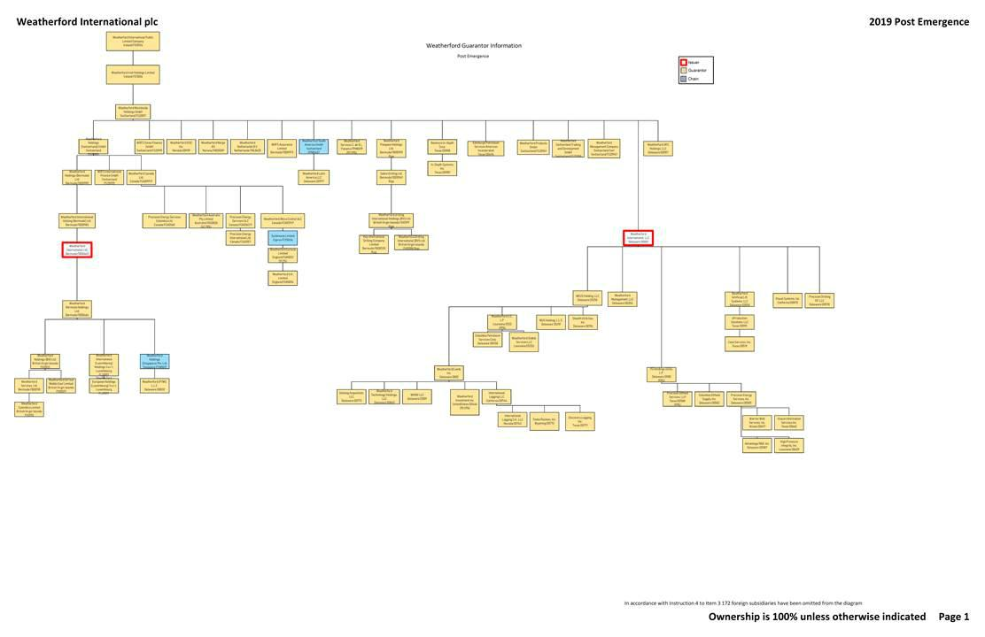

Exhibit 99.2

Directors, Executive Officers and Capitalization of each Applicant

 |  |  |  | Amount |  | Amount |  |  |  | Directors/Managing
Name of Guarantor |  | Title of Class |  | Authorized |  | Outstanding |  | Officers |  | Members
Advantage R&D, Inc. |  | Common Stock |  | 1,000 |  | 1,000 |  | E. Kyle Chapman (President) |  | Christine M. Morrison
 |  |  |  |  |  |  |  | Danielle J.M. Nicholas (Vice President)
 |  |  |  |  |  |  |  | Steven F. Carvalho (Vice President)
 |  |  |  |  |  |  |  | Christine M. Morrison (Vice President And Secretary)
 |  |  |  |  |  |  |  | Mark M. Rothleitner (Vice President and Treasurer)
 |  |  |  |  |  |  |  | Joshua S. Silverman (Assistant Treasurer)
Benmore In-Depth Corp. |  | Common Stock |  | 1,000,000 |  | 1,000 |  | E. Kyle Chapman (President) |  | Christine M. Morrison
 |  |  |  |  |  |  |  | Danielle J.M. Nicholas (Vice President)
 |  |  |  |  |  |  |  | Steven F. Carvalho (Vice President)
 |  |  |  |  |  |  |  | William Marchant (Vice President)
 |  |  |  |  |  |  |  | Christine M. Morrison (Vice President and Secretary)
 |  |  |  |  |  |  |  | Mark M. Rothleitner (Vice President and Treasurer)
 |  |  |  |  |  |  |  | Joshua S. Silverman (Assistant Treasurer)
Case Services, Inc. |  | Common Stock |  | 1,000 |  | 1,000 |  | E. Kyle Chapman (President) |  | Christine M. Morrison
 |  |  |  |  |  |  |  | Danielle J.M. Nicholas (Vice President)
 |  |  |  |  |  |  |  | Steven F. Carvalho (Vice President)
 |  |  |  |  |  |  |  | Christine M. Morrison (Vice President and Secretary)
 |  |  |  |  |  |  |  | Mark M. Rothleitner (Vice President and Treasurer)
 |  |  |  |  |  |  |  | Joshua S. Silverman (Assistant Treasurer)
Colombia Petroleum Services Corp. |  | Common Stock |  | 1,000 |  | 1,000 |  | E. Kyle Chapman (President) |  | Christine M. Morrison
 |  |  |  |  |  |  |  | Danielle J.M. Nicholas (Vice President)
 |  |  |  |  |  |  |  | Steven F. Carvalho (Vice President)
 |  |  |  |  |  |  |  | Christine M. Morrison (Vice President and Secretary)
 |  |  |  |  |  |  |  | Mark M. Rothleitner (Vice President and Treasurer)
 |  |  |  |  |  |  |  | Joshua S. Silverman (Assistant Treasurer)
Columbia Oilfield Supply, Inc. |  | Common Stock |  | 1,000 |  | 100 |  | E. Kyle Chapman (President) |  | Christine M. Morrison
 |  |  |  |  |  |  |  | Danielle J.M. Nicholas (Vice President)
 |  |  |  |  |  |  |  | Steven F. Carvalho (Vice President)
 |  |  |  |  |  |  |  | Christine M. Morrison (Vice President and Secretary)
 |  |  |  |  |  |  |  | Mark M. Rothleitner (Vice President and Treasurer)
 |  |  |  |  |  |  |  | Joshua S. Silverman (Assistant Treasurer)
Datalog Acquisition, LLC |  | Membership Units |  | Unlimited |  | 100 |  | E. Kyle Chapman (President) |  | Christine M. Morrison
 |  |  |  |  |  |  |  | Charles L. Miller (Vice President)
 |  |  |  |  |  |  |  | Chris L. Marshall (Vice President)
 |  |  |  |  |  |  |  | Danielle J.M. Nicholas (Vice President)
 |  |  |  |  |  |  |  | David Morris (Vice President)
 |  |  |  |  |  |  |  | Dean Bell (Vice President)
 |  |  |  |  |  |  |  | Ellen Chin (Vice President)
 |  |  |  |  |  |  |  | Etienne Roux (Vice President)
 |  |  |  |  |  |  |  | Lawrence Allen Sinor (Vice President)
 |  |  |  |  |  |  |  | Marco E. Boos (Vice President)
 |  |  |  |  |  |  |  | Mark Hopmann (Vice President)
 |  |  |  |  |  |  |  | Maximiliano Alberto Kricorian Sanchez Moreno (Vice President)
 |  |  |  |  |  |  |  | Steven F. Carvalho (Vice President)
 |  |  |  |  |  |  |  | William Marchant (Vice President)
 |  |  |  |  |  |  |  | Christine M. Morrison (Vice President and Secretary)
 |  |  |  |  |  |  |  | Mark M. Rothleitner (Vice President and Treasurer)
 |  |  |  |  |  |  |  | Joshua S. Silverman (Assistant Treasurer)
Discovery Logging, Inc. |  | Common Stock |  | 20,000 |  | 2,500 |  | E. Kyle Chapman (President and Vice President) |  | Christine M. Morrison
 |  |  |  |  |  |  |  | Danielle J.M. Nicholas (Vice President)
 |  |  |  |  |  |  |  | David Morris (Vice President)
 |  |  |  |  |  |  |  | Dean Bell (Vice President)
 |  |  |  |  |  |  |  | Ellen Chin (Vice President)
 |  |  |  |  |  |  |  | Etienne Roux (Vice President)
 |  |  |  |  |  |  |  | Lawrence Allen Sinor (Vice President)
 |  |  |  |  |  |  |  | Marco E. Boos (Vice President)
 |  |  |  |  |  |  |  | Mark Hopmann (Vice President)

Maximiliano Alberto Kricorian Sanchez Moreno (Vice President)
Steven F. Carvalho (Vice President)
William Marchant (Vice President)
Christine M. Morrison (Vice President and Secretary)
Mark M. Rothleitner (Vice President and Treasurer)

 |  |  |  | Joshua S. Silverman (Assistant Treasurer)
Edinburgh Petroleum Services Americas Incorporated | Common Stock | 10,000 | 1,000 | E. Kyle Chapman (President) | Christine M. Morrison
 |  |  |  | Danielle J.M. Nicholas (Vice President)
 |  |  |  | Steven F. Carvalho (Vice President)
 |  |  |  | William Marchant (Vice President)
 |  |  |  | Christine M. Morrison (Vice President and Secretary)
 |  |  |  | Mark M. Rothleitner (Vice President and Treasurer)
 |  |  |  | Joshua S. Silverman (Assistant Treasurer)
eProduction Solutions, LLC | Membership Units | Unlimited | 1,000 | E. Kyle Chapman (President) | Weatherford Artificial Lift Systems, LLC
 |  |  |  | Chris L. Marshall (Vice President)
 |  |  |  | Danielle J.M. Nicholas (Vice President)
 |  |  |  | David Morris (Vice President)
 |  |  |  | Dean Bell (Vice President)
 |  |  |  | Ellen Chin (Vice President)
 |  |  |  | Etienne Roux (Vice President)
 |  |  |  | Marco E. Boos (Vice President)
 |  |  |  | Mark Hopmann (Vice President)
 |  |  |  | Maximiliano Alberto Kricorian Sanchez Moreno (Vice President)
 |  |  |  | Oscar Rivera (Vice President)
 |  |  |  | Steven F. Carvalho (Vice President)
 |  |  |  | William Marchant (Vice President)
 |  |  |  | Christine M. Morrison (Vice President and Secretary)
 |  |  |  | Mark M. Rothleitner (Vice President and Treasurer)
 |  |  |  | Joshua S. Silverman (Assistant Treasurer)
High Pressure Integrity, Inc. | Common Stock | 10,000 | 125 | E. Kyle Chapman (President) | Christine M. Morrison
 |  |  |  | Danielle J.M. Nicholas (Vice President)
 |  |  |  | Dean Bell (Vice President)
 |  |  |  | Etienne Roux (Vice President)
 |  |  |  | Mark Hopmann (Vice President)
 |  |  |  | Maximiliano Alberto Kricorian Sanchez Moreno (Vice President)
 |  |  |  | Steven F. Carvalho (Vice President)
 |  |  |  | Christine M. Morrison (Vice President and Secretary)
 |  |  |  | Mark M. Rothleitner (Vice President and Treasurer)
 |  |  |  | Joshua S. Silverman (Assistant Treasurer)
In-Depth Systems, Inc. | Common Stock | 5,000,000 | 1,545,827 | E. Kyle Chapman (President) | Christine M. Morrison
 |  |  |  | Danielle J.M. Nicholas (Vice President)
 |  |  |  | Steven F. Carvalho (Vice President)
 |  |  |  | Christine M. Morrison (Vice President and Secretary)
 |  |  |  | Mark M. Rothleitner (Vice President and Treasurer)
 |  |  |  | Joshua S. Silverman (Assistant Treasurer)
International Logging LLC | Membership Units | 100 | 100 | Charles L. Miller (President) | Christine M. Morrison
 |  |  |  | Danielle J.M. Nicholas (Vice President)
 |  |  |  | Dean Bell (Vice President)
 |  |  |  | E. Kyle Chapman (Vice President)
 |  |  |  | Etienne Roux (Vice President)
 |  |  |  | Mark Hopmann (Vice President)
 |  |  |  | Maximiliano Alberto Kricorian Sanchez Moreno (Vice President)
 |  |  |  | Steven F. Carvalho (Vice President)
 |  |  |  | William Marchant (Vice President)
 |  |  |  | Christine M. Morrison (Vice President and Secretary)
 |  |  |  | Mark M. Rothleitner (Vice President and Treasurer)
 |  |  |  | Joshua S. Silverman (Assistant Treasurer)
International Logging S.A., LLC | Membership Units | Unlimited | 100 | Charles L. Miller (President) | Christine M. Morrison
 |  |  |  | Danielle J.M. Nicholas (Vice President)
 |  |  |  | Dean Bell (Vice President)
 |  |  |  | E. Kyle Chapman (Vice President)
 |  |  |  | Etienne Roux (Vice President)
 |  |  |  | Mark Hopmann (Vice President)
 |  |  |  | Steven F. Carvalho (Vice President)
 |  |  |  | William Marchant (Vice President)
 |  |  |  | Christine M. Morrison (Vice President and Secretary)
 |  |  |  | Mark M. Rothleitner (Vice President and Treasurer)
 |  |  |  | Joshua S. Silverman (Assistant Treasurer)
Key International Drilling Company Limited | Common Stock | 12,000 | 12,000 | Andrew Gold (President) | Andrew Gold
 |  |  |  | Stuart Fraser (Senior Vice President)
 |  |  |  | Danielle J.M. Nicholas (Vice President)
 |  |  |  | Mark M. Rothleitner (Vice President and Treasurer)
 |  |  |  | Conyers Corporate Services (Bermuda) Limited (Secretary)
 |  |  |  | Christine M. Morrison (Assistant Secretary)

 |  |  |  | Joshua S. Silverman (Assistant Treasurer)
PD Holdings (USA), L.P. | Partnership Interests | N/A | N/A | E. Kyle Chapman (President) | Christine M. Morrison
 |  |  |  | Danielle J.M. Nicholas (Vice President)
 |  |  |  | Steven F. Carvalho (Vice President)
 |  |  |  | Christine M. Morrison (Vice President and Secretary)
 |  |  |  | Mark M. Rothleitner (Vice President and Treasurer)
 |  |  |  | Joshua S. Silverman (Assistant Treasurer)
Precision Drilling GP, LLC | Membership Units | Unlimited | 300 | John David Reed (President) | Weatherford International, LLC
 |  |  |  | Christine M. Morrison (Vice President and Secretary)
 |  |  |  | Mark M. Rothleitner (Treasurer)
Precision Energy International Ltd. | Common Stock | Unlimited | 1 | J. David Reed (Vice President) | J. David Reed
 | Preferred Stock | Unlimited |  | Pamela M. Webb (Vice President and Assistant Secretary) | Pamela M. Webb
 |  |  |  | Mark M. Rothleitner (Vice President and Treasurer)
 |  |  |  | Christine M. Morrison (Secretary)
 |  |  |  | Joshua S. Silverman (Assistant Treasurer)
Precision Energy Services Colombia Ltd. | Common Stock | Unlimited | 100 | J. David Reed (Vice President) | J. David Reed
 |  |  |  | Pamela M. Webb (Vice President and Assistant Secretary) | Pamela M. Webb
 |  |  |  | Mark M. Rothleitner (Vice President and Treasurer)
 |  |  |  | Christine M. Morrison (Secretary)
 |  |  |  | Joshua S. Silverman (Assistant Treasurer)
Precision Energy Services ULC | Common Stock | Unlimited | 908,868,693 | J. David Reed (Vice President) | J. David Reed
 | Preferred Stock | 1,000,000 |  | Pamela M. Webb (Vice President and Assistant Secretary) | Pamela M. Webb
 |  |  |  | Mark M. Rothleitner (Vice President and Treasurer)
 |  |  |  | Christine M. Morrison (Secretary)
 |  |  |  | Joshua S. Silverman (Assistant Treasurer)
Precision Energy Services, Inc. | Common Stock | 1,100 | 1,010 | E. Kyle Chapman (President) | Christine M. Morrison
 |  |  |  | Chris L. Marshall (Vice President)
 |  |  |  | Danielle J.M. Nicholas (Vice President)
 |  |  |  | David Morris (Vice President)
 |  |  |  | Dean Bell (Vice President)
 |  |  |  | Ellen Chin (Vice President)
 |  |  |  | Etienne Roux (Vice President)
 |  |  |  | Lawrence Allen Sinor (Vice President)
 |  |  |  | Marco E. Boos (Vice President)
 |  |  |  | Mark Hopmann (Vice President)
 |  |  |  | Maximiliano Alberto Kricorian Sanchez Moreno (Vice President)
 |  |  |  | Steven F. Carvalho (Vice President)
 |  |  |  | William Adey (Vice President)
 |  |  |  | William Marchant (Vice President)
 |  |  |  | Christine M. Morrison (Vice President and Secretary)
 |  |  |  | Mark M. Rothleitner (Vice President and Treasurer)
 |  |  |  | Joshua S. Silverman (Assistant Treasurer)
Precision Oilfield Services, LLP | Partnership Interests | N/A | N/A | Danielle J.M. Nicholas (Vice President) | Precision Energy Services, Inc. (General
 |  |  |  | E. Kyle Chapman (Vice President) | Partner)
 |  |  |  | Steven F. Carvalho (Vice President)
 |  |  |  | Christine M. Morrison (Vice President and Secretary)
 |  |  |  | Mark M. Rothleitner (Vice President and Treasurer)
 |  |  |  | Joshua S. Silverman (Assistant Treasurer)
Sabre Drilling Ltd. | Common Stock | 100 | 100 | Miguel Sanchez (Vice President) | Tan Kah Huan
 |  |  |  | Peter A. White (Vice President)
 |  |  |  | Tan Kah Huan (Vice President)
 |  |  |  | Mohammed Dadhiwala (Vice President)
 |  |  |  | Christine M. Morrison (Vice President and Assistant Secretary)
 |  |  |  | Mark M. Rothleitner (Vice President and Treasurer)
 |  |  |  | Conyers Corporate Services (Bermuda) Limited (Secretary)
 |  |  |  | Joshua S. Silverman (Assistant Treasurer)
Stealth Oil & Gas, Inc. | Common Stock | 1,000 | 100 | E. Kyle Chapman (President) | Christine M. Morrison
 |  |  |  | Danielle J.M. Nicholas (Vice President)
 |  |  |  | Steven F. Carvalho (Vice President)
 |  |  |  | William Marchant (Vice President)
 |  |  |  | Christine M. Morrison (Vice President and Secretary)
 |  |  |  | Mark M. Rothleitner (Vice President and Treasurer)
 |  |  |  | Joshua S. Silverman (Assistant Treasurer)
Tooke Rockies, Inc. | Common Stock | 50,000 | 1,960 | Charles L. Miller (President) | Christine M. Morrison
 |  |  |  | Danielle J.M. Nicholas (Vice President)
 |  |  |  | Dean Bell (Vice President)
 |  |  |  | E. Kyle Chapman (Vice President)
Etienne Roux (Vice President)
Lawrence Allen Sinor (Vice President)

 |  |  |  | Mark Hopmann (Vice President)
 |  |  |  | Steven F. Carvalho (Vice President)
 |  |  |  | William Marchant (Vice President)
 |  |  |  | Christine M. Morrison (Vice President and Secretary)
 |  |  |  | Mark M. Rothleitner (Vice President and Treasurer)
 |  |  |  | Joshua S. Silverman (Assistant Treasurer)
Visean Information Services Inc. | Common Stock | 100,000 | 1,000 | Danielle J.M. Nicholas (Vice President) | Christine M. Morrison
 |  |  |  | E. Kyle Chapman (Vice President)
 |  |  |  | Steven F. Carvalho (Vice President)
 |  |  |  | Christine M. Morrison (Vice President and Secretary)
 |  |  |  | Mark M. Rothleitner (Vice President and Treasurer)
 |  |  |  | Joshua S. Silverman (Assistant Treasurer)
Visual Systems, Inc. | Common Stock | 1,000 | 100 | E. Kyle Chapman (President) | Christine M. Morrison
 |  |  |  | Charles L. Miller (Vice President)
 |  |  |  | Danielle J.M. Nicholas (Vice President)
 |  |  |  | Mark Hopmann (Vice President)
 |  |  |  | Steven F. Carvalho (Vice President)
 |  |  |  | William Marchant (Vice President)
 |  |  |  | Christine M. Morrison (Vice President and Secretary)
 |  |  |  | Mark M. Rothleitner (Vice President and Treasurer)
 |  |  |  | Joshua S. Silverman (Assistant Treasurer)
Warrior Well Services, Inc. | Common Stock | 100,000 | 50,000 | E. Kyle Chapman (President) | Christine M. Morrison
 |  |  |  | Danielle J.M. Nicholas (Vice President)
 |  |  |  | Steven F. Carvalho (Vice President)
 |  |  |  | William Marchant (Vice President)
 |  |  |  | Christine M. Morrison (Vice President and Secretary)
 |  |  |  | Mark M. Rothleitner (Vice President and Treasurer)
 |  |  |  | Joshua S. Silverman (Assistant Treasurer)
Weatherford (Nova Scotia) ULC | Common Stock | Unlimited | 9,990 | J. David Reed (Vice President) | J. David Reed
 | Preferred Stock | Unlimited | 1,738 | Pamela M. Webb (Vice President and Assistant Secretary) | Pamela M. Webb
 |  |  |  | Mark M. Rothleitner (Vice President and Treasurer)
 |  |  |  | Christine M. Morrison (Secretary)
 |  |  |  | Joshua S. Silverman (Assistant Treasurer)
Weatherford (PTWI), L.L.C. | Membership Units | Unlimited | 1,000 | E. Kyle Chapman (President) | Weatherford Holdings (Singapore) PTE. Ltd.
 |  |  |  | Mohammed Dadhiwala (Vice President)
 |  |  |  | Steven F. Carvalho (Vice President)
 |  |  |  | Tan Kah Huan (Vice President)
 |  |  |  | William Marchant (Vice President)
 |  |  |  | Christine M. Morrison (Vice President and Secretary)
 |  |  |  | Mark M. Rothleitner (Vice President and Treasurer)
 |  |  |  | Joshua S. Silverman (Assistant Treasurer)
Weatherford Artificial Lift Systems, LLC | Membership Units | Unlimited | 100 | E. Kyle Chapman (President) | Weatherford International, LLC
 |  |  |  | Chris L. Marshall (Vice President)
 |  |  |  | Danielle J.M. Nicholas (Vice President)
 |  |  |  | David Morris (Vice President)
 |  |  |  | Dean Bell (Vice President)
 |  |  |  | Ellen Chin (Vice President)
 |  |  |  | Etienne Roux (Vice President)
 |  |  |  | Jeff J. Lembcke (Vice President)
 |  |  |  | Lawrence Allen Sinor (Vice President)
 |  |  |  | Marco E. Boos (Vice President)
 |  |  |  | Mark Hopmann (Vice President)
 |  |  |  | Marwan Sabah (Vice President)
 |  |  |  | Philip Scott (Vice President)
 |  |  |  | Robert McDonald (Vice President)
 |  |  |  | Steven F. Carvalho (Vice President)
 |  |  |  | William Marchant (Vice President)
 |  |  |  | Christine M. Morrison (Vice President and Secretary)
 |  |  |  | Mark M. Rothleitner (Vice President and Treasurer)
 |  |  |  | Joshua S. Silverman (Assistant Treasurer)
Weatherford Australia Pty Limited | Ordinary Shares | 1,746,760 | N/A | N/A | Antonino Gullotti
 |  |  |  |  | Robert Antonio DeGasperis
Weatherford Bermuda Holdings Ltd. | Common Stock | 14,000 | 14,000 | Stuart Fraser (Vice President) | Peter A. White
 |  |  |  | Peter A. White (Vice President) | Tan Kah Huan
 |  |  |  | Tan Kah Huan (Vice President) | Mohammed Dadhiwala
 |  |  |  | Mohammed Dadhiwala (Vice President)
 |  |  |  | Christine M. Morrison (Vice President and Assistant Secretary)
 |  |  |  | Mark M. Rothleitner (Vice President and Treasurer)
 |  |  |  | Mark Gregory (Secretary)

 |  |  |  | Conyers Corporate Services (Bermuda) Limited (Assistant Secretary)
 |  |  |  | Joshua S. Silverman (Assistant Treasurer)
Weatherford Canada Ltd. | Common Stock | Unlimited | 5,927,913 | J. David Reed (Vice President) | J. David Reed
 | Class A Preferred Stock | Unlimited | 3,390,000 | Pamela M. Webb (Vice President and Assistant Secretary) | Pamela M. Webb
 | Class B Preferred Stock |  |  | Ryan Leskiw (Director Sales, Canada) | Shekhar Patel
 |  | 1,000,000 |  | Mark M. Rothleitner (Vice President and Treasurer)
 |  |  |  | Christine M. Morrison (Secretary)
 |  |  |  | Joshua S. Silverman (Assistant Treasurer)
Weatherford Colombia Limited | Common Stock | 50,000 | 7,500 | E. Kyle Chapman (President) | Christine M. Morrison
 |  |  |  | Peter A. White (Vice President)
 |  |  |  | Tan Kah Huan (Vice President)
 |  |  |  | Mohammed Dadhiwala (Vice President)
 |  |  |  | Gustavo Torres Abraham (Vice President)
 |  |  |  | Christine M. Morrison (Vice President and Secretary)
 |  |  |  | Mark M. Rothleitner (Vice President and Treasurer)
 |  |  |  | Joshua S. Silverman (Assistant Treasurer)
Weatherford DISC Inc. | Common Stock | 100 | 100 | E. Kyle Chapman (President) | Christine M. Morrison
 |  |  |  | Steven F. Carvalho (Vice President)
 |  |  |  | Christine M. Morrison (Vice President and Secretary)
 |  |  |  | Mark M. Rothleitner (Vice President and Treasurer)
 |  |  |  | Joshua S. Silverman (Assistant Treasurer)
Weatherford Drilling International (BVI) Ltd. | Common Stock | 1 | 1 | Andrew Gold (President) | Tan Kah Huan
 |  |  |  | Tan Kah Huan (Senior Vice President)
 |  |  |  | Mohammed Dadhiwala (Vice President)
 |  |  |  | Mark M. Rothleitner (Controller and Assistant Secretary)
 |  |  |  | Christine M. Morrison (Secretary)
 |  |  |  | Joshua S. Silverman (Assistant Treasurer)
Weatherford Drilling International Holdings (BVI) | Common Stock | 50,000 | 5,359.7478 | Miguel Sanchez (Vice President) | Peter A. White
Ltd. |  |  |  | Peter A. White (Vice President) | Tan Kah Huan
 |  |  |  | Tan Kah Huan (Vice President) | Mohammed Dadhiwala
 |  |  |  | Mohammed Dadhiwala (Vice President)
 |  |  |  | Christine M. Morrison (Vice President and Secretary)
 |  |  |  | Mark M. Rothleitner (Vice President and Treasurer)
 |  |  |  | Joshua S. Silverman (Assistant Treasurer)
Weatherford Eurasia Limited | Ordinary Shares | 97,650,438 | N/A | N/A | Richard Strachan
 |  |  |  |  | Neil MacLeod
Weatherford European Holdings (Luxembourg) S.à r.l. | Common Shares | 1,308,755 | 1,308,755 | N/A | Dragos Cioaca
 |  |  |  |  | Mathias Neuenschwander
 |  |  |  |  | Roberto Marchetti
 |  |  |  |  | Sebastien Francois
Weatherford Global Services LLC | Membership Interest | N/A | N/A | E. Kyle Chapman (President) | Christine M. Morrison
 |  |  |  | Steven F. Carvalho (Vice President)
 |  |  |  | Stuart Fraser (Vice President)
 |  |  |  | Christine M. Morrison (Vice President and Secretary)
 |  |  |  | Mark M. Rothleitner (Vice President and Treasurer)
 |  |  |  | Joshua S. Silverman (Assistant Treasurer)
Weatherford Holdings (Bermuda) Ltd. | Common Stock | 100 | 10 | Stuart Fraser (Vice President) | Peter A. White
 |  |  |  | Peter A. White (Vice President) | Tan Kah Huan
 |  |  |  | Tan Kah Huan (Vice President) | Mohammed Dadhiwala
 |  |  |  | Mohammed Dadhiwala (Vice President)
 |  |  |  | Christine M. Morrison (Vice President and Assistant Secretary)
 |  |  |  | Mark M. Rothleitner (Vice President and Treasurer)
 |  |  |  | Mark Gregory (Secretary)
 |  |  |  | Conyers Corporate Services (Bermuda) Limited (Assistant Secretary)
 |  |  |  | Joshua S. Silverman (Assistant Treasurer)
Weatherford Holdings (BVI) Ltd. | Common Stock | 10,000 | 3,421 | Tan Kah Huan (President and General Manager) | Tan Kah Huan
 |  |  |  | Mohammed Dadhiwala (Senior Vice President)
 |  |  |  | Mark M. Rothleitner (Vice President and Treasurer)
 |  |  |  | Christine M. Morrison (Secretary)
 |  |  |  | Joshua S. Silverman (Assistant Treasurer)
Weatherford Holdings (Switzerland) GmbH | Quotas | 200 | 200 | N/A | Andrzej Puchala
 |  |  |  |  | Mathias Neuenschwander
 |  |  |  |  | Valentin Mueller

Weatherford International (Luxembourg) Holdings S.à | Initial Shares | 800 | 800 | N/A | Dragos Cioaca
r.l. | Class A Shares | 58,719 | 58,719 |  | Mathias Neuenschwander
 | Class B Shares | 58,719 | 58,719 |  | Roberto Marchetti
 | Class C Shares | 58,719 | 58,719 |  | Sebastien Francois
 | Class D Shares | 58,719 | 58,719
 | Class E Shares | 58,719 | 58,719
 | Class F Shares | 58,719 | 58,719
 | Class G Shares | 58,719 | 58,719
 | Class H Shares | 58,719 | 58,719
 | Class I Shares | 58,719 | 58,719
Weatherford International Holding (Bermuda) Ltd. | Common Stock | 100 | 10 | Stuart Fraser (Vice President) | Peter A. White
 |  |  |  | Peter A. White (Vice President) | Tan Kah Huan
 |  |  |  | Tan Kah Huan (Vice President) | Mohammed Dadhiwala
 |  |  |  | Mohammed Dadhiwala (Vice President)
 |  |  |  | Christine M. Morrison (Vice President and Assistant Secretary)
 |  |  |  | Mark M. Rothleitner (Vice President and Treasurer)
 |  |  |  | Mark Gregory (Secretary)
 |  |  |  | Conyers Corporate Services (Bermuda) Limited (Assistant Secretary)
 |  |  |  | Joshua S. Silverman (Assistant Treasurer)
Weatherford International Ltd. | Common Shares | 1,000,000,000 | 481,001,513 | Christoph Bausch (President and Chief Financial Officer) | Peter A. White
 | Preferred Shares | 10,000,000 | 0 | Stuart Fraser (Vice President and Chief Accounting Officer) | Tan Kah Huan
 |  |  |  | Peter A. White (Vice President) | Mohammed Dadhiwala
 |  |  |  | Tan Kah Huan (Vice President)
 |  |  |  | Mohammed Dadhiwala (Vice President)
 |  |  |  | Christine M. Morrison (Vice President and Assistant Secretary)
 |  |  |  | Mark M. Rothleitner (Vice President and Treasurer)
 |  |  |  | Mark Gregory (Secretary)
 |  |  |  | Conyers Corporate Services (Bermuda) Limited (Assistant Secretary)
 |  |  |  | Joshua S. Silverman (Assistant Treasurer)
Weatherford International plc | Deferred Ordinary Shares | 40,000 | 0 | Mark A. McCollum (President and Chief Executive Officer) | Mohamed A. Awad
 | Common Stock |  |  | Christoph Bausch (Executive Vice President and Chief Financial Officer) | Roxanne J. Decyk
 |  | 1,354,000,000 | 1,004,079,258 | Christina M. Ibrahim (Executive Vice President, General Counsel, Chief Compliance | John D. Gass
 |  |  |  | Officer and Corporate Secretary) | Emyr Jones Parry
 |  |  |  | Karl Blanchard (Executive Vice President and Chief Operating Officer) | Francis S. Kalman
 |  |  |  | Stuart Fraser (Vice President and Chief Accounting Officer) | David S. King
 |  |  |  | Karl Blanchard (Executive Vice President and Chief Operating Officer) | William E. Macaulay
 |  |  |  | Frederico Justus (President, Eastern Hemisphere) | Mark A. McCollum
 |  |  |  | Mark D. Swift (President, Western Hemisphere) | Angela A. Minas
 |  |  |  | E. Kyle Chapman (Vice President) | Guillermo Ortiz
 |  |  |  | Ellen Chin Vice (Vice President)
 |  |  |  | Steven F. Carvalho (Vice President)
 |  |  |  | Valentin Mueller (Vice President)
 |  |  |  | Karen David-Green (Vice President)
 |  |  |  | Mark M. Rothleitner (Vice President and Treasurer)
 |  |  |  | Christine M. Morrison (Assistant Secretary)
 |  |  |  | Joshua S. Silverman (Assistant Treasurer)
Weatherford International, LLC | Membership Units | Unlimited | 100 | E. Kyle Chapman (President) | Weatherford U.S. Holdings, L.L.C.
 |  |  |  | Chris L. Marshall (Vice President)
 |  |  |  | Danielle J.M. Nicholas (Vice President)
 |  |  |  | David Morris (Vice President)
 |  |  |  | Dean Bell (Vice President)
 |  |  |  | Ellen Chin (Vice President)
 |  |  |  | Etienne Roux (Vice President)
 |  |  |  | Jeff J. Lembcke (Vice President)
 |  |  |  | Lawrence Allen Sinor (Vice President)
 |  |  |  | Marco E. Boos (Vice President)
 |  |  |  | Mark Hopmann (Vice President)
 |  |  |  | Maximiliano Alberto Kricorian Sanchez Moreno (Vice President)
 |  |  |  | Oscar Rivera (Vice President)
 |  |  |  | Philip Scott (Vice President)
 |  |  |  | Richard Warren (Vice President)
 |  |  |  | Steven F. Carvalho (Vice President)
 |  |  |  | William M. Imwalle (Vice President)
 |  |  |  | William Marchant (Vice President)
 |  |  |  | Stuart Fraser (Vice President and Chief Financial Officer)

 |  |  |  | Christine M. Morrison (Vice President and Secretary)
 |  |  |  | Mark M. Rothleitner (Vice President and Treasurer)
 |  |  |  | Joe B. Dillard, Jr. (Manager)
 |  |  |  | Joshua S. Silverman (Assistant Treasurer)
Weatherford Investment Inc. | Common Stock | 5,000 | 1,953.09 | E. Kyle Chapman (President) | Christine M. Morrison
 |  |  |  | Maximiliano Alberto Kricorian Sanchez Moreno (Vice President and Chief Financial
 |  |  |  | Officer)
 |  |  |  | Steven F. Carvalho (Vice President)
 |  |  |  | Christine M. Morrison (Vice President and Secretary)
 |  |  |  | Mark M. Rothleitner (Vice President and Treasurer)
 |  |  |  | Joshua S. Silverman (Assistant Treasurer)
Weatherford Irish Holdings Limited | Ordinary Shares | Unlimited | 2 | N/A | Neil Alexander Macleod
Weatherford Latin America LLC | Membership Interest | N/A | N/A | E. Kyle Chapman (President) | Weatherford South America GmbH
 |  |  |  | Steven F. Carvalho (Vice President)
 |  |  |  | Christine M. Morrison (Vice President and Secretary)
 |  |  |  | Mark M. Rothleitner (Vice President and Treasurer)
 |  |  |  | Wesley Shields (Assistant Secretary)
 |  |  |  | Joshua S. Silverman (Assistant Treasurer)
Weatherford Management Company Switzerland Sàrl | Quotas | 200 | 200 | E. Kyle Chapman (President) | Andrzej Puchala
 |  |  |  | Christina M. Ibrahim (Executive Vice President, General Counsel and Secretary) | Mathias Neuenschwander
 |  |  |  | Karen David-Green (Vice President) | Steven F. Carvalho
 |  |  |  | Mark M. Rothleitner (Vice President and Treasurer) | Valentin Mueller
 |  |  |  | Joshua S. Silverman (Assistant Treasurer)
Weatherford Management, LLC | Membership Units | Unlimited | 100 | E. Kyle Chapman (President) | Weatherford International, LLC
 |  |  |  | Steven F. Carvalho (Vice President)
 |  |  |  | Christine M. Morrison (Vice President and Secretary)
 |  |  |  | Mark M. Rothleitner (Vice President and Treasurer)
 |  |  |  | Joshua S. Silverman (Assistant Treasurer)
Weatherford Netherlands B.V. | Registered Shares | 900 | N/A | N/A | August Willem Versteeg
 |  |  |  |  | Marcus Johannes van Dijk
Weatherford Norge AS | Registered Shares | 3,385 | N/A | N/A | Geir Egil Moller Olsen
 |  |  |  |  | Arve Eide Haraldsen
 |  |  |  |  | Hege Juul Bruheim
 |  |  |  |  | Aadne Aasheim Andersen
 |  |  |  |  | Bernt Tore Lilleeng
 |  |  |  |  | Tore Simonsen
 |  |  |  |  | Espen Sirevag
 |  |  |  |  | Stig Magne Eik
 |  |  |  |  | Terje Nysted
Weatherford Oil Tool Middle East Limited | Common Stock | 50,000 | 10,000 | Tan Kah Huan (President) | Tan Kah Huan
 |  |  |  | Mohammed Dadhiwala (Senior Vice President) | Tony Azizi
 |  |  |  | Tony Azizi (Vice President) | Mohammed Dadhiwala
 |  |  |  | Torman Limited (Secretary)
 |  |  |  | Christine M. Morrison (Assistant Secretary)
 |  |  |  | Mark M. Rothleitner (Treasurer)
 |  |  |  | Joshua S. Silverman (Assistant Treasurer)
Weatherford Pangaea Holdings Ltd. | Common Stock | 100 | 100 | Miguel Sanchez (Vice President) | Tan Kah Huan
 |  |  |  | Peter A. White (Vice President)
 |  |  |  | Tan Kah Huan (Vice President)
 |  |  |  | Mohammed Dadhiwala (Vice President)
 |  |  |  | Christine M. Morrison (Vice President and Assistant Secretary)
 |  |  |  | Mark M. Rothleitner (Vice President and Treasurer)
 |  |  |  | Mark Gregory (Secretary)
 |  |  |  | Conyers Corporate Services (Bermuda) Limited (Secretary)
 |  |  |  | Joshua S. Silverman (Assistant Treasurer)
Weatherford Products GmbH | Quotas | 100 | 100 | N/A | Andrzej Puchala
 |  |  |  |  | Mathias Neuenschwander
 |  |  |  |  | Steven F. Carvalho
Weatherford Services S. de R.L. | Quotas | 50,000 | 50,000 | Christine M. Morrison | Weatherford Worldwide Holding GmbH &
 |  |  |  | Mohammed Dadhiwala | Weatherford Services, Ltd.
 |  |  |  | Steven F. Carvalho
 |  |  |  | Tan Kah Huan

Weatherford Services, Ltd. | Common Stock | 1,012,000 | 12,000 | E. Kyle Chapman (President) | Mohammed Dadhiwala
 | Preferred Stock | 5,000 | 5,000 | Danielle J.M. Nicholas (Vice President) | Timothy J. Bryant
 |  |  |  | Frederico Justus (Vice President)
 |  |  |  | Timothy J. Bryant (Vice President)
 |  |  |  | Christine M. Morrison (Vice President and Secretary)
 |  |  |  | Mark M. Rothleitner (Vice President and Treasurer)
 |  |  |  | Joshua S. Silverman (Assistant Treasurer)
 |  |  |  | Conyers Corporate Services (Bermuda) Limited (Resident Representative and Assistant
 |  |  |  | Secretary)
Weatherford Switzerland Trading and Development | Quotas | 20 | 20 | Mark M. Rothleitner (Vice President and Treasurer) | Andrzej Puchala
GmbH |  |  |  | Joshua S. Silverman (Assistant Treasurer) | Mathias Neuenschwander
 |  |  |  |  | Steven F. Carvalho
Weatherford Technology Holdings, LLC | Membership Units | Unlimited | 100 | E. Kyle Chapman (President) | Christine M. Morrison
 |  |  |  | Steven F. Carvalho (Vice President)
 |  |  |  | William M. Imwalle (Vice President)
 |  |  |  | Christine M. Morrison (Vice President and Secretary)
 |  |  |  | Mark M. Rothleitner (Vice President and Treasurer)
 |  |  |  | Joshua S. Silverman (Assistant Treasurer)
Weatherford U.K. Limited | Ordinary Shares | 1,000 | N/A | N/A | Richard Strachan
 | Preference Shares | 6,154,000 |  |  | Alexander Olsson
Weatherford U.S., L.P. | Class A Units | 10 | 1 | E. Kyle Chapman (President) | Christine M. Morrison
 | Class B Units | 100,000 |  | Charles L. Miller (Vice President)
 |  |  |  | Chris L. Marshall (Vice President)
 |  |  |  | Danielle J.M. Nicholas (Vice President)
 |  |  |  | David Morris (Vice President)
 |  |  |  | Dean Bell (Vice President)
 |  |  |  | Ellen Chin (Vice President)
 |  |  |  | Etienne Roux (Vice President)
 |  |  |  | Jeff J. Lembcke (Vice President)
 |  |  |  | Lawrence Allen Sinor (Vice President)
 |  |  |  | Marco E. Boos (Vice President)
 |  |  |  | Mark Hopmann (Vice President)
 |  |  |  | Maximiliano Alberto Kricorian Sanchez Moreno (Vice President)
 |  |  |  | Oscar Rivera (Vice President)
 |  |  |  | Philip Scott (Vice President)
 |  |  |  | Richard Warren (Vice President)
 |  |  |  | Steven F. Carvalho (Vice President)
 |  |  |  | William M. Imwalle (Vice President)
 |  |  |  | William Marchant (Vice President)
 |  |  |  | Christine M. Morrison (Vice President and Secretary)
 |  |  |  | Mark M. Rothleitner (Vice President and Treasurer)
 |  |  |  | Joe B. Dillard, Jr. (Manager)
 |  |  |  | Joshua S. Silverman (Assistant Treasurer)
Weatherford URS Holdings, LLC | Membership Units | Unlimited | 10 | E. Kyle Chapman (President) | Christine M. Morrison
 |  |  |  | Steven F. Carvalho (Vice President)
 |  |  |  | Christine M. Morrison (Vice President and Secretary)
 |  |  |  | Mark M. Rothleitner (Vice President and Treasurer)
 |  |  |  | Joshua S. Silverman (Assistant Treasurer)
Weatherford Worldwide Holdings GmbH | Quotas | 21 | 21 | Mark M. Rothleitner (Vice President and Treasurer) | Philipp Andermatt
 |  |  |  | Joshua S. Silverman (Assistant Treasurer) | Mathias Neuenschwander
 |  |  |  |  | Steven F. Carvalho
 |  |  |  |  | Valentin Mueller
Weatherford/Lamb, Inc. | Common Stock | 200,000 | 184,522 | E. Kyle Chapman (President) | Christine M. Morrison
 |  |  |  | Danielle J.M. Nicholas (Vice President)
 |  |  |  | Steven F. Carvalho (Vice President)
 |  |  |  | William M. Imwalle (Vice President)
 |  |  |  | Christine M. Morrison (Vice President, Secretary and Assistant Secretary)
 |  |  |  | Mark M. Rothleitner (Vice President and Treasurer)
 |  |  |  | Joshua S. Silverman (Assistant Treasurer)
WEUS Holding, LLC | Membership Units | Unlimited | 100 | E. Kyle Chapman (President) | Weatherford International, LLC
 |  |  |  | Steven F. Carvalho (Vice President)
 |  |  |  | Christine M. Morrison (Vice President and Secretary)
 |  |  |  | Mark M. Rothleitner (Vice President and Treasurer)
 |  |  |  | Joshua S. Silverman (Assistant Treasurer)

WIHBV LLC | Membership Interests | N/A | N/A | E. Kyle Chapman (President) | Christine M. Morrison
 |  |  |  | Maximiliano Alberto Kricorian Sanchez Moreno (Vice President and Chief Financial
 |  |  |  | Officer)
 |  |  |  | Steven F. Carvalho (Vice President)
 |  |  |  | Christine M. Morrison (Vice President and Secretary)
 |  |  |  | Mark M. Rothleitner (Vice President and Treasurer)
 |  |  |  | Joshua S. Silverman (Assistant Treasurer)
WOFS Assurance Limited | Common Stock | 12,000,000 | 12,000,000 | Neil Alexander MacLeod (President) | Mark M. Rothleitner
 |  |  |  | Stuart Fraser (Chief Financial Officer) | Neil Alexander MacLeod
 |  |  |  | Javier B Garcia (Vice President) | Javier B Garcia
 |  |  |  | Mohammed Dadhiwala (Vice President) | Sophia Greaves
 |  |  |  | Tan Kah Huan (Vice President)
 |  |  |  | Conyers Corporate Services (Bermuda) Limited (Secretary) | William Cooper (Alternate Director)
 |  |  |  | Christine M. Morrison (Assistant Secretary)
 |  |  |  | Mark M. Rothleitner (Treasurer)
 |  |  |  | Joshua S. Silverman (Assistant Treasurer)
WOFS International Finance GmbH | Quotas | 200 | 200 | N/A | Andrzej Puchala
 |  |  |  |  | Mathias Neuenschwander
 |  |  |  |  | Steven F. Carvalho
WOFS Swiss Finance GmbH | Class A Quotas | 298 | 298 | N/A | Arjana Cabariu-Truong
 | Class B Quotas | 287 | 287 |  | Philipp Andermatt
WUS Holding, L.L.C. | Membership Interests | 100 | 100 | E. Kyle Chapman (President) | WEUS Holding, LLC
 |  |  |  | Danielle J.M. Nicholas (Vice President)
 |  |  |  | Steven F. Carvalho (Vice President)
 |  |  |  | Christine M. Morrison (Vice President and Secretary)
Mark M. Rothleitner (Vice President and Treasurer)
Joshua S. Silverman (Assistant Treasurer)

Exhibit 99.3

Principal Ownership of Voting Securities of each Applicant

 |  |  |  |  |  |  |  | Percentage of Voting
Name of Guarantor |  | Record Owner |  | Title of Class Owned |  | Amount Owned |  | Securities Owned
Advantage R&D, Inc. |  | Precision Energy Services, Inc. |  | Common Stock |  | 1,000 |  | 100%
Benmore In-Depth Corp. |  | Weatherford Holdings U.S. LLC |  | Common Stock |  | 1,000 |  | 100%
Case Services, Inc. |  | eProduction Solutions, LLC |  | Common Stock |  | 1,000 |  | 100%
Colombia Petroleum Services Corp. |  | Weatherford U.S., L.P. |  | Common Stock |  | 1,000 |  | 100%
Columbia Oilfield Supply, Inc. |  | PD Holdings (USA), L.P. |  | Common Stock |  | 100 |  | 100%
Datalog Acquisition, LLC |  | Weatherford/Lamb, Inc. |  | Membership Units |  | 100 |  | 100%
Discovery Logging, Inc. |  | International Logging LLC |  | Common Stock |  | 2,500 |  | 100%
Edinburgh Petroleum Services Americas |  | Weatherford Holdings U.S. LLC |  | Common Stock |  | 1,000 |  | 100%
Incorporated
eProduction Solutions, LLC |  | Weatherford Artificial Lift Systems, LLC |  | Membership Units |  | 1,000 |  | 100%
High Pressure Integrity, Inc. |  | Precision Energy Services, Inc. |  | Common Stock |  | 125 |  | 100%
In-Depth Systems, Inc. |  | Benmore In-Depth Corp. |  | Common Stock |  | 1,545,827 |  | 100%
International Logging LLC |  | Weatherford/Lamb, Inc. |  | Membership Units |  | 100 |  | 100%
International Logging S.A., LLC |  | International Logging LLC |  | Membership Units |  | 100 |  | 100%
Key International Drilling Company Limited |  | Weatherford Drilling International |  | Common Stock |  | 12,000 |  | 100%
 |  | Holdings (BVI) Ltd.
PD Holdings (USA), L.P. |  | Weatherford International, LLC |  | Partnership Interests |  | N/A |  | 100%
Precision Drilling GP, LLC |  | Weatherford International, LLC |  | Membership Units |  | 100 |  | 100%
Precision Energy International Ltd. |  | Precision Energy Services ULC |  | Common Stock |  | 1 |  | 100%
 |  |  |  | Preferred Stock
Precision Energy Services Colombia Ltd. |  | Weatherford Canada Ltd. |  | Common Stock |  | 100 |  | 100%
Precision Energy Services ULC |  | Weatherford Canada Ltd. |  | Common Stock |  | 908,868,693 |  | 100%
 |  |  |  | Preferred Stock
Precision Energy Services, Inc. |  | PD Holdings (USA), L.P. |  | Common Stock |  | 1,010 |  | 100%
Precision Oilfield Services, LLP |  | PD Holdings (USA) L.P. |  | Partnership Interests |  | N/A |  | 100%
Sabre Drilling Ltd. |  | Weatherford Pangaea Holdings Ltd. |  | Common Stock |  | 100 |  | 100%
Stealth Oil & Gas, Inc. |  | WEUS Holding, LLC |  | Common Stock |  | 100 |  | 100%
Tooke Rockies, Inc. |  | International Logging LLC |  | Common Stock |  | 1,960 |  | 100%
Visean Information Services Inc. |  | Precision Energy Services, Inc. |  | Common Stock |  | 1,000 |  | 100%
Visual Systems, Inc. |  | Weatherford International, LLC |  | Common Stock |  | 100 |  | 100%
Warrior Well Services, Inc. |  | Precision Energy Services, Inc. |  | Common Stock |  | 50,000 |  | 100%
Weatherford (Nova Scotia) ULC |  | Weatherford Canada Ltd. |  | Common Stock |  | 9,990 |  | 100%
 |  |  |  | Preferred Stock |  | 1,738
Weatherford (PTWI), L.L.C. |  | Weatherford Holdings (Singapore) Pte. |  | Membership Units |  | 1,000 |  | 100%
 |  | Ltd.
Weatherford Artificial Lift Systems, LLC |  | Weatherford International, LLC |  | Membership Units |  | 100 |  | 100%
Weatherford Australia Pty Limited |  | Weatherford Canada Ltd. |  | Ordinary Shares |  | N/A |  | 100%
Weatherford Bermuda Holdings Ltd. |  | Weatherford International Ltd. |  | Common Stock |  | 14,000 |  | 100%
Weatherford Canada Ltd. |  | Weatherford Holdings (Switzerland) |  | Common Stock |  | 5,927,913 |  | 100%
 |  | GmbH |  | Class A Preferred Stock |  | 3,390,000
 |  |  |  | Class B Preferred Stock
Weatherford Colombia Limited |  | Weatherford Services, Ltd. |  | Common Stock |  | 7,500 |  | 100%
Weatherford DISC Inc. |  | Weatherford Worldwide Holdings GmbH |  | Common Stock |  | 100 |  | 100%

Weatherford Drilling International (BVI) Ltd. | Weatherford Drilling International | Common Stock | 1 | 100%
 | Holdings (BVI) Ltd.
Weatherford Drilling International Holdings (BVI) | Sabre Drilling Ltd. | Common Stock | 5,359.7478 | 100%
Ltd.
Weatherford Eurasia Limited | Sunbreeze Limited | Ordinary Shares | N/A | 51%
Weatherford European Holdings (Luxembourg) S.à | Weatherford International (Luxembourg) | Common Shares | 1,308,755 | 100%
r.l. | Holdings S.à r.l.
Weatherford Global Services LLC | Weatherford U.S., L.P. | Membership Interests | 100% | 100%
Weatherford Holdings (Bermuda) Ltd. | Weatherford Holdings (Switzerland) | Common Stock | 10 | 100%
 | GmbH
Weatherford Holdings (BVI) Ltd. | Weatherford Bermuda Holdings Ltd. | Common Stock | 3,421 | 100%
Weatherford Holdings (Switzerland) GmbH | Weatherford Worldwide Holdings GmbH | Quotas | 200 | 100%
Weatherford International (Luxembourg) Holdings | Weatherford Bermuda Holdings Ltd. | Initial Shares | 800 | 100%
S.à r.l. |  | Class A Shares | 58,719
 |  | Class B Shares | 58,719
 |  | Class C Shares | 58,719
 |  | Class D Shares | 58,719
 |  | Class E Shares | 58,719
 |  | Class F Shares | 58,719
 |  | Class G Shares | 58,719
 |  | Class H Shares | 58,719
 |  | Class I Shares | 58,719
Weatherford International Holding (Bermuda) Ltd. | Weatherford Holdings (Bermuda) Ltd. | Common Stock | 10 | 100%
Weatherford International Ltd. | Weatherford International Holding | Common Shares | 481,001,513 | 100%
 | (Bermuda) Ltd.
Weatherford International plc | N/A | Deferred Ordinary Shares | N/A | N/A
 |  | Common Stock
Weatherford International, LLC | Weatherford U.S. Holdings, L.L.C. | Membership Units | 100 | 100%
Weatherford Investment Inc. | Weatherford/Lamb, Inc. | Common Stock | 1,855.66 | 95.01%
 | Weatherford U.S. Holdings, L.L.C. |  | 97.43 | 4.99%
Weatherford Irish Holdings Limited | Weatherford International plc | Ordinary Shares | 2 | 100%
Weatherford Latin America LLC | Weatherford South America GmbH | Membership Interests | 100% | 100%
Weatherford Management Company Switzerland Sàrl | Weatherford International plc | Quotas | 200 | 100%
Weatherford Management, LLC | Weatherford International, LLC | Membership Units | 100 | 100%
Weatherford Netherlands B.V. | Weatherford Worldwide Holdings GmbH | Registered Shares | N/A | 100%
Weatherford Norge AS | Weatherford Worldwide Holdings GmbH | Registered Shares | N/A | 100%
Weatherford Oil Tool Middle East Limited | Weatherford Holdings (BVI) Ltd. | Common Stock | 10,000 | 100%
Weatherford Pangaea Holdings Ltd. | Weatherford Worldwide Holdings GmbH | Common Stock | 100 | 100%
Weatherford Products GmbH | Weatherford International plc | Quotas | 100 | 100%
Weatherford Services S. de R.L. | Weatherford Worldwide Holding GmbH | Quotas | 49,999 | 99.99%
 | Weatherford Services, Ltd. |  | 1 | 0.01%
Weatherford Services, Ltd. | Weatherford Holdings (BVI) Ltd. | Common Stock | 12,000 | 100%
 |  | Preferred Stock | 5,000
Weatherford Switzerland Trading and Development | Weatherford International plc | Quotas | 20 | 100%
GmbH
Weatherford Technology Holdings, LLC | Weatherford/Lamb, Inc. | Membership Units | 100 | 100%
Weatherford U.K. Limited | Weatherford Eurasia Limited | Ordinary Shares | N/A | 100%
 |  | Preference Shares

Weatherford U.S., L.P. | Weatherford U.S. Holdings, L.L.C. | Class A Units | 1 | 99%
 | WUS Holding, L.L.C. | Class B Units |  | 1%
Weatherford URS Holdings, LLC | Weatherford U.S. Holdings, L.L.C. | Membership Units | 10 | 100%
Weatherford Worldwide Holdings GmbH | Weatherford International plc | Quotas | 21 | 100%
Weatherford/Lamb, Inc. | WEUS Holding, LLC | Common Stock | 184,522 | 100%
WEUS Holding, LLC | Weatherford International, LLC | Membership Units | 100 | 100%
WIHBV LLC | Weatherford/Lamb, Inc. | Membership Interests | 100% | 100%
WOFS Assurance Limited | Weatherford Worldwide Holdings GmbH | Common Stock | 12,000,000 | 100%
WOFS International Finance GmbH | Weatherford Holdings (Switzerland) | Quotas | 200 | 100%
 | GmbH
WOFS Swiss Finance GmbH | Weatherford Worldwide Holdings GmbH | Class A Quotas | 298 | 100%
 |  | Class B Quotas | 287
WUS Holding, L.L.C. | WEUS Holding, LLC | Membership Interests | 100 | 100%

